Kosuke Takahashi

Liu

CS596

October 21st, 2019

Homework Assignment 3 Write-up

**Problem I. Logistic Regression**

Using Gradient Descent:

Using sklearn:

For placeholder #2, when using the sklearn method or the GD method there was a performance difference. The sklearn method processed extremely faster while the GD method took longer.

I used the following line in python to create these numerical results:

﻿from sklearn.metrics import classification_report

**Problem II. Confusion Matrix**

The algorithm had 7 correct predictions where the Predicted class matched the True class in a data set of 20 tests.

Accuracy = (# of correct predictions / # of predictions) * 100

accuracy = (7/20) * 100 = 35%

The precision of this animal class trained classifier was 35%. Looking at the results of the graph we can see:

|  |  |  |  |  |
| --- | --- | --- | --- | --- |
|  | True Class |  |  |  |
| Predicted Class |  | Cats | Dogs | Monkeys |
|  | Cats | 1 | 3 | 2 |
|  | Dogs | 3 | 3 | 2 |
|  | Monkeys | 1 | 2 | 3 |

Cat recall: True_Positive / True_Positive + False_Negative = 1/5 = 20%

Cat precision: True_Positive / True_Positive + True_Negative = 1/6 = 16.67%

Dog recall = 3/8 = 37.5%

Dog precision = 3/8 = 37.5%

Monkey recall = 3/7 = 42.86%

Monkey precision = 3/6 = 50%

**Problem III. Comparative Studies**

Using Gradient Descent:

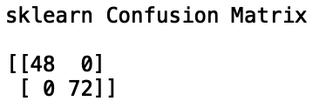Using sklearn: