Project 1: Gradient Descent Variants

Team Information
Team Name: I’m Only Kenny (I’m OK)
Team Members: Kenneth O’Dell
Name: Project 1 – Gradient Descent Variants
Date: 2026-09-10
Exemption to work alone was confirmed via email.

Public Link to Demo and Summary Video

Introduction

Methods

Results

Experimental Analysis

Conclusion

Appendix

4. Feature Selection Methods
The two different feature selection methods that I tested entail removing words based on their frequency. To define a cutoff, terms were ranked according to their frequency. After visually inspecting a frequency chart of the terms (see Figure 1), I chose rank 25 to be a cutoff, since term frequencies dropped off prior to rank 25, and frequencies remained low afterwards. Terms were excluded based on their rank relative to the cutoff.
4.1 Exclude Top Ranked Terms
The first feature selection method excluded terms that were Rank 25 or higher. This amounted to excluding the most frequent terms. The intuition behind this method was to exclude common terms that may not contribute novel semantic meaning (like superlatives ‘very’, which can apply in both positive and negative contexts). The remaining less frequent terms were predicted to contain more contextual information that would be relevant for models to learn. This feature selection method is compared against the default baseline, which is to keep all terms irrespective of their frequency. It is also compared against excluding bottom-ranked terms.
4.2 Exclude Bottom Ranked Terms
The second feature selection method excluded terms that were Rank 25 or lower. This amounted to excluding the less frequent terms. Whereas excluding the top most frequent terms might leave behind more contextually specific terms, on the one hand, it is also intuitive to expect that some higher frequency terms (like ‘bad’ or ‘good’) may be quite relevant for a classification task wherein the binary labels are ‘positive’ and ‘negative’. This feature selection method is compared against the default baseline, which is to keep all terms irrespective of their frequency. This feature selection method is compared against the default baseline, which is to keep all terms irrespective of their frequency. It is also compared against excluding top-ranked terms.

5. Text Preprocessing Methods
The first text preprocessing method is TF-IDF compared to the default one-hot encoding (i.e., no TF-IDF). The term frequency—inverse document frequency method is a method that considers the relative importance of a term (based on its frequency) as that term appears in a larger corpus or set of documents. The general idea is that more frequent terms in a given document are suggested to be more important. At the same time, if that word appears frequently across the corpus—that is, if it is common among multiple documents—then the weight of that term is lower as it becomes increasingly common. Thus, words that appear in fewer documents are considered rare and therefore may contribute more contextually important information.
The second text preprocessing method is stop-word removal compared to no stop-word removal. Stop words are common words that contribute very little, both contextually and semantically. These are words like the articles ‘a’ and ‘the’, as well as common prepositions. The idea is that removing these stop-words should reduce the noise that a model receives while learning the training data.
The third text preprocessing method is the use of stemming vs. no stemming. The idea of stemming is to remap words to their roots, thereby allowing semantically similar words to map to the same feature. An example would be mapping words like ‘stupider’ and ‘stupidity’ to ‘stupid’, such that a single dimension can be used to capture the lexical data instead of creating three separate dimensions (i.e., one column for ‘stupider’, a second for ‘stupidity’, and a third for ‘stupid’). The idea is that this can reduce the sparsity of the data.

6. Classification Models
6.1 Naïve Bayes: The naïve Bayes classifiers as probabilistic models that assume that the probability of a certain feature value (in our case, it could be term presence/absence or relative frequency) are independent from one another, resulting in a quite scalable and intuitive-to-understand model. The main parameter choice is the probability distribution that is assumed for estimating feature distribution, which in this case is either the multinomial distribution or the Bernoulli distribution.
6.2 Logistic Regression: The logistic regression is a kind of linear classifier that predicts the probability of an event y, which in this case can be a discrete class, like ‘positive’ or ‘negative’. To be sure, binary probability distributions cannot be modelled linearly, so the logistic regression actually models the logarithm of the odds, which is the log(p / 1 – p), where p is the probably that that y = 1 and 1 – p is the probability that y = 0. The main parameter is C, which is the inverse of regularization strength (See LogisticRegression — scikit-learn 1.8.0 documentation). A higher C results in stronger regularization, which essentially increases the loss penalty. This has the effect of reducing overfitting, which should increase generalizability. A lower C allows the model to increase in complexity, which allows the model to more closely fit the training data at the risk of overfitting. I chose to test three values of C that are an order of magnitude different: 0.1, 1.0 and 10.0.
6.3 Decision Tree: This is a simple model chosen as a baseline for the ensemble method (Random Forest). A decision tree is akin to a dichotomous key that applies inferred simple rules (yes/no) to split the data according to a feature value. To assess the quality of the splits, I used the Gini impurity (default criterion), which essentially quantifies how well a given feature splits the data (purity). The parameters that I tested include the minimum number of samples required for a split (2 vs 10, where 2 is the default minimum for very deep trees, and 10 would result in shallower trees), and max depth, which constrains how deep the tree can become (1, 10 or 100, chosen to have at least an order of magnitude of difference).
6.4 Linear SVC: I chose a fourth model, which is a linear support vector machine for classification (SVC). It’s linear because the kernel function is linear. For this, I test regularization strength, similar to the logistic regression above, using values of 0.1, 1.0 and 10.0.(See https://scikit-learn.org/stable/modules/generated/sklearn.svm.LinearSVC.html) .

7. Ensemble Method
7.1 Ensemble Architecture
The ensemble method is the Random Forest (Breiman 2001), as implemented in sklearn (See 1.11. Ensembles: Gradient boosting, random forests, bagging, voting, stacking — scikit-learn 1.8.0 documentation and RandomForestClassifier — scikit-learn 1.8.0 documentation), which uses many small simple decision trees that are each trained on (i) a subset of training records with (ii) a subset of features. I chose this model due to having used it before, and its ease of access via the scikit-learn package. Thus, the parameters to be tested include the maximum number of features that a given tree can be trained on (two choices of which are [1] sqrt of the number of features or [2] the log₂ of the number of features, which is much lower). Another important parameter is the number of trees that compose the forest, and I initially tested 100, 200 and 400 estimators. While performing iterations to improve performance, I increased the number of estimators beyond 400.

8. Algorithms and Pseudocode
The main algorithm is encapsulated in the run function that I wrote, which is the main pipeline. The ensemble method used the sklearn implementation, so no new ensemble implementation was created.

9. Validation and Evaluation
9.1 Validation Protocol
The single-run metrics were obtained using the compute_metrics function from the template (modified to be more easily printable). The main validation protocol used K-fold cross validation with K = 5. I chose 5 instead of 10 to allow for time-savings. Plus, 5-fold seemed sufficient with the ample training split of 90:10 train/test.
9.2 Evaluation Metrics
The main evaluation metric is the average accuracy (obtained from the 5-fold cross validation) with ± standard deviation. These are reported tabularly under Results, along with visualizations with error bars.

10. Results
10.1 Quantitative Results
Tabulated results have been recorded below, comparing models, parameter choices, feature selection, and preprocessing. Table 1 corresponds to Figure 2 data, and Table 2 corresponds to Figure 3 data. Figure 1 shows how visual inspection of the term frequency chart informed a rank cutoff threshold for features selection.
 | Exclude Bottom |  | Exclude Top |  | Default
Model + Param | Avg. Accuracy | Std | Avg. Accuracy | Std | Avg. Accuracy | Std
NB Bernoulli | 0.814 | 0.163 | 0.815 | 0.018 | 0.795 | 0.025
NB Multinomial | 0.904 | 0.005 | 0.851 | 0.026 | 0.819 | 0.016
SVC C = 0.1 | 0.906 | 0.017 | 0.952 | 0.009 | 0.852 | 0.005
SVC C = 1.0 | 0.906 | 0.01 | 0.952 | 0.006 | 0.849 | 0.016
SVC C = 10.0 | 0.9 | 0.01 | 0.954 | 0.009 | 0.854 | 0.027
LR C = 0.1 | 0.911 | 0.012 | 0.956 | 0.01 | 0.862 | 0.012
LR C = 1.0 | 0.912 | 0.011 | 0.954 | 0.004 | 0.868 | 0.008
LR C = 10.0 | 0.913 | 0.004 | 0.956 | 0.007 | 0.861 | 0.016
DT Max Depth = 1, Min Split = 2 | 0.885 | 0.009 | 0.874 | 0.006 | 0.628 | 0.025
DT Max Depth = 10, Min Split = 2 | 0.896 | 0.011 | 0.904 | 0.011 | 0.612 | 0.031
DT Max Depth = 100, Min Split = 2 | 0.891 | 0.005 | 0.904 | 0.005 | 0.631 | 0.012
DT Max Depth = 1, Min Split = 10 | 0.885 | 0.015 | 0.874 | 0.013 | 0.628 | 0.012
DT Max Depth = 10, Min Split = 10 | 0.893 | 0.008 | 0.89 | 0.017 | 0.627 | 0.015
DT Max Depth = 100, Min Split = 10 | 0.908 | 0.004 | 0.9 | 0.007 | 0.627 | 0.022
RF sqrt, N = 100 | 0.909 | 0.016 | 0.928 | 0.012 | 0.815 | 0.009
RF sqrt, N = 200 | 0.91 | 0.011 | 0.946 | 0.015 | 0.821 | 0.012
RF sqrt, N = 400 | 0.908 | 0.009 | 0.96 | 0.012 | 0.838 | 0.017
RF log2, N = 100 | 0.903 | 0.015 | 0.795 | 0.027 | 0.743 | 0.031
RF log2, N = 200 | 0.901 | 0.016 | 0.824 | 0.031 | 0.772 | 0.033
RF log2, N = 400 | 0.908 | 0.012 | 0.851 | 0.021 | 0.793 | 0.028
Table 1: Tabulated results of data shown in Figure 2, comparing features selection methods.
 | Stop word Removal |  | Use Stemming |  | TF-IDF
Model + Param | Avg. Accuracy | Std | Avg. Accuracy | Std | Avg. Accuracy | Std
NB Bernoulli | 0.815 | 0.018 | 0.825 | 0.012 | 0.798 | 0.033
NB Multinomial | 0.851 | 0.026 | 0.846 | 0.022 | 0.528 | 0.045
SVC C = 0.1 | 0.952 | 0.009 | 0.943 | 0.01 | 0.643 | 0.028
SVC C = 1.0 | 0.952 | 0.006 | 0.942 | 0.008 | 0.663 | 0.025
SVC C = 10.0 | 0.954 | 0.009 | 0.945 | 0.009 | 0.682 | 0.037
LR C = 0.1 | 0.956 | 0.01 | 0.951 | 0.01 | 0.615 | 0.023
LR C = 1.0 | 0.954 | 0.004 | 0.951 | 0.008 | 0.648 | 0.022
LR C = 10.0 | 0.956 | 0.007 | 0.95 | 0.008 | 0.665 | 0.019
DT Max Depth = 1, Min Split = 2 | 0.874 | 0.006 | 0.874 | 0.006 | 0.628 | 0.03
DT Max Depth = 10, Min Split = 2 | 0.904 | 0.011 | 0.891 | 0.011 | 0.649 | 0.007
DT Max Depth = 100, Min Split = 2 | 0.904 | 0.005 | 0.895 | 0.018 | 0.646 | 0.025
DT Max Depth = 1, Min Split = 10 | 0.874 | 0.013 | 0.874 | 0.014 | 0.628 | 0.029
DT Max Depth = 10, Min Split = 10 | 0.89 | 0.017 | 0.89 | 0.024 | 0.643 | 0.028
DT Max Depth = 100, Min Split = 10 | 0.9 | 0.007 | 0.891 | 0.011 | 0.635 | 0.017
RF sqrt, N = 100 | 0.928 | 0.012 | 0.916 | 0.014 | 0.773 | 0.029
RF sqrt, N = 200 | 0.946 | 0.015 | 0.941 | 0.007 | 0.809 | 0.025
RF sqrt, N = 400 | 0.96 | 0.012 | 0.953 | 0.016 | 0.814 | 0.021
RF log2, N = 100 | 0.795 | 0.027 | 0.802 | 0.026 | 0.745 | 0.009
RF log2, N = 200 | 0.824 | 0.031 | 0.823 | 0.01 | 0.767 | 0.016
RF log2, N = 400 | 0.85 | 0.021 | 0.853 | 0.026 | 0.798 | 0.02
Table 2: Tabulated results of data shown in Figure 2, comparing features selection methods.

10.2 Visualizations
To determine the cutoff rank for the feature selection based on term exclusion, I visually inspected the frequency chart to make an informed decision on a cutoff threshold. Rank 25 was chosen (Figure 1).
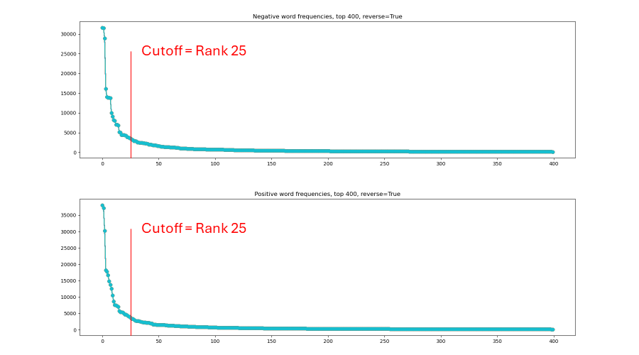
Figure 1: Figure shows term frequencies for the positive and negative examples plotted against their ranking. Frequencies drop off steeply before rank 25, which was chosen as a cutoff threshold based on visual inspection.

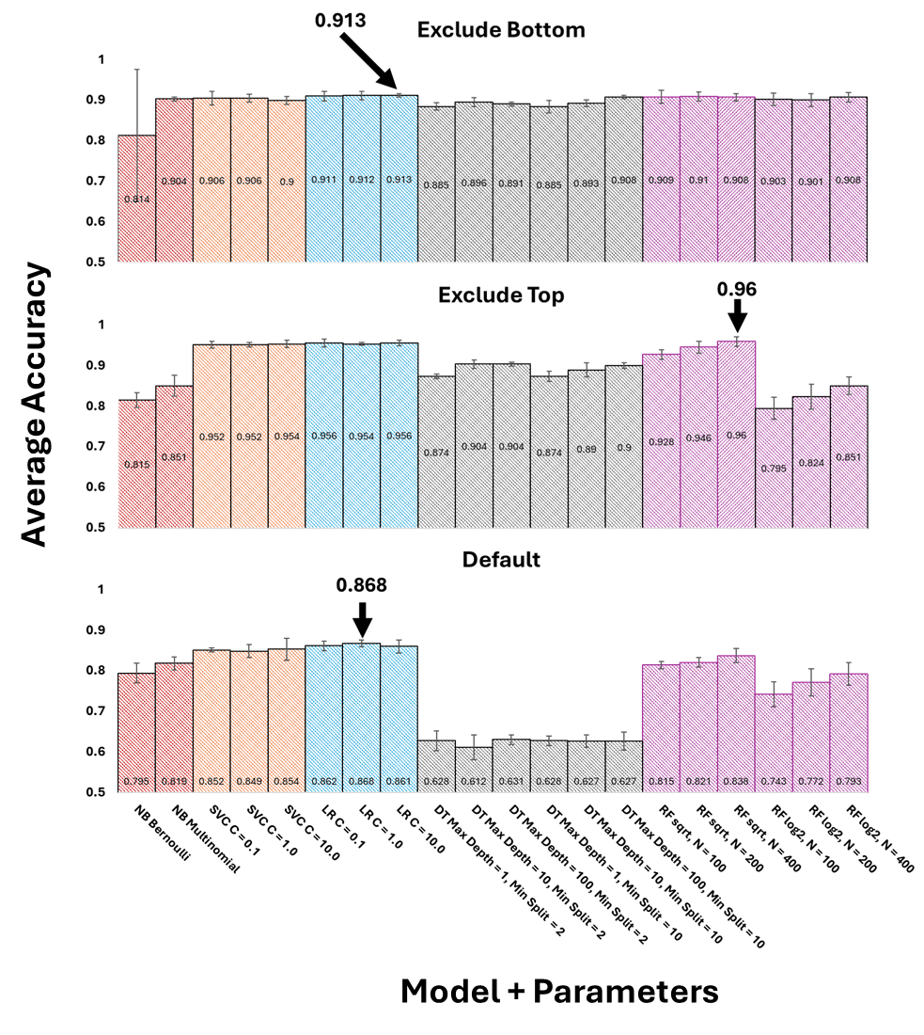
Figure 2: Result of comparing features selection across models + hyperparameters. Excluding terms with rank 25 or lower (Top), excluding terms with rank 25 or higher (Middle), and default to keeping all terms (Bottom). Pipeline settings: One-hot encoded features (no TF-IDF), no stop-word removal, no stemming. Training split 90:10, Random Seed = 42. Validation performed with 5-Fold Cross Validation, with accuracy reported. Error bars denote standard deviation. Models are color coded to allow easy parameter comparison. The best model is annotated. NB = naïve Bayes, SVC = Support Vector Classification, LR = Logistic Regression, DT = Decision Tree, RF = Random Forest.

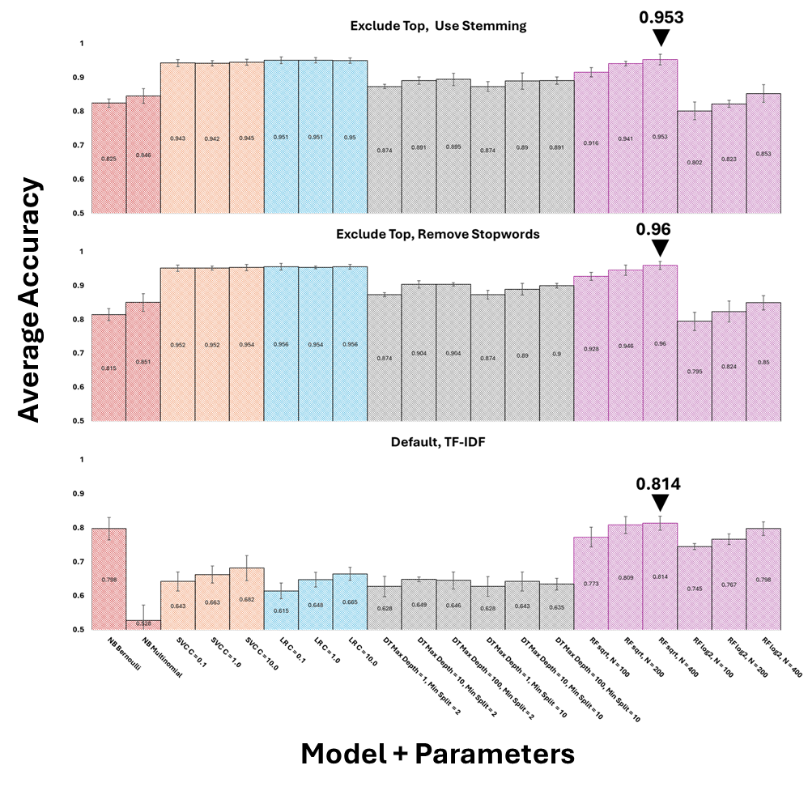
Figure 3: Result of comparing pre-processing strategies across models + hyperparameters. Use of stemming + excluding top-ranked terms (Top), Removing stopwords + excluding top-ranked terms (Middle), and Use of TF-IDF + keeping all terms (Bottom). Excluding Top was used for Stemming and Stopword due to higher performance as indicated in Figure 1. TF-IDF was implemented with ‘Default’ features selection since my TF-IDF implementation, if used with exclusion, would result in data leakage. Training split 90:10, Random Seed = 42. Validation performed with 5-Fold Cross Validation, with accuracy reported. Error bars denote standard deviation. Models are color coded to allow easy parameter comparison. The best model is annotated. NB = naïve Bayes, SVC = Support Vector Classification, LR = Logistic Regression, DT = Decision Tree, RF = Random Forest.

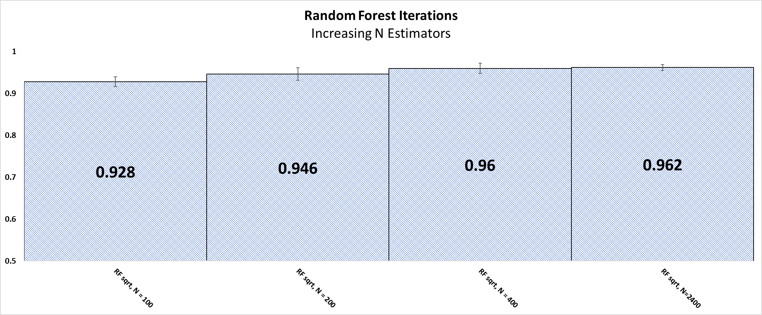
Figure 4: Iterations to improve performance of Random Forest classifier. Increasing N estimators resulted in diminishing returns of performance and lower variance during the K-fold cross-validation. Pipeline settings: Exclude top-25 terms, no stop-word removal, no stemming, one-hot encoding (no tf-idf).

11. Analysis and Discussion
The effects of features selection were significant (Figure 2). Excluding the most frequent terms yielded the best performing model (96% accuracy, Random Forest, Sqrt Max Features, N=400), which likely confirms the intuition that the most relevant contextual information is in the less-frequent terms that more fully differentiate positive from negative reviews.
Parameter impacts can be observed across feature selection. The regularization strength did not impact accuracy much for SVC or LR, which is interesting. One reason for this may be that certain terms (features) are very good signals for a model to pick up on. That is, the data may already be presenting a good signal-to-noise ratio, i.e., it is relatively easy for the model to find clear separating boundaries between the classes. For NB, the multinomial distribution assumption performed better than the Bernoulli, which may be due to the Bernoulli taking into account only presence/absence, which can throw out some important information, whereas the multinomial considers the count of terms. An unexplained anomaly is the large variance observed for the Bernoulli Naïve Bayes when excluding the bottom ranked terms. It could be that the presence/absence of those bottom-ranked terms are very important in predicting whether a review is positive or negative. The Ensemble model (RF) improved its performance with increasing N, which means there are more simple learners to become “experts” on certain subsets of features / examples. It seems, again, that including more features (with max features set to sqrt instead of log) resulted in significantly better performance. Increasing N estimators (the number of simple trees) resulted in diminishing returns of performance and lower variance during the K-fold cross-validation.
Because excluding the top frequency terms resulted in the best performance, I tested that configuration with stop-word removal and stemming. In general, the pre-processing strategies impacted model performance very little. The use of stemming slightly reduced model performance across the board, although no significant differences could be detected as they were within expected variation. It might be that reduction of terms to roots resulted in slight loss of connotation. The removal of stop-words slightly improved model performance across the board except for the best performing model (Random Forest, Sqrt max features, N=400 estimators) which gave the same exact performance (96% accuracy). It is likely that the stop-word removal had little effect when performed in conjunction with the top-25 term exclusions. TF-IDF with the default feature selection, compared to one-hot encoding, resulted in the poorest performance. This might be due to lower weights being assigned to common terms appearing across multiple documents (i.e., reviews), and such common terms contributed meaningul semantic information for models to learn.

12. Conclusion and Insights
In summary, the best feature selection strategy was to exclude the top 25 ranked terms (by frequency). Feature selection had a larger impact than the text pre-processing, and this is largely due to the fact that the feature selection strategy transformed the data in a functional similar way as the pre-processing strategies would have. In other words, excluding the top-ranked words would likely have removed many stop words. Also, stemming slightly reduced model performance, suggesting the some useful information might’ve been lost when reducing words to their roots. In the case of movie reviews, the presence/absence of common but less-frequent terms across multiple documents may also have provided a sufficient signal (amidst any noise) that enabled models better to learn to predict the sentiment. In this sense, using TF-IDF might’ve downplayed the importance of key contextual terms.
The main lessons learned were to take care in features selection and pre-processing, all of which were performed on the training split to avoid data leakage. Also, wrapping the pipeline in a simple run function enabled quick and easy configurations to test model and parameter combinations. Finally, this was a good lesson in exploring how models compared in a binary classification task, as well as demonstrating the power of ensembles methods like the random forest.

References
In addition to the lecture slides provided in CSE 621, the provided template notebooks for this project, and the ample Scikit-learn API documentation referenced via links throughout the report, I also benefited from the following references:
Breiman, L., 2001. Random forests. Machine learning, 45(1), pp.5-32.
Pang, B. and Lee, L., 2004. A sentimental education: Sentiment analysis using subjectivity summarization based on minimum cuts. arXiv preprint cs/0409058.
Pedregosa, F., Varoquaux, G., Gramfort, A., Michel, V., Thirion, B., Grisel, O., Blondel, M., Prettenhofer, P., Weiss, R., Dubourg, V. and Vanderplas, J., 2011. Scikit-learn: Machine learning in Python. the Journal of machine Learning research, 12, pp.2825-2830.

