SentinelAI
AI Cybersecurity Assistant
Unified Threat Detection & Response Platform

Student: Mohammed Moneer Al-absi
ID: 2023050086
Section: Cybersecurity (CS)
Supervisor: Eng. Sondos Saif
Date: 2026

2. Abstract
SentinelAI is an end-to-end AI security assistant that detects attacks in network traffic, spam/phishing in messages and malware families in files, then chooses a response automatically. Six supervised classifiers were trained on 25,022 network flows; the best (RandomForest) reached 99.76% accuracy and 99.70% macro-F1. Unsupervised analysis (K-Means, DBSCAN, Isolation Forest) discovers attack structure without labels and flags novel behaviour (94.78% anomaly precision). A neural network (MLP), an NLP spam engine on the real UCI SMS corpus (98.48% accuracy) and a CNN malware-family classifier complete the advanced engines. A hand-implemented Q-Learning agent learned a response policy that beats all baselines, and the SentinelAgent orchestrates every engine: it routes each event to the right model, fuses a risk score, decides the response and writes an automated security report. The project covers the complete AI workflow at Expert level (Level 3).
الملخص (AR): «سينتينل آي آي» مساعد أمني ذكي متكامل يكشف الهجمات في تدفقات الشبكة والرسائل التصيّدية وعائلات البرمجيات الخبيزة، ثم يقرر الاستجابة تلقائياً. جُمّعت البيانات من مصدر حقيقي عام (UCI) ومولّدات موثّقة، وعولجت (تنظيف، ترميز، تحجيم، اختيار سمات)، ودُرّبت ستة نماذج خاضعة للإشراف (أفضلها Random Forest بدقة 99.76%)، مع تحليل غير خاضع للإشراف (K-Means وIsolation Forest) وتعلم عميق (MLP وCNN) ومعالجة لغة طبيعية، ثم وكيل تعلم معزز (Q-Learning) ووكيل ذكي ينسق كل المحركات ويصدر التقرير الأمني والتوصيات.

3. Introduction
Security teams face thousands of heterogeneous events every day: network flows, email/SMS messages and suspicious files. Signature tools only catch known threats, manual triage is slow, and the final response decision (monitor, alert, block or isolate) is often made under time pressure.

3.1 Problem
How can one AI system automatically (1) classify network attacks, (2) flag unusual zero-day-like behaviour without labels, (3) detect spam/phishing text, (4) identify malware families from byte-plot images, and (5) choose a cost-aware response for every event - then document everything in a security report?

3.2 Purpose and applicability
SentinelAI answers with a single orchestrated pipeline. It demonstrates the complete AI workflow: data collection, preprocessing, supervised learning, unsupervised learning, evaluation, deep learning, NLP, computer vision, reinforcement learning and an AI agent.

3.3 Target users
- SOC / security analysts - automated triage and recommendations
- Network operators - DDoS/scan/brute-force visibility
- Mail administrators - phishing detection with explanations
- Malware analysts - quick family identification

4. Dataset
Dataset | Type | Records | Classes | Source
Network flows | tabular, 16 features | 25,200 (raw) | 5 (Benign 45%, DDoS 20%, PortScan 15%, BruteForce 12%, Botnet 8%) | Generated - seeded statistical models, documented
SMS Spam (NLP) | text | 5,572 | ham 86.6% / spam 13.4% | REAL - UCI ML Repository (Almeida & Hidalgo)
Malware images (CV) | 48x48 grayscale byte-plots | 720 | 4 families | Generated - Nataraj et al. (2011) approach
Threat-intel feed | domain blocklist | 18,146 domains | malicious / clean | REAL - downloaded over HTTP (web/network programming): stamparm/blackbook public feed
Data types: numeric (14 flow features), categorical (protocol), free text, and images. The flows dataset is intentionally imbalanced and contains overlapping 'hard' benign behaviours (IT/SSH work, beacon apps, monitoring probes, flash crowds) so that realistic false positives/negatives exist to discuss.

5. Data Collection
- Network flows: generated with class-specific statistical models (log-normal sizes, Beta rates, family-typical ports) in src/data_collection.py - reproducible with a fixed seed; using generated data is explicitly allowed by the project outline.
- Realistic imperfections were injected on purpose: ~0.8% duplicate rows, ~1.5% missing values in byte_std / flow_iat_mean, 0.3% impossible negative values.
- Spam texts: downloaded from the UCI ML Repository (public, legitimate academic dataset).
- Malware images: each 'binary' is rendered as a grayscale byte-plot with per-family visual signatures plus noise, brightness shift and occlusion artefacts.
- Threat-intelligence feed: a real public malware-domain blocklist (stamparm/blackbook, 18,000+ domains) is downloaded over HTTPS at collection time - demonstrating web/network programming - and is used by the agent for IOC enrichment (with a documented offline fallback list).

6. Data Preprocessing
Operation | Applied | Why (justification)
Remove duplicates | 178 rows removed | Double-exported flows bias training and inflate accuracy
Clip impossible values | 75 fixed | Negative packet sizes are sensor glitches
Median imputation | {'byte_std': 378, 'flow_iat_mean': 378} | Median is robust to the heavy right tail (vs mean)
One-hot encoding | protocol -> 2 dummy columns | Nominal feature; avoids fake ordinal order
log1p transform | 6 skewed columns | Compresses right-skewed byte/packet counters
StandardScaler | fitted on train only | KNN / SVM / MLP require comparable feature scales; prevents leakage
Feature selection | SelectKBest(mutual_info) kept 12 | Removes noise, speeds SVM, reduces overfitting
Train/test split | stratified 80/20 -> 20,017 / 5,005 | Preserves class imbalance in both sets
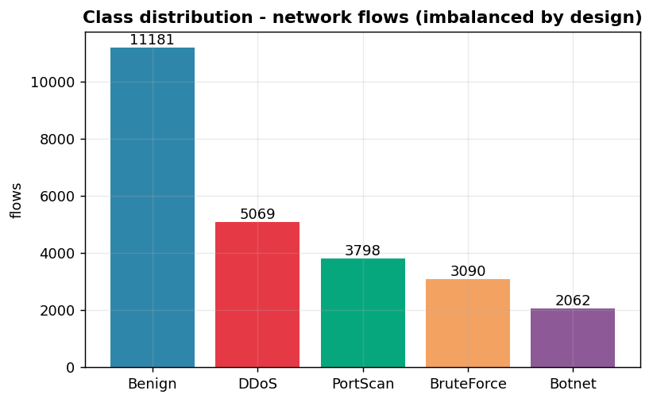
Figure 1 - Class distribution of the flows dataset (intentionally imbalanced).
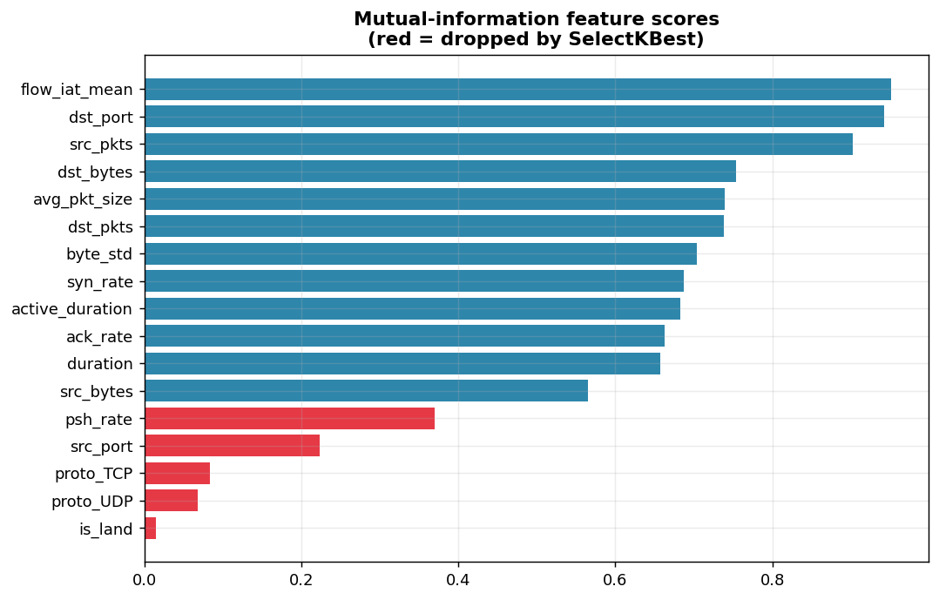
Figure 2 - Mutual-information feature scores; dropped features shown in red.

7. AI Methodology

7.1 Supervised learning
Six algorithms from the project list were trained on identical data: Logistic Regression (linear baseline), KNN (k=7, distance based), Decision Tree, Random Forest (200 trees, ensemble), SVM (RBF kernel, fitted on a 10,000-row subsample because SVC training is O(n^2)) and Gaussian Naive Bayes (probabilistic baseline). Multiclass (5 classes) via one-vs-rest where needed.

7.2 Unsupervised learning
K-Means (k chosen by elbow + silhouette) discovers the natural structure of unlabelled traffic; DBSCAN adds density/noise perspective; hierarchical (agglomerative Ward) clustering builds a merge tree (dendrogram) confirming the same structure; Isolation Forest is trained on BENIGN traffic only (one-class) so it can flag any deviation from normal - the zero-day detector. PCA projects to 2-D for visualization.

7.3 Deep learning (MLP)
Architecture: 12 -> Dense64(ReLU) -> Dropout.3 -> Dense32(ReLU) -> Dropout.2 -> Dense5(Softmax) (3,077 parameters), chosen because the data is tabular - convolution/recurrence would be unjustified. Trained with Adam and early stopping; compared against the best classic model on the same split.

7.4 NLP
Pipeline: lowercase -> mask URLs/emails/numbers -> strip punctuation -> NLTK stop-word removal -> Porter stemming -> TF-IDF (uni+bigrams, 3,000 features). Models compared: Logistic Regression, Multinomial Naive Bayes, and a sequence model (Embedding 32 -> LSTM 32 -> Dense) that learns from token order instead of bag-of-words - covering the RNN/LSTM branch of the deep-learning requirement on the data type where sequences are justified.

7.5 Computer vision (CNN)
Architecture: Conv2D(32,3x3)+MaxPool -> Conv2D(64,3x3)+MaxPool -> Dense128 + Dropout0.35 -> Softmax4 (838,660 parameters). Images normalized to [0,1]; convolutions learn the local visual signature of each malware family.

7.6 Reinforcement learning
Tabular Q-Learning implemented from scratch (no RL library). States: 18 = 3 threat x 3 confidence x 2 criticality; Actions: ['Monitor', 'Alert_Analyst', 'Block_IP', 'Isolate_Host']. Reward = SOC cost model (missing an attack -4 x threat level; blocking benign -3; isolating benign -5; correct escalation +2..+5). Update rule: Q[s,a] += alpha*(r + gamma*max Q[s',a'] - Q[s,a]) with epsilon-greedy exploration decaying 1.0 -> 0.05.

7.7 AI agent
SentinelAgent perceives an event, ROUTES it to the right engine (flow / message / image), adds the Isolation Forest second opinion, fuses a 0-100 risk score, queries the learned Q-table for the response and writes the incident + aggregate security report with recommendations.

8. Model Training
Model | Accuracy | Precision(m) | Recall(m) | F1(m)
LogisticRegression | 93.35% | 91.95% | 93.00% | 92.42%
KNN | 97.10% | 95.05% | 98.46% | 96.60%
DecisionTree | 99.18% | 99.21% | 99.01% | 99.11%
RandomForest | 99.76% | 99.67% | 99.73% | 99.70%
SVM | 97.46% | 95.79% | 98.15% | 96.91%
NaiveBayes | 91.97% | 88.29% | 96.06% | 91.31%
Best classic model: RandomForest. The MLP trained for 60 epochs (accuracy 98.54%), the CNN for 14 epochs (accuracy 100.00% on 144 test images), the NLP engine on 4,457 messages, and the RL agent for 6,000 episodes.

8.1 Validation strategy (5-fold cross-validation)
Model | CV accuracy (mean ± std) | CV macro-F1 (mean)
LogisticRegression | 0.9291 ± 0.0014 | 0.9201
KNN | 0.9652 ± 0.0026 | 0.9609
DecisionTree | 0.9900 ± 0.0010 | 0.9885
RandomForest | 0.9969 ± 0.0007 | 0.9961
SVM | 0.9712 ± 0.0027 | 0.9669
NaiveBayes | 0.9146 ± 0.0038 | 0.9091
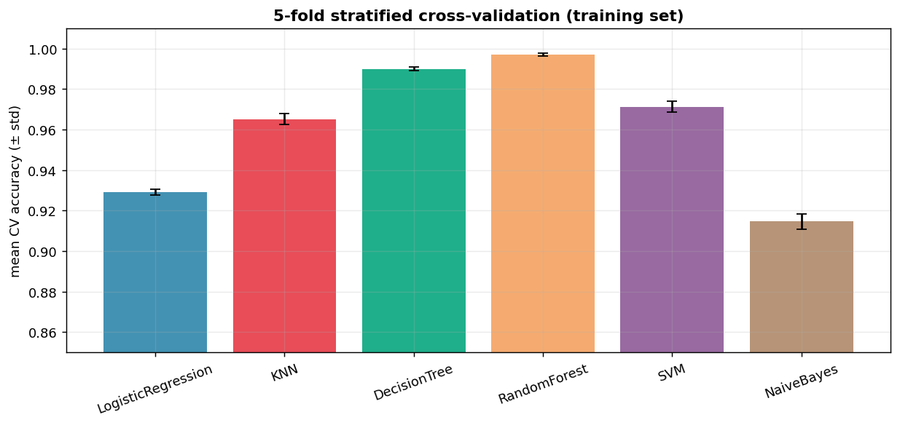
Figure - 5-fold stratified cross-validation on the training set.
Hyperparameter tuning (GridSearchCV, 3-fold): best Random Forest configuration = {'max_depth': 22, 'n_estimators': 200} with CV macro-F1 99.59%.
Class-imbalance handling: a class_weight='balanced' variant was trained and compared - the effect is small because the remaining errors are driven by genuine class overlap, not by imbalance (documented experiment below).
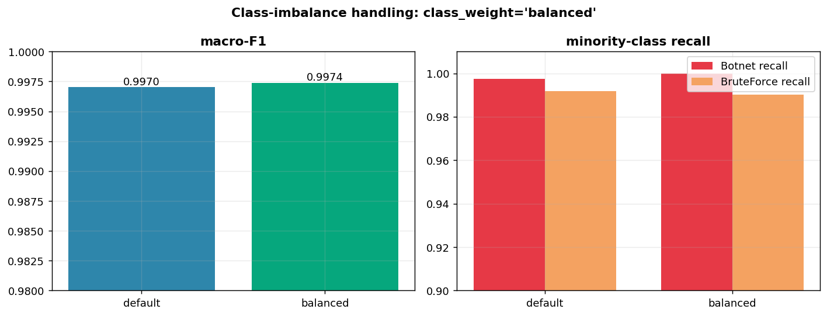
Figure - Default vs class-weighted Random Forest.

9. Evaluation

9.1 Supervised - RandomForest
Class | FP | FN | FP rate | FN rate
Benign | 6 | 6 | 0.27% | 0.27%
Botnet | 5 | 1 | 1.21% | 0.24%
BruteForce | 1 | 5 | 0.16% | 0.81%
DDoS | 0 | 0 | 0.00% | 0.00%
PortScan | 0 | 0 | 0.00% | 0.00%
False positives: benign IT/SSH sessions and beacon-like apps are occasionally misread as BruteForce/Botnet - disruptive if auto-blocked. False negatives: a few BruteForce and Botnet flows hiding inside benign-like patterns pass undetected - the most expensive error in a SOC, which is why recall is weighted highly. DDoS and PortScan were detected perfectly: their statistical signatures (SYN storms, empty ultra-short probes) are highly distinctive.
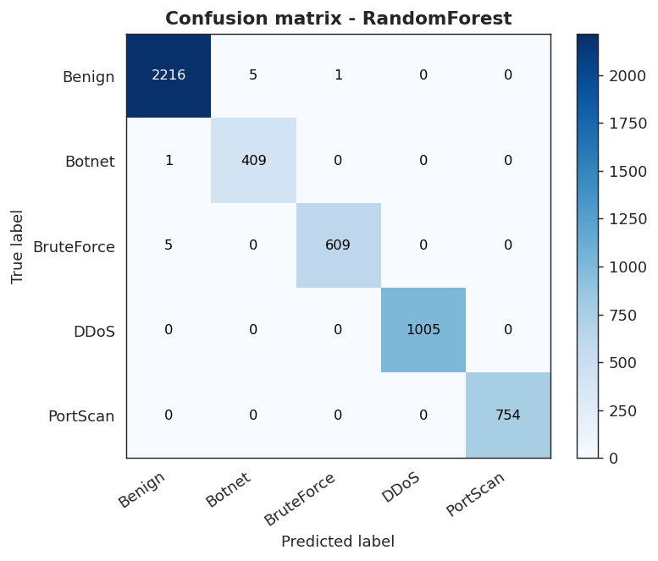
Figure 3 - Confusion matrix, RandomForest.
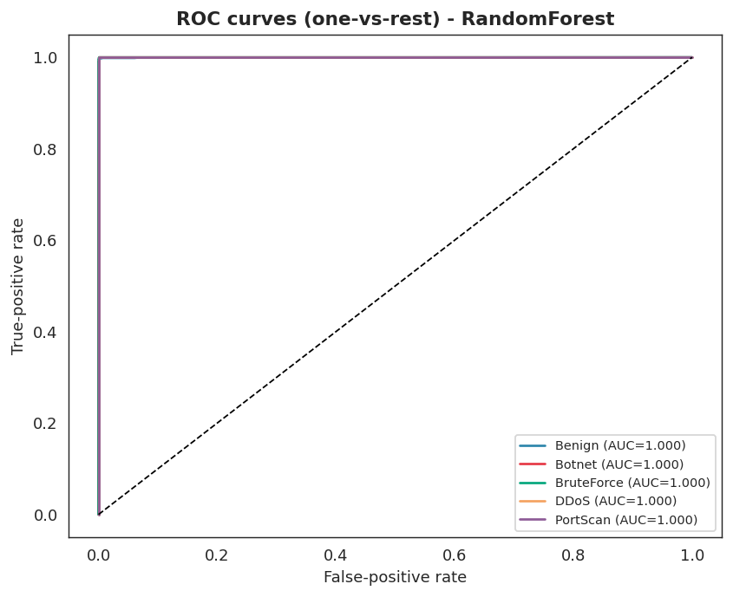
Figure 4 - ROC curves (one-vs-rest), RandomForest.
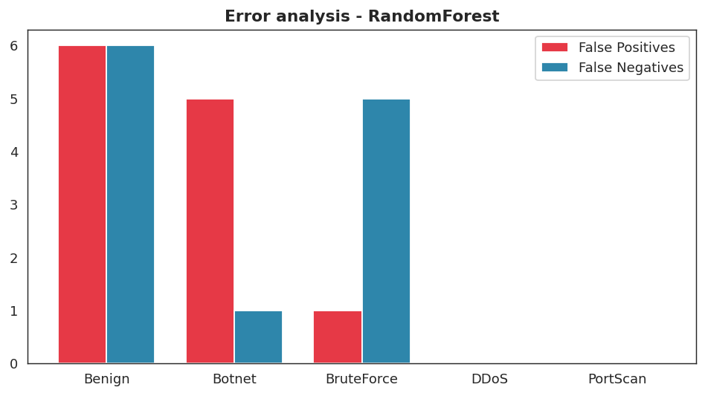
Figure 5 - False positives vs false negatives per class.

9.2 Unsupervised
K-Means chose k=4 (silhouette 0.482) and recovered the attack structure with ARI 0.463, purity 76.66% - WITHOUT labels. Hierarchical (Ward) clustering independently recovered the same structure (ARI 0.474, NMI 0.665) - two different algorithms agreeing is strong evidence the structure is real. Isolation Forest (benign-only training) flags attacks with precision 94.78% / recall 61.37% at a 4.23% benign false-alarm rate. Supervised answers 'WHICH known attack is this?'; unsupervised answers 'does this look unusual?' - together they also expose possible zero-days.
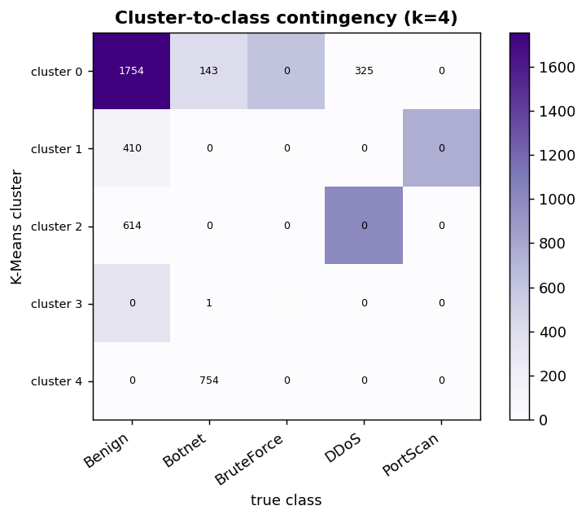
Figure 6 - K-Means clusters vs true classes.
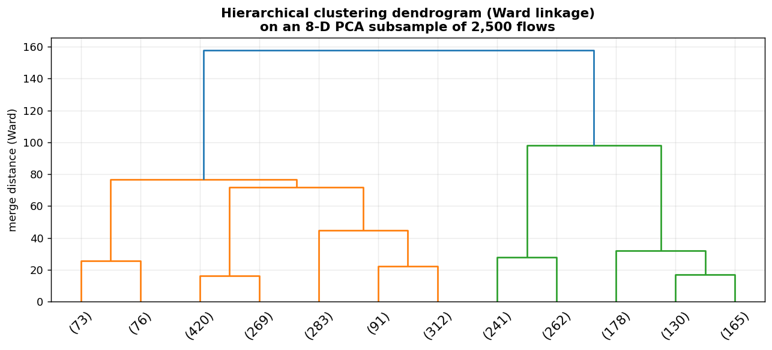
Figure - Hierarchical (Ward) dendrogram confirming the cluster structure.
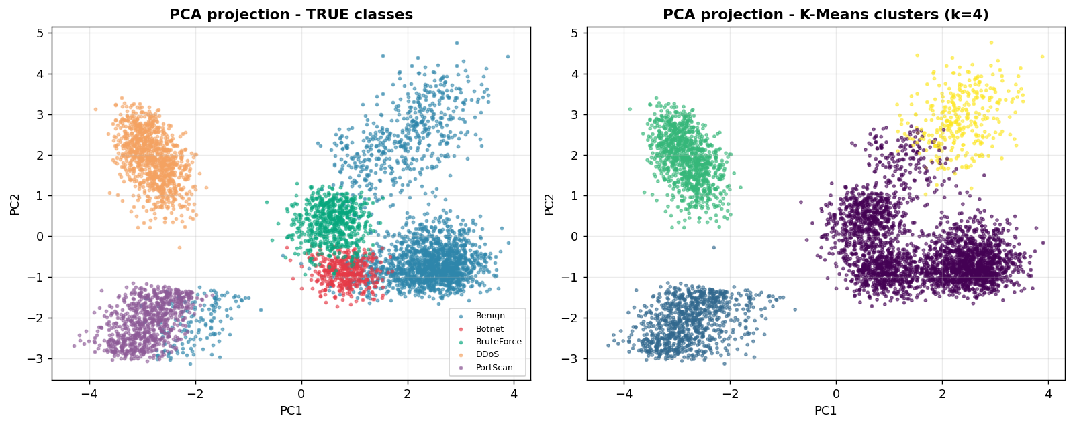
Figure 7 - PCA projection: true classes (left) vs discovered clusters (right).
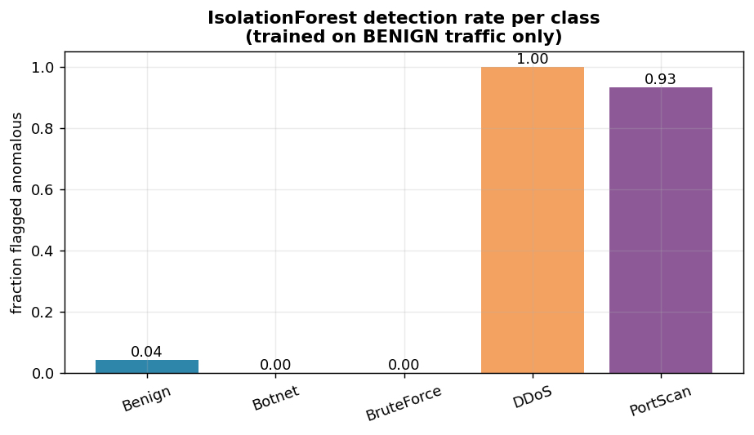
Figure 8 - Isolation Forest detection rate per class.

9.3 Deep learning vs classic ML
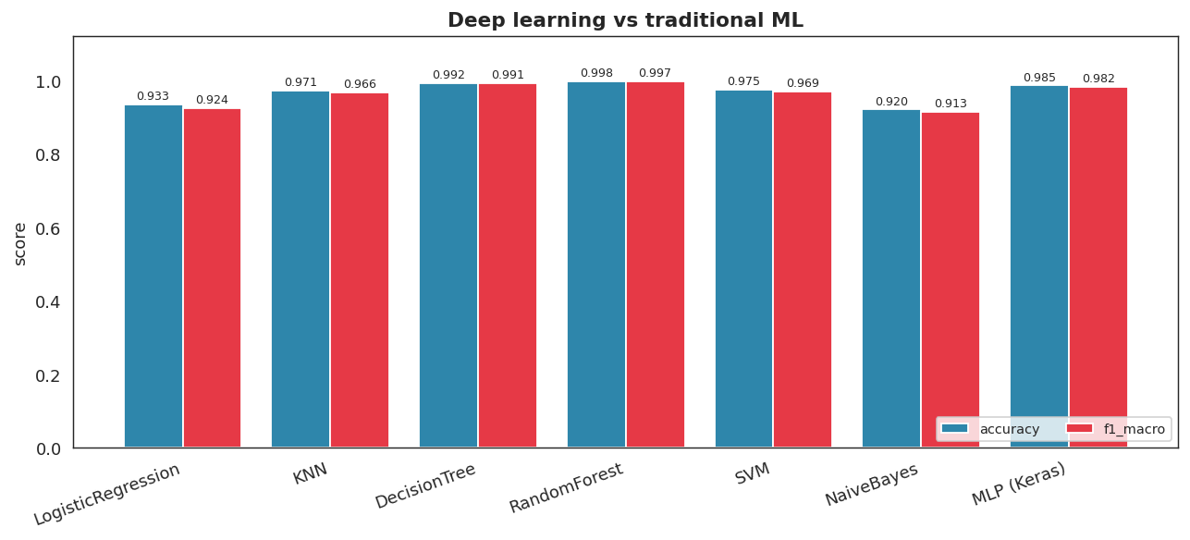
Figure 9 - MLP vs classic models (same split).
MLP macro-F1 98.17% vs RandomForest 99.70% (delta -1.53%): tree ensembles remain extremely strong on small tabular datasets - an honest, expected result.

9.4 NLP
LogisticRegression (TF-IDF) on real data: accuracy 97.94%, precision 97.73%, recall 86.58%, F1 91.81%. The LSTM sequence model improved F1 to 93.99% (accuracy 98.48%) - word ORDER helps: 'claim your prize' reads differently from 'prize your claim'. Recall remains the weak spot: 'polite' spam without links/numbers resembles ham. Top spam indicators learned: num, call num, url, txt, free, repli, mobil, text, claim, servic.
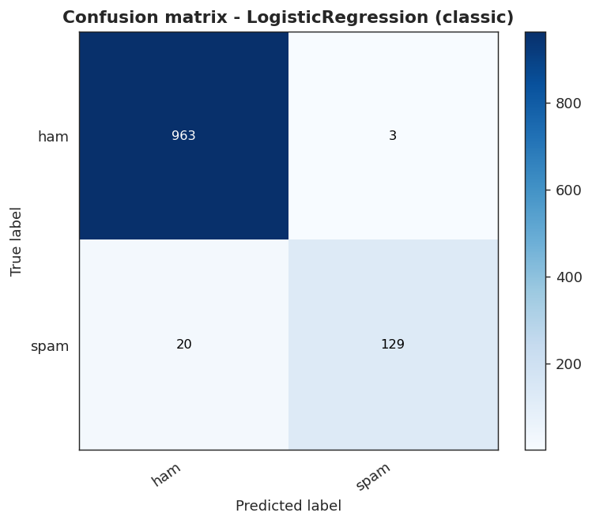
Figure 10 - NLP confusion matrix.
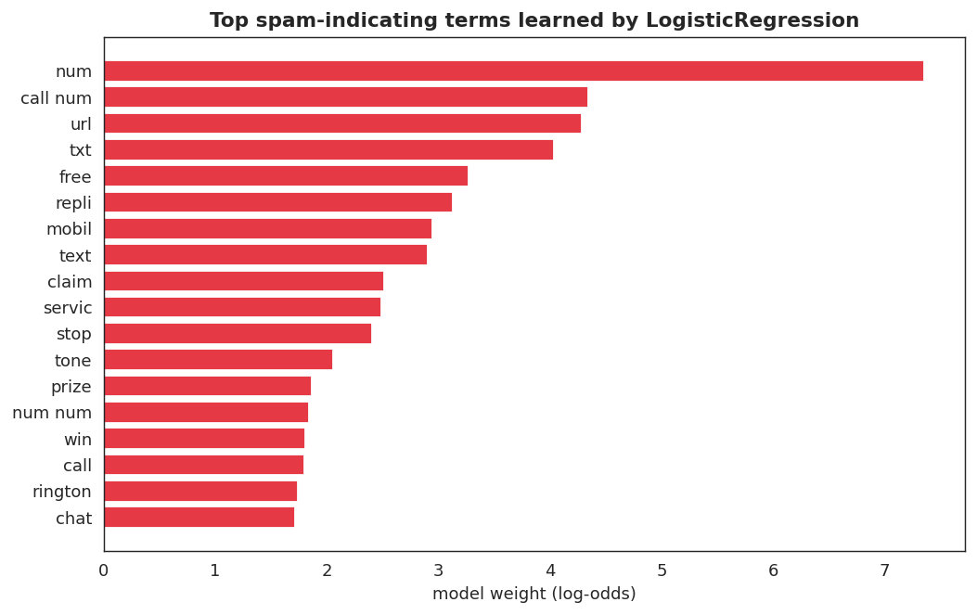
Figure 11 - Most spam-indicating terms (model weights).
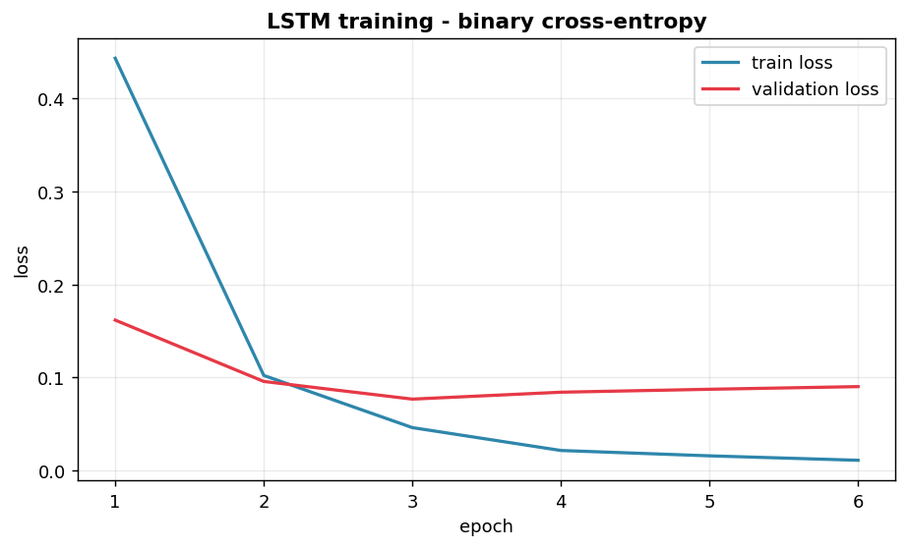
Figure - LSTM training curves (validation early stopping).

9.5 Computer vision
CNN accuracy 100.00%, macro-F1 100.00% on 144 unseen images. Traditional-ML baseline (HOG texture features + RBF SVM) reaches 100.00% on the same split - with such visually distinct family signatures both approaches saturate the task; the CNN would pull ahead on real corpora with subtler differences (documented honestly). Per-family recall: Allaple 100.00%, Autorun 100.00%, C2LOP 100.00%, Yuner 100.00%.
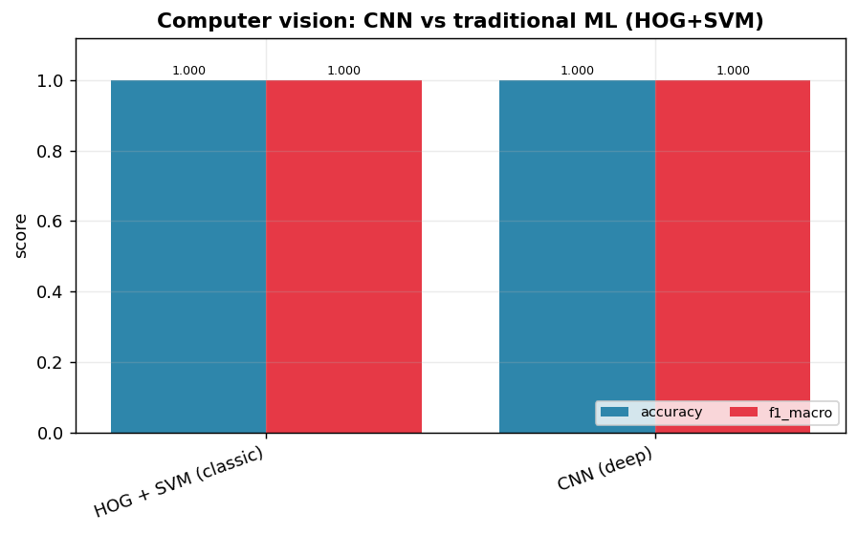
Figure - CNN vs traditional ML (HOG+SVM) for malware images.
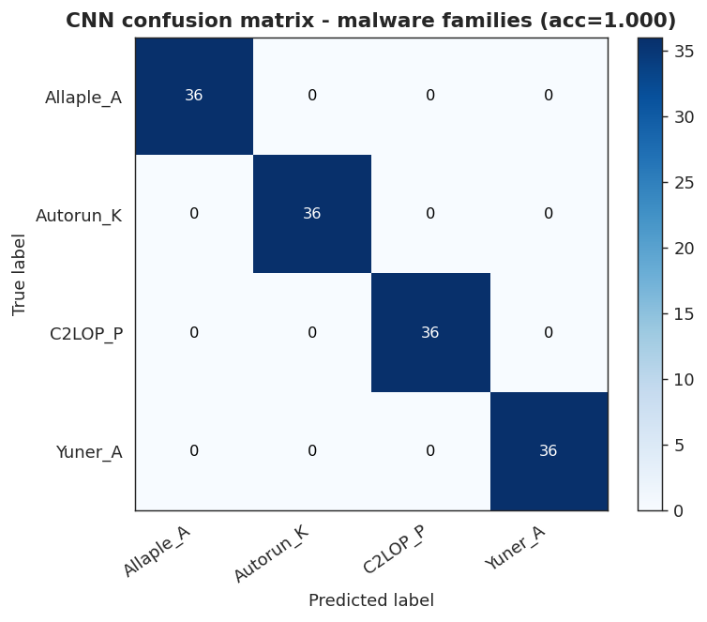
Figure 12 - CNN confusion matrix.

9.6 Reinforcement learning
Average reward per decision over all states: AlwaysMonitor -3.67, AlwaysBlock 1.00, Random -0.45, Q-Learning policy 2.33. The learned policy clearly beats every fixed baseline: it learned to monitor benign events, alert on suspicious ones and block/isolate high-confidence malware on critical assets - purely from reward feedback.
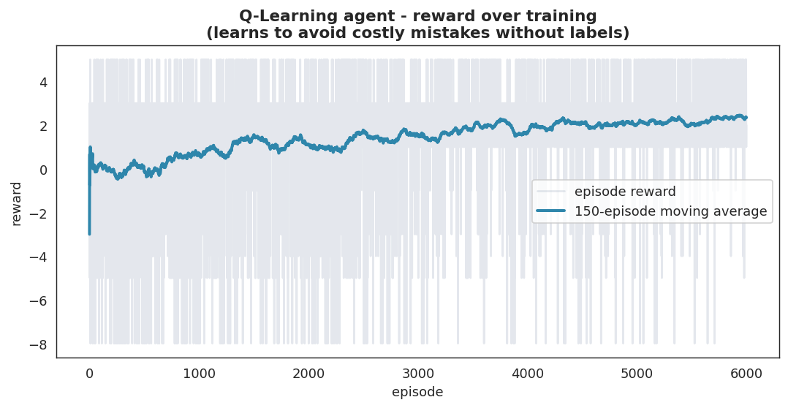
Figure 13 - Q-Learning reward curve (learning from rewards).
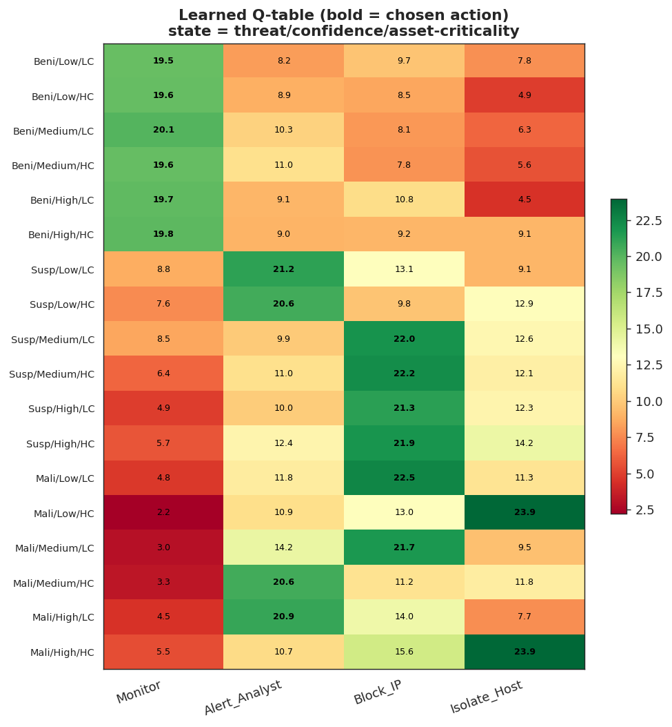
Figure 14 - Learned Q-table and policy.
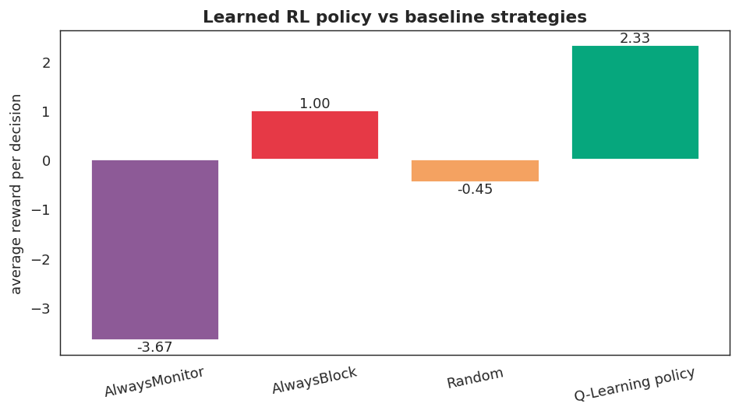
Figure 15 - Learned policy vs baselines.

10. Results and Visualization
Agent run on 27 held-out events across the three engines: {'Monitor': 14, 'Isolate_Host': 7, 'Alert_Analyst': 4, 'Block_IP': 2}. 8 high-risk events (>=70) and 1 classifier/anomaly disagreements (zero-day candidates) were escalated. The agent also matched 1 event(s) against the real downloaded malware-domain blocklist (IOC enrichment) - including one message the classifier itself judged 'ham', proving the value of layering intelligence feeds on top of models. The full automated report is written to results/reports/security_report.md.
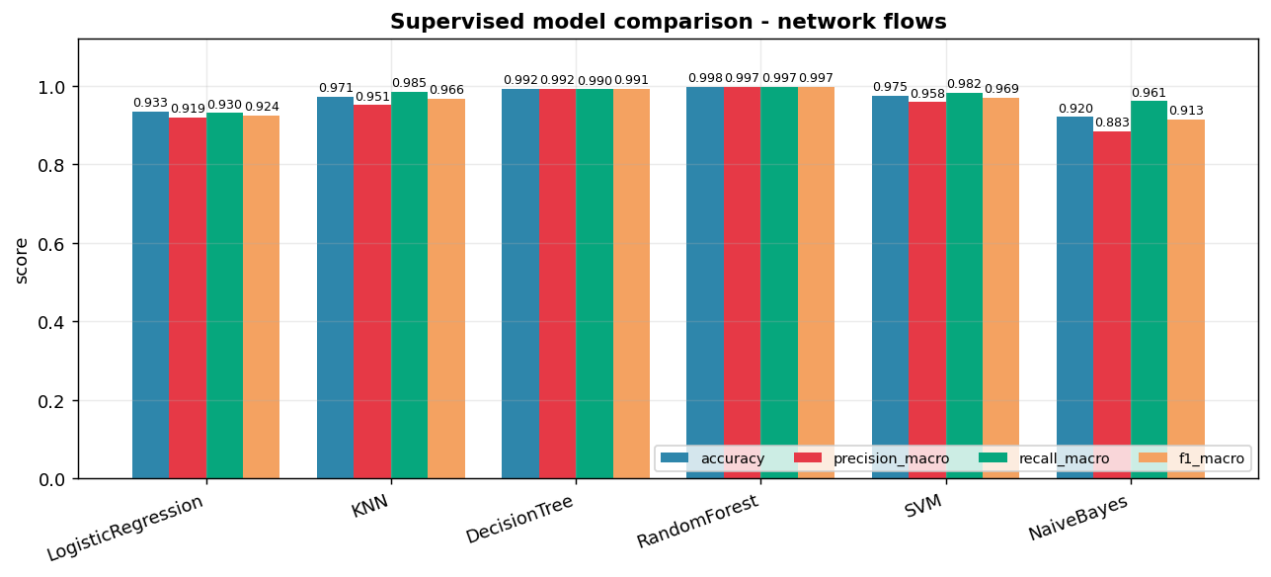
Figure 16 - Six supervised models compared.
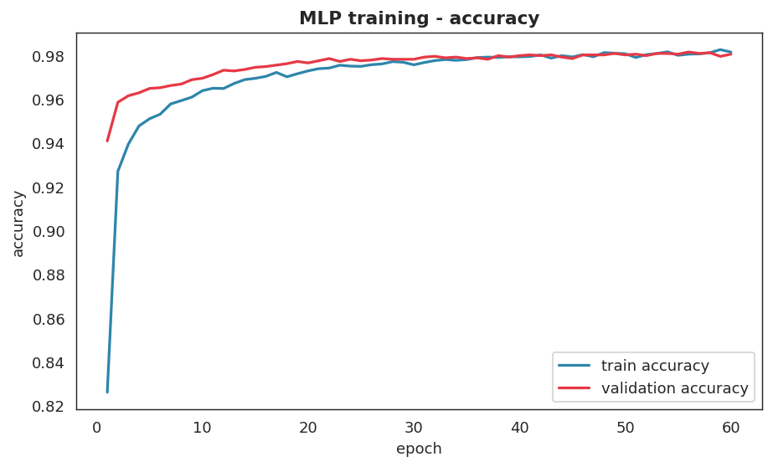
Figure 17 - MLP training curves.
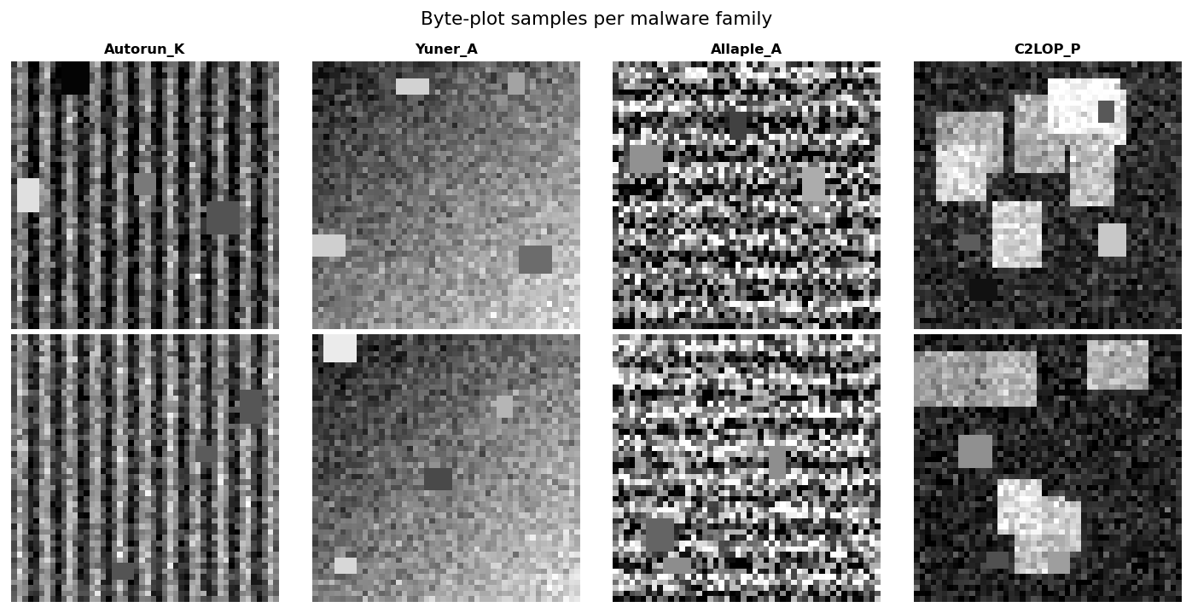
Figure 18 - Byte-plot samples per malware family.
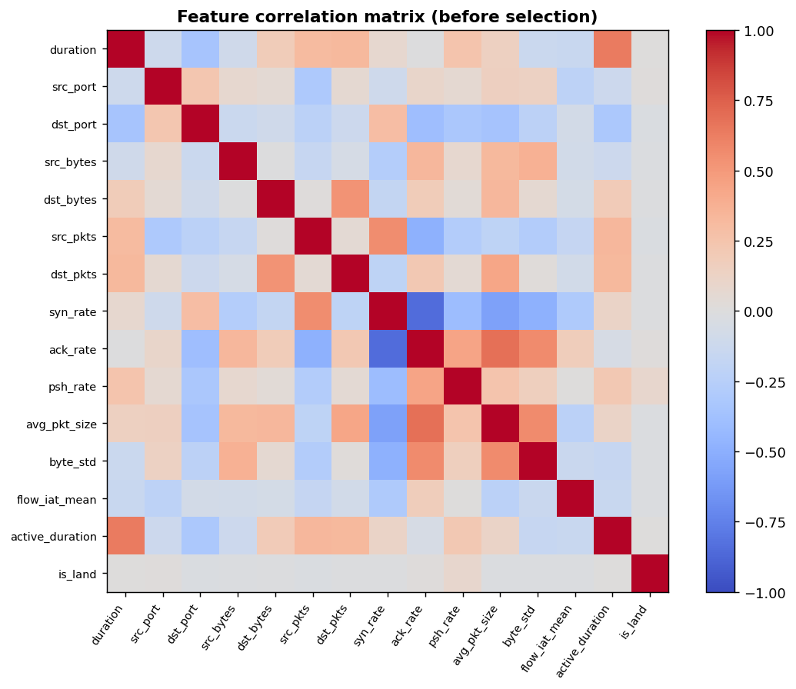
Figure 19 - Feature correlation matrix.
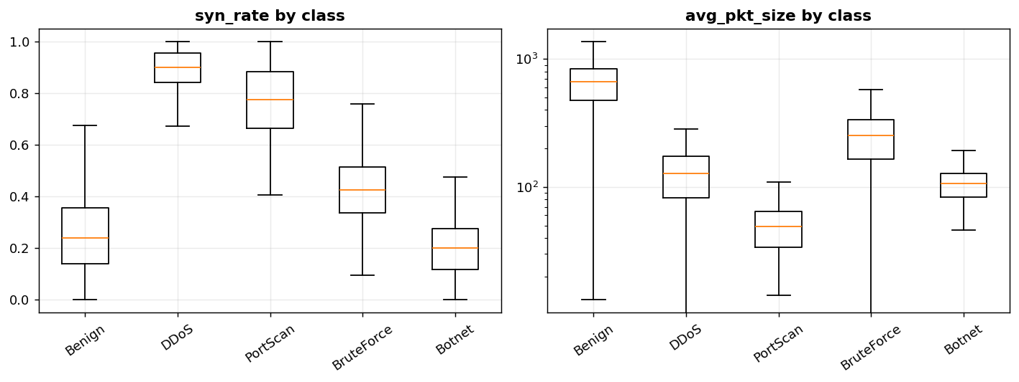
Figure 20 - Feature behaviour per class.

11. Future Work and Recommendations
- Train on real captured traffic (e.g. CICIDS2017) and real malware image corpora (Malimg) to validate against fully real data
- Deep learning for text (LSTM/transformer embeddings) to lift spam recall beyond the TF-IDF baseline
- Explainability: SHAP values per decision for analyst-facing justifications
- Online/continual learning so Isolation Forest adapts to evolving normal traffic
- Multi-agent RL where network, mail and endpoint responders coordinate
- Streaming deployment (Kafka + model server) with analyst feedback loops

12. Conclusion
SentinelAI demonstrates the complete AI workflow on one coherent security problem: data collection (real + generated, documented), justified preprocessing, six supervised models (best RandomForest 99.76%), unsupervised discovery and anomaly detection, deep learning compared honestly against classic ML, NLP on real data (97.94%), a CNN malware classifier (100.00%), a from-scratch Q-Learning response policy that beats fixed baselines, and an agent that orchestrates everything into decisions and reports. Every error was analysed, and every design choice justified.

13. References
[1] Almeida, T., Hidalgo, J., Yamakami, A. - Contributions to the Study of SMS Spam Filtering. UCI ML Repository (SMS Spam Collection).
[2] Nataraj, L., Karthikeyan, S., Jacob, G., Manjunath, B. (2011) - Malware Images: Visualization and Automatic Classification. VizSec '11.
[3] Pedregosa, F. et al. (2011) - Scikit-learn: Machine Learning in Python. JMLR 12.
[4] Chollet, F. et al. (2015) - Keras. https://keras.io
[5] Sutton, R., Barto, A. (2018) - Reinforcement Learning: An Introduction (2nd ed.), MIT Press - Q-learning chapter.
[6] Liu, F., Ting, K., Zhou, Z. (2008) - Isolation Forest. ICDM '08.
[7] Breiman, L. (2001) - Random Forests. Machine Learning 45(1).
[8] Project outline - AI Final Project Requirements (Eng. Sondos Saif).

