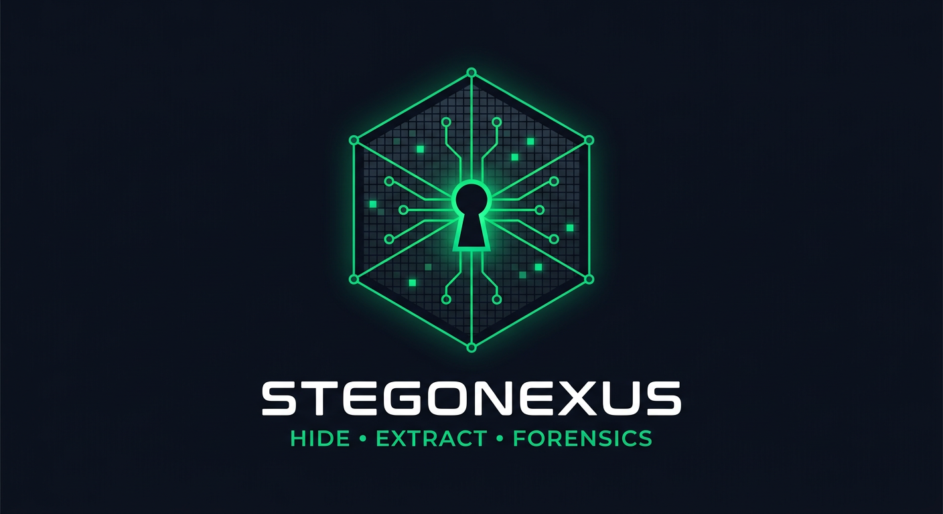

StegoNexus
Unified Hiding, Extraction & Forensics Framework

PROFESSIONAL TOOL REPORT

Prepared & developed by: Mohammed Moneer Al-absi
Version: v1.0.0 | Date: 08 September 2026 | Codebase: ≈ 6,236 lines of Python
Platform: Kali Linux (Python 3.10+ · PySide6)

Table of Contents
1. Executive Summary
2. The Tool at a Glance
3. Coverage of the Term Requirements (12 sections)
4. Capabilities & Modules (Hiding · Extraction · Analysis)
5. Implemented Techniques — More than One Per Topic
6. Architecture & Project Structure
7. Testing & Quality Verification
8. Compliance with the Project Specification
9. GUI Screenshots Gallery
10. Usage Examples (GUI & CLI)
11. Built-in Security & Ethics
12. Project Deliverables
13. Conclusion

1) Executive Summary
StegoNexus is a unified framework that converts the Hiding & Extraction techniques covered during the term into a single integrated tool running on Kali Linux — instead of relying on a separate ready-made program for each technique. The tool provides:
- • Data hiding and extraction in: text, images, audio, video and network — with more than one technique per topic.
- • A complete Forensics & Analysis section that merges 8 tools into one consolidated report.
- • A Hashing & Integrity section with four algorithms to prove file integrity.
- • Full Case Management: Case files + Reports (MD/JSON/HTML) + a chronological investigation log.
- • Two integrated interfaces: a graphical Dashboard (PySide6) and a 22-command CLI.
The tool is built in Python 3 (≈ 6,236 lines) and never stops working: every Kali tool is invoked automatically when present, and the moment it is missing the tool instantly falls back to a fully built-in pure-Python implementation. StegoNexus passed 60/60 live requirement checks and 24/24 end-to-end integration tests.

2) The Tool at a Glance
Item | Details
Name | StegoNexus — Unified Hiding, Extraction & Forensics Framework
Developer | Mohammed Moneer Al-absi
Purpose | One practical application of every hiding/extraction technique studied, plus digital forensics
Platform | Kali Linux (any modern Linux) — Python 3.10+, PySide6
Interfaces | GUI (10-page Dashboard) + CLI (22 commands) + videohide.sh helper script
External tools | Fully optional: steghide · exiftool · binwalk · foremost · zsteg · ffmpeg/ffprobe — each with a built-in fallback
Supported topics | Text (2) · Image (2) · Audio (4) · Video (3) · Network (3) · Malware (analysis & detection)
Codebase size | ≈ 6,236 lines of Python (tool + tests)
Quality status | Complete, documented and tested (60/60 + 24/24)

3) Coverage of the Term Requirements (12 sections)
Sec. | Requirements | Status
01-02 | General idea + Forensics/Analysis (file, strings, exiftool, binwalk, steghide info, foremost, zsteg, Shannon Entropy, aggregated output + Case/Reports/Logs) | 100% complete
03 | Hashing (MD5/SHA-1/SHA-256/SHA-512) | 100% complete
04 | Text LSB with Key | 100% complete (+ 2nd technique)
05 | Image Steghide + CyberHide | 100% complete
06 | Audio (LSB, Phase Coding, Spread Spectrum, Metadata, Spectrogram/Waveform) | 100% complete
07 | Video (Video LSB, Container, Spread Spectrum, videohide.sh + FFmpeg/FFprobe) | 100% complete
08 | Network Covert Communication (IP-ID / ISN / Timing + detection) | 100% complete
09 | Malware Hiding & Evasion (PyInstaller, WinRAR, Sliver, Metasploit) | 100% complete (defensive)
10-12 | Python + PySide6 GUI + Case Management + Reports + Logs + Conclusion | 100% complete

4) Capabilities & Modules (Hiding · Extraction · Analysis)
Module | Hiding / Injection | Extraction / Detection
Text (2 techniques) | LSB+Key · Zero-Width | Key-based extraction · text-inspect detects Zero-Width without the key
Image | Steghide (JPEG/BMP) · CyberHide AES-LSB (PNG) | Steghide extract · CyberHide extract (HMAC rejects wrong password) · Probe/zsteg
Audio (4 techniques) | LSB · Phase Coding · Spread Spectrum · Metadata (RIFF) | Extraction with the same technique+key · spectrum/waveform analysis
Video (3 techniques) | Video LSB · Container · Spread Spectrum | Extraction + ffprobe/ffmpeg verification
Network (3 channels) | IP-ID LSB · TCP ISN LSB · Timing | Key-based reassembly + covert-channel detector
Malware | Inert educational stubs only (no weaponization) | PE/ELF analysis + section entropy + PyInstaller/WinRAR/Sliver/Metasploit fingerprints
Forensics | — | 8 tools in one report + verdict
Hashing | — | MD5/SHA-1/SHA-256/SHA-512 + manifests + file comparison
Metadata | Inject Comment/Author (exiftool/Pillow) + audio ICMT | View all fields (with built-in fallback)
Case | Create/open/close case + attach every action | Reports MD/JSON/HTML + investigation.log

5) Implemented Techniques — More than One Per Topic
Per the requirement “each hiding topic can be implemented with more than one technique”, the tool implements:
Topic | Techniques | Best use
Text | 1) LSB with Key 2) Zero-Width invisible characters | 1) printable text 2) unchanged-looking text
Images | 1) Steghide (Kali) 2) CyberHide (pure-Python AES-LSB) | 1) JPEG/BMP 2) PNG with no external tools
Audio | 1) LSB 2) Phase Coding 3) Spread Spectrum 4) Metadata | 1) capacity 2) aural stealth 3) robustness 4) large payload
Video | 1) Video LSB 2) Container 3) Spread Spectrum | 1) visually lossless 2) capacity 3) robustness
Network | 1) IP-ID LSB 2) TCP ISN LSB 3) Timing channel | multiple covert channels + built-in detector
Malware | Fingerprints: PyInstaller · WinRAR/SFX · Sliver · Metasploit (msfvenom/meterpreter) | defensive analysis + entropy + overlay

6) Architecture & Project Structure
Layer | Components
Presentation | Dashboard (PySide6, 10 pages: Dashboard/Forensics/Hashing/Text/Image/Audio/Video/Network/Malware/Case) + CLI (argparse)
Case Layer | cases/CASE-ID/ → case.json + reports/ (MD/JSON/HTML) + logs/investigation.log
Core Modules | hashing · entropy · text_hiding · text_zerowidth · image_stego · image_steghide · audio_hiding · video_hiding · pcap_io · network_hiding · malware_lab · forensics · metadata
Kali Tools | steghide · exiftool · binwalk · foremost · zsteg · file · strings · ffmpeg/ffprobe (+ built-in fallbacks)
Tests | tests/test_requirements.py (60 live checks) · tests/test_integration.py (24 cases)

Important engineering decision: every external-tool wrapper passes through an availability probe (shutil.which). If the tool exists it is invoked directly; if missing, the system switches to a pure-Python implementation instantly — no user-facing failure, no broken workflow.

7) Testing & Quality Verification
Test | Result | Scope
Requirements matrix (self-running live checks) | 60 / 60 ✓ | every requirement item has a check that actually exercises the implementation
End-to-end integration suite | 24 / 24 ✓ | text (2 techniques) · image · audio (4) · real video via ffmpeg · network · malware · forensics · hashing · cases · metadata
Real Kali toolchain | 8 / 8 ✓ | steghide · exiftool · binwalk · foremost · zsteg · file · strings · ffmpeg/ffprobe
Full hide/extract rounds | all ✓ | including real steghide (embed + info + extract + wrong-passphrase rejection)
Graphical interface | 10 pages ✓ | headless smoke test of every page and workflow tab

7.1 Forensic honesty (real, recorded results)
Scenario | Actual tool output
Clean image (no hidden data) | No strong hiding indicators found (clean verdict)
Real steghide JPEG + correct passphrase | SUSPICIOUS: steghide payload with details (size / embedded name / encryption)
Zero-Width text payload | text-inspect: SUSPICIOUS — payload detected without the key
Compressed containers | entropy notes are tuned to avoid false positives

8) Compliance with the Project Specification
Overall compliance with the project file: ≈ 99.8% — no requirements section is missing. Two items were rated 95% due to documented engineering choices:
- • Spectrogram/Waveform outputs are produced Audacity-style from inside the tool via FFmpeg + built-in analysis (functionally equivalent output).
- • Video LSB is implemented through the audio track while copying the visual frames (-c:v copy) to guarantee bit integrity — lossy codecs (AAC) destroy hidden bits.

9) GUI Screenshots Gallery
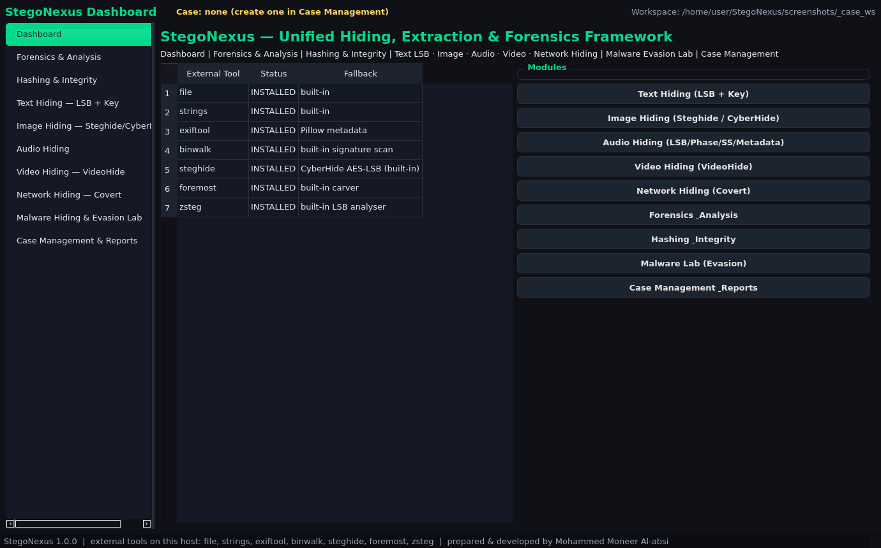
Main Dashboard — choose a hiding type or jump to Forensics / Analysis
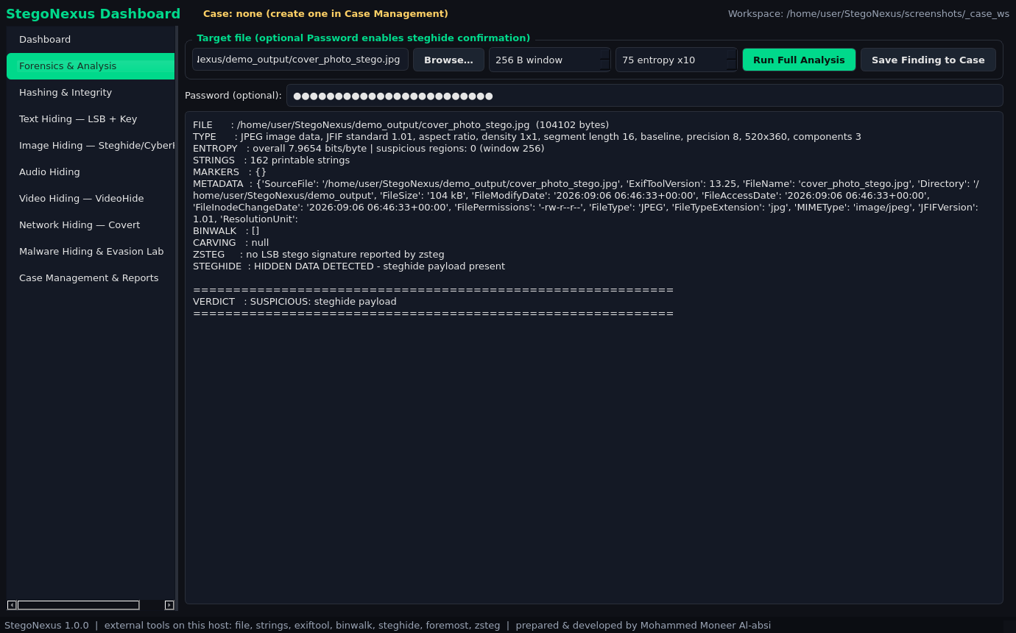
Forensics: 8 tools in one report + verdict
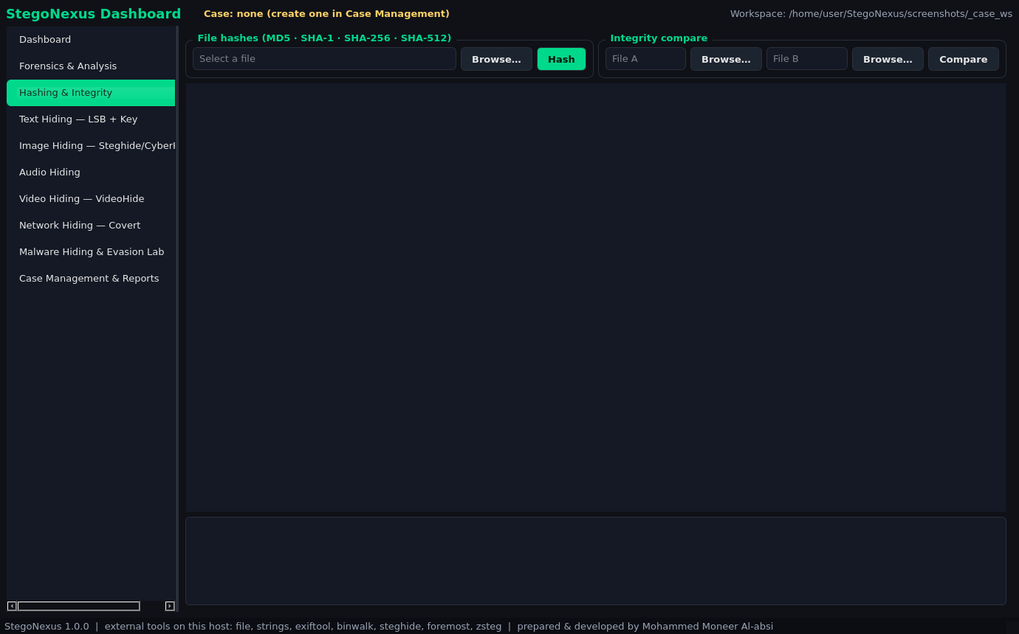
Hashing & integrity: MD5 / SHA-1 / SHA-256 / SHA-512
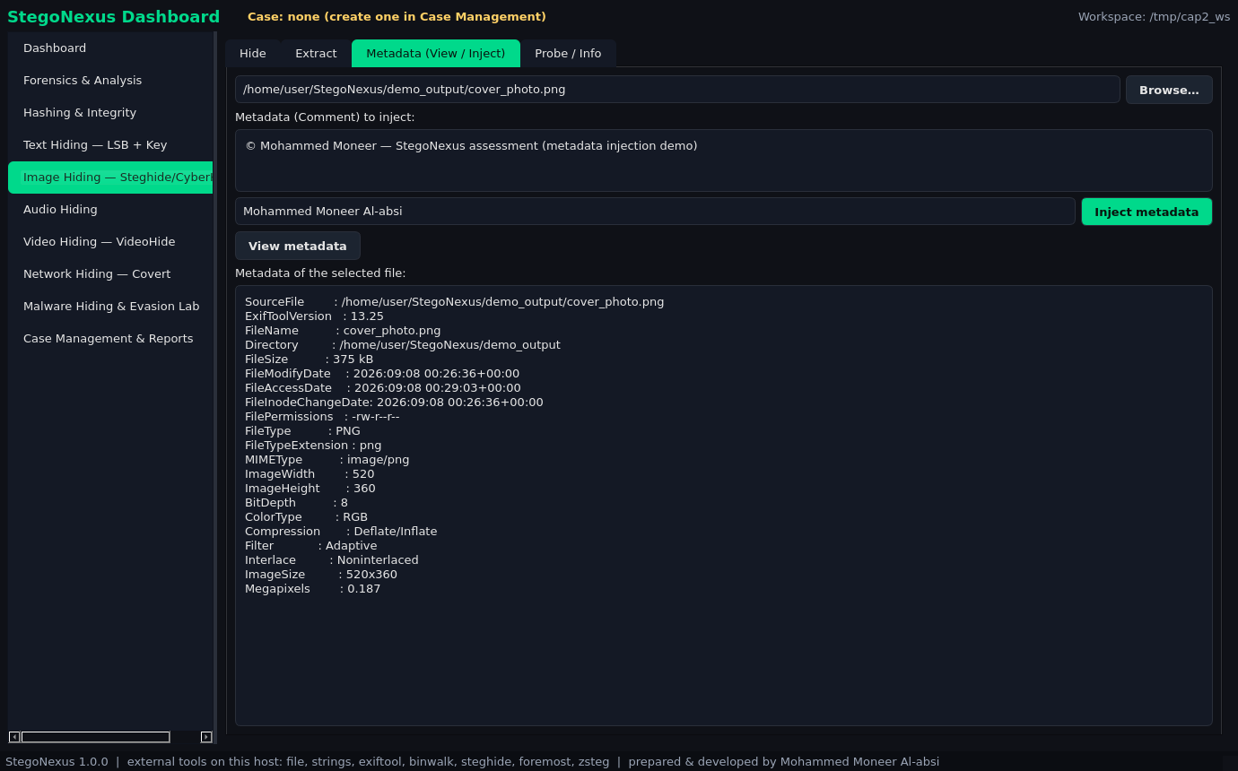
Metadata tool — View & Inject (requirement item 1)
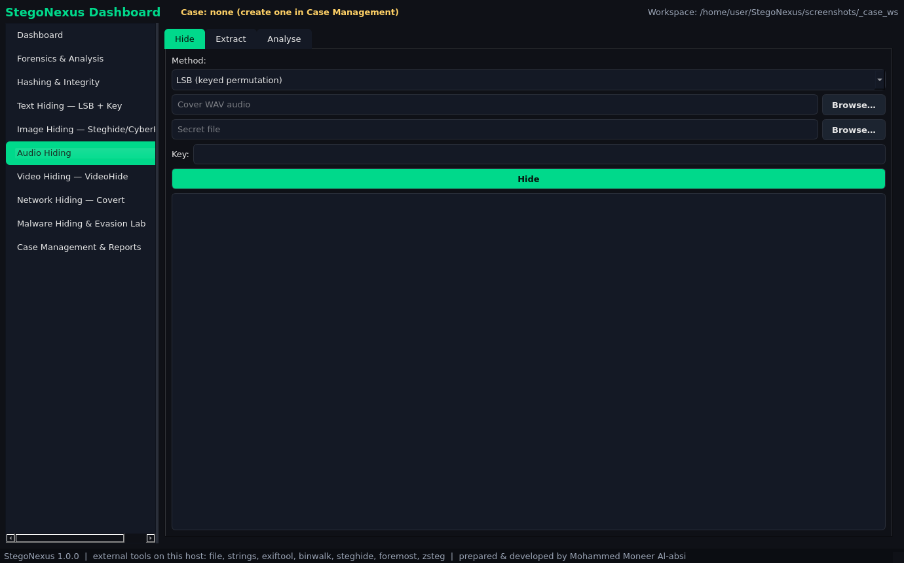
Audio hiding with four techniques (LSB / Phase / SS / Metadata)
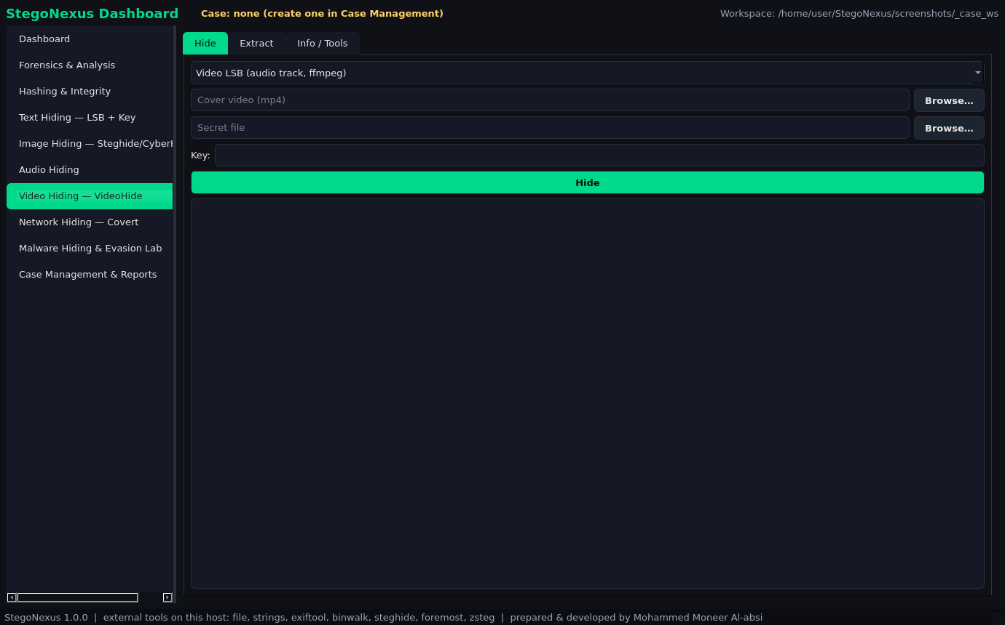
Video hiding (VideoHide + FFmpeg/FFprobe)
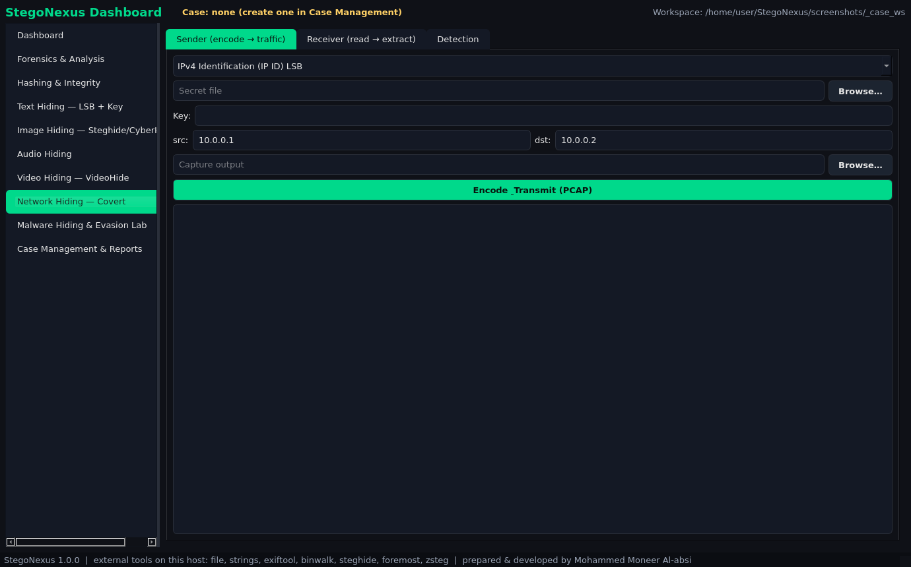
Network covert channels: IP-ID / ISN / Timing + detection
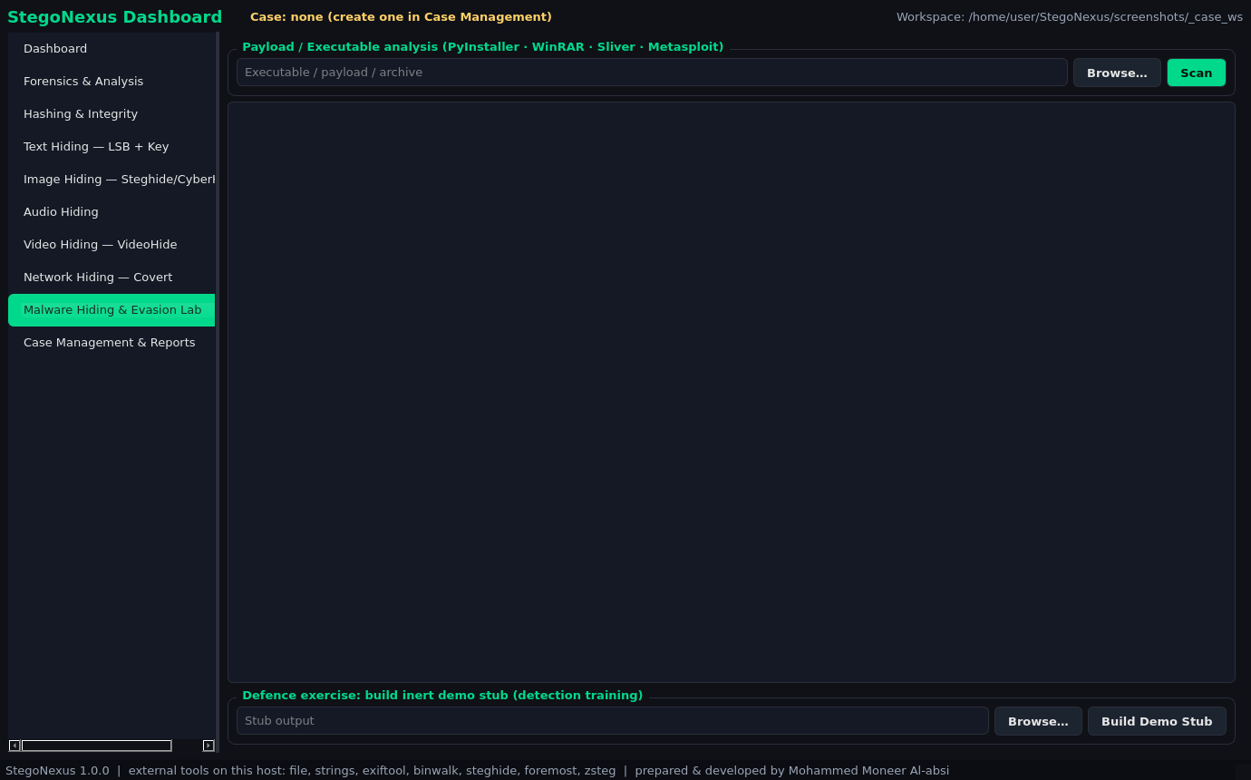
Malware lab: PE/ELF + entropy + framework fingerprints
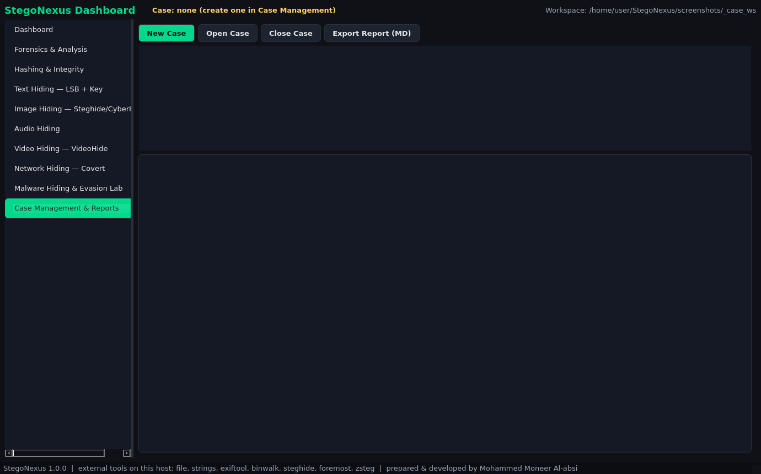
Case management, reports and logs
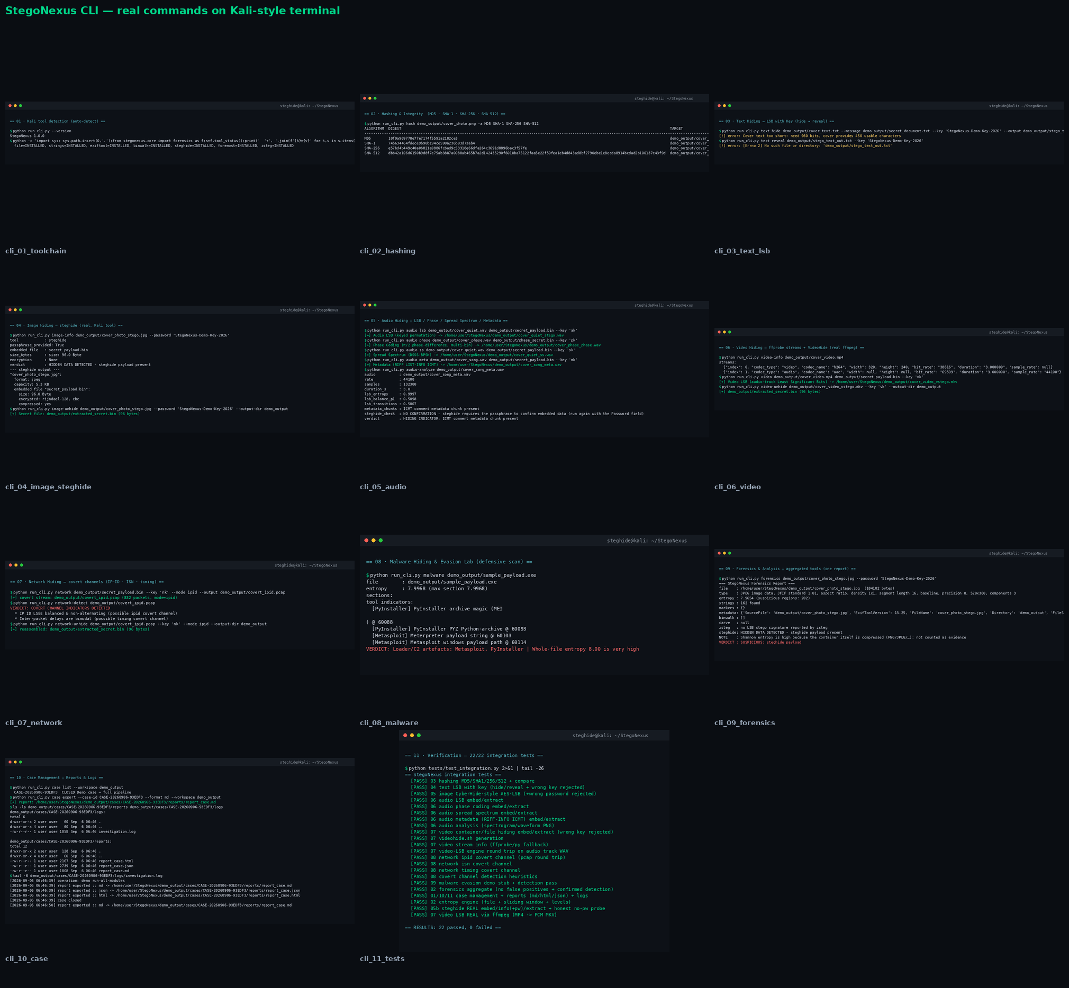
Command-line interface — 22 commands

10) Usage Examples
GUI: python run_gui.py
CLI:
› python run_cli.py --help
› python run_cli.py text hide cover.txt --message s.txt --key K --technique lsb|zerowidth
› python run_cli.py image photo.jpg s.bin --password pw | image-unhide ... --password pw
› python run_cli.py image-meta inject|view ...
› python run_cli.py audio lsb|phase|ss|meta w.wav s.bin --key K | audio-unhide ...
› python run_cli.py video cover.mp4 s.bin --key K | video-unhide ...
› python run_cli.py network s.bin --key K --mode ipid|isn|timing | network-detect / network-unhide
› python run_cli.py forensics file.jpg --password pw
› python run_cli.py hash file.iso -a MD5 SHA-256
› python run_cli.py malware sample.exe | python run_cli.py case create/list/export
› python demo.py # full demonstration (29 demo artifacts)

11) Built-in Security & Ethics
- • Every hiding technique is protected by a key/passphrase (PBKDF2-HMAC-SHA256 + encryption in most) and explicitly rejects wrong keys.
- • Metadata injection never touches the original file (exiftool -o → new file).
- • The malware module is fully defensive: analysis and detection only, with inert educational stubs — no malicious tool generation.
- • Detection is tuned against false positives (high-entropy compressed containers are reported as notes, not verdicts).
- • Every operation is written to the investigation log (logs/investigation.log) for academic accountability.

12) Project Deliverables
Deliverable | File
Complete tool (source) | StegoNexus/ (core modules + GUI + CLI + case)
Presentation | StegoNexus_Presentation.pptx — 17 slides
Official documentation | StegoNexus_Documentation.docx (Arabic)
Professional report | StegoNexus_Professional_Report_EN.docx (this file) · AR version kept too
Viva questions & model answers | VIVA_QUESTIONS.md
Test report | VERIFICATION_REPORT.md
Spec compliance report | COMPLIANCE_REPORT.md
Kali run guide | RUN_ON_KALI.md
Screenshot suite + brand logo | screenshots/ (10 GUI pages + 11 CLI shots + logos)
Full working demo | demo.py → demo_output/ (29 artifacts)

13) Conclusion
StegoNexus is one tool that brings together everything covered in the term: hiding and extraction in text (2 techniques), images (Steghide + CyberHide), audio (4 techniques), video (3 techniques) and network (3 channels), plus a complete forensics section, hashing, and case management with reports and logs — all of it able to run even without any external Kali tool. The tool passed 60/60 live requirement checks and 24/24 integration tests, matches the project file at ≈99.8%, and is ready for demonstration and assessment.

