**Group members**

* Danielle F. **Project Leader**.
* Ismael Perez Saavedra
* Logan Orlando
* Amir

**Important links:**

* Admin & User: Danielle’s github: <https://github.com/koa2019/yahtzee>
* Scorecard & Dice: Ismael’s Github: <https://github.com/Error1417/Yahtzee_Project>
* Gantt Chart <https://docs.google.com/spreadsheets/d/1jXmEnUfsL37aRnG8E6Z-XX4FZrRRHcmFdeqjoNkU2AE/edit?usp=sharing>

**List the meeting times each week, how/when you are meeting, etc......**

* **How are we going to meet?**
  + Danielle doesn’t mind meeting at RCC.
  + Ismael doesn’t mind meeting at RCC.
  + Logan prefers to meet via Zoom.
  + Amir prefers to meet via Zoom
* **Availability**
  + Danielle: Usually anytime
  + Ismael: Mondays before/after class or Fridays @10am
  + Logan: Mondays before class. Possibly Fridays via zoom?
  + Amir: Fridays
* **Next meetup?**
  + March 19: Coundron coffee shop in Riverside @11am
  + March 24 @Riverside Computer Lab @10am
  + March 27 @Riverside Computer Lab @12pm
  + March 31st @Albertos @10am
  + April 3rd before class [CCC Lab](https://www.google.com/maps/place/CCC+Lab/data=!4m2!3m1!19sChIJEWvmsXrPADsRQhhQ39r5Beg)
  + April 11th @11 am Riverside Library
  + April 14th in-person or discord @11am–1245pm
  + April 17th before class @CCC Lab ?

**Timeline. What do we need to get done each week?**

* **March 19-25:**
  + Have a basic working game and try plan how we’re going to merge it with User+Admin classes (in progress)
* **March 26-31:** 
  + Finish the Admin and User classes
  + Have a working scorecard class
  + Dice class to push and pull.
* **April 1-8**:
  + Merge User and Game classes
  + Merge scorecard & dice
* **April 9-15:** 
  + Finish game
  + Start documentation
  + Plan our presentation
* **April 16-24:**
  + Finalize game. Clean up code.
  + Finalize Documentation: UML, flowchart,
  + Finalize presentation

**Meeting Summary for April 11:**

* Merged Yahtzee class with Admin & User classes.
* Restricted hierarchy of User & Admin classes.
* Discussed how it would run with 2 players when only 1 person is logged in vs playing it with 2 guest players.
* Have the scoreboard displayed with possible points after each roll.

**Meeting Summary for April 14:**

* Worked on the bug in scorecard.’s category 13.
* Presented the double pointer of User’s inside of Yahtzee class and how I changed play() to rewrite high score when player 1 is winner AND has a new high score.
* **Ismael’s comments:** 
  + # of lines coded/modified:
  + Versions created:
* **Danielle’s comments:**
  + # of lines coded/modified:
  + Versions created:
    - cis17A_project2_battleshipYahtzee_v
* **Logan’s comments:** 
  + # of lines coded/modified: ?
* **Amir comments:** 
  + # of lines coded/modified: ?

**Weekly Assignments for April 10 to April 16:**

* Ismael:
  + Finish category selection✅
  + Get the sums for both upper and lower sections of the scorecard✅
  + Error checking
  + Styling: Space out more of the options and make it look nicer
  + Get the user to pick a category and pass the value picked to the scorecard class✅
  + Fix the selection bug with the dice picker✅
* Logan:
  + Complete UML chart based on Danielle’s github yahtzee_v21
    - You can use <https://app.diagrams.net/> or excel or docs to create it
    - <https://github.com/koa2019/yahtzee/tree/main/yahtzee_v21_dblPlayrPtr_in_Yahtzee>
    - Admin aggregates an instance of User class & Yahtzee aggregates Dice, Score_card & User classes. Tony Gaddis textbook chapter 13 section 6 talks about UML charts. Also please look below at the screenshot of an UML example of this.
  + Start styling the user interface(HTML and CSS)
    - Yahtzee title
    - ScoreCard
    - Checkout this website. I’ve used it before & it might make styling html easier. <https://getbootstrap.com/docs/5.3/getting-started/introduction/>
* Danielle:
  + Create a double pointer array for 2 players in Yahtzee class✅
  + Figure out how to save new high score inside of Yahtzee class✅
  + Figure out how to save all User records to double pointer & access it outside of the function it's created in.
  + DRY. Clean up code in Admin & User classes.
* Amir:
  + ?

**Screenshot of UML aggregation from Tony Gaddis textbook**

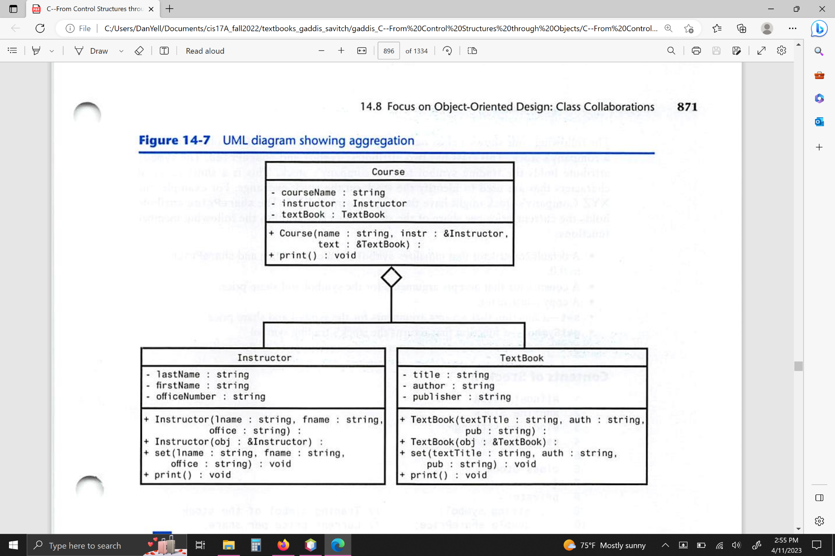

**Simple UML Chart** - 3/24/23



**Pseudo:**

1. **Parent: Admin class**
   1. Dilemma. Option 1: User class will be the parent and then the Admin and Player classes will inherit User?
      1. Admin & Player both use User class’s variables & functions, but how will the Player ask Admin to test their hiScore variable?
   2. Dilemma. Option 2: Admin is the parent, list wrtBinary() as private and then User inherits Admin?
      1. Admin doesn’t need hiScore when it creates a new object for itself, but it needs to be able to reassign hiScore.
   3. Admin object:
      1. Private members:
         1. Static int num records /* Doesn’t hold value between runs */
         2. unique ID
         3. name
         4. password
         5. email
         6. hiScore ? Should this be in User or Admin?
         7. readBinary()
         8. checkHiScore()
         9. setHiScore()
   4. Read inputs for 1 Admin record:
      1. Confirm inputs
      2. Save 1 admin record to object
      3. Write the object to text and binary files.
      4. Print message if successful or not
   5. ONLY Admin is allowed to read binary files
   6. Admin login()
      1. Read first record in Admin’s binary file
      2. Save it to an object
      3. Test login
      4. Print message if login was correct or not
      5. If login is correct, then allow them access to admin only functions
   7. Read User’s binary file:
      1. User login()
         1. Find a record by email
         2. Save it to an object
         3. Test login
         4. Print message if login was correct or not
         5. If login is correct, then allow them to view their profile and play game
      2. Be able to delete/edit a record or member’s of record
         1. Accept an ID or record as an object AND score from User, test if it’s bigger than their current hiSCore and update it accordingly
2. **Child: User class**
   1. Create User Class. User and game classes will have to be combined at some point.
   2. User object:
      1. Private members:
         1. Record #
         2. Unique ID
         3. name
         4. password
         5. email
         6. hiScore ? Should this be in User or Admin?
         7. scorecard[ ]
         8. dice array or vector
   3. Sign up for a new account. Read in name, email, password
      1. Confirm user inputs before saving their info to object
   4. Write and append each User to a binary file
      1. ONLY has permission to write to binary file
   5. Write and append each User’s to text file
      1. ONLY has permission to write to text file
   6. Play game as guest or as logged in user
   7. When they win they should send their ID or their record as an object AND their current score to Admin, so then Admin can test if it’s bigger than the hiScore saved to their record
3. **Game Play**
   1. **Dice** 
      1. Function returns a random num between 1 and 6
      2. Function that saves up to 5 dice in an array or vector to represent which dice the player is keeping towards their score
         1. Needs to add and remove a dice between rolls.
      3. Print the value of 1-5 different dice
         1. Test dice against 13 categories and print a score for categories player can potential get points from
            1. Ask user if they want to:

Keep one of the potential points

If yes, then turn ends and save points to scorecard

or keep 1-4 dice and roll again

If yes, get which dice they want to keep and roll the remaining dice again.

Needs to keep count of how many dice the player is keeping on each roll and the value of each dice.

* + 1. Allow user to remove dice if they still rolls remaining
       1. Consider using vectors for which dice the player is keeping between rolls?
  1. **Scorecard class:** 13 scoring categories + 3 different sums
     1. Upper Section categories
        1. 6 categories that summing each side of dice
           1. Sum function that accepts x number of dice and adds their face value?
        2. Total score from all 6 sides of a dice
        3. Bonus – if score is 63 or over, then +35 pts
        4. Total of upper section
     2. Lower Section categories: has to check if the dice meet the conditions for each of these categories. If they do, then it needs to return points.
        1. pts = three of a kind ? sum of all 3 dice : 0;
        2. pts = four of a kind ? sum of all 4 dice : 0;
        3. pts = full House (threeKind + twoKind) ? 25 pts : 0;
        4. pts = small Straight ? 30 pts : 0;
        5. pts = large Straight ? 40 pts : 0;
        6. pts = Yahtzee (5 of kind) ? 50 pts : 0;
           1. pts = Yahtzee bonus? ? 100 pts : 0;
        7. pts = chance pts = sum of all 5 dice : 0;
     3. Total of lower section
     4. Grand total = total of lower + upper section