Project I

Battleship

CIS-17A-48206

November 05, 2022

Danielle Fernandez

# Table of Contents

Introduction.…………………………………………..... 3

Development Summary….……………………………... 3

Sample Inputs/Outputs….…………………………….... 5

Flowchart….……………………………………………. 7

Pseudo Code ………………………………………….. 12

Major Variables ………………………………………. 15

Checklist …….………………………………………... 16

GitHub ….……….……………………………………..16

Reference ……….……………………………………..17

Program ………………………………………………..17

## 

## **Introduction**

This game simulates a slimmed-down version of the classic board game, Battleship.

**Objective:**

Guess the location of your opponent's ship.

**Rules**:

* Each player has 1 ship per game.
* The board has 20 different locations that are represented by an integer between 1 and 20 (For ease of use, the application automatically generates the ship’s location with a random number).
* When a player successfully guesses their opponent's ship location, then a “HIT” message is printed. If their guess is wrong, then a “MISS” message is printed, and it is the other player’s turn. If both player’s guess wrong, then a “You both missed. Try again” message is printed.
* Players continue taking one guess at a time until someone gets a “HIT”.
  + It can sometimes take over 10 guesses before a player is correct, so for ease of use, the computer automatically generates each player’s guess with a random number.
* Once someone gets a win, a scoreboard will show how many wins each player has earned. As well as how many games are left.
* The game asks the user to press “Enter” before proceeding to the next game, so they can review the scoreboard.
* For ease of use, the max number of games is preset to five and the game automatically generates each player’s guess and ship’s location after the user presses “Enter”.

## **Development Summary**

|  |  |
| --- | --- |
| Lines of code  (including h files) | 521 |
| Comment lines | 89 |
| Blank lines | 116 |
| Total lines of source file | 316 |

This game covers chapters nine through twelve in the textbook by illustrating pointers, dynamic memory, c-strings, strings, structures, writing structures to binary files, and random-access files.

My initial challenge was figuring out how to convert my project 2 Battleship game from CIS-5 to utilize structures. I thought it would be easy to convert an already functioning game, but I was partially wrong. My project 2 game is an advanced version using concepts I have used for years and feel very confident using. Whereas my experience with structures and pairing them with binary files is minimal. I understand how they work theoretically and my experience with using them has been limited to the last few weeks. I wasn’t even sure where to start converting my old code. I was passing two-dimensional arrays to numerous functions. My first attempt to change a two-dimensional array to a pointer failed. My second attempt consisted of trying to convert a static one-dimensional array went better, but then I changed something and couldn’t get the code to work again. I resolved my problem by going back to the final version of my Project 1 Battleship game from CIS-5. This version had a working game and did not use functions or two-dimensional arrays yet. This version matched my abilities to work with structures.

My second dilemma involved writing and reading my Score structure to a binary file. I tried to write a structure that had a structure inside of it to binary but could not get it work. My solution was to create a new and very basic structure, and then write that to binary. I was successful in writing a simple structure to binary as well as locating a random record within it.

My third dilemma was trying to figure out why I couldn’t write a Score structure read the correct data from binary. Eventually I asked Dr. Lehr for help, and he told me that I was not able to pass a pointer of a pointer of a structure to binary the same way I was handling my simple structure. I thought I could write the entire contents of structure to binary by sending its reference. I imagined it was like passing an array to a function, but I completely skipped the part where you still need to write each member of the structure to binary. I ended up giving up on this because I did not need it to meet the project’s requirements.

My fourth dilemma came when one of my pushes to Github got messed up and my latest version was overwritten by a previous version. I am not sure how I managed to do that, but after that I started keeping a copy of my latest version in a text file that was not connected to my Github.

My final hurdle came when I got the smart idea to clean my code within fillScore( ) function by getting rid of repetitive code and replacing it with functions. I moved variable declarations from one function to another, and things got hairy. Variables were being reinitialized to zero each the function was called. I was never able to get the number of total games variable to accumulate properly in play( ) function. I resolved the issue by not setting the variables to zero and setting structures member to zero in the beginning of the function that sets a Score structure.

#### **Sample Inputs:** Enter, Enter, Enter, Enter, Enter

#### **Sample Outputs****:**

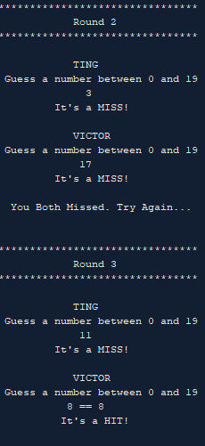

#### **Version 1**

* Changed P1 & P2 strings to pointers.
* Created Player structure and set number of wins as a structure member.
* Added name, total rounds to structure.
* Added char array for choices to randomly fills game board with a ship or blank and writes it to a text file.
* Created game banner function that passes a pointer to a structure.

#### **Version 2**

* Added number of players to Score structure.
* Added player's guess to Player structure.
* Changed names array to all lowercase so I could utilize toupper().
* Created a pointer for number of rounds, passed it to a function and added 1 to it each time it was called.
* Changed names array to all lowercase so I could utilize toupper()
* Created string *toUpper(string *) with a parameter that accepts a pointer to an array to the array index that I'm looking to convert to capitals.

#### **Version 3**

* Changed Player.name to a char[] instead of string for binary files.
* Created fillScore() to dynamically create and fill Score and Player structures.
* The function randomly selects a player's name from a static array and initializes the name member.
* Added enumeration and referenced it inside of for loops.

#### **Version 4**

* Changed choices from 2D to a new structure Choices.
* Wrote a Choices structure to binary and text files.
* Then I looked for a specific rand() record, read it from the binary file.
* Confirmed the correct record was located by comparing it to the text file.

#### **Version 5**

* Wrote to Choices & Scores structures to separate binary files because I can't get scores to read from binary correctly.
* Had choices binary pick a random letter and then switched it back to reference
* chcePtr that points to array of Ships or blanks.
* Fixed scores->board[ ][ ] bug by randomly picking a row and col inside of its brackets.
* Got rid of inFile and set number of players inside fillScore().
* Cleaned up play() by printing end of game results in the printScore();
* PrintScore() displays their opponent’s corresponding row, so you can compare for correct guesses.

## **Flowchart**

I have included the main function’s flowchart below. Please see the Documents folder for the complete flowchart that illustrates each function’s flowchart.

## **Pseudo Code for main( )**

* Include libraries: iostream, iomanip, cmath, cstdlib, fstream, cstring, string,cctype,ctime.
* Include user libraries. 3 structures: Choices.h, Player.h, Score.h
* Declare enumeration numbers to reference [0,10]
* Declare function protypes
* Start main function.
* Set random number seed.
* Declare fstream variables for text and binary files.
* Declare and set data type variables.
* Declare string array, names with 7 different first names in lowercase letters.
* Fill a 2D game board with ships or blanks
  + Declare a static char array. Set with letters to represent ships or blank spaces on a game board.
  + Declare char pointer, *bordPtr. Set to nullptr.
  + Assigns address of static char array to bordPtr
  + Declare a char 2D pointer, **board2D. Set to nullptr.
  + Set board2D with random letters from bordPtr by calling fill2DPtr( ). Pass bordPtr and its array size as arguments.
* Fill 1 instances of a Score structure
  + Create a pointer to the Score structure, *score.
  + Initialize score to Score by calling fillScore( ). Pass names array and reference **pointer.
  + Set game board that’s a member of score by calling setBoard( ). Pass reference to score and **pointer reference as arguments.
* Open binary file for reading, writing, or binary.
  + Conditional to check if binary file does not exist, then print message.
  + Open text file for reading or writing.
  + Create 20 records inside of binary and text files with for loop
    - Create a pointer to the Choices structure, *choice, and set with a function that returns a pointer to Choices that has been set with values. Pass bordPtr and its size as arguments.
    - Write each record to binary and text files
    - Delete choice pointer
  + Read a random record from binary file. Use text file to confirm correct record was read.
    - Get random number [0,20]
    - Create a pointer, *choice, to Choices structure and set with a function call to read binary file and returns the record looking for. Pass binary file and record number as arguments.
    - For loop on the size of choice->size member.
      * Print record contents
    - Delete choice
    - Close binary and text files
* De-allocate any dynamic memory that was created.
* Reset pointers to nullptr.

**Pseudo for functions**

**void setBoard(Score *score, char **board2D)**

* Create and set dynamic 2D array, **board, for each player.
  + Loop based on number of players inside of score
  + Set number of rows and columns the **board will have
  + Create a new array of rows inside of players->board for 2D array
  + Allocate each row with 10 columns because **board should be a 2D array with a for loop
  + Set **board [ ] [ ] with random elements from **board2D
  + Print to confirm board was set inside of score

**char **fill2DPtr (char *bordPtr, const int SIZE17)**

* Function accepts a pointer, and its size. Return reference to a 2D pointer
  + Declare **pointer. Set to nullptr.
  + Allocate pointer with a char array of pointer
  + For loop to allocate 10 columns in each row
  + For loop to set each element in **pointer by randomly filling it with ships or blank from bordPtr.
  + Return pointer to main

**Choices *readBin1(fstream &binFile, int recInd)**

* Read binary file with 20 records and return one record from it
  + Create new instance of Choice structure
  + Calculate cursors size
    - Set cursor to beginning of file
    - Call .read( ) to read in the size of choice->size
    - Calculate the sum # of bytes by multiplying recInd & size of each data type in Choice structure
  + Call seekg( ) to find record we’re looking for. Pass the size of the actual record and to read from the beginning of that record.
  + Read binary record’s size.
  + Allocate memory for char array
  + Read binary record’s char [ ] and save to choice’s array member
  + Allocate choice’s indx member with integer array
  + Read binary record and save it choice’s indx member
  + Return choice to main

**Score *fillScore (string names[], char **bordPtr)**

* Fill instance of Score structure by playing game
* While loop
  + Initialize each player's ship to random number between 1-20 to represent its location on game board
  + Set p1_correct and p2_correct to default starting values == false
  + Display “BATTLESHIP” banner
  + Loops until a player correctly guesses opponents ship location.
    - Display round variable
    - Call bool function to check if player 1’s guess is correct or not.
    - If player 1 is wrong, then call bool function to check if player 2’s guess is correct or not.
    - If both players are wrong, then print message
  + Decrement number of games left
  + Set score’s total Games member to the number of games left.
  + Call function to print score structure
  + If number of games is not zero, then call function to pause the game to view score
  + Reset variables for the next game
  + Return score to main

**bool play(Score *score, int a, int b, int &round)**

* Returns if player's guess is correct or not. Changes value of round
  + Automatically generate player’s guess to a rand num between 1-20
  + if conditional to check if p1Guess equals the location of opponent’s ship
    - Increment player’s win by 1
    - Decrement nGmsLft by 1
    - set score’s isRight member to true
    - Calculate total number of games won & number rounds played
    - Call function to print player was correct
    - Return true to fillScore( )
  + if player1 guess is wrong display MISS message
  + set score’s isRight member to false.
  + Call function to print that player was wrong
  + Return false to fillScore( )

## **Major Variables**

fstream binFile;

fstream outFile;

char *bordPtr;

char **board2D;

Score *score;

Choices *choice;

int cursor;

#### **Checklist**

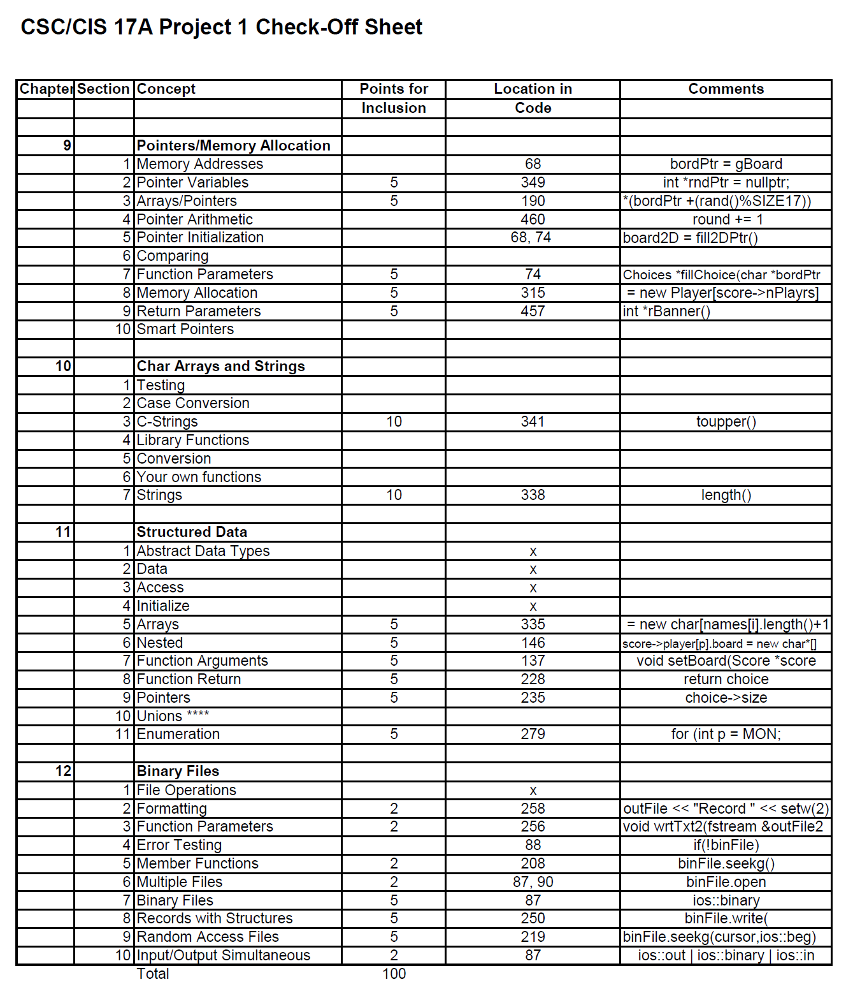

## **Github Repository**

https://github.com/koa2019/danielle_csc17A_48290/tree/main/project/project_1

## **Reference**

1. Gaddis, Tony. *Starting out with C++: From Control Structures through Objects*. 9th ed., Pearson, 2018.
2. Lehr, Mark. “2022_Spring_CSC_CIS_5/Projects at Master · ml1150258/2022_spring_csc_cis_5.” *GitHub*, 2022, https://github.com/ml1150258/2022_Fall_CSC_CIS_17a.

## **Program**

/* File: main.cpp

* Author: Danielle Fernandez

* Created: 11-04-2022 @ 4 PM

* Purpose: CIS 17A Project 1. Covers chapters 9-12 in Tony Gaddis. Battleship v1

Version 6f:

*/

// System Libraries:

#include <iostream> // cin, cout

#include <iomanip> // fixed, setprecision()

#include <cmath> // round()

#include <cstdlib> // rand()

#include <fstream> // fstream

#include <cstring> // char [] library

#include <string> // length() library

#include <ctime> // time library for rand()

#include <cctype> // toupper()

using namespace std;

// User libraries

#include "Choices.h"

#include "Player.h"

#include "Score.h"

// Global Constants

// Physics/Chemistry/Math/Conversions

enum nums {

ZERO, ONE, TWO, THREE, FOUR, FIVE, SIX, SEVEN, EIGHT, NINE, TEN

};

// Function prototypes

Choices *fillChoice(char *,const int); // fills Choice structure

void wrtTxt1(fstream&,Choices *,int); //write Choices structure to text file

void wrtBin1(fstream &,Choices *); // write Choices structure to binary file

Choices *readBin1(fstream &,int); // read binary file

Score *fillScore(string [],char **); // fill Score structure by playing game

bool play(Score *,int,int,int &); // run's each player's guess

char **fill2DPtr(char *,const int); // fills a dynamic 2D pointer

void setBoard(Score *score,char **ptr2D); // sets 2D pointer with Score structure

void prntScore(Score *); // prints Score structure

void pause(); // pauses game to allow user to view results before proceeding

void banner(Score *,string); // print banner

int *rBanner(int &); // print round banner

void hitMiss(Score *,int,int,bool); // print message after each player guesses

int main(int argc, char** argv) {// Program execution begins here

// set random number seed

srand(static_cast<unsigned int> (time(0)));

// declare variables

fstream binFile; // write Choices structure to binary file

fstream outFile; // write Choices structure to text file

const int SIZE17 = 17; // # of characters in choices array

int nRecords = 20,

recInd; // index for random record

string names[SEVEN] = {"mom", "bart", "homer", "jillian", "ting", "victor", "danielle"};

// Fill game board with ships or blanks

//char gBoard[SIZE17 + 1] = "SbSsaSsehSjSwpSsx"; // S=ship B=blank

char gBoard[SIZE17 + 1] = "SbSsBSsbBSBSbbSsb"; // S=ship B=blank

char *bordPtr = nullptr; // declare pointer to a char

bordPtr = gBoard; // assigns address of gBoard array to bordPtr

// 2D array to represent a player's game board

char **board2D = nullptr;

// Call fill2Darr func to fill **board2D with random letters from *bordPtr

board2D = fill2DPtr(bordPtr,SIZE17);

// creating 1 new Score structure

Score *score = new Score;

// Initialize pointer to Score by calling fillScore function

score = fillScore(names,board2D);

// fill **board within Score structure

setBoard(score,board2D);

/*********** 1 Write Choices structure to binary file **************/

binFile.open("2choices.bin", ios::in|ios::out|ios::binary);

if(!binFile) cout <<"Error opening choices.bin\n";

outFile.open("choices.txt", ios::in|ios::out); // Create text file to write to

// Create 20 records of Choice structures in binary & text files

for (int record = 0; record < nRecords; record++) {

// Declare pointer & set with a Choice structure

Choices *choice = fillChoice(bordPtr,SIZE17);

// write each instance of Choice to binary & text files

wrtTxt1(outFile,choice,record);

wrtBin1(binFile,choice);

delete choice;

}

/*********** 1 Read Binary Files **************/

recInd = rand() % nRecords;

Choices *choice = readBin1(binFile,recInd);

cout << "Reading choices.bin...\nLocating record #"<<recInd<<"\nFound Choices record # " << recInd << "\n";

for(int i=ZERO;i<choice->size;i++){

cout << choice->arr[choice->indx[i]];

if(i%TEN==NINE) cout<<endl;

}

delete choice;

// close file

binFile.close();

outFile.close();

//de-allocate dynamic memory

for (int p = 0; p < score->nPlayrs; p++) {

for (int row = 0; row < score->player[p].rows; row++) {

delete []score->player[p].board[row]; //Deletes the Data row by row

}

}

//delete []choice->a;

delete []score->player;

delete score;

score = nullptr;

bordPtr = nullptr;

// exit code

return 0;

}

/************* FUNCTION DEFINITIONS ***************/

void setBoard(Score *score,char **board2D){

// Create & Set dynamic 2D array inside of players for **board

for (int p = 0; p < score->nPlayrs; p++) {

score->player[p].rows = TWO; // set rows to 2

score->player[p].cols = TEN; // set columns to 10

// create new array of rows inside of players->board for 2D array

score->player[p].board = new char*[score->player[p].rows];

// allocate each row with 10 columns because **board should be a 2D array

for (int r = 0; r < score->player[p].rows; r++) {

score->player[p].board[r] = new char[score->player[p].cols];

}

//set **board[][] with

cout<<score->player[p].name << " board in Score structure: \n";

int r,c;

for (int row = 0; row < score->player[p].rows; row++) {

for (int col = 0; col < score->player[p].cols; col++) {

r=rand()%TWO;

c=rand()%TEN;

// Setting structure to a rand() value from 2D char[][]

score->player[p].board[row][col] = board2D[r][c];

cout<< score->player[p].board[row][col];

if(col%10==9) cout<<endl;

}

}

cout<<endl;

}

cout<<endl;

}

// fill **pointer

char **fill2DPtr(char *bordPtr,const int SIZE17){

char **ptr2D = nullptr;

ptr2D = new char*[TWO];

for (int row = 0; row < TWO; row++) {

ptr2D[row] = new char[TEN];

}

// fill 2D array with game board with a random char from gBoard[]

for (int row = 0; row < TWO; row++) {

for (int col = 0; col < TEN; col++) {

// setting 2D array to a random value from gBoard[]

//board[row][col] = *(bordPtr + (rand()%SIZE17));

ptr2D[row][col] = *(bordPtr + (rand()%SIZE17));

}

}

return ptr2D;

}

// read binary file and return one record

Choices *readBin1(fstream &binFile,int recInd){

int count=0;

long cursor = 0L;

Choices *choice = new Choices;

// Find the record by finding the size of one Choice structure &

// multiplying it by the index we're looking for

while(++count<=recInd){

// set cursor to beginning of file

binFile.seekg(cursor,ios::beg);

// reading size of char arr[]

binFile.read(reinterpret_cast<char *>(&choice->size),sizeof(int));

// calculates # of bytes by multiplying index & size of each data types in Choice structure

cursor += ( sizeof(int) + choice->size*sizeof(char) + choice->size*sizeof(int));

}

//cout << "cursor " << cursor << " bits\n";

// set cursor to beginning of file so it can read that record

binFile.seekg(cursor, ios::beg);

// read 1 record from binary file & save to new pointer

binFile.read(reinterpret_cast<char *> (&choice->size), sizeof(int));

choice->arr = new char[choice->size]; // allocate memory for char[]

binFile.read(reinterpret_cast<char *>(choice->arr),choice->size*sizeof(char));

choice->indx = new int[choice->size];

binFile.read(reinterpret_cast<char *>(choice->indx),choice->size*sizeof(int));

return choice;

}

// Declare & fill 1 instances of Choice structure

Choices *fillChoice(char *bordPtr,const int SIZE17){

Choices *choice = new Choices;

choice->size = TWO*TEN;

choice->arr = new char[choice->size];

choice->indx = new int[choice->size];

//Fill array inside of Choice structure

for(int i=0;i<choice->size;i++){

choice->arr[i]=*(bordPtr+(rand()%SIZE17)); // fills with S=ship or B=blank

//choice->arr[i]=rand() % 26 + 65; // rand() letters from alphabet

choice->indx[i]=i;

}

return choice;

}

// write Choices structure to binary file

void wrtBin1(fstream &binFile, Choices *choice) {

binFile.write(reinterpret_cast<char *> (&choice->size), sizeof (int));

binFile.write(reinterpret_cast<char *> (choice->arr),choice->size*sizeof(char));

binFile.write(reinterpret_cast<char *> (choice->indx),choice->size*sizeof(int));

}

// write Choices structure to text file

void wrtTxt1(fstream &outFile, Choices *choice, int recInd) {

int perLine=TEN;

outFile << "Record " << setw(2) << right << recInd << " \n";

for(int i=0;i<choice->size;i++){

outFile << setw(2) << choice->arr[choice->indx[i]];

if(i%perLine==(perLine-1))outFile<<endl;

}

outFile<<endl;

}

// print Score structure member's

void prntScore(Score *score) {

// Display scoreboard banner

banner(score, "SCOREBOARD");

cout <<"\n "<< score->ttlGams << " games left.\n";

cout << " Total rounds in this game: " << score->ttlRnds << endl << endl;

cout << " Player 1's Ship Location: " << score->player[0].shipLoc << endl

<< " Player 2's Ship Location: " << score->player[1].shipLoc << endl << endl;

for (int p=ZERO; p < score->player[p].rows; p++) {

cout << " Player "<<p+1<<"'s Game board \n";

for (int row = 0; row < score->player[p].rows; row++) {

for (int col = 0; col < score->player[p].cols; col++) {

cout<< "&" << score->player[p].board[row][col];

if(col%TEN==NINE) cout<<endl;

}

}

}

cout << endl << endl;

}

// play game

Score *fillScore(string names[],char **bordPtr) {

int MAX = TEN*2, // maximum number for rand()

SIZE17 = 17; //size of choices array

bool p1_crrt, // player 1 correct

p2_crrt; // player 2 correct

int indx1, // index for player 1's name

indx2, // index for player 2's name

maxGmes = FIVE, // number of games

nGmsLft, // number of games left

round = ZERO, // round

numPlay = TWO;

// create new pointer to Score structure

Score *score = new Score;

score->nPlayrs = numPlay;

score->maxGmes = maxGmes;

score->ttlGams = ZERO;

// create a pointer to Player's structure and create array size of 2

score->player = new Player[score->nPlayrs];

// loop through number of players

for (int i = ZERO; i < score->nPlayrs; i++) {

// generate new random name for each player

if (i == ZERO) {

indx1 = rand()%SEVEN;

} else { //makes sure the same 2 names are NOT picked from the names array

do {

indx2 = rand() % SEVEN;

} while (indx2 == indx1);

indx1 = indx2;

}

// creating new char[] the size of string +1

score->player[i].name = new char[names[indx1].length() + 1];

// loop through the length of name string

for (int c = ZERO; c < names[indx1].length() + 1; c++) {

// convert string to c-string and to uppercase. static_cast as char

score->player[i].name[c] = (char) toupper(names[indx1].c_str()[c]);

}

// set each player's number of wins to zero

score->player[i].numWins = 0;

}

// pointer for rounds

int *rndPtr = nullptr;

// read in maximum number of games that can be played from file

nGmsLft = score->maxGmes; // set numberOfGamesLeft to equal maxGames

while (nGmsLft>ZERO) {

// initial variables to represent the location of each player's ship

score->player[0].shipLoc = rand() % (ZERO+MAX); // random number between [1,14]

score->player[1].shipLoc = rand() % (ZERO+MAX);

// sets variables to default starting values

p1_crrt = p2_crrt = false;

// display game's introduction message

banner(score,"BATTLESHIP");

// loops until a player correctly guesses opponents ship location

while ((!p1_crrt) && (!p2_crrt)) {

// display round number banner

rndPtr = rBanner(round);

// Player 1's Guess

p1_crrt = play(score,0,1,round);

// conditional only runs if player 1 misses player 2's ship

// Player 2's Guess

if(!p1_crrt) {

p2_crrt = play(score,1,0,round);

}

// if both players guess wrong, then display message

if ((!p1_crrt) && (!p2_crrt)) cout << endl << " You Both Missed. Try Again...\n\n";

} // ends while((!p1_crrt) && (!p2_crrt))

nGmsLft--;

score->ttlGams = nGmsLft;

prntScore(score);

// checks maximum number of games has NOT been played

if(nGmsLft>ZERO) pause();

// reset variables for next game

*rndPtr = 0;

p1_crrt = p2_crrt = false;

} // ends while(nGmsLft> ZERO)

return score;

}

// returns if player's guess is correct or not

bool play(Score *score,int a, int b, int &round){

int MAX = 20, // maximum number for rand()

SIZE17 = 17; //size of choices array

int maxGmes = 3, // number of games

pGuess, // player 1 guess

numWins, // counter for player 1 wins

ttlGmes, // sum of both players number of wins

ttlRnds = ZERO; // sum of total rounds played

// display instructions

cout << endl << setw(12) << " " << score->player[a].name << "\n Guess a number between "<<ZERO<<" and " << MAX-1 << endl;

// Generates random number guess between [1,14]

pGuess = rand()%(ZERO+MAX);

// checks if player guess is correct

if (pGuess == score->player[b].shipLoc) {

numWins = score->player[a].numWins+1; // increment player 1 number of wins

// set structure's member value for player

score->player[a].numWins = numWins;

score->player[a].isRight = true;

// calculate total number of games won & number rounds played

ttlGmes = score->player[a].numWins + score->player[b].numWins;

score->ttlGams = ttlGmes;

score->ttlRnds = ttlRnds + round; // sums the total number of rounds from all games

// display HIT message for player's correct guess

hitMiss(score, pGuess, b, true); // display MISS message for player 2's wrong guess

return true;

}

// if player1 guess is wrong display MISS message

score->player[a].isRight = false;

hitMiss(score, pGuess,b, false);

return false;

}

// display hit message when player guesses correctly

void hitMiss(Score *score, int pGuess, int b, bool isHit) {

if (isHit) {

cout << setw(12) << pGuess << " == " << score->player[b].shipLoc << endl;

cout << setw(22) << "It\'s a HIT!\n" << endl;

} else {

cout << setw(15) << pGuess << endl << setw(22) << "It\'s a MISS!\n";

}

}

// banner displays round number

int *rBanner(int &round) {

int *rndPtr = nullptr;

round += 1;

rndPtr = &round;

cout << endl << setw(26) << "********************************" << endl;

cout << setw(18) << "Round " << *rndPtr << endl;

cout << setw(26) << "********************************" << endl;

return rndPtr;

}

// displays game's name and instructions in a banner

void banner(Score *score, string title) {

cout << "********************************\n" << setw(21) << title << endl;

cout << "********************************\n";

cout << setw(10) << setfill(' ') << score->player[0].name

<< setw(6) << setfill(' ') << right << "vs"

<< setw(12) << score->player[1].name << endl;

if (title == "SCOREBOARD") {

cout << setw(8) << score->player[0].numWins

<< setw(14) << score->player[1].numWins << endl;

} else {

cout << setw(2) << " " << "\n Try to guess the location of \n"

<< setw(6) << " " << "your opponent\'s ship." << endl;

}

}

// pause screen before game starts

void pause() {

cout << "\nPress enter to continue. \n\n";

cin.get();

}