Caesar Cipher Activity Name _______________________

The following message was encrypted using the classic +13 key. Use your cipher wheel to decode the text.

**AB BAR JVYY OR NOYR GB QRPBQR BHE ZRFFNTR.**

Encode the following plaintext to cipher text using the key of +5.

**MEET AT THE BRIDGE. COME ALONE.**

The following message was encoded using an unknown key, can you decrypt?

**X HDATBCAN HLTPG X PB JE ID CD VDDS.**

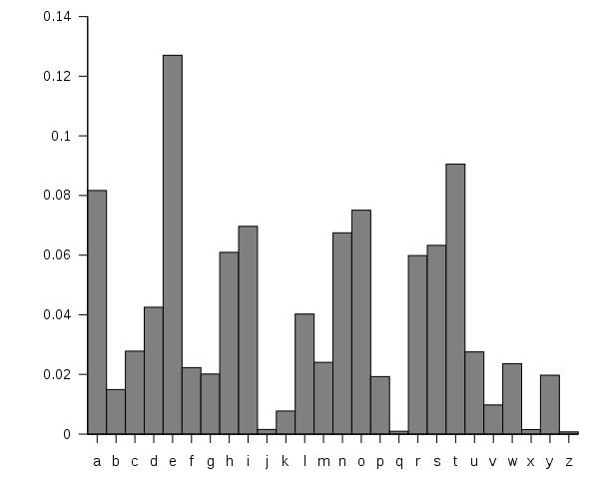That last problem was too easy. Here is another one that was encrypted with an unknown key but the spaces and punctuation have been removed. Drat.

I know the frequency of letters in the English language is this:

**JCRRCPDPCOSCLAWAYLZCYSQCDSJAJSC**

Here is the frequency analysis on the phrase.

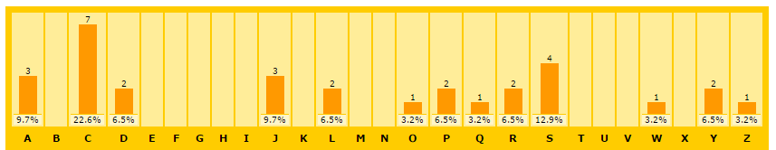

On the back, encode a message of your choice with a key of your choice. We will try to break these messages in a moment as a class.