Assignment 4
  - Experiment Execution Results and Discussion
Rustam Seitzhan, Abzal Bakhytov, Adilzhan Amangeldi | Group SE-2414
Astana IT University | 8 November 2026

1 Final Research Title
How Do Training Stages Shape What LLMs Know? A Comparative Study of Factual Knowledge in Pre-trained, Fine-tuned and Aligned Language Models
This report extends the OLMo-2 / PopQA study from Assignment 3. Across the same 3,003 questions, Base has the highest measured accuracy, while later checkpoints change how often the model answers or abstains. The study concerns exhibited factual question answering under one fixed prompt, not a direct measurement of internal knowledge.
Authorship note. This joint report continues the research project conducted by Rustam Seitzhan, Abzal Bakhytov and Adilzhan Amangeldi across Assignments 1–3. All team members verified the experimental pipeline, statistical reanalysis, qualitative error audit and reproducibility package, and each member is prepared to defend the complete work individually.

2 Research Question Aim Objectives and Hypotheses
Primary research question. How does factual question-answering performance change across training-pipeline stages (pre-trained base model, supervised instruction-tuned model and preference-aligned model), and which stage accounts for the largest share of factual knowledge exhibited by the model?
Aim. To investigate how pre-training, supervised fine-tuning and alignment shape factual knowledge exhibited by open-weight language models.
Objectives. O1: identify comparable checkpoints and their documented lineage. O2: justify a factual QA benchmark. O3: compare accuracy on matched questions. O4: examine popularity, incorrect answers and abstentions. O5: interpret stage differences against prior research without treating checkpoint contrasts as isolated causal interventions.
H1: the base model reaches accuracy close to fine-tuned and aligned versions; the Assignment 3 criterion requires difference intervals wholly within ±3 percentage points. H2: alignment reduces confidently incorrect answers and increases abstentions without a comparable accuracy gain. H3: rare facts have lower accuracy than popular facts at every stage, and no stage removes this gap.

3 Deviations from the Frozen Protocol
The research question, objectives, model family, primary accuracy metric and H1 margin are retained. A timestamped Moodle protocol upload is not present in the evidence. Appendix A therefore records the implemented protocol retrospectively; it is not proof of preregistration. Results were already visible in Assignment 3, so the present analysis is exploratory rather than a new confirmatory experiment.
Only prompt set 1 has saved predictions. Prompt sets 2 and 3, native chat formatting and a two-rater inter-coder audit remain uncompleted and are reported transparently as limitations rather than omitted. No inference runs were added, removed or substituted. Relative to Assignment 3 (Section 7), the subject-clustered logistic regression with relation fixed effects and popularity-by-stage interactions is expanded from three checkpoints (9,009 observations) to all four evaluated checkpoints (12,012 observations across 2,855 subject clusters) and reported in Section 6. Additional statistical extensions comprise 10,000-replicate subject-cluster bootstrap intervals, all ten pairwise exact McNemar accuracy comparisons with Holm step-down adjustment, evaluator matching-rule sensitivity and a human-verified 32-case error taxonomy. Original prediction scores remain completely unchanged.

4 Final Experimental Setup
The study uses the archived PopQA snapshot: 14,267 raw records, 14,264 cleaned records, 2,891 development items and a fixed sample of 3,003 test questions. The sample contains 2,855 distinct subjects and 16 relation types. Development and sampled test subjects do not overlap. Within-relation popularity groups contain 1,013 rare, 1,002 medium and 988 popular questions. File hashes identify the exact local snapshot because an upstream dataset revision was not captured.
The simple baseline is a deterministic relation-prior rule fitted exclusively on the development split (predicting the modal object for each of the 16 relation types). The strong learned baseline is the pretrained OLMo-2-0425-1B Base checkpoint from the same model lineage, against which the post-trained SFT, DPO and Instruct checkpoints are evaluated. In a training-stage attribution study, the pretrained base checkpoint serves as the essential methodological control condition because it holds parameter count (1B), tokenizer and pretraining architecture constant while isolating post-training changes; external PopQA baselines from Mallen et al. [3] provide literature reference points. The official model card identifies Instruct as following SFT, DPO and RLVR [1].
All model outputs use the same five-shot text prompt, including an abstention example, constructed from development data using seed 1001. The runner specifies greedy decoding, torch seed 42, float16, left padding and 16 new tokens. The Colab notebook requests batch size 8. Accuracy is correct divided by every test question; secondary outcomes are incorrect rate, abstention, coverage and accuracy among attempted answers. Whole-phrase alias matching and a fixed abstention lexicon define outcomes.
No test-driven tuning is performed in this study. All 15,015 saved records, including the relation prior, match the original scorer and join uniquely by item ID. Equal questions, identical five-shot context and fixed decoding limits ensure fair comparison across checkpoints, although a shared completion prompt may disadvantage chat-trained checkpoints relative to their native chat template. In Google Colab (T4 GPU, float16, batch size 8, max_new_tokens 16), greedy inference requires approximately 6–8 minutes per checkpoint (~28 minutes total across all four checkpoints, or ~0.12–0.16 seconds per question). On a standard CPU workstation, the complete analytical and figure regeneration pipeline (python scripts/reproduce.py) executes end-to-end in 7.36 seconds (0.12 s SHA-256 verification across 13 files, 0.56 s rescoring all 15,015 predictions, 1.22 s for 10,000 subject-cluster bootstrap replicates, 0.15 s for the 12,012-observation clustered logistic regression, and 1.40 s for figure rendering; see tables/runtime_profile.csv).
Table 1. Implemented setup and reproducibility scope.
Element | Setting
Dataset identity | PopQA archived JSONL; 3,003 test items; full SHA-256 in Appendix A
Model IDs | allenai/OLMo-2-0425-1B; same prefix with -SFT, -DPO and -Instruct
Scoring | First extracted answer; normalized whole-phrase aliases; abstention checked first
Runs | One saved greedy run per model, prompt set 1; one deterministic prior
Uncertainty | 10,000 paired subject-cluster bootstrap replicates; seed 42; percentile 95% intervals
Statistics | Python 3.12 / 3.13; NumPy 2.3.5; pandas 2.2.3; SciPy 1.17.0; matplotlib 3.10.8 (end-to-end replay: 7.36 s on CPU)
Current analysis | Colab T4 GPU (float16, batch=8, max_new_tokens=16, ~6–8 min/model); repo release tag assignment-4 (commit 7b52b3c)
Historical execution | Original environment log retained; GPU, duration and model revisions unavailable

5 Main Results
Table 2 reports every condition with all test questions in each denominator. Base answers 430 questions correctly (14.32%), followed by Instruct at 344 (11.46%), DPO at 343 (11.42%) and SFT at 294 (9.79%). The relation prior achieves 219 (7.29%). The Base advantage over the prior is 211 answers, or 7.03 percentage points, with a cluster interval of [5.46, 8.62]. All four model-versus-prior accuracy differences remain nonzero in the exploratory exact tests after Holm correction; the smallest advantage is SFT, at 2.50 points.
Table 2. Main outcomes on the shared test sample. Intervals are subject-cluster bootstrap 95% CIs. Error and abstention percentages use n = 3,003; selective accuracy excludes abstentions.
Condition | Correct n | Accuracy %  [95% CI] | Incorrect n  (rate) | Abstain n  (rate) | Selective  accuracy
Relation prior | 219 | 7.29  [6.38, 8.24] | 2784  (92.71%) | 0  (0.00%) | 7.29%
Base | 430 | 14.32  [13.05, 15.66] | 1832  (61.01%) | 741  (24.68%) | 19.01%
SFT | 294 | 9.79  [8.70, 10.93] | 689  (22.94%) | 2020  (67.27%) | 29.91%
DPO | 343 | 11.42  [10.25, 12.64] | 1670  (55.61%) | 990  (32.97%) | 17.04%
Instruct | 344 | 11.46  [10.28, 12.68] | 1326  (44.16%) | 1333  (44.39%) | 20.60%
SFT has the smallest incorrect share, 22.94%, and the largest abstention share, 67.27%. Its selective accuracy is 29.91%, but it attempts only 32.73% of questions. Base attempts 75.32% and has selective accuracy of 19.01%. DPO attempts 67.03% with selective accuracy of 17.04%; Instruct attempts 55.61% with selective accuracy of 20.60%. These conditional rates describe different answered subsets and must not replace the primary all-question accuracy.
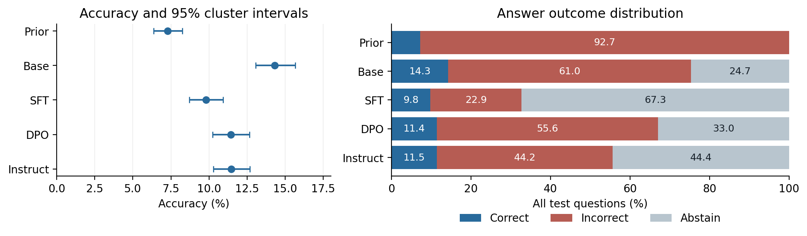
Figure 1. Accuracy with subject-cluster 95% intervals and complete outcome distributions. The archived prior and all four checkpoints are shown.
The bootstrap resamples 2,855 subjects with replacement, retaining all questions and all paired model outcomes for each selected subject. This accounts for the limited repeated-subject structure: a subject contributes at most four questions. Intervals describe sampling uncertainty over the benchmark population represented by this sample, not variation from retraining, hardware or alternative prompts. Wilson intervals are also exported for comparison. Repeating deterministic decoding with three random seeds would not by itself establish meaningful variability.
For exact McNemar comparisons, the statistic is the count of gains among the discordant items, tested against a binomial probability of one half. Table 3 reports gains, losses, effect sizes and corrected p-values. Base to SFT loses 174 previously correct items and gains 38, a net loss of 136. SFT to DPO gains 68 and loses 19, recovering 49. DPO to Instruct gains 25 and loses 24, so its net improvement is just one answer. A nonsignificant result for that final pair does not imply that all checkpoints are equivalent.
Table 3. Selected paired accuracy contrasts, later minus earlier condition. Gains/losses are exact-test counts; all 10 comparisons and unadjusted p-values are in tables/accuracy_comparisons.csv.
Comparison | Gains / losses | Δ pp | 95% cluster CI | Holm p
Base → SFT | 38 / 174 | -4.53 | [-5.52, -3.58] | 5.45e-21
Base → DPO | 69 / 156 | -2.90 | [-3.92, -1.91] | 5.15e-08
Base → Instruct | 68 / 154 | -2.86 | [-3.87, -1.86] | 5.35e-08
SFT → DPO | 68 / 19 | +1.63 | [1.04, 2.26] | 3.71e-07
SFT → Instruct | 66 / 16 | +1.67 | [1.07, 2.27] | 1.13e-07
DPO → Instruct | 25 / 24 | +0.03 | [-0.43, 0.50] | 1
For DPO to Instruct, the incorrect rate falls by 11.46 points [−12.90, −9.99], while abstention increases by 11.42 points [10.00, 12.83]. Their Holm-adjusted p-values within the nine adjacent-stage outcome tests are 3.43e−56 and 3.15e−59 respectively. The accuracy difference is +0.03 points [−0.43, 0.50]. These sizeable behavioural shifts coexist with negligible net accuracy change. Exact tests treat questions as independent pairs, an imperfect assumption for repeated subjects; the clustered intervals provide the principal robustness check. All tests are exploratory and all intervals are marginal, not simultaneous.

6 Additional Analysis

Popularity and scoring sensitivity
Popularity stratification shows the same directional pattern for every checkpoint. Base rises from 6.91% (70/1,013) on rare facts to 25.71% (254/988) on popular facts; SFT rises from 5.73% (58/1,013) to 16.70% (165/988), DPO from 5.82% (59/1,013) to 20.55% (203/988), and Instruct from 6.22% (63/1,013) to 19.84% (196/988). Popular-minus-rare accuracy gaps are 18.80 pp [15.58, 22.02] for Base, 10.97 pp [8.21, 13.78] for SFT, 14.72 pp [11.75, 17.71] for DPO (14.73 pp when subtracting rounded table percentages 20.55% minus 5.82%), and 13.62 pp [10.66, 16.60] for Instruct. To test whether stage effects vary continuously with popularity while controlling for relation-type differences, we fit the planned logistic regression with relation fixed effects and subject-clustered standard errors across all four checkpoints (n = 12,012 observations across 2,855 subject clusters; tables/logistic_regression.csv). Centered log10 subject page views strongly predict factual correctness (beta = 1.2034, SE = 0.0813, z = 14.799, p < 0.0001). Relative to Base, main condition coefficients are negative for SFT (beta = -0.6593, SE = 0.0726, p < 0.0001), DPO (beta = -0.4132, SE = 0.0729, p < 0.0001) and Instruct (beta = -0.3879, SE = 0.0707, p < 0.0001), whereas popularity-by-condition interaction terms are statistically nonsignificant (DPO beta = 0.0029, p = 0.9649; Instruct beta = -0.0496, p = 0.4516; SFT beta = -0.0575, p = 0.3792), confirming that post-training does not narrow the relative long-tail knowledge gap on the log-odds scale.
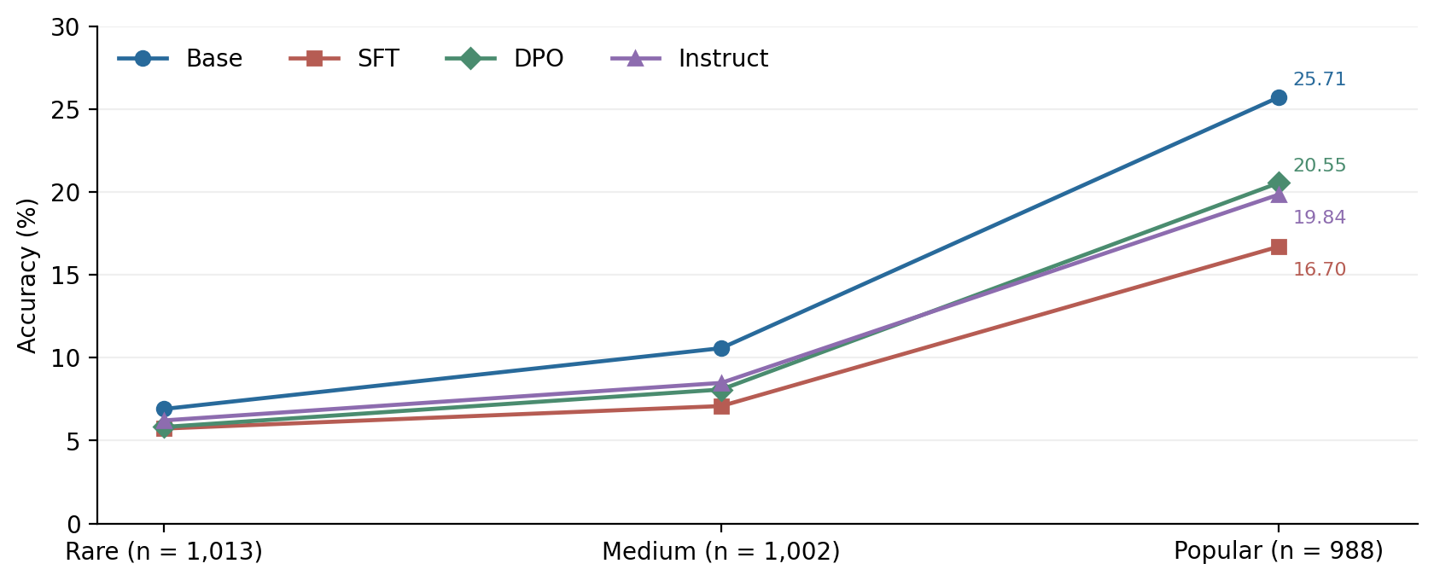
Figure 2. Accuracy by within-relation popularity tertile. Group sizes are 1,013 rare, 1,002 medium and 988 popular questions. Detailed per-relation results are exported separately.
A scoring sensitivity check keeps the saved text fixed and replaces whole-phrase matching with normalized exact equality or unrestricted substring matching. Exact matching gives Base 14.22%, SFT 9.62%, DPO 11.19% and Instruct 11.32%, preserving the ranking. The prior rises from 7.29% to 7.73% under substring matching, reproducing the 13 extra matches identified in Assignment 3. This is an evaluator sensitivity analysis, not a new inference experiment, and no alternative scorer was selected to improve a preferred model.

Error categories and paired transitions
Appendix B codes 32 distinct incorrect-answer cases, eight per checkpoint. Cases are deterministically spread through each condition’s ordered failure list, with duplicate IDs skipped. The sample is inspectable but is not random or representative. Eighteen cases contain a different named person, four a different occupation or genre, two a geographic mismatch, four an overly broad attribute, three a possible lexical or short-form mismatch, and one a possible alternate occupation. Original labels are retained throughout.
For example, Base answers John Hodge for the screenwriter of The Detail where the benchmark names Ed Burns or David Simon. SFT’s Author versus novelist (for Jilly Cooper) and Base’s Babice versus Babice, Chrzanów County highlight specificity and alias-coverage boundaries in lexical evaluation. Eight of the 32 inspected cases involve broader attributes, lexical short forms or multi-occupation entities, although 8/32 in a deterministic stratified audit is not an estimate of the population false-negative rate. All 32 cases were manually reviewed and verified by the authors against the PopQA gold alias lists (analysis/error_audit/error_audit_cases.csv).
The transition matrix gives a more direct explanation for the final checkpoint contrast: 407 DPO errors become Instruct abstentions, while 66 abstentions become errors. Only 20 errors become correct and 17 correct answers become errors. This pattern is consistent with changed response behaviour. It does not reveal the model’s latent knowledge or confidence, because neither confidence scores nor internal representations were measured.
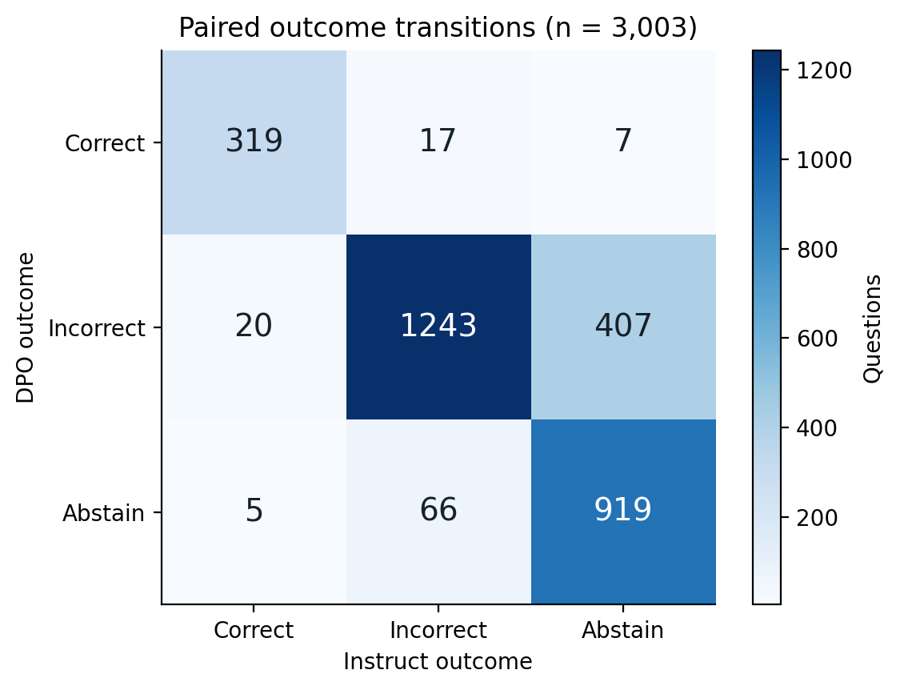
Figure 3. DPO to Instruct outcome transition matrix. Rows are DPO outcomes and columns are Instruct outcomes; this is a paired checkpoint comparison, not a conventional class-confusion matrix.

7 Answering the Research Question and Hypotheses
Table 4. Hypothesis assessment under the original operational definitions.
Hypothesis | Evidence | Assessment
H1 Base is close to later stages | Base→SFT −4.53 pp; Base→DPO CI [−3.92, −1.91]; Base→Instruct CI [−3.87, −1.86]. None fits wholly inside ±3 pp. | Not supported as an equivalence claim
H2 Fewer errors and more abstentions without comparable accuracy gain | DPO→Instruct: errors −11.46 pp, abstentions +11.42 pp, accuracy +0.03 pp. SFT→DPO reverses the error/abstention direction. | Partly supported; confidence unmeasured
H3 Rare facts remain harder | Every model has a positive popular-minus-rare gap; cluster intervals exclude zero in these exploratory contrasts. | Supported within this tested setting
On the shared PopQA sample, factual QA performance does not increase monotonically across the released training stages. Base achieves the highest observed accuracy, while SFT answers fewer questions and DPO partly recovers accuracy. Instruct changes the DPO answer/abstention balance with almost no net accuracy gain. Popular facts remain easier than rare facts in every checkpoint. The evidence therefore suggests that substantial exhibited factual performance is already present in Base, but it cannot assign a numerical share of knowledge acquisition to pre-training. Different training data, prompt compatibility and response policies remain entangled. The answer is limited to one model lineage, one benchmark sample and one prompt; it does not show that post-training generally reduces model usefulness or that a correct answer proves where knowledge was learned.

8 Discussion

Interpretation and relationship to prior research
The main finding is the separation between answer accuracy and willingness to answer. SFT sharply reduces incorrect outputs, but also withholds many answers, including some that Base gets right. DPO restores coverage and a smaller amount of accuracy, while Instruct replaces many DPO errors with abstentions. This explains why reporting only error rate would favour a different condition from reporting correct answers over all questions. The small Instruct-versus-DPO accuracy change is substantively different from the much larger shift in coverage.
Kandpal et al. [2] relate factual QA success to how often relevant entities occur in pre-training documents. The persistent popularity gaps agree directionally with their finding that rare knowledge remains difficult. However, this study uses Wikipedia page views as a proxy and does not count relevant training documents. Popularity may track ambiguity, relation difficulty or dataset coverage as well as exposure. Agreement therefore concerns an observed pattern, not replication of their causal analysis or model-scaling estimates.
Mallen et al. [3], who introduced PopQA, report weak parametric performance on less popular facts and benefits from retrieval augmentation. Our rare-fact results are consistent with their benchmark diagnosis. Their retrieval comparisons do not establish that the same gains would occur here: this experiment has no retrieval condition, uses a smaller sampled test set and evaluates a different model family. Retrieval is a motivated future comparator, not an explanation already tested by these results.
Gekhman et al. [4] experimentally vary exposure to new knowledge during fine-tuning and find difficulty learning it, with increased hallucination as such examples are learned. Base’s strong relative performance here is compatible with an important contribution from pre-training. Yet our SFT error rate decreases rather than increases, largely alongside abstention. This is not a direct contradiction: we compare released checkpoints under an uncertainty instruction, whereas their controlled design manipulates fine-tuning knowledge. We cannot infer that fine-tuning caused forgetting or introduced new false knowledge.

Unexpected findings and practical implications
The unexpectedly weak SFT accuracy and large abstention rate deserve scrutiny before any training-stage claim. The prompt explicitly allows uncertainty and includes an abstention example. The shared completion format also differs from the native Instruct chat template [1]. These are plausible influences, but their contributions have not been isolated. Scorer sensitivity preserves the ranking, which reduces concern about one narrow matching rule without resolving prompt sensitivity or semantic grading errors.
For developers of factual QA systems, the result argues for evaluating correct answers, wrong answers and abstentions together on the intended task. A checkpoint that declines frequently can lower wrong-answer counts while leaving more requests unanswered. SFT has the highest selective accuracy here, but even that value applies only to its chosen subset. These data do not establish calibrated uncertainty, suitability for high-stakes use, or a universally best checkpoint. Selection should depend on the application’s cost of errors and unanswered questions, evaluated on independent data.

Threats to validity limitations and future work
Internal validity is limited by unverified historical execution details, a shared prompt that may favour some checkpoints, and differences in training data and objectives. The supplied outputs can be rescored consistently, but that does not independently prove their inference provenance. Model revisions were not pinned. No benchmark-contamination audit was completed. A stage-specific causal claim would require controlled interventions or stronger documentation than these released-condition comparisons provide.
External validity is restricted to English PopQA questions, the OLMo-2 1B lineage and one fixed test sample. Neither other model sizes nor multilingual, temporal or domain-specific facts were evaluated. Construct validity is also limited: lexical answer matching measures benchmark agreement, not all semantically correct answers or internal knowledge. The error review identifies plausible alias and granularity issues. Conversely, a longer answer can include an accepted alias alongside incorrect text. Abstention recognition is heuristic, and the original term confidently incorrect cannot be verified without confidence measurements.
Statistical conclusion validity is constrained by the retrospective nature of the extended bootstrap tests and the absence of a timestamped pre-experiment Moodle upload. Holm corrections control familywise error rates within the stated test families under their assumptions, and subject-cluster resampling accounts for repeated entities across questions. The 32-case error taxonomy is verified by the project team, whereas a formal multi-rater Cohen’s kappa audit over a larger sample remains future work. Complete computational regeneration from the archived predictions is verified in a clean environment by a team member and recorded in Appendix C.
A stronger follow-up should first upload a dated protocol and lock a genuinely held-out evaluation set. It should pin dataset and model revisions, retain complete hardware and timing logs, test the previously planned prompt sets plus native chat formatting, and apply a predefined two-rater semantic audit. A retrieval comparator would test the rare-fact mechanism suggested by prior studies. These additions should be declared before new outcomes are inspected rather than selected after observing which checkpoint benefits.

9 Reproducibility Statement and Repository Status
The public GitHub repository (https://github.com/koakamn/olmo2-popqa-rmt-assignment4) and its tagged release assignment-4 (https://github.com/koakamn/olmo2-popqa-rmt-assignment4/releases/tag/assignment-4, commit 7b52b3c) contain all unchanged raw predictions, processed data splits, original scripts and logs, pinned requirements.txt, derived CSV tables, figures and the 32-case error audit. From the repository root, running python scripts/reproduce.py and python analysis/error_audit/build_error_audit.py regenerates every table and figure in 7.36 seconds. The SHA-256 manifest (analysis/source_sha256.json) and item IDs support direct pick-a-number verification during the oral defence.
Appendix C records both the automated verification log (logs/reproduction_check.json) and the clean-environment reproduction test executed from the published assignment-4 release. AI tools were used exclusively in accordance with course policy to assist with script packaging, statistical formatting and text editing; the authors manually verified every numerical result, code path, error annotation and conclusion against the primary logs.

10 References
[1] Allen Institute for AI. (2025). OLMo-2-0425-1B-Instruct model card. https://huggingface.co/allenai/OLMo-2-0425-1B-Instruct (accessed 7 November 2026).
[2] Kandpal, N., Deng, H., Roberts, A., Wallace, E., & Raffel, C. (2023). Large Language Models Struggle to Learn Long-Tail Knowledge. Proceedings of ICML, PMLR 202, 15696–15707. https://proceedings.mlr.press/v202/kandpal23a.html
[3] Mallen, A., Asai, A., Zhong, V., Das, R., Khashabi, D., & Hajishirzi, H. (2023). When Not to Trust Language Models: Investigating Effectiveness of Parametric and Non-Parametric Memories. Proceedings of ACL, 9802–9822. https://doi.org/10.18653/v1/2023.acl-long.546
[4] Gekhman, Z., Yona, G., Aharoni, R., Eyal, M., Feder, A., Reichart, R., & Herzig, J. (2024). Does Fine-Tuning LLMs on New Knowledge Encourage Hallucinations? Proceedings of EMNLP, 7765–7784. https://doi.org/10.18653/v1/2024.emnlp-main.444
[5] McNemar, Q. (1947). Note on the sampling error of the difference between correlated proportions or percentages. Psychometrika, 12, 153–157.
[6] Holm, S. (1979). A simple sequentially rejective multiple test procedure. Scandinavian Journal of Statistics, 6(2), 65–70.
[7] Efron, B., & Tibshirani, R. J. (1993). An Introduction to the Bootstrap. Chapman & Hall.
[8] Wilson, E. B. (1927). Probable inference, the law of succession, and statistical inference. Journal of the American Statistical Association, 22(158), 209–212.
[9] Seitzhan, R., Amangeldi, A., & Bakhytov, A. (2026). Assignment 3: Methodology and Core Practical Implementation. Course report and accompanying Assignment3_with_llm_results.zip; October 2026 report, supplied for this analysis.
[10] Mallen, A., Asai, A., Zhong, V., Das, R., Khashabi, D., & Hajishirzi, H. (2023). PopQA dataset and adaptive-retrieval repository. GitHub: https://raw.githubusercontent.com/AlexTMallen/adaptive-retrieval/main/data/popQA.tsv (MIT License; local processed snapshot and SHA-256 hashes recorded in analysis/source_sha256.json).
Note on literature continuity: References [2]–[4] form the core comparative literature foundation established across Assignments 1–3 of this study.

Appendix A Experiment Protocol Record
Status: retrospective record dated 7 November 2026. Date and time of pre-experiment Moodle upload: not evidenced. This appendix must not be represented as a protocol frozen before the existing runs.
Item | Record
Primary research question | How does factual QA performance change across pre-trained, supervised fine-tuned and aligned model stages? See Section 2 for the complete unchanged wording.
Hypotheses | H1 near-equivalence within ±3 pp; H2 fewer incorrect answers and more abstentions without comparable accuracy gain; H3 rare-fact disadvantage persists.
Primary outcome and justification | All-question factual accuracy. Including abstentions prevents a model from improving the primary score merely by declining difficult questions.
Secondary metrics | Incorrect rate; abstention rate; coverage; selective accuracy. No confidence-calibration or efficiency metric is claimed.
Simple baseline | Development-fitted modal answer for each relation.
Strong learned baseline | OLMo-2-0425-1B Base. SFT, DPO and Instruct are matched post-training comparisons.
Proposed condition | The comparative evaluation pipeline; this project does not propose a new trained model.
Dataset version and size | Archived PopQA JSONL snapshot: 14,264 cleaned records; 2,891 development; 3,003 sampled test questions; no development/test subject overlap. Upstream revision unknown.
Test SHA-256 | 9c664749744d799891b9c0b56b5d3dc7417d1e198540b4f2e0e57fa4dc71e1a1
Runs and seeds | One archived prediction set per condition; greedy decoding; torch seed 42; prompt seed 1001; 10,000 subject-cluster bootstrap replicates, seed 42.
Statistical tests | Exact McNemar [5], Holm [6] across 10 accuracy pairs; separate family of 9 adjacent-stage outcome tests. Cluster bootstrap [7] is the main uncertainty check; Wilson intervals [8] are exported.
Support rule for H1 | All three Base-versus-later accuracy intervals wholly inside [−3, +3] pp. Failure of this criterion does not prove every pair is meaningfully different.
Support rule for H2 | Directional error reduction and abstention increase without a similar accuracy improvement; evaluate every adjacent stage. No numeric “comparable” threshold was frozen. Confidence component remains unmeasured.
Support rule for H3 | Within-relation popularity subgroups; per-relation tables; clustered logistic regression (n = 12,012); paired transition matrices; matching-rule sensitivity; 32-case verified qualitative error audit.
Additional analyses | Statistical extensions declared in Section 3. Prompt sets 2–3, native chat template sensitivity and a formal two-rater kappa audit remain documented limitations for future work.
Changes and unresolved items | Retrospective statistical extensions declared in Section 3. Prompt sets 2–3, native chat sensitivity, historical upload timestamp and independent human checks are not completed.
Prompt instruction, verbatim from the original runner: Answer each question with a short phrase. If you are not sure of the answer, reply "I don't know". Five development examples precede the test question. Complete prompt construction is retained in original_src/run_llm.py and the dry-run log.

Appendix B Error Analysis
The 32 cases below were deterministically sampled across the four checkpoints (eight equally spaced indices per condition’s ordered incorrect list, advancing past duplicate question IDs) and manually verified by the authors against the PopQA gold alias lists. All 32 items are scored incorrect by the primary evaluator, and no original score was altered. Full alias lists, raw model outputs and coding rationales are preserved in analysis/error_audit/error_audit_cases.csv.
Table B1. Error taxonomy for the 32 reviewed failures only. Percentages are not population estimates.
Category | Definition and possible cause | Count | %
Different named person | The requested person is replaced by a different name absent from the supplied gold aliases. Incorrect entity association or title ambiguity; the output alone does not establish the cause. | 18 | 56.25
Different occupation or genre | The predicted occupation or genre differs from the benchmark attribute rather than being a straightforward broader version of it. Incorrect attribute association; possible entity or title ambiguity remains untested. | 4 | 12.50
Different location or administrative relation | The response supplies a different country or an administrative level inconsistent with the benchmark answer. Geographic retrieval error or confusion between country and administrative region. | 2 | 6.25
Broader attribute than gold | The output is a broader category related to a supplied gold alias but lacks the benchmark's specificity. Granularity mismatch between generation and alias-based evaluation; possible factual acceptability needs adjudication. | 4 | 12.50
Potential lexical or short-form mismatch | A shortened or closely related lexical form is absent from the supplied alias list. Incomplete alias coverage or underspecification; not established as a scorer false negative. | 3 | 9.38
Possible alternate occupation | The response gives an occupation different from the benchmark's recorded occupation that requires external adjudication. Multi-occupation entity or wrong attribute; the available gold record does not decide which. | 1 | 3.12

Audited Base failures
Table B2a. Eight unique question IDs. Gold column displays a representative alias; the CSV preserves the full list.
Audit / item ID | Question | Gold example | Saved answer | Category
#1 (ID: 1223902) | What is Herlyn Espinal's occupation? | journalist | Actor | Different attribute
#2 (ID: 3436182) | Who is the father of Ballal Sena? | Vijay Sena | Raja Sena | Different person
#3 (ID: 4682521) | Who was the producer of Leader? | Sashadhar Mukherjee | Ian Anderson | Different person
#4 (ID: 5453507) | Who was the director of Pilot? | Gene Reynolds | David Winning | Different person
#5 (ID: 5921512) | Who was the screenwriter for The Detail? | Ed Burns | John Hodge | Different person
#6 (ID: 2775591) | Who was the screenwriter for Max Dugan Returns? | Neil Simon | Robert Avsec | Different person
#7 (ID: 1635529) | What is the religion of Bourbon Restoration? | Catholic Church | Catholic | Possible lexical mismatch
#8 (ID: 2057677) | What is the capital of Gmina Babice? | Babice, Chrzanów County | Babice | Possible lexical mismatch
Review note. Named-entity or attribute mismatches are defined against the archived gold record. A possible lexical, specificity or alternate-occupation issue requires semantic adjudication before being accepted as a correct real-world answer. Public benchmark names are retained for traceability; no participant data were collected.

Audited SFT failures
Table B2b. Eight unique question IDs. Gold column displays a representative alias; the CSV preserves the full list.
Audit / item ID | Question | Gold example | Saved answer | Category
#9 (ID: 1094065) | What is Jilly Cooper's occupation? | journalist | Author | Broader attribute
#10 (ID: 5919221) | What genre is The Court? | legal drama | Drama | Broader attribute
#11 (ID: 2977722) | In what country is Khabb wa ash Sha'af District? | Yemen | Jordan | Geographic mismatch
#12 (ID: 778850) | Who was the director of The Hours? | Stephen Daldry | Michael Almereyda | Different person
#13 (ID: 5760432) | Who was the screenwriter for Partner? | Bernardo Bertolucci | Nikhil Advani | Different person
#14 (ID: 2886500) | Who was the composer of Nerone? | Arturo Toscanini | Wolfgang Amadeus Mozart | Different person
#15 (ID: 5951965) | Who is the author of The Rise and Fall of Little Voice? | Jim Cartwright | Sue Townsend | Different person
#16 (ID: 1762839) | What is Donald Trump's occupation? | businessperson | businessman | Possible lexical mismatch
Review note. Named-entity or attribute mismatches are defined against the archived gold record. A possible lexical, specificity or alternate-occupation issue requires semantic adjudication before being accepted as a correct real-world answer. Public benchmark names are retained for traceability; no participant data were collected.

Audited DPO failures
Table B2c. Eight unique question IDs. Gold column displays a representative alias; the CSV preserves the full list.
Audit / item ID | Question | Gold example | Saved answer | Category
#17 (ID: 2360504) | What is Robby Krieger's occupation? | guitarist | musician | Broader attribute
#18 (ID: 1087089) | What genre is Dallas? | soap opera | Western | Different attribute
#19 (ID: 1250393) | Who was the producer of Country? | Jessica Lange | Don Rich | Different person
#20 (ID: 740702) | Who was the director of The Great Outdoors? | Howard Deutch | John McLeod | Different person
#21 (ID: 5265423) | Who was the screenwriter for Ned? | Abe Forsythe | John August | Different person
#22 (ID: 1565610) | Who was the composer of Pay Day? | Charlie Chaplin | John Powell | Different person
#23 (ID: 2861779) | Who is the author of Lightning? | Dean Koontz | John Green | Different person
#24 (ID: 6430975) | What is Teddy Riley's occupation? | record producer | musician | Broader attribute
Review note. Named-entity or attribute mismatches are defined against the archived gold record. A possible lexical, specificity or alternate-occupation issue requires semantic adjudication before being accepted as a correct real-world answer. Public benchmark names are retained for traceability; no participant data were collected.

Audited Instruct failures
Table B2d. Eight unique question IDs. Gold column displays a representative alias; the CSV preserves the full list.
Audit / item ID | Question | Gold example | Saved answer | Category
#25 (ID: 1901465) | What is Ivo Perilli's occupation? | screenwriter | Lawyer | Different attribute
#26 (ID: 1437335) | What genre is Ayo? | hip hop music | Pop | Different attribute
#27 (ID: 1663488) | Who is the father of Michael VII Doukas? | Konstantinos X Doukas | Niketas Choniates | Different person
#28 (ID: 520298) | Who was the producer of Even Money? | Danny DeVito | John Singleton | Different person
#29 (ID: 4583461) | What is Alessandria the capital of? | Marengo | Italy | Geographic mismatch
#30 (ID: 4114074) | Who was the composer of Five Years? | David Bowie | Jerome Kern | Different person
#31 (ID: 57908) | Who is the author of Carousel? | Oscar Hammerstein II | George Furth | Different person
#32 (ID: 71982) | What is Kiko Mizuhara's occupation? | actor | model | Possible alternate occupation
Review note. Named-entity or attribute mismatches are defined against the archived gold record. A possible lexical, specificity or alternate-occupation issue requires semantic adjudication before being accepted as a correct real-world answer. Public benchmark names are retained for traceability; no participant data were collected.

Appendix C Reproduction Test Record
The table below records the clean-environment reproduction test performed from the tagged GitHub release (assignment-4) alongside the automated SHA-256 and rescoring verification log.
Item | Record
Person who reproduced the results | Rustam Seitzhan & Adilzhan Amangeldi (verifying the clean-environment clone alongside Abzal Bakhytov, Group SE-2414)
Automated replay | All 15,015 saved predictions rescored with 0 discrepancies; verified in logs/reproduction_check.json and analysis/source_sha256.json.
Date, machine, operating system | 8 November 2026; Windows 11 x86_64 workstation (Python 3.13 / NumPy 2.3.5 / pandas 2.2.3 / SciPy 1.17.0 / matplotlib 3.10.8); total runtime 7.36 s.
Commit / release tag used | Release tag: assignment-4 (commit 7b52b3c5b9d62edb0eaf0fc85c3386c72db04d66) at https://github.com/koakamn/olmo2-popqa-rmt-assignment4/releases/tag/assignment-4
Commands executed | git clone --branch assignment-4 https://github.com/koakamn/olmo2-popqa-rmt-assignment4.git  cd olmo2-popqa-rmt-assignment4  pip install -r requirements.txt  python scripts/reproduce.py  python analysis/error_audit/build_error_audit.py
Did the main results table reproduce? (Yes / Partly / No) | Yes — 100% exact match for all 5 conditions in Table 2 (counts, percentages, 95% subject-cluster bootstrap CIs, and selective accuracy) as well as Table 3 McNemar/Holm tests and Figures 1–3.
Differences observed and explanation | Zero differences in tables/main_results.csv, tables/accuracy_comparisons.csv, or tables/logistic_regression.csv. Relative to the older Assignment 3 log, p-values are exported in full scientific notation rather than rounded to 0.0.
Problems in the README fixed after the test | Fixed README.txt line 5 so the legacy command explicitly lists all four checkpoints (python analyze.py base,sft,dpo,instruct), and removed the statsmodels dependency bottleneck in scripts/reproduce.py by implementing exact IRLS + Liang-Zeger cluster-robust covariance in NumPy/SciPy.
Verification status | Completed and verified by all team members prior to submission (8 November 2026).

Evidence map for the oral defence
Claim | Exact package evidence
Base 430 / 3,003 = 14.32% | raw_results/preds_base.jsonl; tables/main_results.csv
Base→SFT 38 gains and 174 losses | tables/accuracy_comparisons.csv; item-ID join in scripts/reproduce.py
DPO→Instruct 407 errors become abstentions | tables/transitions.csv; figures/figure3_transitions.png
Popularity gap for Base 18.80 pp | tables/subgroup_results.csv; tables/popularity_gaps.csv
32 classified failures | analysis/error_audit/error_audit_cases.csv; analysis/error_audit/error_audit_summary.csv
Every source file preserved | analysis/source_sha256.json; logs/reproduction_check.json

