Ko Outlaw-Spruell
SID: 914662783
ECS 174: Computer Vision
Problem Set 1
I. Short Answer Problems

- Give an example of how one can exploit the associative property of convolution to more efficiently filter an image.
If a filter is separable, then we can use the associative property to reduce the computational complexity. When processing an image h, if a k x k filter can be separated into two filters g = 1 x k and f = k x 1, the complexity will be reduced to 2*k by doing f * (g * h), instead of doing (f *g) * h, which will result in k^2 calculations.
- This is the input image: [1 0 1 1 0 0 0 1]. What is the result of dilation with a structuring element [1 1 1]?
[1 1 1 1 1 0 1 1]
- Describe a possible flaw in the use of additive Gaussian noise to represent image noise.
The noise in the image might not be Gaussian noise(salt and pepper, etc), in which case other methods should be used to represent image noise.
- Design a method that takes video data from a camera perched above a conveyor belt at an
automotive equipment manufacturer, and reports any flaws in the assembly of a part. Your
response should be a list of concise, specific steps, and should incorporate several techniques covered in class thus far. Specify any important assumptions your method makes.
  - Store an image of the background, without any equipment going through the belt
  - Take a snapshot image with a certain interval
  - subtract the background image from the snapshot
  - Produce Gradient magnitude image
  - Use canny edge detector to produce edge image
  - Perform distance transform
  - Use Chamfer distance algorithm to find the shape of the equipment
  - If the shape if not found, then the assemby did not work
Assumption: the camera does not move.

II. Programming Problem

- seam_carving_decrease_width

outputReduceWidthPrague.png
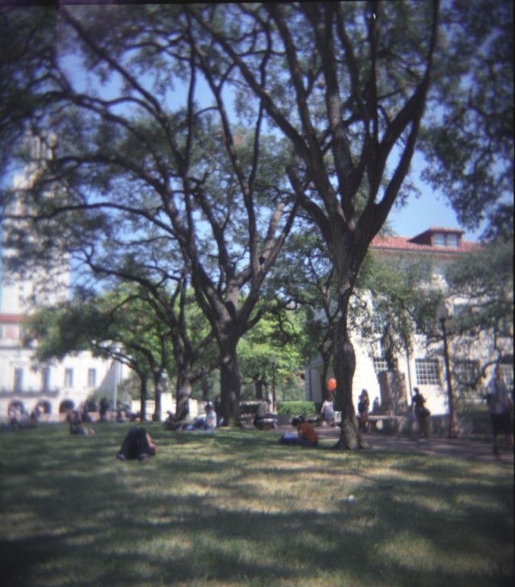
outputReduceWidthMall.png

- seam_carving_decrease_height

outputReduceHeightPrague.png

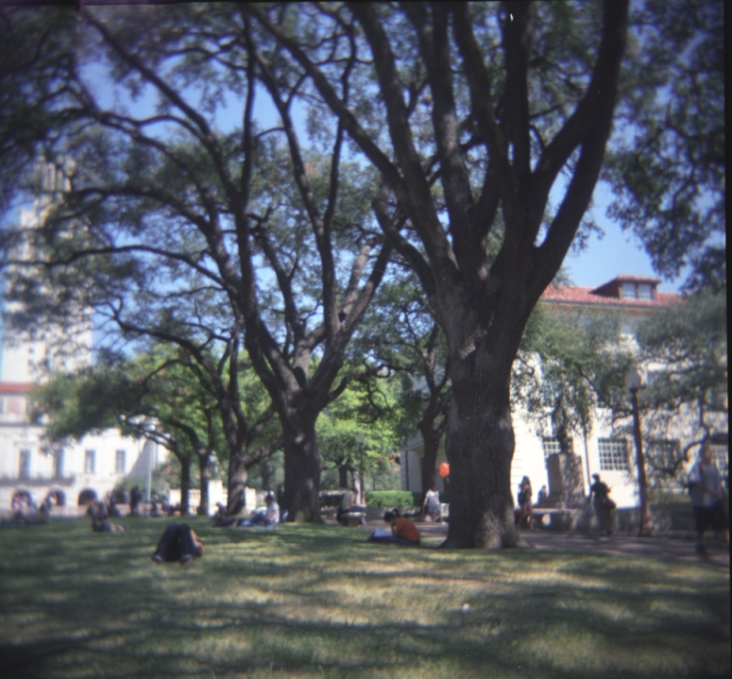
outputReduceHeightMall.png

  - energy function output for inputSeamCarvingPrague.jpg
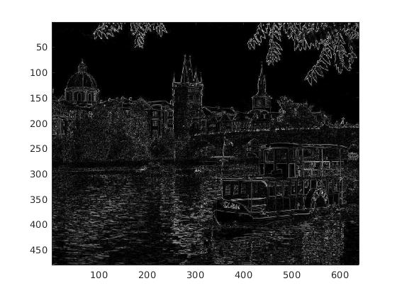
  - Corresponding cumulative minimum energy maps
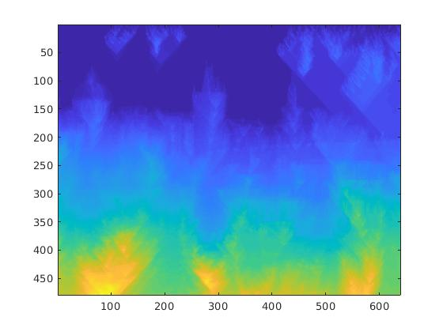
vertical:
horizontal:
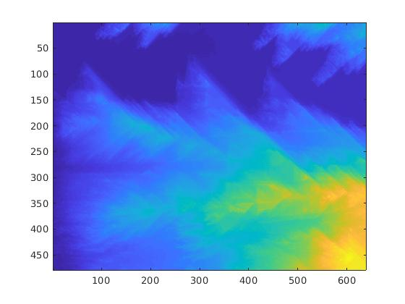

The energy function output highlights places where there is a sudden color change. Since the edges of objects and reflections on the water have high change in color, those parts get a higher value than the places where the pixels are similar.

The vertical cumulative minimum energy map adds the lowest energy value above(j-1, j, j+1) a certain pixel with its own energy value. Since the map is cumulative, the values go up as it goes down, which is represented in a more yellow color here. The parts in the image with the sky has a lower value because there is not much energy around there. The values go up around the structures and the reflection in the water, because there are a lot of edges there, meaning that it is high energy.

The horizontal cumulative minimum energy map does a similar thing, but adds the lowest value to the left(i-1, i, i+1) of a certain pixel with its own energy value. Since the map is cumulative, the values go up towards the right. You can see the values increasing a lot when going through buildings and the boat. There are a lot of edges(high energy), so the cumulative values are higher there.

  - inputSeamCarvingPrague.jpg with horizontal seam
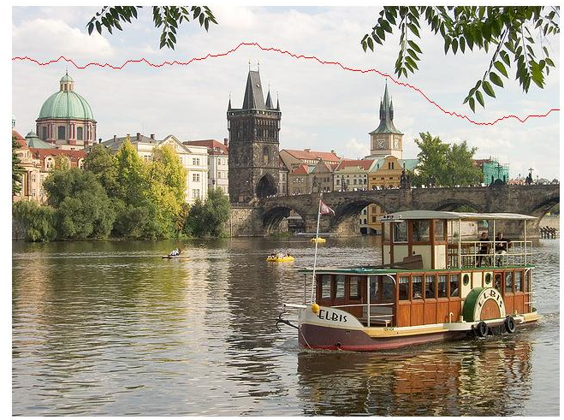
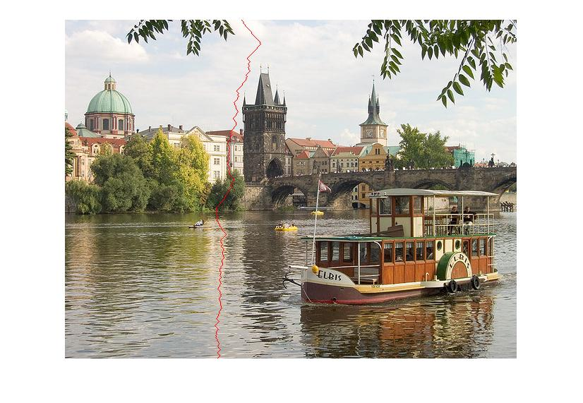
  - inputSeamCarvingPrague.jpg with vertical seam
These are optimal seams because it goes through the pixels with the lowest energy output

  - horizontal seam
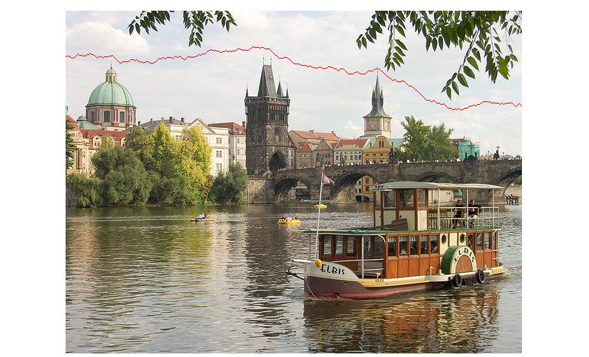
  - vertical seam
Used the Sobel filter instead to compute the energy function. There were slight changes in both the seams, but they generally behaved the same. The impact of using this filter might have been small because the image did not have a lot of noise, and bigger filters are usually used to reduce the impact of noisy images.

a) Dimensions: 1028x1488 → 828x1088

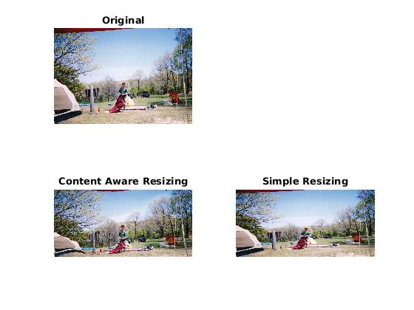
shrunk 200px horizontally and 400px vertically
the sky seems to have been removed mostly

- Dimensions: 1024x1420 → 824x1020
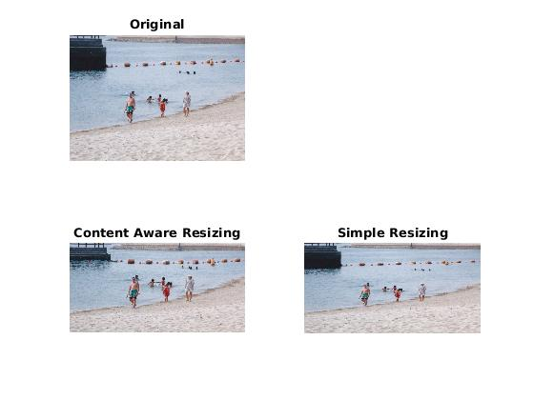
shrunk 200px horizontally and 400px vertically
the beach and sand seem to have been removed and the concrete island as well

- Dimensions: 1776x1124 → 1676x824
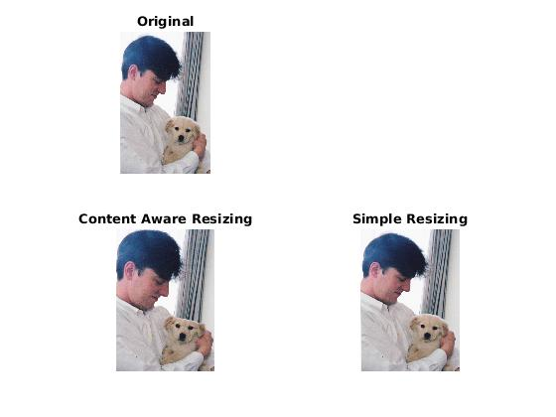
shrunk 100px horizontally and 300px vertically
not successful; the dog’s head was squashed down a bit

source: all images are taken from my family

