Bar Codes
 |  |  |  | Code 39 |  |  |  |  |  |  |  |  |  |  |  |  |  |  |  | Code 39 Extended |  |  |  |  |  |  |  |  |  |  |  |  |  |  |  | DataMatrix
 |  |  |  |  |  |  |  |  |  |  |  |  |  |  |  |  |  |  |  |  |  |  |  |  |  |  |  |  |  |  |  |  |  |  |  |  |  |  | 
 | 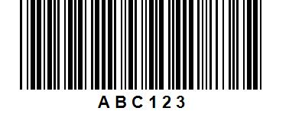 |  |  |  |  |  |  |  |  |  |  |  |  |  |  |  |  | 
 |  |  |  | Code 93 |  |  |  |  |  |  |  |  |  |  | Code 93 Extended |  |  |  |  |  |  |  |  |  |  |  |  | Plessey |  |  |  |  |  |  |  |  |  |  |  |  |  |  |  |  |  | Msi
 | 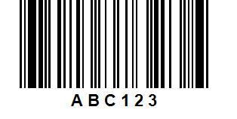 |  |  |  |  |  |  |  |  |  |  |  |  |  |  |  |  |  |  |  |  |  |  |  |  |  | 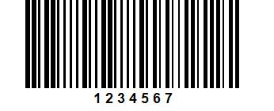 |  |  |  |  |  |  |  |  |  |  |  |  |  |  |  |  | 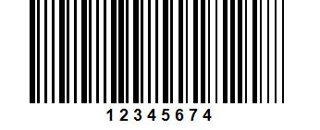
 |  |  |  |  |  |  |  |  |  |  |  |  | 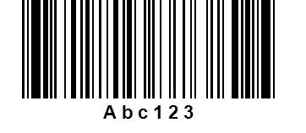
 |  |  |  | EAN-8 |  |  |  |  |  |  | EAN-13 |  |  |  |  |  |  |  |  |  |  | UPC-Sup5
 |  |  |  |  |  |  |  |  |  |  |  |  |  |  |  |  |  |  |  |  |  |  |  |  |  |  |  |  |  |  | UPC-A |  |  |  |  |  |  |  |  |  |  |  |  |  | UPC-E |  |  |  |  | UPC-Sup2
 |  |  |  | 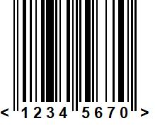 |  |  |  |  | 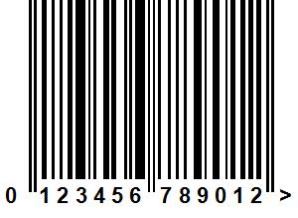 |  |  |  |  |  |  |  |  |  |  |  |  | 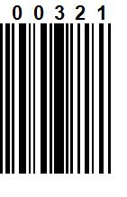 |  |  |  |  |  |  | 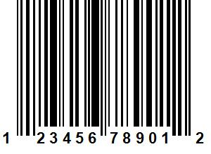 |  |  |  |  |  |  |  |  |  |  |  |  |  |  |  | 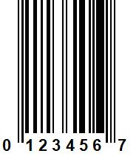 |  |  |  |  |  | 
 |  |  |  |  | Code 128a |  |  |  |  |  |  |  |  |  |  |  |  |  | Code 128b |  |  |  |  |  |  |  |  |  |  |  |  |  |  |  | Code 128c
 |  | 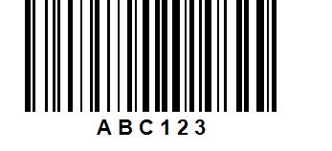 |  |  |  |  |  |  |  |  |  |  |  |  |  |  |  |  |  |  |  |  |  |  |  |  |  |  |  |  |  |  |  | 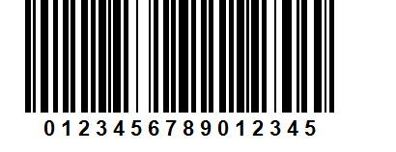
 |  |  |  |  |  |  |  |  |  |  |  |  |  |  |  | 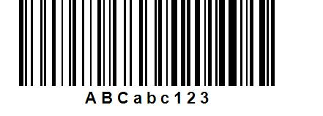
 |  |  |  |  |  |  |  |  |  |  |  |  |  |  |  |  |  |  | EAN-128b
 |  |  |  |  | EAN-128a |  |  |  |  |  |  |  |  |  |  |  |  |  |  |  |  |  |  |  |  |  |  |  |  |  |  |  |  |  | EAN-128c
 |  | 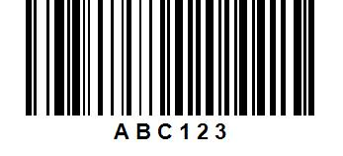 |  |  |  |  |  |  |  |  |  |  |  |  |  | 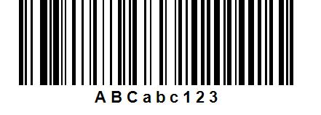 |  |  |  |  |  |  |  |  |  |  |  |  |  |  |  |  |  | 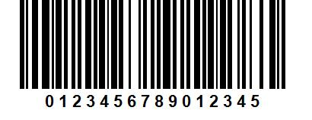
 |  |  |  |  |  | 2 of 5 Standard |  |  |  |  |  |  |  |  |  |  | 2 of 5 Interleaved
 |  |  |  |  |  |  |  |  |  |  |  |  |  |  |  |  |  |  |  |  |  |  |  |  |  |  | Codabar
 |  |  | 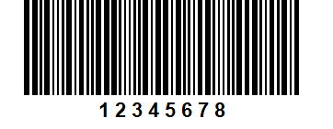 |  |  |  |  |  |  |  |  |  |  |  |  |  | 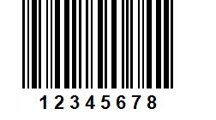 |  |  |  |  |  |  |  |  | 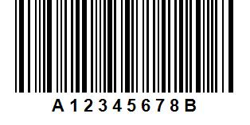
 |  |  |  |  | Postnet
 |  |  | 

