Republic Polytechnic

Graded Assignment

Course: TIPP-AAI

Submitted By: Koay Seng Tian, Date: 06 March 2020

Module Name: Applied AI Solution Development – Computer Vision

1. **Question 1**
   1. Question_1\question_1_cv_colab.ipynb is to be executed in google’s colab. Each epoch takes about 7-9 seconds to run in colab with GPU. 75 epochs are run for this task.
   2. The directory structure is documented in the .ipynb files.
   3. ‘cv_imgToClass.ipynb’ is a jupyter notebook file for moving the respective bird image to their respective directory. The directory names are then used as label for the classification problem.
   4. The dataset created in (c) can be found under ‘clean_dataset’ directory. This directory contains the bird images for training.
   5. Two files were generated when executing question_1_cv_colab.ipynb. Both files can be found under ‘model’ directory. The files are 1) bird_cv_labels.pkl and 2) bird_cv_model.h5. These two will be needed for the prediction in question 2.
2. **Question 2**
   1. There are two files under ‘Question_2’ directory. Both files performed the same function except bird_predict.py runs in a terminal and question_2_cv_colab.ipynb runs in google colab environment.
   2. An example to run bird_predict.py is like this.

Python bird_predict.py -t test_bird \

-m ..\model\bird_cv_model.h5 \

-e ..\model\bird_cv_labels.pkl

* 1. In the test_bird directory, an extra jpeg file (3_Grey_heron_removebg.jpg) was added to the test. It was discovered that by removing the wavy (water) background, the model can easily identify the bird image as a ‘Grey Heron’. This would suggest that some form of background removal pre-processing is needed to increase the model accuracy.

1. **Directory Structures**
   1. Google Colab

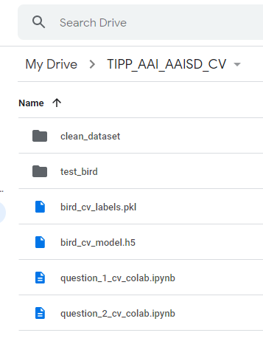

* 1. Local

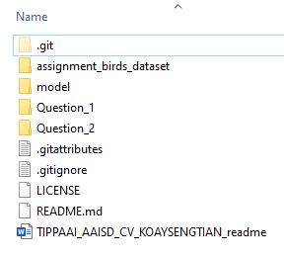

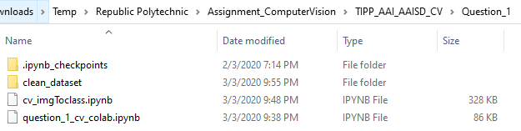

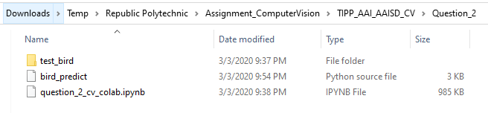

1. **Learnings**

* Images class imbalances: To further improve the accuracy, needs to collect/source more images of different bird species to balance out so that one class of birds will not overpower another bird class.
* Some species of birds have similar shape pattern but different in colours. It seems that the bird colour has little effect to the bird species recognition model. Need to explore other pre-processing techniques (future improvement) or other machine learning computer vision processing techniques to learn about the colour of the bird before feeding it to a classifier.
* For some species of bird, the male and female birds have different colors but the shape is the same.
* Also, would like to explore (future improvement) whether an object (bird) recognition will help to further improve the classification since some bird images have ‘complicated’ or ‘noisy’ background. After a bird object is detected, the bird image is extracted and feed into the classifier algorithm. For example, the ‘White Throated Kingfishes’ had a raining background. But the test images had bokeh effect background.