Title Goes Here

Myfirstname Mylastname1,✉, and Yourfirstname Yourlastname2

11 9月, 2019

Text of abstract

1 University of One Place  
2 University of Another Place

✉ Correspondence: [Myfirstname Mylastname <[fl@oneplace.edu](mailto:fl@oneplace.edu)>](mailto:fl@oneplace.edu)

このセンテンスはRコードを入れられる。「10」。ここには5＋5が入っています。

長い式も入れられる。100*3が入っています。

#> [1] 300

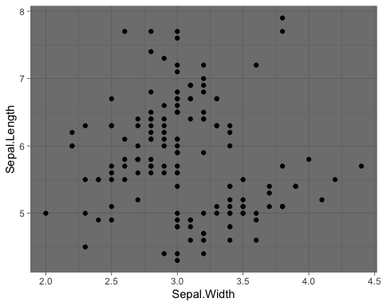

Figure 1: アイリスの表

この図はFigure 1。自動で図表番号が入ります。

6行のみ読み込み。

Table 1: アイリスの表

|  |  |  |  |  |
| --- | --- | --- | --- | --- |
| Sepal.Length | Sepal.Width | Petal.Length | Petal.Width | Species |
| 5.1 | 3.5 | 1.4 | 0.2 | setosa |
| 4.9 | 3.0 | 1.4 | 0.2 | setosa |
| 4.7 | 3.2 | 1.3 | 0.2 | setosa |
| 4.6 | 3.1 | 1.5 | 0.2 | setosa |
| 5.0 | 3.6 | 1.4 | 0.2 | setosa |
| 5.4 | 3.9 | 1.7 | 0.4 | setosa |

この表はTable　1。やはり自動で番号が入ります。

# Introduction

Here is a citation (Marwick, 2017)

# Background

# Methods

# Results

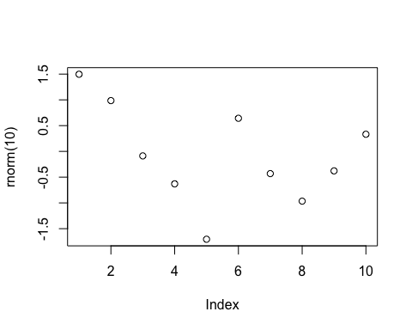

Figure 2: A plot of random numbers

Figure 2 shows how we can have a caption and cross-reference for a plot

Here is an example of inline code 3.14 in the middle of a sentence.

# Discussion

# Conclusion

# Acknowledgements

# References

Marwick, B., 2017. Computational reproducibility in archaeological research: Basic principles and a case study of their implementation. Journal of Archaeological Method and Theory 24, 424–450. <https://doi.org/10.1007/s10816-015-9272-9>

### Colophon

This report was generated on 2019-09-11 15:22:04 using the following computational environment and dependencies:

#> ─ Session info ──────────────────────────────────────────────────────────  
#> setting value   
#> version R version 3.6.1 (2019-07-05)  
#> os macOS Mojave 10.14.6   
#> system x86_64, darwin15.6.0   
#> ui X11   
#> language (EN)   
#> collate ja_JP.UTF-8   
#> ctype ja_JP.UTF-8   
#> tz Asia/Tokyo   
#> date 2019-09-11   
#>   
#> ─ Packages ──────────────────────────────────────────────────────────────  
#> package * version date lib source   
#> assertthat 0.2.1 2019-03-21 [1] CRAN (R 3.6.0)  
#> backports 1.1.4 2019-04-10 [1] CRAN (R 3.6.0)  
#> bookdown 0.13 2019-08-21 [1] CRAN (R 3.6.0)  
#> callr 3.3.1 2019-07-18 [1] CRAN (R 3.6.0)  
#> cli 1.1.0 2019-03-19 [1] CRAN (R 3.6.0)  
#> colorspace 1.4-1 2019-03-18 [1] CRAN (R 3.6.0)  
#> crayon 1.3.4 2017-09-16 [1] CRAN (R 3.6.0)  
#> desc 1.2.0 2018-05-01 [1] CRAN (R 3.6.0)  
#> devtools 2.2.0 2019-09-07 [1] CRAN (R 3.6.0)  
#> digest 0.6.20 2019-07-04 [1] CRAN (R 3.6.0)  
#> DT 0.8 2019-08-07 [1] CRAN (R 3.6.0)  
#> ellipsis 0.2.0.1 2019-07-02 [1] CRAN (R 3.6.0)  
#> evaluate 0.14 2019-05-28 [1] CRAN (R 3.6.0)  
#> fs 1.3.1 2019-05-06 [1] CRAN (R 3.6.0)  
#> ggplot2 * 3.2.1 2019-08-10 [1] CRAN (R 3.6.0)  
#> glue 1.3.1 2019-03-12 [1] CRAN (R 3.6.0)  
#> gtable 0.3.0 2019-03-25 [1] CRAN (R 3.6.0)  
#> highr 0.8 2019-03-20 [1] CRAN (R 3.6.0)  
#> htmltools 0.3.6 2017-04-28 [1] CRAN (R 3.6.0)  
#> htmlwidgets 1.3 2018-09-30 [1] CRAN (R 3.6.0)  
#> knitr 1.24 2019-08-08 [1] CRAN (R 3.6.0)  
#> labeling 0.3 2014-08-23 [1] CRAN (R 3.6.0)  
#> lazyeval 0.2.2 2019-03-15 [1] CRAN (R 3.6.0)  
#> magrittr 1.5 2014-11-22 [1] CRAN (R 3.6.0)  
#> memoise 1.1.0 2017-04-21 [1] CRAN (R 3.6.0)  
#> munsell 0.5.0 2018-06-12 [1] CRAN (R 3.6.0)  
#> pillar 1.4.2 2019-06-29 [1] CRAN (R 3.6.0)  
#> pkgbuild 1.0.5 2019-08-26 [1] CRAN (R 3.6.0)  
#> pkgconfig 2.0.2 2018-08-16 [1] CRAN (R 3.6.0)  
#> pkgload 1.0.2 2018-10-29 [1] CRAN (R 3.6.0)  
#> prettyunits 1.0.2 2015-07-13 [1] CRAN (R 3.6.0)  
#> processx 3.4.1 2019-07-18 [1] CRAN (R 3.6.0)  
#> ps 1.3.0 2018-12-21 [1] CRAN (R 3.6.0)  
#> R6 2.4.0 2019-02-14 [1] CRAN (R 3.6.0)  
#> Rcpp 1.0.2 2019-07-25 [1] CRAN (R 3.6.0)  
#> remotes 2.1.0 2019-06-24 [1] CRAN (R 3.6.0)  
#> rlang 0.4.0 2019-06-25 [1] CRAN (R 3.6.0)  
#> rmarkdown 1.15 2019-08-21 [1] CRAN (R 3.6.0)  
#> rprojroot 1.3-2 2018-01-03 [1] CRAN (R 3.6.0)  
#> scales 1.0.0 2018-08-09 [1] CRAN (R 3.6.0)  
#> sessioninfo 1.1.1 2018-11-05 [1] CRAN (R 3.6.0)  
#> stringi 1.4.3 2019-03-12 [1] CRAN (R 3.6.0)  
#> stringr 1.4.0 2019-02-10 [1] CRAN (R 3.6.0)  
#> testthat 2.2.1 2019-07-25 [1] CRAN (R 3.6.0)  
#> tibble 2.1.3 2019-06-06 [1] CRAN (R 3.6.0)  
#> usethis 1.5.1 2019-07-04 [1] CRAN (R 3.6.0)  
#> withr 2.1.2 2018-03-15 [1] CRAN (R 3.6.0)  
#> xfun 0.9 2019-08-21 [1] CRAN (R 3.6.0)  
#> yaml 2.2.0 2018-07-25 [1] CRAN (R 3.6.0)  
#>   
#> [1] /Library/Frameworks/R.framework/Versions/3.6/Resources/library

The current Git commit details are:

#> Local: master /Users/kobayashitoku/yayoitown  
#> Remote: master @ origin (https://github.com/kobayashi-toku/yayoitown.git)  
#> Head: [0dbec81] 2019-09-11: add readme