PRI-Audit: matched baselines and grouped validation for interpreting representation gains in psoriasis transcriptomics
Kaiwen Deng, Liwei Liu*
School of Railway Intelligent Engineering, Dalian Jiaotong University, Dalian, 116028, China
*Corresponding author: Liwei Liu
Email: liutree80@163.com

Abstract
Background: High-resolution transcriptomic representations can encode cellular composition and tissue organisation. Their apparent disease-state performance, however, depends on the expression reference and the biological unit used for validation.
Methods: The Paired Representation Incremental-value Audit (PRI-Audit) compares each candidate with a matched expression baseline on identical held-out source samples, donors, or patients; all adaptive steps use training groups only. We evaluated three primary psoriasis cohorts, two prespecified boundary cohorts, and a recovered-coordinate spatial-graph check in an independent Visium cohort. A positive declaration required an area under the receiver operating characteristic curve (AUROC) gain (ΔAUROC) of at least 0.05, a positive lower 95% confidence bound, fold-local fitting, and each applicable source diagnostic. A nested group-resampling sensitivity analysis re-fitted the full PCA/NMF pipeline for the key primary comparisons.
Results: Expression, principal component analysis (PCA), and non-negative matrix factorisation (NMF) each achieved AUROC 1.000 in GSE151177 and GSE173706. In GSE206391, PCA gained +0.002 AUROC over matched expression (conditional grouped-bootstrap 95% interval, −0.024 to +0.038); the full-refit group-resampling interval was −0.031 to +0.049. NMF remained negative under both analyses. With the PCA candidate held fixed, changing only the expression reference from 2,000 to 50 highly variable genes changed the apparent gain from +0.002 to +0.111; full refitting at the weak-reference endpoint still gave an interval that included zero. Recovered GSE202011 array coordinates matched all 3,563 quality-controlled spots. In that independent five-patient Visium cohort, expression and both graph branches were score-saturated at AUROC 1.000, and coordinate shuffling did not lower the observed graph score.
Conclusions: Matched baselines and grouped validation materially change how representation gains should be interpreted. No tested implementation showed a reliable gain over its matched expression reference for the disease-state tasks studied.
Keywords: psoriasis; single-cell RNA sequencing; spatial transcriptomics; matched baseline; grouped validation; incremental value

1. Introduction
Transcriptomic classifiers are usually judged by how accurately they distinguish disease states in held-out samples. In psoriasis, lesional expression reflects keratinocyte activation, cytokine signalling, immune recruitment, and tissue remodelling [1–3]. A high disease-state score therefore shows that a model detects disease-associated expression. It does not, by itself, show that resolving cells or retaining tissue location improves prediction beyond a comparable expression representation.
That gap defines the task here. For a held-out biopsy, does a cell-level, low-rank, or spatial representation rank disease state more accurately than an expression model evaluated on the same biological units? This is an incremental comparison: candidate and reference must share held-out samples, folds, and a comparable feature budget. It differs from asking whether single-cell or spatial data describe cell identity, tissue organisation, or disease biology [4–6]. A representation may reveal biological structure without adding disease-state discrimination in this task.
These requirements motivate the Paired Representation Incremental-value Audit (PRI-Audit), a paired grouped-validation protocol for interpreting a candidate representation's gain beyond matched expression.
We applied PRI-Audit to three public psoriasis cohorts. GSE151177 includes emigrating-cell profiles from psoriasis and control biopsies; source samples are the defensible independent units because deposited records lack validated patient identifiers [4]. GSE173706 contains paired lesional and non-lesional single-cell profiles from 11 donors [5]. GSE206391 contains paired lesional and non-lesional spatial samples from 12 patients [6]. GSE47751 provides a bulk expression/PCA boundary comparison [7]. GSE202011 contributes five independent biologic-naïve psoriasis pairs profiled by Visium [8]. We recovered each retained GSE202011 spot's array coordinate from its public barcode and used it for an independent graph check. PCA, NMF, spatial-graph, and spot-topic branches are evaluated as specified implementations for these tasks; they are not claims about every high-resolution representation.

2. Materials and methods

2.1. Prediction target and evidence rule
PRI-Audit evaluates prediction of a cohort-specific psoriasis state for held-out biological units, not classification of individual cells or spots. The primary contrast is psoriasis versus healthy control in GSE151177 and lesional versus non-lesional skin in GSE173706 and GSE206391. The two boundary cohorts also compare lesional and non-lesional profiles, with GSE47751 restricted to baseline pairs. Source samples, donors, or patients define the outer holdout groups. Figure 1 summarises the cohort structure and outer holdout units. Candidate and expression-reference predictions are paired on identical test observations (Figure 2), and discrimination is summarised by the area under the receiver operating characteristic curve (AUROC).
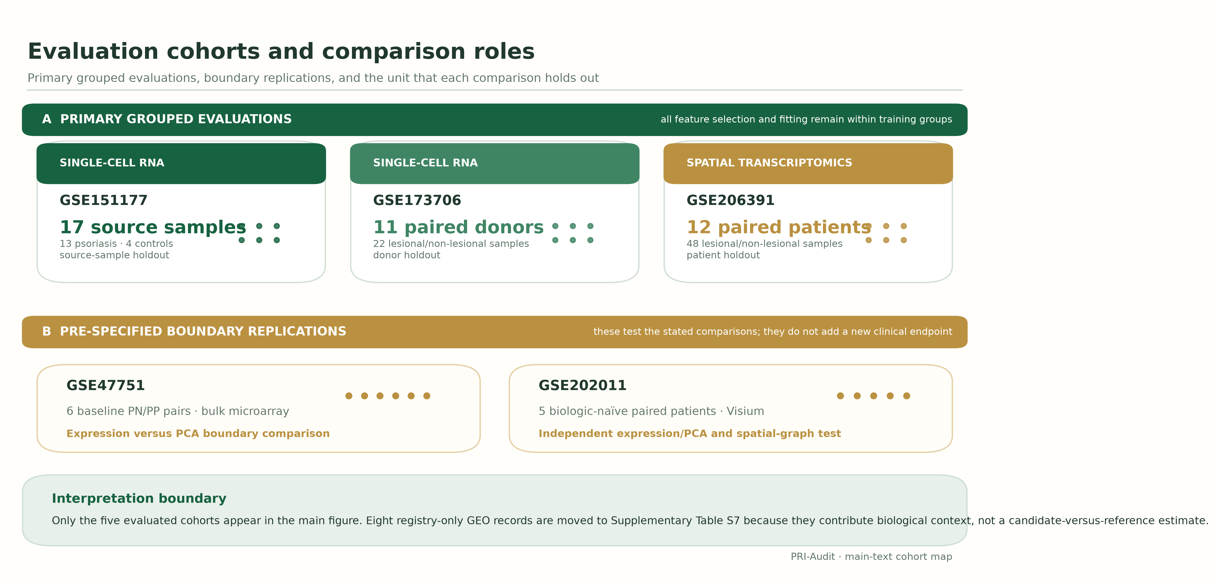
Figure 1. Evaluation cohorts and comparison roles. (A) Three primary grouped evaluations with their outer holdout units. (B) Two prespecified boundary replications. GSE202011 uses independent Visium pairs with array coordinates recovered by barcode matching. Eight registry-only GEO records are moved to Supplementary Table S7 because they provide biological context but no candidate-versus-reference estimate.
Each outer fold holds out one biological group g. We fit representation family m on the remaining groups, then apply it to measurements from held-out sample i: ${\text{X}}_{\text{i}}$
$\begin{aligned}{\text{r}}_{\text{i},\text{m}}^{(−\text{g})}={\text{T}}_{\text{m}}({\text{X}}_{\text{i}};{\hat{\text{θ}}}_{\text{m}}^{(−\text{g})}) \\ {\hat{\text{θ}}}_{\text{m}}^{(−\text{g})}=\text{Fit}(\{{\text{X}}_{\text{j}}:\text{group}(\text{j})≠\text{g}\})\end{aligned}$ (1)
Within each fold, θ contains training-derived gene selection, scaling, factorisation, and graph summaries. We fit the classifier on the same training data. Candidate and reference models then predict the same held-out samples. For cohort d, their AUROC difference is defined as:
${\text{Δ}}_{\text{m}}^{(\text{d})}=\text{AUROC}({\text{y}}^{(\text{d})},{\hat{\text{p}}}_{\text{candidate},\text{m}}^{(\text{d})})−\text{AUROC}({\text{y}}^{(\text{d})},{\hat{\text{p}}}_{\text{expression},\text{m}}^{(\text{d})})$ (2)
The v21 specification set ΔAUROC ≥ 0.05 as an operational threshold for practical gain before formal evaluation. It is not a clinically validated minimum important difference. Let Lm,0.95 denote the lower bound of the paired grouped-bootstrap 95% confidence interval (CI) for ΔAUROC. Fm equals 1 only when every adaptive preprocessing, representation, and classifier step is fitted using training groups. Sm records an applicable representation-specific source diagnostic: 1 denotes a passing result and 0 a result that does not pass. Sm = not applicable (NA) only when no source diagnostic applies. In that case, Sm is neutral in the pre-specified criteria and does not indicate a passing diagnostic. The complete evidence criteria are:
$\begin{aligned}G_{m} = 1[Δ_{m} ≥ 0.05] × 1[L_{m,0.95} > 0] \\ × 1[F_{m} = 1] × 1[S_{m} = 1 or S_{m} = NA]\end{aligned}$ (3)
Algorithm 1. PRI-Audit decision rule. Before evaluating outcomes, specify the independent unit, candidate, matched reference, gain threshold, and any applicable source diagnostic with its pass criterion. Fit adaptive transformations and classifiers using training groups, then generate paired predictions for identical held-out observations. Estimate ΔAUROC and its uncertainty by resampling independent units. Report diagnostic failures and non-applicability explicitly. A positive declaration requires the numerical thresholds, fold-local fitting, and a passing diagnostic whenever one applies. S = NA is neutral only when no diagnostic applies.

2.2. Cohort roles and reconstruction of public inputs
Five Gene Expression Omnibus (GEO) datasets have direct analytical roles in the main text (Table 1). GSE151177 [4] contributed 18 emigrating-cell profiles before quality control; sample-level screening retained 17 source samples for leave-one-source-sample-out evaluation. GSE173706 [5] contributed 22 paired lesional (PP) and non-lesional (PN) samples from 11 donors, evaluated by leave-one-donor-out splits. GSE206391 [6] contributed 48 paired lesional (LS) and non-lesional (NL) samples from 12 patients, evaluated by leave-one-patient-out splits. GSE47751 [7] and GSE202011 [8] are prespecified boundary cohorts. Eight registry-only records are moved to Supplementary Table S7 because they supply biological context but no candidate-versus-reference estimate.

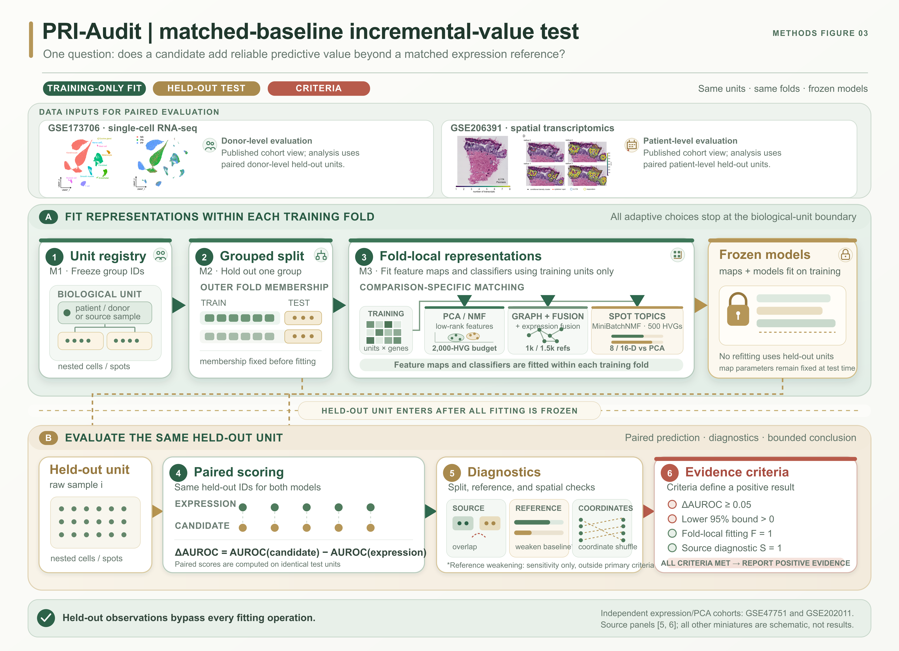
Figure 2. Data inputs for paired grouped evaluation. (A) Published cell-type, condition, tissue-expression, and spatial-neighbourhood views illustrate the two data modalities used in the paired analyses [5,6]; they are contextual source views, not analysis results. NS, healthy skin; PN, non-lesional psoriasis skin; PP, lesional psoriasis skin. Source panels are adapted under the Creative Commons Attribution 4.0 International (CC BY 4.0) licence; spatial labels were re-typeset. (B) Count matrices, sample identifiers, and, for GSE206391, coordinates enter fold-local fitting; the candidate and its matched expression reference then score the same held-out biological units.

We reconstructed the three primary inputs from public raw data. For single-cell profiles and spatial spots, we excluded cells or spots with fewer than 500 total counts, fewer than 300 detected genes, or a mitochondrial fraction above 0.20. We identified mitochondrial genes from the gene-symbol field. For GSE206391, we also required spots to be marked in tissue. GSE151177 used the registered sample-level screen; Control05, with a median of 160 detected genes, failed the 300-gene threshold and was excluded from the primary analysis. We aggregated retained counts by sample, normalised each sample to counts per million (CPM), and applied log1p transformation. The reproducibility manifest records raw-source hashes, input paths, software versions, random seeds, output hashes, and figure and table sources.
The primary GSE151177 analysis included 17 source samples and 23,528 retained cells. GSE173706 contributed 22 samples from 11 donors, and GSE206391 contributed 48 samples from 12 patients. The GSE151177 roster audit lists all 23 deposited records and their sample-level dispositions (Supplementary Table S6). The GSE173706 and GSE206391 reconstructions matched their archived analysis inputs. For GSE173706, reconstruction corrected a missing mitochondrial-gene identifier in the Ensembl annotation; the provenance manifest records this correction.
The two boundary cohorts answer narrower questions. GSE47751 provided six baseline PN/PP pairs measured by bulk microarray for an expression/PCA comparison [7]. An outcome-blind candidate audit selected GSE202011 before its expression matrix was inspected. This Visium archive contains paired lesional and non-lesional sections from five biologic-naïve psoriasis patients [8]. The matrix archive retains each spot barcode. We joined all quality-controlled barcodes to the 4,992-position Space Ranger Visium V1 array reference, yielding coordinates for 3,563 retained spots. This supports an independent array-coordinate graph check but does not recover histology-image registration.

Table 1. Public datasets with direct roles in the main analysis.
Cohort | Modality | Main-text role | Held-out unit | Analysed subset
GSE151177 [4] | Single-cell RNA-seq | Primary benchmark | Source sample | 17 retained samples (13 psoriasis, 4 controls)
GSE173706 [5] | Single-cell RNA-seq | Primary paired benchmark | Donor | 22 samples from 11 paired donors
GSE206391 [6] | Spatial transcriptomics | Primary spatial benchmark | Patient | 48 LS/NL samples from 12 paired patients
GSE47751 [7] | Bulk microarray | Expression/PCA boundary | Patient pair | 6 baseline PN/PP pairs
GSE202011 [8] | Visium spatial | Independent graph boundary | Patient | 10 sections from 5 paired patients; 3,563 QC spots
Archived counts are GEO sample records, not verified independent-patient counts. Analysed subsets are given in the final column. LS/NL, lesional/non-lesional; RNA-seq, RNA sequencing.

2.3. Expression references and candidate representations
Within each outer fold, we selected the 2,000 genes with the highest training-set variance as highly variable genes (HVGs). Their log1p counts-per-million values formed the expression reference. PCA and NMF re-encoded the same HVGs and used the same eligible samples, outer folds, and class-balanced logistic-regression learner (C = 1; liblinear solver). PCA used training-fitted scaling. NMF used non-negative log1p CPM values, nonnegative double singular value decomposition initialisation with zeros filled by the training-matrix mean (NNDSVDa), and a fixed seed. Each low-rank representation used up to eight components, subject to the training sample count. These settings define the PCA and NMF implementations evaluated here; the results are not statements about all low-rank methods.
For GSE206391 and the independent GSE202011 check, the spatial graph summarised local expression agreement and contrast across six-nearest-neighbour sets defined from spot-array coordinates (Figure 3). The graph-only representation contained two summaries for each of 500 training-fold HVGs and was compared with 500-HVG expression. The combined representation contained 500 expression and 1,000 spatial features; its reference used 1,500 HVGs. These settings test the specified graph construction, not spatial transcriptomics in general.
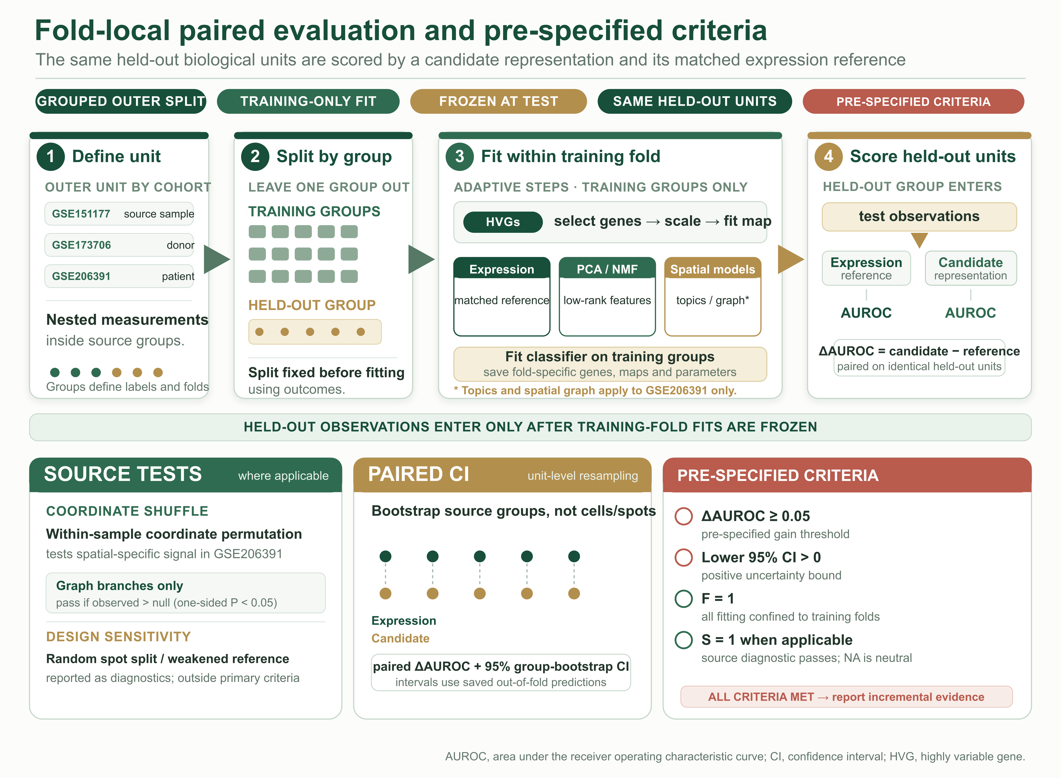
Figure 3. Fold-local paired evaluation and pre-specified evidence criteria. The schematic shows the shared split and fitting boundary: adaptive steps use training groups, while the candidate and matched expression reference score the same held-out units. The four criteria define when a positive incremental result may be reported. Spot-topic and spatial-graph branches apply only to GSE206391. Random spot splits and weakened-reference comparisons are sensitivity diagnostics outside the primary criteria.
For gene h in sample i, the graph summarises local agreement ${\text{I}}_{\text{ih}}$ and contrast ${\text{C}}_{\text{ih}}$ across the spatial neighbourhood N(u) of spot u. Here ${\text{n}}_{\text{i}}$ is the number of retained spots, ${\text{x}}_{\text{iuh}}$ is gene expression at a spot, and ${\text{z}}_{\text{iuh}}$ is expression centred within sample i. Bars indicate neighbourhood or sample means; ε stabilises the denominator. The summaries are:
$\begin{aligned}{\text{I}}_{\text{ih}}=\frac{{\text{n}}_{\text{i}}^{−1}∑_{\text{u}}{\text{z}}_{\text{iuh}}{\overline{\text{z}}}_{\text{i},\text{N}(\text{u}),\text{h}}}{{\text{n}}_{\text{i}}^{−1}∑_{\text{u}}{\text{z}}_{\text{iuh}}^{2}+\text{ε}} \\ {\text{z}}_{\text{iuh}}={\text{x}}_{\text{iuh}}−{\overline{\text{x}}}_{\text{ih}}\end{aligned}$ (4)
${\text{C}}_{\text{ih}}={\text{n}}_{\text{i}}^{−1}∑_{\text{u}}|{\text{x}}_{\text{iuh}}−{\overline{\text{x}}}_{\text{i},\text{N}(\text{u}),\text{h}}|$ (5)

2.4. Simulated validation of paired-gain criteria and spot-topic comparisons
We used a hierarchical simulation to validate the statistical components of the paired-gain criteria under controlled information sources. Each dataset contained 12, 24, or 48 paired patients, with two samples per patient and 40 nested measurements per sample. The generator varied disease-associated aggregate expression, a coordinate-associated effect with zero pseudobulk mean, and a sample fingerprint. Four scenarios tested no spatial increment, a coordinate-specific increment, source overlap without disease signal, and a weakened expression reference. We evaluated a fixed L2 logistic learner using leave-one-patient-out prediction. The statistical components required ΔAUROC ≥ 0.05 and a positive lower patient-bootstrap 95% bound. Each condition used 400 repeats and 250 bootstrap draws per repeat, with seed 20260824. Supplementary Table S1 reports the settings and outcomes. The simulation did not apply or calibrate representation-specific source diagnostics, so its results verify the statistical components rather than the complete reporting criteria or a biological effect.
In a separate GSE206391 spot-topic branch, we compared a conventional high-resolution composition implementation with dimension-matched expression PCA. Within each held-out-patient fold, we selected 500 pseudobulk HVGs and scaled them using training patients. We fitted eight-component and 16-component PCA models. We then fitted an eight-topic mini-batch non-negative matrix factorisation (MiniBatchNMF; NNDSVDa initialisation, maximum 600 iterations) to up to 300 spots per training sample. We transformed held-out spots and averaged topic activations within each sample. The eight-topic model was compared with eight-component PCA; expression-plus-topic fusion was compared with 16-component PCA. The primary analysis used 300 spots per sample. Sensitivity analyses used 150 and 450 spots (Supplementary Table S2). These results are limited to this topic construction, sampling rule, and disease-state task.

2.5. Source diagnostics and uncertainty
We evaluated two diagnostics of design sensitivity. For the GSE206391 random-spot splits, we selected features and fitted PCA across all measurements before splitting rows. Spots from the same source sample could therefore enter both partitions. This estimates interpolation within observed sources, not transfer to a new patient. We also weakened the GSE206391 expression reference from 2,000 to 16 HVGs while holding candidate predictions fixed. This mismatched-reference comparison remained outside the primary evidence rule.
For the spatial source test, we shuffled coordinates within each sample while keeping counts, labels, outer folds, and fold-specific HVGs fixed. The null distribution tests whether the observed coordinate assignment adds predictive information to the specified graph. Label permutations respected biological groups, with paired labels swapped within each group. The reported main-table intervals resample groups from saved out-of-fold predictions; models are not refitted in those draws and therefore condition on the fitted prediction set. To assess the impact of that condition, we added a nested sensitivity analysis for the GSE206391 PCA and NMF comparisons. Each of 400 draws resampled paired held-out patients and re-fitted HVG selection, scaling, representation, and classifier stages using resampled remaining patients. For B permutations, the finite-permutation tail probability is:
$\text{P}=\frac{1+\#\{{\text{T}}^{\text{b}}≥{\text{T}}_{\text{obs}}\}}{\text{B}+1}$ (6)
For the complete evidence criteria, the coordinate-shuffle diagnostic applied to the graph-only and expression-plus-graph branches in both spatial cohorts. A one-sided tail probability below 0.05 in the observed-greater-than-null direction was required to pass. Low-rank, spot-topic, and bulk PCA comparisons had no applicable candidate-specific source test and are recorded as Sm = NA. In these cases, S is neutral, but the numerical gain and lower-bound criteria still apply. Supplementary Table S5 reports this distinction.

2.6. Boundary-cohort checks, learner sensitivity, and reproducibility
We evaluated GSE47751 on six baseline PN/PP pairs using leave-one-pair-out splits. GSE202011 supplied five biologic-naïve patient pairs. For ST14, the prespecified rule retained the first lesion section (R1) and excluded its replicate. We filtered the processed 10x matrices using the stated count, detected-gene, and mitochondrial criteria. Spot barcodes were joined to the public Space Ranger Visium V1 barcode-to-array-coordinate reference before the graph analysis. Expression, PCA, graph, and combined graph branches were evaluated by leave-one-patient-out splits; all feature selection, scaling, representation fitting, and classifier fitting used training patients only. The resulting analysis is an independent spatial-graph boundary replication, although score saturation limits the increment it can resolve.
The reproducibility workflow links raw-data reconstruction, primary comparisons, diagnostics, boundary-cohort analyses, and figure and table generation. The v1.33 release records hashes for the GSE202011 H5 matrices and the Visium barcode-coordinate reference, a 100% barcode-join check, independent graph predictions, coordinate-shuffle distributions, full-refit group-resampling draws, and fixed-candidate reference-sensitivity outputs. The public package also retains the corrected GSE151177 script, input verifier, derived outputs, and reproducibility manifest.
After freezing the primary comparisons, we assessed learner sensitivity on the same outer groups using three learners: class-balanced logistic regression (C = 1), ridge classification (alpha = 1), and a linear support vector machine (SVM; C = 1). Scaling was fitted within training groups. We did not select a learner or representation from these results. Each candidate was compared with the expression reference fitted by the same learner. The original learner-sensitivity intervals use saved out-of-fold scores and are conditional on fitted predictions; the full-refit sensitivity is reported separately for the core GSE206391 PCA/NMF comparisons. A distinct exploratory comparator-sensitivity analysis fixed each PCA-8 or NMF-8 candidate at 2,000 training-fold HVGs while refitting only the expression reference at 16–2,000 HVGs. Patient-level intervals were then recomputed; the analysis diagnoses comparator dependence and does not select a new primary reference.

3. Results

3.1. Three primary cohorts and two boundary comparisons
The three primary prediction cohorts contributed 17 source samples, 11 paired donors, and 12 paired patients. GSE47751 provided a six-pair bulk boundary comparison. GSE202011 provided five independent Visium patient pairs and 3,563 quality-controlled spots with reconstructed array coordinates (Figure 1; Table 2). Registry-only context datasets are listed separately in Supplementary Table S7.

3.2. Matched comparisons show no gain above the prespecified threshold
Across the primary cohorts, expression AUROC was 1.000 in GSE151177 and GSE173706 and 0.908 in GSE206391. No tested PCA or NMF implementation reached +0.05 in any primary cohort (Table 2; Figure 4A). In GSE151177, expression, PCA, and NMF each scored 1.000, with ΔAUROC = 0.000 for both candidates. All three also scored 1.000 in GSE173706. In GSE206391, the PCA increment was +0.002 and the NMF increment was −0.036. The original saved-prediction bootstrap lower bounds did not exceed zero. Full-pipeline grouped resampling gave a PCA median increment of +0.003 (95% interval, −0.031 to +0.049) and an NMF median increment of −0.030 (−0.090 to +0.017), so refitting all learned stages did not change the interpretation.
Expression and PCA both scored AUROC 1.000 in the six GSE47751 baseline pairs (ΔAUROC = 0.000; Table 2). This saturated bulk comparison provides a boundary check, not evidence that PCA improves on expression.
In GSE206391, the specified spatial-graph increment was −0.021 (95% CI, −0.087 to +0.038), and the expression-plus-spatial increment was −0.026 (95% CI, −0.073 to +0.014; Table 2). Neither coordinate-shuffle diagnostic distinguished the observed graph scores from its within-sample null distribution (Section 3.5). These estimates concern the declared graph summaries and disease-state task.

Table 2. Candidate AUROCs and paired gains over matched references.
Cohort / unit / role | Candidate (AUROC) | Matched reference (AUROC) | ΔAUROC (95% CI)
Primary — GSE151177 (17 source samples) | PCA (1.000) | Expression (2,000 HVGs): 1.000 | +0.000 (0.000, 0.000)
Primary — GSE151177 (17 source samples) | NMF (1.000) | Expression (2,000 HVGs): 1.000 | +0.000 (0.000, 0.000)
Primary — GSE173706 (11 donors) | PCA (1.000) | Expression (2,000 HVGs): 1.000 | +0.000 (0.000, 0.000)
Primary — GSE173706 (11 donors) | NMF (1.000) | Expression (2,000 HVGs): 1.000 | +0.000 (0.000, 0.000)
Primary — GSE206391 (12 patients) | PCA (0.910) | Expression (2,000 HVGs): 0.908 | +0.002 (−0.024, +0.038)
Primary — GSE206391 (12 patients) | NMF (0.872) | Expression (2,000 HVGs): 0.908 | −0.036 (−0.099, +0.003)
Bulk boundary — GSE47751 (6 pairs) | PCA (1.000) | Expression (2,000 HVGs): 1.000 | +0.000 (+0.000, +0.000)
Independent Visium — GSE202011 (5 patients) | PCA (1.000) | Expression (2,000 HVGs): 1.000 | +0.000 (+0.000, +0.000)
Independent graph — GSE202011 (5 patients) | Spatial graph, 1,000 (1.000) | Expression (500 HVGs): 1.000 | +0.000 (0.000, 0.000)
Independent graph — GSE202011 (5 patients) | Expression + graph, 1,500 (1.000) | Expression (1,500 HVGs): 1.000 | +0.000 (0.000, 0.000)
Primary graph — GSE206391 (12 patients) | Spatial graph, 1,000 (0.870) | Expression (1,000 HVGs): 0.891 | −0.021 (−0.087, +0.038)
Primary graph — GSE206391 (12 patients) | Expression + graph, 1,500 (0.875) | Expression (1,500 HVGs): 0.901 | −0.026 (−0.073, +0.014)
Spot-topic — GSE206391 (12 patients) | Fold-local topics, 8 (0.804) | Expression PCA (8 components): 0.892 | −0.089 (−0.186, 0.000)
Spot-topic — GSE206391 (12 patients) | Expression + topics, 16 (0.795) | Expression PCA (16 components): 0.880 | −0.085 (−0.182, +0.007)
Candidate and reference AUROCs are shown in their respective columns. ΔAUROC is candidate minus matched reference on identical held-out units; reported main-table intervals are grouped-bootstrap 95% intervals conditional on saved out-of-fold predictions. Figure 4B reports the separate full-refit sensitivity. Expr., expression; HVGs, highly variable genes.

The tested spot-topic implementation did not improve on dimension-matched expression PCA. The eight-topic model achieved an AUROC of 0.804, compared with 0.892 for eight-component PCA (ΔAUROC = −0.089, 95% CI, −0.186 to 0.000). The 16-dimensional fusion achieved 0.795, compared with 0.880 for 16-component PCA (ΔAUROC = −0.085, 95% CI, −0.182 to +0.007). With 150 and 450 spots per sample, topic-only gains were −0.109 and −0.094; fusion gains were −0.068 and −0.071 (Supplementary Table S2). This comparison does not evaluate other topic models or downstream tasks.
The fixed-learner sensitivity analysis did not change the threshold-based result for the tested PCA and NMF implementations (Supplementary Table S3). Across the primary cohorts, no comparison under ridge or linear SVM reached ΔAUROC = +0.05, and every saved-prediction group-bootstrap interval included zero. In GSE206391, PCA increments ranged from +0.002 to +0.019, and NMF increments ranged from −0.056 to +0.017. Point estimates varied by learner, but none met the prespecified gain criterion.
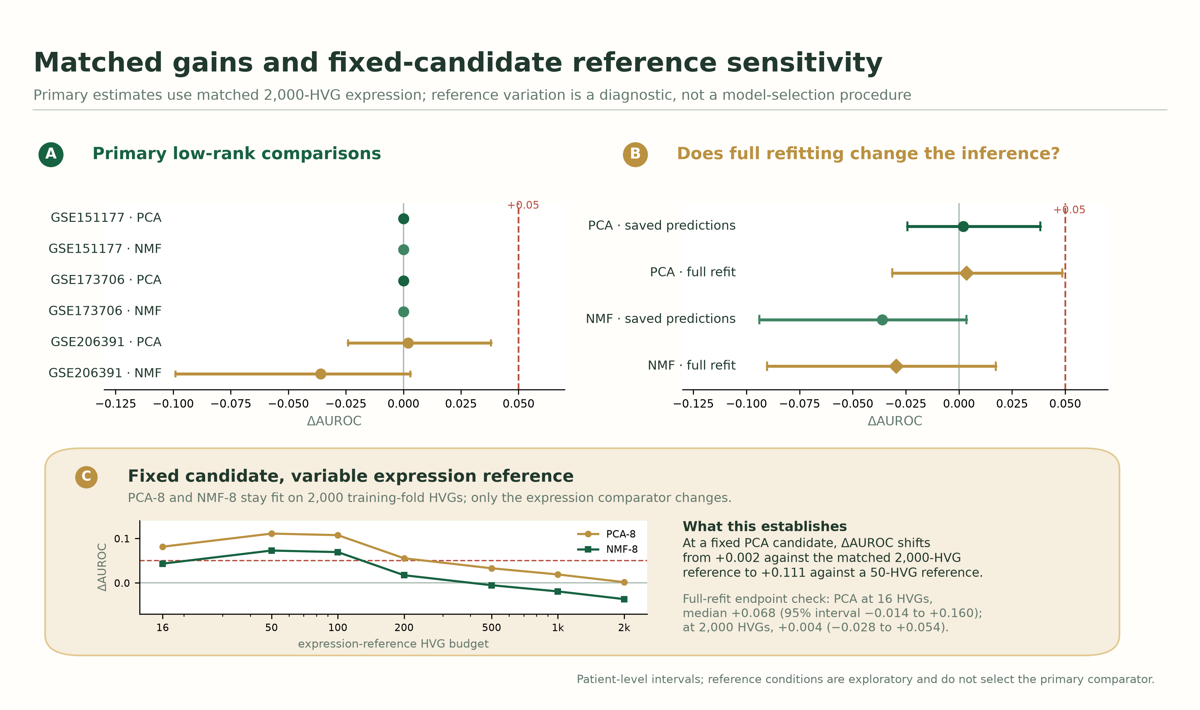
Figure 4. Matched representation gains and fixed-candidate reference sensitivity. (A) PCA/NMF gains over matched 2,000-HVG expression, with conditional grouped-bootstrap 95% intervals; the dashed line marks +0.05. (B) GSE206391 saved-prediction and 400-draw full-pipeline group-resampling sensitivity intervals. (C) PCA-8 and NMF-8 remain fixed at 2,000 training-fold HVGs while only the expression reference changes. This exploratory diagnostic shows comparator dependence; it does not select a primary reference or establish a reliable gain at a weakened reference.

3.3. Simulated validation of paired-gain criteria
With no increment, the statistical gain-and-interval criteria produced zero positive declarations in 400 replicates at each patient count (n = 12, 24, and 48; upper 95% Monte Carlo bound, 0.009). Under zero-mean coordinate-associated effects, detection rates were 0.755, 0.903, and 0.808, respectively (Figure 5; Supplementary Table S1). These rates describe the simulated settings, not a fixed-effect power curve. The simulations validate the declared statistical components; they do not provide biological evidence about psoriasis representations.
The source-fingerprint scenario separated prediction for new patients from interpolation within known sources. With a sample fingerprint but no disease or spatial signal, patient-grouped median AUROCs were 0.507, 0.519, and 0.508 at 12, 24, and 48 patients. Random-measurement splits reached 1.000 because every test measurement came from a source represented in training. The statistical-only criteria were met in 6/400, 11/400, and 9/400 repeats at 12, 24, and 48 patients (1.5%, 2.8%, and 2.3%; respective 95% Wilson intervals, 0.7–3.2%, 1.5–4.9%, and 1.2–4.2%). These are not complete-criteria false-positive rates because the simulation did not apply or calibrate the source-specific diagnostic. Under the weakened-reference scenario, strict increments stayed near zero because the candidate and matched expression contained the same information. Removing the expression-signal block from the reference produced apparent gains of +0.459, +0.481, and +0.492. The simulation results therefore show why matching and grouping are necessary; they are not a second empirical finding.
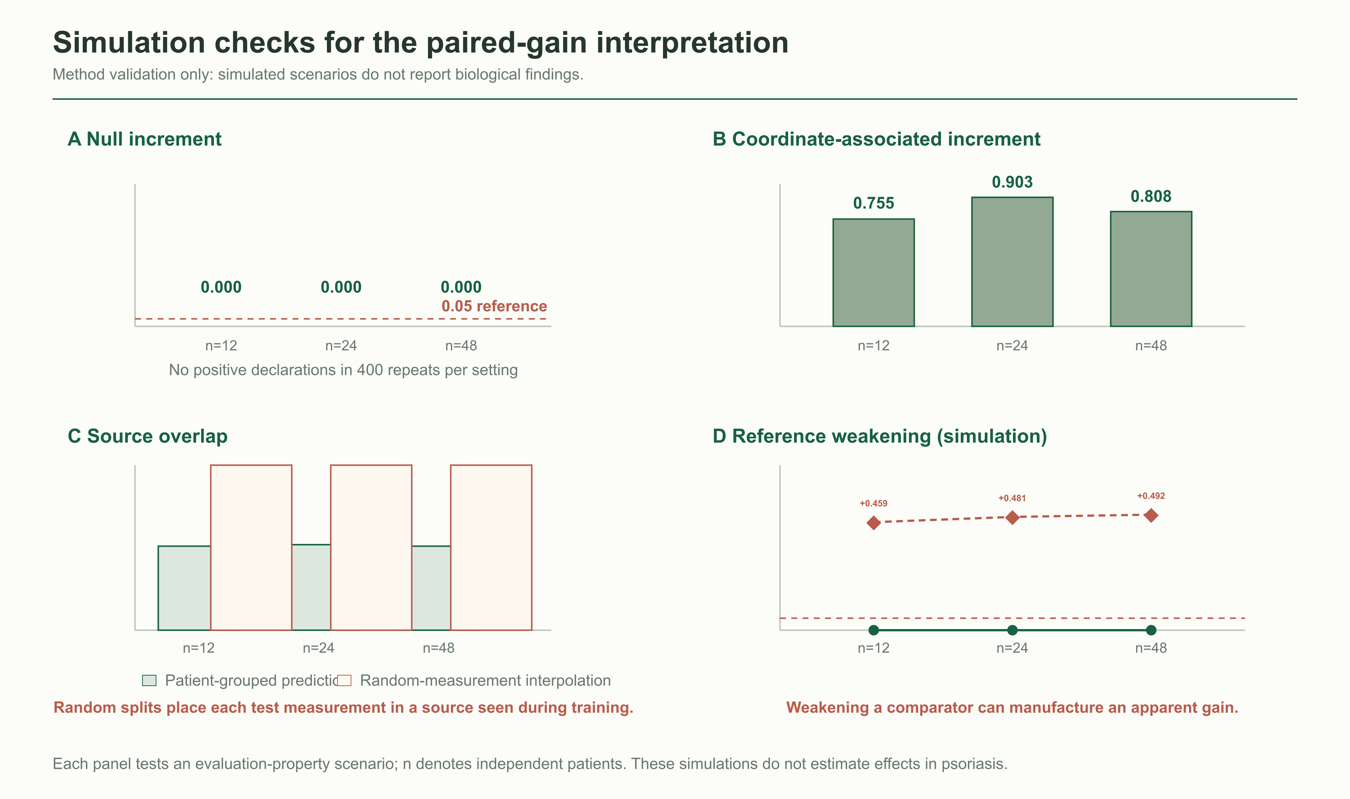
Figure 5. Simulation checks for the paired-gain interpretation. (A) Under no incremental information, the statistical gain-and-interval criteria produced no positive declarations in 400 repeats per patient-count setting, with exact 95% binomial intervals. (B) Detection of a zero-mean coordinate-associated increment. (C) A source-fingerprint scenario contrasts patient-grouped prediction with random-measurement interpolation. (D) Weakening a reference that originally contains the same information as the candidate manufactures an apparent gain. These are protocol-validation scenarios, not biological findings. Panels A and B assess the statistical components only; source-specific diagnostics were not simulated, so panel C rates are not complete-criteria false-positive estimates. Patient-count settings differ in their realised population increments (Supplementary Table S1).

3.4. Evaluation choices shape the prediction target and apparent gain
In the GSE206391 random-spot diagnostic, median AUROC was 0.970 (2.5th–97.5th percentile range, 0.966–0.974 across 50 repetitions; Table 3; Figure 6A). Every test spot came from a source sample represented in training. This estimates interpolation within observed samples, not prediction for a new patient. The primary analysis therefore uses patient-level splits for GSE206391.
In GSE206391, fixed-candidate comparator sensitivity made the role of the reference explicit. PCA-8 was always fit from 2,000 training-fold HVGs, while only the expression reference changed. Its apparent gain was +0.002 against the matched 2,000-HVG reference, +0.082 against 16 HVGs, and +0.111 against 50 HVGs (Figure 4C). The 16-HVG endpoint gave a full-refit median of +0.068 with a 95% interval of −0.014 to +0.160; the 2,000-HVG endpoint was +0.004 (−0.028 to +0.054). Thus the diagnostic shows that comparator definition changes the apparent gain, but neither endpoint supplies reliable evidence of an incremental PCA advantage. The 2,000-HVG matched reference remains the primary comparator.

3.5. Observed graph scores fall within the coordinate-shuffle null distributions
The primary coordinate-shuffle test asked whether the observed coordinates improved held-out prediction under the specified graph construction. The graph achieved AUROC 0.870; the mean across 500 within-sample coordinate shuffles was also 0.870 (one-sided P = 0.563). The expression-plus-spatial model scored 0.875, compared with a null mean of 0.879 (P = 0.677; Figure 6B). Counts, labels, patient folds, and fold-specific HVGs remained fixed during shuffling. These results do not support a coordinate-specific predictive increment for the specified graph features. They do not test whether spatial organisation is biologically absent.
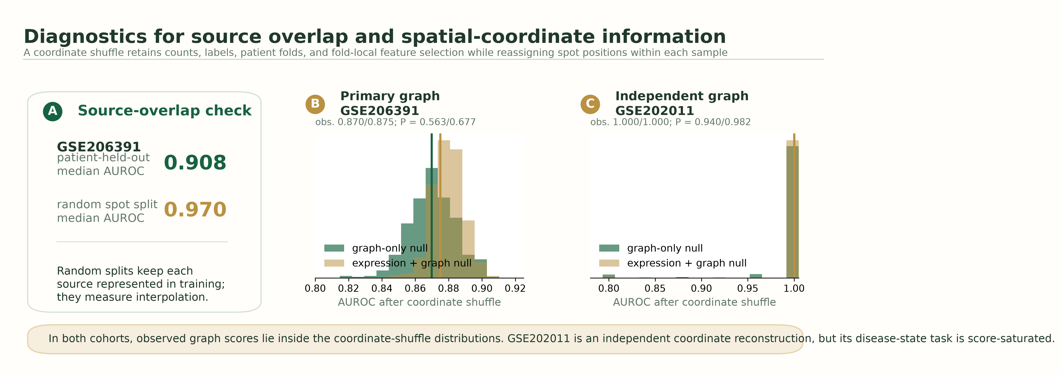
Figure 6. Source-overlap and coordinate-shuffle diagnostics. (A) Held-out-patient prediction is contrasted with random spot-level splits in GSE206391. (B) Primary-cohort null distributions from within-sample coordinate shuffles. (C) Independent GSE202011 coordinate-reconstruction null distributions. Coordinate shuffles preserve counts, labels, folds, and fold-local feature selection while reassigning spot positions within each sample.

Table 3. Input-reconstruction checks, full-refit sensitivity, and evaluation diagnostics.
Check / cohort | Result / diagnostic | Interpretation
Input reconstruction (primary cohorts) | GSE151177 was reprocessed with a symbol-based mitochondrial-gene filter; GSE173706 and GSE206391 match archived inputs. Roster/QC details: Table S6. | Corrected inputs used in the primary rerun.
Roster and QC (GSE151177) | 23 GEO records; five enzyme-digestion profiles excluded. Of 18 emigrating profiles screened, 17 were retained. Control05: median 160 detected genes (<300); 23,528 cells retained. | Primary set: 13 psoriasis and 4 control samples.
Control05 sensitivity (GSE151177) | With Control05 included: expression/PCA/NMF AUROC = 1.000; logistic/ridge Δ = 0; SVM-NMF Δ = −0.015; intervals include 0. | Primary conclusion unchanged.
Random spot split (GSE206391) | Median AUROC = 0.970 (0.966–0.974 across 50 repetitions); all test spots came from represented samples. | Within-source interpolation.
Fixed-candidate reference sensitivity (GSE206391) | PCA-8 fixed at 2,000 HVGs: Δ = +0.002 at 2,000-HVG reference and +0.111 at 50-HVG reference; 16-HVG full-refit interval −0.014 to +0.160. | Comparator choice changes apparent gain; it does not establish a weak-reference advantage.
Coordinate shuffle (GSE206391) | 500 within-sample shuffles. Graph observed/null AUROC = 0.870/0.870 (P = 0.563); expression-plus-graph = 0.875/0.879 (P = 0.677). | Observed scores lie within coordinate-null distributions.
Full-pipeline resampling (GSE206391) | 400 nested grouped draws: PCA median +0.003 (−0.031, +0.049); NMF median −0.030 (−0.090, +0.017). | Refitting learned stages does not change the decision.
Independent spatial boundary (GSE202011) | 3,563 QC spots; 100% barcode join to Visium V1 array reference. Expression/PCA/graph AUROC = 1.000; graph/combined shuffle P = 0.940/0.982. | Independent coordinate-based check; disease-state task is saturated.

3.6. The independent Visium comparison is score-saturated
In GSE202011, recovery of the array coordinates was complete for all 3,563 quality-controlled spots. The 500-HVG expression reference, spatial graph, 1,500-HVG reference, and expression-plus-graph branch each achieved AUROC 1.000 across five lesional/non-lesional patient pairs. Both graph increments were 0.000 (patient-bootstrap 95% CI, 0.000 to 0.000). Coordinate shuffling produced mean graph AUROC 0.993 (P = 0.940) and mean combined AUROC 0.997 (P = 0.982; Figure 6C). This is a true independent coordinate-based graph check, but the score-saturated disease-state task cannot resolve an incremental advantage.

4. Discussion
Across the three primary psoriasis cohorts, expression discriminated disease state. None of the tested PCA, NMF, spot-topic, or spatial-graph implementations met the prespecified paired-gain criteria against its matched expression reference (Table 2). The result concerns prediction under the stated source-sample, donor, and patient splits. It does not establish equivalence between representations or deny their descriptive biological value.
Predictive value and biological description answer different questions. Single-cell and spatial studies can localise disease-associated processes [4–6] even when their features do not improve this disease-state classification task. The independent GSE202011 graph check now has recovered coordinates, but all relevant methods are score-saturated. The appropriate conclusion is therefore limited: this task cannot show an incremental graph benefit in that cohort. An outcome with more headroom could provide a stronger test.
The diagnostics show why matched references and grouped splits must be specified together. In GSE206391, random spot splits placed sources in both partitions and produced higher AUROC than patient-held-out evaluation. This split estimates interpolation within observed sources. With the PCA candidate held fixed, changing only the expression comparator shifted its apparent gain from +0.002 at 2,000 HVGs to +0.111 at 50 HVGs. The primary and independent graph scores both fell within coordinate-shuffle null distributions. Full-pipeline group resampling widened the PCA sensitivity interval modestly but did not alter the decision. These results support reporting paired gains with their biological unit, fitted-pipeline sensitivity, reference definition, and applicable source test [18–21].
The evidence is bounded by small numbers of independent units and score saturation, which limit comparisons and do not support equivalence claims. GSE151177 source-sample identifiers were not mapped to verified patient identifiers. The main-table intervals condition on saved predictions; full-pipeline refitting was added for the core GSE206391 PCA/NMF comparisons but not every branch. Coordinate-based source diagnostics apply only to graph branches. For other candidates, S = NA means that no source test applied; it is neutral in the rule, while the numerical gain criteria still apply. The GSE202011 coordinate reconstruction provides array positions but not histology-image registration, and its five-patient task is saturated.
The next test requires a larger independent cohort with an endpoint that is not already saturated by expression. Prespecified clinical or mechanistic outcomes could test whether a defined cellular or spatial implementation adds information under the same grouped splits and matched references. The analysis should retain raw coordinates, define its source-specific diagnostic before evaluation, and use full-pipeline resampling for the primary comparison.

5. Conclusion
PRI-Audit pairs each tested transcriptomic candidate with a matched expression reference at the cohort's sampling level. It evaluates paired gain, uncertainty at the independent-unit level, fold-local fitting, fitted-pipeline sensitivity, and applicable source diagnostics. In the psoriasis cohorts studied, no tested PCA, NMF, spot-topic, or spatial-graph implementation met the numerical positive-declaration criteria together with the other applicable conditions. This conclusion is limited to these implementations, cohorts, and disease-state prediction tasks.

Declarations

Author contributions
Kaiwen Deng: conceptualization, methodology, software, data curation, formal analysis, validation, visualization, and writing (original draft preparation). Liwei Liu: conceptualization, methodology, writing (review and editing), supervision, and project administration.

Funding
This work was supported by the Fundamental Research Funds for the Provincial Universities of Liaoning (grant number LJ212410150016).

Ethics approval and consent to participate
This study reanalysed previously published, publicly available, de-identified transcriptomic datasets. It involved no participant recruitment, contact, intervention, or new specimen collection. The authors had no access to directly identifying information. The source study for GSE151177 reports Institutional Review Board approval and compliance with the Declaration of Helsinki [4]. The studies underlying GSE173706 and GSE206391 report ethics approval and written informed consent [5,6]. For the two boundary cohorts, we relied on the data-access and ethical statements reported by their source publications [7,8]. No new consent was collected for this secondary analysis.

Consent for publication
Not applicable. This manuscript contains no identifiable participant information.

Data availability statement
All analysed datasets are de-identified public Gene Expression Omnibus records [9]. The five main-text cohorts are GSE151177, GSE173706, GSE206391, GSE47751, and GSE202011 [4–8]. Supplementary Table S7 lists eight registry-only biological-context records. GSE202011 spatial coordinates were reconstructed by joining retained H5 barcodes to the public Space Ranger Visium V1 barcode-to-array-coordinate reference. Retrieval paths, raw-input SHA-256 checksums, coordinate-join checks, and derived outputs are recorded in the reproducibility manifest.

Code availability
The executable workflows, input verifier, derived outputs, figure sources, and reproducibility manifest are archived in the public PRI-Audit v1.33.1 release at https://github.com/kobayashi0512/PRI-Audit/releases/tag/v1.33.1. The release contains the GSE202011 barcode-to-coordinate graph-validation scripts and results, grouped full-pipeline resampling, and fixed-candidate reference-sensitivity analysis. It is released under the MIT License. The GSE151177 fetcher retrieves public inputs from GEO and verifies them against the manifest.

Acknowledgements
We thank the investigators who generated and publicly deposited the transcriptomic datasets and the participants who contributed to the source studies.

Conflicts of interest
The authors declare no conflicts of interest.

Supplementary information
Supplementary Table S1 reports the controlled simulation settings and outcomes. Table S2 reports sensitivity to spot sampling, and Table S3 reports fixed-learner sensitivity. Table S4 lists paired boundary-cohort accessions. Table S5 reports the PRI-Audit evidence-criteria status for each candidate. Table S6 lists all GSE151177 GEO records and their quality-control dispositions. Table S7 lists registry-only biological-context datasets excluded from main-text performance claims.

References
[1] W. H. Boehncke and M. P. Schön, “Psoriasis,” Lancet, vol. 386, no. 9997, pp. 983–994, 2015, doi: 10.1016/s0140-6736(14)61909-7.
[2] M. A. Lowes, M. Suárez-Fariñas, and J. G. Krueger, “Immunology of psoriasis,” Annu. Rev. Immunol., vol. 32, no. 1, pp. 227–255, 2014, doi: 10.1146/annurev-immunol-032713-120225.
[3] S. Tian et al., “Meta-analysis derived (MAD) transcriptome of psoriasis defines the ‘core’ pathogenesis of disease,” PLOS ONE, vol. 7, no. 9, Art. no. e44274, 2012, doi: 10.1371/journal.pone.0044274.
[4] J. Kim et al., “Single-cell transcriptomics applied to emigrating cells from psoriasis elucidate pathogenic versus regulatory immune cell subsets,” J. Allergy Clin. Immunol., vol. 148, no. 5, pp. 1281–1292, 2021, doi: 10.1016/j.jaci.2021.04.021.
[5] F. Ma et al., “Single cell and spatial sequencing define processes by which keratinocytes and fibroblasts amplify inflammatory responses in psoriasis,” Nat. Commun., vol. 14, no. 1, Art. no. 3455, 2023, doi: 10.1038/s41467-023-39020-4.
[6] A. Schäbitz et al., “Spatial transcriptomics landscape of lesions from non-communicable inflammatory skin diseases,” Nat. Commun., vol. 13, no. 1, Art. no. 7729, 2022, doi: 10.1038/s41467-022-35319-w.
[7] A. Johnston, A. M. Guzman, W. R. Swindell, F. Wang, S. Kang, and J. E. Gudjonsson, “Early tissue responses in psoriasis to the antitumour necrosis factor-α biologic etanercept suggest reduced interleukin-17 receptor expression and signalling,” Br. J. Dermatol., vol. 171, no. 1, pp. 97–107, 2014, doi: 10.1111/bjd.12937.
[8] R. L. Castillo et al., “Spatial transcriptomics stratifies psoriatic disease severity by emergent cellular ecosystems,” Sci. Immunol., vol. 8, no. 84, Art. no. eabq7991, 2023, doi: 10.1126/sciimmunol.abq7991.
[9] R. Edgar, M. Domrachev, and A. E. Lash, “Gene Expression Omnibus: NCBI gene expression and hybridization array data repository,” Nucleic Acids Res., vol. 30, no. 1, pp. 207–210, 2002, doi: 10.1093/nar/30.1.207.
[10] C. Brodmerkel et al., “Modulation of inflammatory gene transcripts in psoriasis vulgaris: Differences between ustekinumab and etanercept,” J. Allergy Clin. Immunol., vol. 143, no. 5, pp. 1965–1969, 2019, doi: 10.1016/j.jaci.2019.01.017.
[11] K. M. Page et al., “Molecular and cellular responses to the TYK2/JAK1 inhibitor PF-06700841 reveal reduction of skin inflammation in plaque psoriasis,” J. Invest. Dermatol., vol. 140, no. 8, pp. 1546–1555.e4, 2020, doi: 10.1016/j.jid.2019.11.027.
[12] D. F. Choy et al., “Comparative transcriptomic analyses of atopic dermatitis and psoriasis reveal shared neutrophilic inflammation,” J. Allergy Clin. Immunol., vol. 130, no. 6, pp. 1335–1343.e5, 2012, doi: 10.1016/j.jaci.2012.06.044.
[13] J. E. Kim et al., “Genomic profiling of the overlap phenotype between psoriasis and atopic dermatitis,” J. Invest. Dermatol., vol. 144, no. 1, pp. 43–52.e6, 2024, doi: 10.1016/j.jid.2023.06.194.
[14] A. Chiricozzi et al., “Integrative responses to IL-17 and TNF-α in human keratinocytes account for key inflammatory pathogenic circuits in psoriasis,” J. Invest. Dermatol., vol. 131, no. 3, pp. 677–687, 2011, doi: 10.1038/jid.2010.340.
[15] H. Sofen et al., “Guselkumab (an IL-23-specific mAb) demonstrates clinical and molecular response in patients with moderate-to-severe psoriasis,” J. Allergy Clin. Immunol., vol. 133, no. 4, pp. 1032–1040, 2014, doi: 10.1016/j.jaci.2014.01.025.
[16] M. Quaranta et al., “Intraindividual genome expression analysis reveals a specific molecular signature of psoriasis and eczema,” Sci. Transl. Med., vol. 6, no. 244, Art. no. 244ra90, 2014, doi: 10.1126/scitranslmed.3008946.
[17] J. Correa da Rosa, J. Kim, S. Tian, L. E. Tomalin, J. G. Krueger, and M. Suárez-Fariñas, “Shrinking the psoriasis assessment gap: Early gene-expression profiling accurately predicts response to long-term treatment,” J. Invest. Dermatol., vol. 137, no. 2, pp. 305–312, 2017, doi: 10.1016/j.jid.2016.09.015.
[18] K. D. Zimmerman, M. A. Espeland, and C. D. Langefeld, “A practical solution to pseudoreplication bias in single-cell studies,” Nat. Commun., vol. 12, no. 1, Art. no. 738, 2021, doi: 10.1038/s41467-021-21038-1.
[19] J. W. Squair et al., “Confronting false discoveries in single-cell differential expression,” Nat. Commun., vol. 12, no. 1, Art. no. 5692, 2021, doi: 10.1038/s41467-021-25960-2.
[20] C. Ambroise and G. J. McLachlan, “Selection bias in gene extraction on the basis of microarray gene-expression data,” Proc. Natl. Acad. Sci. U.S.A., vol. 99, no. 10, pp. 6562–6566, 2002, doi: 10.1073/pnas.102102699.
[21] S. Varma and R. Simon, “Bias in error estimation when using cross-validation for model selection,” BMC Bioinformatics, vol. 7, no. 1, Art. no. 91, 2006, doi: 10.1186/1471-2105-7-91.

Supplementary information
Supplementary Table S1. Controlled simulation outcomes.
Each setting used 400 repeats. Pass rate requires ΔAUROC ≥ 0.05 and a positive lower 95% patient-bootstrap bound. Mean ΔAUROCs are ordered strict/population; median AUROCs are ordered grouped/random-cell. Each patient contributes two samples with 40 nested measurements. These are statistical-only rates; representation-specific source diagnostics were not applied or calibrated.
Scenario | Patients | Mean ΔAUROC (strict / population) | Pass rate | Median AUROC (grouped / random-cell)
No increment | 12 | -0.003 / -0.002 | 0.000 | 0.965 / 0.995
No increment | 24 | -0.001 / -0.001 | 0.000 | 0.984 / 0.989
No increment | 48 | -0.000 / -0.000 | 0.000 | 0.993 / 0.986
Coordinate increment | 12 | 0.165 / 0.150 | 0.755 | 0.840 / 0.970
Coordinate increment | 24 | 0.111 / 0.103 | 0.903 | 0.898 / 0.954
Coordinate increment | 48 | 0.086 / 0.083 | 0.808 | 0.917 / 0.937
Source fingerprint | 12 | -0.002 / -0.000 | 0.015 | 0.507 / 1.000
Source fingerprint | 24 | 0.002 / -0.001 | 0.028 | 0.519 / 1.000
Source fingerprint | 48 | 0.001 / -0.000 | 0.023 | 0.508 / 1.000
Weak reference | 12 | -0.004 / -0.002 | 0.000 | 0.965 / 0.995
Weak reference | 24 | -0.001 / -0.001 | 0.000 | 0.986 / 0.989
Weak reference | 48 | -0.000 / -0.000 | 0.000 | 0.992 / 0.986
Supplementary Table S2. Sensitivity to spot sampling.
Spots per sample | Representation | Held-out AUROC | ΔAUROC (95% CI)
150 | Spot topics (8) | 0.783 | −0.109 (−0.215, +0.000)
150 | Expression + spot topics (16) | 0.813 | −0.068 (−0.130, +0.002)
300 | Spot topics (8) | 0.804 | −0.089 (−0.186, +0.000)
300 | Expression + spot topics (16) | 0.795 | −0.085 (−0.182, +0.007)
450 | Spot topics (8) | 0.799 | −0.094 (−0.201, −0.007)
450 | Expression + spot topics (16) | 0.809 | −0.071 (−0.153, +0.000)
All comparisons use patient-grouped folds. Eight-topic features are compared with eight-component expression PCA; 16-dimensional fusion is compared with 16-component expression PCA. Intervals resample saved paired patient predictions.
Supplementary Table S3. Fixed-learner sensitivity analysis.
Each candidate is compared with the expression reference fitted by the same learner on the same outer folds. Intervals are 95% paired group-bootstrap intervals from 5,000 draws of saved out-of-fold scores; models are not refitted within bootstrap draws. All intervals include zero, and no alternative-learner gain reaches +0.05.
Cohort (held-out units) | Learner | Expression AUROC | PCA ΔAUROC (95% CI) | NMF ΔAUROC (95% CI)
GSE151177 (17 source samples) | Ridge | 1.000 | 0.000 (0.000, 0.000) | −0.019 (−0.101, 0.000)
GSE151177 (17 source samples) | Linear SVM | 1.000 | 0.000 (0.000, 0.000) | −0.019 (−0.115, 0.000)
GSE173706 (11 donors) | Ridge | 1.000 | 0.000 (0.000, 0.000) | 0.000 (0.000, 0.000)
GSE173706 (11 donors) | Linear SVM | 1.000 | 0.000 (0.000, 0.000) | 0.000 (0.000, 0.000)
GSE206391 (12 patients) | Ridge | 0.887 | +0.019 (−0.028, +0.104) | +0.017 (−0.028, +0.102)
GSE206391 (12 patients) | Linear SVM | 0.906 | +0.002 (−0.033, +0.089) | −0.056 (−0.125, +0.028)

Supplementary Table S4. Paired sample accessions for the additional boundary cohorts.
GSE47751 entries are baseline day-0 non-lesional (PN) and lesional (PP) bulk-microarray samples. GSE202011 entries are non-lesional and lesional Visium samples from five biologic-naïve psoriasis patients. For ST14, lesion section R1 (GSM6086617) was retained and the technical/section replicate R2 (GSM6086618) was excluded by the deterministic rule before expression inspection. Coordinates were not included in the analysed GSE202011 inputs; no spatial-graph result is implied.
Cohort / unit | Non-lesional GSM | Lesional GSM | Platform / selection | Analysis role
GSE47751 / TLW18 | GSM1155751 | GSM1155752 | Bulk microarray; baseline day 0 | Bulk boundary
GSE47751 / CAB10 | GSM1155756 | GSM1155757 | Bulk microarray; baseline day 0 | Bulk boundary
GSE47751 / CEM11 | GSM1155762 | GSM1155763 | Bulk microarray; baseline day 0 | Bulk boundary
GSE47751 / EUR12 | GSM1155768 | GSM1155769 | Bulk microarray; baseline day 0 | Bulk boundary
GSE47751 / KPW13 | GSM1155774 | GSM1155775 | Bulk microarray; baseline day 0 | Bulk boundary
GSE47751 / CLS14 | GSM1155779 | GSM1155780 | Bulk microarray; baseline day 0 | Bulk boundary
GSE202011 / ST13 | GSM6086616 | GSM6086615 | Visium; biologic-naïve pair | Independent high-resolution boundary
GSE202011 / ST14 | GSM6086619 | GSM6086617 | Visium; R1 retained, R2 excluded | Independent high-resolution boundary
GSE202011 / ST17 | GSM6086626 | GSM6086625 | Visium; biologic-naïve pair | Independent high-resolution boundary
GSE202011 / ST20 | GSM6086631 | GSM6086630 | Visium; biologic-naïve pair | Independent high-resolution boundary
GSE202011 / ST21 | GSM6086633 | GSM6086632 | Visium; biologic-naïve pair | Independent high-resolution boundary
Supplementary Table S5. PRI-Audit evidence-criteria status by candidate representation.
F = 1 indicates fold-local fitting. S = 0 denotes an applicable coordinate-shuffle diagnostic that did not pass the one-sided P < 0.05 criterion; S = NA denotes that no candidate-specific source diagnostic applies and is neutral in the pre-specified criteria. The numerical gain and lower-bound criteria remain required. Δ and confidence intervals are reported in Table 2 and Supplementary Table S2. No candidate met both numerical gain criteria; the graph branches also did not pass their applicable source diagnostic.
Cohort / candidate | Δ ≥ 0.05 | Lower 95% bound > 0 | F / S status | Criteria met
GSE151177 / PCA | No | No (0.000) | F = 1; S = NA | No
GSE151177 / NMF | No | No (0.000) | F = 1; S = NA | No
GSE173706 / PCA | No | No (0.000) | F = 1; S = NA | No
GSE173706 / NMF | No | No (0.000) | F = 1; S = NA | No
GSE206391 / PCA | No | No (−0.024) | F = 1; S = NA | No
GSE206391 / NMF | No | No (−0.099) | F = 1; S = NA | No
GSE206391 / spatial graph | No | No (−0.087) | F = 1; S = 0 (P = 0.563) | No
GSE206391 / expression + graph | No | No (−0.073) | F = 1; S = 0 (P = 0.677) | No
GSE206391 / spot-topic (8) | No | No (−0.186) | F = 1; S = NA | No
GSE206391 / expression + topic (16) | No | No (−0.182) | F = 1; S = NA | No
GSE47751 / PCA | No | No (0.000) | F = 1; S = NA | No
GSE202011 / PCA | No | No (0.000) | F = 1; S = NA | No

Supplementary Table S6. GEO sample roster and quality-control disposition for GSE151177.
GSE151177 has 23 GEO records: 18 emigrating-cell and five enzyme-digestion profiles (excluded by protocol). The 18 eligible profiles were screened under the registered sample-level rule; Control05 appears only in QC sensitivity. GEO IDs are sample records, not verified patient IDs. Values are medians: detected genes / mitochondrial fraction / retained cells; —, not applicable.
GEO accession / sample | Condition / method | Median genes / mt fraction / cells | Disposition
GSM4567877  Control01 | Control; Emigrating-cell | 1443 / 0.006 / 2472 | Included
GSM4567878  Control02 | Control; Emigrating-cell | 607 / 0.059 / 893 | Included
GSM4567879  Control03 | Control; Emigrating-cell | 789 / 0.018 / 316 | Included
GSM4567880  Control04 | Control; Emigrating-cell | 851 / 0.048 / 1427 | Included
GSM4567881  Control05 | Control; Emigrating-cell | 160 / 0.047 / 70 | Excluded: median genes <300; sensitivity only
GSM4567882  Control05F | Control; Enzyme-digestion | — / — / — | Excluded by protocol
GSM4567883  Psoriasis01 | Psoriasis; Emigrating-cell | 1074 / 0.025 / 613 | Included
GSM4567884  Psoriasis02 | Psoriasis; Emigrating-cell | 1012 / 0.031 / 673 | Included
GSM4567885  Psoriasis02F | Psoriasis; Enzyme-digestion | — / — / — | Excluded by protocol
GSM4567886  Psoriasis03 | Psoriasis; Emigrating-cell | 1163 / 0.037 / 1192 | Included
GSM4567887  Psoriasis03F | Psoriasis; Enzyme-digestion | — / — / — | Excluded by protocol
GSM4567888  Psoriasis04 | Psoriasis; Emigrating-cell | 1423 / 0.052 / 928 | Included
GSM4567889  Psoriasis04F | Psoriasis; Enzyme-digestion | — / — / — | Excluded by protocol
GSM4567890  Psoriasis05 | Psoriasis; Emigrating-cell | 1175 / 0.010 / 901 | Included
GSM4567891  Psoriasis06 | Psoriasis; Emigrating-cell | 1178 / 0.025 / 1256 | Included
GSM4567892  Psoriasis06F | Psoriasis; Enzyme-digestion | — / — / — | Excluded by protocol
GSM4567893  Psoriasis07 | Psoriasis; Emigrating-cell | 1102 / 0.034 / 675 | Included
GSM4567894  Psoriasis08 | Psoriasis; Emigrating-cell | 1038 / 0.033 / 2102 | Included
GSM4567895  Psoriasis09 | Psoriasis; Emigrating-cell | 1066 / 0.009 / 2778 | Included
GSM4567896  Psoriasis10 | Psoriasis; Emigrating-cell | 1221 / 0.028 / 1842 | Included
GSM4567897  Psoriasis11 | Psoriasis; Emigrating-cell | 1352 / 0.060 / 1354 | Included
GSM4567898  Psoriasis12 | Psoriasis; Emigrating-cell | 1052 / 0.082 / 2922 | Included
GSM4567899  Psoriasis13 | Psoriasis; Emigrating-cell | 456 / 0.100 / 1184 | Included

Supplementary Table S7. Registry-only biological-context datasets.
These datasets informed cohort selection and biological context only. They were not used to estimate any candidate-versus-reference AUROC or incremental gain.
Accession | Modality | Registry-only role
GSE117239 [10] | Bulk RNA | Paired treatment/baseline context
GSE136757 [11] | Bulk RNA | Treatment-response context
GSE153007 [12] | Bulk RNA | Lesional/non-lesional disease context
GSE182740 [13] | Bulk RNA | Psoriasis/atopic-dermatitis overlap context
GSE24767 [14] | Bulk perturbation | IL-17/TNF-alpha cytokine context
GSE51440 [15] | Bulk RNA | Guselkumab treatment context
GSE57225 [16] | Bulk RNA | Intra-individual disease context
GSE85034 [17] | Bulk RNA | Longitudinal treatment context

