Pixel Accuracy Is Not Biomarker Validity:
RMDB–BiRAP, a Framework with Dual Readouts and Reliability Gating for Retinal Vascular Phenotyping Across Domains
[Author names]
[Affiliations]
[Corresponding author and email]
Full scientific manuscript | Author and governance fields must be completed before submission
Abstract
Background: A retinal vessel map may be valid at pixel level while the derived number remains unstable, not transportable, or clinically redundant. Methods: We developed RMDB–BiRAP, a measurement first framework that separates vessel occupancy from artery–vein identity, constructs mass preserving and occupancy gated factorized readouts, and freezes a repeatable phenotype core before outcome access. Seven retinal image resources—FIVES, RAV, Fundus-AVSeg, AFIO, STARE, China Fundus–CIMT, and mBRSET—were assigned distinct development, measurement, stress testing, reliability, and clinical roles. Results: Frozen VascX identity measurement achieved mean artery/vein Dice 0.8256 across RAV; RAV was also used separately to develop the residual corrector and therefore was not treated as independent validation of UDCT. In the locked Fundus-AVSeg evaluation, mass preservation improved mean artery/vein Dice from 0.5545 to 0.5635 (paired Δ=0.0090, 95% CI 0.0079–0.0101), while low quality and diabetic retinopathy images remained failure domains. Frozen structure migration was negative on held out FIVES (vessel Dice 0.356) and STARE (0.167). Four of nine prespecified phenotypes passed ICC(1,1)≥0.60 across 2,359 same eye repeat pairs. Outcome blind transport analysis showed that these four scales were strongly separable by cohort (CIMT versus external domain AUROC 0.866–0.996), prohibiting naive pooling. Direct fusion of 104 variables worsened CIMT prediction; frozen validation of conditional deviation was inconclusive. In calibrated mBRSET analyses, the reliable core did not improve hypertension discrimination or Brier score (overall ΔAUROC=+0.00188, 95% CI −0.00588 to +0.00942). Interpretation: External pixel measurement, phenotype repeatability, scale transport, and clinical increment are distinct evidential gates. RMDB–BiRAP supports an auditable measurement framework and four reproducible phenotypes, but independent high resolution outcome confirmation remains required.
Keywords: retinal vasculature; digital biomarker; artery–vein segmentation; repeatability; domain transport; CIMT; hypertension; nested cross validation
1. Introduction
A retinal image can be segmented correctly and still yield the wrong biomarker. Pixel overlap asks whether a model traced the labelled vessel. A biomarker claim asks something harder: whether the resulting quantity survives reacquisition, domain shift, and adjustment for information already available at the bedside. These questions are routinely compressed into one performance number, creating a hidden failure mode between computer vision and clinical inference.
This gap matters because the retina is an accessible window onto systemic microvascular health. Deep learning has linked fundus photographs to cardiovascular and metabolic phenotypes [1–4], yet a high AUROC does not prove that a model measured a stable vascular attribute. It may instead exploit age, acquisition, pigmentation, ocular disease, or appearance specific to the camera. Conversely, a segmentation improvement may be statistically real but clinically irrelevant if it does not propagate into a repeatable patient level phenotype.
Conventional multiclass vessel maps further confound two biologically different errors. Missing vascular support answers the question “is a vessel present?”, whereas an artery–vein identity error answers “what kind of vessel is present?”. Treating both as the same class mistake obscures whether failure arises from weak vessel evidence, identity ambiguity, or a mismatch between the two. Downstream feature stacking then magnifies this ambiguity while appearing methodologically sophisticated.
We therefore organized the study around three gates that cannot substitute for one another: measurement validity across domains, outcome blind repeatability of the same eye, and incremental patient level utility beyond clinical covariates. RMDB–BiRAP separates occupancy from identity, creates complementary mass preserving and factorized vascular readouts, and retains phenotypes by repeated view reliability before any systemic outcome is used.
The contribution is deliberately falsifiable. We report where the evidence survives—external measurement transfer and four reproducible global phenotypes—and where it stops: direct high dimensional fusion, uncertainty based on disagreement, repeatability core replacement, and calibrated mBRSET clinical increment. The resulting framework is not a claim that fundus imaging replaces carotid ultrasonography or blood pressure assessment; it is a reproducible method for deciding when a retinal measurement has, and has not, earned the name biomarker.
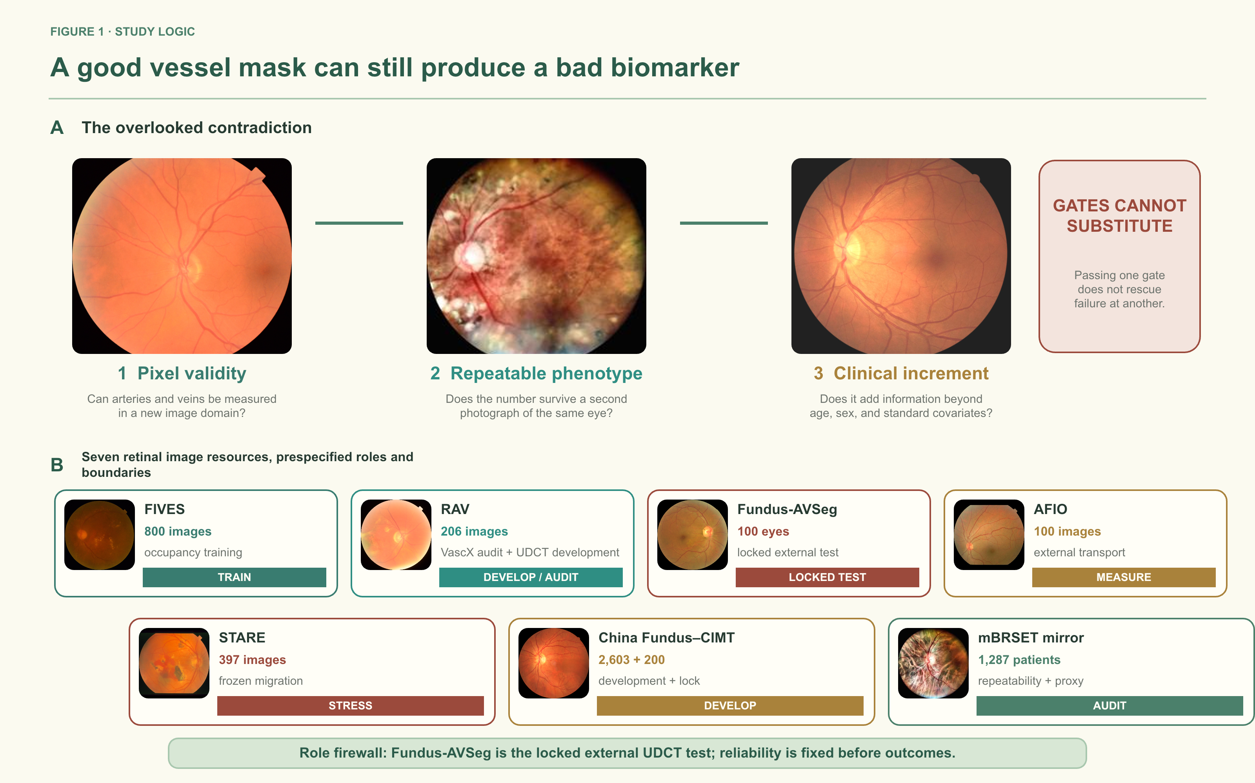
Figure 1. Study logic and cohort role firewall. Panel A uses different real local images to illustrate the three distinct gates: pixel valid measurement, same eye repeatability, and clinical increment. Panel B assigns a prespecified role to each of seven retinal image resources. RAV is used to audit frozen VascX on all 206 images and, in a separate split, to develop and hold out the UDCT corrector. Only Fundus-AVSeg provides a completely locked external evaluation of UDCT. Repeatability is fixed before outcome access; mBRSET supports repeated view reliability and exploratory patient level analysis rather than independent confirmation.
2. Materials and methods
2.1 Study cohorts and evidence roles
Seven retinal image resources had distinct roles before analysis (Table 1). FIVES [13] supplied occupancy supervision and a held out frozen migration audit. RAV [14] served two declared purposes: all 206 images audited the frozen VascX identity backbone, while a split by imaging device, comprising training, validation, and a seven image analog camera holdout, was used to develop UDCT. Fundus-AVSeg [15] was untouched during development and supplied the locked external evaluation of UDCT. AFIO [18] supplied an additional open measurement and transport resource, and STARE [19] supplied a frozen structure migration stress test. China Fundus–CIMT supplied development and previously locked internal validation; mBRSET/BRSET [16] supplied repeated views and systemic annotations. A feasibility audit of NHANES retinal grading records [20] found no locally obtainable raw retinal pixels and therefore did not treat NHANES as an image cohort.
Table 1. Image resources, available labels, and prespecified analytical roles.
Resource | Scale | Available information | Prespecified role | Evidence status
FIVES | 800 images (600 train/200 held out) | Binary vessel masks | Occupancy training + frozen migration | Training / negative stress
RAV | 206 images; device split for UDCT | Artery and vein masks | Frozen VascX audit + UDCT development | VascX measurement / method development
Fundus-AVSeg | 100 images | Vessel/A/V masks; disease; quality | Locked without tuning stress test | Measurement partially supported
AFIO | 100 images; 100 vessel pairs; 99 A/V pairs | Vessels, A/V, disc, lesions | External extraction + transport | Measurement only
STARE | 397 images; 20 AH labels scored | Vessel masks for labelled subset | Frozen structure migration | Negative domain shift
China Fundus–CIMT | 2,603 development; 200 frozen validation | Age, sex, bilateral fundus, CIMT | Normative deviation mechanism | Development + inconclusive lock
mBRSET mirror | 1,287 patients; 4,884 images; 2,359 repeat pairs | Repeated views; ocular/systemic labels | Reliability + exploratory HTN | External mechanism / internal CV
NHANES audit | 2,934/3,863 retinal grading records | Clinical and grading files; no raw pixels | External outcome feasibility audit | Not an image cohort
Cohort isolation was treated as part of the method. Pixel labels from RAV, Fundus-AVSeg, AFIO, FIVES, and STARE never entered patient level outcome models. The 2,603 patient CIMT training split was used for development; the 200 patient validation split was accessed only after E8 choices were frozen. An access audit identified an early clinical baseline test artifact; it was not used for RMDB feature development or model selection, but the test split is not described as pristine or unopened. AFIO extraction was required to finish all 100 images; one missing artery–vein source pair was reported rather than patched.

2.2 Anatomy aware preprocessing
Fundus photographs were standardized by circular field of view handling, colour normalization, and geometry anchoring to the optic disc and fovea. Optic disc centred coordinates provided a common frame for global and peripapillary measurements. Zone specific quantities were calculated only when disc localization passed quality control; global features remained available when zone localization failed.
The preprocessing audit required finite outputs, one to one manifest matching, and patient/eye integrity. For mBRSET, all 4,884 images completed preprocessing, although 189 images required the documented disc fallback. This fallback frequency was retained as a limitation and motivated a strict disc quality sensitivity analysis.
2.3 RMDB: dual readout vascular measurement
The occupancy branch estimated P(vessel) from a binary vessel model trained with FIVES supervision. The identity branch used the frozen VascX model [17] to produce a four class vascular representation encoding background, artery, vein, and crossing or uncertain identity. The two branches therefore addressed different questions: whether vascular structure was present and what identity the detected structure carried.
Let x denote a standardized fundus image, z⁽⁰⁾ the frozen four class VascX logits, H the normalized identity entropy, and D(x) the multiscale Hessian direction field. The UDCT corrector updates only residual logits for two shared weight iterations:
z⁽ᵗ⁺¹⁾ = z⁽ᵗ⁾ + gθ([x, z⁽⁰⁾, H₄(p⁽⁰⁾), D(x), p⁽ᵗ⁾]), t ∈ {0,1}
pM = softmax(z⁽²⁾) (1)
The refinement objective matched the implemented training loss: weighted pixel classification, soft Dice overlap, directional continuity, binary vessel support, confidence weighted residual restraint, artery/vein mass balance, and total vessel mass balance. The last two weights were frozen at 0.20 and 0.05 in the archived checkpoint:
LUDCT = LCE + 0.5LDice + 0.10Ldir + 0.10Lves + 0.01Lid
+ 0.20LAVmass + 0.05LVmass (2)
Two complementary reconstructions were derived. The mass preserving readout retained the calibrated joint four class probability mass, preserving weak but potentially real vascular evidence. The factorized readout multiplied vessel occupancy by conditional identity probabilities, producing an occupancy gated geometry representation. This separation makes it possible to distinguish missing vessel support from identity error and to quantify their disagreement.
The factorized readout combined fixed FIVES occupancy oF with corrected conditional identity. A confidence gate c(x), derived from base identity entropy, interpolated between derived from identity vessel support and the external occupancy estimator; τ=0.525 was fixed before external evaluation:
c(x) = σ(((1 − H₄(p⁽⁰⁾(x))) − 0.35)/0.20), õ(x) = c(x)[1 − p⁽⁰⁾₀(x)] + [1 − c(x)]o_F(x)
pF,k(x) = I[õ(x) ≥ τ] × õ(x) × pM,k(x) / Σ_{q∈{A,V,C}} pM,q(x), τ = 0.525 (3)
Candidates at eye level included soft vessel mass fraction, mass and factorized skeleton length densities, branch density, artery/vein log ratios, entropy, and disagreement between readouts. The framework did not assume that disagreement was a calibrated uncertainty score; this interpretation was tested and ultimately rejected in later experiments.
The two readouts generated interpretable, continuous operators over the valid retinal domain Ω. Vessel support, artery–vein balance, and disagreement between readouts were defined as:
ϕmass = |Ω|⁻¹ Σ_{x∈Ω}[1 − pᴹ₀(x)]
ϕAV = log{[Σ_{x∈Ω}(pᴹ_A + pᴹ_C) + 1] / [Σ_{x∈Ω}(pᴹ_V + pᴹ_C) + 1]}
ϕdis = |V_M △ V_F| / |V_M ∪ V_F| (4)
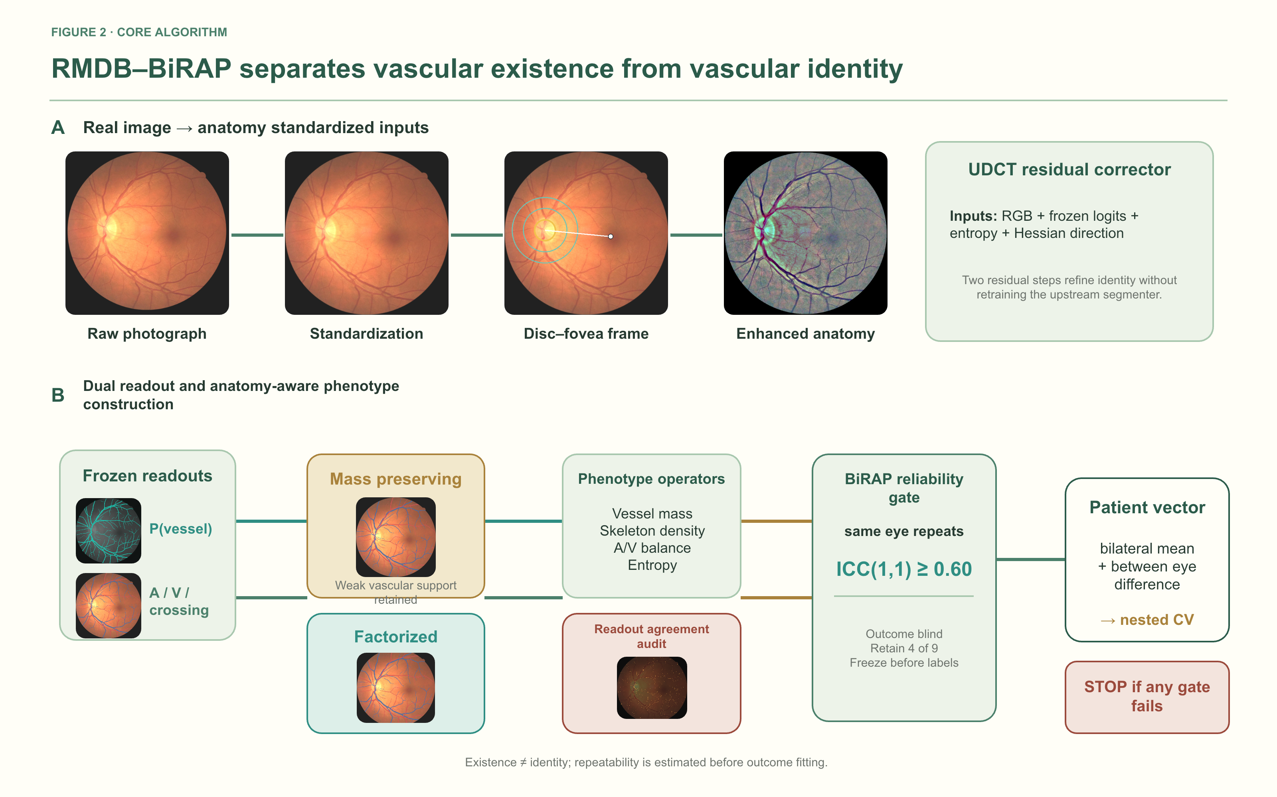
Figure 2. RMDB–BiRAP dual readout measurement and phenotype construction. Panel A uses a real CIMT development eye different from the cohort examples in Figure 1 and shows anatomy standardization, the disc–fovea frame, enhanced anatomy, and the two step UDCT residual corrector. Panel B separates frozen occupancy and vascular identity readouts, constructs complementary mass preserving and factorized maps, derives interpretable phenotype operators and disagreement between readouts, applies the outcome blind BiRAP reliability gate, and only then forms the patient vector for nested cross validation.
2.4 BiRAP: outcome blind reliability and patient aggregation
For each patient, eye level features were summarized using the bilateral mean and the absolute between eye difference where both eyes were available. Repeated views were first aggregated within eye when estimating patient level quantities so that image count could not act as a surrogate for outcome.
Reliability was evaluated using 2,359 same eye repeat pairs in mBRSET. Nine global phenotypes were specified before disease outcome analysis. ICC(1,1) with bootstrap 95% confidence intervals was calculated from the paired views [5,6,9]. The retention threshold was fixed at ICC ≥0.60. Outcome labels and systemic covariates were not used in this selection step.
Reliability was used only as a label blind retention rule. Candidate phenotype j was retained when ICCj(1,1) ≥ 0.60, with the decision fixed before any systemic outcome analysis.
Algorithm 1. RMDB–BiRAP phenotype construction and evidence gating
Input. Standardized left/right fundus photographs; frozen VascX logits; frozen FIVES occupancy estimator; optic disc metadata.
Output. A patient level reliable phenotype vector and an evidence status that is independent of outcome guided feature selection.
1 Standardize anatomy. Normalize the field of view; locate the disc; construct Zone B only when disc quality control passes.
2 Refine vascular identity. Apply the two step UDCT residual corrector to the frozen four class identity logits.
3 Construct complementary readouts. Retain the mass preserving four class probabilities and form the occupancy gated factorized identity map using the fixed gate and threshold.
4 Extract eye level candidates. Measure vessel mass, skeleton density, branch density, A/V balance, entropy, and disagreement between readouts globally and, when available, within Zone B.
5 Estimate label blind reliability. Compute ICC(1,1) from same eye repeated views without systemic outcomes or clinical covariates.
6 Apply the reliability gate. Retain phenotype j only when ICCj ≥ 0.60; preserve excluded candidates as transparent negative results.
7 Aggregate at patient level. For each retained phenotype, compute the bilateral mean and absolute between eye difference after within eye repeat aggregation.
8 Test incremental utility. Within grouped by patient nested cross validation, compare clinical model and clinical plus retinal models using paired patient level bootstrap intervals.
Stopping rule. A clinical biomarker claim is permitted only when measurement validity, repeatability, and clinical increment all pass their prespecified gates.
2.5 Measurement evaluation across domains
On RAV, artery Dice, vein Dice, mean artery/vein Dice, type accuracy on reference vessel pixels, and artery/vein ratio error were computed for the frozen VascX identity backbone. Because a separate device split of RAV was used to develop UDCT, RAV was not interpreted as independent validation of that corrector. On Fundus-AVSeg, VascX, mass preserving UDCT, and factorized UDCT were evaluated without training, early stopping, calibration, or threshold selection on the external images. Paired bootstrap confidence intervals were calculated at image level.
Disease and image quality strata were used to identify failure domains rather than to retune the locked models. This distinction preserves the external status of the validation while still exposing where the measurement system degrades.
An outcome blind transport audit then applied the four frozen phenotypes selected by ICC to CIMT train, mBRSET, AFIO, RAV, and Fundus-AVSeg. Repeated images were collapsed to one median row for each patient and eye. For every cohort pair, a logistic domain classifier with four variables was evaluated by cross validation grouped by patient; 2,000 patient cluster bootstrap repetitions quantified AUROC uncertainty. Mean Wasserstein distance normalized by the CIMT interquartile range summarized scale shift. Cohort identity was the only target: no clinical outcome and no CIMT validation or test row was read.
2.6 Patient level modelling, normative deviation, and evidence gating
The direct CIMT experiments used five outer patient folds with three fold inner tuning and 5,000 paired patient level bootstrap repetitions, following established clinical prediction modelling principles [7,11,12]. E0 included age and sex. E2 and E3 added single readout phenotype sets; E4 added the 104 variable dual readout set; E5 and E6 removed Zone B and uncertainty related features, respectively. All decisions through E8 were made without using frozen validation performance or test data for RMDB model selection; the access audit caveat is reported explicitly in the limitations.
Because direct fusion primarily recapitulated age, E7 estimated a normative CIMT mean and scale conditional on age and sex within each training fold. Out of fold standardized deviation was then predicted from compact vascular phenotypes. E8 additionally removed the age/sex expectation from each phenotype inside the outer training fold (double orthogonalization) and repeated the outer cross fitting across five fixed seeds. The selected E8-B regression model and E8-D classification model were frozen before the single locked E9 validation.
To prevent age and sex from masquerading as retinal vascular signal, both CIMT and each retinal phenotype were residualized using estimators fitted only in the corresponding outer training fold (subscript −k). CIMT was reconstructed on its original scale after predicting conditional deviation:
zCIMT,i = [y_i − μ_−k(a_i,s_i)] / σ_−k(a_i,s_i)
Φ⊥,ij = Φ_ij − E_−k[Φ_ij | a_i,s_i]
ŷ_i = μ_−k(a_i,s_i) + σ_−k(a_i,s_i)h_−k(Φ⊥,i) (5)
For mBRSET hypertension, the clinical baseline contained age, sex, and diabetes duration. The reliable core model added the four phenotypes selected by ICC. Grouped by patient nested cross validation produced out of fold probabilities. A transparently labelled secondary calibration rerun used outer training cross fitted Platt calibration and paired bootstrap comparisons. Model specification and reporting followed clinical prediction guidance [7,8,11,12]. Paired uncertainty estimation used patient bootstrap resampling, with correlated ROC inference used as methodological context rather than as the reported interval estimator [9,10].
2.7 Reporting hierarchy
Evidence was classified as supported, exploratory, or not supported. Evaluation across domains pixel validity and outcome blind repeatability were supported when prespecified criteria were met. Patient level signals were exploratory unless reproduced in an independent, appropriately resolved cohort. A favourable point estimate with a confidence interval crossing the null was not called confirmation, consistent with transparent prediction reporting principles [8]. New analyses used only the CIMT train split; no fixed CIMT test was read.
3. Results
3.1 External measurement could pass while phenotype scales remained not exchangeable
All 206 RAV images were evaluated with the frozen VascX backbone before any RAV trained residual correction. Mean artery Dice was 0.8119, mean vein Dice was 0.8393, mean artery/vein Dice was 0.8256, and type accuracy on reference vessels was 0.8105. No global artery–vein identity swaps were observed. These values support portability of the frozen identity backbone, but they do not constitute independent validation of UDCT.
The locked Fundus-AVSeg evaluation included all 100 images. VascX achieved vessel Dice 0.5898 and mean artery/vein Dice 0.5545. The mass preserving readout increased these values to 0.6019 and 0.5635, respectively. The paired mean artery/vein Dice difference was 0.00902 (95% CI 0.00792–0.01011), and all 100 images improved. The factorized readout achieved the lowest artery/vein ratio log error (0.0689) but only a smaller mean artery/vein Dice improvement, illustrating complementary rather than interchangeable readouts.
Absolute external performance remained moderate and strongly heterogeneous. For the mass preserving readout, mean artery/vein Dice was 0.5743 in normal images, 0.5844 in AMD, 0.5808 in glaucoma, and 0.5037 in diabetic retinopathy. High quality images achieved 0.5783 versus 0.4914 in low quality images. Figure 3 pairs real external images and masks with the prespecified disease and image quality failure domains.
Open resource expansion did not erase the domain boundary. AFIO completed frozen phenotype extraction for 100 images, with 100 vessel label pairs and 99 artery–vein pairs; the single absent source pair was left missing. Frozen binary vessel transfer was poor on held out FIVES (Dice 0.356) and STARE (Dice 0.167), and these branches were stopped without retuning. In the five cohort outcome blind transport audit, CIMT versus mBRSET was separable at AUROC 0.9958 (95% CI 0.9942–0.9973; normalized Wasserstein distance 3.2467), CIMT versus AFIO at 0.9412 (0.9209–0.9581; 0.9911), CIMT versus RAV at 0.8664 (0.8382–0.8923; 0.7814), and CIMT versus Fundus-AVSeg at 0.9605 (0.9412–0.9766; 0.5754). Thus, successful local measurement did not make the four phenotype scales exchangeable across cohorts.
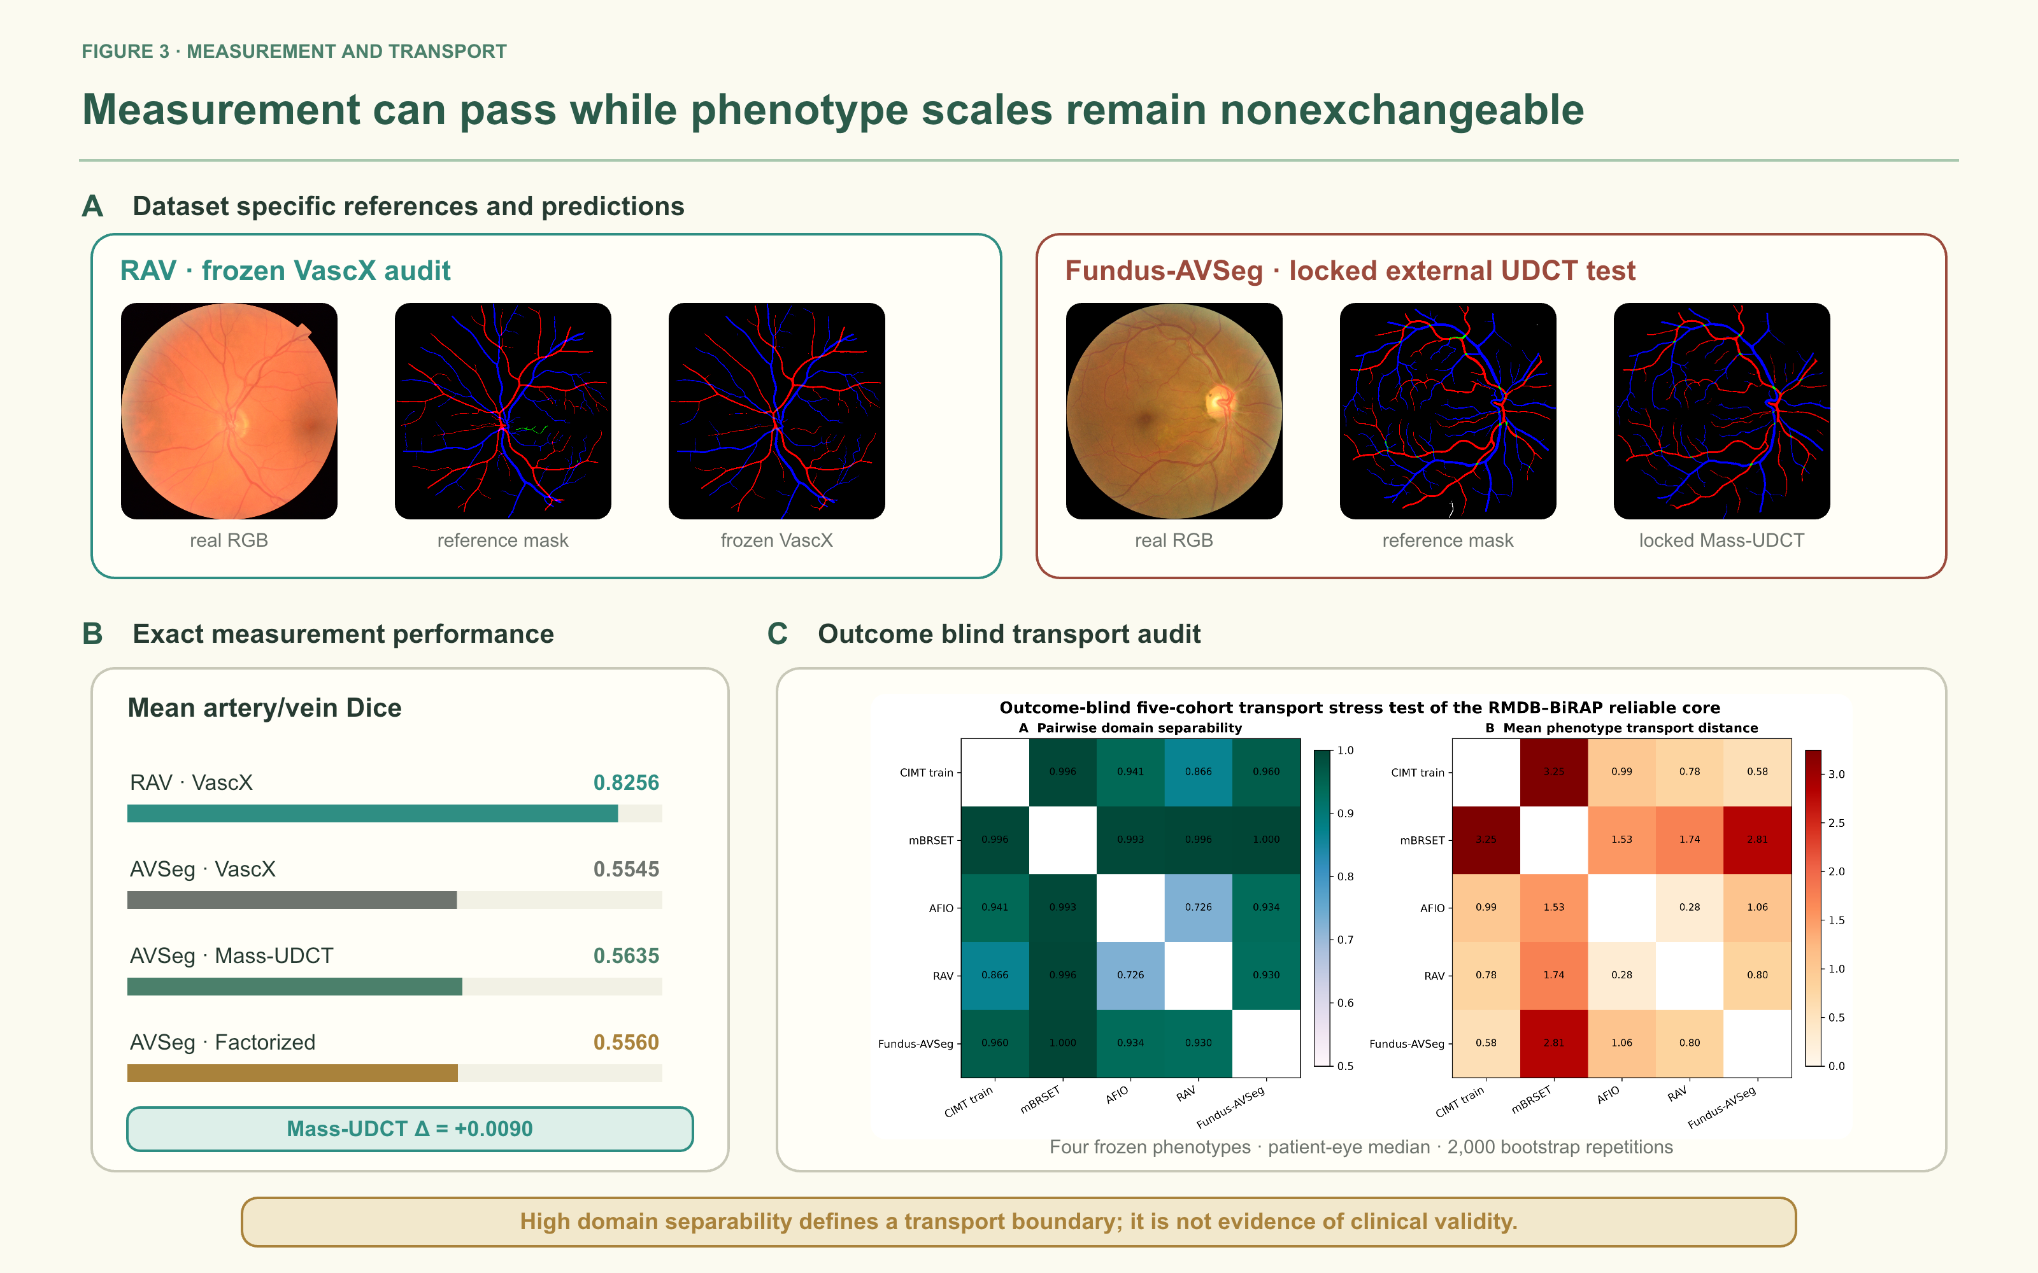
Figure 3. Measurement and outcome blind phenotype transport. Panel A shows a real RAV photograph with its reference mask and frozen VascX output, and a different real Fundus-AVSeg photograph with its reference mask and locked Mass-UDCT output. RAV supports an audit of frozen VascX and method development, whereas Fundus-AVSeg is the locked external UDCT evaluation. Panel B reports exact mean artery/vein Dice values. Panel C reports exact five cohort pairwise domain separability and normalized transport distance matrices for the four reliable phenotypes. Strong cohort separability defines a transport boundary; it is not evidence of clinical validity.
Table 2. External measurement performance and outcome blind phenotype transport. Dice improvement is favourable; domain AUROC near 0.5 and smaller normalized Wasserstein distance indicate greater overlap.
Layer | Comparison/readout | n | Primary estimate | 95% CI | Secondary value | Interpretation
Measurement | RAV · VascX | 206 | Mean A/V Dice 0.8256 | — | Type accuracy 0.8105 | Supported
Measurement | Fundus-AVSeg · VascX | 100 | Mean A/V Dice 0.5545 | — | Vessel Dice 0.5898 | External baseline
Measurement | Fundus-AVSeg · Mass-UDCT | 100 | Δ mean A/V Dice +0.00902 | 0.00792–0.01011 | Mean A/V Dice 0.5635 | Improved; absolute moderate
Measurement | Fundus-AVSeg · Factorized | 100 | Mean A/V Dice 0.5560 | — | A/V ratio error 0.0689 | Complementary
Transport | CIMT–mBRSET | 7,729 eyes | Domain AUROC 0.9958 | 0.9942–0.9973 | W=3.2467 | Strong shift
Transport | CIMT–AFIO | 5,306 eyes | Domain AUROC 0.9412 | 0.9209–0.9581 | W=0.9911 | Strong shift
Transport | CIMT–RAV | 5,412 eyes | Domain AUROC 0.8664 | 0.8382–0.8923 | W=0.7814 | Shift
Transport | CIMT–Fundus-AVSeg | 5,306 eyes | Domain AUROC 0.9605 | 0.9412–0.9766 | W=0.5754 | Strong shift

3.2 Outcome blind repeatability selected four phenotypes
Four of nine prespecified global phenotypes exceeded the ICC(1,1) ≥0.60 threshold. Occupancy disagreement showed the highest reliability (ICC 0.811, 95% CI 0.791–0.829), followed by factorized skeleton density (0.772, 0.752–0.789), mass skeleton density (0.688, 0.665–0.710), and soft vessel mass fraction (0.676, 0.653–0.699).
The other five phenotypes did not meet the gate. Identity entropy reached ICC 0.503, branch density 0.484, soft A/V logarithmic mass ratio 0.384, factorized A/V logarithmic area ratio 0.360, and identity disagreement between base and mass readouts 0.282. These results indicate that global vessel support and geometry were more reproducible than A/V ratio or disagreement between heads quantities under routine repeated view variation.
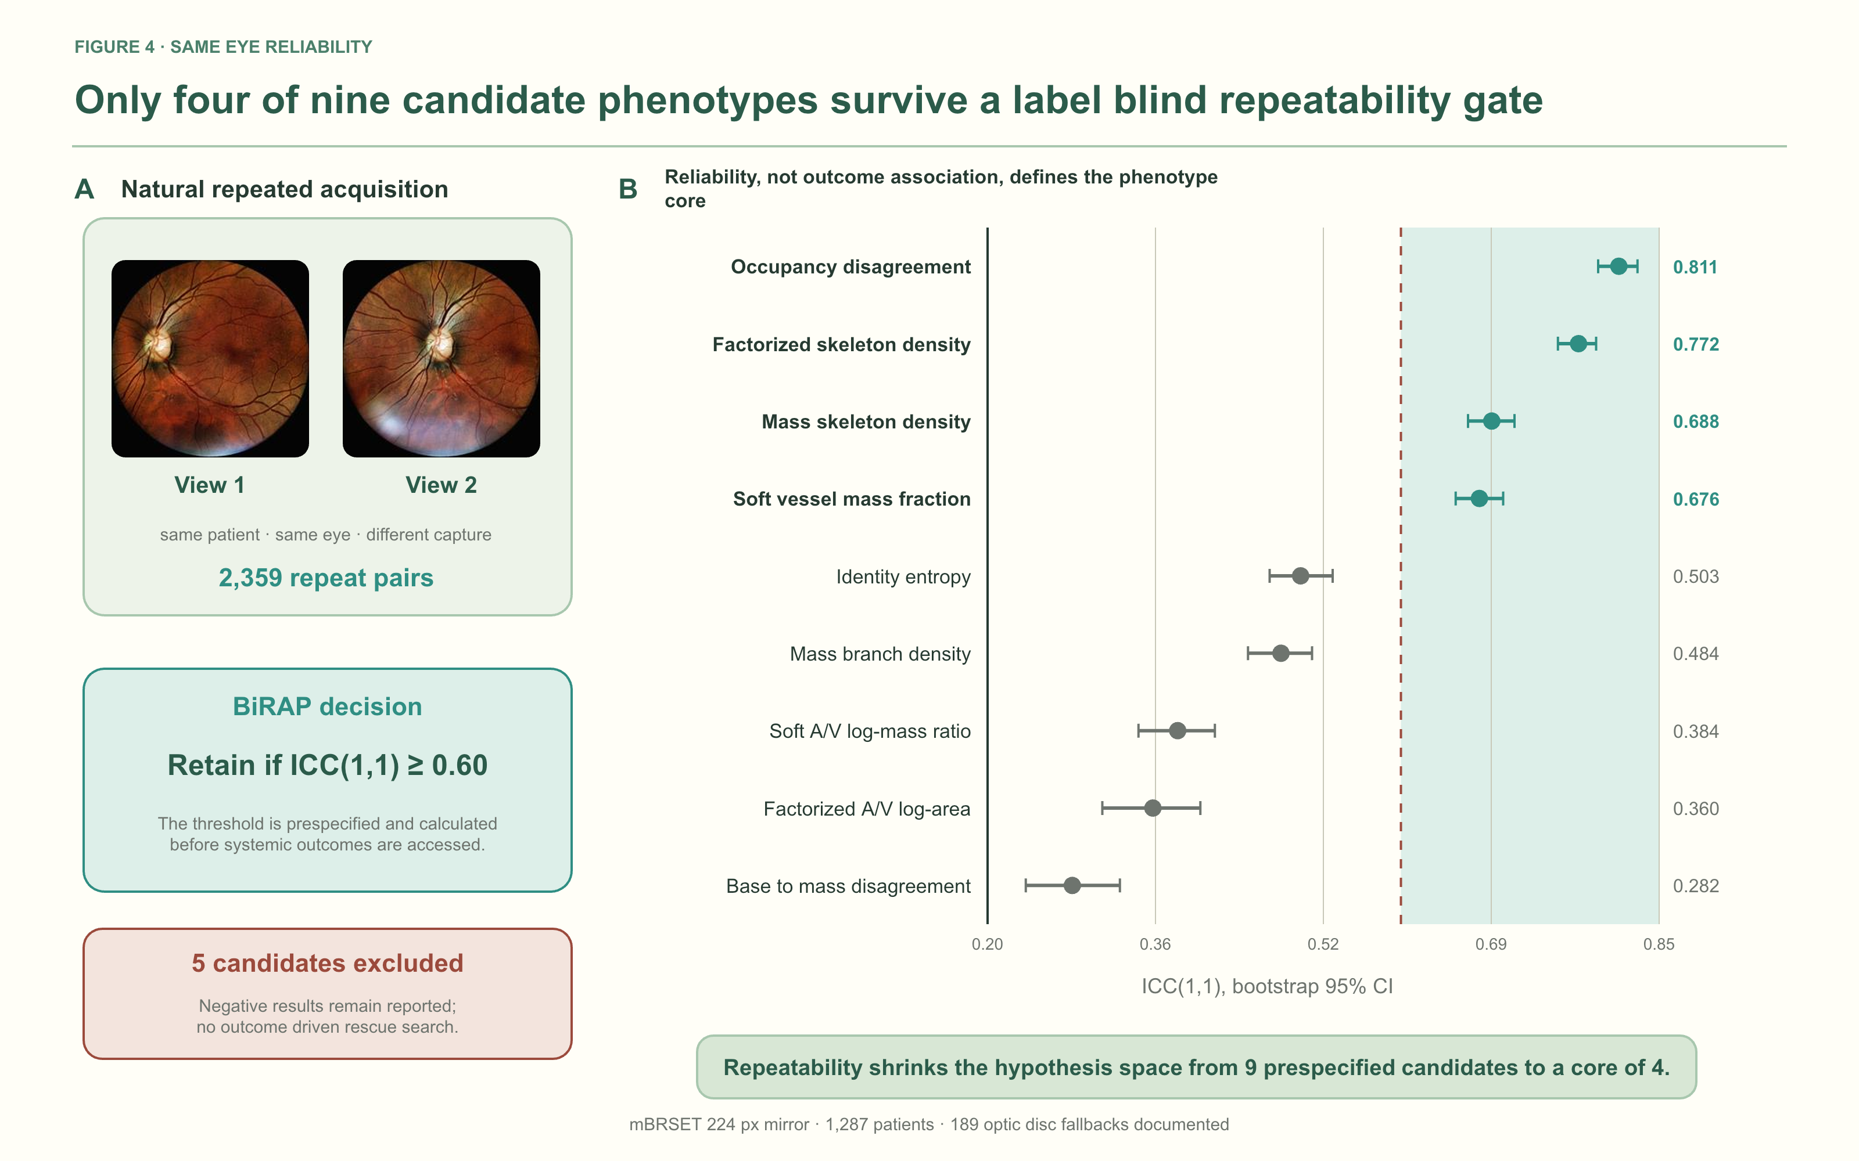
Figure 4. Outcome blind repeatability gate. Panel A shows a real same eye repeated view pair from mBRSET. Panel B reports ICC(1,1) and bootstrap 95% confidence intervals for all nine prespecified global phenotypes. The dashed line marks the fixed ICC=0.60 threshold. Four phenotypes were retained before any hypertension label was used.

3.3 High dimensional dual readout fusion failed to add CIMT value
In 2,603 development patients, the age/sex baseline E0 achieved a CIMT MAE of 0.114558 mm, R² of 0.3536, and AUROC of 0.8521 for the thresholded endpoint. The 104 variable E4 direct dual readout model achieved MAE 0.115435 mm and AUROC 0.8444. Relative to E0, the paired MAE difference was +0.000885 mm (95% CI −0.000259 to +0.002038) and AUROC difference was −0.007615 (95% CI −0.014294 to −0.001073).
E4 was also worse than the mass only E2 model in MAE, AUROC, and AUPRC. Removing Zone B or uncertainty related features produced slightly better point estimates than E4, but their paired confidence intervals against E4 crossed zero. Accordingly, neither Zone B nor entropy/disagreement was supported as a predictive enhancement. The consistent failure of direct fusion motivated conditional modelling rather than additional feature stacking.
3.4 Conditional normative deviation revealed a small development signal
The E7 nonlinear normative model achieved MAE 0.110446 mm. Predicting standardized conditional on age and sex deviation from compact vascular phenotypes reduced MAE to 0.109698 mm, a paired difference of −0.000748 mm (95% CI −0.001369 to −0.000113). All five outer folds improved. The standardized deviation had only weak residual correlation with age (Spearman ρ=0.030), indicating that the principal age trend had been removed.
In the five seed by five fold E8 experiment, double orthogonalization achieved MAE 0.109596±0.000085 mm and improved on the raw mass representation by −0.000186 mm (95% CI −0.000307 to −0.000064). Improvement versus the normative baseline occurred in 24 of 25 outer folds. PCA compression did not improve the double orthogonal model, while bilateral means were sufficient for the simplified accelerated deviation classifier.
The frozen E9 validation contained 200 patients and 43 accelerated deviation positives. The normative model achieved MAE 0.141470 mm and the frozen E8-B model achieved 0.140230 mm. The paired difference was −0.001240 mm (95% CI −0.003464 to 0.001086). The E8-D AUROC was 0.5575 (95% CI 0.4596–0.6567). Thus, direction replicated but strong confirmation criteria were not met. The 100 patient test artifact was not used for RMDB feature selection or model tuning.

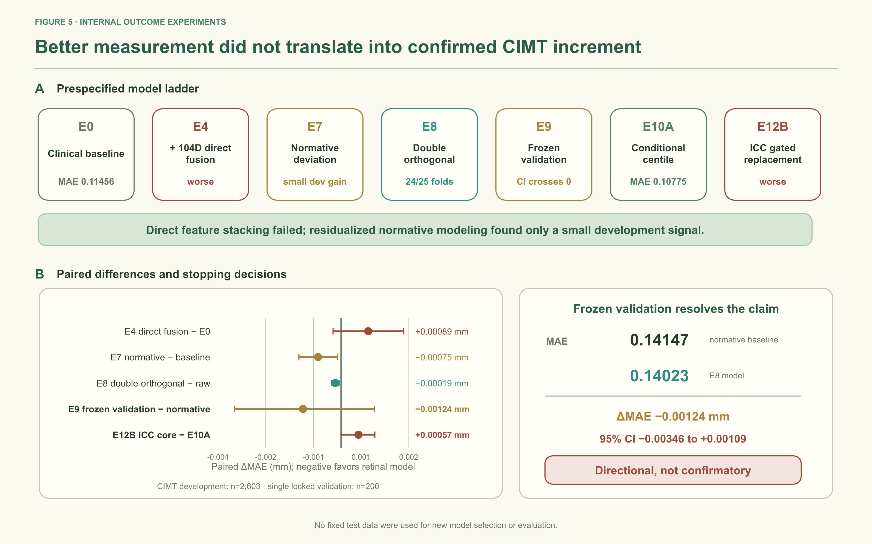
Figure 5. CIMT clinical increment experiments. Panel A summarizes the prespecified development and frozen validation ladder. Panel B reports paired MAE differences and the frozen validation result; negative values favour the retinal model. Double orthogonalization was directionally favourable in 24 of 25 development folds, but its absolute gain was small. In the single locked validation of 200 patients, the direction was preserved while the paired confidence interval crossed zero. The result is therefore directional rather than confirmatory.

3.5 Calibrated mBRSET analyses did not establish incremental hypertension information
Among 1,276 mBRSET patients with complete hypertension analysis, 912 were positive. After cross fitted Platt calibration within outer training sets, the clinical model (age, sex, diabetes duration) had AUROC 0.6651 and Brier score 0.1887; adding the four phenotypes selected by repeatability yielded AUROC 0.6669 and Brier score 0.1892. The paired differences were +0.00188 in AUROC (95% CI −0.00588 to +0.00942) and +0.00050 in Brier score (95% CI −0.00064 to +0.00165). Thus, neither discrimination nor probability error showed a reliable increment from the repeatability core.
The conclusion was unchanged in prespecified sensitivity subsets. In 882 patients without diabetic retinopathy, paired ΔAUROC was −0.00052 (95% CI −0.01021 to +0.00909) and ΔBrier was +0.00062 (95% CI −0.00087 to +0.00214). In 1,105 patients passing strict disc quality control, paired ΔAUROC was +0.00558 (95% CI −0.00327 to +0.01449) and ΔBrier was −0.00017 (95% CI −0.00165 to +0.00135). All intervals crossed the null.
3.6 Negative controls, transport boundaries, and unavailable external pixels
A 200 permutation patient label negative control reran the nested workflow in 1,276 patients. Observed AUROC was 0.6648 for the clinical model and 0.6663 for the reliable core model, exceeding their corresponding null distributions (one sided empirical p=0.005); outer fold patient overlap was zero. This supports implementation integrity and argues against patient leakage, but it does not establish a reliable core clinical increment.
A label blind Fundus-AVSeg quality gate, fixed from CIMT development, passed all 100 external images and did not isolate a higher performing subset. The five cohort transport audit independently showed strong shifts in the retained phenotype scales; its high domain AUROCs prohibit naive between cohort pooling or calibration transfer. The NHANES feasibility audit located public retinal grading and clinical files but no raw retinal pixels in the obtainable release; publicly downloadable NHANES TIFF archives were radiographs and were excluded. These are access and transport findings, not external outcome confirmation.

Figure 6. Patient level results, negative control, and claim boundary. Panel A reports calibrated increments of the reliable core over the clinical model in mBRSET overall and in the prespecified no diabetic retinopathy and strict disc quality analyses; every paired 95% confidence interval crosses zero. Panel B shows the 200 permutation patient label negative control and verifies zero patient overlap between outer folds. Panel C separates supported measurement and repeatability evidence from exploratory clinical analyses and the missing independent high resolution outcome confirmation.
Table 3. Patient level clinical increment experiments and prespecified decisions.
Experiment | Analysis set and comparison | Estimate | 95% CI / context | Decision
CIMT E4 | 2,603 development; 104 variable fusion vs E0 | ΔAUROC −0.007615; ΔMAE +0.000885 mm | AUROC −0.014294 to −0.001073; MAE −0.000259 to +0.002038 | Not supported
CIMT E7 | 2,603 development; normative deviation vs normative mean | ΔMAE −0.000748 mm | −0.001369 to −0.000113 | Development only
CIMT E8 | 2,603; 25 outer folds; double orthogonal vs raw mass | ΔMAE −0.000186 mm; 24/25 favourable | −0.000307 to −0.000064 | Development only
CIMT E9 | 200 frozen validation; frozen E8-B vs normative mean | ΔMAE −0.001240 mm | −0.003464 to +0.001086 | Not confirmed
mBRSET overall | 1,276 patients; clinical + core vs clinical | ΔAUROC +0.00188; ΔBrier +0.00050 | AUROC −0.00588 to +0.00942; Brier −0.00064 to +0.00165 | Not supported
mBRSET no DR | 882 patients; clinical + core vs clinical | ΔAUROC −0.00052 | −0.01021 to +0.00909 | Not supported
mBRSET strict disc | 1,105 patients; clinical + core vs clinical | ΔAUROC +0.00558 | −0.00327 to +0.01449 | Not supported
Permutation control | 1,276 patients; 200 permutations | Empirical p=0.00498 | Zero outer fold patient overlap | Integrity control passed

3.7 Negative experiments defined the stopping rule
Conditional percentile modelling improved development MAE relative to the Gaussian conditional mean head, but increased RMSE and tail error. A nested blend did not meet the prespecified RMSE noninferiority margin. Separately, replacing the mass 5 E10A representation with the outcome blind core selected by ICC worsened MAE. These results show that a reliable measurement is necessary but not sufficient for prediction, and they rule out feature expansion driven by outcomes in the current cohorts.
Most importantly, the disagreement between the conditional mean and conditional percentile heads was not a valid uncertainty proxy. Its correlation with absolute error was −0.032 and its AUROC for large error detection was 0.475. Retaining only low disagreement patients worsened rather than improved MAE. Head disagreement was therefore removed from the reliability claim instead of being presented as post hoc uncertainty.
4. Discussion
4.1 Principal finding: the evidence layers diverged
The central result is a separation, not a leaderboard win. Frozen VascX identity measurement transferred to RAV, the complete RMDB measurement stack improved performance in the locked Fundus-AVSeg audit, four global phenotypes were reproducible across repeated photographs, and AFIO expanded outcome blind measurement transport. Yet frozen FIVES/STARE migration failed, the same four scales remained strongly separable by cohort, and neither direct CIMT fusion nor calibrated mBRSET analysis established clinical increment. Measurement validity, repeatability, transport, and patient level utility therefore cannot substitute for one another.
This divergence explains why apparently strong retrospective retinal models may fail to become usable biomarkers. A biomarker claim requires every link in the chain: a valid measurement under domain shift, a stable patient attribute under reacquisition, and a clinically meaningful increment estimated at the patient level.
4.2 Algorithmic and methodological contribution
The dual readout decomposition is the main algorithmic contribution. Occupancy asks whether vascular support is present; identity asks which vascular class is supported. Mass preservation and occupancy gated factorization then implement two explicit measurement operators rather than hiding their tradeoff inside a single network output. On Fundus-AVSeg, mass preservation improved overlap and type accuracy, whereas factorization minimized A/V ratio error. Disagreement between readouts was highly repeatable, but it was not promoted to calibrated uncertainty—a distinction enforced by the negative uncertainty experiment.
The second contribution is the outcome blind reliability gate. It reduced nine prespecified candidates to four without hypertension, CIMT, or any disease label. Unlike embedded feature importance, repeatability selection tests whether a quantity behaves like a patient attribute under routine acquisition variation. The retained core was dominated by vessel support and skeleton density; A/V ratios, branch density, and entropy were not stable enough to carry the same evidential weight.
The third contribution is a cohort role and evidence firewall. Pixel labels validate measurement only; repeated views define reliability only; cohort identity audits transport without outcomes; and systemic outcomes are accessed only after phenotype definition. This design turns leakage prevention, lack of scale exchangeability, unavailable data audits, and negative experiments into method outputs rather than retrospective caveats.
4.3 Clinical interpretation and limits of increment
The CIMT experiments show why feature quantity is not equivalent to information. Age and sex already explained substantial CIMT variation; adding 104 correlated retinal descriptors increased variance without consistent signal. Conditional target standardization and double orthogonalization revealed a small independent of age development effect, but the frozen interval crossed zero. The correct interpretation is a candidate mechanism for normative deviation, not a clinically useful CIMT estimator.
The mBRSET analysis is now bounded more tightly. Cross fitted Platt calibration reduced probability error for both the clinical and reliable core models, but the reliable core did not contribute a separable improvement in AUROC, AUPRC, Brier score, or log loss. The patient level permutation control supports pipeline integrity, not a clinical association claim. Accordingly, mBRSET contributes external mechanism and repeatability evidence only.
Accordingly, the framework should be viewed as an auditable measurement layer for mechanistic and prospective studies. The present evidence does not support replacing carotid ultrasound, blood pressure measurement, or standard cardiovascular assessment.
4.4 Limitations and confirmatory path
The resources differed in resolution, pathology prevalence, imaging hardware, field definition, and covariate availability. Frozen binary vessel transfer was poor on FIVES and STARE, and the four retained phenotype scales were not exchangeable across all five transport cohorts. Disc localization required fallback in 189 mBRSET images. Repeatability arose from naturally repeated rather than prospectively standardized acquisitions. The mBRSET mirror was limited to 224 pixels and used internal patient level cross validation. The 200 patient CIMT validation set was small and already accessed once; no fixed test data were read for new selection. AFIO lacked one A/V source pair, and the available NHANES release did not provide raw retinal pixels. These constraints prevent a claim of independent external clinical confirmation.
A definitive study should freeze preprocessing, both readouts, the four phenotype core, quality exclusions, and clinical baselines before accessing a new high resolution cohort. Primary discrimination and calibration criteria should be prespecified, with paired patient level confidence intervals and prospective repeatability assessment. If uncertainty is required, it should be calibrated independently using ensembles, conformal intervals, or an external calibration set rather than inferred from disagreement between prediction heads.
5. Conclusion
A retinal vascular feature should not be called a biomarker merely because it can be segmented, repeated, or associated with an outcome. Across seven retinal image resources, RMDB–BiRAP supported portability of frozen VascX identity measurement, locked external evaluation of the complete RMDB measurement stack, and four reproducible global phenotypes. Frozen structure migration, scale exchangeability between cohorts, direct high dimensional fusion, uncertainty based on disagreement, and clinical increment failed their respective gates. The contribution is a reproducible architecture for deciding which retinal measurements can advance to confirmation, while stopping before pixel performance is misreported as biomarker validity.
Declarations
Ethics approval and consent to participate
[Insert institutional review board identifiers, consent status, and data governance statements for the China Fundus–CIMT cohort. Public data use should follow the original cohort licences.]
Data and code availability
Public cohort access should be cited through the original FIVES, RAV, Fundus-AVSeg, AFIO, STARE, mBRSET, and NHANES documentation. Analysis code, frozen manifests, feature dictionaries, fold assignments, transport matrices, and aggregate result files should be archived at submission. Patient level China Fundus–CIMT data availability is subject to the governing ethics approval.
Competing interests
[The authors declare no competing interests / insert disclosures.]
Funding
[Insert funding sources and grant numbers.]
Author contributions
[Insert CRediT author contribution statement.]
References
1. Wong TY, Mitchell P. The eye in hypertension. Lancet. 2007;369:425–435.
2. Poplin R, Varadarajan AV, Blumer K, et al. Prediction of cardiovascular risk factors from retinal fundus photographs via deep learning. Nature Biomedical Engineering. 2018;2:158–164.
3. Ting DSW, Cheung CYL, Lim G, et al. Development and validation of a deep learning system for diabetic retinopathy and related eye diseases using retinal images from multiethnic populations with diabetes. JAMA. 2017;318:2211–2223.
4. Zhou Y, Chia MA, Wagner SK, et al. A foundation model for generalizable disease detection from retinal images. Nature. 2023;622:156–163.
5. McGraw KO, Wong SP. Forming inferences about some intraclass correlation coefficients. Psychological Methods. 1996;1:30–46.
6. Koo TK, Li MY. A guideline of selecting and reporting intraclass correlation coefficients for reliability research. Journal of Chiropractic Medicine. 2016;15:155–163.
7. Steyerberg EW. Clinical Prediction Models. 2nd ed. Springer; 2019.
8. Collins GS, Reitsma JB, Altman DG, Moons KGM. Transparent reporting of a multivariable prediction model for individual prognosis or diagnosis (TRIPOD). Annals of Internal Medicine. 2015;162:55–63.
9. Efron B, Tibshirani RJ. An Introduction to the Bootstrap. Chapman & Hall/CRC; 1993.
10. DeLong ER, DeLong DM, Clarke-Pearson DL. Comparing the areas under two or more correlated receiver operating characteristic curves. Biometrics. 1988;44:837–845.
11. Harrell FE Jr. Regression Modeling Strategies. 2nd ed. Springer; 2015.
12. Riley RD, van der Windt D, Croft P, Moons KGM, editors. Prognosis Research in Healthcare. Oxford University Press; 2019.
13. Jin K, Huang X, Zhou J, et al. FIVES: A Fundus Image Dataset for Artificial Intelligence based Vessel Segmentation. Scientific Data. 2022;9:475. doi:10.1038/s41597-022-01564-3.
14. Vargas Quiros J, Liefers B, van Garderen KA, Vermeulen JP, Eyened Reading Center, Klaver C. Rotterdam artery–vein segmentation (RAV) dataset. arXiv. 2025;arXiv:2512.17322. Dataset doi:10.34894/9OIMWY.
15. Deng Z, Gao W, Gong Z, et al. A Fundus Image Dataset for AI-based Artery-Vein Vessel Segmentation. Scientific Data. 2025;12. doi:10.1038/s41597-025-05381-2. Dataset doi:10.6084/m9.figshare.27938034.v2.
16. Nakayama LF, Ribeiro LZ, Restrepo D, et al. BRSET: A Brazilian Multilabel Ophthalmological Dataset of Retina Fundus Photos. PLOS Digital Health. 2024;3:e0000454. doi:10.1371/journal.pdig.0000454. Dataset doi:10.13026/xcxw-8198.
17. Vargas Quiros J, Liefers B, van Garderen KA, Vermeulen JP, Klaver C. VascX Models: Deep Ensembles for Retinal Vascular Analysis From Color Fundus Images. Translational Vision Science & Technology. 2025;14(7):19. doi:10.1167/tvst.14.7.19.
18. Akram MU, Akbar S, Hassan T, Khawaja SG, Yasin U, Basit I. Data on fundus images for vessels segmentation, detection of hypertensive retinopathy, diabetic retinopathy and papilledema. Data in Brief. 2020;29:105282. doi:10.1016/j.dib.2020.105282. Dataset doi:10.17632/3csr652p9y.2.
19. Hoover A, Kouznetsova V, Goldbaum M. Locating blood vessels in retinal images by piecewise threshold probing of a matched filter response. IEEE Transactions on Medical Imaging. 2000;19:203–210. doi:10.1109/42.845178.
20. National Center for Health Statistics. NHANES 2005–2008 Ophthalmology—Retinal Imaging documentation and data files. Centers for Disease Control and Prevention. Accessed 13 August 2026.

