Supplementary Appendix
Pixel Accuracy Is Not Biomarker Validity: RMDB–BiRAP Across Domains
Transparent negative results, calibration analyses, and confirmation preflight
Supplementary Methods
All after optimization CIMT analyses used only artifacts/manifest.csv split=train (2,603 patients). The fixed CIMT test set was not read. mBRSET analyses were grouped at patient level, and the 224 pixel mirror is interpreted as an external mechanism cohort rather than independent high resolution clinical confirmation.
The quality gate was defined from outcome blind CIMT development phenotype completeness and quantiles before Fundus-AVSeg ground truth was joined. Nested mBRSET calibration used a Platt model cross fitted only within the outer training data. These analyses were secondary and transparent; no new outcome guided feature search was undertaken.
Supplementary Tables
Table S1. CIMT patient level model results and the constrained by repeatability negative experiment.
Model / analysis | n | MAE (mm) | AUROC | Paired comparison | Interpretation
E10A conditional centile | 2,603 | 0.10775 | 0.5550 | vs E10_0: −0.00204 [−0.00282, −0.00124] | development reference
E12B gated by ICC core | 2,603 | 0.10826 | 0.5446 | vs E10A: +0.00057 [+0.00002, +0.00110] | worse; 6/25 not inferior
All values are repeated five seed × 5 fold outer cross validation summaries. Lower MAE is better.
Table S2. mBRSET calibrated reliable core increment over clinical covariates.
Analysis set | n (positive) | ΔAUROC | ΔAUPRC | ΔBrier | Evidence status
Overall | 1,276 (912) | +0.00188 [-0.00588, +0.00942] | -0.00104 [-0.00714, +0.00526] | +0.00049 [-0.00064, +0.00165] | not supported
No diabetic retinopathy | 882 (628) | -0.00052 [-0.01021, +0.00909] | -0.00026 [-0.00735, +0.00683] | +0.00062 [-0.00087, +0.00214] | not supported
Strict disc QC | 1,105 (782) | +0.00558 [-0.00327, +0.01449] | +0.00152 [-0.00723, +0.00980] | -0.00017 [-0.00165, +0.00135] | not supported
R2 − R0; 95% paired bootstrap intervals. Lower Brier is better. All intervals for the primary increment cross zero.
Table S3. Negative, failed, and transport boundary experiments.
Experiment | Result | Conclusion
Between head disagreement | error Spearman −0.032; large error AUROC 0.475 | not a valid uncertainty proxy
Fundus-AVSeg blind QC gate | 100/100 images passed | no external QC separation; branch stopped
Quality overlap transport | domain AUROC: mBRSET 1.000; RAV 0.923; Fundus-AVSeg 0.921 | cohorts not exchangeable; no pooling
Patient label permutation | R0 observed 0.6648; R2 observed 0.6663; p=0.005 | pipeline integrity, not clinical increment
Table S4. Frozen external confirmation preflight.
Required item | Local status | Implication
Independent high resolution images | absent | cannot execute frozen confirmation
Linked patient level outcome | absent | RAV/Fundus-AVSeg are measurement only
MESA manifest + images | BLOCKED_EXTERNAL_DATA | controlled access data not present locally
Permitted confirmation contract | patient_id, image_id, eye, image_path, age, sex, cimt_mm | run frozen E10A once without retuning
Supplementary Figures
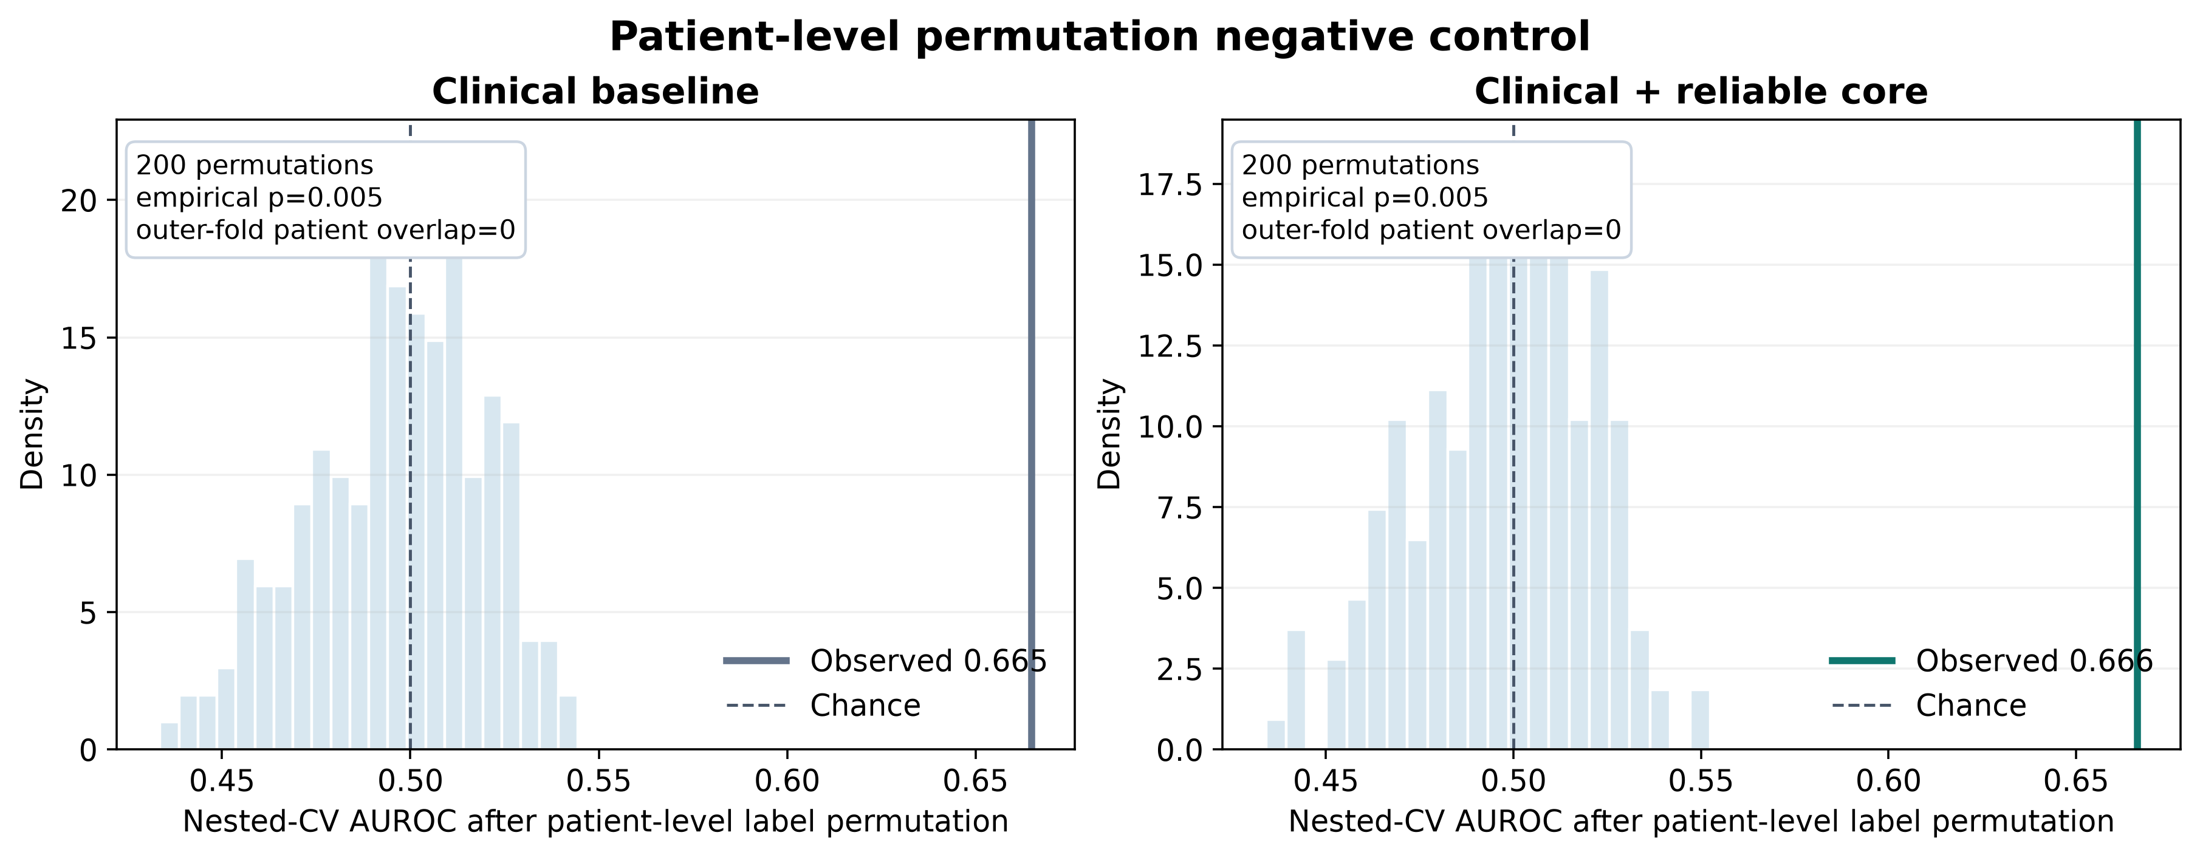
Figure S1. Patient level label permutation negative control. The observed out of fold AUROC values for R0 and R2 exceed their random label null distributions, while the R2–R0 increment remains clinically unsupported.
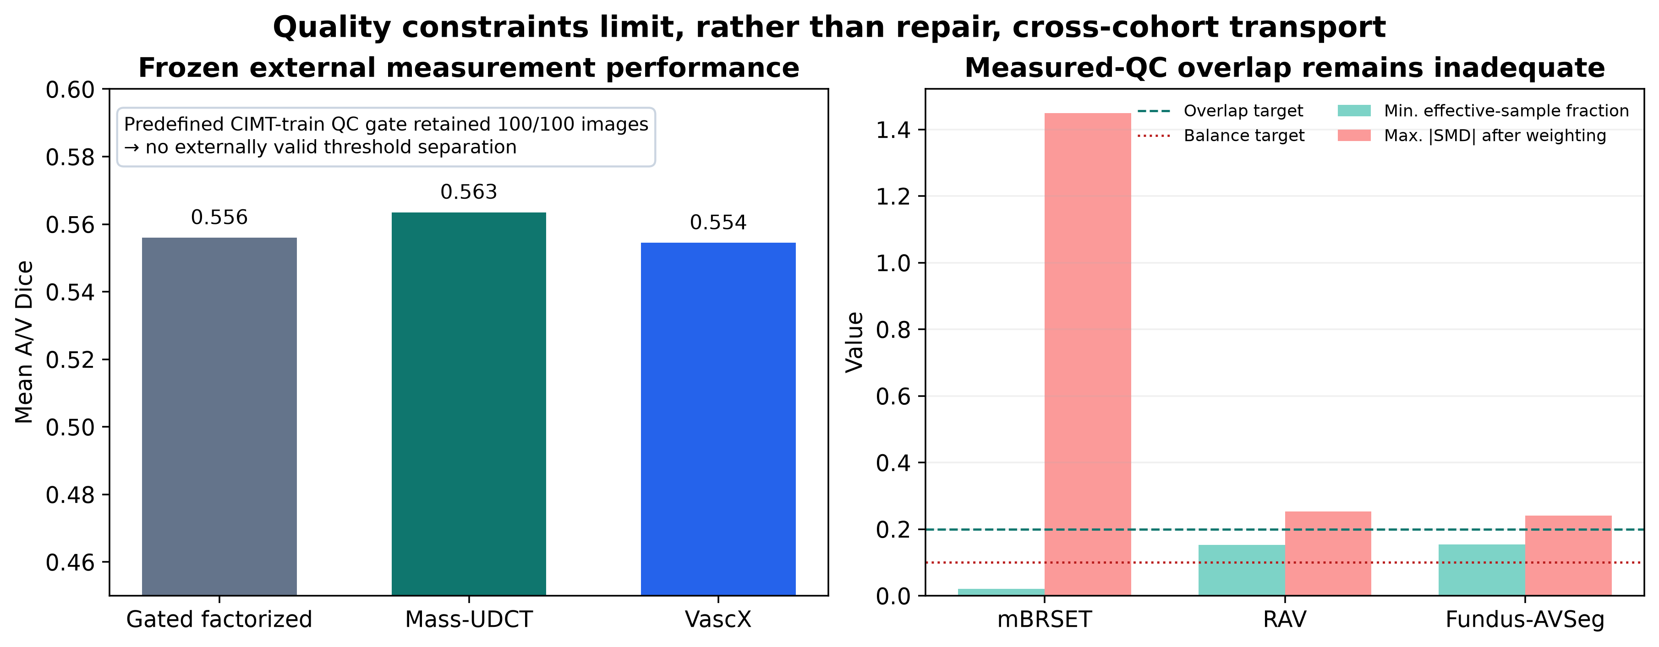
Figure S2. Outcome blind quality gate and phenotype transport audit. The fixed gate did not separate Fundus-AVSeg images, and covariate/quality transport overlap was insufficient for pooled outcome inference.
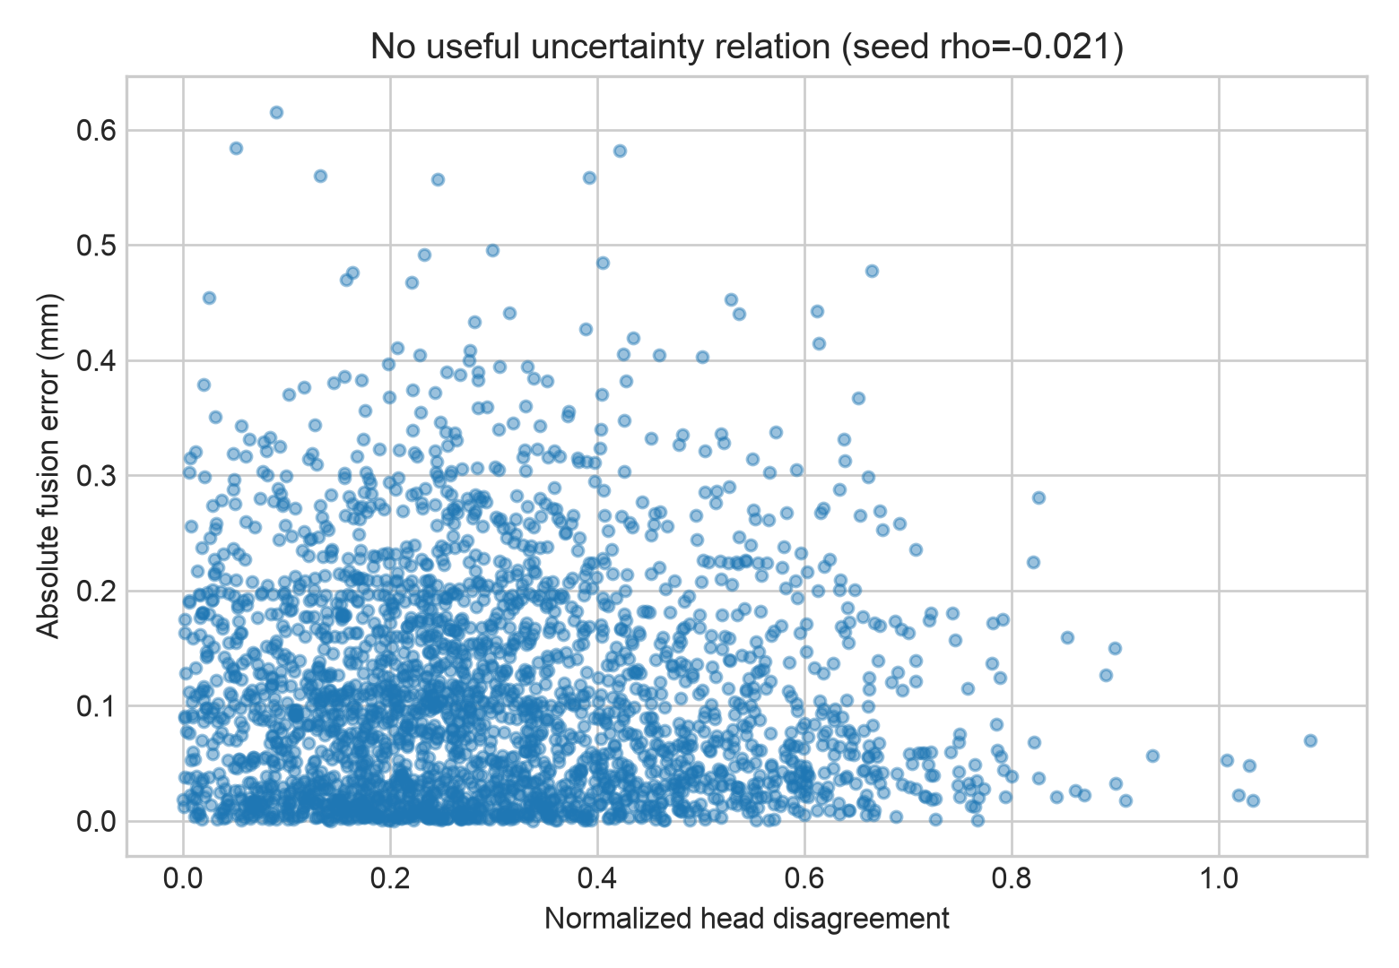
Figure S3. Rejected uncertainty hypothesis. Between head disagreement did not track absolute prediction error and was removed from the uncertainty claim.
Submission readiness items that remain dependent on the authors
Before journal submission, insert author names and affiliations; institutional review board and consent language; data use statements for each source; and verified bibliographic citations for FIVES, RAV, Fundus-AVSeg, mBRSET, and China Fundus–CIMT. These author/governance fields are intentionally not fabricated in this draft.

Supplementary transport and access audits
The following analyses were outcome blind and used only the frozen four phenotype reliable core. CIMT input was restricted to split=train; no CIMT validation or test row and no systemic outcome was read. Repeated views were collapsed to the patient and eye median before domain classification.
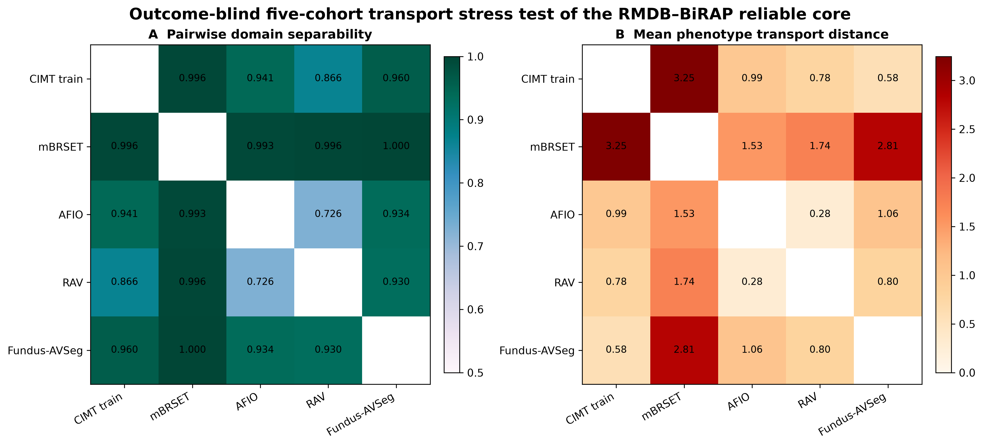
Figure S4. Exact five cohort transport audit. Pairwise grouped by patient domain AUROC and normalized Wasserstein distance show that the four retained phenotype scales remain not exchangeable across image resources.
Table S5. All pairwise five cohort transport results.
Pair | n eyes | Domain AUROC | 95% CI | Mean normalized W | Mean |ΔSpearman|
CIMT train vs mBRSET | 7729 | 0.9958 | 0.9942–0.9973 | 3.2467 | 0.3325
CIMT train vs AFIO | 5306 | 0.9412 | 0.9209–0.9581 | 0.9911 | 0.1319
CIMT train vs RAV | 5412 | 0.8664 | 0.8382–0.8923 | 0.7814 | 0.1143
CIMT train vs Fundus-AVSeg | 5306 | 0.9605 | 0.9412–0.9766 | 0.5754 | 0.0764
mBRSET vs AFIO | 2623 | 0.9931 | 0.9789–0.9999 | 1.5313 | 0.2077
mBRSET vs RAV | 2729 | 0.9962 | 0.9914–0.9997 | 1.7388 | 0.4463
mBRSET vs Fundus-AVSeg | 2623 | 1.0000 | 1.0000–1.0000 | 2.8095 | 0.4082
AFIO vs RAV | 306 | 0.7257 | 0.6690–0.7811 | 0.2814 | 0.2432
AFIO vs Fundus-AVSeg | 200 | 0.9341 | 0.8980–0.9631 | 1.0571 | 0.2083
RAV vs Fundus-AVSeg | 306 | 0.9300 | 0.9026–0.9579 | 0.7997 | 0.0952
Table S6. Frozen structure migration and public pixel feasibility results.
Resource | Analysis | n | Result | Decision
FIVES held out | Frozen binary vessel migration | 200 | Vessel Dice 0.356 | Negative domain shift; no retuning
STARE AH | Frozen binary vessel migration | 20 | Vessel Dice 0.167 | Negative domain shift; no retuning
AFIO | Frozen extraction completeness | 100 | 100 vessel pairs; 99 A/V pairs | One absent source pair left missing
NHANES | Public retinal pixel feasibility | 2,934/3,863 records | Grading/clinical files found; raw retinal pixels unavailable | Not an image cohort

