From Retinal Vessel Maps to Digital Biomarkers: Testing Measurement Validity, Repeatability, Transportability, and Clinical Increment
Kaiwen Deng, Liwei Liu*
School of Railway Intelligent Engineering, Dalian Jiaotong University, Dalian, 116028, China
*Corresponding author
Email: Liwei Liu (liutree80@163.com)

Abstract:
Retinal vascular artificial intelligence is usually judged by the accuracy of a vessel map. Yet a technically convincing map may still yield a quantity that is unstable between repeated photographs, nonexchangeable across imaging domains, or redundant once routine clinical variables are known. This neglected separation means that artery–vein segmentation is not itself validation of a digital biomarker from the retinal vasculature. We therefore tested four complementary evidential dimensions—measurement validity, repeatability, transportability, and clinical increment—without outcome-driven phenotype selection.
We developed RMDB–BiRAP, a measurement-first framework that factorizes vessel occupancy from artery–vein identity, constructs mass-preserving and occupancy-gated readouts, and freezes a phenotype core using same-eye intraclass correlation before any systemic outcome is inspected. FIVES supplied occupancy supervision; RAV and Fundus-AVSeg supplied external pixel references; China Fundus–CIMT supported conditional-deviation development and one-shot frozen validation; and a publicly mirrored 224-pixel mBRSET subset supported repeatability and exploratory patient-grouped nested cross-validation.
Mean artery and vein Dice was 0.8256 on RAV. In locked Fundus-AVSeg evaluation, mass preservation increased mean artery and vein Dice from 0.5545 to 0.5635 (paired difference 0.0090, 95% confidence interval 0.0079 to 0.0101), although diabetic retinopathy and low-quality images remained failure domains. Four of nine prespecified phenotypes reached ICC(1,1) ≥ 0.60 across 2,359 same-eye repeat pairs. Direct fusion of 104 variables worsened CIMT prediction. In calibrated mBRSET analyses, the reliable core did not improve hypertension discrimination or Brier score (ΔAUROC 0.00188, 95% confidence interval −0.00588 to 0.00942), and patient-label permutation controls detected no leakage signal.
The evidence layers diverged: pixel measurement and repeated-view reliability could be demonstrated, but phenotype scales were not directly exchangeable across cohorts and clinical increment was not confirmed. RMDB–BiRAP therefore provides an auditable route from vessel maps to reproducible retinal phenotypes, while defining the point at which the present evidence must stop. Independent high-resolution outcome confirmation remains required before a clinical biomarker claim is justified.
Keywords: retinal vasculature; digital biomarker; artery–vein segmentation; measurement validity; repeatability; transportability; clinical increment; nested cross-validation

1. Introduction
A retinal image can be segmented correctly and still yield the wrong biomarker. Pixel overlap asks whether a model traced the labelled vessel. A biomarker claim asks something harder: whether the resulting quantity survives reacquisition, domain shift, and adjustment for information already available at the bedside. These questions are routinely compressed into one performance number, creating a hidden failure mode between computer vision and clinical inference.
This gap matters because the retina is an accessible window onto systemic microvascular health. Deep learning has linked fundus photographs to cardiovascular and metabolic phenotypes [1–4], yet a high AUROC does not prove that a model measured a stable vascular attribute. It may instead exploit age, acquisition, pigmentation, ocular disease, or camera-specific appearance. Conversely, a segmentation improvement may be statistically real but clinically irrelevant if it does not propagate into a repeatable patient level phenotype.
Conventional multiclass vessel maps further confound two biologically different errors. Missing vascular support answers the question “is a vessel present?”, whereas an artery–vein identity error answers “what kind of vessel is present?”. Treating both as the same class mistake obscures whether failure arises from weak vessel evidence, identity ambiguity, or a mismatch between the two. Downstream feature stacking then magnifies this ambiguity while appearing methodologically sophisticated.
We therefore operationalized four complementary evidential dimensions that answer different questions: pixel-level measurement validity on labelled data, same-eye repeatability under reacquisition, transportability of phenotype scales across imaging domains, and incremental patient-level information beyond clinical covariates. RMDB–BiRAP separates occupancy from identity, creates complementary mass-preserving and factorized vascular readouts, and retains phenotypes by repeated-view reliability before any systemic outcome is used.
The contribution is deliberately falsifiable. We report where evidence survives—external measurement transfer and four reproducible global phenotypes—and where it stops: scale exchangeability across cohorts, direct high-dimensional fusion, uncertainty-by-disagreement, frozen conditional-deviation validation, and calibrated mBRSET clinical increment. The framework is not a claim that fundus imaging replaces carotid ultrasonography or blood-pressure assessment; it is a reproducible method for determining which claims a retinal measurement can support and which remain unproven. Figure 1 summarises the prespecified resource roles, the RMDB–BiRAP workflow, and the boundaries among the four evidential claims.
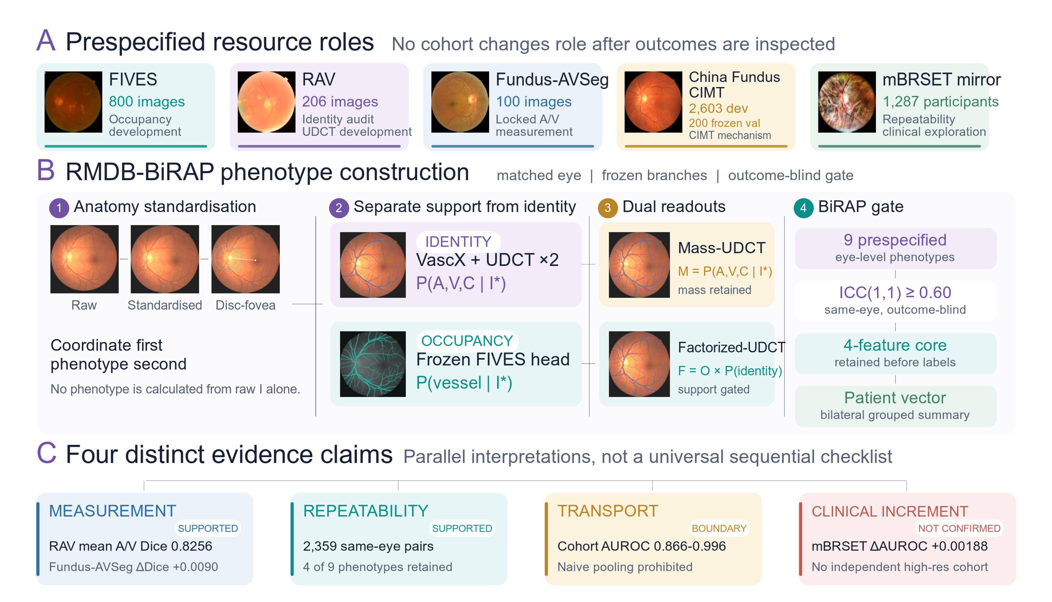
Figure 1. Prespecified evidence architecture and RMDB–BiRAP workflow. (A) FIVES, RAV, Fundus-AVSeg, China Fundus–CIMT, and mBRSET were assigned non-overlapping development, locked measurement, mechanism, repeatability, or clinical-exploration roles. Real study photographs are shown only where recoverable source images were available. (B) Anatomy standardisation precedes separation of vascular identity from vessel support, complementary Mass-UDCT and Factorized-UDCT readouts, and outcome-blind BiRAP retention. (C) Measurement validity, repeatability, transportability, and clinical increment are reported as distinct evidential claims; a phenotype does not advance beyond its strongest demonstrated evidence level.

2. Materials and methods

2.1 Study cohorts and evidence roles
Five data resources had non-overlapping roles before analysis (Table 1). FIVES [13] provided occupancy supervision. RAV [14] and Fundus-AVSeg [15] supplied artery–vein references for cross domain measurement audits. China Fundus–CIMT supplied paired bilateral fundus photographs, age, sex, and CIMT for a separate normative-deviation analysis. The publicly mirrored 224-pixel mBRSET image subset [16], linked to public mBRSET metadata, provided 4,884 images from 1,287 indexed participants and 2,359 same eye repeat pairs for outcome-blind repeatability screening and exploratory patient level analyses. It was not used as independent high resolution clinical confirmation. No outcome label was used to select the phenotype core.
Cohort isolation was treated as part of the method. Pixel labels from RAV and Fundus-AVSeg never entered patient level outcome models. The 2,603-participant China Fundus–CIMT development split supported method development; the 200-participant frozen validation split was not reused for feature search, threshold setting, model selection, or post hoc tuning. No CIMT fixed test data were read or evaluated in this reconstruction. The publicly mirrored mBRSET subset was used only after the phenotype core and reliability threshold had been fixed, and its patient level association analyses are explicitly exploratory.

Table 1. Cohorts, labels, and prespecified analytical roles.
Cohort | Scale | Available labels | Prespecified role | Evidence status
FIVES | 800 images (600 train/200 test) | Binary vessel mask | Occupancy-estimator source | Training/measurement only
RAV | 206 images | Artery and vein masks | Cross-domain identity audit | External measurement
Fundus-AVSeg | 100 images | Vessel/A/V masks; disease; quality | Locked zero tuning validation | External measurement
China Fundus–CIMT | n=2,603 dev.; n=200 frozen val. | Age, sex, bilateral fundus, CIMT | Normative-deviation mechanism | Development and frozen validation
mBRSET mirror | 1,287 participants; 4,884 images; 2,359 same-eye pairs | Repeated views; ocular grades; systemic outcomes | Repeatability and exploratory hypertension analysis | Exploratory; not independent high-resolution confirmation

2.2 Anatomy-aware preprocessing
Fundus photographs were standardized by circular field-of-view handling, colour normalization, and geometry anchoring to the optic disc and fovea. Disc-centred coordinates provided a common frame for global and peripapillary measurements. Zone-specific quantities were calculated only when disc localization passed quality control; global features remained available when zone localization failed.
The preprocessing audit required finite outputs, one-to-one manifest matching, and patient and eye integrity. All 4,884 publicly mirrored mBRSET images completed preprocessing, although 189 images required the documented disc fallback. This frequency was retained as a limitation and motivated sensitivity analyses rather than outcome driven exclusion.

2.3 RMDB module: dual-readout vascular measurement
Terminology conventions. RMDB–BiRAP denotes the complete framework; RMDB denotes its dual-readout measurement module and BiRAP its outcome-blind reliability and patient-aggregation module. The two RMDB outputs are the mass-preserving UDCT readout (Mass-UDCT) and the occupancy-gated factorized UDCT readout (Factorized-UDCT). Phenotypes meeting the prespecified ICC(1,1) threshold comprise the ICC-gated phenotype core.
The occupancy branch estimated P(vessel) from a binary vessel model trained with FIVES supervision. The identity branch produced a four-class vascular representation encoding background, artery, vein, and crossing or uncertain identity. The two branches therefore addressed different questions: whether vascular structure was present and what identity the detected structure carried.
Let x denote a standardized fundus image, z⁽⁰⁾ the frozen four-class VascX logits, H the normalized identity entropy, and D(x) the multiscale Hessian direction field. The UDCT corrector updates only residual logits for two shared-weight iterations:
$z⁽ᵗ⁺¹⁾ = z⁽ᵗ⁾ + αₜ rθ(x, z⁽ᵗ⁾, H(x), D(x)), t = 0, 1.$ (1)
The refinement objective combined pixel classification, vascular topology, directional continuity, residual restraint, A/V mass preservation, and total vessel-mass preservation:
$ℒ = λclsℒcls + λtopℒtop + λdirℒdir + λresℒres + λAVℒAV + λmassℒmass.$ (2)
RMDB produced two complementary readouts. The mass-preserving UDCT readout (Mass-UDCT) retained the calibrated joint four-class probability mass, preserving weak but potentially real vascular evidence. The occupancy-gated factorized UDCT readout (Factorized-UDCT) multiplied vessel occupancy by conditional identity probabilities, producing an occupancy-gated geometry representation. This separation makes it possible to distinguish missing vessel support from identity error and to quantify their disagreement.
The Factorized-UDCT readout combined fixed FIVES occupancy oF with corrected conditional identity. A confidence gate c(x), derived from base identity entropy, interpolated between identity-derived vessel support and the external occupancy estimator; τ=0.525 was fixed before external evaluation:
$Fᵥ(x) = O(x)[c(x)Pᵥ(x|I∗) + \{1 − c(x)\}Ṕᵥ(x|I∗)].$ (3)
Eye-level candidates included soft vessel mass fraction, Mass-UDCT and Factorized-UDCT skeleton-length densities, branch density, artery/vein log ratios, entropy, and cross-readout disagreement. The framework did not assume that disagreement was a calibrated uncertainty score; this interpretation was tested and ultimately rejected in later experiments. Figure 2 details the factorised measurement architecture, complementary readouts, and outcome-blind BiRAP reliability gate.
The two readouts generated interpretable continuous operators over the valid retinal domain Ω. Vessel support, artery–vein balance, and cross-readout disagreement were defined as the three-part equation set (4a–c):
$φmass = |Ω|⁻¹ Σₓ∈Ω [1 − pᴹ₀(x)]$ (4a)
$φA/V = log\{[Σₓ(pᴹ_A + pᴹ_C) + 1] / [Σₓ(pᴹ_V + pᴹ_C) + 1]\}$ (4b)
$φdis = |Ω|⁻¹ Σₓ∈Ω |pᴹ_v(x) − Fᵥ(x)|$ (4c)
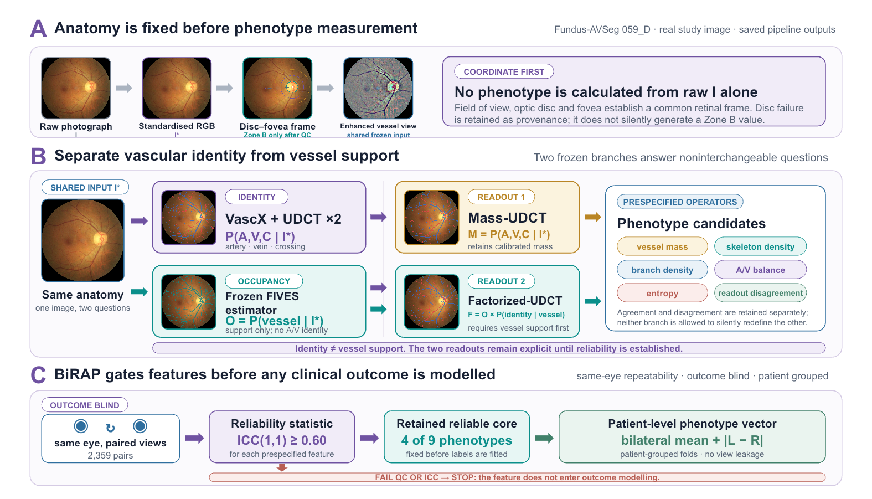
Figure 2. RMDB–BiRAP phenotype construction and outcome-blind reliability gating. (A) A real Fundus-AVSeg image (059_D) is standardised before measurement; optic-disc and foveal landmarks establish the retinal coordinate frame, and Zone B is constructed only when disc quality control passes. (B) Two frozen branches retain the distinction between vascular identity and vessel support. VascX with the two-step UDCT corrector estimates artery, vein, and crossing identity, whereas the FIVES-derived occupancy estimator quantifies vessel support without assigning identity. Mass-UDCT retains calibrated four-class probability mass, whereas Factorized-UDCT requires occupancy support before identity is expressed. Prespecified operators generate candidate phenotypes while retaining entropy and cross-readout disagreement. (C) BiRAP applies ICC(1,1) to 2,359 same-eye repeat pairs before clinical labels are modelled. Four of nine prespecified phenotypes met ICC(1,1) ≥ 0.60 and were aggregated as bilateral patient-level summaries using patient-grouped folds; features failing quality control or repeatability stop before outcome modelling.

2.4 BiRAP module: outcome-blind reliability and patient aggregation
For each patient, eye-level features were summarized using the bilateral mean and the absolute inter-eye difference where both eyes were available. Repeated views were first aggregated within eye when estimating patient level quantities so that image count could not act as a surrogate for outcome.
Reliability was evaluated using 2,359 same eye repeat pairs in mBRSET. Nine global phenotypes were specified before disease-outcome analysis. ICC(1,1) with bootstrap 95% confidence intervals was calculated from the paired views. The retention threshold was fixed at ICC(1,1) ≥ 0.60. Outcome labels and systemic covariates were not used in this selection step. The four retained phenotypes formed the ICC-gated phenotype core.
Reliability was used only as a label blind retention rule. For candidate phenotype j, rⱼ was fixed before any systemic outcome analysis:
$rⱼ = 1\{ICCⱼ(1,1) ≥ 0.60\}.$ (5)
2.5 Prespecified phenotype construction and evidence gating
The prespecified inputs were standardized left and right fundus photographs, frozen VascX identity logits, the frozen FIVES occupancy estimator, and optic-disc metadata. The output was a patient-level, ICC-gated phenotype vector accompanied by an evidence status independent of outcome-driven feature selection.
Phenotype construction proceeded in four fixed stages. First, the field of view was normalized and disc-centred geometry was created only when optic-disc quality control passed. Second, the two-step UDCT residual corrector refined the frozen four-class identity logits. Third, Mass-UDCT preserved the calibrated four-class probability mass, whereas Factorized-UDCT combined the fixed occupancy gate with conditional vascular identity. Fourth, nine prespecified eye-level candidates quantified vessel mass, skeleton and branch density, artery-to-vein balance, entropy, and cross-readout disagreement globally and, when available, within Zone B.
Same-eye ICC(1,1) was estimated before systemic outcomes or clinical covariates were accessed. Candidate j entered the reliable core only when ICC(1,1) ≥ 0.60; excluded candidates were retained as transparent negative results. Repeats were aggregated within eye, followed by bilateral means and absolute inter-eye differences at patient level.
Incremental utility was then evaluated with patient-grouped nested cross-validation and paired patient-level bootstrap intervals. Failure at any evidential dimension bounded the corresponding claim; it did not retroactively invalidate evidence established at an earlier measurement layer.

2.6 Cross-domain measurement evaluation
On RAV, artery Dice, vein Dice, mean artery/vein Dice, type accuracy on ground-truth vessel pixels, and artery/vein ratio error were computed for the identity system. On Fundus-AVSeg, frozen VascX, Mass-UDCT, and Factorized-UDCT were evaluated without training, early stopping, calibration, or threshold selection on the external images. Paired bootstrap confidence intervals were calculated at image level.
Disease and image-quality strata were used to identify failure domains rather than to retune the locked models. This distinction preserves the external status of the validation while still exposing where the measurement system degrades.

2.7 Patient-level modelling, normative deviation, and evidence gating
The direct CIMT experiments used five outer patient folds with three-fold inner tuning and 5,000 paired patient level bootstrap repetitions. E0 included age and sex. E2 and E3 added single-readout phenotype sets; E4 added the 104-dimensional dual-readout set; E5 and E6 removed Zone B and uncertainty-related features, respectively. All decisions through E8 were made without using frozen validation performance or test data for RMDB model selection; the access audit caveat is reported explicitly in the limitations.
Because direct fusion primarily recapitulated age, E7 estimated an age- and sex-conditional normative CIMT mean and scale within each training fold. Out-of-fold standardized deviation was then predicted from compact vascular phenotypes. E8 additionally removed the age/sex expectation from each phenotype inside the outer training fold (double orthogonalization) and repeated the outer cross-fitting across five fixed seeds. The selected E8-B regression model and E8-D classification model were frozen before the one shot E9 validation.
To prevent age and sex from masquerading as retinal vascular signal, both CIMT and each retinal phenotype were residualized using estimators fitted only in the corresponding outer-training fold (subscript −k). CIMT was reconstructed on its original scale after predicting conditional deviation:
$dᵢ = [yᵢ − μ̂₋ₖ(aᵢ, sᵢ)] / σ̂₋ₖ(aᵢ, sᵢ).$ (6)
For exploratory mBRSET hypertension analysis, the clinical baseline contained age, sex, and diabetes duration. The phenotype-core augmented model added the ICC-selected phenotype core to the clinical baseline. Patient-grouped nested cross-validation produced out of fold probabilities. A transparently labelled secondary calibration rerun used outer-training cross fitted Platt calibration and paired bootstrap comparisons to determine whether any probability improvement was specific to the vascular core rather than to calibration itself.

2.8 Reporting hierarchy
Evidence was classified as supported, exploratory, or not supported. Cross-domain pixel validity and outcome-blind repeatability were supported when prespecified criteria were met. Patient-level signals were exploratory unless reproduced in an independent, appropriately resolved cohort. A favourable point estimate with a confidence interval crossing the null was not called confirmation. New analyses used only the CIMT train split; no fixed CIMT test was read.

3. Results

3.1 Cross-domain measurement validity was heterogeneous
All 206 RAV images were evaluated. Mean artery Dice was 0.8119, mean vein Dice was 0.8393, mean artery/vein Dice was 0.8256, and type accuracy on ground-truth vessels was 0.8105. No global artery–vein identity swaps were observed. These values support transfer of vascular identity measurement to RAV.
The locked Fundus-AVSeg evaluation included all 100 images. VascX achieved vessel Dice 0.5898 and mean artery/vein Dice 0.5545. The mass-preserving readout increased these values to 0.6019 and 0.5635, respectively. The paired mean artery/vein Dice difference was 0.00902 (95% CI 0.00792–0.01011), and all 100 images improved. The factorized readout achieved the lowest artery/vein ratio log error (0.0689) but only a smaller mean artery/vein Dice improvement, illustrating complementary rather than interchangeable readouts.
Absolute external performance remained moderate and strongly heterogeneous. For the Mass-UDCT readout, mean artery/vein Dice was 0.5743 in normal images, 0.5844 in AMD, 0.5808 in glaucoma, and 0.5037 in diabetic retinopathy. High-quality images achieved 0.5783 versus 0.4914 in low quality images.
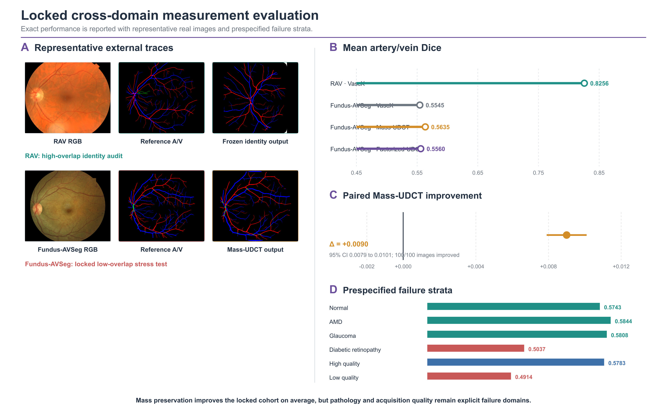
Figure 3. Locked cross-domain measurement evaluation. (A) Representative real RAV and Fundus-AVSeg images, references, and frozen outputs. (B) Exact mean artery/vein Dice. (C) Paired Mass-UDCT improvement on all 100 Fundus-AVSeg images. (D) Prespecified pathology and image-quality strata. Models were not retuned on external labels.
Table 2. External measurement performance. Lower is better only for A/V ratio log error.
Cohort | Readout | Vessel Dice | Artery Dice | Vein Dice | Mean A/V Dice | Type accuracy | A/V ratio error
RAV | VascX | — | 0.8119 | 0.8393 | 0.8256 | 0.8105 | 0.0716
Fundus-AVSeg | VascX | 0.5898 | 0.5461 | 0.5629 | 0.5545 | 0.5057 | 0.0713
Fundus-AVSeg | Mass-UDCT | 0.6019 | 0.5553 | 0.5716 | 0.5635 | 0.5328 | 0.0706
Fundus-AVSeg | Factorized-UDCT | 0.5929 | 0.5479 | 0.5640 | 0.5560 | 0.5059 | 0.0689

3.2 Outcome-blind repeatability selected four phenotypes
Four of nine prespecified global phenotypes exceeded the ICC(1,1) ≥ 0.60 threshold. Occupancy disagreement showed the highest reliability (ICC 0.811, 95% CI 0.791–0.829), followed by Factorized-UDCT skeleton density (0.772, 0.752–0.789), Mass-UDCT skeleton density (0.688, 0.665–0.710), and soft vessel mass fraction (0.676, 0.653–0.699).
The other five phenotypes did not meet the gate. Identity entropy reached ICC 0.503, branch density 0.484, soft A/V log-mass ratio 0.384, factorized A/V log-area ratio 0.360, and base-to-mass identity disagreement 0.282. These results indicate that global vessel support and geometry were more reproducible than A/V ratio or head-disagreement quantities under routine repeated-view variation.
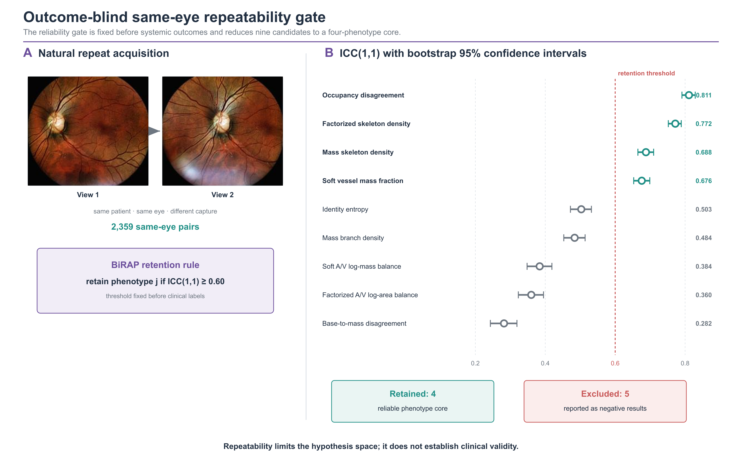
Figure 4. Outcome-blind same-eye repeatability. (A) Representative repeated views from the same mBRSET eye. (B) ICC(1,1) with bootstrap 95% confidence intervals for all nine candidates. The prespecified threshold retained four candidates and excluded five before any systemic outcome was accessed.
Table 3. Label-blind repeated-view reliability and phenotype retention.
Phenotype | Measurement interpretation | ICC(1,1) | 95% CI | Decision
Occupancy disagreement | Existence-readout mismatch | 0.811 | 0.791–0.829 | Retain
Factorized-UDCT skeleton density | Occupancy-gated geometry | 0.772 | 0.752–0.789 | Retain
Mass-UDCT skeleton density | Mass-preserving geometry | 0.688 | 0.665–0.710 | Retain
Soft vessel mass fraction | Continuous vessel support | 0.676 | 0.653–0.699 | Retain
Identity entropy | Identity ambiguity | 0.503 | 0.473–0.534 | Exclude
Mass branch density | Topological complexity | 0.484 | 0.452–0.514 | Exclude
Soft A/V log-mass ratio | Soft identity balance | 0.384 | 0.346–0.420 | Exclude
Factorized-UDCT A/V log-area ratio | Gated identity balance | 0.360 | 0.311–0.406 | Exclude
Base-to-mass disagreement | Identity-head mismatch | 0.282 | 0.237–0.328 | Exclude

3.3 High-dimensional dual-readout fusion failed to add CIMT value
In 2,603 development patients, the age/sex baseline E0 achieved a CIMT MAE of 0.114558 mm, R² of 0.3536, and AUROC of 0.8521 for the thresholded endpoint. The 104-variable E4 direct dual-readout model achieved MAE 0.115435 mm and AUROC 0.8444. Relative to E0, the paired MAE difference was +0.000885 mm (95% CI −0.000259 to +0.002038) and AUROC difference was −0.007615 (95% CI −0.014294 to −0.001073).
E4 was also worse than the mass-only E2 model in MAE, AUROC, and AUPRC. Removing Zone B or uncertainty-related features produced slightly better point estimates than E4, but their paired confidence intervals against E4 crossed zero. Accordingly, neither Zone B nor entropy/disagreement was supported as a predictive enhancement. The consistent failure of direct fusion motivated conditional modelling rather than additional feature stacking.

3.4 Conditional normative deviation revealed a small development signal
The E7 nonlinear normative model achieved MAE 0.110446 mm. Predicting standardized age/sex-conditional deviation from compact vascular phenotypes reduced MAE to 0.109698 mm, a paired difference of −0.000748 mm (95% CI −0.001369 to −0.000113). All five outer folds improved. The standardized deviation had only weak residual correlation with age (Spearman ρ=0.030), indicating that the principal age trend had been removed.
In the five-seed by five-fold E8 experiment, double orthogonalization achieved MAE 0.109596±0.000085 mm and improved on the raw mass representation by −0.000186 mm (95% CI −0.000307 to −0.000064). Improvement versus the normative baseline occurred in 24 of 25 outer folds. PCA compression did not improve the double-orthogonal model, while bilateral means were sufficient for the simplified accelerated-deviation classifier.
The frozen E9 validation contained 200 patients and 43 accelerated-deviation positives. The normative model achieved MAE 0.141470 mm and the frozen E8-B model achieved 0.140230 mm. The paired difference was −0.001240 mm (95% CI −0.003464 to 0.001086). The E8-D AUROC was 0.5575 (95% CI 0.4596–0.6567). Thus, direction replicated but strong confirmation criteria were not met. The 100-patient test artifact was not used for RMDB feature selection or model tuning.

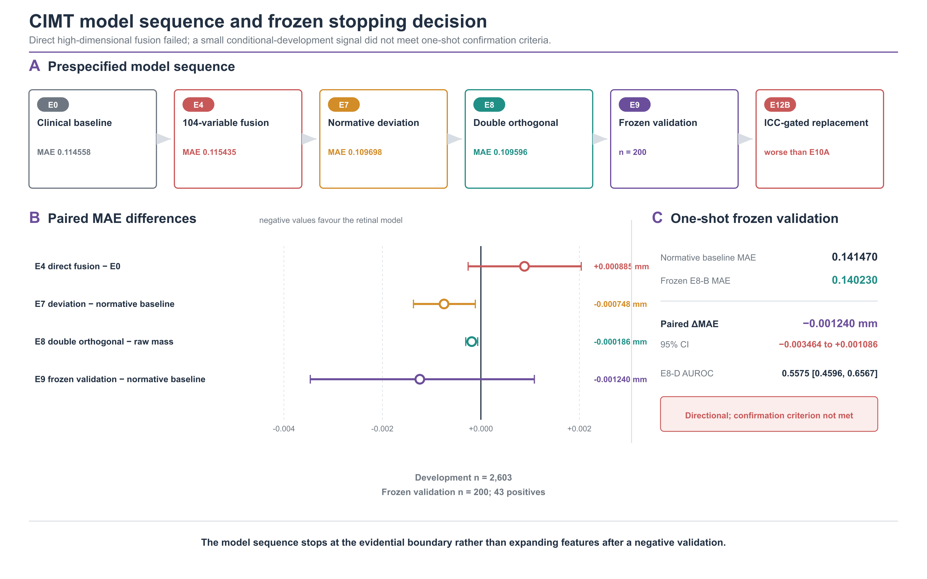
Figure 5. CIMT model sequence and stopping decision. (A) Prespecified progression from the clinical baseline to direct fusion, conditional deviation, double orthogonalisation, frozen validation, and reliability-gated replacement. (B) Paired MAE differences; negative values favour the retinal model. (C) The one-shot E9 validation reproduced direction but not the confirmation criterion.

3.5 Exploratory mBRSET analyses did not establish incremental hypertension information
Among 1,276 mBRSET patients with complete hypertension analysis, 912 were positive. After outer-training cross fitted Platt calibration, the clinical model (age, sex, diabetes duration) had AUROC 0.6651 and Brier score 0.1887; adding the ICC-gated phenotype core yielded AUROC 0.6669 and Brier score 0.1892. The paired differences were +0.00188 in AUROC (95% CI −0.00588 to +0.00942) and +0.00050 in Brier score (95% CI −0.00064 to +0.00165). Thus, neither discrimination nor probability error showed a reliable phenotype-core increment.
The conclusion was unchanged in prespecified sensitivity subsets. In 882 patients without diabetic retinopathy, paired ΔAUROC was −0.00052 (95% CI −0.01021 to +0.00909) and ΔBrier was +0.00062 (95% CI −0.00087 to +0.00214). In 1,105 patients passing strict disc-quality control, paired ΔAUROC was +0.00558 (95% CI −0.00327 to +0.01449) and ΔBrier was −0.00017 (95% CI −0.00165 to +0.00135). All intervals crossed the null.

3.6 Negative controls and transport boundaries
A 200-permutation patient-label negative control reran the nested workflow in 1,276 patients. Observed AUROC was 0.6648 for the clinical model and 0.6663 for the phenotype-core–augmented model, exceeding their corresponding null distributions (one-sided empirical p=0.005); outer-fold patient overlap was zero. This supports implementation integrity and argues against patient leakage, but it does not establish a phenotype-core clinical increment.
A label blind Fundus-AVSeg quality gate, fixed from the CIMT development split, passed all 100 external images and therefore did not separate a usable from an unusable measurement subset. Quality-overlap transport analyses also failed the prespecified exchangeability thresholds across mBRSET, RAV, and Fundus-AVSeg. These negative results prohibit pooling the cohorts or presenting measurement transfer as outcome confirmation.

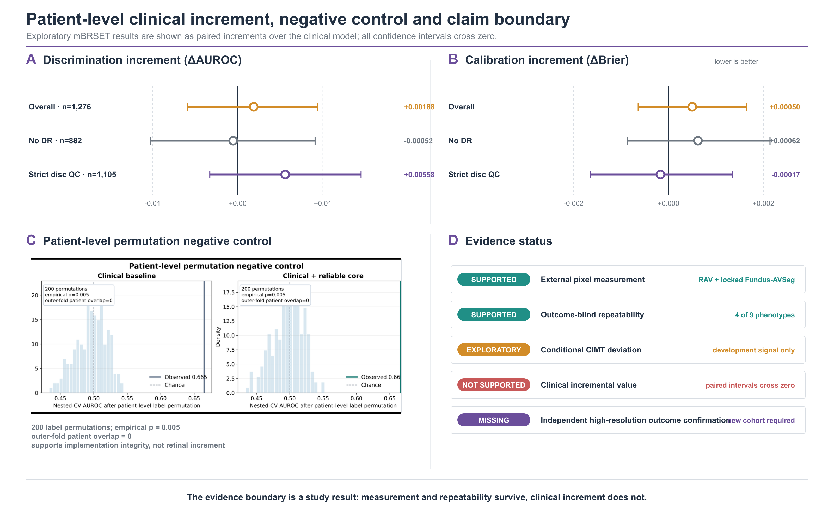
Figure 6. Patient-level clinical increment and evidence boundary. (A, B) Paired AUROC and Brier increments for the reliable core over the clinical model in mBRSET overall and sensitivity analyses. (C) Patient-level permutation negative control. (D) Final evidence status. All increment intervals crossed zero; the permutation test supports implementation integrity only.

3.7 Negative experiments defined the stopping rule
Conditional-percentile modelling improved development MAE relative to the Gaussian conditional-mean head, but increased RMSE and tail error. A nested blend did not meet the prespecified RMSE non-inferiority margin. Separately, replacing the mass-5 E10A representation with the outcome-blind ICC-gated phenotype core worsened MAE. These results show that a reliable measurement is necessary but not sufficient for prediction, and they rule out outcome driven feature expansion in the current cohorts.
A high-resolution residual domain-generalization branch was extended to 12 epochs to test whether the limited external gain reflected undertraining; checkpoint selection remained restricted to development data. The best checkpoint remained epoch 5. It achieved mean artery/vein Dice 0.8266 on the RAV development split versus 0.8446 for the frozen reference, FIVES vessel Dice 0.8136, and Dice 0.6038 on a seven-image retrospective device stress set versus 0.6042 for the frozen baseline. Because discrimination did not improve consistently and probability calibration worsened slightly, the branch was stopped. The seven-image stress result is descriptive only.
Most importantly, the disagreement between the conditional-mean and conditional-percentile heads was not a valid uncertainty proxy. Its correlation with absolute error was −0.032 and its AUROC for high-error detection was 0.475. Retaining only low-disagreement patients worsened rather than improved MAE. Head disagreement was therefore removed from the reliability claim instead of being presented as post hoc uncertainty.

4. Discussion

4.1 Principal finding: the evidence layers diverged
The central result is a separation, not a leaderboard win. Retinal vascular measurement transferred across external pixel-labelled cohorts and four global phenotypes were reproducible across repeated photographs, yet these successes did not translate into robust clinical increment. Direct high dimensional fusion worsened CIMT performance; the conditional-deviation signal was small; and calibrated mBRSET phenotype-core increments crossed the null overall and in sensitivity analyses. Measurement validity, repeatability, and clinical utility were empirically distinct.
This divergence explains why apparently strong retrospective retinal models may fail to become usable biomarkers. A biomarker claim requires every link in the chain: a valid measurement under domain shift, a stable patient attribute under reacquisition, and a clinically meaningful increment estimated at the patient level.

4.2 Algorithmic and methodological contribution
The dual-readout decomposition is the main algorithmic contribution. Occupancy asks whether vascular support is present; identity asks which vascular class is supported. Mass preservation and occupancy-gated factorization then implement two explicit measurement operators rather than hiding their trade-off inside a single network output. On Fundus-AVSeg, mass preservation improved overlap and type accuracy, whereas factorization minimized A/V ratio error. Cross-readout disagreement was highly repeatable, but it was not promoted to calibrated uncertainty—a distinction enforced by the negative uncertainty experiment.
The second contribution is the outcome-blind reliability gate. It reduced nine prespecified candidates to four without hypertension, CIMT, or any disease label. Unlike embedded feature importance, repeatability selection tests whether a quantity behaves like a patient attribute under routine acquisition variation. The retained core was dominated by vessel support and skeleton density; A/V ratios, branch density, and entropy were not stable enough to carry the same evidential weight.
The third contribution is the cohort-role firewall. Pixel labels validated measurement only, repeated images defined reliability only, and systemic outcomes were accessed only after phenotype definition. This design turns leakage prevention and negative findings into parts of the method rather than retrospective caveats.

4.3 Clinical interpretation and limits of increment
The CIMT experiments show why feature quantity is not equivalent to information. Age and sex already explained substantial CIMT variation; adding 104 correlated retinal descriptors increased variance without consistent signal. Conditional target standardization and double orthogonalization revealed a small age-independent development effect, but the frozen interval crossed zero. The correct interpretation is a candidate mechanism for normative deviation, not a clinically useful CIMT estimator.
The mBRSET analysis is now bounded more tightly. Cross-fitted Platt calibration reduced probability error for both the clinical and phenotype-core–augmented models, but the ICC-gated phenotype core did not contribute a separable improvement in AUROC, AUPRC, Brier score, or log loss. The patient level permutation control supports pipeline integrity, not a clinical association claim. Accordingly, mBRSET contributes external mechanism and repeatability evidence only.
Accordingly, the framework should be viewed as an auditable measurement layer for mechanistic and prospective studies. The present evidence does not support replacing carotid ultrasound, blood-pressure measurement, or standard cardiovascular assessment.

4.4 Limitations and confirmatory path
The cohorts differed in resolution, pathology prevalence, imaging hardware, and covariate availability. Disc localization required fallback in 189 mBRSET images. Repeatability arose from naturally repeated rather than prospectively standardized acquisitions. The mBRSET resource was a publicly mirrored, quality-filtered 224-pixel image subset that omitted 280 official image records, disproportionately records labelled low quality. It cannot substitute for independent high resolution outcome confirmation. The clinical analyses were exploratory and constrained by label prevalence, calibration sensitivity, and available covariates. The study did not establish causal relations, future vascular events, or clinical utility.
A definitive study should freeze preprocessing, both readouts, the ICC-gated phenotype core, quality exclusions, and clinical baselines before accessing a new high resolution cohort. Primary discrimination and calibration criteria should be prespecified, with paired patient level confidence intervals and prospective repeatability assessment. If uncertainty is required, it should be calibrated independently using ensembles, conformal intervals, or an external calibration set rather than inferred from disagreement between prediction heads.

5. Conclusion
A retinal vascular feature does not become a clinical biomarker merely because its source map is accurate or its association is statistically detectable. Across five core cohorts, RMDB–BiRAP supported external pixel measurement and four reproducible global phenotypes, while cross-cohort scale differences, direct high-dimensional fusion, a head-disagreement uncertainty proxy, the 12-epoch residual optimization branch, reliability-gated representation replacement, and calibrated mBRSET increment all failed to justify a stronger clinical claim. The contribution is an auditable route from measurable pixels to reproducible phenotypes, together with a transparent stopping rule until frozen confirmation in an independent high-resolution outcome cohort becomes possible.
Declarations
Ethics approval and consent to participate
This work analysed de-identified or publicly released data and involved no new participant recruitment or intervention. The source China Fundus–CIMT study remains governed by its original ethics approval and data-use agreement. Public resources were used according to their respective terms of access. The specific institutional review-board identifier and consent statement must be confirmed by the corresponding author before submission.
Data and code availability
Public cohort access should be cited through the original FIVES, RAV, Fundus-AVSeg, and mBRSET repositories. The reproducibility archive will contain analysis code, frozen manifests, feature dictionaries, fold assignments, and aggregate result files. The publicly mirrored mBRSET images are not redistributed by the authors. Patient-level China Fundus–CIMT data cannot be deposited without source data-governance permission.
Competing interests
[To be confirmed by all authors before submission.]
Funding
[To be completed by the corresponding author before submission.]
Author contributions
[To be completed and approved by all authors before submission.]

References
[1] Wong TY, Mitchell P. The eye in hypertension. Lancet. 2007;369:425–435.
[2] Poplin R, Varadarajan AV, Blumer K, et al. Prediction of cardiovascular risk factors from retinal fundus photographs via deep learning. Nature Biomedical Engineering. 2018;2:158–164.
[3] Ting DSW, Cheung CYL, Lim G, et al. Development and validation of a deep learning system for diabetic retinopathy and related eye diseases using retinal images from multiethnic populations with diabetes. JAMA. 2017;318:2211–2223.
[4] Zhou Y, Chia MA, Wagner SK, et al. A foundation model for generalizable disease detection from retinal images. Nature. 2023;622:156–163.
[5] McGraw KO, Wong SP. Forming inferences about some intraclass correlation coefficients. Psychological Methods. 1996;1:30–46.
[6] Koo TK, Li MY. A guideline of selecting and reporting intraclass correlation coefficients for reliability research. Journal of Chiropractic Medicine. 2016;15:155–163.
[7] Steyerberg EW. Clinical Prediction Models. 2nd ed. Springer; 2019.
[8] Collins GS, Reitsma JB, Altman DG, Moons KGM. Transparent reporting of a multivariable prediction model for individual prognosis or diagnosis (TRIPOD). Annals of Internal Medicine. 2015;162:55–63.
[9] Efron B, Tibshirani RJ. An Introduction to the Bootstrap. Chapman & Hall/CRC; 1993.
[10] DeLong ER, DeLong DM, Clarke-Pearson DL. Comparing the areas under two or more correlated receiver operating characteristic curves. Biometrics. 1988;44:837–845.
[11] Harrell FE Jr. Regression Modeling Strategies. 2nd ed. Springer; 2015.
[12] Riley RD, van der Windt D, Croft P, Moons KGM, editors. Prognosis Research in Healthcare. Oxford University Press; 2019.
[13] Jin K, Huang X, Zhou J, et al. FIVES: A Fundus Image Dataset for Artificial Intelligence based Vessel Segmentation. Scientific Data. 2022;9:475. doi:10.1038/s41597-022-01564-3.
[14] Vargas Quiros J, Liefers B, van Garderen KA, Vermeulen JP, Eyened Reading Center, Klaver C. Rotterdam artery–vein segmentation (RAV) dataset. arXiv. 2025;arXiv:2512.17322. Dataset doi:10.34894/9OIMWY.
[15] Deng Z, Gao W, Gong Z, et al. A Fundus Image Dataset for AI-based Artery-Vein Vessel Segmentation. Scientific Data. 2025;12. doi:10.1038/s41597-025-05381-2. Dataset doi:10.6084/m9.figshare.27938034.v2.
[16] Nakayama LF, Ribeiro LZ, Restrepo D, et al. BRSET: A Brazilian Multilabel Ophthalmological Dataset of Retina Fundus Photos. PLOS Digital Health. 2024;3:e0000454. doi:10.1371/journal.pdig.0000454. Dataset doi:10.13026/xcxw-8198.
[17] Vargas Quiros J, Liefers B, van Garderen KA, Vermeulen JP, Klaver C. VascX Models: Deep Ensembles for Retinal Vascular Analysis From Color Fundus Images. Translational Vision Science & Technology. 2025;14(7):19. doi:10.1167/tvst.14.7.19.

