Pixel Accuracy Is Not Biomarker Validity:
RMDB–BiRAP for Dual-Readout, Reliability-Gated Retinal Vascular Phenotyping
[Author names]
[Affiliations]
[Corresponding author and email]
Full scientific manuscript | Author and governance fields must be completed before submission
Abstract
Background: Retinal vascular artificial intelligence commonly treats pixel-level artery–vein segmentation as biomarker validation. This leaves a consequential but rarely tested gap: a vessel map can be accurate although its derived phenotype is nonrepeatable, nontransportable, or clinically redundant. We asked whether a digital biomarker from the retinal vasculature can pass these distinct evidential gates without outcome-driven feature selection. Methods: RMDB–BiRAP separates vessel occupancy from artery–vein identity, builds mass-preserving and occupancy-gated readouts, and freezes an ICC-gated phenotype core before outcome modelling. FIVES, RAV, Fundus-AVSeg, China Fundus–CIMT, and mBRSET had non-overlapping roles in development, locked evaluation, repeatability analysis, and patient-level modelling. Results: Mean artery/vein Dice was 0.8256 on RAV. In locked Fundus-AVSeg evaluation, mass preservation increased mean artery/vein Dice from 0.5545 to 0.5635 (paired Δ = 0.0090, 95% CI 0.0079–0.0101), but diabetic retinopathy and low-quality images remained failure domains. Across 2,359 same-eye repeat pairs, only four of nine prespecified phenotypes reached the intraclass correlation threshold of ICC(1,1) ≥ 0.60. Direct 104-dimensional fusion worsened CIMT prediction. In patient-grouped nested cross-validation, the ICC-gated phenotype core did not improve hypertension discrimination or Brier score in calibrated mBRSET analyses (ΔAUROC = +0.00188, 95% CI −0.00588 to +0.00942); permutation controls showed no leakage signal. Interpretation: Pixel accuracy, phenotype repeatability, cross-domain measurement, and clinical increment are separate evidential claims. RMDB–BiRAP yields four reproducible retinal phenotypes, but independent high-resolution outcome confirmation remains required.
Keywords: retinal vasculature; digital biomarker; artery–vein segmentation; repeatability; intraclass correlation; CIMT; hypertension; nested cross-validation
1. Introduction
A retinal image can be segmented correctly and still yield the wrong biomarker. Pixel overlap asks whether a model traced the labelled vessel. A biomarker claim asks something harder: whether the resulting quantity survives reacquisition, domain shift, and adjustment for information already available at the bedside. These questions are routinely compressed into one performance number, creating a hidden failure mode between computer vision and clinical inference.
This gap matters because the retina is an accessible window onto systemic microvascular health. Deep learning has linked fundus photographs to cardiovascular and metabolic phenotypes [1–4], yet a high AUROC does not prove that a model measured a stable vascular attribute. It may instead exploit age, acquisition, pigmentation, ocular disease, or camera-specific appearance. Conversely, a segmentation improvement may be statistically real but clinically irrelevant if it does not propagate into a repeatable patient-level phenotype.
Conventional multiclass vessel maps further confound two biologically different errors. Missing vascular support answers the question “is a vessel present?”, whereas an artery–vein identity error answers “what kind of vessel is present?”. Treating both as the same class mistake obscures whether failure arises from weak vessel evidence, identity ambiguity, or a mismatch between the two. Downstream feature stacking then magnifies this ambiguity while appearing methodologically sophisticated.
We therefore organized the study around three gates that cannot substitute for one another: cross-domain measurement validity, outcome-blind same-eye repeatability, and incremental patient-level utility beyond clinical covariates. RMDB–BiRAP separates occupancy from identity, creates complementary mass-preserving and factorized vascular readouts, and retains phenotypes by repeated-view reliability before any systemic outcome is used.
The contribution is deliberately falsifiable. We report where the evidence survives—external measurement transfer and four reproducible global phenotypes—and where it stops: direct high-dimensional fusion, uncertainty-by-disagreement, substitution of the E10A representation with the ICC-gated phenotype core, and calibrated mBRSET clinical increment. The resulting framework is not a claim that fundus imaging replaces carotid ultrasonography or blood-pressure assessment; it is a reproducible method for deciding when a retinal measurement has, and has not, earned the name biomarker.
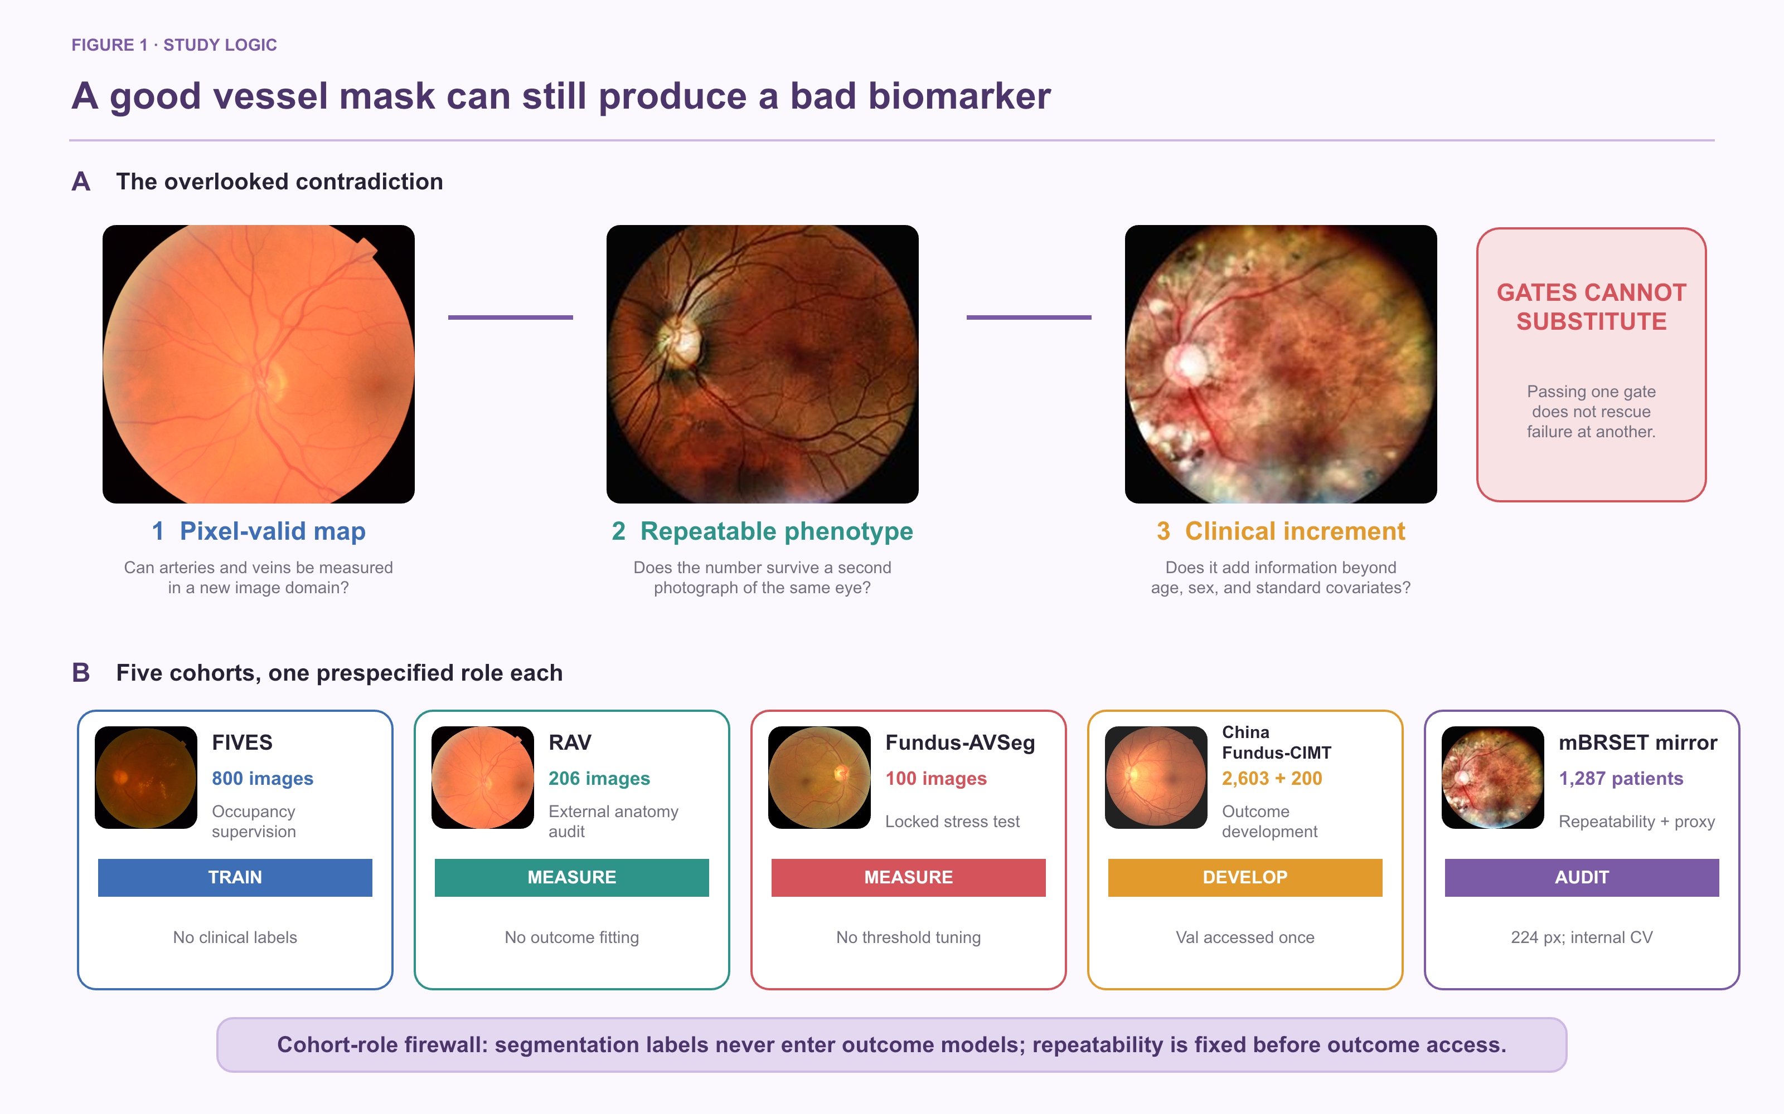
Figure 1. Five-cohort study design and evidence hierarchy. Panel A shows real photographs from every data resource and its single prespecified role. Panel B separates measurement validity, outcome-blind repeatability, and clinical increment into three non-interchangeable gates. Segmentation labels are confined to Gate 1, and the ICC-gated phenotype core is fixed before outcome access. The mBRSET 224-pixel mirror supports external mechanism analysis with internal patient-level cross-validation, not independent high-resolution confirmation.
2. Materials and methods
2.1 Study cohorts and evidence roles
Five data resources had non-overlapping roles before analysis (Table 1). FIVES [13] provided occupancy supervision. RAV [14] and Fundus-AVSeg [15] supplied independent artery–vein references for cross-domain measurement audits. China Fundus–CIMT supplied paired bilateral fundus photographs and carotid intima–media thickness for development and previously locked internal validation. mBRSET, the 224-pixel BRSET mirror [16], supplied repeated views and systemic annotations for outcome-blind repeatability and exploratory mechanism analysis. VascX [17] provided the frozen identity backbone.
Cohort isolation was treated as part of the method. Pixel labels from RAV and Fundus-AVSeg were never used in patient-level outcome models. The 2,603-patient CIMT training split was used for method development; the 200-patient validation split was accessed only after E8 choices were frozen. An access audit identified an early clinical-baseline test artifact; it was not used for RMDB–BiRAP feature development or model selection, but the test split is therefore not described as pristine or unopened. The mBRSET analysis used patient-grouped folds and is described as external mechanism validation because the available 224-pixel mirror does not reproduce the source-resolution confirmation setting.

Table 1. Cohorts, labels, and prespecified analytical roles.
Cohort | Scale | Available labels | Prespecified role | Evidence status
FIVES | 800 images (600 train/200 test) | Binary vessel mask | Occupancy-estimator source | Training/measurement only
RAV | 206 images | Artery and vein masks | Cross-domain identity audit | External measurement
Fundus-AVSeg | 100 images | Vessel/A/V masks; disease; quality | Locked zero-tuning validation | External measurement
China Fundus–CIMT | 2,603 development; 200 frozen validation; 100 test artifact | Age, sex, bilateral fundus, CIMT | Normative-deviation mechanism | Development + frozen validation
mBRSET 224-pixel mirror | 1,287 patients; 4,884 images; 2,359 same-eye repeat pairs | Repeated views, ocular grades, systemic outcomes | Reliability + exploratory HTN association | External mechanism/internal CV

2.2 Anatomy-aware preprocessing
Fundus photographs were standardized by circular field-of-view handling, colour normalization, and geometry anchoring to the optic disc and fovea. Disc-centred coordinates provided a common frame for global and peripapillary measurements. Zone-specific quantities were calculated only when disc localization passed quality control; global features remained available when zone localization failed.
The preprocessing audit required finite outputs, one-to-one manifest matching, and patient/eye integrity. For mBRSET, all 4,884 images completed preprocessing, although 189 images required the documented disc fallback. This fallback frequency was retained as a limitation and motivated a strict-disc-quality sensitivity analysis.
2.3 RMDB module: dual-readout vascular measurement
Terminology conventions. RMDB–BiRAP denotes the complete framework; RMDB denotes its dual-readout measurement module and BiRAP its outcome-blind reliability and patient-aggregation module. The two RMDB outputs are the mass-preserving UDCT readout (Mass-UDCT) and the occupancy-gated factorized UDCT readout (Factorized-UDCT). Phenotypes meeting the prespecified ICC(1,1) threshold comprise the ICC-gated phenotype core.
The occupancy branch estimated P(vessel) from a binary vessel model trained with FIVES supervision. The identity branch produced a four-class vascular representation encoding background, artery, vein, and crossing or uncertain identity. The two branches therefore addressed different questions: whether vascular structure was present and what identity the detected structure carried.
Let x denote a standardized fundus image, z⁽⁰⁾ the frozen four-class VascX logits, H the normalized identity entropy, and D(x) the multiscale Hessian direction field. The UDCT corrector updates only residual logits for two shared-weight iterations:
$z⁽ᵗ⁺¹⁾ = z⁽ᵗ⁾ + gθ[x, z⁽⁰⁾, H(p⁽⁰⁾), D(x), p⁽ᵗ⁾], t∈\{0,1\}; pᴹ=softmax(z⁽²⁾)$ (1)
The refinement objective combined pixel classification, vascular topology, directional continuity, residual restraint, A/V mass preservation, and total vessel-mass preservation:
$ℒUDCT = ℒCE + 0.5ℒDice + 0.10ℒdir + 0.10ℒves + 0.01ℒres + λAVℒAV + λmℒm$ (2)
RMDB produced two complementary readouts. The mass-preserving UDCT readout (Mass-UDCT) retained the calibrated joint four-class probability mass, preserving weak but potentially real vascular evidence. The occupancy-gated factorized UDCT readout (Factorized-UDCT) multiplied vessel occupancy by conditional identity probabilities, producing an occupancy-gated geometry representation. This separation makes it possible to distinguish missing vessel support from identity error and to quantify their disagreement.
The Factorized-UDCT readout combined fixed FIVES occupancy oF with corrected conditional identity. A confidence gate c(x), derived from base identity entropy, interpolated between identity-derived vessel support and the external occupancy estimator; τ=0.525 was fixed before external evaluation:
$c=σ\{[(1−H₄(p⁽⁰⁾))−0.35)/0.20\}; õ=c(1−p⁽⁰⁾₀)+(1−c)oF; pᶠₖ=1(õ≥τ)·õ·pᴹₖ/Σq∈\{A,V,C\}pᴹq$ (3)
Eye-level candidates included soft vessel mass fraction, Mass-UDCT and Factorized-UDCT skeleton-length densities, branch density, artery/vein log ratios, entropy, and cross-readout disagreement. The framework did not assume that disagreement was a calibrated uncertainty score; this interpretation was tested and ultimately rejected in later experiments.
The two readouts generated interpretable, continuous operators over the valid retinal domain Ω. Vessel support, artery–vein balance, and cross-readout disagreement were defined as:
$ϕmass=|Ω|⁻¹Σx∈Ω(1−pᴹ₀); ϕAV=log\{[Σx(pᴹA+pᴹC)+1]/[Σx(pᴹV+pᴹC)+1]\}; ϕdis=|VM△VF|/|VM∪VF|$ (4)
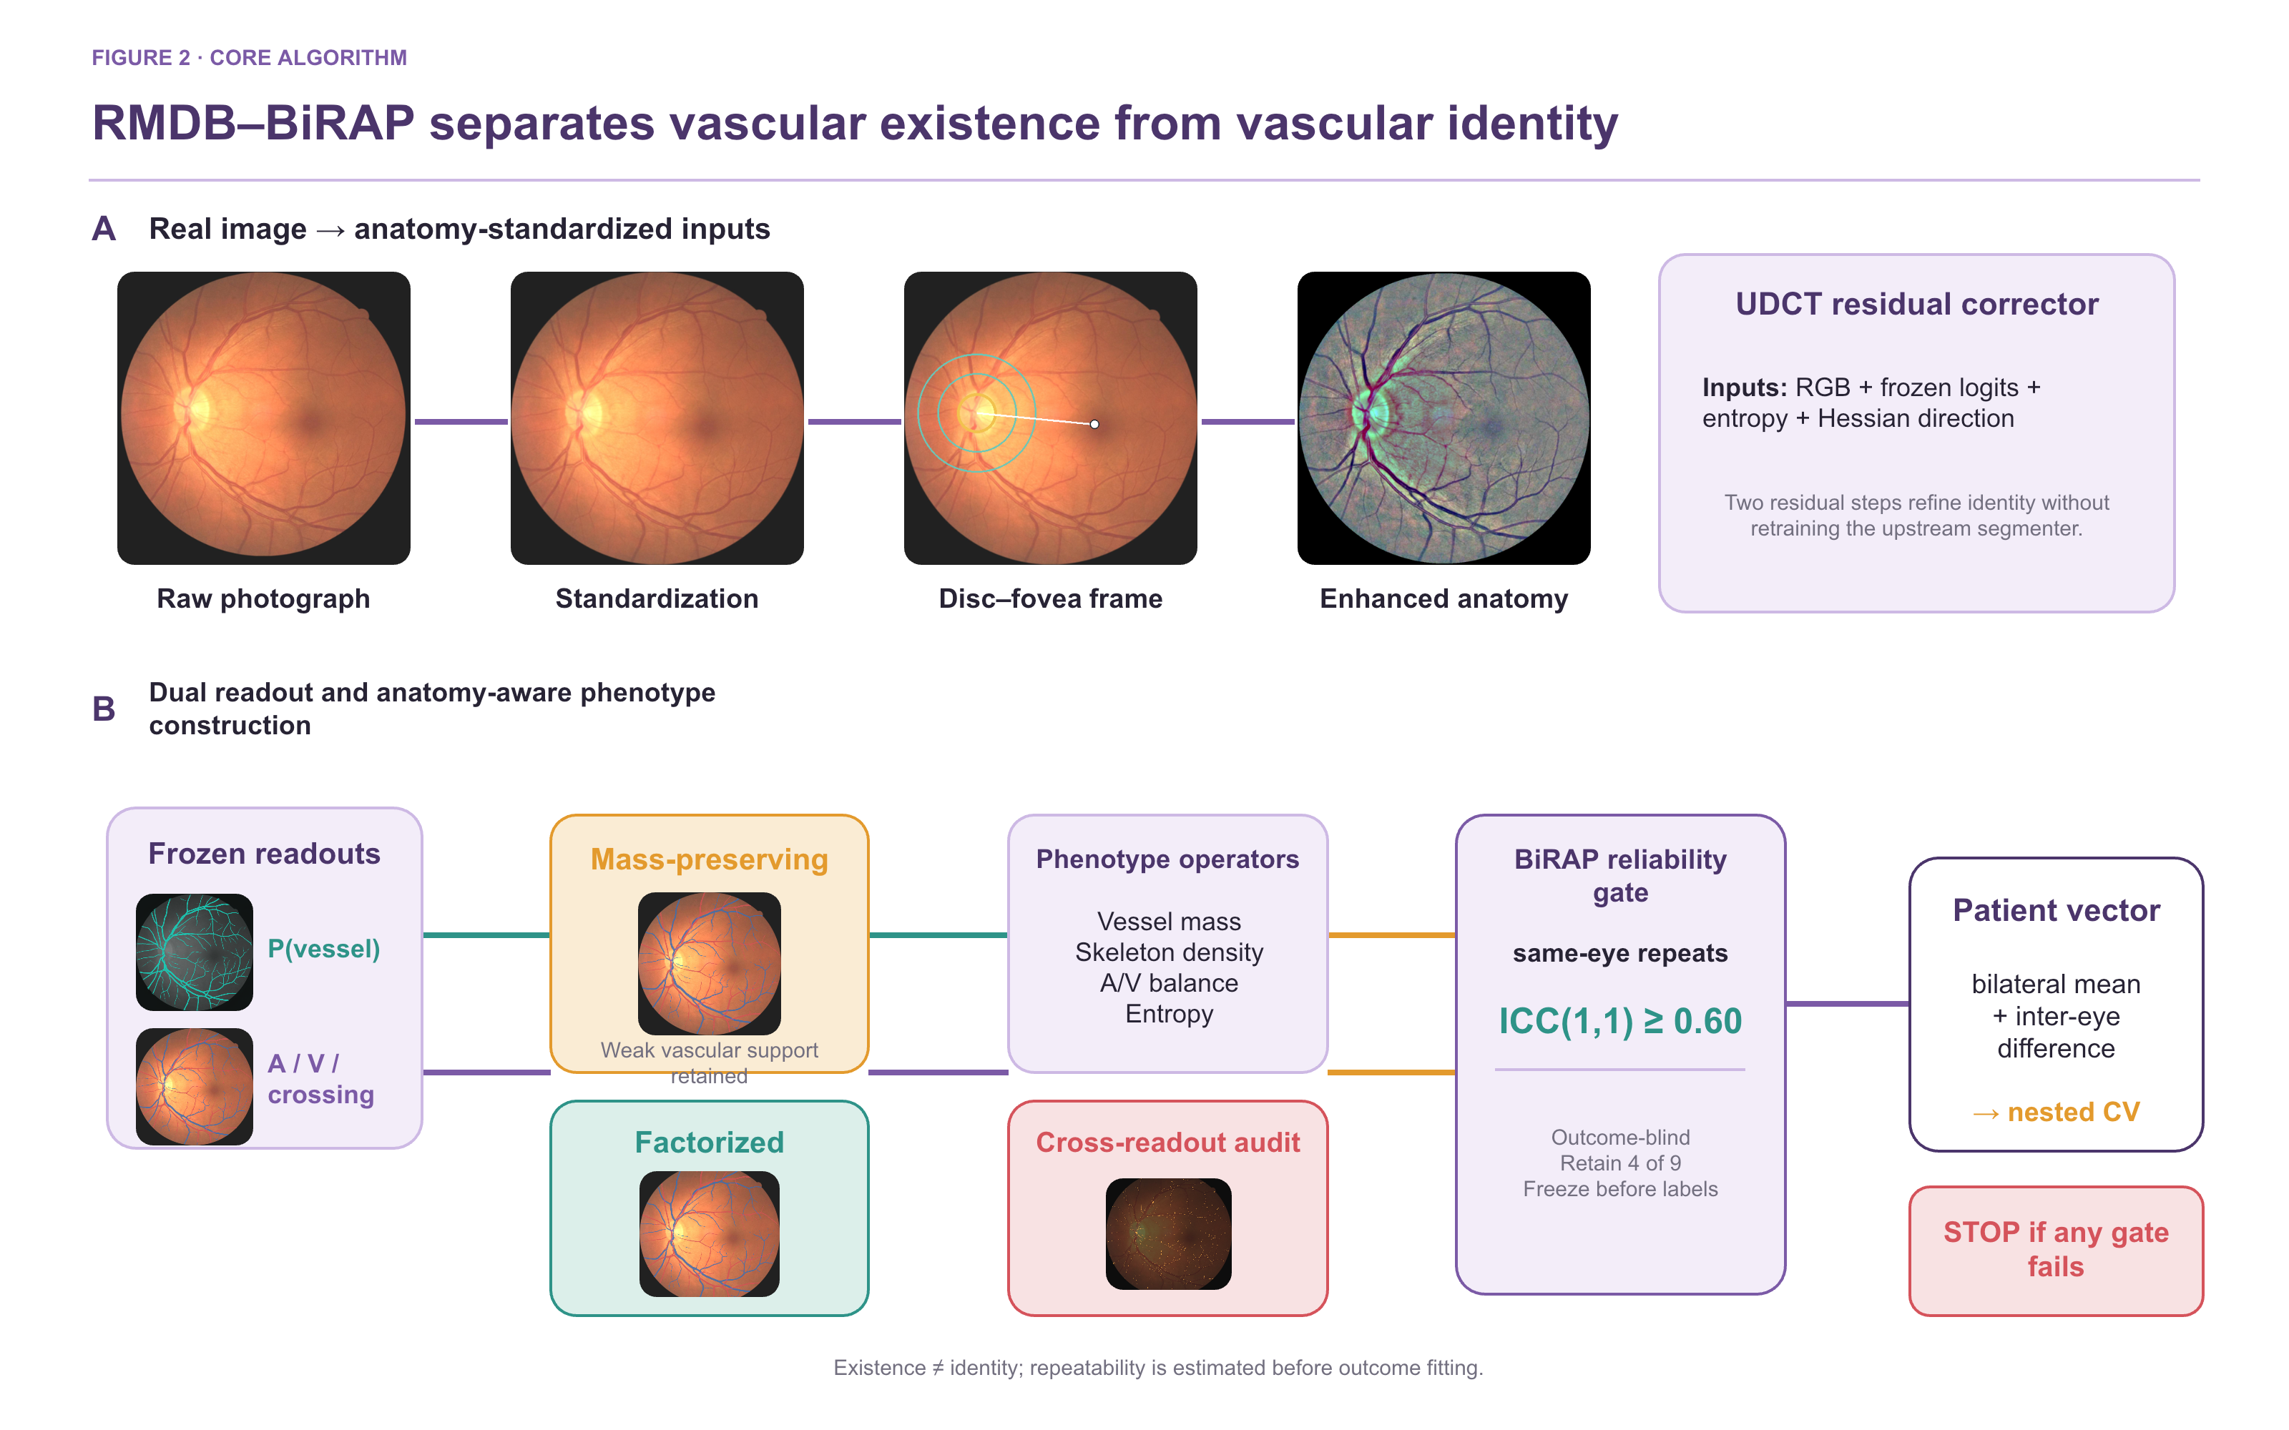
Figure 2. RMDB–BiRAP dual-readout measurement and phenotype construction. Panel A uses a real CIMT development eye different from the cohort examples in Figure 1 and shows anatomy standardization, the disc–fovea frame, enhanced anatomy, and the two-step UDCT residual corrector. Panel B separates frozen occupancy and vascular-identity readouts, constructs complementary Mass-UDCT and Factorized-UDCT maps, derives interpretable phenotype operators and cross-readout disagreement, applies the outcome-blind BiRAP ICC gate, and only then forms the ICC-gated patient phenotype vector for nested cross-validation.
2.4 BiRAP module: outcome-blind reliability and patient aggregation
For each patient, eye-level features were summarized using the bilateral mean and the absolute inter-eye difference where both eyes were available. Repeated views were first aggregated within eye when estimating patient-level quantities so that image count could not act as a surrogate for outcome.
Reliability was evaluated using 2,359 same-eye repeat pairs in mBRSET. Nine global phenotypes were specified before disease-outcome analysis. ICC(1,1) with bootstrap 95% confidence intervals was calculated from the paired views. The retention threshold was fixed at ICC(1,1) ≥ 0.60. Outcome labels and systemic covariates were not used in this selection step. The four retained phenotypes formed the ICC-gated phenotype core.
Reliability was used only as a label-blind retention rule. For candidate phenotype j, rj was fixed before any systemic outcome analysis:
$rⱼ = 1\{ICCⱼ(1,1) ≥ 0.60\}$ (5)
Algorithm 1. RMDB–BiRAP phenotype construction and evidence gating
Input. Standardized left/right fundus photographs; frozen VascX logits; frozen FIVES occupancy estimator; optic-disc metadata.
Output. A patient-level ICC-gated phenotype vector and an evidence status that is independent of outcome-driven feature selection.
1 Standardize anatomy. Normalize the field of view; locate the disc; construct Zone B only when disc quality control passes.
2 Refine vascular identity. Apply the two-step UDCT residual corrector to the frozen four-class identity logits.
3 Construct complementary readouts. Retain the mass-preserving four-class probabilities and form the occupancy-gated factorized identity map (Factorized-UDCT) using the fixed gate and threshold.
4 Extract eye-level candidates. Measure vessel mass, skeleton density, branch density, A/V balance, entropy, and cross-readout disagreement globally and, when available, within Zone B.
5 Estimate label-blind reliability. Compute ICC(1,1) from same-eye repeated views without systemic outcomes or clinical covariates.
6 Apply the reliability gate. Retain phenotype j only when its ICC(1,1) is ≥ 0.60; preserve excluded candidates as transparent negative results.
7 Aggregate at patient level. For each retained phenotype, compute the bilateral mean and absolute inter-eye difference after within-eye repeat aggregation.
8 Test incremental utility. Within patient-grouped nested cross-validation, compare clinical-only and clinical-plus-retinal models using paired patient-level bootstrap intervals.
Stopping rule. A clinical biomarker claim is permitted only when measurement validity, repeatability, and clinical increment all pass their prespecified gates.
2.5 Cross-domain measurement evaluation
On RAV, artery Dice, vein Dice, mean artery/vein Dice, type accuracy on ground-truth vessel pixels, and artery/vein ratio error were computed for the identity system. On Fundus-AVSeg, frozen VascX, Mass-UDCT, and Factorized-UDCT were evaluated without training, early stopping, calibration, or threshold selection on the external images. Paired bootstrap confidence intervals were calculated at image level.
Disease and image-quality strata were used to identify failure domains rather than to retune the locked models. This distinction preserves the external status of the validation while still exposing where the measurement system degrades.
2.6 Patient-level modelling, normative deviation, and evidence gating
The direct CIMT experiments used five outer patient folds with three-fold inner tuning and 5,000 paired patient-level bootstrap repetitions. E0 included age and sex. E2 and E3 added single-readout phenotype sets; E4 added the 104-dimensional dual-readout set; E5 and E6 removed Zone B and uncertainty-related features, respectively. All decisions through E8 were made without using frozen validation performance or test data for RMDB model selection; the access audit caveat is reported explicitly in the limitations.
Because direct fusion primarily recapitulated age, E7 estimated an age- and sex-conditional normative CIMT mean and scale within each training fold. Out-of-fold standardized deviation was then predicted from compact vascular phenotypes. E8 additionally removed the age/sex expectation from each phenotype inside the outer training fold (double orthogonalization) and repeated the outer cross-fitting across five fixed seeds. The selected E8-B regression model and E8-D classification model were frozen before the one-shot E9 validation.
To prevent age and sex from masquerading as retinal vascular signal, both CIMT and each retinal phenotype were residualized using estimators fitted only in the corresponding outer-training fold (subscript −k). CIMT was reconstructed on its original scale after predicting conditional deviation:
$zᶜᴵᴹᵀᵢ=[yᵢ−μ₋ₖ(aᵢ,sᵢ)]/σ₋ₖ(aᵢ,sᵢ); Φ⊥ᵢⱼ=Φᵢⱼ−E₋ₖ(Φᵢⱼ|aᵢ,sᵢ); ŷᵢ=μ₋ₖ+σ₋ₖh₋ₖ(Φ⊥ᵢ)$ (6)
For mBRSET hypertension, the clinical baseline contained age, sex, and diabetes duration. The phenotype-core–augmented model added the ICC-gated phenotype core to the clinical baseline. Patient-grouped nested cross-validation produced out-of-fold probabilities. A transparently labelled secondary calibration rerun used outer-training cross-fitted Platt calibration and paired bootstrap comparisons; it was designed to determine whether any probability improvement was specific to the vascular core rather than to calibration itself.
2.7 Reporting hierarchy
Evidence was classified as supported, exploratory, or not supported. Cross-domain pixel validity and outcome-blind repeatability were supported when prespecified criteria were met. Patient-level signals were exploratory unless reproduced in an independent, appropriately resolved cohort. A favourable point estimate with a confidence interval crossing the null was not called confirmation. New analyses used only the CIMT train split; no fixed CIMT test was read.
3. Results
3.1 Cross-domain measurement validity was heterogeneous
All 206 RAV images were evaluated. Mean artery Dice was 0.8119, mean vein Dice was 0.8393, mean artery/vein Dice was 0.8256, and type accuracy on ground-truth vessels was 0.8105. No global artery–vein identity swaps were observed. These values support transfer of vascular identity measurement to RAV.
The locked Fundus-AVSeg evaluation included all 100 images. VascX achieved vessel Dice 0.5898 and mean artery/vein Dice 0.5545. The mass-preserving readout increased these values to 0.6019 and 0.5635, respectively. The paired mean artery/vein Dice difference was 0.00902 (95% CI 0.00792–0.01011), and all 100 images improved. The factorized readout achieved the lowest artery/vein ratio log error (0.0689) but only a smaller mean artery/vein Dice improvement, illustrating complementary rather than interchangeable readouts.
Absolute external performance remained moderate and strongly heterogeneous. For the Mass-UDCT readout, mean artery/vein Dice was 0.5743 in normal images, 0.5844 in AMD, 0.5808 in glaucoma, and 0.5037 in diabetic retinopathy. High-quality images achieved 0.5783 versus 0.4914 in low-quality images. Figure 3 pairs real external images and masks with the prespecified disease and image-quality failure domains.
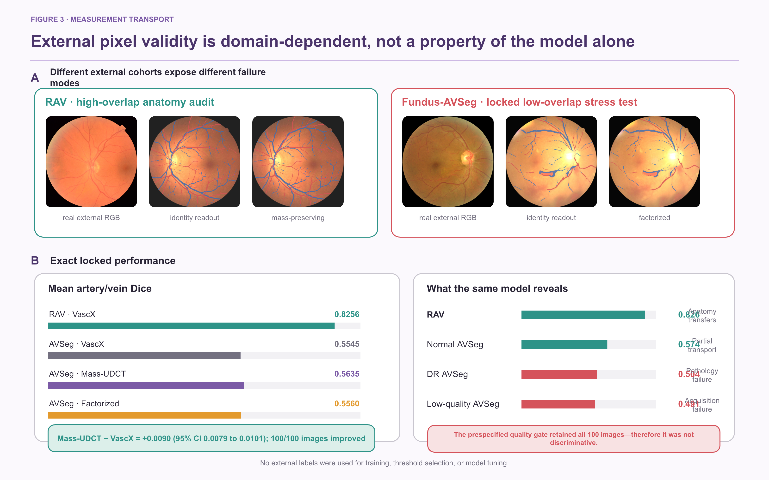
Figure 3. Cross-domain measurement validity and failure domains. Panel A shows real RAV and Fundus-AVSeg photographs together with the locked reference and dual-readout outputs for a low-quality glaucoma example. Panel B compares exact Fundus-AVSeg metrics. Panels C–D show disease- and acquisition-quality strata for the Mass-UDCT readout. The paired gain transferred across all 100 images, but absolute performance remained moderate and degraded most in diabetic retinopathy and low-quality photographs.
Table 2. External measurement performance. Lower is better only for A/V ratio log error.
Cohort | Readout | Vessel Dice | Artery Dice | Vein Dice | Mean A/V Dice | Type accuracy | A/V ratio error
RAV | VascX | — | 0.8119 | 0.8393 | 0.8256 | 0.8105 | 0.0716
Fundus-AVSeg | VascX | 0.5898 | 0.5461 | 0.5629 | 0.5545 | 0.5057 | 0.0713
Fundus-AVSeg | Mass-UDCT | 0.6019 | 0.5553 | 0.5716 | 0.5635 | 0.5328 | 0.0706
Fundus-AVSeg | Factorized-UDCT | 0.5929 | 0.5479 | 0.5640 | 0.5560 | 0.5059 | 0.0689

3.2 Outcome-blind repeatability selected four phenotypes
Four of nine prespecified global phenotypes exceeded the ICC(1,1) ≥ 0.60 threshold. Occupancy disagreement showed the highest reliability (ICC 0.811, 95% CI 0.791–0.829), followed by Factorized-UDCT skeleton density (0.772, 0.752–0.789), Mass-UDCT skeleton density (0.688, 0.665–0.710), and soft vessel mass fraction (0.676, 0.653–0.699).
The other five phenotypes did not meet the gate. Identity entropy reached ICC 0.503, branch density 0.484, soft A/V log-mass ratio 0.384, factorized A/V log-area ratio 0.360, and base-to-mass identity disagreement 0.282. These results indicate that global vessel support and geometry were more reproducible than A/V ratio or head-disagreement quantities under routine repeated-view variation.
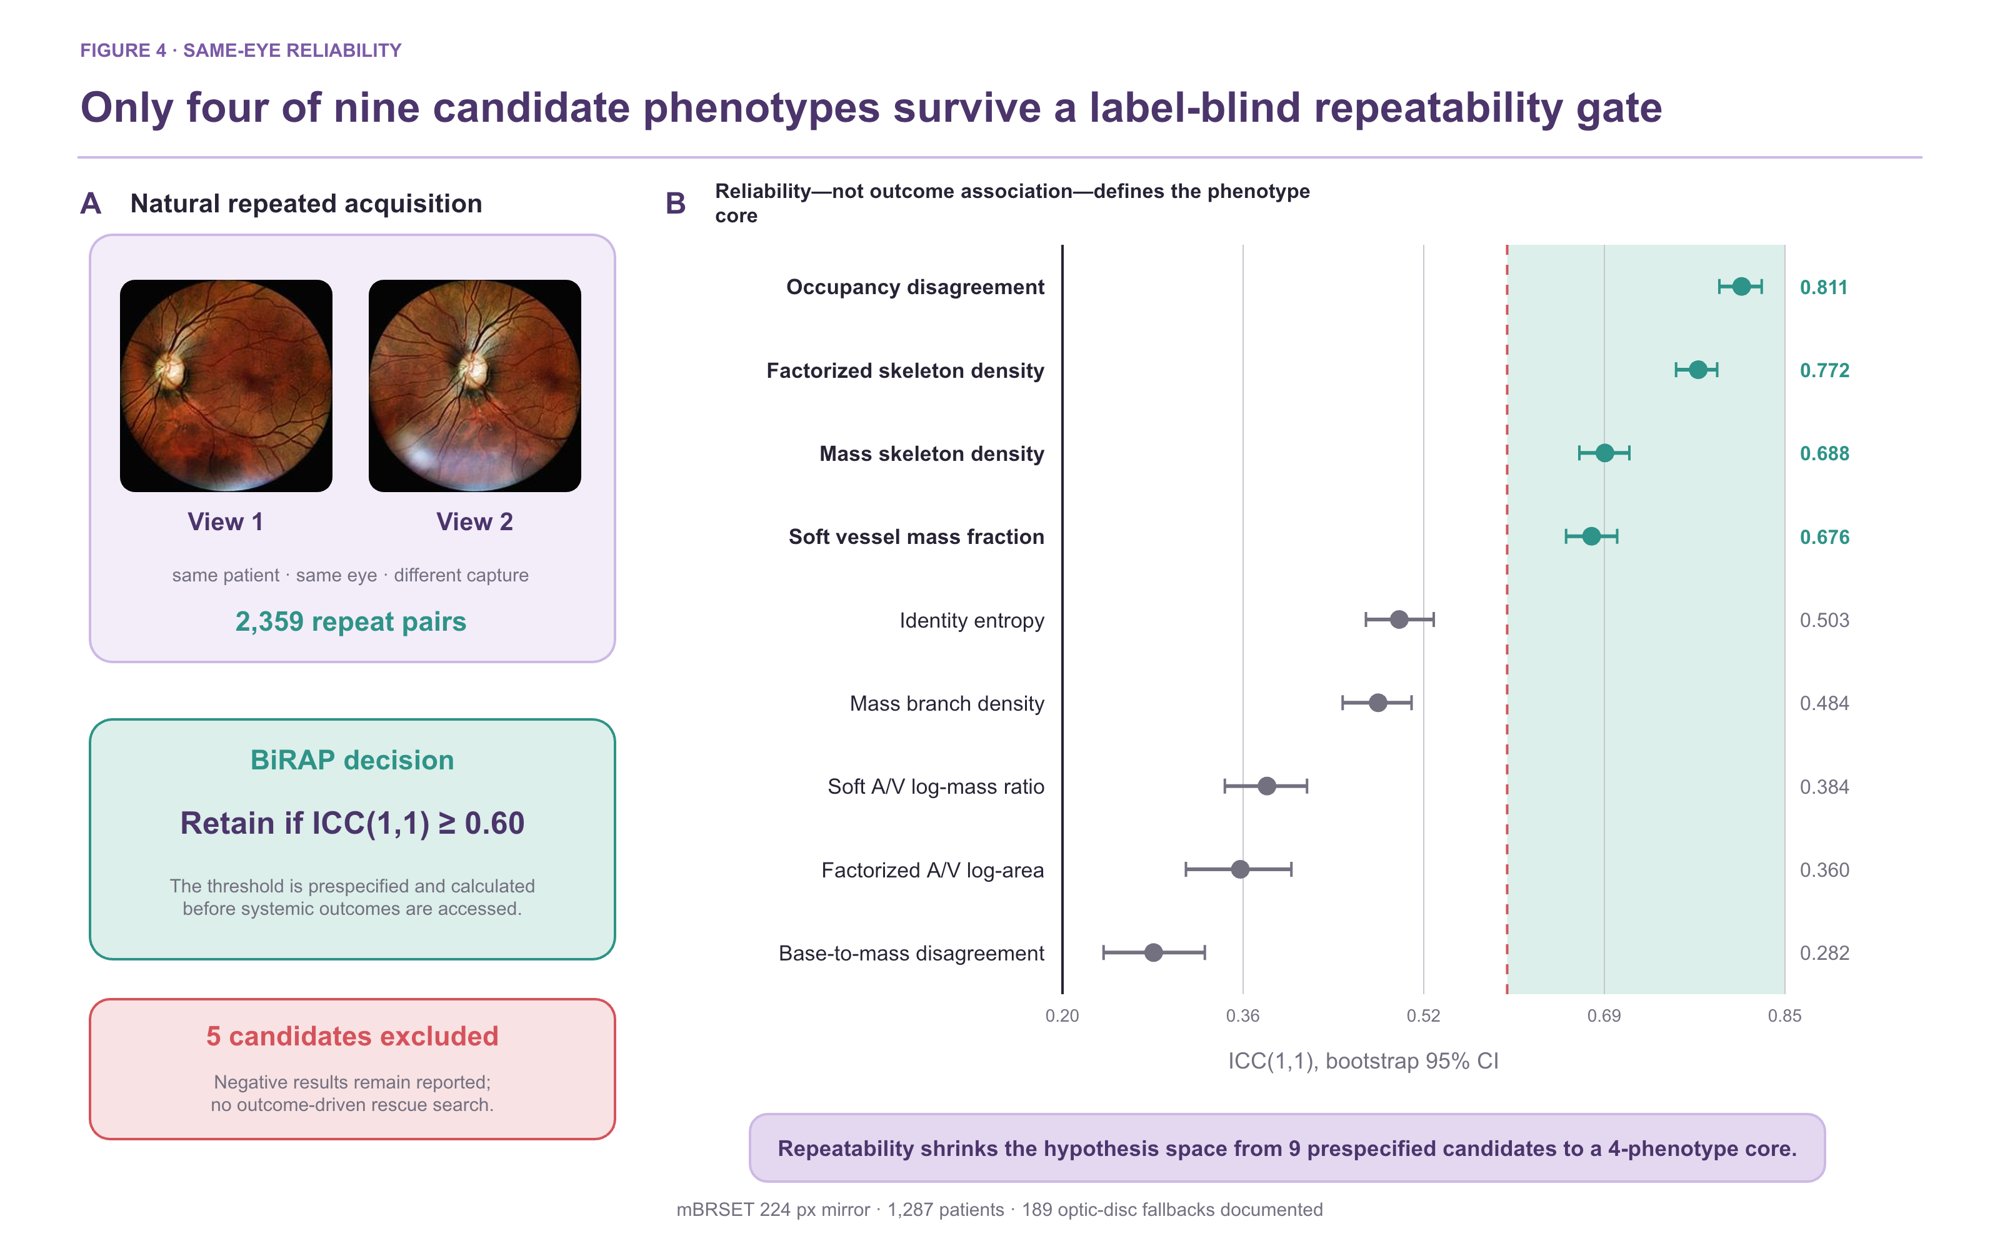
Figure 4. Outcome-blind repeatability gate. Panel A shows a real same-eye repeated-view pair from mBRSET. Panel B reports ICC(1,1) and bootstrap 95% confidence intervals for all nine prespecified global phenotypes. The dashed line marks the fixed ICC=0.60 threshold. Four phenotypes were retained before any hypertension label was used.
Table 3. Label-blind repeated-view reliability and phenotype retention.
Phenotype | Measurement interpretation | ICC(1,1) | 95% CI | Decision
Occupancy disagreement | Existence-readout mismatch | 0.811 | 0.791–0.829 | Retain
Factorized-UDCT skeleton density | Occupancy-gated geometry | 0.772 | 0.752–0.789 | Retain
Mass-UDCT skeleton density | Mass-preserving geometry | 0.688 | 0.665–0.710 | Retain
Soft vessel mass fraction | Continuous vessel support | 0.676 | 0.653–0.699 | Retain
Identity entropy | Identity ambiguity | 0.503 | 0.473–0.534 | Exclude
Mass branch density | Topological complexity | 0.484 | 0.452–0.514 | Exclude
Soft A/V log-mass ratio | Soft identity balance | 0.384 | 0.346–0.420 | Exclude
Factorized-UDCT A/V log-area ratio | Gated identity balance | 0.360 | 0.311–0.406 | Exclude
Base-to-mass disagreement | Identity-head mismatch | 0.282 | 0.237–0.328 | Exclude

3.3 High-dimensional dual-readout fusion failed to add CIMT value
In 2,603 development patients, the age/sex baseline E0 achieved a CIMT MAE of 0.114558 mm, R² of 0.3536, and AUROC of 0.8521 for the thresholded endpoint. The 104-variable E4 direct dual-readout model achieved MAE 0.115435 mm and AUROC 0.8444. Relative to E0, the paired MAE difference was +0.000885 mm (95% CI −0.000259 to +0.002038) and AUROC difference was −0.007615 (95% CI −0.014294 to −0.001073).
E4 was also worse than the mass-only E2 model in MAE, AUROC, and AUPRC. Removing Zone B or uncertainty-related features produced slightly better point estimates than E4, but their paired confidence intervals against E4 crossed zero. Accordingly, neither Zone B nor entropy/disagreement was supported as a predictive enhancement. The consistent failure of direct fusion motivated conditional modelling rather than additional feature stacking.
3.4 Conditional normative deviation revealed a small development signal
The E7 nonlinear normative model achieved MAE 0.110446 mm. Predicting standardized age/sex-conditional deviation from compact vascular phenotypes reduced MAE to 0.109698 mm, a paired difference of −0.000748 mm (95% CI −0.001369 to −0.000113). All five outer folds improved. The standardized deviation had only weak residual correlation with age (Spearman ρ=0.030), indicating that the principal age trend had been removed.
In the five-seed by five-fold E8 experiment, double orthogonalization achieved MAE 0.109596±0.000085 mm and improved on the raw mass representation by −0.000186 mm (95% CI −0.000307 to −0.000064). Improvement versus the normative baseline occurred in 24 of 25 outer folds. PCA compression did not improve the double-orthogonal model, while bilateral means were sufficient for the simplified accelerated-deviation classifier.
The frozen E9 validation contained 200 patients and 43 accelerated-deviation positives. The normative model achieved MAE 0.141470 mm and the frozen E8-B model achieved 0.140230 mm. The paired difference was −0.001240 mm (95% CI −0.003464 to 0.001086). The E8-D AUROC was 0.5575 (95% CI 0.4596–0.6567). Thus, direction replicated but strong confirmation criteria were not met. The 100-patient test artifact was not used for RMDB feature selection or model tuning.

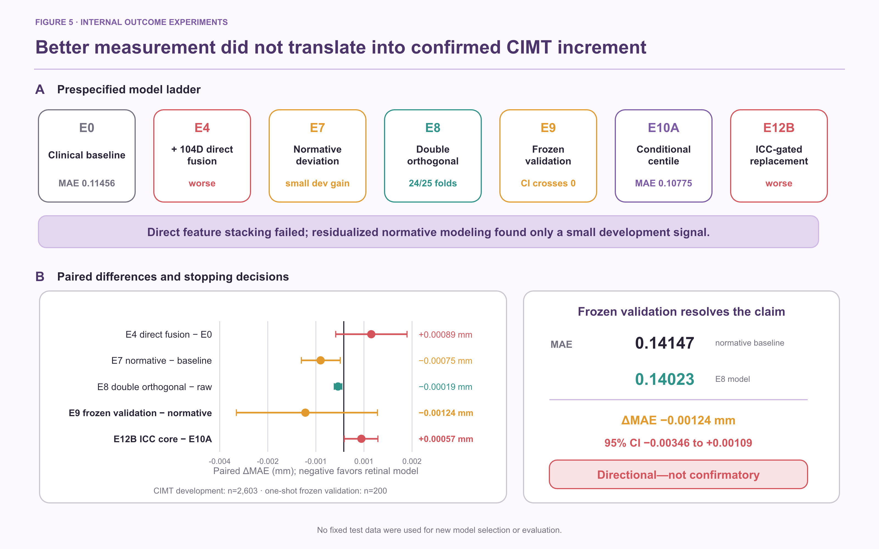
Figure 5. CIMT clinical-increment experiments. Panel A reports paired MAE differences for direct fusion, conditional normative deviation, double orthogonalization, and frozen validation; negative values favour the retinal model. Panel B shows fold-level MAE differences for the 25 repeated outer folds, of which 24 favoured double orthogonalization. Panel C compares patient-level absolute errors in the one-shot frozen validation. The direction was preserved, but the paired interval crossed zero and the accelerated-deviation classifier remained uncertain.

3.5 Calibrated mBRSET analyses did not establish incremental hypertension information
Among 1,276 mBRSET patients with complete hypertension analysis, 912 were positive. After outer-training cross-fitted Platt calibration, the clinical model (age, sex, diabetes duration) had AUROC 0.6651 and Brier score 0.1887; adding the ICC-gated phenotype core yielded AUROC 0.6669 and Brier score 0.1892. The paired differences were +0.00188 in AUROC (95% CI −0.00588 to +0.00942) and +0.00050 in Brier score (95% CI −0.00064 to +0.00165). Thus, neither discrimination nor probability error showed a reliable phenotype-core increment.
The conclusion was unchanged in prespecified sensitivity subsets. In 882 patients without diabetic retinopathy, paired ΔAUROC was −0.00052 (95% CI −0.01021 to +0.00909) and ΔBrier was +0.00062 (95% CI −0.00087 to +0.00214). In 1,105 patients passing strict disc-quality control, paired ΔAUROC was +0.00558 (95% CI −0.00327 to +0.01449) and ΔBrier was −0.00017 (95% CI −0.00165 to +0.00135). All intervals crossed the null.
3.6 Negative controls and transport boundaries
A 200-permutation patient-label negative control reran the nested workflow in 1,276 patients. Observed AUROC was 0.6648 for the clinical model and 0.6663 for the phenotype-core–augmented model, exceeding their corresponding null distributions (one-sided empirical p=0.005); outer-fold patient overlap was zero. This supports implementation integrity and argues against patient leakage, but it does not establish a phenotype-core clinical increment.
A label-blind Fundus-AVSeg quality gate, fixed from the CIMT development split, passed all 100 external images and therefore did not separate a usable from an unusable measurement subset. Quality-overlap transport analyses also failed the prespecified exchangeability thresholds across mBRSET, RAV, and Fundus-AVSeg. These negative results prohibit pooling the cohorts or presenting measurement transfer as outcome confirmation.

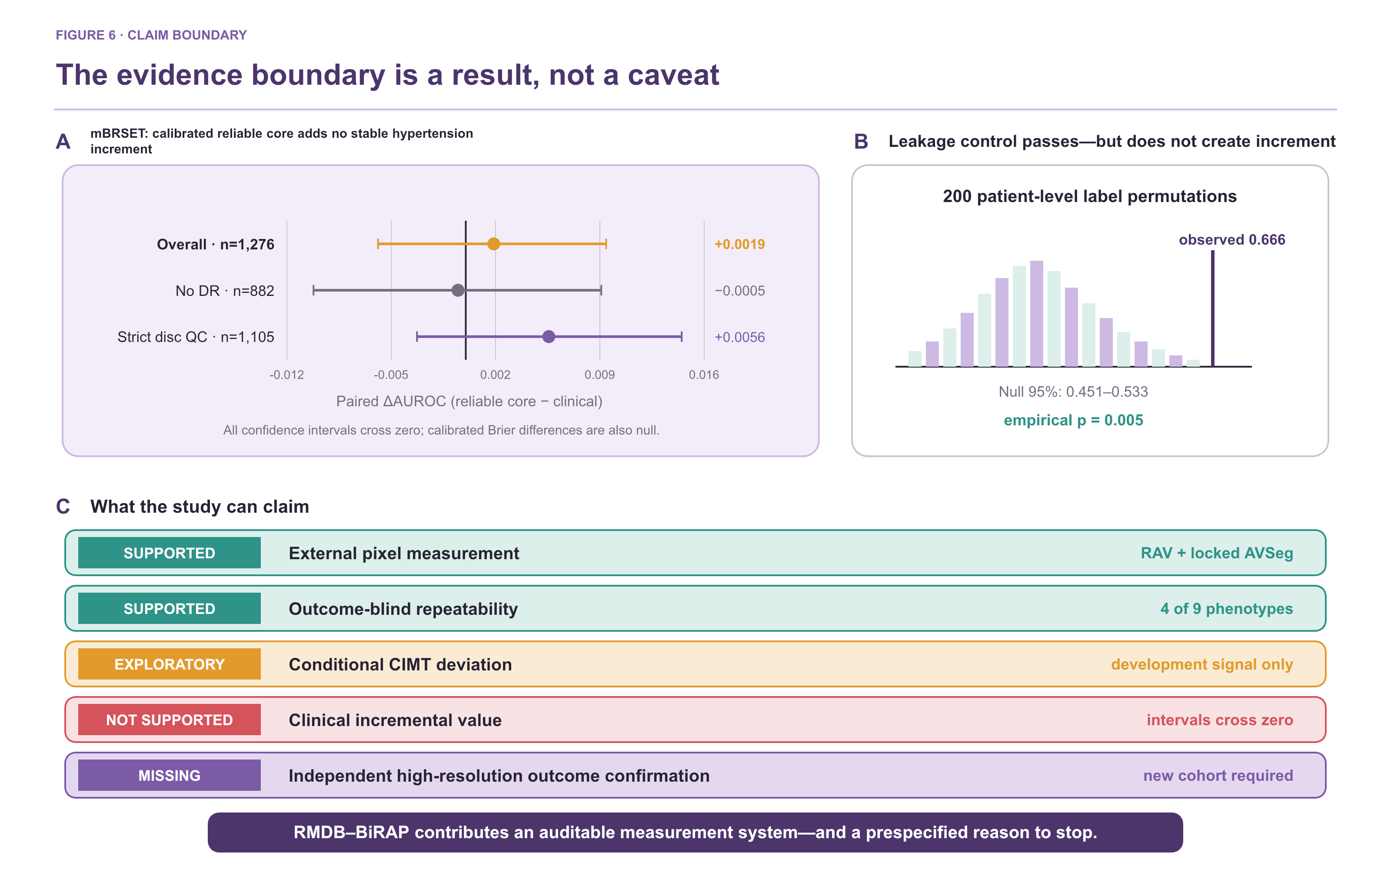
Figure 6. Patient-level results, negative controls, and claim boundary. Panel A shows that substituting the E10A representation with the ICC-gated phenotype core worsened repeated development MAE. Panel B reports calibrated phenotype-core increments over the clinical model in mBRSET overall and sensitivity analyses; all paired 95% confidence intervals cross zero. Panel C is a 200-permutation, patient-level negative control with zero outer-fold patient overlap. Panel D separates supported measurement evidence from exploratory association and the missing independent high-resolution outcome confirmation.

3.7 Negative experiments defined the stopping rule
Conditional-percentile modelling improved development MAE relative to the Gaussian conditional-mean head, but increased RMSE and tail error. A nested blend did not meet the prespecified RMSE non-inferiority margin. Separately, replacing the mass-5 E10A representation with the outcome-blind ICC-gated phenotype core worsened MAE. These results show that a reliable measurement is necessary but not sufficient for prediction, and they rule out outcome-driven feature expansion in the current cohorts.
Most importantly, the disagreement between the conditional-mean and conditional-percentile heads was not a valid uncertainty proxy. Its correlation with absolute error was −0.032 and its AUROC for high-error detection was 0.475. Retaining only low-disagreement patients worsened rather than improved MAE. Head disagreement was therefore removed from the reliability claim instead of being presented as post hoc uncertainty.
4. Discussion
4.1 Principal finding: the evidence layers diverged
The central result is a separation, not a leaderboard win. Retinal vascular measurement transferred across external pixel-labelled cohorts and four global phenotypes were reproducible across repeated photographs, yet these successes did not translate into robust clinical increment. Direct high-dimensional fusion worsened CIMT performance; the conditional-deviation signal was small; and calibrated mBRSET phenotype-core increments crossed the null overall and in sensitivity analyses. Measurement validity, repeatability, and clinical utility were empirically distinct.
This divergence explains why apparently strong retrospective retinal models may fail to become usable biomarkers. A biomarker claim requires every link in the chain: a valid measurement under domain shift, a stable patient attribute under reacquisition, and a clinically meaningful increment estimated at the patient level.
4.2 Algorithmic and methodological contribution
The dual-readout decomposition is the main algorithmic contribution. Occupancy asks whether vascular support is present; identity asks which vascular class is supported. Mass preservation and occupancy-gated factorization then implement two explicit measurement operators rather than hiding their trade-off inside a single network output. On Fundus-AVSeg, mass preservation improved overlap and type accuracy, whereas factorization minimized A/V ratio error. Cross-readout disagreement was highly repeatable, but it was not promoted to calibrated uncertainty—a distinction enforced by the negative uncertainty experiment.
The second contribution is the outcome-blind reliability gate. It reduced nine prespecified candidates to four without hypertension, CIMT, or any disease label. Unlike embedded feature importance, repeatability selection tests whether a quantity behaves like a patient attribute under routine acquisition variation. The retained core was dominated by vessel support and skeleton density; A/V ratios, branch density, and entropy were not stable enough to carry the same evidential weight.
The third contribution is the cohort-role firewall. Pixel labels validated measurement only, repeated images defined reliability only, and systemic outcomes were accessed only after phenotype definition. This design turns leakage prevention and negative findings into parts of the method rather than retrospective caveats.
4.3 Clinical interpretation and limits of increment
The CIMT experiments show why feature quantity is not equivalent to information. Age and sex already explained substantial CIMT variation; adding 104 correlated retinal descriptors increased variance without consistent signal. Conditional target standardization and double orthogonalization revealed a small age-independent development effect, but the frozen interval crossed zero. The correct interpretation is a candidate mechanism for normative deviation, not a clinically useful CIMT estimator.
The mBRSET analysis is now bounded more tightly. Cross-fitted Platt calibration reduced probability error for both the clinical and phenotype-core–augmented models, but the ICC-gated phenotype core did not contribute a separable improvement in AUROC, AUPRC, Brier score, or log loss. The patient-level permutation control supports pipeline integrity, not a clinical association claim. Accordingly, mBRSET contributes external mechanism and repeatability evidence only.
Accordingly, the framework should be viewed as an auditable measurement layer for mechanistic and prospective studies. The present evidence does not support replacing carotid ultrasound, blood-pressure measurement, or standard cardiovascular assessment.
4.4 Limitations and confirmatory path
The cohorts differed in resolution, pathology prevalence, imaging hardware, and covariate availability. Disc localization required fallback in 189 mBRSET images. Repeatability arose from naturally repeated rather than prospectively standardized acquisitions. The mBRSET mirror was limited to 224 pixels and used internal patient-level cross-validation. The previously accessed CIMT validation cohort was small and directionally informative but cannot be reused for model selection; no fixed test data were read in the new analyses. Critically, no unused high-resolution external cohort with linked systemic outcome is currently available locally, so independent clinical confirmation remains absent.
A definitive study should freeze preprocessing, both readouts, the ICC-gated phenotype core, quality exclusions, and clinical baselines before accessing a new high-resolution cohort. Primary discrimination and calibration criteria should be prespecified, with paired patient-level confidence intervals and prospective repeatability assessment. If uncertainty is required, it should be calibrated independently using ensembles, conformal intervals, or an external calibration set rather than inferred from disagreement between prediction heads.
5. Conclusion
A retinal vascular feature should not be called a biomarker merely because it can be segmented, repeated, or associated with an outcome. Across five cohorts, RMDB–BiRAP supported cross-domain measurement and four reproducible global phenotypes, while direct high-dimensional fusion, a head-disagreement uncertainty proxy, substitution of the E10A representation with the ICC-gated phenotype core, and calibrated mBRSET increment all failed to justify a clinical claim. The contribution is an auditable route from measurable pixels to reproducible phenotypes—and a transparent stopping rule until frozen confirmation on an independent high-resolution outcome cohort is possible.
Declarations
Ethics approval and consent to participate
[Insert institutional review-board identifiers, consent status, and data-governance statements for the China Fundus–CIMT cohort. Public-data use should follow the original cohort licences.]
Data and code availability
Public cohort access should be cited through the original FIVES, RAV, Fundus-AVSeg, and mBRSET repositories. Analysis code, frozen manifests, feature dictionaries, fold assignments, and aggregate result files should be archived at submission. Patient-level China Fundus–CIMT data availability is subject to the governing ethics approval.
Competing interests
[The authors declare no competing interests / insert disclosures.]
Funding
[Insert funding sources and grant numbers.]
Author contributions
[Insert CRediT author-contribution statement.]
References
1. Wong TY, Mitchell P. The eye in hypertension. Lancet. 2007;369:425–435.
2. Poplin R, Varadarajan AV, Blumer K, et al. Prediction of cardiovascular risk factors from retinal fundus photographs via deep learning. Nature Biomedical Engineering. 2018;2:158–164.
3. Ting DSW, Cheung CYL, Lim G, et al. Development and validation of a deep learning system for diabetic retinopathy and related eye diseases using retinal images from multiethnic populations with diabetes. JAMA. 2017;318:2211–2223.
4. Zhou Y, Chia MA, Wagner SK, et al. A foundation model for generalizable disease detection from retinal images. Nature. 2023;622:156–163.
5. McGraw KO, Wong SP. Forming inferences about some intraclass correlation coefficients. Psychological Methods. 1996;1:30–46.
6. Koo TK, Li MY. A guideline of selecting and reporting intraclass correlation coefficients for reliability research. Journal of Chiropractic Medicine. 2016;15:155–163.
7. Steyerberg EW. Clinical Prediction Models. 2nd ed. Springer; 2019.
8. Collins GS, Reitsma JB, Altman DG, Moons KGM. Transparent reporting of a multivariable prediction model for individual prognosis or diagnosis (TRIPOD). Annals of Internal Medicine. 2015;162:55–63.
9. Efron B, Tibshirani RJ. An Introduction to the Bootstrap. Chapman & Hall/CRC; 1993.
10. DeLong ER, DeLong DM, Clarke-Pearson DL. Comparing the areas under two or more correlated receiver operating characteristic curves. Biometrics. 1988;44:837–845.
11. Harrell FE Jr. Regression Modeling Strategies. 2nd ed. Springer; 2015.
12. Riley RD, van der Windt D, Croft P, Moons KGM, editors. Prognosis Research in Healthcare. Oxford University Press; 2019.
13. Jin K, Huang X, Zhou J, et al. FIVES: A Fundus Image Dataset for Artificial Intelligence based Vessel Segmentation. Scientific Data. 2022;9:475. doi:10.1038/s41597-022-01564-3.
14. Vargas Quiros J, Liefers B, van Garderen KA, Vermeulen JP, Eyened Reading Center, Klaver C. Rotterdam artery–vein segmentation (RAV) dataset. arXiv. 2025;arXiv:2512.17322. Dataset doi:10.34894/9OIMWY.
15. Deng Z, Gao W, Gong Z, et al. A Fundus Image Dataset for AI-based Artery-Vein Vessel Segmentation. Scientific Data. 2025;12. doi:10.1038/s41597-025-05381-2. Dataset doi:10.6084/m9.figshare.27938034.v2.
16. Nakayama LF, Ribeiro LZ, Restrepo D, et al. BRSET: A Brazilian Multilabel Ophthalmological Dataset of Retina Fundus Photos. PLOS Digital Health. 2024;3:e0000454. doi:10.1371/journal.pdig.0000454. Dataset doi:10.13026/xcxw-8198.
17. Vargas Quiros J, Liefers B, van Garderen KA, Vermeulen JP, Klaver C. VascX Models: Deep Ensembles for Retinal Vascular Analysis From Color Fundus Images. Translational Vision Science & Technology. 2025;14(7):19. doi:10.1167/tvst.14.7.19.

