From Vessel Maps to Reproducible Phenotypes: An Evidence-Gated Dual-Readout Framework for Retinal Vascular Biomarker Evaluation
[Author names]
[Affiliations]
[Corresponding author and email]
Full scientific manuscript | Author and governance fields must be completed before submission

Abstract:
Retinal vascular artificial intelligence has become increasingly proficient at drawing vessels, yet the phenotype derived from the same map may still fail when an image is reacquired, an imaging domain changes, or routine clinical information is considered. This distinction is no longer theoretical: high test–retest agreement between segmentation maps can coexist with marked volatility among downstream vascular measurements. The unresolved problem is therefore not simply how to segment another vessel map, but how to prevent an unstable or nontransportable quantity from being promoted to a digital biomarker.
We developed RMDB–BiRAP, an evidence-gated phenotype-construction framework that separates vessel occupancy from artery–vein identity, implements complementary Mass-UDCT and Factorized-UDCT measurement operators, and freezes an outcome-blind phenotype core using same-eye repeatability. Nine phenotype candidates were prespecified before outcome access; intraclass correlation determined which candidates could enter patient-grouped nested cross-validation. FIVES, RAV, Fundus-AVSeg, China Fundus–CIMT, and mBRSET were assigned non-interchangeable roles in development, locked measurement evaluation, repeatability analysis, and patient-level modelling.
Frozen VascX identity measurement achieved mean artery/vein Dice 0.8256 on RAV; because RAV also supported residual-corrector development, it was not treated as independent validation of UDCT. In the locked Fundus-AVSeg evaluation, Mass-UDCT increased mean artery/vein Dice from 0.5545 to 0.5635 (paired Δ = 0.0090, 95% CI 0.0079–0.0101), although diabetic retinopathy and low-quality images remained failure domains. Across 2,359 same-eye repeat pairs, four of nine prespecified phenotypes reached ICC(1,1) ≥ 0.60. Direct 104-dimensional fusion worsened CIMT prediction. In calibrated mBRSET hypertension analyses, adding the repeatable core did not improve discrimination or Brier score (ΔAUROC = +0.00188, 95% CI −0.00588 to +0.00942), and permutation controls showed no leakage signal. RMDB–BiRAP therefore operationalizes measurement validity, phenotype repeatability, scale transport, and clinical increment as separate evidential claims. It yields four reproducible retinal phenotypes and an explicit stopping rule, but independent high-resolution outcome confirmation remains required.
Keywords: retinal vascular artificial intelligence; digital biomarker; vessel occupancy; artery–vein identity; repeatability; intraclass correlation; CIMT; hypertension; nested cross-validation

1. Introduction
Modern retinal artificial intelligence can produce an accurate vessel map and an unreliable phenotype from the same pair of acquisitions. In a recent AutoMorph retest study, segmentation accuracy remained above 97%, whereas the intraclass correlation of derived retinal measurements ranged from 0.31 to 0.99 [19]. Pixel overlap therefore establishes where an algorithm drew vessels; it does not establish that the derived quantity survives reacquisition or behaves as a patient attribute.
This distinction matters because the retina is an accessible window onto systemic microvascular health. Deep learning has linked fundus photographs to cardiovascular and metabolic phenotypes [1–4], yet predictive performance alone does not prove that a model measured a stable vascular attribute. A model may exploit age, acquisition, pigmentation, ocular disease, or camera-specific appearance. Conversely, a segmentation improvement may be statistically real but clinically redundant if it does not propagate into a repeatable patient-level phenotype.
Automated pipelines such as AutoMorph and VascX now combine image quality control, binary vessel segmentation, artery–vein labelling, and morphology extraction [17,18]. Multi-task artery–vein systems also use vessel support to improve identity classification [23]. These advances make retinal vascular quantification scalable, but they principally optimize or audit maps and derived measurements. They do not require a candidate phenotype to pass same-eye repeatability before outcomes are inspected, nor do they enforce distinct data roles for development, locked measurement evaluation, reliability selection, and patient-level modelling.
The need to separate technical performance from clinical validation is well established in digital-measurement and quantitative-imaging frameworks [21,22]. Retinal studies additionally show that different software systems can return poorly interchangeable vascular measurements from the same photographs [20], while repeatability-based feature filtering has precedents in radiomics [24]. What remains incompletely operationalized in retinal oculomics is an end-to-end, outcome-blind procedure that prevents clinical information from rescuing an unstable measurement.
We therefore introduce RMDB–BiRAP as a retinal phenotype-construction and falsification framework. RMDB separates vessel occupancy from artery–vein identity and produces complementary Mass-UDCT and Factorized-UDCT readouts. BiRAP retains prespecified phenotypes by same-eye reliability before any systemic outcome is accessed, aggregates repeated views and fellow eyes at patient level, and applies a stopping rule across locked measurement validity, outcome-blind repeatability, and incremental clinical utility. To our knowledge, the contribution is not any one gate in isolation, but their implementation as one frozen retinal vascular evidence pipeline with non-interchangeable cohort roles and transparent negative results.
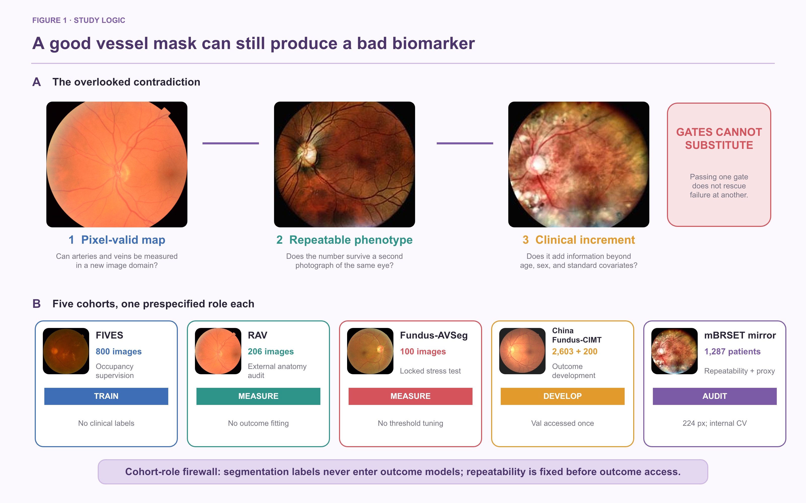
Figure 1. Five-cohort study design and evidence hierarchy. Panel A uses real retinal photographs to distinguish three non-interchangeable questions: whether a vessel map is pixel-valid, whether its derived phenotype is repeatable in a second photograph of the same eye, and whether it adds clinical information beyond standard covariates. Passing one gate cannot rescue failure at another. Panel B assigns one prespecified role to each resource: FIVES provides occupancy supervision; RAV audits frozen identity transfer and separately supports corrector development; Fundus-AVSeg provides locked independent evaluation of the final measurement stack; China Fundus–CIMT supports development and previously frozen internal validation; and the mBRSET 224-pixel mirror supports outcome-blind repeatability and exploratory patient-grouped internal cross-validation. Segmentation labels never enter outcome models, and the ICC-gated phenotype core is fixed before outcome access.

2. Materials and methods

2.1 Study cohorts and evidence roles
Five data resources had prespecified, non-interchangeable roles (Table 1). FIVES [13] provided occupancy supervision. RAV [14] characterized transfer of the frozen VascX identity backbone and separately supported development of the UDCT residual corrector; it was therefore not an independent validation set for UDCT. Fundus-AVSeg [15] supplied the locked, zero-tuning independent evaluation of the final measurement stack. China Fundus–CIMT supplied paired bilateral fundus photographs and carotid intima–media thickness for development and previously locked internal validation. mBRSET, the 224-pixel BRSET mirror [16], supplied repeated views and systemic annotations for outcome-blind repeatability and exploratory mechanism analysis. VascX [17] provided the frozen identity backbone.
Cohort isolation was treated as part of the method. Pixel labels were never used in patient-level outcome models, and Fundus-AVSeg remained untouched until all final-stack choices were frozen. The 2,603-patient CIMT training split was used for method development; the 200-patient validation split was accessed only after E8 choices were frozen. An access audit identified an early clinical-baseline test artifact; it was not used for RMDB–BiRAP feature development or model selection, but the test split is therefore not described as pristine or unopened. The mBRSET analysis used patient-grouped folds and is described as external mechanism validation because the available 224-pixel mirror does not reproduce the source-resolution confirmation setting.

Table 1. Cohorts, labels, and prespecified analytical roles.
Cohort | Scale | Available labels | Prespecified role | Evidence status
FIVES | 800 images (600 train/200 test) | Binary vessel mask | Occupancy-estimator source | Training/measurement only
RAV | 206 images | Artery and vein masks | Frozen VascX identity audit; separate UDCT corrector development | Development/audit; not independent validation
Fundus-AVSeg | 100 images | Vessel/A/V masks; disease; quality | Locked zero-tuning final-stack validation | Independent external measurement
China Fundus–CIMT | 2,603 development; 200 frozen validation; 100 test artifact | Age, sex, bilateral fundus, CIMT | Normative-deviation mechanism | Development + frozen validation
mBRSET 224-pixel mirror | 1,287 patients; 4,884 images; 2,359 same-eye repeat pairs | Repeated views, ocular grades, systemic outcomes | Repeatability and exploratory HTN association | Mechanism analysis; internal CV

2.2 Anatomy-aware preprocessing
Fundus photographs were standardized by circular field-of-view handling, colour normalization, and geometry anchoring to the optic disc and fovea. Disc-centred coordinates provided a common frame for global and peripapillary measurements. Zone-specific quantities were calculated only when disc localization passed quality control; global features remained available when zone localization failed.
The preprocessing audit required finite outputs, one-to-one manifest matching, and patient/eye integrity. For mBRSET, all 4,884 images completed preprocessing, although 189 images required the documented disc fallback. This fallback frequency was retained as a limitation and motivated a strict-disc-quality sensitivity analysis.

2.3 RMDB module: dual-readout vascular measurement
Terminology conventions. RMDB–BiRAP denotes the complete evidence-gated framework; RMDB denotes its dual-readout measurement module and BiRAP its outcome-blind reliability and patient-aggregation module. The two RMDB outputs are the mass-preserving UDCT readout (Mass-UDCT) and the occupancy-gated factorized UDCT readout (Factorized-UDCT). Unlike a conventional end-to-end artery–vein map, the two operators preserve the distinction between vascular support and vascular identity after inference. Phenotypes meeting the prespecified ICC(1,1) threshold comprise the ICC-gated phenotype core. These terms are used consistently throughout.
The occupancy branch estimated P(vessel) from a binary vessel model trained with FIVES supervision. The identity branch produced a four-class vascular representation encoding background, artery, vein, and crossing or uncertain identity. The two branches therefore addressed different questions: whether vascular structure was present and what identity the detected structure carried.
Let I* denote the anatomy-standardized fundus image, u a pixel in the valid retinal domain Ω, z⁽⁰⁾ the frozen four-class VascX logits, H₄ the normalized four-class entropy map, and D(I*) the multiscale Hessian direction field. The UDCT corrector applies two shared-weight residual updates and converts the corrected logits to the Mass-UDCT probability field pᴹ:
$z^{(t+1)}(u)=z^{(t)}(u)+g_{θ}\left(I^{*},z^{(0)},H_{4}(p^{(0)}),D(I^{*}),p^{(t)}\right), t∈\{0,1\}$ (1a)
$p^{M}(u)=softmax\left(z^{(2)}(u)\right)$ (1b)
The refinement objective combined a base loss for pixel classification, overlap, directional continuity, vessel support, and residual restraint with explicit artery–vein and vessel-mass preservation terms:
$ℒ_{UDCT}=ℒ_{base}+λ_{AV}ℒ_{AV}+λ_{mass}ℒ_{mass}$ (2a)
$ℒ_{base}=ℒ_{CE}+0.5ℒ_{Dice}+0.10ℒ_{dir}+0.10ℒ_{ves}+0.01ℒ_{res}$ (2b)
RMDB produced two complementary readouts. Mass-UDCT retained calibrated joint four-class probability mass, preserving weak but potentially real vascular evidence. Factorized-UDCT multiplied a vessel-occupancy estimate by conditional identity probabilities, producing an occupancy-gated geometry representation. The factorization therefore makes missing vessel support distinguishable from artery–vein identity error instead of hiding both inside one class prediction.
Factorized-UDCT combined fixed FIVES occupancy oF with identity-derived vessel support. A scalar confidence gate c(I*), derived from the mean base identity entropy, interpolated between the two support estimates; τ = 0.525 was fixed before the locked Fundus-AVSeg evaluation:
$c(I^{*})=sigmoid\left(\frac{1−{\overset{―}{H}}_{4}(p^{(0)})−0.35}{0.20}\right)$ (3a)
$\tilde{o}(u)=c(I^{*})\left[1−p_{0}^{(0)}(u)\right]+\left[1−c(I^{*})\right]o_{F}(u)$ (3b)
$p_{k}^{F}(u)=1_{\tilde{o}(u)≥τ} \tilde{o}(u) \frac{p_{k}^{M}(u)}{p_{A}^{M}(u)+p_{V}^{M}(u)+p_{C}^{M}(u)}, k∈\{A,V,C\}$ (3c)
The corrected Mass-UDCT field contains separate background, artery, vein, and crossing or uncertain probabilities; Factorized-UDCT retains the same vascular identities after the occupancy gate. Eye-level candidates included soft vessel mass fraction, Mass-UDCT and Factorized-UDCT skeleton-length densities, branch density, artery–vein log ratios, entropy, and cross-readout disagreement. Disagreement was retained as a measurement comparison, not assumed to be a calibrated uncertainty score.
The two readouts generated interpretable continuous operators over Ω. Indexing the |Ω| valid pixels by u = 1,…,|Ω|, we defined vessel support, artery–vein balance, and cross-readout support disagreement as follows. VM and VF denote the thresholded Mass-UDCT and Factorized-UDCT vessel support sets, respectively:
$ϕ_{mass}=\frac{1}{|Ω|}\sum_{u=1}^{|Ω|}{\left[1−p_{0}^{M}(u)\right]}$ (4a)
$ϕ_{AV}=log\left(\frac{\sum_{u=1}^{|Ω|}{\left[p_{A}^{M}(u)+p_{C}^{M}(u)\right]+1}}{\sum_{u=1}^{|Ω|}{\left[p_{V}^{M}(u)+p_{C}^{M}(u)\right]+1}}\right)$ (4b)
$ϕ_{dis}=\frac{|V_{M} △ V_{F}|}{|V_{M} ∪ V_{F}|}$ (4c)
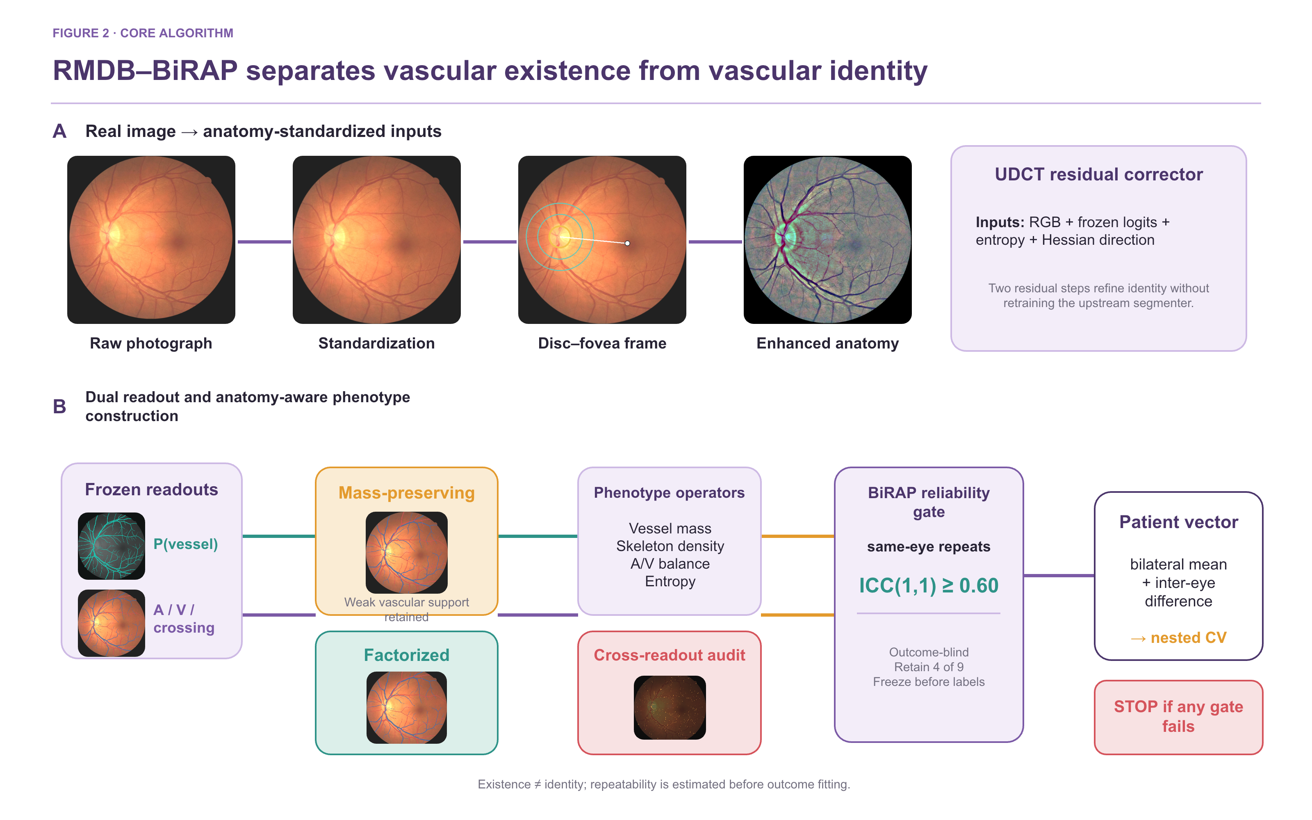
Figure 2. RMDB–BiRAP dual-readout measurement and phenotype construction. Panel A uses a real CIMT development eye different from the cohort examples in Figure 1 and shows anatomy standardization, the disc–fovea frame, enhanced anatomy, and the two-step UDCT residual corrector. Panel B separates frozen occupancy and vascular-identity readouts, constructs complementary Mass-UDCT and Factorized-UDCT maps, derives interpretable phenotype operators and cross-readout disagreement, applies the outcome-blind BiRAP ICC gate, and only then forms the ICC-gated patient phenotype vector for nested cross-validation.

2.4 BiRAP module: outcome-blind reliability and patient aggregation
For each patient, repeated photographs were first aggregated within eye so that image count could not act as an outcome surrogate. Each retained eye-level phenotype was then summarized by the bilateral mean and absolute inter-eye difference when both eyes were available.
Reliability was evaluated using 2,359 same-eye repeat pairs in mBRSET. Nine global phenotypes were specified before disease-outcome analysis. ICC(1,1) with bootstrap 95% confidence intervals was calculated from the paired views, following the quantitative-imaging principle that measurement stability should be established before clinical interpretation [22]. The retention threshold was fixed at ICC(1,1) ≥ 0.60. Outcome labels and systemic covariates were not used in this selection step. The four retained phenotypes formed the ICC-gated phenotype core.
Reliability was a label-blind retention rule rather than a performance metric. For candidate phenotype j, a binary retention indicator was fixed before systemic outcome analysis. The patient vector then contained the bilateral mean and absolute inter-eye difference only for retained candidates:
$r_{j}=I\left({ICC}_{j}(1,1)≥0.60\right)$ (5a)
$Φ_{i}=\left\{({\bar{ϕ}}_{ij},Δϕ_{ij})∣r_{j}=1\right\}$ (5b)
Algorithm 1. RMDB–BiRAP phenotype construction and evidence gating
Input. Standardized left/right fundus photographs; frozen VascX logits; frozen FIVES occupancy estimator; optic-disc metadata.
Output. A patient-level ICC-gated phenotype vector and an evidence status that is independent of outcome-driven feature selection.
1 Standardize anatomy. Normalize the field of view; locate the disc; construct Zone B only when disc quality control passes.
2 Refine vascular identity. Apply the two-step UDCT residual corrector to the frozen four-class identity logits.
3 Construct complementary readouts. Retain the mass-preserving four-class probabilities and form the occupancy-gated factorized identity map (Factorized-UDCT) using the fixed gate and threshold.
4 Extract eye-level candidates. Measure vessel mass, skeleton density, branch density, A/V balance, entropy, and cross-readout disagreement globally and, when available, within Zone B.
5 Estimate label-blind reliability. Compute ICC(1,1) from same-eye repeated views without systemic outcomes or clinical covariates.
6 Apply the reliability gate. Retain phenotype j only when its ICC(1,1) is ≥ 0.60; preserve excluded candidates as transparent negative results.
7 Aggregate at patient level. For each retained phenotype, compute the bilateral mean and absolute inter-eye difference after within-eye repeat aggregation.
8 Test incremental utility. Within patient-grouped nested cross-validation, compare clinical-only and clinical-plus-retinal models using paired patient-level bootstrap intervals.
Stopping rule. A clinical digital biomarker claim is permitted only when locked measurement validity, outcome-blind repeatability, and patient-level clinical increment each pass its prespecified gate. Passing one gate cannot compensate for failing another.

2.5 Cross-domain measurement evaluation
On RAV, artery Dice, vein Dice, mean artery/vein Dice, type accuracy on reference vessel pixels, and artery/vein ratio error characterized the frozen upstream VascX identity system. Because RAV also supported separate UDCT corrector development, these results were not interpreted as independent validation of UDCT. Final-stack validation was locked to Fundus-AVSeg: frozen VascX, Mass-UDCT, and Factorized-UDCT were evaluated without training, early stopping, calibration, or threshold selection on its images. Paired bootstrap confidence intervals were calculated at image level.
Disease and image-quality strata were used to identify failure domains rather than to retune the locked models. This distinction preserves the independent status of the Fundus-AVSeg evaluation while exposing where the measurement system degrades.

2.6 Patient-level modelling, normative deviation, and evidence gating
The direct CIMT experiments used five outer patient folds with three-fold inner tuning and 5,000 paired patient-level bootstrap repetitions. E0 included age and sex. E2 and E3 added single-readout phenotype sets; E4 added the 104-dimensional dual-readout set; E5 and E6 removed Zone B and uncertainty-related features, respectively. All decisions through E8 were made without using frozen validation performance or test data for RMDB model selection; the access audit caveat is reported explicitly in the limitations.
Because direct fusion primarily recapitulated age, E7 estimated an age- and sex-conditional normative CIMT mean and scale within each outer-training fold. Out-of-fold standardized deviation was then predicted from compact vascular phenotypes. E8 additionally removed the age and sex expectation from every phenotype inside the outer-training fold and repeated outer cross-fitting across five fixed seeds. The selected E8-B regression model and E8-D classification model were frozen before one-shot E9 validation.
For patient i in outer fold k, the conditional CIMT mean, conditional CIMT scale, and expected value of each retinal phenotype were estimated only from the corresponding outer-training data. The fold-specific retinal model predicted orthogonalized conditional deviation, after which CIMT was reconstructed on its original scale:
$z_{i}^{CIMT}=\frac{y_{i}−{\overset{ˆ}{μ}}_{−k}(a_{i},s_{i})}{{\overset{ˆ}{σ}}_{−k}(a_{i},s_{i})}$ (6a)
$ϕ_{ij}^{⟂}=ϕ_{ij}−{\overset{ˆ}{m}}_{j,−k}(a_{i},s_{i})$ (6b)
${\overset{ˆ}{y}}_{i}={\overset{ˆ}{μ}}_{−k}(a_{i},s_{i})+{\overset{ˆ}{σ}}_{−k}(a_{i},s_{i}) h_{−k}(ϕ_{i}^{⟂})$ (6c)
For mBRSET hypertension, the clinical baseline contained age, sex, and diabetes duration. The phenotype-core–augmented model added the ICC-gated phenotype core to the clinical baseline. Patient-grouped nested cross-validation produced out-of-fold probabilities. A transparently labelled secondary calibration rerun used outer-training cross-fitted Platt calibration and paired bootstrap comparisons; it was designed to determine whether any probability improvement was specific to the vascular core rather than to calibration itself.

2.7 Reporting hierarchy
Evidence was classified as supported, exploratory, or not supported. This hierarchy adapts the separation of technical and clinical validation in V3 and quantitative-imaging guidance [21,22] to retinal vascular phenotyping. Frozen upstream identity transfer, locked final-stack measurement validity, and outcome-blind repeatability were reported as separate claims. Patient-level signals remained exploratory unless reproduced in an independent, appropriately resolved outcome cohort. A favourable point estimate with a confidence interval crossing the null was not called confirmation. New analyses used only the CIMT training split; no fixed CIMT test was read.

3. Results

3.1 Cross-domain measurement validity was heterogeneous
All 206 RAV images were evaluated. Mean artery Dice was 0.8119, mean vein Dice was 0.8393, mean artery/vein Dice was 0.8256, and type accuracy on reference vessel pixels was 0.8105. No global artery–vein identity swaps were observed. These values characterize transfer of the frozen upstream VascX identity representation to RAV; because RAV also supported residual-corrector development, they are not independent validation of UDCT.
The locked Fundus-AVSeg evaluation included all 100 images. VascX achieved vessel Dice 0.5898 and mean artery/vein Dice 0.5545. The mass-preserving readout increased these values to 0.6019 and 0.5635, respectively. The paired mean artery/vein Dice difference was 0.00902 (95% CI 0.00792–0.01011), and all 100 images improved. The factorized readout achieved the lowest artery/vein ratio log error (0.0689) but only a smaller mean artery/vein Dice improvement, illustrating complementary rather than interchangeable readouts.
Absolute external performance remained moderate and strongly heterogeneous. For the Mass-UDCT readout, mean artery/vein Dice was 0.5743 in normal images, 0.5844 in AMD, 0.5808 in glaucoma, and 0.5037 in diabetic retinopathy. High-quality images achieved 0.5783 versus 0.4914 in low-quality images. Figure 3 pairs real external images and masks with the prespecified disease and image-quality failure domains.
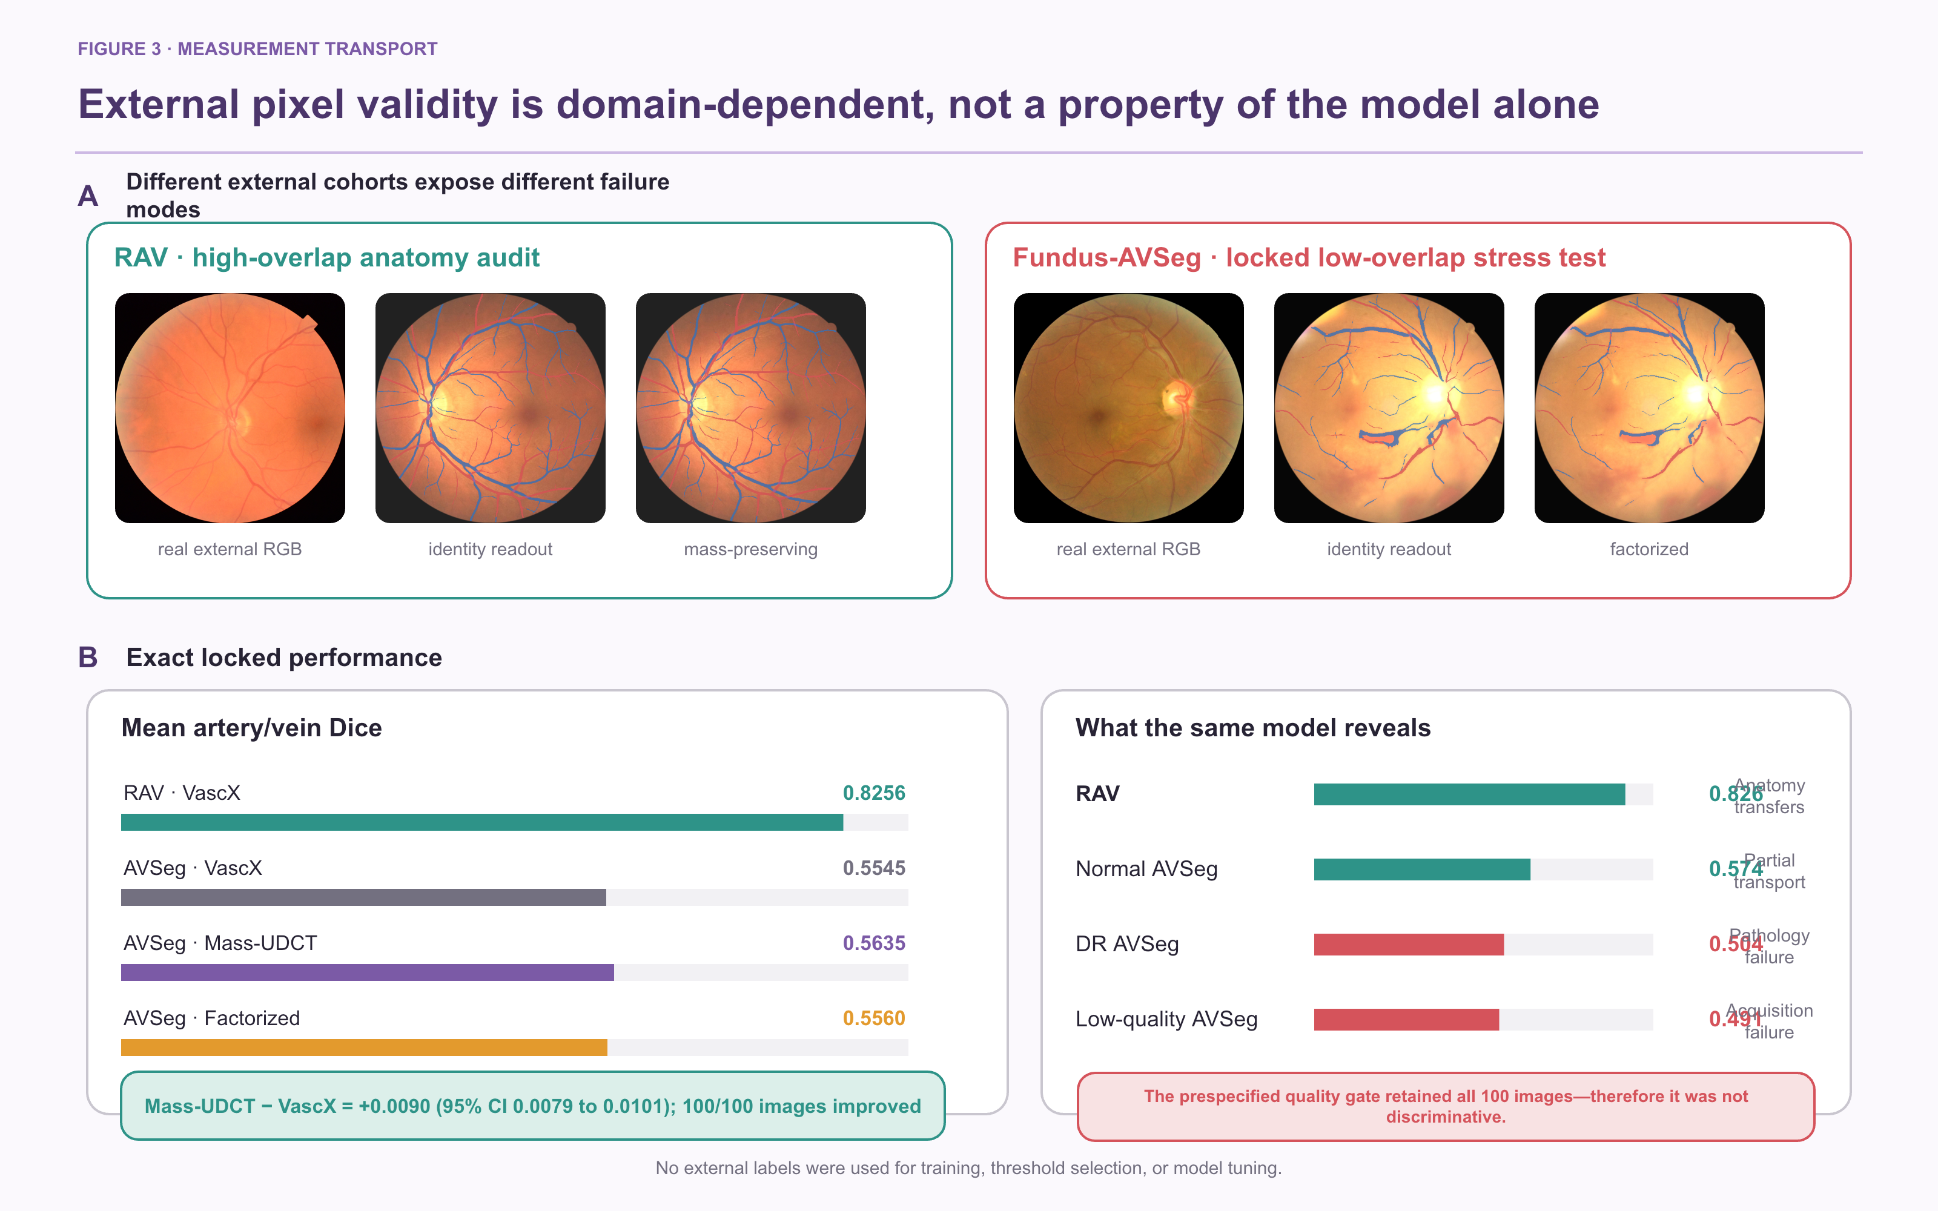
Figure 3. Cross-domain measurement validity and failure domains. Panel A shows real RAV and Fundus-AVSeg photographs with representative identity, Mass-UDCT, and Factorized-UDCT readouts. Panel B reports exact locked mean artery/vein Dice values and the prespecified disease- and image-quality strata for Mass-UDCT. The paired gain transferred across all 100 Fundus-AVSeg images, but absolute performance remained moderate and degraded most in diabetic retinopathy and low-quality photographs.
Table 2. External measurement performance. Lower is better only for A/V ratio log error.
Cohort | Readout | Vessel Dice | Artery Dice | Vein Dice | Mean A/V Dice | Type accuracy | A/V ratio error
RAV | VascX | — | 0.8119 | 0.8393 | 0.8256 | 0.8105 | 0.0716
Fundus-AVSeg | VascX | 0.5898 | 0.5461 | 0.5629 | 0.5545 | 0.5057 | 0.0713
Fundus-AVSeg | Mass-UDCT | 0.6019 | 0.5553 | 0.5716 | 0.5635 | 0.5328 | 0.0706
Fundus-AVSeg | Factorized-UDCT | 0.5929 | 0.5479 | 0.5640 | 0.5560 | 0.5059 | 0.0689

3.2 Outcome-blind repeatability selected four phenotypes
Four of nine prespecified global phenotypes exceeded the ICC(1,1) ≥ 0.60 threshold. Occupancy disagreement showed the highest reliability (ICC 0.811, 95% CI 0.791–0.829), followed by Factorized-UDCT skeleton density (0.772, 0.752–0.789), Mass-UDCT skeleton density (0.688, 0.665–0.710), and soft vessel mass fraction (0.676, 0.653–0.699).
The other five phenotypes did not meet the gate. Identity entropy reached ICC 0.503, branch density 0.484, soft A/V log-mass ratio 0.384, factorized A/V log-area ratio 0.360, and base-to-mass identity disagreement 0.282. These results indicate that global vessel support and geometry were more reproducible than A/V ratio or head-disagreement quantities under routine repeated-view variation.
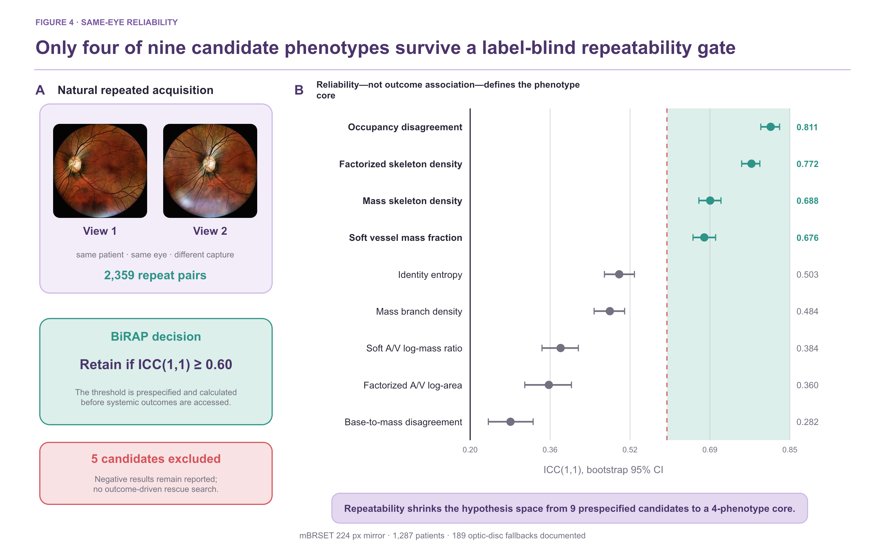
Figure 4. Outcome-blind repeatability gate. Panel A shows a real same-eye repeated-view pair from mBRSET. Panel B reports ICC(1,1) and bootstrap 95% confidence intervals for all nine prespecified global phenotypes. The dashed line marks the fixed ICC=0.60 threshold. Four phenotypes were retained before any hypertension label was used.
Table 3. Label-blind repeated-view reliability and phenotype retention.
Phenotype | Measurement interpretation | ICC(1,1) | 95% CI | Decision
Occupancy disagreement | Existence-readout mismatch | 0.811 | 0.791–0.829 | Retain
Factorized-UDCT skeleton density | Occupancy-gated geometry | 0.772 | 0.752–0.789 | Retain
Mass-UDCT skeleton density | Mass-preserving geometry | 0.688 | 0.665–0.710 | Retain
Soft vessel mass fraction | Continuous vessel support | 0.676 | 0.653–0.699 | Retain
Identity entropy | Identity ambiguity | 0.503 | 0.473–0.534 | Exclude
Mass branch density | Topological complexity | 0.484 | 0.452–0.514 | Exclude
Soft A/V log-mass ratio | Soft identity balance | 0.384 | 0.346–0.420 | Exclude
Factorized-UDCT A/V log-area ratio | Gated identity balance | 0.360 | 0.311–0.406 | Exclude
Base-to-mass disagreement | Identity-head mismatch | 0.282 | 0.237–0.328 | Exclude

3.3 High-dimensional dual-readout fusion failed to add CIMT value
In 2,603 development patients, the age/sex baseline E0 achieved a CIMT MAE of 0.114558 mm, R² of 0.3536, and AUROC of 0.8521 for the thresholded endpoint. The 104-variable E4 direct dual-readout model achieved MAE 0.115435 mm and AUROC 0.8444. Relative to E0, the paired MAE difference was +0.000885 mm (95% CI −0.000259 to +0.002038) and AUROC difference was −0.007615 (95% CI −0.014294 to −0.001073).
E4 was also worse than the mass-only E2 model in MAE, AUROC, and AUPRC. Removing Zone B or uncertainty-related features produced slightly better point estimates than E4, but their paired confidence intervals against E4 crossed zero. Accordingly, neither Zone B nor entropy/disagreement was supported as a predictive enhancement. The consistent failure of direct fusion motivated conditional modelling rather than additional feature stacking.

3.4 Conditional normative deviation revealed a small development signal
The E7 nonlinear normative model achieved MAE 0.110446 mm. Predicting standardized age/sex-conditional deviation from compact vascular phenotypes reduced MAE to 0.109698 mm, a paired difference of −0.000748 mm (95% CI −0.001369 to −0.000113). All five outer folds improved. The standardized deviation had only weak residual correlation with age (Spearman ρ=0.030), indicating that the principal age trend had been removed.
In the five-seed by five-fold E8 experiment, double orthogonalization achieved MAE 0.109596±0.000085 mm and improved on the raw mass representation by −0.000186 mm (95% CI −0.000307 to −0.000064). Improvement versus the normative baseline occurred in 24 of 25 outer folds. PCA compression did not improve the double-orthogonal model, while bilateral means were sufficient for the simplified accelerated-deviation classifier.
The frozen E9 validation contained 200 patients and 43 accelerated-deviation positives. The normative model achieved MAE 0.141470 mm and the frozen E8-B model achieved 0.140230 mm. The paired difference was −0.001240 mm (95% CI −0.003464 to 0.001086). The E8-D AUROC was 0.5575 (95% CI 0.4596–0.6567). Thus, direction replicated but strong confirmation criteria were not met. The 100-patient test artifact was not used for RMDB feature selection or model tuning.

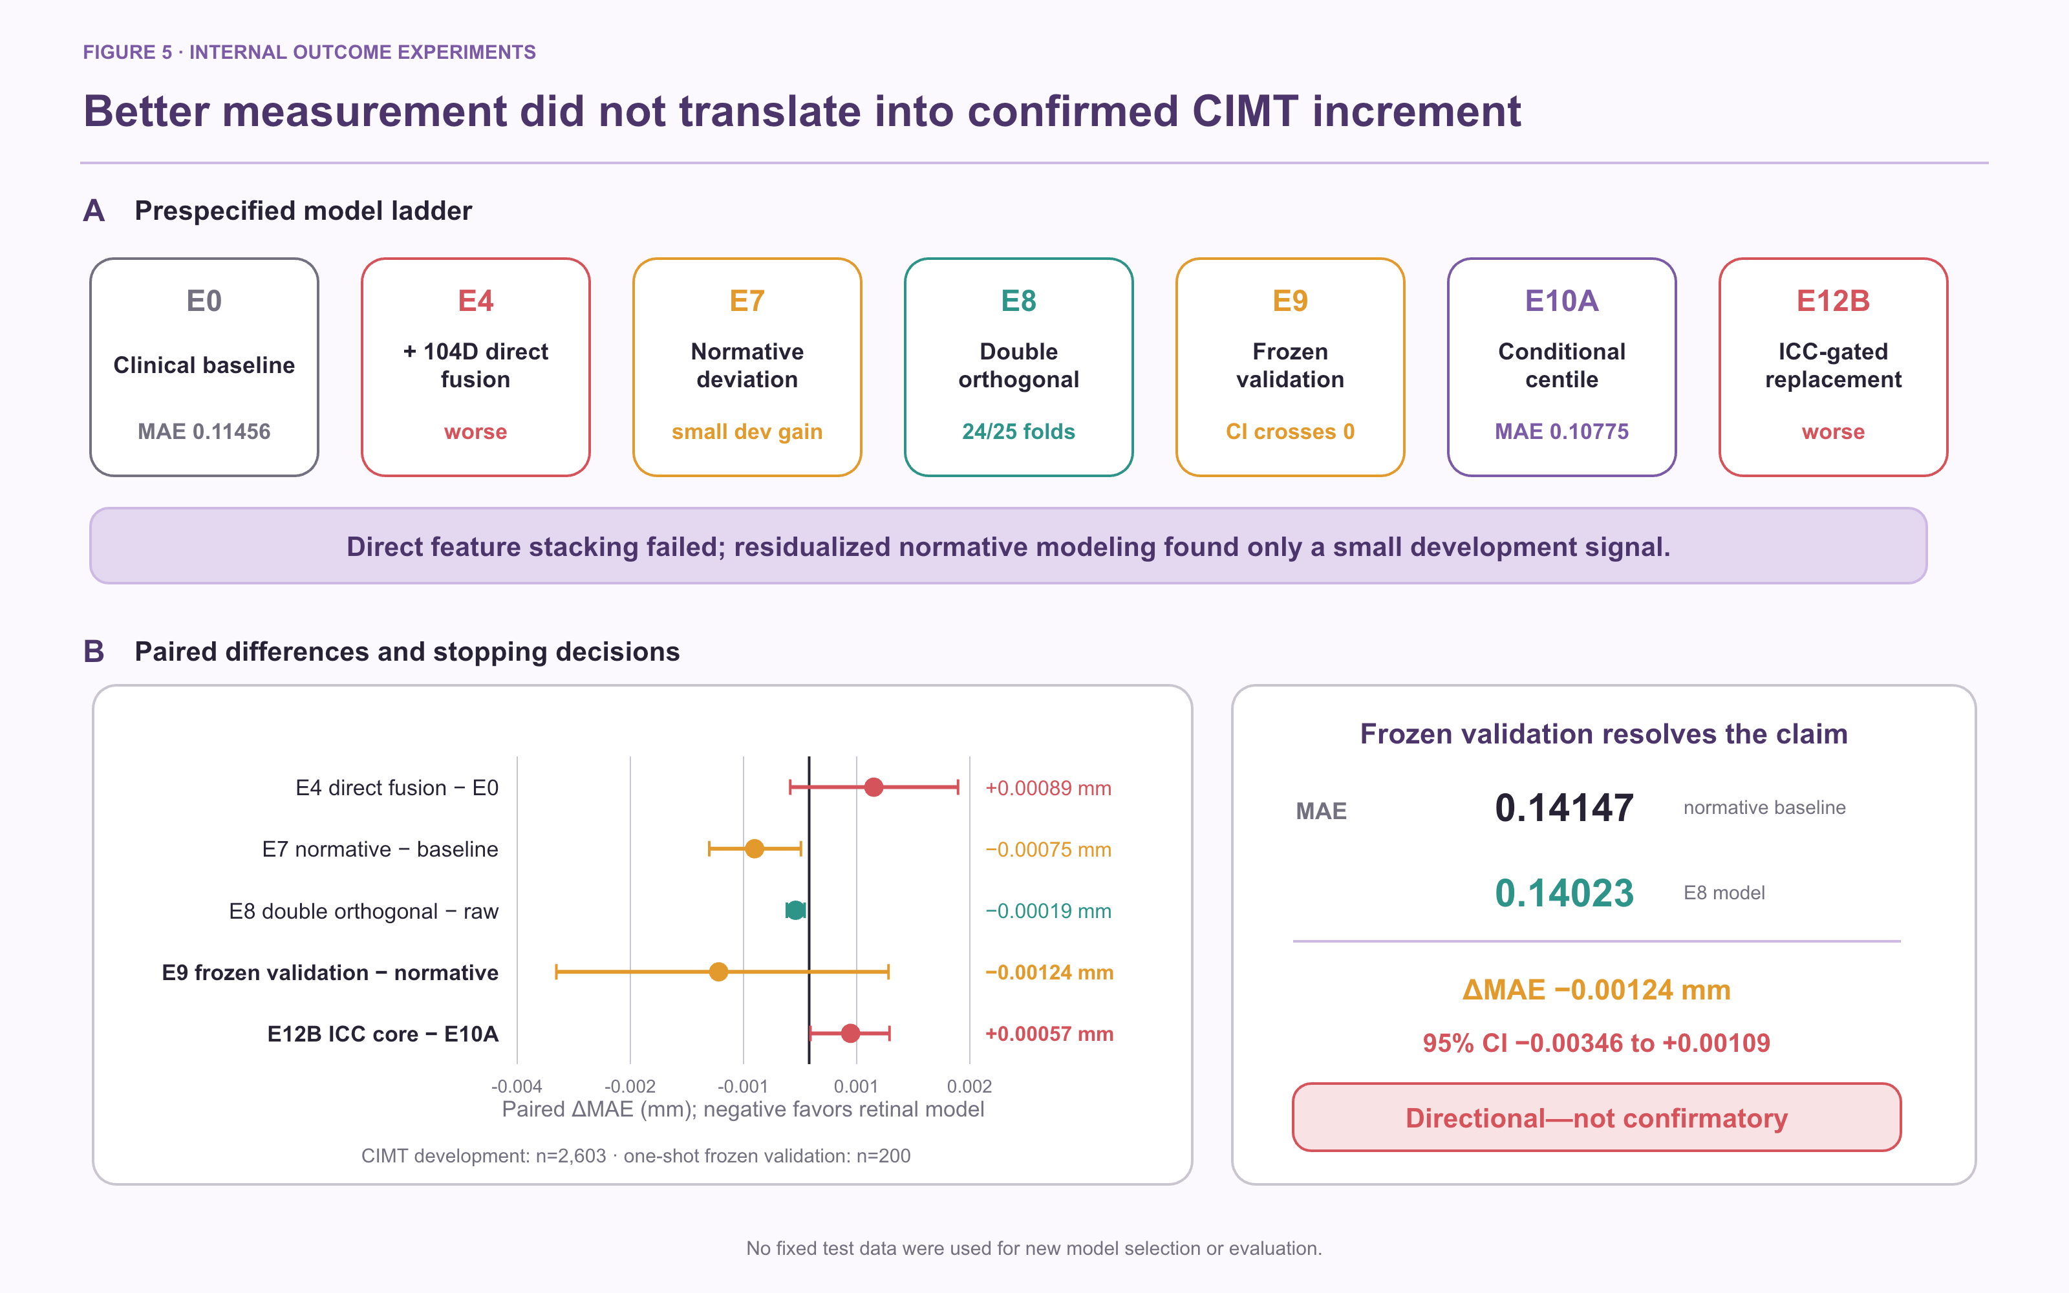
Figure 5. CIMT clinical-increment experiments. Panel A summarizes the prespecified model ladder from the clinical baseline through direct fusion, conditional normative deviation, double orthogonalization, frozen validation, and ICC-gated replacement. Panel B shows paired MAE differences for the principal comparisons on the left and the one-shot frozen-validation result on the right. Negative differences favour the retinal model. The development direction was preserved in frozen validation, but the paired confidence interval crossed zero; clinical increment was therefore not confirmed.

3.5 Calibrated mBRSET analyses did not establish incremental hypertension information
Among 1,276 mBRSET patients with complete hypertension analysis, 912 were positive. After outer-training cross-fitted Platt calibration, the clinical model (age, sex, diabetes duration) had AUROC 0.6651 and Brier score 0.1887; adding the ICC-gated phenotype core yielded AUROC 0.6669 and Brier score 0.1892. The paired differences were +0.00188 in AUROC (95% CI −0.00588 to +0.00942) and +0.00050 in Brier score (95% CI −0.00064 to +0.00165). Thus, neither discrimination nor probability error showed a reliable phenotype-core increment.
The conclusion was unchanged in prespecified sensitivity subsets. In 882 patients without diabetic retinopathy, paired ΔAUROC was −0.00052 (95% CI −0.01021 to +0.00909) and ΔBrier was +0.00062 (95% CI −0.00087 to +0.00214). In 1,105 patients passing strict disc-quality control, paired ΔAUROC was +0.00558 (95% CI −0.00327 to +0.01449) and ΔBrier was −0.00017 (95% CI −0.00165 to +0.00135). All intervals crossed the null.

3.6 Negative controls and transport boundaries
A 200-permutation patient-label negative control reran the nested workflow in 1,276 patients. Observed AUROC was 0.6648 for the clinical model and 0.6663 for the phenotype-core–augmented model, exceeding their corresponding null distributions (one-sided empirical p=0.005); outer-fold patient overlap was zero. This supports implementation integrity and argues against patient leakage, but it does not establish a phenotype-core clinical increment.
A label-blind Fundus-AVSeg quality gate, fixed from the CIMT development split, passed all 100 external images and therefore did not separate a usable from an unusable measurement subset. Quality-overlap transport analyses also failed the prespecified exchangeability thresholds across mBRSET, RAV, and Fundus-AVSeg. These negative results prohibit pooling the cohorts or presenting measurement transfer as outcome confirmation.

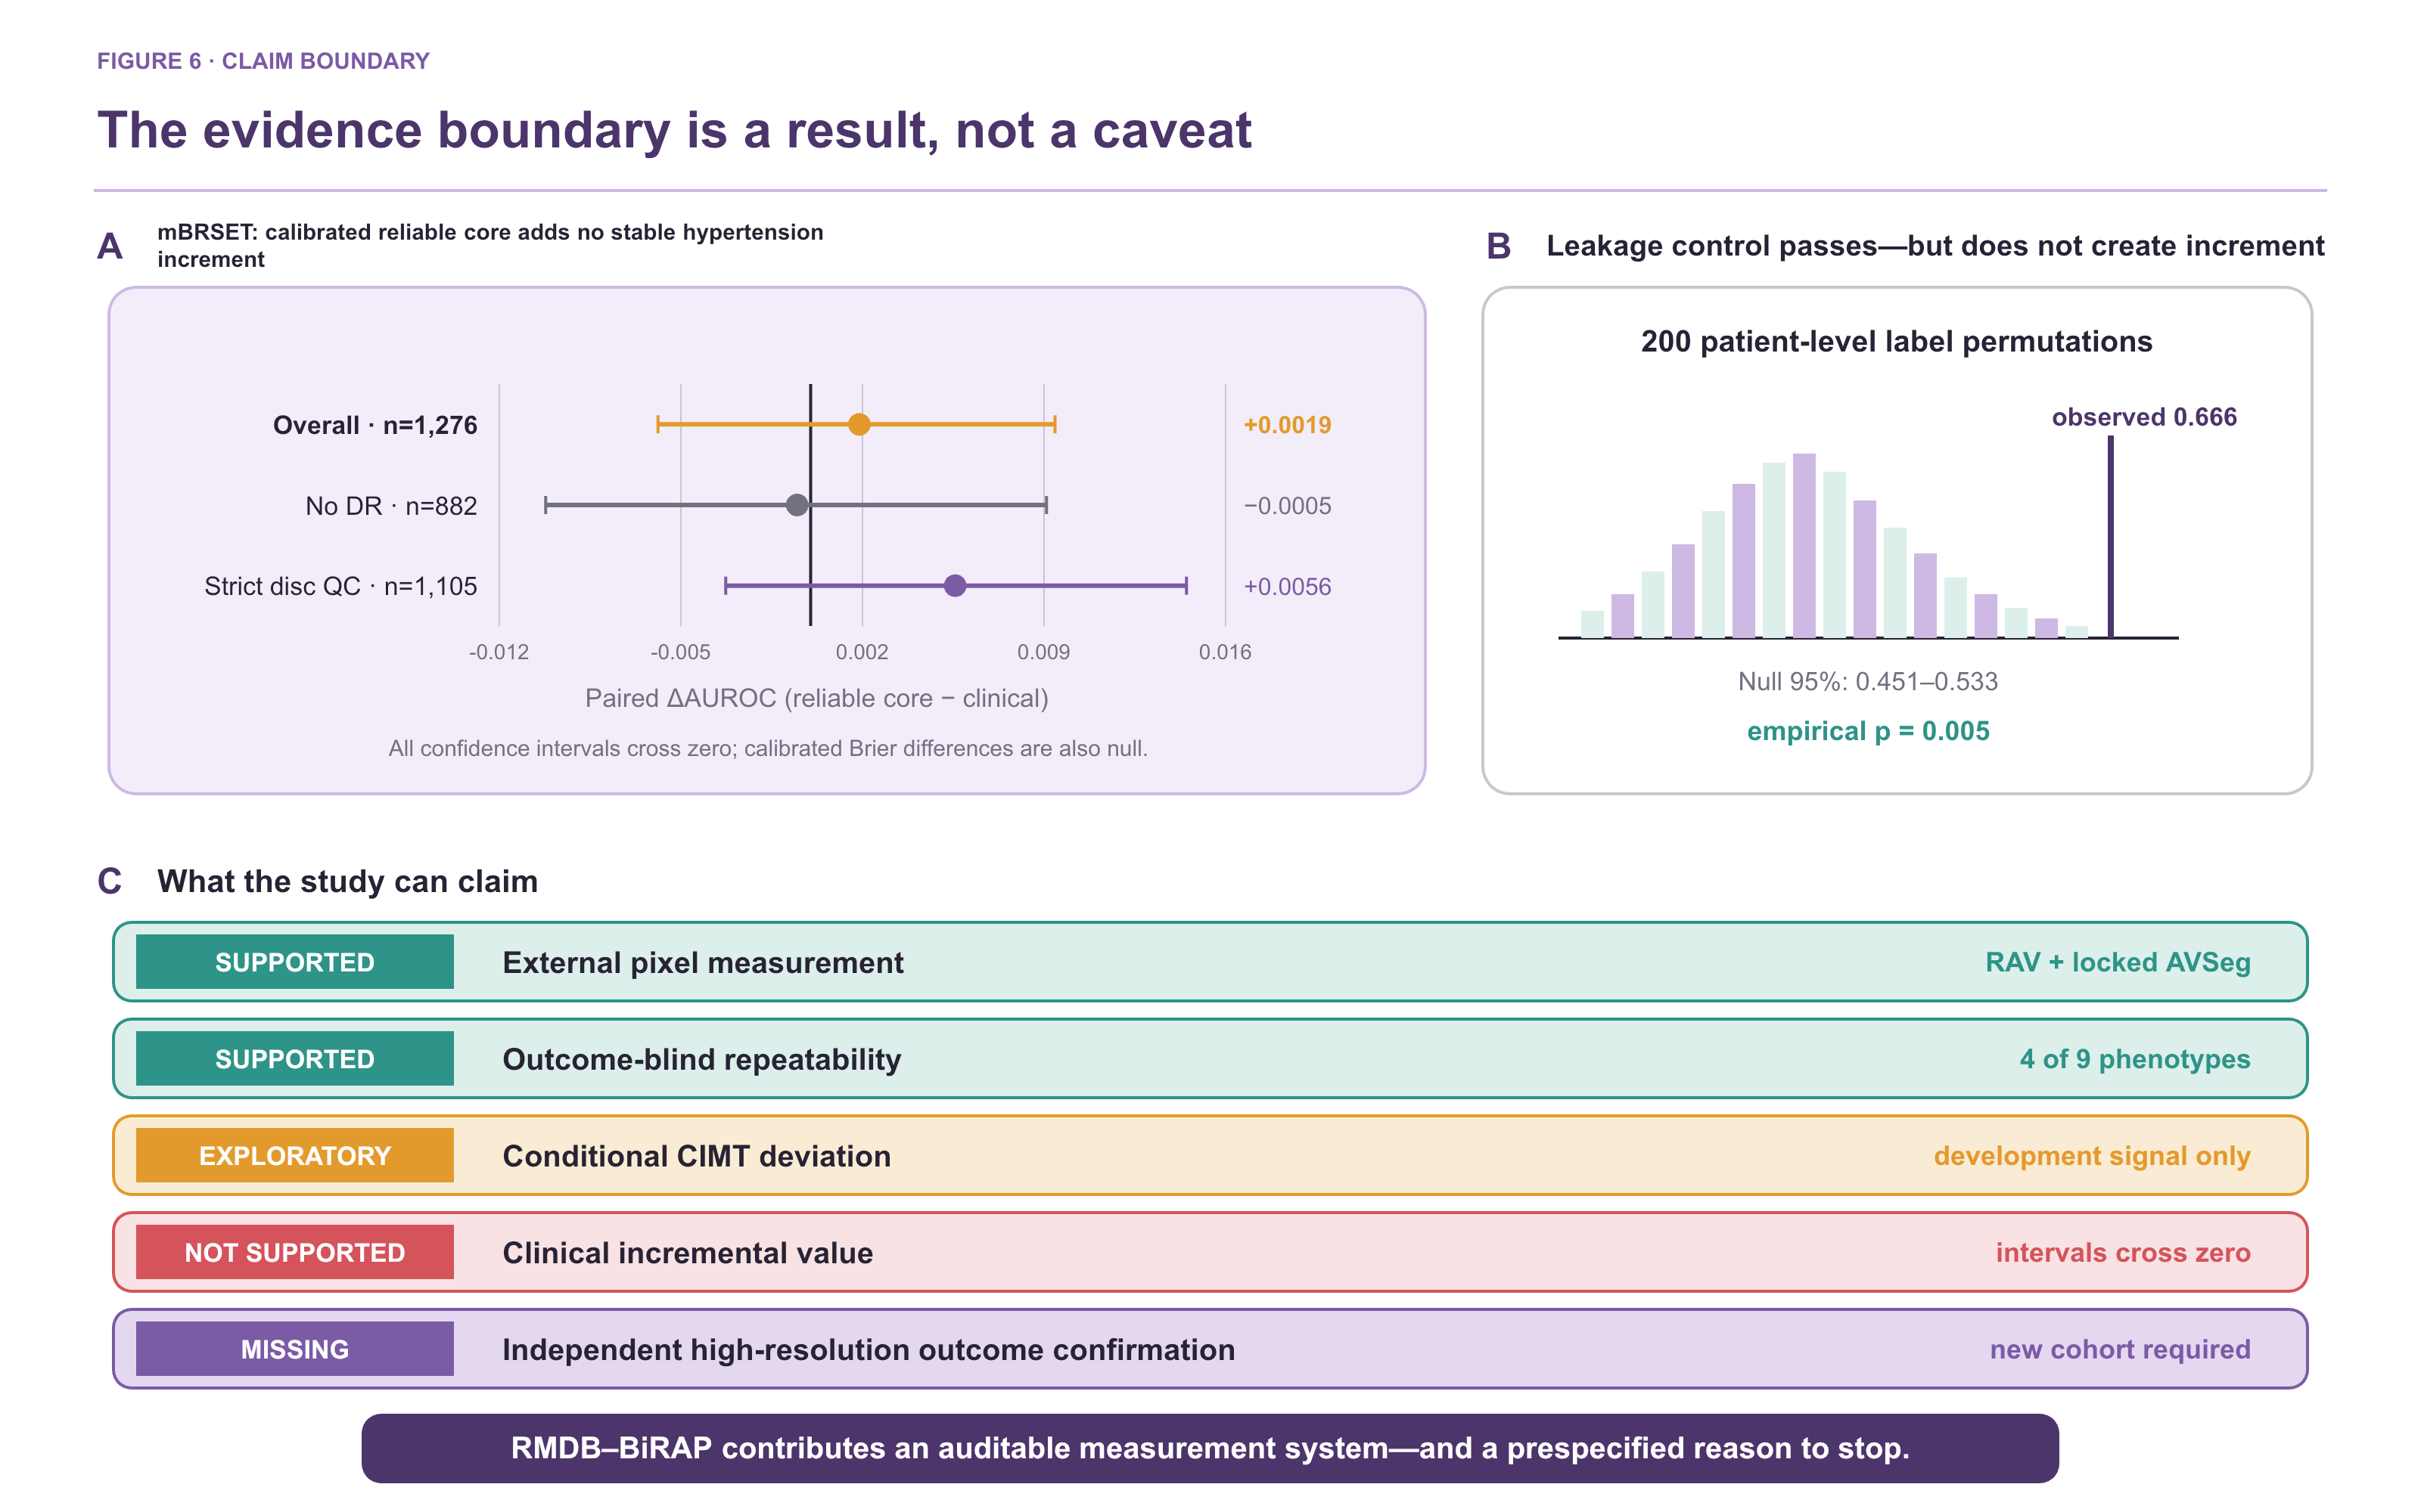
Figure 6. Patient-level results, negative controls, and claim boundary. Panel A reports calibrated mBRSET AUROC increments for the ICC-gated phenotype core over the clinical baseline in the overall cohort, the no-diabetic-retinopathy subset, and the strict disc-quality subset; every paired 95% confidence interval crosses zero. Panel B shows the 200-permutation patient-level negative control and confirms zero outer-fold patient overlap, supporting implementation integrity without establishing phenotype-core increment. Panel C separates supported external pixel measurement and outcome-blind repeatability from exploratory conditional CIMT deviation, unsupported clinical incremental value, and the still-missing independent high-resolution outcome confirmation.

3.7 Negative experiments defined the stopping rule
Conditional-percentile modelling improved development MAE relative to the Gaussian conditional-mean head, but increased RMSE and tail error. A nested blend did not meet the prespecified RMSE non-inferiority margin. Separately, replacing the mass-5 E10A representation with the outcome-blind ICC-gated phenotype core worsened MAE. These results show that a reliable measurement is necessary but not sufficient for prediction, and they rule out outcome-driven feature expansion in the current cohorts.
Most importantly, the disagreement between the conditional-mean and conditional-percentile heads was not a valid uncertainty proxy. Its correlation with absolute error was −0.032 and its AUROC for high-error detection was 0.475. Retaining only low-disagreement patients worsened rather than improved MAE. Head disagreement was therefore removed from the reliability claim instead of being presented as post hoc uncertainty.

4. Discussion

4.1 Principal finding: the evidence layers diverged
The central result is a separation, not a leaderboard win. Frozen upstream identity transferred to RAV, the locked Mass-UDCT stack improved final measurement on Fundus-AVSeg, and four global phenotypes were reproducible across repeated photographs. These successes did not translate into robust clinical increment: direct high-dimensional fusion worsened CIMT performance, the conditional-deviation signal was small, and calibrated mBRSET phenotype-core increments crossed the null overall and in sensitivity analyses. RMDB–BiRAP thus demonstrates in one retinal pipeline what prior technical frameworks predict in principle: measurement validity, repeatability, scale transport, and clinical increment can diverge [21,22].
This divergence exposes the evidential gap hidden by many retrospective retinal models. A biomarker claim requires every link in sequence: a valid measurement under domain shift, a stable patient attribute under reacquisition, and a clinically meaningful increment estimated at the patient level. None of these links is implied by another.

4.2 Algorithmic and methodological contribution
The dual-readout decomposition is the principal algorithmic contribution. Binary vessel support and artery–vein classification have previously been combined in automated retinal pipelines and multi-task networks [18,23]. RMDB differs by retaining two explicit post-inference measurement operators instead of collapsing support and identity into one final map. Mass-UDCT preserves calibrated four-class probability mass, whereas Factorized-UDCT requires occupancy evidence before identity informs geometry. In the locked Fundus-AVSeg evaluation, the operators exhibited different advantages: Mass-UDCT improved overlap and type accuracy, while Factorized-UDCT minimized artery/vein ratio error. Their disagreement was highly repeatable but, after failing the uncertainty experiment, was not promoted to calibrated uncertainty.
The second contribution is the outcome-blind implementation of the reliability gate. ICC-based filtering is not new in quantitative imaging or radiomics [22,24], and retinal retest studies have already documented substantial feature-dependent volatility [19]. BiRAP operationalizes these observations prospectively within automated retinal phenotyping: candidates are prespecified, repeated views are assessed before clinical labels are accessed, excluded features remain visible as negative results, and only retained quantities can enter patient-grouped models. The retained core was dominated by vessel support and skeleton density; artery–vein ratios, branch density, and entropy were not stable enough to carry the same evidential weight.
The third contribution is the cohort-role firewall coupled to an explicit stopping rule. RAV characterized frozen upstream identity and supported corrector development; Fundus-AVSeg independently evaluated the locked final stack; repeated mBRSET images defined reliability; and systemic outcomes were accessed only after phenotype definition. General validation frameworks distinguish technical from clinical evidence [21,22], but RMDB–BiRAP makes that distinction executable at dataset, eye, phenotype, and patient levels. Passing one gate cannot compensate for failure at another, which is why null clinical increments and failed uncertainty experiments remain part of the method rather than being hidden by further outcome-driven feature search.

4.3 Clinical interpretation and limits of increment
The CIMT experiments show why feature quantity is not equivalent to information. Age and sex already explained substantial CIMT variation; adding 104 correlated retinal descriptors increased variance without consistent signal. Conditional target standardization and double orthogonalization revealed a small age-independent development effect, but the frozen interval crossed zero. The correct interpretation is a candidate mechanism for normative deviation, not a clinically useful CIMT estimator.
The mBRSET analysis is now bounded more tightly. Cross-fitted Platt calibration reduced probability error for both the clinical and phenotype-core–augmented models, but the ICC-gated phenotype core did not contribute a separable improvement in AUROC, AUPRC, Brier score, or log loss. The patient-level permutation control supports pipeline integrity, not a clinical association claim. Accordingly, mBRSET contributes external mechanism and repeatability evidence only.
Accordingly, the framework should be viewed as an auditable measurement layer for mechanistic and prospective studies. The present evidence does not support replacing carotid ultrasound, blood-pressure measurement, or standard cardiovascular assessment.

4.4 Limitations and confirmatory path
The cohorts differed in resolution, pathology prevalence, imaging hardware, and covariate availability. Disc localization required fallback in 189 mBRSET images. Repeatability arose from naturally repeated rather than prospectively standardized acquisitions. The mBRSET mirror was limited to 224 pixels and used internal patient-level cross-validation. The previously accessed CIMT validation cohort was small and directionally informative but cannot be reused for model selection; no fixed test data were read in the new analyses. Critically, no unused high-resolution external cohort with linked systemic outcome is currently available locally, so independent clinical confirmation remains absent.
A definitive study should freeze preprocessing, both readouts, the ICC-gated phenotype core, quality exclusions, and clinical baselines before accessing a new high-resolution cohort. Primary discrimination and calibration criteria should be prespecified, with paired patient-level confidence intervals and prospective repeatability assessment. If uncertainty is required, it should be calibrated independently using ensembles, conformal intervals, or an external calibration set rather than inferred from disagreement between prediction heads.

5. Conclusion
A vessel map becomes a credible retinal phenotype only when its measurement rule, repeatability, transport boundary, and clinical role are evaluated separately. RMDB–BiRAP contributes two complementary occupancy–identity measurement operators, an outcome-blind same-eye reliability gate, a cohort-role firewall, and an explicit stopping rule. Across five resources, the framework established frozen upstream identity transfer, locked final-stack measurement improvement, and four reproducible global phenotypes. Direct high-dimensional fusion, head-disagreement uncertainty, replacement of the E10A representation by the ICC-gated core, and calibrated mBRSET increment did not support a clinical claim. The present contribution is therefore a reproducible route from vessel maps to evidence-bounded phenotypes, not an independently confirmed clinical biomarker; frozen validation in a new high-resolution outcome cohort remains necessary.
Declarations
Ethics approval and consent to participate
[Insert institutional review-board identifiers, consent status, and data-governance statements for the China Fundus–CIMT cohort. Public-data use should follow the original cohort licences.]
Data and code availability
Public cohort access should be cited through the original FIVES, RAV, Fundus-AVSeg, and mBRSET repositories. Analysis code, frozen manifests, feature dictionaries, fold assignments, and aggregate result files should be archived at submission. Patient-level China Fundus–CIMT data availability is subject to the governing ethics approval.
Competing interests
[The authors declare no competing interests / insert disclosures.]
Funding
[Insert funding sources and grant numbers.]
Author contributions
[Insert CRediT author-contribution statement.]

References
1. Wong TY, Mitchell P. The eye in hypertension. Lancet. 2007;369:425–435.
2. Poplin R, Varadarajan AV, Blumer K, et al. Prediction of cardiovascular risk factors from retinal fundus photographs via deep learning. Nature Biomedical Engineering. 2018;2:158–164.
3. Ting DSW, Cheung CYL, Lim G, et al. Development and validation of a deep learning system for diabetic retinopathy and related eye diseases using retinal images from multiethnic populations with diabetes. JAMA. 2017;318:2211–2223.
4. Zhou Y, Chia MA, Wagner SK, et al. A foundation model for generalizable disease detection from retinal images. Nature. 2023;622:156–163.
5. McGraw KO, Wong SP. Forming inferences about some intraclass correlation coefficients. Psychological Methods. 1996;1:30–46.
6. Koo TK, Li MY. A guideline of selecting and reporting intraclass correlation coefficients for reliability research. Journal of Chiropractic Medicine. 2016;15:155–163.
7. Steyerberg EW. Clinical Prediction Models. 2nd ed. Springer; 2019.
8. Collins GS, Reitsma JB, Altman DG, Moons KGM. Transparent reporting of a multivariable prediction model for individual prognosis or diagnosis (TRIPOD). Annals of Internal Medicine. 2015;162:55–63.
9. Efron B, Tibshirani RJ. An Introduction to the Bootstrap. Chapman & Hall/CRC; 1993.
10. DeLong ER, DeLong DM, Clarke-Pearson DL. Comparing the areas under two or more correlated receiver operating characteristic curves. Biometrics. 1988;44:837–845.
11. Harrell FE Jr. Regression Modeling Strategies. 2nd ed. Springer; 2015.
12. Riley RD, van der Windt D, Croft P, Moons KGM, editors. Prognosis Research in Healthcare. Oxford University Press; 2019.
13. Jin K, Huang X, Zhou J, et al. FIVES: A Fundus Image Dataset for Artificial Intelligence based Vessel Segmentation. Scientific Data. 2022;9:475. doi:10.1038/s41597-022-01564-3.
14. Vargas Quiros J, Liefers B, van Garderen KA, Vermeulen JP, Eyened Reading Center, Klaver C. Rotterdam artery–vein segmentation (RAV) dataset. arXiv. 2025;arXiv:2512.17322. Dataset doi:10.34894/9OIMWY.
15. Deng Z, Gao W, Gong Z, et al. A Fundus Image Dataset for AI-based Artery-Vein Vessel Segmentation. Scientific Data. 2025;12. doi:10.1038/s41597-025-05381-2. Dataset doi:10.6084/m9.figshare.27938034.v2.
16. Nakayama LF, Ribeiro LZ, Restrepo D, et al. BRSET: A Brazilian Multilabel Ophthalmological Dataset of Retina Fundus Photos. PLOS Digital Health. 2024;3:e0000454. doi:10.1371/journal.pdig.0000454. Dataset doi:10.13026/xcxw-8198.
17. Vargas Quiros J, Liefers B, van Garderen KA, Vermeulen JP, Klaver C. VascX Models: Deep Ensembles for Retinal Vascular Analysis From Color Fundus Images. Translational Vision Science & Technology. 2025;14(7):19. doi:10.1167/tvst.14.7.19.
18. Zhou Y, Wagner SK, Chia MA, et al. AutoMorph: Automated Retinal Vascular Morphology Quantification Via a Deep Learning Pipeline. Translational Vision Science & Technology. 2022;11(7):12. doi:10.1167/tvst.11.7.12.
19. Giesser SD, Turgut F, Saad A, et al. Evaluating the Impact of Retinal Vessel Segmentation Metrics on Retest Reliability in a Clinical Setting: A Comparative Analysis Using AutoMorph. Investigative Ophthalmology & Visual Science. 2024;65(13):24. doi:10.1167/iovs.65.13.24.
20. McGrory S, Taylor AM, Pellegrini E, et al. Towards Standardization of Quantitative Retinal Vascular Parameters: Comparison of SIVA and VAMPIRE Measurements in the Lothian Birth Cohort 1936. Translational Vision Science & Technology. 2018;7(2):12. doi:10.1167/tvst.7.2.12.
21. Goldsack JC, Coravos A, Bakker JP, et al. Verification, analytical validation, and clinical validation (V3): the foundation of determining fit-for-purpose for Biometric Monitoring Technologies (BioMeTs). npj Digital Medicine. 2020;3:55. doi:10.1038/s41746-020-0260-4.
22. Raunig DL, McShane LM, Pennello G, et al.; QIBA Technical Performance Working Group. Quantitative imaging biomarkers: a review of statistical methods for technical performance assessment. Statistical Methods in Medical Research. 2015;24(1):27–67. doi:10.1177/0962280214537344.
23. Yi J, Chen C. Multi-Task Segmentation and Classification Network for Artery/Vein Classification in Retina Fundus. Entropy. 2023;25(8):1148. doi:10.3390/e25081148.
24. Gong J, Wang Q, Li J, et al. Using high-repeatable radiomic features improves the cross-institutional generalization of prognostic model in esophageal squamous cell cancer receiving definitive chemoradiotherapy. Insights into Imaging. 2024;15(1):239. doi:10.1186/s13244-024-01816-3.

