RegionSuff: Visibility-Conditioned Auditing of Model-Specific Retinal Evidence under Limited Fields of View in Ultra-Widefield Fundus Imaging

Kaiwen Deng, Liwei Liu*
School of Railway Intelligent Engineering, Dalian Jiaotong University, Dalian, 116028, China

*Corresponding author
Email: Liwei Liu (liutree80@163.com)

Abstract:
Reliable AI-assisted retinal diagnosis depends not only on image clarity but also on whether the acquired field contains the evidence required for the target task. Existing retinal image-quality assessment methods mainly evaluate blur, illumination, contrast, and imaging artifacts. A technically gradable image may nevertheless omit macular, optic-disc, or peripheral signs relevant to diabetic retinopathy (DR) grading, leaving diagnostic sufficiency unexamined.
We introduce RegionSuff, a visibility-conditioned model for evaluating DR classification under restricted retinal coverage in ultra-widefield fundus imaging. RegionSuff divides the retinal foreground into a 3×3 evidence bank, extracts regional features using a frozen retinal image-quality encoder, and applies visibility-conditioned masked attention to aggregate only visible regions. Random region-level masking introduces controlled evidence loss during training, while region-level masks and pixel-space apertures examine how evidence composition, area, location, shape, and topology affect prediction. The model was developed using 1,630 UWF-DR records and evaluated without target-domain adaptation or model selection on the official 2,597-image MMRDR-UWF test set.
On UWF-DR, macro-F1 decreased from 0.830 with the full-view to 0.790 with the center-only view and increased to 0.829 when the four axial neighboring regions were restored. On MMRDR-UWF, macro-F1 was 0.625, 0.600, and 0.642 for full-view, center-only, and center-plus-cross inference, respectively. Equal-area apertures with different locations or shapes produced different outcomes, and central-region occlusion caused the largest performance loss. A downstream paired-view risk model detected limited-view underestimation with an AUROC of 0.740 on the held-out split, although grouped nested evaluation reduced the AUROC to 0.653. RegionSuff extends retinal image-quality assessment from photographic quality to the model-specific retinal evidence availability and the spatial organization of task-relevant retinal evidence.
Keywords: diagnostic sufficiency; retinal image-quality assessment; ultra-widefield fundus imaging; diabetic retinopathy; masked attention; limited-view underestimation

1. Introduction
Diabetic retinopathy (DR) remains a major cause of preventable visual impairment. Retinal photography is now widely used in teleophthalmic screening and autonomous AI systems, and deep-learning models have achieved strong performance for DR detection and severity grading in large and diverse populations. [1–5] These systems, however, usually assume that an image passing image-quality control also contains the retinal evidence needed for the diagnostic task. This assumption is not always valid. An image can be sharp, well illuminated, and technically gradable while failing to show the macular, optic-disc, or peripheral findings required for DR assessment. Technical gradability and diagnostic sufficiency should therefore be considered separately: the former concerns the clarity of the observed retina, whereas the latter concerns whether the observed field contains enough task-relevant evidence.
This issue is particularly important for ultra-widefield (UWF) fundus imaging. Conventional color fundus photography generally covers approximately 30–60°, whereas UWF systems can image close to 200° of the retina. The additional peripheral field can reveal DR lesions that are not visible in the posterior pole and that may be associated with subsequent disease progression. [6–9] UWF imaging therefore provides a useful setting for examining how task-relevant retinal evidence is distributed across the retina. A wider nominal field, however, does not guarantee identical anatomical coverage in every acquisition. The macula, optic disc, or peripheral retina may still be incompletely captured even when focus, illumination, and contrast are acceptable. Consequently, two images with similar photographic quality may provide different amounts of evidence for DR grading.
Retinal image-quality assessment has developed from handcrafted measurements of sharpness and illumination to learning-based methods that evaluate blur, contrast, illumination, and imaging artifacts. Early approaches mainly aimed to identify images suitable for teleophthalmic screening or to characterize common forms of photographic degradation. [10–12] More recent studies have expanded the available datasets and tasks. MSHF introduced heterogeneous fundus images for quality assessment, DeepDRiD combined DR grading with image-quality estimation, and quality-aware models incorporated image quality into disease prediction. [13–15] Quality assessment has also been studied specifically for UWF photographs. [16] These methods are valuable for excluding technically unusable images, but their definition of quality is generally based on photographic clarity or overall gradability. They do not explicitly indicate which retinal regions are visible or whether the visible regions contain task-relevant retinal evidence for a particular disease task. A technically acceptable image may therefore remain diagnostically incomplete.
Confidence-based methods provide only a partial answer to this problem. Calibration and selective prediction can identify uncertain cases or refer high-risk cases for further review, while out-of-distribution detection can identify images that differ from the training distribution. [17–20] Yet these methods primarily describe the model’s confidence and the statistical properties of the observed image. They do not directly represent task-relevant retinal evidence that was not captured. A restricted-view image may consequently receive a confident prediction if the visible features support an incomplete interpretation. Regional attention provides another useful but limited perspective. It assigns weights to the available regional features, [21] but a high attention weight alone does not show that the region is causally responsible for the prediction. [22] These limitations motivate an audit in which regional visibility is represented explicitly and evidence can be removed in a controlled manner.
We therefore introduce RegionSuff, a visibility-conditioned framework for studying DR classification under restricted retinal coverage in UWF fundus imaging. The retinal foreground is divided into a 3×3 evidence bank, and each region is represented using a frozen retinal image-quality encoder. Visibility-conditioned masked attention then aggregates evidence only from regions marked as visible. During training, random region-level masking exposes the model to controlled evidence loss while keeping the original disease label unchanged. At evaluation, region-level masks and pixel-space apertures are used to vary the composition, area, location, shape, and topology of the visible retina. The central question is whether model performance depends on how retinal evidence is spatially organized, rather than on photographic quality or visible area alone.
RegionSuff was developed using 1,630 UWF-DR records with group-disjoint partitions and five source-training seeds. [23] The primary analysis compared full-view, center-only, and center-plus-cross inference. Additional experiments examined regional granularity, masking probability, aggregation strategy, encoder choice, continuous pixel-space apertures, and one-region occlusion. The occlusion analysis further tested whether the regions receiving higher attention were also the regions whose removal produced greater performance loss. For external evaluation, we used the official 2,597-image MMRDR-UWF test set without target-domain adaptation or model selection. [24] We also performed a downstream paired-view audit in which the same severity model was evaluated under full-view and center-plus-cross masks. The resulting prediction differences were used to rank limited-view underestimation risk and to examine how risk thresholds behaved under grouped nested evaluation.
In this study, diagnostic sufficiency is operationalized as model-specific retinal evidence availability. Through controlled visibility restrictions, RegionSuff examines how a fixed DR classifier responds to changes in retinal coverage and its spatial organization. The framework is therefore intended as an evidence-auditing approach for model behavior under restricted views.

2. Methodology

2.1 Study design, endpoints, and reporting boundary
Using publicly available, de-identified data, we conducted a retrospective computational study without additional image acquisition. Model performance was evaluated on a held-out test set under three prespecified visibility settings: full-view, center-only, and center-plus-cross. Macro-F1 for three-class DR grading was the primary endpoint. Accuracy, ordinal severity mean absolute error (MAE), and underestimation rate were secondary endpoints. Source-domain training was repeated across five random seeds to characterize optimization variability. Where per-image predictions were available, view contrasts were summarized with image-level paired bootstrap 95% confidence intervals. [25]
The study workflow is summarized in Figure 1. We first distinguish technical gradability from model-specific retinal evidence availability. We then impose region-level masks and pixel-space apertures on the same UWF image to vary the composition, area, location, shape, and topology of visible task-relevant retinal evidence while keeping the source DR label fixed. RegionSuff applies visibility-conditioned masked attention for three-class DR prediction. Finally, internal testing, one-region occlusion, independent same-modality UWF external evaluation, and the paired-view audit examine whether prediction changes are consistent with the available task-relevant retinal evidence. The masks are controlled interventions rather than real paired conventional-field and UWF acquisitions; the operational construct is model-specific retinal evidence availability.
The complete information flow is shown in Figure 2. A single UWF image is partitioned into nine regional crops; the shared frozen encoder and trainable projection convert each visible crop into one regional token. The visibility mask is applied inside the visibility-conditioned masked-attention module, so unavailable regions contribute no weight and the remaining tokens are normalized before DR severity prediction. The same fitted severity model is then evaluated under the full-view and center-plus-cross limited-view conditions before the paired-view audit compares the two outputs.
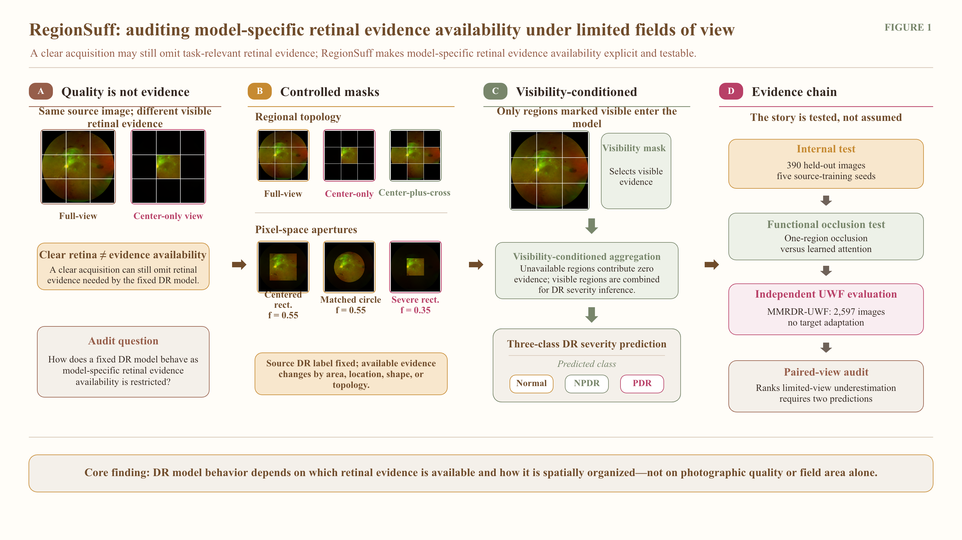Figure 1. Overview of the RegionSuff framework. (A) Technical gradability does not guarantee task-relevant retinal evidence. (B) Region-level masks and pixel-space apertures impose controlled restrictions on visible task-relevant retinal evidence. (C) RegionSuff aggregates visible regional representations with visibility-conditioned masked attention for three-class DR prediction. (D) Paired full-view and center-plus-cross limited-view predictions are compared in an exploratory underestimation audit. All restrictions are synthetic and the source DR label remains unchanged.
For the paired-view audit, the same fitted RegionSuff severity model was evaluated under the full-view mask m_{full} and the center-plus-cross limited-view mask m_{limited}, producing:
$$p_{F}= p(m_{full}),p_{L}= p(m_{limited}).$$
The two probability vectors were then compared by the downstream paired-view risk model. This analysis characterizes prediction shifts under restricted views and requires both visibility conditions; it is not an independent single-image triage rule.

2.2 Datasets, records, and label harmonization
Table 1. Datasets, study records, model partitions, and experimental roles.
Dataset | Records used in this study | Partition or evaluation set | Labels used | Experimental role
UWF-DR | 1,630 | Source training 876; validation 364; test 390 | Normal 496; NPDR 634; PDR 500 | Model development, controlled perturbation analyses, and internal evaluation
MMRDR-UWF | 2,597 | Official UWF external test subset | Grade 0→Normal; grades 1–3→NPDR; grade 4→PDR | Independent same-modality external evaluation; no target-domain adaptation
UWF-DR contributed 1,630 publicly released 512×512 UWF image records acquired with an Optomap Daytona system and labeled as Normal, NPDR, or PDR. Because the release did not contain a dedicated patient-identifier column, we derived a grouping key from the first two underscore-separated filename fields. This procedure yielded 783 non-overlapping groups and source partitions of 876, 364, and 390 records for training, validation, and testing, respectively. [23]
An audit of the released metadata identified 1,608 unique filenames among the 1,630 records. Eleven filenames were duplicated, and two duplicated filenames were associated with conflicting labels. Group membership remained disjoint, and the 390-record test partition contained no repeated filename. A separate sensitivity analysis was performed on the validation list by retaining one row per filename and resolving the two conflicts with majority voting and a severe-class tie-break. The test set was not modified. Full-view, center-only, and center-plus-cross macro-F1 values in this analysis were 0.833, 0.790, and 0.832, respectively, closely matching the primary analysis.
MMRDR contains CFP, OCT, and UWF modalities. We used only the official 2,597-image UWF test subset for independent same-modality external evaluation. Its original five-level DR labels were mapped to the prespecified three-class task: grade 0 to Normal, grades 1–3 to NPDR, and grade 4 to PDR. The resulting class counts were 800, 1,411, and 386. MMRDR images and labels were not used for source training, early stopping, calibration, model selection, or threshold selection. [24]

2.3 Retinal foreground and controlled evidence loss
After scaling each image channel to [0,1], we computed the per-pixel mean intensity and defined the retinal foreground as pixels whose mean intensity exceeded 0.035. The foreground box was then obtained as the tight axis-aligned bounding rectangle of these pixels. If the detected foreground occupied less than 8% of the image frame, the full frame was used as a fallback. Region-level views were generated from a 1-indexed 3×3 row-major grid: full-view retained all nine regions, center-only retained region 5, and center-plus-cross retained regions 2, 4, 5, 6, and 8.
Pixel-space apertures were applied before feature extraction. The source image, reference DR label, retinal foreground box, and 3×3 regional coordinates were kept fixed across all interventions. The parameter f denoted retained width and height as fractions of the foreground box. For nominal-area calculations, the foreground box was mapped affinely to a unit square and A_{box} denoted its normalized area. Centered rectangles and nominally area-matched circles were evaluated at f=0.35, 0.45, 0.55, 0.65, 0.75, and 0.90. A rectangle with f=0.55 was additionally translated leftward, rightward, superiorly, and inferiorly to examine location effects, whereas the centered rectangle with f=0.35 served as the severe rectangular aperture.
$$A_{rectangle}/A_{box}=f^{2},r_{circle}(norm) = f / √π,A_{circle}/A_{box}=f^{2}.$$
Thus, r_{circle} is the radius in normalized foreground-box coordinates, and the rectangle and circle are matched by nominal aperture area rather than by the exact amount of retained retinal tissue. The actual retained tissue can still differ because of retinal shape, image boundaries, and black background.

2.4 Regional representation
Each retinal foreground box was partitioned into K=9 rectangular regions. The full-view, center-plus-cross, and representative regional-crop examples in Figure 2 were generated from the same source UWF image; black tiles denote regions excluded by the visibility mask. Each crop was resized to 256×256, center-cropped to 224×224, and normalized using the ImageNet channel-wise mean and standard deviation. For each regional crop, a local RetinaRadar EfficientNet-B0 checkpoint generated a frozen global pooled feature vector. The checkpoint contained 17 retinal image-quality outputs covering laterality, image type, artifacts, clarity, illumination, contrast, field, and usability. It was used here solely as a frozen retinal image-quality encoder. The projection layer, visibility-conditioned masked-attention module, and DR classifier were trained on UWF-DR. The shared feature path is shown in Figure 2B. The checkpoint identifier and checksum are provided in the accompanying code-and-results archive. [26]
$$z_{i}=P_{θ}(E(r_{i})) ∈R^{128}, i ∈ \{1,…,K\}.$$
Here, rᵢ denotes the i-th regional crop, E is the frozen EfficientNet-B0 encoder, and Pθ is a trainable projection module consisting of a linear layer, layer normalization, and ReLU activation. The resulting 128-dimensional vector zᵢ serves as the regional token.

2.5 Visibility-conditioned attention and severity loss
The visibility-conditioned masked-attention module—shown in Figure 2—applies a 128-to-48 linear layer, a tanh activation, and a 48-to-1 linear readout to each regional token. Accordingly, W_{a} maps the 128-dimensional token to 48 dimensions; b_{a} and w_{a} each contain 48 elements; b_{s} is scalar; and W_{c} with b_{c} maps the 128-dimensional aggregate to three DR-class logits. The module produces a regional evidence score eᵢ for every region. In the implementation, logits corresponding to unavailable regions (mᵢ=0) were set to −10⁴ before softmax. For any nonempty K-element binary visibility vector m, this is numerically equivalent at the reported precision to the following visible-set formulation:
$$e_{i} = {w_{a}}^{T} tanh(W_{a}z_{i} + b_{a}) + b_{s}$$
$$a_{i}(m) = \frac{m_{i} exp(e_{i})}{∑_{j=1}^{K}m_{j} exp(e_{j})}$$
$$h(m) = ∑_{i=1}^{K}a_{i}(m)z_{i}, p(m) = softmax(W_{c}h(m) + b_{c})$$
The binary visibility vector m identifies the regions available in the current view, with mᵢ=1 for a visible region and mᵢ=0 otherwise. In the displayed visible-set form, aᵢ(m)=0 when mᵢ=0, and attention weights sum to one only across visible tokens; the −10⁴ implementation yields the same result to numerical precision. Their weighted sum forms h(m), from which the classifier produces probabilities for Normal, NPDR, and PDR. The predicted class is ŷ(m)=arg max_{c} p_{c}(m), with c∈{0,1,2}. The all-empty mask case was handled using the fallback rule described in Section 2.6. The model was optimized with unweighted cross-entropy because class weights were not used in the locked implementation. Here, B is the minibatch size, yₙ is the reference class for sample n, mₙ is its visibility mask, and the final probability term is the probability assigned to sample n's reference class.
$$L_{CE} = −\frac{1}{B} ∑_{n=1}^{B} log p_{n,yₙ}(m_{n})$$

2.6 Stochastic visibility masking
During source training, each of the nine regional tokens was independently masked with probability ρ=0.30. If an all-empty mask was sampled, the top-left region in row-major order was restored in the locked Exp35/Exp36 implementation; the event probability was 0.3⁹≈2.0×10⁻⁵ per training image. A sensitivity run restored the geometric center token instead and, together with validation-list deduplication, produced nearly unchanged test results. Deterministic full-view, center-only, and center-plus-cross masks were reserved for evaluation.
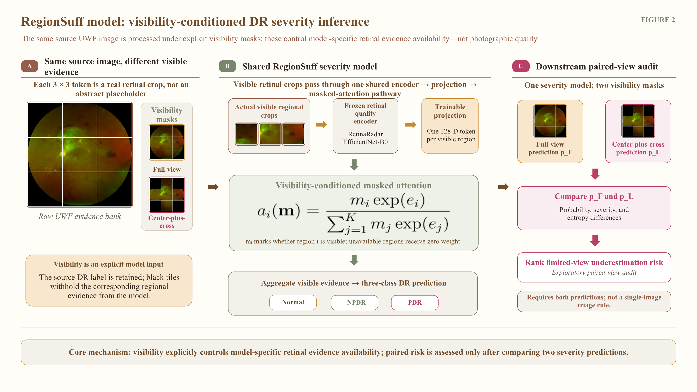
Figure 2. RegionSuff information flow. A single UWF image is partitioned into a 3×3 regional evidence bank; visible regions follow a shared frozen regional encoder and trainable projection before visibility-conditioned masked attention produces the three-class DR prediction. The fitted severity model is subsequently evaluated under the full-view and center-plus-cross limited-view conditions for the exploratory paired-view audit. Black tiles denote excluded task-relevant retinal evidence; the paired audit requires two model predictions.

2.7 Severity and underestimation endpoints
Predicted classes were coded ordinally as 0=Normal, 1=NPDR, and 2=PDR. Severity MAE was the mean absolute difference between predicted and reference class. The expected ordinal severity s(m) was computed from the three-class probability vector and was used only as a paired-view risk feature; it did not replace the discrete predicted class. Underestimation was the event that the predicted class was lower than the reference class.
$$ŷ(m) = {arg max}_{c∈\{0,1,2\}} p_{c}(m), s(m) = ∑_{c=0}^{2} cp_{c}(m), u(m) = 1[ŷ(m) < y]$$

2.8 Downstream paired-view risk model
For each image, the same fitted RegionSuff severity model was evaluated twice. The full-view mask m_{full} retained all K=9 regions and produced p_{F}=p(m_{full}); the center-plus-cross limited-view mask m_{limited} retained the center-plus-cross regions {2,4,5,6,8} and produced p_{L}=p(m_{limited}). These two outputs were passed to the downstream paired-view risk model rather than treated as parallel outputs of the visibility-conditioned masked-attention module. The resulting 18-dimensional feature contains four three-class probability blocks (12 values), three expected-severity terms, two predictive entropies, and one symmetric Kullback–Leibler divergence.
$$H(p) = −∑_{c=0}^{2}p_{c} log(p_{c}+ε), D_{SKL}(p_{F},p_{L}) = \frac{1}{2}[KL(p_{F}∥p_{L})+KL(p_{L}∥p_{F})]$$
$$g = [p_{F}, p_{L}, p_{F}−p_{L}, |p_{F}−p_{L}|, s_{F}, s_{L}, s_{F}−s_{L}, H_{F}, H_{L}, D_{SKL}] ∈ R^{18}$$
$$g̃ = (g−μ_{g}) ⊘ σ_{g}, q(g) = sigmoid(β^{T}g̃+b)$$
Here, ε=10⁻⁸ was used for numerical stability; s_{F}=s(m_{full}) and s_{L}=s(m_{limited}) are expected severity scores; H_{F} and H_{L} are the corresponding predictive entropies; and D_{SKL} is the average of the two directed KL divergences. The operator ⊘ denotes elementwise division. The featurewise mean μ_g and standard-deviation vector σ_g were estimated only from the risk-development partition, and the logistic risk model used an 18-element coefficient vector β with scalar intercept b. It used L2 regularization (C=0.1), balanced class weights, and liblinear optimization. In the fixed-split analysis, the same validation predictions were used to fit the logistic model and choose the risk threshold; the held-out test ranking is informative, but the threshold claim is exploratory because model fitting and calibration were not separated.

2.9 Risk-controlled thresholds and nested audit
For a target accepted underestimation risk α, candidate thresholds accepted samples with q(g)≤τ. The largest accepted set whose one-sided 95% Clopper–Pearson upper confidence bound did not exceed α was selected. [27]
$$τ_{α} = max\{τ : U_{CP}(k_{τ},n_{τ};0.95) ≤ α\}$$
Here, U_{CP} denotes the one-sided Clopper–Pearson upper confidence bound at level 0.95, nτ is the number of accepted threshold-development cases, and kτ is the corresponding number of underestimations. The stricter audit used four outer filename-grouped folds on the original train+validation pool. Within each outer-training fold, a group split supplied a severity-model fitting subset and an inner risk-development subset; risk ranking and thresholds were evaluated once on the outer test fold. Because the inner subset supplied severity early stopping, logistic-risk fitting, and threshold selection, this remains a nested robustness audit rather than a fully separated or prospective calibration design.

2.10 Training and model selection
Regional-feature mean and standard deviation were estimated from source training regions only. Trainable heads used AdamW with learning rate 1.5×10⁻³ and weight decay 3×10⁻⁴, for at most 180 epochs with patience 25. Full-view validation macro-F1—not center-plus-cross performance—selected the epoch in the locked implementation. Five seeds (0–4) were run for the primary configuration. The held-out test set was evaluated after each seed-specific model was frozen.

2.11 Control experiments and aperture augmentation
Single-split controls were used to assess pooling (mean, max, and attention), token-mask probability (0, 0.15, 0.30, 0.45, and 0.60), grid size (1×1 through 4×4), and regional representation (RetinaRadar, ImageNet ResNet-50, 67-dimensional handcrafted statistics, and random ResNet-50). The 0.30 mask ratio and 3×3 grid were reference configurations inherited from the experimental registry; the non-monotonic single-split sensitivity does not justify calling them unique optima. A separate five-seed 4×4 run and per-seed paired bootstrap compared 4×4 with 3×3.
A supplementary pixel-space aperture augmentation variant generated one additional representation per source-training record. Aperture shape was sampled uniformly from rectangle and circle; fraction was sampled uniformly from 0.45 to 0.80; and position was sampled uniformly from center, left, right, superior, and inferior. These representations were concatenated with the original source-training bank, while token masking remained active. Epoch selection again used full-view source-validation macro-F1, and this variant was evaluated only on four fixed internal stress apertures.
For this paired optimization analysis, both the baseline and augmented heads were retrained with the geometric-center fallback for all-empty token masks and with a dedicated random-mask sequence. Its baseline is therefore the protocol-matched comparator for the augmentation arm; it is not a reuse of the independently trained aperture-sensitivity models reported in Section 3.2.

2.12 Functional validation of regional attention
Regional attention was interpreted only through an intervention that held the fitted model and reference label fixed. Each test image was re-evaluated nine times, with one region removed on each pass. For region i, the occlusion loss was defined as the decrease in full-view macro-F1 after its removal. Spearman correlation then compared the nine mean full-view attention weights with the nine occlusion losses. This analysis tests functional alignment rather than causal attribution; the small number of regions limits inferential power. [22]

2.13 External evaluation and statistical analysis
The five source-trained 3×3 severity heads were applied to MMRDR-UWF without target-label training, calibration, early stopping, or model selection. Point metrics are mean±sample SD across source seeds. Within each seed, view differences used 2,000 paired image-level bootstrap resamples, preserving image identity between views. [25]
An exploratory external quality proxy combined retinal coverage, within-retina contrast, and first-difference sharpness. It is not a clinical image-quality label. All p values are two-sided and are reported descriptively without multiplicity adjustment. Seed SD represents optimization variability; paired bootstrap intervals represent image-sampling uncertainty conditional on a fitted seed and must not be interpreted as interchangeable.

3. Results

3.1 Internal filename-group-held-out performance
Across five seeds, full-view macro-F1 was 0.830±0.017. Center-only evidence reduced macro-F1 to 0.790±0.012 and increased underestimation from 0.070±0.007 to 0.093±0.006. Center-plus-cross recovered macro-F1 to 0.829±0.017, while severity MAE was 0.182±0.016. These values are optimization dispersion across the same 390-record test partition, not independent image-level confidence intervals.
Table 2. Internal held-out results across five source-training seeds. Values are mean±sample SD.
View | Accuracy | Macro-F1 | Severity MAE | Under. rate
Full-view | 0.829±0.017 | 0.830±0.017 | 0.180±0.018 | 0.070±0.007
Center-only | 0.789±0.012 | 0.790±0.012 | 0.228±0.013 | 0.093±0.006
Center-plus-cross | 0.828±0.017 | 0.829±0.017 | 0.182±0.016 | 0.075±0.012

3.2 Evidence effects depend on area, location, shape, and topology
Centered pixel-space apertures generally improved as fraction increased, but neither shape followed a monotonic trajectory at every step and variability was large at small fractions. Rectangular macro-F1 ranged from 0.643±0.150 at fraction 0.35 to 0.814±0.022 at 0.90; circular macro-F1 ranged from 0.584±0.114 to 0.819±0.018. At the matched nominal area f² for f=0.55, the circle yielded macro-F1 0.750±0.046 versus 0.678±0.085 for the rectangle, showing that equal nominal area did not equal equivalent evidence.
Translating the 0.55 rectangle changed mean macro-F1 little (0.672–0.678) but altered underestimation markedly: the inferior aperture reached 0.159±0.099 compared with 0.050±0.017 at the center. Region topology showed a clearer and more stable pattern: center-only was lower than full in all five seeds, whereas center-plus-cross nearly restored full-view performance.
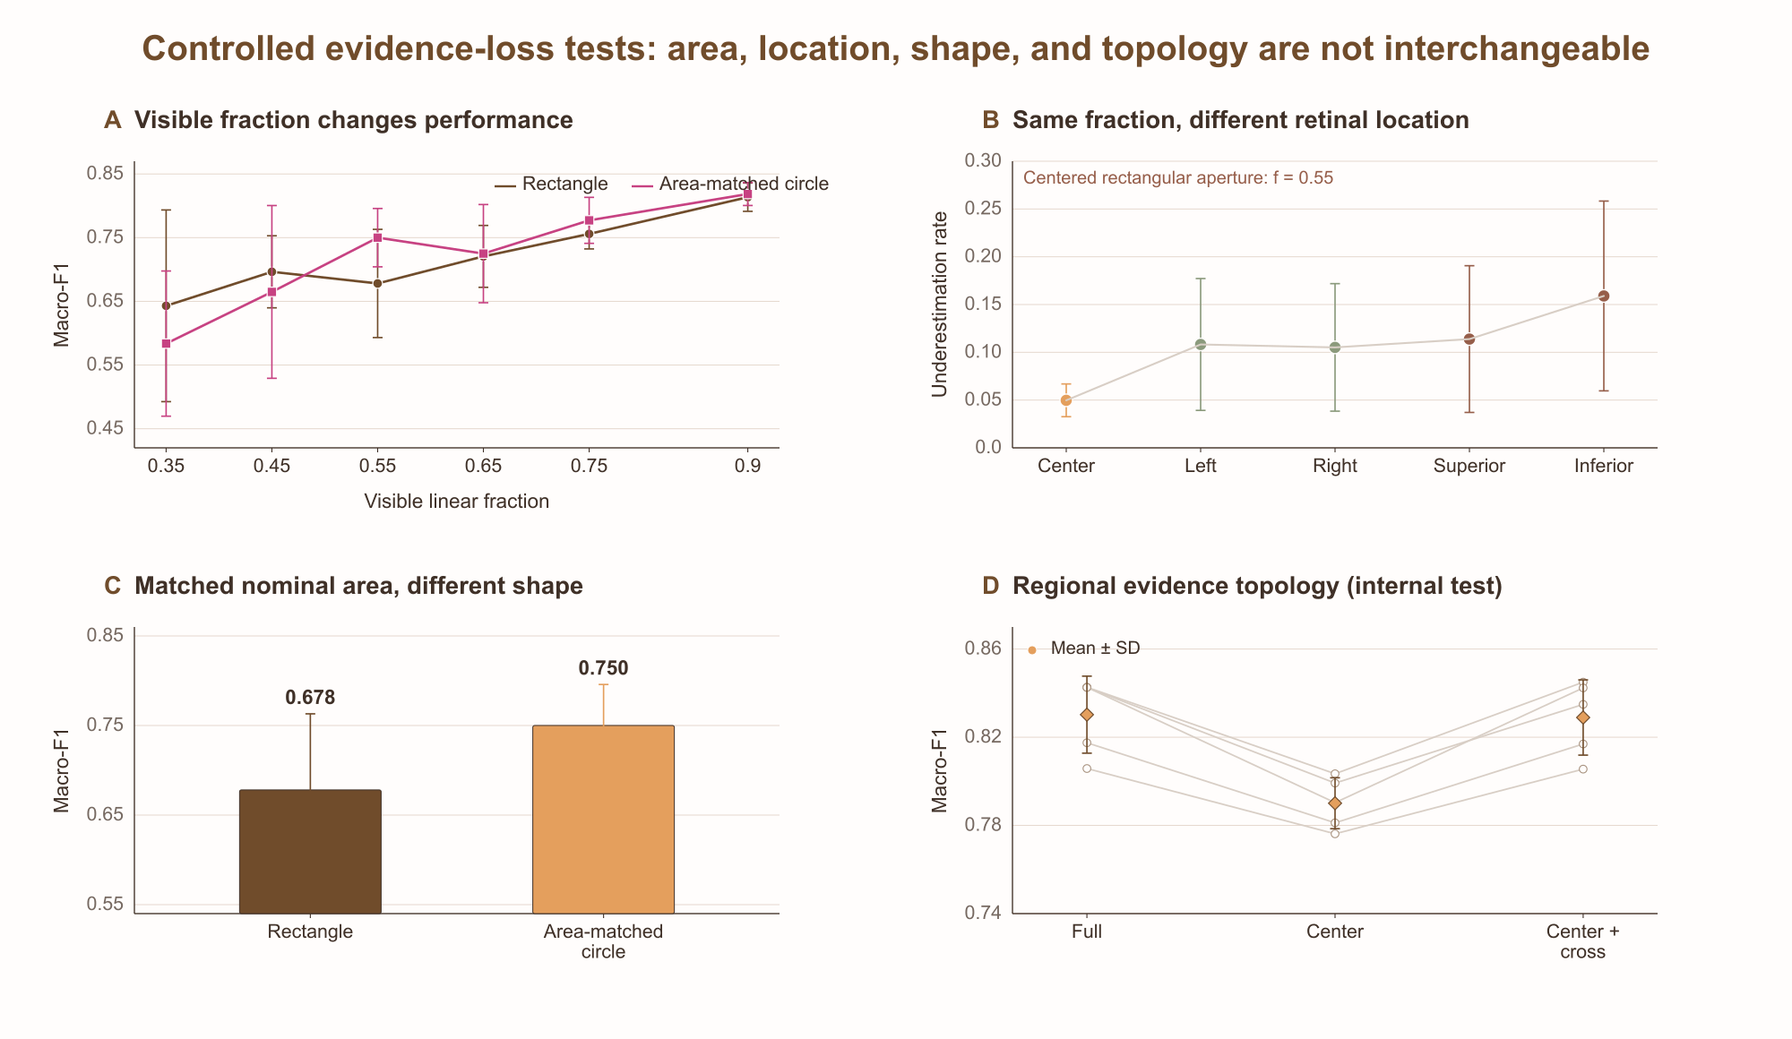
Figure 3. Controlled evidence-loss tests. (A) Five-seed macro-F1 across centered rectangle and circle fractions. (B) fixed-size translated rectangles; magenta labels give mean underestimation. (C) rectangle and circle at matched nominal aperture area; actual retinal overlap and evidence topology may differ. (D) per-seed internal macro-F1 for full, center, and center-plus-cross region masks. Error bars denote seed SD.

3.3 Component controls are informative but non-monotonic
With the same 3×3 attention head, the frozen RetinaRadar representation achieved center-plus-cross macro-F1 0.837, compared with 0.772 for ImageNet-pretrained ResNet-50 [28,29], 0.604 for handcrafted statistics, and 0.161 for a random ResNet-50. This descriptive control supports domain-relevant retinal features but does not isolate the checkpoint's training data or label contributions.
Attention pooling improved full-view macro-F1 from 0.799 for mean and 0.810 for max to 0.840; center-plus-cross values were 0.820, 0.824, and 0.837. Mask-ratio results were non-monotonic: 0.60 reached the highest single-split test macro-F1, so 0.30 should be treated as the reference configuration rather than a proven optimum. Single-split grid results also favored 4×4 slightly, but the five-seed paired 4×4−3×3 bootstrap intervals all crossed zero.
Table 3. Single-split descriptive controls. Test values did not redefine the multi-seed primary result.
Component | Variant | Full-view F1 | Center-only F1 | Center-plus-cross F1
Pooling | Mean | 0.799 | 0.759 | 0.820
 | Max | 0.810 | 0.778 | 0.824
 | Attention | 0.840 | 0.793 | 0.837
Mask ratio | 0.00 | 0.837 | 0.801 | 0.847
 | 0.15 | 0.817 | 0.795 | 0.820
 | 0.30 | 0.840 | 0.793 | 0.837
 | 0.45 | 0.834 | 0.795 | 0.843
 | 0.60 | 0.853 | 0.798 | 0.856
Grid / attention | 1×1 | 0.781 | 0.781 | 0.781
 | 2×2 | 0.824 | 0.824 | 0.824
 | 3×3 | 0.840 | 0.793 | 0.837
 | 4×4 | 0.842 | 0.837 | 0.842
Encoder | RetinaRadar | 0.840 | — | 0.837
 | ImageNet ResNet-50 | 0.780 | — | 0.772
 | Handcrafted | 0.605 | — | 0.604
 | Random ResNet-50 | 0.161 | — | 0.161
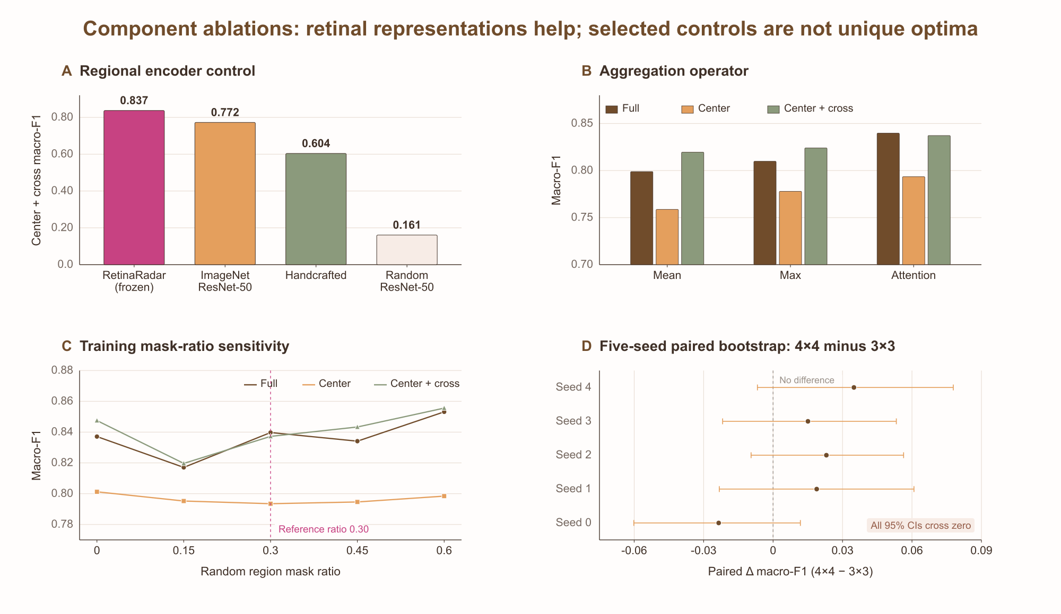
Figure 4. Component controls. (A) Regional representation. (B) aggregation operator. (C) single-split mask-ratio sensitivity; 0.30 marks the reference configuration, not a unique optimum. (D) per-seed paired image-bootstrap differences in center-plus-cross macro-F1 for 4×4 minus 3×3; every 95% interval crosses zero.

3.4 Attention is directionally supported by model intervention
The middle-center region received mean attention 0.398 and caused the largest macro-F1 loss when removed (0.065). Removing middle-left and middle-right reduced macro-F1 by 0.018 and 0.011. Several peripheral removals caused near-zero or slightly negative changes, indicating that attention was not merely a smooth centrality prior.
Across nine regions, the rank correlation between mean attention and occlusion loss was ρ=0.60 (p=0.088). The direction supports functional alignment, but the p value and nine-region sample do not warrant a definitive explanation claim. Class-stratified attention was center-dominant for Normal and NPDR; PDR shifted more weight laterally while retaining a central maximum.
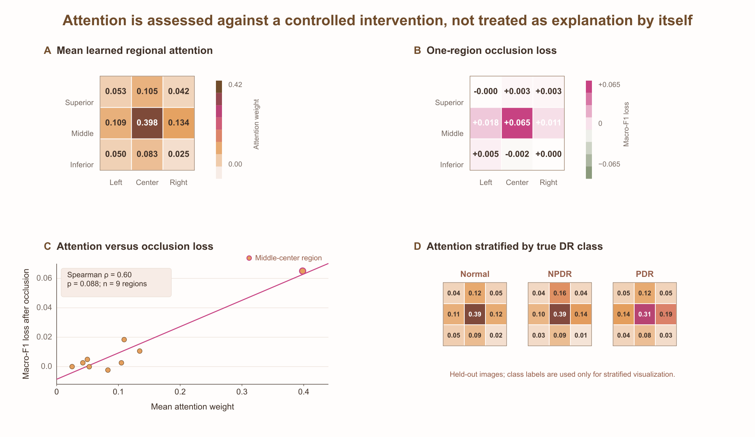
Figure 5. Attention and model intervention. (A) Mean learned regional attention. (B) Macro-F1 change after hiding each region. (C) Attention versus occlusion loss with descriptive Spearman association. (D) Held-out attention stratified by true DR class. The analysis tests model-level functional alignment and is not lesion localization.

3.5 Independent MMRDR-UWF severity evaluation
Domain shift reduced absolute performance, but the evidence-topology ordering was reproduced. External full-view macro-F1 was 0.625±0.010, center fell to 0.600±0.004, and center-plus-cross reached 0.642±0.005. Center-plus-cross also had the lowest severity MAE (0.378±0.006) and underestimation (0.260±0.005).
Within-seed paired bootstrap differences for center versus full were negative or crossed zero. Center-plus-cross point differences were positive in all five seeds and ranged from approximately 0.007 to 0.025. This does not imply that peripheral retina should be discarded; it may reflect suppression of device borders or source-target nuisance variation by the structured mask. The external quality proxy showed no uniform monotonic performance gradient and remains descriptive.
Table 4. Independent MMRDR-UWF results across five source-trained seeds. Values are mean±sample SD; no target labels entered fitting or selection.
View | Accuracy | Macro-F1 | Severity MAE | Under. rate | Δ F1 vs full
Full-view | 0.627±0.010 | 0.625±0.010 | 0.400±0.013 | 0.272±0.013 | Reference
Center-only | 0.602±0.004 | 0.600±0.004 | 0.432±0.005 | 0.284±0.016 | −0.025±0.013
Center-plus-cross | 0.644±0.004 | 0.642±0.005 | 0.378±0.006 | 0.260±0.005 | +0.017±0.006
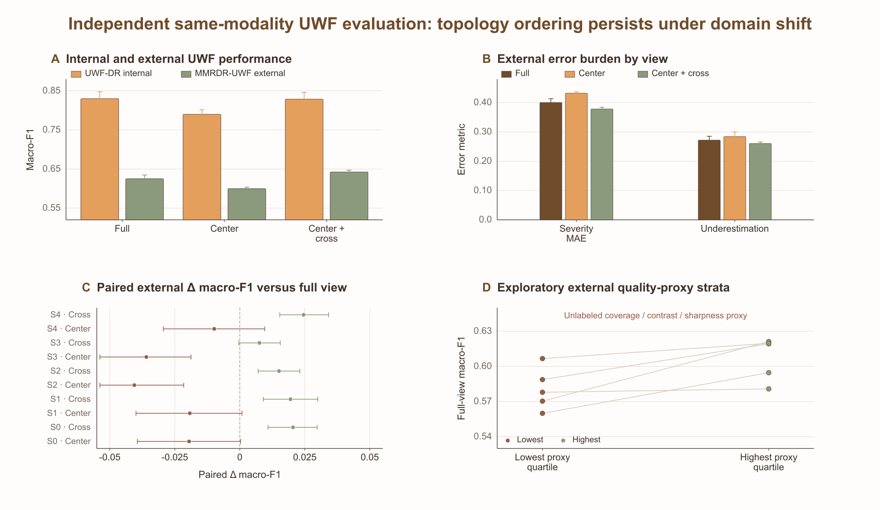
Figure 6. Independent same-modality UWF external evaluation. (A) internal and external macro-F1 across views. (B) external ordinal error and underestimation. (C) per-seed 2,000-resample paired bootstrap differences versus full-view. (D) exploratory lowest/highest quartiles of an unlabeled coverage/contrast/sharpness proxy. External labels were used only for severity evaluation.

3.6 Paired-view risk ranking and threshold transport
The fixed-split downstream paired-view risk model achieved test AUROC 0.740 and average precision 0.139 at an underestimation prevalence of 0.077. Severity gap alone reached AUROC 0.677 and symmetric KL 0.539. Because the risk model and Clopper–Pearson threshold both used the same validation predictions, fixed-split coverage values are reported as exploratory: 0.628, 0.918, and 0.997 at nominal risk targets 5%, 10%, and 20%.
The grouped nested audit yielded lower and more variable performance. Mean outer-fold AUROC was 0.653±0.034. At target 5%, coverage was 0.567±0.274 and accepted risk 0.050±0.033; fold-specific coverage ranged from 0.365 to 0.958. At target 10%, coverage was 0.812±0.165 and accepted risk 0.092±0.034. Threshold transport, rather than ranking alone, is therefore the central limitation.
Table 5. Paired-view underestimation-risk audit. The fixed-split rows are exploratory because one validation set was used for both risk fitting and threshold calibration; nested rows are mean±SD across four outer filename-grouped folds.
Protocol | Risk AUROC | Target | Coverage | Accepted risk
Fixed exploratory | 0.740 | 5% | 0.628 | 0.029
 |  | 10% | 0.918 | 0.075
 |  | 20% | 0.997 | 0.077
Nested grouped | 0.653±0.034 | 5% | 0.567±0.274 | 0.050±0.033
 |  | 10% | 0.812±0.165 | 0.092±0.034
 |  | 20% | 0.980±0.014 | 0.097±0.040
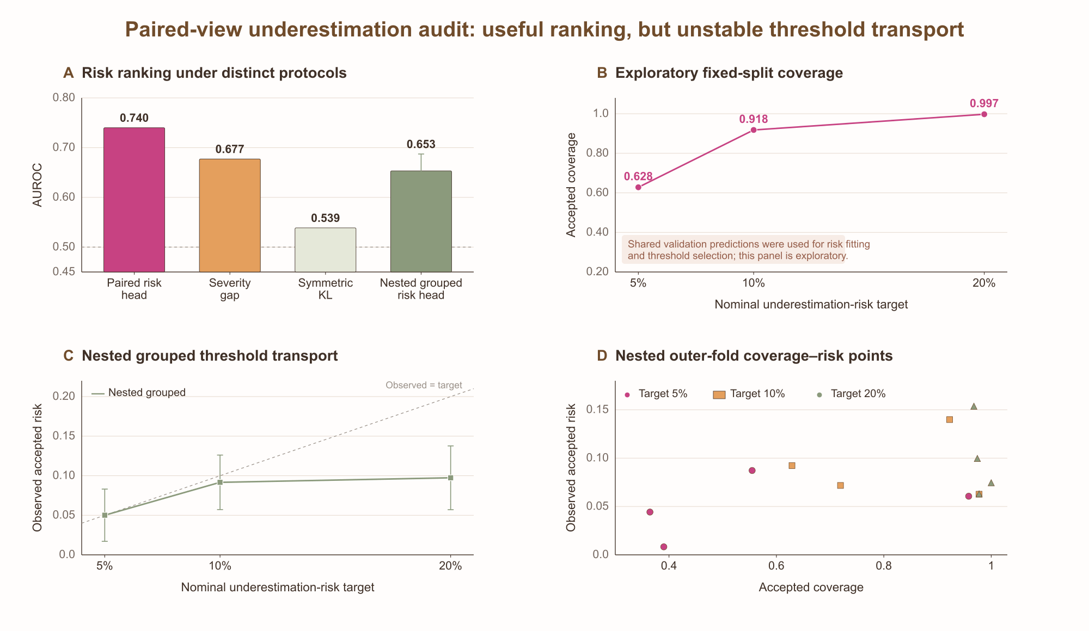
Figure 7. Paired-view underestimation audit. (A) AUROC under fixed exploratory and grouped nested protocols; values are not pooled because the protocols differ. (B) exploratory fixed-split test coverage at nominal risk targets. (C) nested mean accepted risk with fold SD. (D) nested outer-fold coverage–risk points. The module requires paired full-view/center-plus-cross predictions.

3.7 Pixel-space aperture augmentation and safety trade-off
A supplementary source-only variant concatenated one random pixel-space aperture representation per training image with the unmasked source representation. Both arms were retrained under the same corrected empty-mask fallback and with a dedicated random-mask sequence; the baseline values below are therefore protocol-matched within this optimization experiment and are not the independently trained estimates in Section 3.2. Across five seeds, macro-F1 and severity MAE improved in every held-out aperture. The largest gain occurred for the 0.35 rectangle, where macro-F1 increased from 0.519±0.160 to 0.794±0.013 and MAE fell from 0.446±0.123 to 0.221±0.014.
The safety endpoint was asymmetric. Underestimation fell from 0.272±0.092 to 0.097±0.007 at the severe 0.35 rectangle, but increased at the 0.55 rectangle, 0.75 rectangle, and 0.55 circle by 0.030, 0.018, and 0.019. The augmentation is therefore a useful stress-robustness result with an explicit trade-off, not a uniformly safer replacement for the primary model.
Table 6. Protocol-matched retrained baseline and source-only aperture-training results on held-out pixel-space aperture stress tests. Values are mean±sample SD across five seeds; Δ is augmented minus baseline.
Aperture | F1 base | F1 aug. | MAE base | MAE aug. | Under base | Under aug. | Δ Under
Rect. 0.35 | 0.519±0.160 | 0.794±0.013 | 0.446±0.123 | 0.221±0.014 | 0.272±0.092 | 0.097±0.007 | −0.175
Rect. 0.55 | 0.688±0.055 | 0.802±0.017 | 0.334±0.058 | 0.208±0.018 | 0.059±0.019 | 0.089±0.008 | +0.030
Rect. 0.75 | 0.731±0.027 | 0.811±0.015 | 0.306±0.041 | 0.199±0.016 | 0.063±0.005 | 0.081±0.008 | +0.018
Circle 0.55 | 0.752±0.051 | 0.804±0.011 | 0.264±0.050 | 0.206±0.011 | 0.070±0.013 | 0.090±0.005 | +0.019
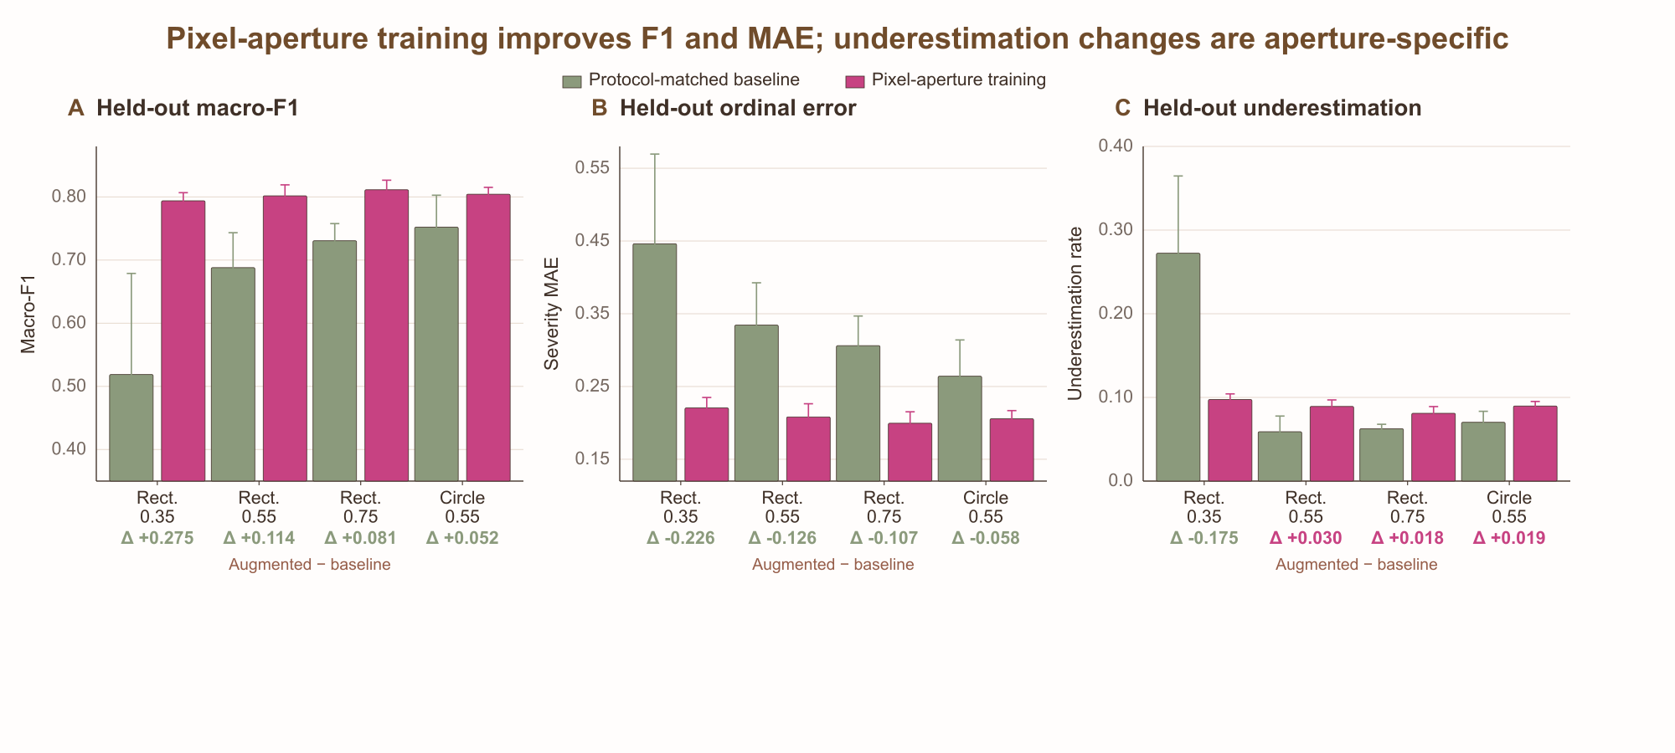
Figure 8. Pixel-space aperture augmentation against its protocol-matched retrained baseline. (A) Macro-F1, (B) ordinal severity MAE, and (C) underestimation across four held-out apertures. Error bars denote seed SD and annotations give augmented-minus-baseline change. F1 and MAE improve consistently, whereas underestimation improves only for the most severe aperture.

4. Discussion

4.1 Principal findings
This study examines a hidden assumption in retinal AI: technical gradability is often treated as evidence that an acquisition contains all information required for a requested diagnostic task. RegionSuff makes model-specific retinal evidence availability an explicit model input and evaluates the same fitted severity model as visible area, location, shape, and topology are varied. The central observation is not that one view is universally best, but that these visibility attributes are not interchangeable: with the source image and DR label fixed, changing their composition can alter model behavior.
Four observations support that conclusion. Center-only evidence degraded both internal and external performance, whereas center-plus-cross nearly recovered internal full-view performance and exceeded nominal full-view performance on the external cohort. In the prespecified encoder controls, the frozen retinal image-quality representation outperformed the ImageNet, handcrafted, and random-feature comparators. The region with the highest mean attention also caused the largest intervention loss, showing descriptive directional concordance between learned attention and intervention loss rather than a causal explanation. Pixel-space aperture augmentation improved macro-F1 and ordinal error on the predefined stress apertures, particularly under severe evidence loss, but its underestimation trade-off shows why no single metric should define safety.

4.2 Relationship to image quality
Image-quality assessment and model-specific retinal evidence availability are complementary. Quality asks whether observed structures are clear enough to interpret; evidence auditing asks what structures and disease cues were observed. A future acquisition system should treat them as separate axes and define sufficiency relative to a clinical task, because requirements for referable-DR screening, fine grading, or peripheral-lesion surveillance are different. [10–16]

4.3 Interpreting the external center-plus-cross result
Center-plus-cross exceeded the nominal full-view on MMRDR-UWF. One post hoc explanation is that, under domain shift, a full frame can contain task-relevant retinal evidence together with device-specific borders, illumination patterns, and peripheral nuisance variation; a structured mask may suppress part of that nuisance. This is an inference from the observed ordering, not evidence that clinicians should discard peripheral retina. Prospective same-eye, multi-device acquisitions and clinician sufficiency labels are needed to separate task-relevant retinal evidence from nuisance variation.

4.4 Attention and paired-view risk
The occlusion experiment provides a stricter test than visual plausibility alone and prevents attention from being presented as explanation by itself. The observed ρ=0.60 was directionally consistent but did not reach conventional statistical significance (p=0.088); it is therefore interpreted as descriptive concordance. Lesion-level annotations would permit stronger tests of whether attention and intervention correspond to hemorrhage, neovascularization, or peripheral lesions.
The downstream paired-view risk model illustrates the difference between risk ranking and a transportable policy. Fixed-split AUROC was useful for hypothesis generation, but threshold calibration reused the risk-fitting validation predictions. Nested grouped evaluation lowered AUROC and revealed wide coverage variation. A deployable system would need a single-view risk feature, a truly independent calibration cohort, prespecified recapture or referral actions, subgroup auditing, and temporal monitoring. [17,18,27]

4.5 Strengths
Strengths include filename-derived grouped model partitions, a held-out internal test set, five training seeds, region-level and pixel-space perturbation families, encoder/pooling/grid/mask controls, intervention-based attention analysis, independent same-modality UWF external evaluation, paired bootstrap contrasts, nested grouped risk auditing, and a data-release integrity audit of duplicate and conflicting source-list entries. Reporting also includes non-monotonic sensitivities, underestimation trade-offs, threshold variability, and source metadata limitations.

5. Limitations
This study evaluates model-specific retinal evidence availability rather than clinician-adjudicated diagnostic sufficiency. All visibility restrictions were synthetic; consequently, the effects of real acquisition conditions, including camera optics, gaze, eyelash artifacts, and naturally paired fields of view, remain to be established. The UWF-DR release did not include dedicated patient identifiers, so grouping was derived from filenames. Although the held-out test set was duplicate-free and a deduplicated-validation sensitivity analysis was stable, independent replication with explicit patient-level metadata is needed. In addition, the five external DR grades were harmonized to the three-class source task, and only one independent same-modality UWF cohort was available.
RetinaRadar was used as a frozen local image-quality encoder, but its publicly available provenance is insufficient to independently reconstruct its pretraining; the present findings should therefore not be interpreted as validation of a disease foundation model. The external quality proxy was unlabeled and was not intended as a clinical quality endpoint. The downstream paired-view risk model requires full-view and center-plus-cross limited-view predictions for the same image and therefore does not constitute a single-image triage model. Finally, severity-model early stopping, downstream paired-view risk-model fitting, and threshold selection were not fully separated across independent prospective cohorts. Seed-to-seed standard deviations and image-level bootstrap intervals characterize different sources of uncertainty, but neither replaces multicenter prospective validation.

6. Conclusion
A sharp, technically gradable fundus image can still lack task-relevant retinal evidence required for a specific DR decision. RegionSuff represents regional visibility explicitly and enables controlled auditing of how a fixed DR model responds to restricted fields of view. Across internal perturbation experiments and independent same-modality UWF external evaluation, visible area, location, shape, and topology were not interchangeable determinants of model behavior. Pixel-space aperture augmentation and the paired-view audit further showed that gains in discrimination can coexist with changes in underestimation and unstable threshold transport.
These findings support evidence-aware auditing of retinal AI under restricted retinal coverage, rather than a deployable diagnostic-sufficiency claim. Clinician-adjudicated labels, explicit patient metadata, real paired acquisitions, and independently calibrated single-view risk models are required before clinical deployment can be considered.

Declarations
Data Availability
The UWF-DR dataset is publicly available from Figshare (https://doi.org/10.6084/m9.figshare.31259494), and the MMRDR-UWF dataset is publicly available from Figshare (https://doi.org/10.6084/m9.figshare.29423747.v2). Reuse of these datasets must comply with the respective source licenses and terms of use. The analysis code, model configurations, frozen experiment outputs, paired-bootstrap results, validation-list audit, manuscript builder, and editable figure source files are archived at https://github.com/kobayashi0512/RegionSuff. Dataset and model reuse remains subject to the corresponding source licenses and terms.
Author Contributions
K.D. (Kaiwen Deng): Conceptualization, Methodology, Software, Investigation, Data Curation, Formal Analysis, Validation, Visualization, and Writing—Original Draft.
L.L. (Liwei Liu): Supervision, Project Administration, Resources, and Writing—Review & Editing.
Conflicts of Interest
The authors declare no known competing financial interests or personal relationships that could have influenced the work reported in this study.
Ethics Statement
This retrospective computational study used fully anonymized, publicly released datasets. No new participant recruitment, intervention, image acquisition, or data collection was performed. As the analysis relied exclusively on previously collected and de-identified data, institutional review board approval and informed consent were not required for this secondary analysis. Ethical approvals and consent or waiver procedures for the source datasets are described in the corresponding dataset publications.

References
[1] Wilkinson CP, Ferris FL III, Klein RE, et al. Proposed international clinical diabetic retinopathy and diabetic macular edema disease severity scales. Ophthalmology. 2003;110:1677–1682. doi:10.1016/S0161-6420(03)00475-5.
[2] Wong TY, Cheung CMG, Larsen M, Sharma S, Simó R. Diabetic retinopathy. Nat Rev Dis Primers. 2016;2:16012. doi:10.1038/nrdp.2016.12.
[3] Gulshan V, Peng L, Coram M, et al. Development and validation of a deep learning algorithm for detection of diabetic retinopathy in retinal fundus photographs. JAMA. 2016;316:2402–2410. doi:10.1001/jama.2016.17216.
[4] Ting DSW, Cheung CYL, Lim G, et al. Development and validation of a deep learning system for diabetic retinopathy and related eye diseases using retinal images from multiethnic populations with diabetes. JAMA. 2017;318:2211–2223. doi:10.1001/jama.2017.18152.
[5] Abràmoff MD, Lavin PT, Birch M, Shah N, Folk JC. Pivotal trial of an autonomous AI-based diagnostic system for detection of diabetic retinopathy in primary care offices. npj Digit Med. 2018;1:39. doi:10.1038/s41746-018-0040-6.
[6] Silva PS, Cavallerano JD, Haddad NMN, et al. Peripheral lesions identified on ultrawide field imaging predict increased risk of diabetic retinopathy progression over 4 years. Ophthalmology. 2015;122:949–956. doi:10.1016/j.ophtha.2015.01.008.
[7] Ashrafkhorasani M, Habibi A, Nittala MG, et al. Peripheral retinal lesions in diabetic retinopathy on ultra-widefield imaging. Saudi J Ophthalmol. 2024;38:123–131. doi:10.4103/sjopt.sjopt_151_23.
[8] Rajalakshmi R, Mohammed R, Vengatesan K, et al. Wide-field imaging with smartphone based fundus camera: grading of severity of diabetic retinopathy and locating peripheral lesions in diabetic retinopathy. Eye. 2024. doi:10.1038/s41433-024-02928-2.
[9] Rajalakshmi R, Prathiba V, Arulmalar S, Usha M. Review of retinal cameras for global coverage of diabetic retinopathy screening. Eye. 2021;35:162–172. doi:10.1038/s41433-020-01262-7.
[10] Saha SK, Fernando B, Cuadros J, Xiao D, Kanagasingam Y. Automated quality assessment of colour fundus images for diabetic retinopathy screening in telemedicine. J Digit Imaging. 2018;31:869–878. doi:10.1007/s10278-018-0084-9.
[11] Fu H, Wang B, Shen J, et al. Evaluation of retinal image quality assessment networks in different color-spaces. In: Medical Image Computing and Computer Assisted Intervention—MICCAI 2019. LNCS 11764:48–56. doi:10.1007/978-3-030-32239-7_6.
[12] Gonçalves MB, Nakayama LF, Ferraz D, et al. Image quality assessment of retinal fundus photographs for diabetic retinopathy in the machine learning era: a review. Eye. 2024;38:426–433. doi:10.1038/s41433-023-02717-3.
[13] Jin K, Gao Z, Jiang X, et al. MSHF: A multi-source heterogeneous fundus dataset for image quality assessment. Sci Data. 2023;10:286. doi:10.1038/s41597-023-02188-x.
[14] Liu R, Wang X, Wu Q, et al. DeepDRiD: diabetic retinopathy grading and image quality estimation challenge. Patterns. 2022;3:100512. doi:10.1016/j.patter.2022.100512.
[15] Che H, Chen S, Chen H. Image quality-aware diagnosis via meta-knowledge co-embedding. Proc IEEE/CVF Conf Comput Vis Pattern Recognit. 2023:19819–19829.
[16] Oh R, Park UC, Park KH, Park SJ, Yoon CK. Deep learning-based automatic image quality assessment in ultra-widefield fundus photographs. BMJ Open. 2025;15:e100058. doi:10.1136/bmjopen-2025-100058.
[17] Geifman Y, El-Yaniv R. Selective classification for deep neural networks. Adv Neural Inf Process Syst. 2017;30:4878–4887.
[18] Geifman Y, El-Yaniv R. SelectiveNet: a deep neural network with an integrated reject option. Proc 36th Int Conf Mach Learn. 2019;97:2151–2159.
[19] Guo C, Pleiss G, Sun Y, Weinberger KQ. On calibration of modern neural networks. Proc 34th Int Conf Mach Learn. 2017;70:1321–1330.
[20] Hendrycks D, Gimpel K. A baseline for detecting misclassified and out-of-distribution examples in neural networks. Proc Int Conf Learn Represent. 2017.
[21] Ilse M, Tomczak JM, Welling M. Attention-based deep multiple instance learning. Proc 35th Int Conf Mach Learn. 2018;80:2127–2136.
[22] Jain S, Wallace BC. Attention is not explanation. Proc NAACL-HLT. 2019:3543–3556. doi:10.18653/v1/N19-1357.
[23] Peng S, Yang S, Zhao X, et al. A fundus image dataset for intelligent diabetic retinopathy system. Sci Data. 2026;13:777. doi:10.1038/s41597-026-07093-7. Data available at: 10.6084/m9.figshare.31259494.
[24] Tang Z, Wang L, Guo Z, et al. A multimodal retinal image dataset for diabetic retinopathy detection using foundation models. Sci Data. 2026;13:639. doi:10.1038/s41597-026-07005-9.
[25] Efron B, Tibshirani RJ. An Introduction to the Bootstrap. New York: Chapman & Hall/CRC; 1993.
[26] Tan M, Le QV. EfficientNet: rethinking model scaling for convolutional neural networks. Proc 36th Int Conf Mach Learn. 2019;97:6105–6114.
[27] Clopper CJ, Pearson ES. The use of confidence or fiducial limits illustrated in the case of the binomial. Biometrika. 1934;26:404–413. doi:10.1093/biomet/26.4.404.
[28] He K, Zhang X, Ren S, Sun J. Deep residual learning for image recognition. Proc IEEE Conf Comput Vis Pattern Recognit. 2016:770–778. doi:10.1109/CVPR.2016.90.
[29] Deng J, Dong W, Socher R, Li LJ, Li K, Fei-Fei L. ImageNet: a large-scale hierarchical image database. Proc IEEE Conf Comput Vis Pattern Recognit. 2009:248–255. doi:10.1109/CVPR.2009.5206848.

