RetiESS-Seg: Correlation-Aware Effective Sample Size Auditing for Small-Sample 3D Retinal OCT Layer Segmentation
Kaiwen Deng, Liwei Liu*
School of Railway Intelligent Engineering, Dalian Jiaotong University, Dalian, 116028, China
*Corresponding author
Email: Liwei Liu (liutree80@163.com)

Abstract:
Three-dimensional (3D) optical coherence tomography (OCT) volumes contain correlated B-scans, so image count can overstate independent evidence in small datasets. We propose RetiESS-Seg, a correlation-aware effective sample size (ESS) framework for retinal layer segmentation. It combines slice position and label-free appearance similarity in a positive semidefinite matrix and scales only a cross-slice derivative loss, leaving the predictor unchanged. We evaluated the complete Tian Optical Coherence Tomography Retinal Image Analysis (OCTRIMA) release (10 volumes, 100 B-scans, eight boundaries) by leave-one-volume-out testing. At 60 epochs, SliceCNN and RetiESS-Seg achieved mean absolute errors of 11.450 ± 4.632 and 11.431 ± 4.608 pixels. The paired difference was −0.019 pixels (95% bootstrap confidence interval −0.074 to 0.028; Wilcoxon p = 0.375), showing no accuracy superiority. Deterministic thinning and duplication changed the raw slice count from 5 to 20 while mean ESS remained 1.519–1.562, indicating that copied slices were not treated as independent evidence. RetiESS is therefore a statistical redundancy audit for small-sample OCT studies, not a diagnostic or segmentation-performance breakthrough.
Keywords: optical coherence tomography; retinal segmentation; effective sample size; small data.

1. Introduction
Optical coherence tomography (OCT) provides non-invasive cross-sectional views of retinal microstructure and is routinely acquired as a volume rather than as an isolated image. Retinal layer segmentation converts those volumes into quantitative structural measurements, but manual tracing is slow and observer-dependent. Classical graph methods exploited spatial continuity across adjacent B-scans [1,2], while recent deep learning systems increasingly use volumetric context, multimodal imaging, and pretrained retinal representations [3-7]. The shift from a single central B-scan to a full volume is scientifically useful, yet it creates a statistical question that is often left implicit: how much independent evidence is actually added by the neighboring slices?
This question is most acute in small biomedical datasets. A release with 10 patients and 10 B-scans per patient contains 100 images, but it still contains only 10 independent patient volumes. Random slice-level splitting would leak subject-specific anatomy across training and test sets, and even volume-level training can overweight a densely sampled or duplicated scan. More generally, cross-validation uncertainty is high when the number of independent subjects is small, regardless of the number of correlated observations within each subject [8,9]. Data augmentation may improve optimization, but it must remain inside each training fold and cannot manufacture new patients [10].
Effective sample size (ESS) is traditionally used to express how dependence reduces nominal information [11]. We adapt this idea to OCT volumes by constructing a slice correlation matrix from normalized position and appearance. A quadratic form then reports how much effectively independent slice evidence remains after accounting for similarity. This statistic is intentionally separated from the boundary prediction itself. It can therefore be evaluated by controlled duplication and thinning without claiming that it corrects a clinical decision or improves segmentation accuracy.
The paper makes four bounded contributions. First, it formulates a label-free position–appearance correlation matrix and a differentiable effective slice count for a complete small-sample 3D OCT dataset. Second, it evaluates an ESS-scaled cross-slice derivative loss while preserving a conventional per-slice boundary regressor. Third, it uses outer leave-one-volume-out testing, inner-only protocol selection, repeated seeds, and volume-level statistics. Fourth, it distinguishes a positive mechanistic result (duplicate slices are not counted as independent evidence) from a negative predictive result (RetiESS-Seg does not significantly reduce boundary error). This separation is the central methodological contribution.
The manuscript follows the same claim hierarchy throughout. Section 2 fixes the independent unit, the prediction endpoint, and the scope of the ESS statistic before any model comparison. Section 3 then reports four linked experiments: the fixed paired accuracy test, leakage-safe nested protocol development, boundary- and perturbation-level audits, and a deliberately non-interchangeable 2D paired-image extension. This organization prevents a redundancy result, an optimization result, and a clinical validation claim from being conflated.

2. Materials and Methods

2.1 Study design and reporting boundary
We conducted a retrospective computational study using only complete, anonymously downloadable public data. The primary task was eight-boundary regression on three-dimensional (3D) macular OCT. The primary unit of inference was the complete volume, never an individual B-scan. Mean absolute boundary error (MAE) in native axial pixels (px) was the predictive endpoint. Correlation-aware ESS under prespecified slice perturbations was the mechanistic endpoint. RetiESS was not evaluated as a disease classifier, referral score, uncertainty estimator, or external clinical reliability measure.
The design therefore asks four separate questions: Does ESS-scaled regularization change held-out boundary MAE? Does the statistic avoid counting exact copies as independent evidence? What performance follows leakage-safe nested protocol selection and refitting? And can the same patient-disjoint discipline be preserved in a separate paired 2D task? Each question has a different endpoint and permitted conclusion (Table 2).

2.2 Complete public datasets
Tian OCTRIMA. The primary release contains Subject1.mat through Subject10.mat, with 10 B-scans in every volume, eight manually traced retinal boundaries, the original OCTRIMA3D output, and two independent manual observers [1]. The experiment loader refuses to run if any subject file or required annotation field is absent. All 10 volumes and all 100 released B-scans were used, and the downloaded archive passed a recorded 256-bit Secure Hash Algorithm (SHA-256) integrity check. The regression target was the pointwise mean of the two observer traces; observer-specific traces were retained for audit.
Armed Forces Institute of Ophthalmology (AFIO) extension. The secondary archive contains paired optic-nerve-head OCT and color fundus images collected at AFIO [12]. Integrity checking found 50 metadata rows but one duplicate row, leaving 49 unique paired records from 26 patients. The consensus labels were 25 non-glaucoma, 16 glaucoma, and 8 uncertain. The entire 49-pair set was used. Because these are paired two-dimensional (2D) images with a diagnostic label, AFIO cannot validate the Tian 3D boundary task and is reported only as an exploratory small-sample extension.

2.3 Preprocessing and compact boundary network
Each Tian B-scan was scaled to [0,1], resized to 128 × 256 pixels, and standardized independently by its mean and standard deviation. Boundary coordinates were normalized by native image height and linearly resampled to 256 axial-scan (A-scan) positions. BoundaryNet was a compact convolutional neural network (CNN) with three strided convolutional layers (16, 32, and 64 channels; Gaussian error linear unit [GELU] activations) followed by three transposed-convolution layers, consistent with compact biomedical encoder–decoder designs [13,14]. For slice i, boundary b, column x, output height H, and row index v ∈ {1, …, H}, the decoder produced heatmap logits Hᵢ,ᵦ,ₓ,ᵥ. Vertical softmax followed by normalized soft-argmax yielded the continuous boundary coordinate shown below. Global average pooling of the 64-channel encoder map produced the slice embedding. The resulting slice-wise CNN baseline is denoted SliceCNN; RetiESS-Seg uses the identical predictor and adds only the ESS-scaled derivative term described in Section 2.4. The architecture was trained from scratch so that the experiment measured the small-data protocol rather than access to a gated ophthalmic checkpoint.
$${\hat{y}}_{i,b,x}=\sum_{v=1}^{H}{\frac{v−1}{H−1} {\left[\operatorname{softmax}{H_{i,b,x}}\right]}_{v}}$$
The segmentation objective combined smooth L1 (SmoothL1) boundary error with a non-crossing penalty. Because the ordered manual surfaces run from inner to outer retina, a rectified linear unit (ReLU) penalty was applied when boundary b exceeded boundary b + 1 by more than a normalized margin of 0.002. The penalty weight was 0.25.

2.4 Correlation-aware effective sample size
For a volume with m B-scans, let zᵢ be an ℓ2-normalized appearance representation and tᵢ the slice position normalized to [0,1]. RetiESS forms positive semidefinite radial basis function (RBF) kernels for position and appearance and mixes them equally. In the training regularizer, zᵢ is the encoder embedding; in the perturbation audit, zᵢ is a fixed label-free 8 × 8 average-pooled appearance descriptor so that no training outcome can determine the audit statistic. Position and feature bandwidths were 0.20 and 0.60.
$$R_{ij}=\frac{1}{2} \exp\left(−\frac{{\left(t_{i}−t_{j}\right)}^{2}}{2 σ_{t}^{2}}\right)+\frac{1}{2} \exp\left(−\frac{{{\left\|z_{i}−z_{j}\right\|}_{2}}^{2}}{2 σ_{z}^{2}}\right)$$
With zero slice scores, entropy-regularized fixed-point updates distribute a nonnegative, unit-sum slice-weight vector w over the probability simplex while penalizing repeated support. The resulting effective size is the inverse repeated-evidence quadratic form. Highly similar slices receiving joint weight yield an effective size near one; decorrelated support can increase it toward the raw slice count. Forming the correlation matrix costs O(m²d) for descriptor dimension d, and each of T fixed-point iterations costs O(m²); with m = 10, this overhead is negligible relative to CNN inference.
$$n_{eff}={\left(w^{⊤} R w\right)}^{−1}, 1^{⊤}w=1, w≥0$$
RetiESS-Seg adds a cross-slice derivative term: predicted changes between adjacent B-scans are matched to the corresponding manual changes. In the equation below, ℒΔ is the SmoothL1 loss between adjacent predicted and manual boundary differences, and sg(·) denotes the stop-gradient operator. The contribution is multiplied by the ESS-to-slice-count ratio. Thus a highly redundant volume cannot contribute the derivative term as if all m slices were independent. The boundary predictor itself remains the same network, which keeps a redundancy effect separate from an architectural accuracy claim. Figure 1 summarizes the data flow, training role, and claim boundary.
$$ℒ=ℒ_{seg}+0.35 \operatorname{sg}\left(\frac{n_{eff}}{m}\right) ℒ_{Δ}$$
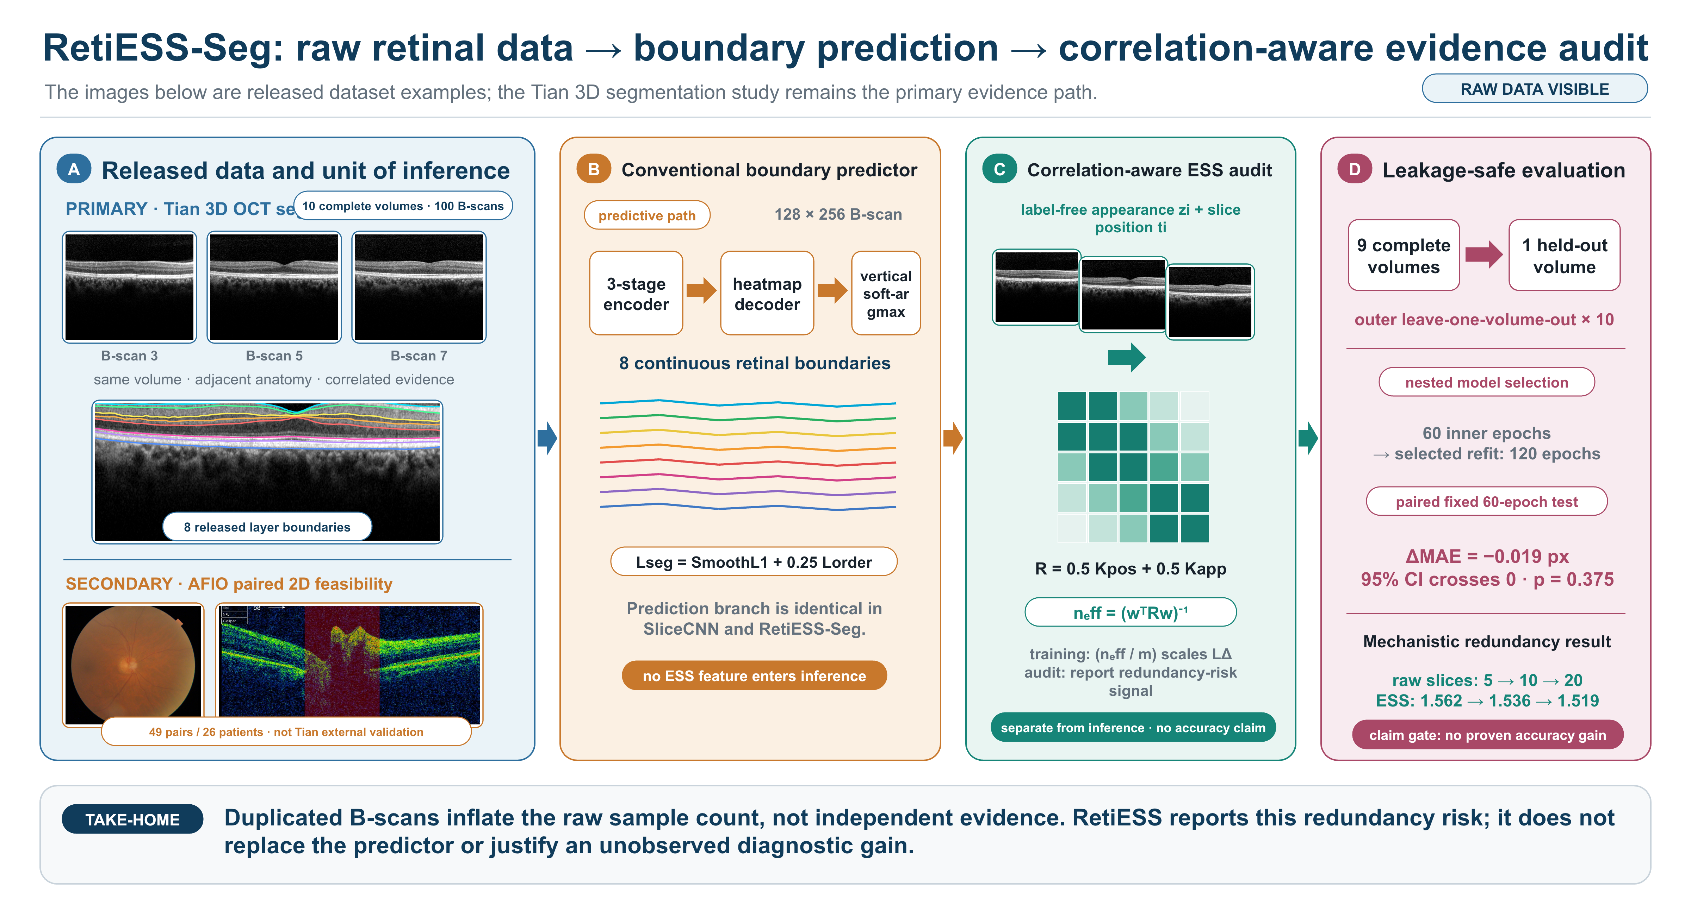
Figure 1. RetiESS-Seg study architecture with released data examples and bounded claims. (A) Three adjacent Tian B-scans and their released manual layer boundaries make the primary complete-volume data visible; the same-eye AFIO OCT–fundus pair is a separate 2D feasibility extension, not external validation of Tian. (B) The compact heatmap regressor is unchanged between matched methods. (C) Position and label-free appearance form the correlation matrix; the resulting effective sample size scales only the cross-slice derivative term during training and is separately reported as a redundancy-risk signal. (D) Nested selection, the fixed paired endpoint, and the mechanistic redundancy audit remain separated, so no unobserved accuracy gain is claimed.

2.5 Training-only augmentation and nested selection
All models used adaptive moment estimation with decoupled weight decay (AdamW) [15] with a learning rate of 1 × 10⁻³, weight decay of 1 × 10⁻⁴, and gradient-norm clipping at 5.0. The fixed comparison trained for 60 epochs in each of 10 leave-one-volume-out (LOO) folds. Training-only augmentation applied a vertical shift sampled from −6 to +6 pixels with the identical shift applied to every boundary label, a contrast factor sampled from 0.90 to 1.10, and Gaussian noise with an SD of 0.025. No augmentation was applied to validation or test volumes.
To prevent post-hoc protocol choice from contaminating the outer test estimate, each outer fold compared plain and combined-augmentation candidates using only the remaining nine volumes. Those nine volumes were partitioned into three non-overlapping validation groups of three volumes. Each candidate trained for 60 inner epochs in every group; the candidate with lower mean inner-volume MAE was refitted on all nine outer-training volumes for 120 epochs and evaluated once on the untouched tenth volume. The entire nested procedure was repeated at seeds 20260831, 20260901, and 20260902.

2.6 Perturbation audit and statistical analysis
The prespecified label-free perturbations were: the original 10 descriptors; one appended exact copy (11); exact duplication of every descriptor (20); retention of alternate descriptors (5); and removal of the central block while retaining two early and three late descriptors (5). We report the mean and sample standard deviation (SD) of ESS over the 10 volumes. For the fixed SliceCNN versus RetiESS-Seg comparison, the paired unit was the held-out volume. A 20,000-draw percentile bootstrap estimated the 95% confidence interval (CI) of the mean paired difference, and a two-sided Wilcoxon signed-rank test assessed whether differences were centered at zero [16,17]. These tests are descriptive at n = 10 and are not converted into a clinical claim.

2.7 Exploratory AFIO multimodal protocol
A directly downloadable ImageNet-1K-pretrained 18-layer residual network (ResNet-18) [18] was frozen and used to cache 512-dimensional features for every fundus image and every OCT image. Three linear probes were compared: fundus only, OCT only, and early feature concatenation. Each probe used dropout 0.25, a class-weighted cross-entropy objective, an AdamW learning rate of 2 × 10⁻³, weight decay of 1 × 10⁻³, and 300 epochs. Five deterministic patient-disjoint folds were repeated with three seeds. Balanced accuracy and macro-averaged F1 score (macro F1) were calculated fold-wise and then summarized across seeds. This protocol tests feasibility under complete paired data; it does not test RetiESS or Tian segmentation transfer.

3. Results

3.1 Dataset and split audit
The Tian loader recovered exactly 10 volumes, 100 B-scans, eight boundaries per B-scan, and two observer arrays per subject. No partial-volume option exists in the analysis code. Every outer split held out one complete volume. The AFIO audit recovered all 49 unique paired records and ensured that no patient's images crossed a fold boundary. Table 1 records the data-level distinctions, whereas Table 2 maps each analysis to its endpoint and allowable conclusion.
Table 1. Complete public datasets, independent units, and non-interchangeable roles. Every listed record is used; neither archive is subsampled.
Dataset / role | Complete data and independent unit | Target | Split and epochs | Reported endpoint | Permitted interpretation
Tian OCTRIMA  (primary 3D study) | 10 complete volumes; 100/100 B-scans  Independent unit: 10 volumes | 8 boundaries; consensus of two manual observers | Outer volume LOO × 10  Fixed: 60 epochs  Nested: 60 inner / 120 refit × 3 seeds | Volume MAE; paired difference; boundary MAE; ESS perturbation | Primary statistical audit and small-data protocol evidence; not clinical validation
AFIO  (exploratory 2D extension) | 49/49 unique OCT–fundus pairs  Independent unit: 26 patients | Three-class glaucoma label: 25 no, 16 yes, 8 uncertain | Five patient-disjoint folds  300 epochs/fold × 3 seeds | Balanced accuracy and macro F1 | Feasibility of grouped paired-image analysis; not Tian external validation

Table 2. Experiment-to-claim ledger. The same small dataset supports several useful but deliberately bounded answers.
Scientific question | Data and leakage safeguard | Endpoint | Observed result | Permitted conclusion
Does the ESS-scaled loss improve segmentation? | Tian; complete-volume outer LOO; fixed 60 epochs | Paired MAE, 20,000-draw bootstrap, Wilcoxon | −0.019 px; 95% CI [−0.074, 0.028]; p = 0.375 | No accuracy superiority claim
Does the statistic count repeated scans as evidence? | Tian; fixed label-free descriptors; 5 perturbations | Raw count and volume ESS | 5→20 raw slices; ESS 1.562→1.519 | Yes: copied scans remain redundant
What performance follows leakage-safe protocol selection and refit? | Tian; 3-group inner selection, 10 outer tests × 3 seeds | Outer-test MAE | Seed means 6.101, 5.929, 5.778 px | Nested selection-and-refit is feasible; an isolated augmentation gain is not established
Can grouped analysis extend to a distinct paired-image task? | AFIO; all 49 pairs, 26 patients, 5 group folds × 3 seeds | Balanced accuracy; macro F1 | Fusion balanced accuracy/F1 0.542/0.485 | Exploratory feasibility; no fusion superiority or 3D transfer claim

3.2 Predictive comparison and nested optimization
At 60 epochs with fixed hyperparameters, SliceCNN obtained 11.450 ± 4.632 pixels and RetiESS-Seg obtained 11.431 ± 4.608 pixels across the 10 held-out volumes. RetiESS-Seg minus SliceCNN was −0.019 pixels; the 95% bootstrap interval (−0.074 to 0.028) included zero and the Wilcoxon p value was 0.375. The effect was also numerically tiny in two additional 60-epoch seeds. Consequently, the ESS-scaled derivative objective is not presented as a segmentation improvement. The fixed endpoint, nested optimization experiment, and protocol attribution are separated in Table 3 and Fig. 2A–B.
The independent model-development experiment used nested selection between plain and combined-augmentation candidates. Outer-volume MAE was 6.101, 5.929, and 5.778 pixels in the three seeds; the mean of the three seed means was 5.936 pixels (seed-level SD 0.162), and augmentation was selected in 16 of 30 outer folds. Every selected candidate was then refitted for 120 epochs, whereas the fixed benchmark used 60 epochs. Therefore, the numerical contrast with the fixed benchmark does not isolate an augmentation effect from the longer refit budget and is not reported as a percentage improvement. Within the fixed 120-epoch ablations, appearance-only augmentation was more favorable than synchronized shift alone.
Table 3. Tian volume-level boundary MAE and protocol attribution. Values after ± are sample SD across 10 held-out volumes unless noted. The nested rows summarize selection-and-refit performance; they do not isolate augmentation or establish RetiESS superiority.
Protocol | Epochs | Seed(s) | MAE (px) | Interpretation
SliceCNN, fixed plain | 60 | 20260831 | 11.450 ± 4.632 | Reference for paired RetiESS test
RetiESS-Seg, fixed plain | 60 | 20260831 | 11.431 ± 4.608 | Difference −0.019 px; not significant
SliceCNN, appearance only | 120 | 20260831 | 5.758 ± 2.419 | Fixed augmentation ablation
RetiESS-Seg, appearance only | 120 | 20260831 | 5.746 ± 2.404 | Near-identical to matched CNN
SliceCNN, shift only | 120 | 20260831 | 6.043 ± 1.510 | Fixed geometry ablation
RetiESS-Seg, shift only | 120 | 20260831 | 6.031 ± 1.491 | Near-identical to matched CNN
Nested selected | 60 inner / 120 refit | 20260831 | 6.101 ± 2.770 | Augmentation selected 7/10
Nested selected | 60 inner / 120 refit | 20260901 | 5.929 ± 2.121 | Augmentation selected 5/10
Nested selected | 60 inner / 120 refit | 20260902 | 5.778 ± 1.766 | Augmentation selected 4/10
Nested cross-seed mean | Same | 3 seeds | 5.936; seed SD 0.162 | Selection-and-refit estimate; not an isolated augmentation effect

3.3 Boundary-specific error and redundancy accounting
Under the exact nested-selected protocol, mean errors for boundaries 1–8 were 5.423, 6.757, 5.121, 5.153, 4.950, 6.097, 6.922, and 8.387 native pixels (Fig. 2C). Error was therefore distributed across the retinal profile, with the two outermost indexed boundaries hardest. These values remain above the approximately one-pixel unsigned error reported for the original graph-based OCTRIMA3D procedure [1]; the present compact CNN is a vehicle for the statistical experiment and not a state-of-the-art replacement.
The perturbation result was more decisive mechanistically. Exact duplication of every B-scan doubled nominal count from 10 to 20, but mean ESS changed only from 1.536 to 1.519. Appending one exact copy gave 1.536; both five-slice thinning rules remained near 1.56 (Fig. 2D and Table 4). Thus the statistic treated copied observations as redundant rather than as independent evidence. Its narrow range is not an accuracy metric and does not demonstrate missing-slice robustness.
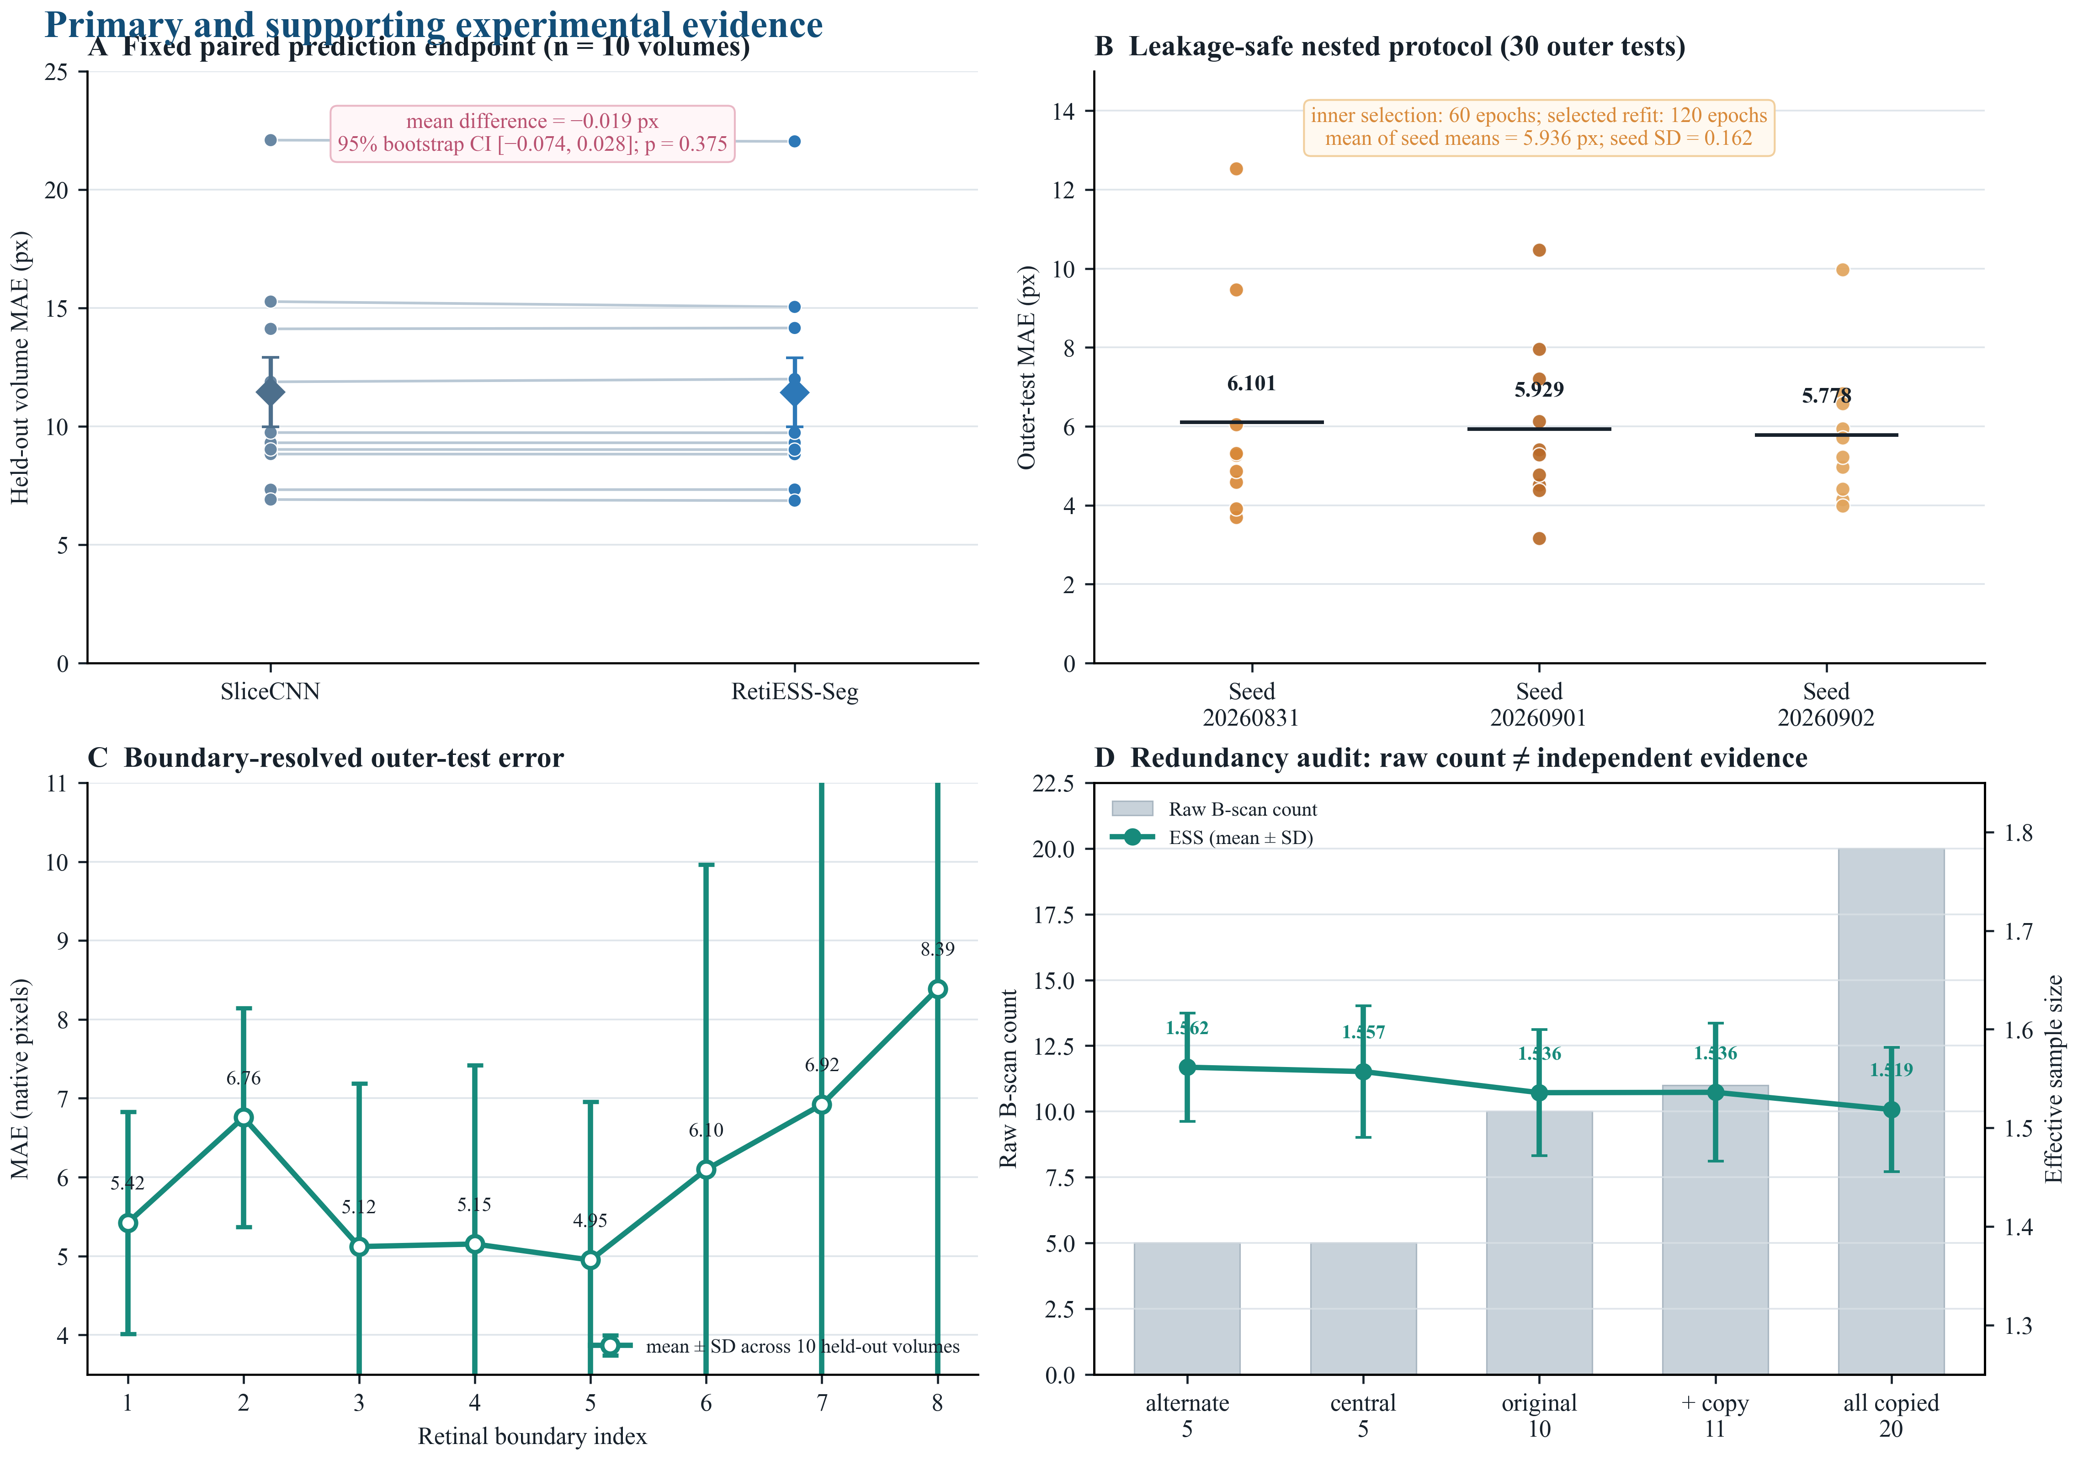
Figure 2. Coherent quantitative evidence from the full Tian analysis. (A) Paired held-out MAE in the fixed 60-epoch comparison; the 95% bootstrap interval of the mean paired difference crosses zero. (B) The 30 outer tests generated by three repeated nested protocols, with each point denoting one held-out volume. (C) Boundary-resolved nested-test error (mean ± SD across 10 held-out volumes). (D) Raw slice count changes fourfold under deterministic perturbation, whereas correlation-aware ESS remains near 1.5; exact copies therefore do not create independent evidence.
Table 4. Label-free RetiESS perturbation audit over all 10 Tian volumes. The statistic is evaluated independently of segmentation labels and predictions.
Variant | Raw B-scans | ESS mean ± SD | Change in raw count | Scientific reading
Original | 10 | 1.536 ± 0.064 | Reference | Correlated baseline
Append one exact copy | 11 | 1.536 ± 0.070 | +10% | No independent evidence added
Duplicate every scan | 20 | 1.519 ± 0.063 | +100% | Copies remain redundant
Keep alternate scans | 5 | 1.562 ± 0.055 | −50% | Lower count, similar ESS
Remove central block | 5 | 1.557 ± 0.067 | −50% | Lower count, similar ESS

3.4 Programmatically selected held-out cases
To avoid visual cherry-picking, the qualitative panel was generated from the minimum- and maximum-error outer folds of the same nested run. Subject1 had 3.70-pixel MAE and Subject2 had 12.54-pixel MAE. The lower-error case follows the consensus traces closely over most A-scan positions, whereas the higher-error case shows larger deviations around curved inner boundaries and lower retinal surfaces. Figure 3 presents these programmatically selected cases, which illustrate the observed spread rather than two manually chosen successes.
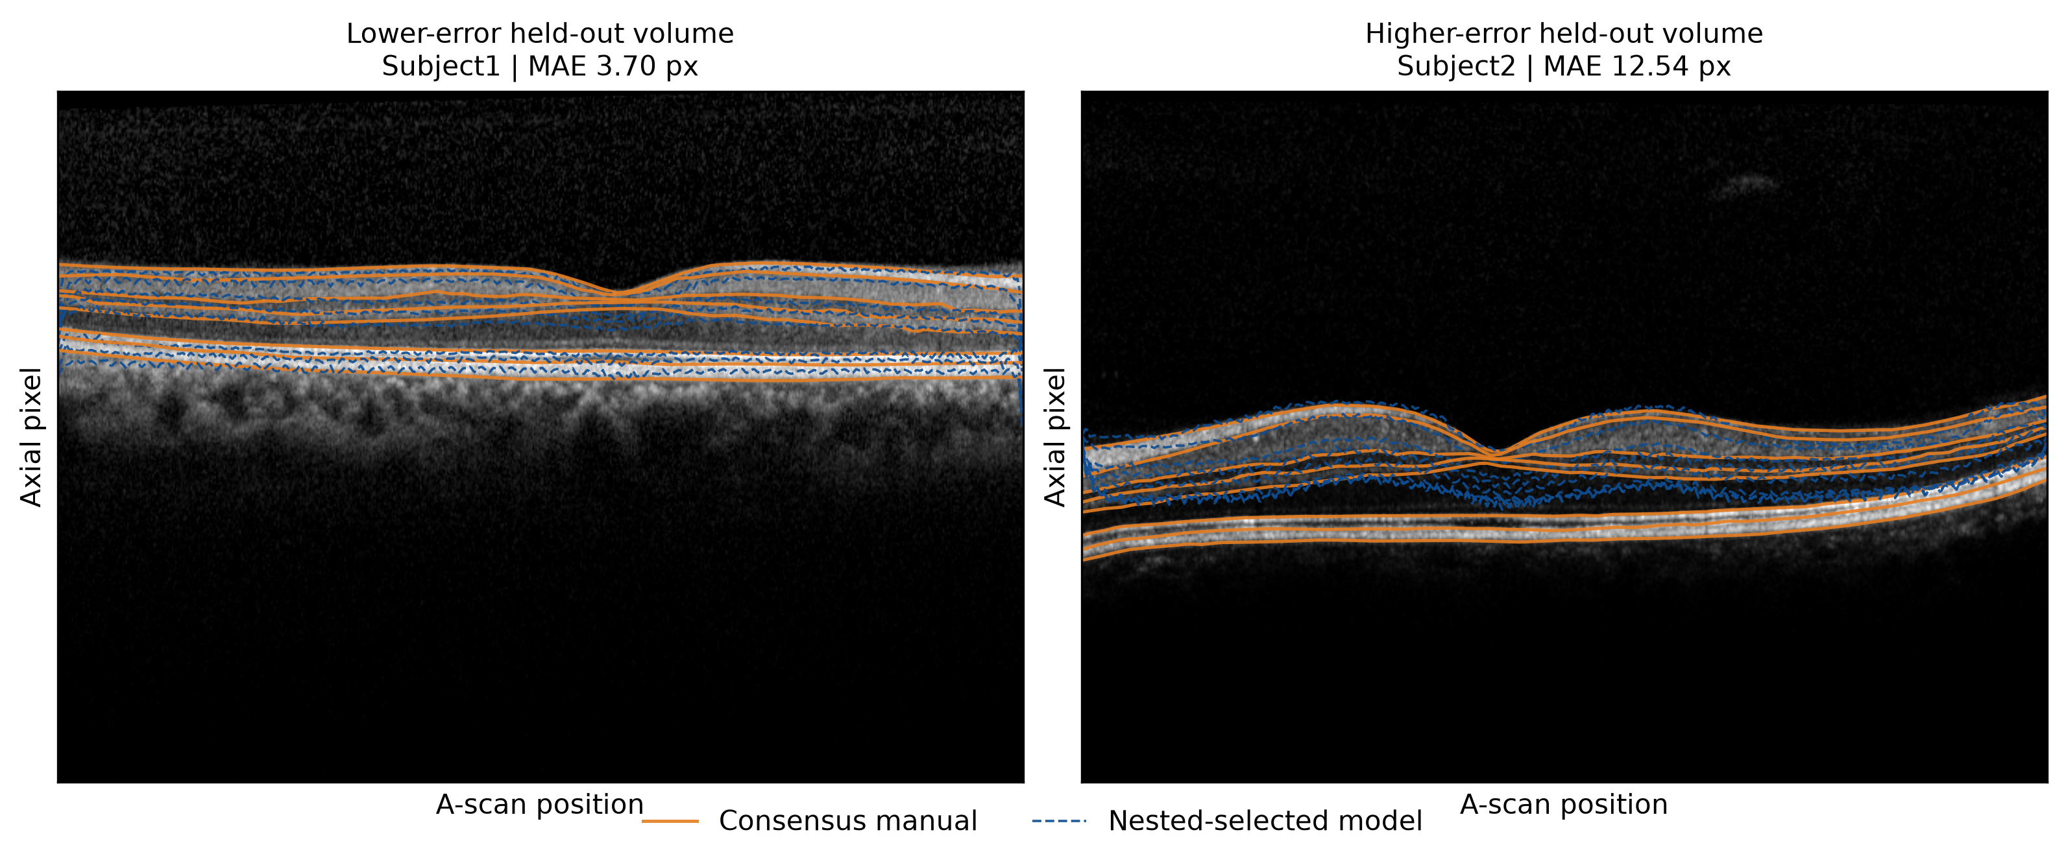
Figure 3. Programmatically selected held-out qualitative cases from the same nested run as Fig. 2B–C. Orange curves are consensus manual boundaries and dashed blue curves are nested-selected predictions. Subject1 (3.70 px) and Subject2 (12.54 px) are respectively the minimum- and maximum-MAE outer folds; no case was selected by visual inspection. The panel illustrates the observed error range rather than a cherry-picked success.

3.5 Exploratory paired-image extension
Across three seeds, fundus-only, OCT-only, and concatenated fusion probes obtained balanced accuracy of 0.437 ± 0.044, 0.519 ± 0.017, and 0.542 ± 0.032, respectively. Macro F1 was 0.369 ± 0.034, 0.453 ± 0.030, and 0.485 ± 0.021. Figure 4 displays seed-level values as well as the data and claim boundary, and Table 5 provides the corresponding three-seed summary. Fusion had the highest mean scores, but 49 records from 26 patients are insufficient for a superiority claim, and some patient folds lack every class. The extension only demonstrates that complete-data and patient-disjoint principles can be retained in a separate 2D multimodal task.
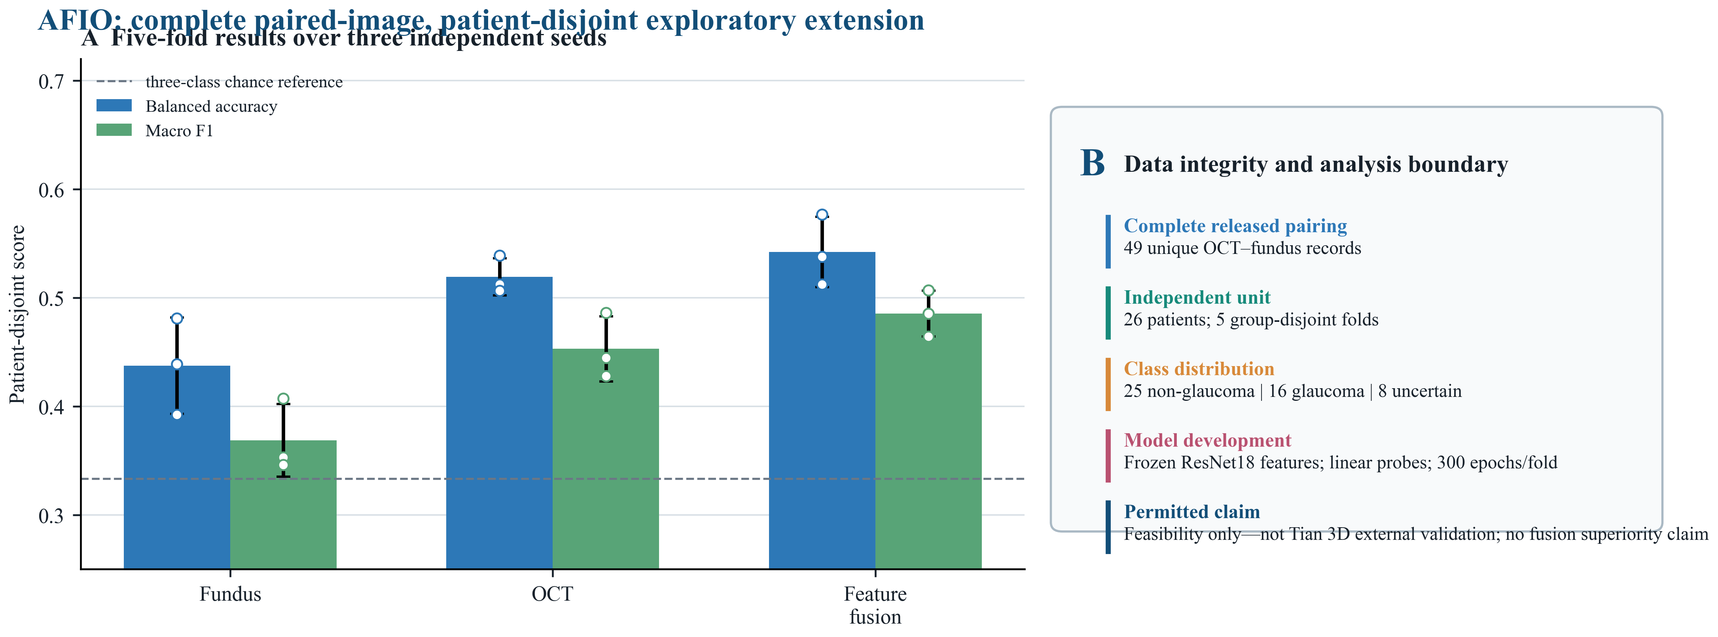
Figure 4. AFIO exploratory paired-image extension. (A) Patient-disjoint five-fold balanced accuracy and macro F1 over three seeds, with individual seed values shown. The dashed line is a three-class chance reference, not a clinical benchmark. (B) Complete-data audit, group-disjoint splitting, training budget, and claim boundary. AFIO is a 2D multimodal feasibility extension and is not external validation of Tian 3D boundary segmentation.
Table 5. AFIO patient-disjoint five-fold results summarized across three seeds. Values demonstrate feasibility only and should not be interpreted as external Tian segmentation validation.
Input | Balanced accuracy | Macro F1 | Feature dimension | Claim boundary
Fundus | 0.437 ± 0.044 | 0.369 ± 0.034 | 512 | Exploratory unimodal
OCT | 0.519 ± 0.017 | 0.453 ± 0.030 | 512 | Exploratory unimodal
Feature fusion | 0.542 ± 0.032 | 0.485 ± 0.021 | 1024 | Highest mean; no superiority claim

4. Discussion

4.1 Principal finding
The central result is statistical rather than diagnostic: a raw stack length is not an independent sample count. On the complete Tian release, a fourfold range of raw B-scan counts produced an ESS range of only 1.519-1.562. Exact copies did not create evidence. This behavior is the intended property of the quadratic correlation model and directly addresses a common small-data ambiguity: a dataset can contain many images while having very few patient-level units.

4.2 Why the negative accuracy result matters
The ESS-scaled cross-slice derivative loss changed MAE by only −0.019 pixels, with a confidence interval spanning zero. Reporting that result prevents a mechanistic statistic from being relabeled as an accuracy innovation. The regularizer may be too weak when the ESS-to-slice-count ratio is near 0.15, the compact model may already learn local continuity, and the healthy ten-volume release may not contain enough structural diversity to reveal a benefit. A future method should be judged by an independently powered pathological-volume study, not by additional tuning on the same ten subjects.

4.3 What the model-development experiment showed
Nested selection preserved an untouched outer estimate, and the selected candidates were refitted for 120 epochs. The most favorable fixed 120-epoch ablation was contrast plus noise, suggesting that exposure and speckle variation may be more limiting than simple vertical translation. However, the nested result cannot isolate augmentation from the longer refit duration because no plain 120-epoch nested control was run. The original OCTRIMA3D graph algorithm remains substantially more accurate on this healthy dataset [1]. The value of the present pipeline is the strict separation of data unit, model development, and evidence accounting.

4.4 Relation to volumetric and multimodal retinal artificial intelligence
Recent retinal artificial intelligence (AI) research demonstrates that full OCT volumes can outperform central-slice analysis and that fundus–OCT combinations can add complementary information [4–7,19]. Those studies usually rely on orders of magnitude more patients or in-domain pretraining. Our result addresses a narrower corner case: when only a complete but very small release is available, correlations must be handled explicitly and all model choices must remain inside grouped validation. The AFIO extension follows the same grouping discipline but cannot repair the absence of pathological 3D external validation.

4.5 Intended use of RetiESS
RetiESS is best treated as a reporting or loss-scaling primitive. It can accompany a volumetric model to state that 20 highly similar slices do not equal 20 independent observations, and it can help define study-level sampling summaries. It should not be interpreted as confidence, calibration, referral priority, or disease evidence without a separate validation that relates ESS to those endpoints. This restrained role is particularly compatible with biomedical statistics, where the number of independent experimental units matters more than the number of derived images.

5. Limitations
The primary dataset contains only 10 healthy volumes and 100 selected B-scans. It is suitable for a proof-of-concept statistical audit but cannot establish robustness to retinal pathology, scanner shift, or clinical acquisition artifacts. The position/appearance kernel, bandwidths, and loss coefficient were fixed in a small development sequence and require prospective confirmation. The perturbations are synthetic and test redundancy accounting, not real missingness. Bootstrap and Wilcoxon summaries at n=10 have limited resolution. The compact CNN is inferior to the original graph-based result on this release and should not be framed as a clinical segmentation system. AFIO contains only 49 unique pairs and uncertain labels; the linear-probe results are highly exploratory. Finally, no independent 3D pathological dataset with matching eight-boundary annotations was used, so external validation remains the critical next step.

6. Conclusion
RetiESS-Seg provides a correlation-aware effective sample size audit for small-sample 3D retinal OCT segmentation. Exact duplication increased the nominal B-scan count without increasing effective evidence, while the ESS-scaled derivative loss did not significantly improve boundary MAE. A separate nested selection-and-refit experiment produced lower outer MAE, but the design did not isolate augmentation from refit duration and the result must not be attributed to RetiESS. The work therefore supports a narrow and testable contribution: explicit redundancy accounting can make small-volume OCT experiments statistically more honest. Pathological external validation and a stronger volumetric backbone are required before journal-level or clinical claims are appropriate.

Declarations

Data Availability
The complete Tian OCTRIMA data are available as Supporting Information to Tian et al. at https://doi.org/10.1371/journal.pone.0133908.s002. The complete paired AFIO data are available from Mendeley Data at https://doi.org/10.17632/2rnnz5nz74.2. No gated or approval-controlled dataset or model weight was used.

Code Availability
The repository contains dataset audits, group-disjoint split files, training scripts, fold-level outputs, statistical summaries, and figure builders. Code and reproducibility materials are available at https://github.com/kobayashi0512/RetiESS-Seg.

Author Contributions
K.D.: Conceptualization, methodology, software, investigation, data curation, formal analysis, visualization, and writing - original draft. L.L.: Supervision, project administration, resources, and writing - review and editing.

Conflicts of Interest
The authors declare no known competing financial interests or personal relationships that could have influenced the work reported in this study.

Ethics Statement
This retrospective computational study used de-identified, publicly released datasets and involved no new participant recruitment, intervention, or data collection. Ethical approvals and consent procedures for the source datasets are described in the corresponding source publications.

References
[1] Tian J, Varga B, Somfai GM, et al. Real-Time Automatic Segmentation of Optical Coherence Tomography Volume Data of the Macular Region. PLoS One. 2015;10(8):e0133908. doi:10.1371/journal.pone.0133908.
[2] Chiu SJ, Li XT, Nicholas P, et al. Automatic segmentation of seven retinal layers in SDOCT images congruent with expert manual segmentation. Opt Express. 2010;18(18):19413-19428. doi:10.1364/OE.18.019413.
[3] Chen X, Wang J, Qian T, et al. An artificial intelligence cloud platform for OCT-based retinal anomalies screening system in real clinical environments. npj Digit Med. 2025;8:559. doi:10.1038/s41746-025-01959-7.
[4] Judkiewicz R, Berkowitz E, Meisel M, et al. Shifting the retinal foundation models paradigm from slices to volumes for optical coherence tomography. npj Digit Med. 2026;9:314. doi:10.1038/s41746-026-02496-7.
[5] Zhou Y, Chia MA, Wagner SK, et al. A foundation model for generalizable disease detection from retinal images. Nature. 2023;622(7981):156-163. doi:10.1038/s41586-023-06555-x.
[6] Yoshida M, Murakami T, Ishihara K, et al. Explainable Artificial Intelligence-Assisted Exploration of Clinically Significant Diabetic Retinal Neurodegeneration on OCT Images. Ophthalmol Sci. 2025;5(5):100804. doi:10.1016/j.xops.2025.100804.
[7] Mukherjee S, Wu D, von der Emde L, et al. ReticularNet: Automated Pixel-Level Segmentation of Reticular Pseudodrusen on Near-Infrared Reflectance Images by Deep Learning. Ophthalmol Sci. 2026;6(2):101038. doi:10.1016/j.xops.2025.101038.
[8] Varoquaux G. Cross-validation failure: Small sample sizes lead to large error bars. Neuroimage. 2018;180:68-77. doi:10.1016/j.neuroimage.2017.06.061.
[9] Bengio Y, Grandvalet Y. No Unbiased Estimator of the Variance of K-Fold Cross-Validation. J Mach Learn Res. 2004;5:1089–1105. Available from: https://www.jmlr.org/papers/v5/grandvalet04a.html.
[10] Shorten C, Khoshgoftaar TM. A survey on image data augmentation for deep learning. J Big Data. 2019;6(1):60. doi:10.1186/s40537-019-0197-0.
[11] Kish L. Survey Sampling. New York, NY: John Wiley & Sons; 1965. ISBN: 9780471109495. Available from: https://www.wiley.com/en-us/Survey+Sampling-p-9780471109495.
[12] Raja H, Akram MU, Khawaja SG, et al. Data on OCT and fundus images for the detection of glaucoma. Data Brief. 2020;29:105342. doi:10.1016/j.dib.2020.105342.
[13] Ronneberger O, Fischer P, Brox T. U-Net: Convolutional Networks for Biomedical Image Segmentation. In: Medical Image Computing and Computer-Assisted Intervention—MICCAI 2015. Lecture Notes in Computer Science. 2015;9351:234–241. doi:10.1007/978-3-319-24574-4_28.
[14] Litjens G, Kooi T, Bejnordi BE, et al. A survey on deep learning in medical image analysis. Med Image Anal. 2017;42:60–88. doi:10.1016/j.media.2017.07.005.
[15] Loshchilov I, Hutter F. Decoupled Weight Decay Regularization. In: 7th International Conference on Learning Representations (ICLR). 2019. Available from: https://openreview.net/forum?id=Bkg6RiCqY7.
[16] Efron B, Tibshirani RJ. An Introduction to the Bootstrap. New York, NY: Chapman & Hall/CRC; 1993. doi:10.1201/9780429246593.
[17] Wilcoxon F. Individual Comparisons by Ranking Methods. Biometrics Bulletin. 1945;1(6):80–83. doi:10.2307/3001968.
[18] He K, Zhang X, Ren S, Sun J. Deep Residual Learning for Image Recognition. In: Proceedings of the IEEE Conference on Computer Vision and Pattern Recognition. 2016:770–778. doi:10.1109/CVPR.2016.90.
[19] Chuter B, Joshi V, Hallaj S, et al. A Novel Multimodal Implementation of a Foundation Artificial Intelligence Model Using Optic Nerve Head Fundus Photographs and OCT Imaging for Glaucoma Detection. Ophthalmol Sci. 2026;6(2):101012. doi:10.1016/j.xops.2025.101012.

