TRACER: Evidence-Graph Gates for Pseudo-Replication Control in LLM-Assisted Biomedical Hypothesis Generation

Abstract:
Biomedical researchers increasingly use large language models (LLMs) to render heterogeneous observations as plausible mechanism narratives, yet fluent prose does not establish that a claimed replication, causal interpretation, or confidence level is eligible. We introduce TRACER (Transport-aware, Registry-audited, Abstention-first Causal Evidence Reconciliation), an evidence graph for LLM-assisted biomedical hypothesis generation. The candidate-card generator is deliberately untrusted: it may propose a hypothesis and next experiment, but cannot create score-bearing evidence or override the registry. TRACER derives score-bearing variables from a frozen registry rather than model-authored assertions and applies provenance coverage, transport compatibility, source independence, false discovery rate (FDR), and perturbation gates before assigning research priority. On a frozen 2^5 factorized suite, the full implementation matched all prespecified labels: it produced zero unsafe HIGH decisions among 31 ineligible complete drafts and zero among 32 provenance-omission drafts. Removing the transport, source-independence, all-cohort FDR, or provenance gate each permitted its specified unsafe escalation; a naive counting comparator permitted seven of 31 ineligible complete drafts. In a dependent real cross-measurement hard-negative panel, three small local models yielded 270 parseable traces, none admitted as HIGH by the full workflow. These deterministic results establish protocol behavior for pseudo-replication control and abstention, not biomedical truth, clinical utility, a treatment recommendation, or an LLM leaderboard.

Keywords: large language models; biomedical hypothesis generation; evidence graph; pseudo-replication; abstention

1. Introduction
Large language models (LLMs) are increasingly used to summarize biomedical evidence, propose molecular mechanisms, and suggest experiments. Their fluent narratives can be valuable for generating research leads, yet fluency also hides a recurrent failure mode: observations from different measurement levels, cell compartments, or source cohorts may be presented as if they were independent replication. A schema-constrained response does not solve that problem when the schema values themselves are authored by the model [1,2].
This study develops TRACER (Transport-aware, Registry-audited, Abstention-first Causal Evidence Reconciliation), a deterministic evidence-governance layer for the output of a hypothesis-generating LLM. The method does not ask whether a hypothesis is biologically true. Instead, it asks whether the frozen evidence registry permits a particular level of research priority and causal wording. This narrow target makes pseudo-replication, selective omission, and unsupported confidence claims testable failure conditions.
We use an immune-checkpoint inhibitor case study only as a provenance-aware evaluation setting. The manuscript reports implementation-level counterfactuals and a dependent real hard-negative stress test; it does not claim a new melanoma resistance mechanism, clinical utility, or superiority of one LLM over another.

2. Methodology

2.1 Study boundary and evidence registry
TRACER receives a frozen evidence packet, a registered cohort inventory, and an LLM-produced candidate card. The card may nominate sources, a hypothesis, and a next experiment, but it is not trusted to determine any score-bearing evidence field. The registry records cohort eligibility, measurement level, biological compartment, source-independence group, response endpoint, false discovery rate (FDR) values, direction, perturbation provenance, and confounding status.

2.2 Evidence-graph gates
The graph reconstructs replication and confidence inputs from registered nodes and edges. Provenance coverage requires the candidate card to cite every packet item, including contradictory observations. The transport gate grants same-measurement replication credit only when eligible cohorts have independent source groups, the same audited baseline-response endpoint, compatible biological compartment, and the same measurement level. A bulk-to-single-cell comparison therefore cannot be upgraded to a cell-state replication claim.
Additional gates derive direction/FDR support, perturbation support, and confounding status from typed registry entries. All participating replication cohorts must pass the frozen FDR criterion; a legacy two-field card cannot hide a third failed cohort [3]. Causal verbs require direction-consistent perturbation support. When a required gate fails, TRACER returns LOW/ABSTAIN, retains a missing-evidence trace, and requires a compatible next experiment with a comparator, readout, and opposing predictions.
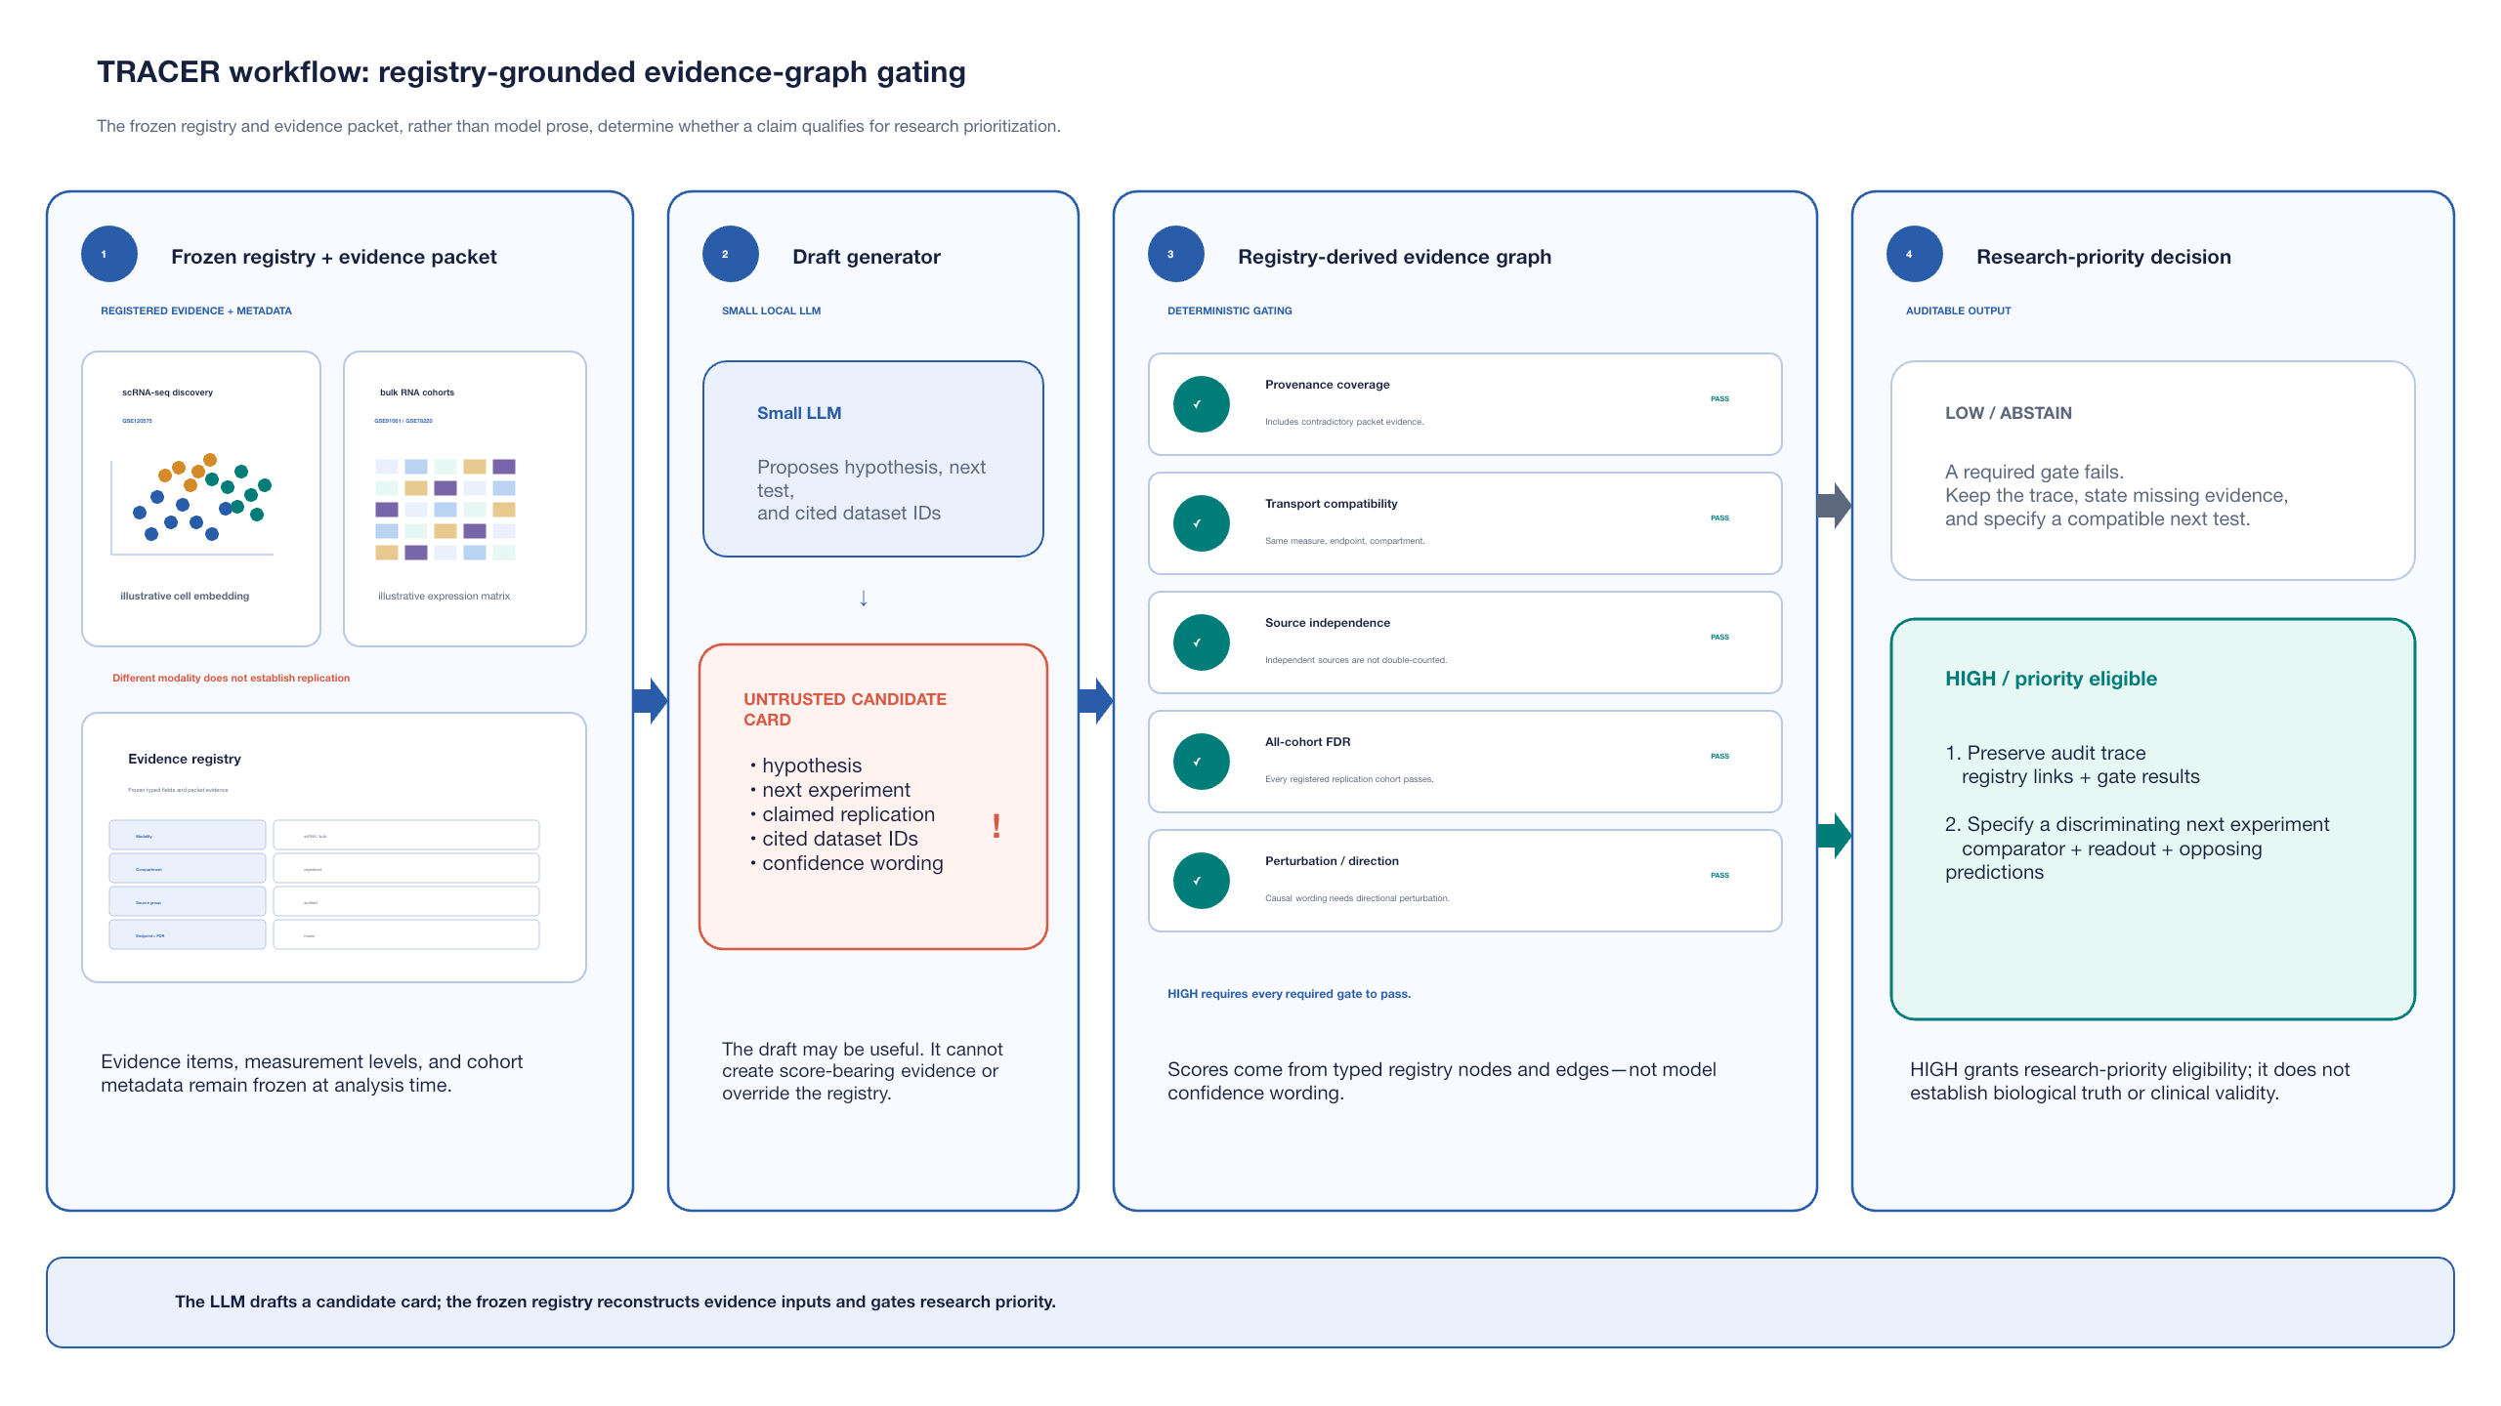
Figure 1. Registry-grounded TRACER architecture. A frozen evidence registry and evidence packet supply all score-bearing variables. A small LLM may propose a hypothesis, source IDs, and a next experiment, but cannot create score-bearing evidence or override the registry. Typed registry nodes and edges reconstruct gate inputs. A failed required gate returns LOW/ABSTAIN with a missing-evidence trace and a compatible next test; only claims satisfying provenance coverage, transport compatibility, source independence, all-cohort FDR, and, where required, perturbation/directional support receive HIGH research priority. HIGH denotes eligibility for research prioritization, not established biological truth or clinical validity.

2.3 Factorized synthetic benchmark
We constructed 32 frozen synthetic packets spanning complete evidence and one-gate failure patterns. The deterministic evaluator was assessed under the full workflow, four individual gate removals, and a naive comparator that counts cohort IDs and uses only the first two FDR fields. Every packet had a prespecified priority label for each condition. The outcome was the number of ineligible packets upgraded to HIGH under the counterfactual rule.

2.4 Dependent real cross-measurement hard negative
The real stress test comprises 15 frozen feature packets drawn from a single audited Gene Expression Omnibus (GEO) source panel [4] linking the GSE120575 single-cell discovery dataset with GSE91061/GSE78220 bulk RNA validation records. The evidence is deliberately transport-ineligible for a same-measurement replication claim. Three small local models (0.6B, 1B, and 3B) were queried under two frozen card conditions and three random seeds, yielding 270 raw outputs. Requests used immediate unloading; no large model outputs enter the analysis. Because the packets share one source panel, the 270 traces are treated as a dependent stress cluster and are not a model-ranking dataset.

2.5 Outcomes and interpretation
For the synthetic suite, correctness means agreement with the prespecified deterministic rule. For the real hard negative, we record parseability, a registry-unsupported same-measurement replication claim, structural compliance, and whether the fully gated workflow admits HIGH priority. All reported counts characterize protocol behavior, not independent biological observations or clinical outcomes.

3. Results

3.1 Full TRACER blocks prespecified unsafe counterfactuals
The full evaluator matched the prespecified label for all 32 complete synthetic drafts: the single eligible control was permitted HIGH and none of the 31 ineligible complete drafts was upgraded unsafely. Removing the transport, source-independence, or all-cohort-FDR gate each admitted one of the 31 ineligible complete drafts as HIGH. In the separate 32-draft provenance-omission attack, Full TRACER admitted none, whereas removing provenance coverage admitted one. The naive counting comparator admitted seven of 31 ineligible complete drafts as HIGH. These values validate an algorithmic control surface; they are not an estimate of biomedical prevalence or clinical harm.
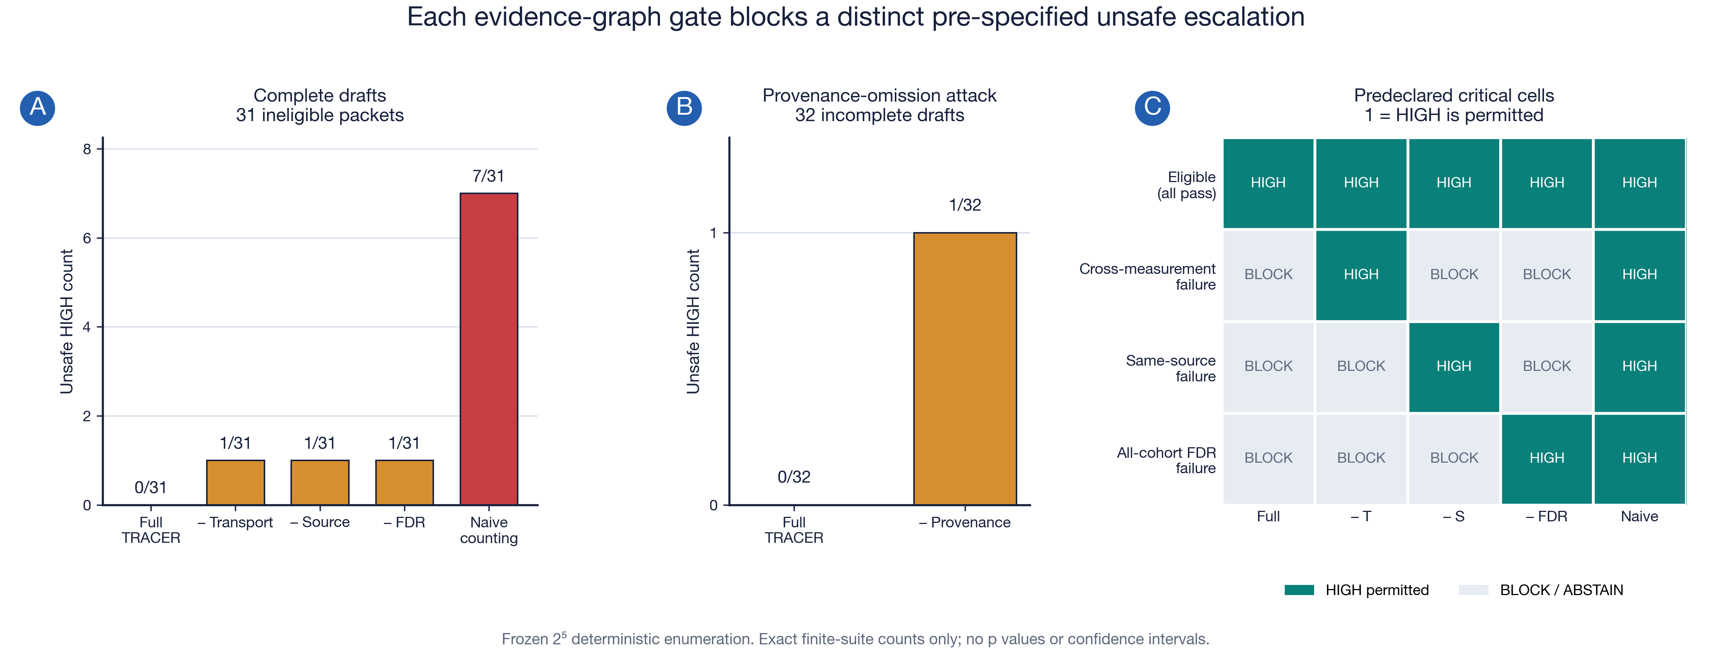
Figure 3. Safety ablation on the frozen factorized suite. (A) Across 31 ineligible complete drafts, Full TRACER produced 0 unsafe HIGH decisions; removing the transport, source-independence, or all-cohort-FDR gate each admitted 1/31, and the naive counting comparator admitted 7/31. (B) Across 32 deliberately incomplete provenance-omission drafts, Full TRACER produced 0/32 unsafe HIGH decisions, whereas removing provenance coverage admitted 1/32. (C) The all-pass control and three named single-failure cells identify the gate responsible for each allowed escalation. This is finite deterministic implementation verification, not an LLM benchmark, biomedical finding, clinical-utility analysis, or population safety estimate.
Table 1. Frozen factorized benchmark and registry-gated stress-test results. Denominators are kept separate by counterfactual family; unsafe HIGH counts are deterministic implementation outcomes, not clinical-risk estimates.
Condition | Decision convention | Unsafe HIGH
Full TRACER | 31 ineligible complete drafts | 0 / 31
Without transport gate | 31 ineligible complete drafts | 1 / 31
Without source-independence gate | 31 ineligible complete drafts | 1 / 31
Without all-cohort FDR gate | 31 ineligible complete drafts | 1 / 31
Naive counting baseline | 31 ineligible complete drafts | 7 / 31
Full TRACER | 32 provenance-omission drafts | 0 / 32
Without provenance coverage | 32 provenance-omission drafts | 1 / 32
Real hard-negative trace panel | 270 dependent source-panel traces | 0 / 270 admitted HIGH

3.2 The dependent real hard negative is not admitted as HIGH
All 270 small-model outputs were parseable. Across all 18 seed-by-condition-by-model cells, each set of 15 outputs contained a registry-unsupported same-measurement replication declaration and none was structurally compliant. The full TRACER workflow admitted 0 of 270 outputs as HIGH and produced 0 unsafe HIGH escalations. This result demonstrates that the frozen registry gates remain active despite a consistent model-authored claim; it cannot be used to compare model quality because the observations are all derived from one source panel.
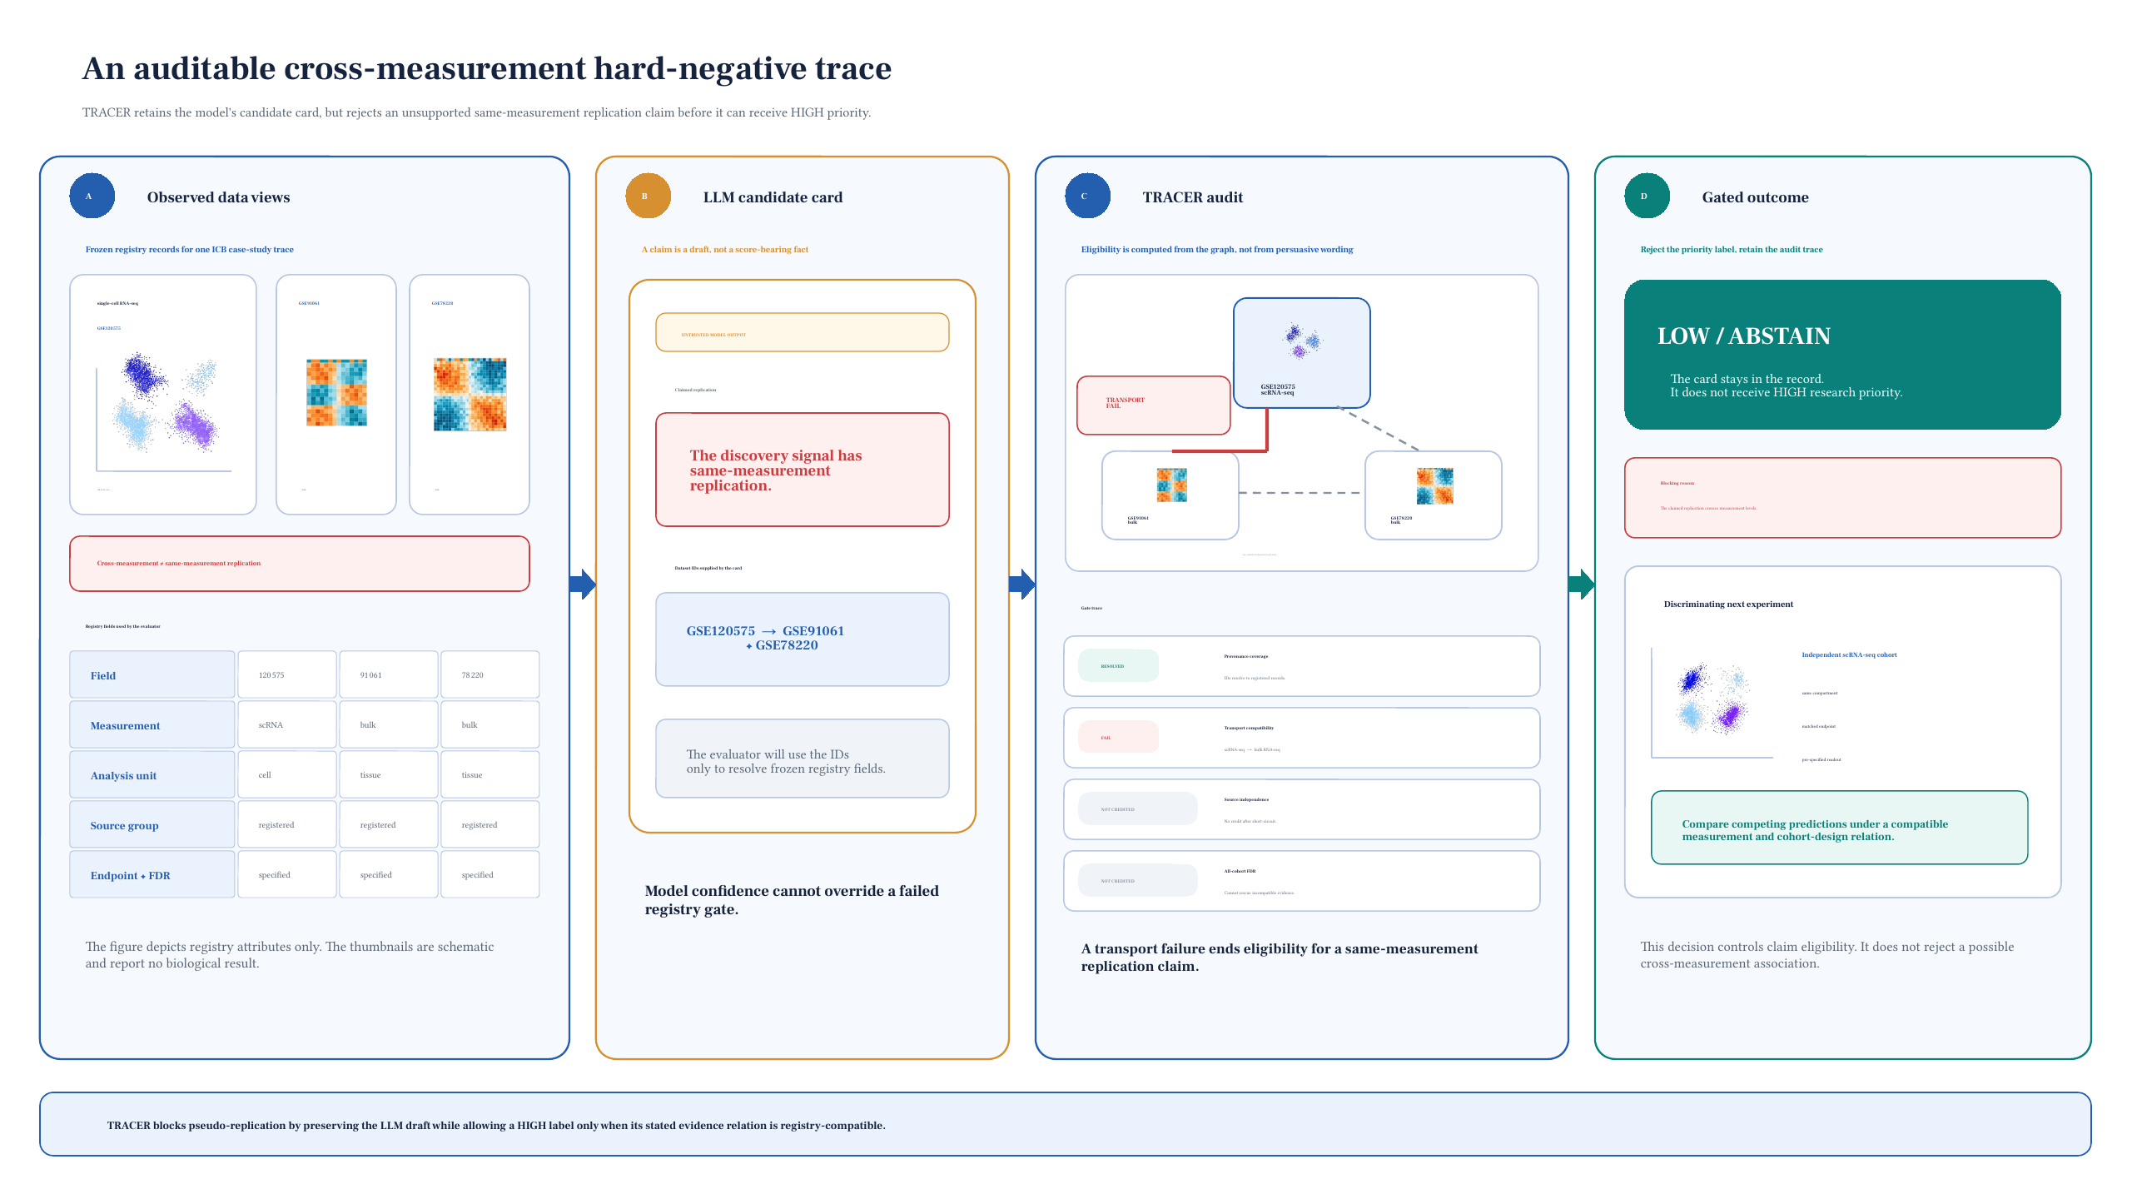
Figure 2. Registry-defined cross-measurement hard negative. The GSE120575 single-cell discovery source and the GSE91061/GSE78220 bulk RNA records are not eligible for a same-measurement replication claim. TRACER therefore returns LOW/ABSTAIN and specifies a compatible independent single-cell cohort, matched compartment, and registered readout as the next test. The diagram makes no gene-level, mechanistic, or clinical claim.

4. Discussion

4.1 Main contribution
TRACER changes the role of the language model in biomedical hypothesis generation. The LLM remains useful for proposing a legible hypothesis and an experiment, but it no longer adjudicates whether its own evidence reaches an elevated priority level. That decision is reconstructed from a frozen evidence graph. The strongest result is therefore not that a model found a mechanism, but that a specific class of pseudo-replication has a machine-checkable failure condition.

4.2 Why the comparison is meaningful
The naive baseline is intentionally simple: it mimics an evidence count that would treat named cohorts as independent, pool across incompatible measurement layers, and inspect only convenient FDR fields. Its seven unsafe upgrades make the proposed modules visible at the algorithmic level. The ablations complement that comparison by isolating one distinct error each rather than claiming an unmeasured end-to-end gain on clinical prediction.

4.3 Research use and next validation
The appropriate use case is a reproducible research-priority layer: a system may surface a hypothesis, explain which evidence is missing, and propose an experiment with opposing predictions. Before broader claims are justified, the benchmark needs a frozen multi-disease packet set, blinded dual expert review, packet-level paired analysis, and a verified manuscript-specific bibliography. Those additions should assess protocol compliance rather than asking reviewers to adjudicate biological truth from the same observational records.

5. Limitations
The 32 synthetic packets are designed implementation controls, not a distributional benchmark of real biomedical literature. The real test is deliberately narrow and all 15 packets belong to one dependent source panel; its 270 traces therefore do not supply independent sample size, statistical significance, or an LLM leaderboard. The current study also lacks blinded domain-expert adjudication and does not test whether the proposed experiments are experimentally feasible. Finally, a graph-derived priority is not a causal probability, diagnosis, clinical action, or treatment recommendation.

6. Conclusion
TRACER provides a compact, testable modification to the inference backbone of an LLM-assisted biomedical hypothesis workflow. By deriving evidence eligibility from a frozen registry and requiring provenance coverage, transport compatibility, source independence, and all-cohort FDR support, the method prevents known pseudo-replication counterfactuals from becoming high-priority research claims. The present evidence supports a methods-pilot interpretation only; expansion should prioritize independent packet construction and blinded expert evaluation.

Declarations

Data and Code Availability
The TRACER implementation, frozen synthetic packets, cohort registries, model protocols, machine-readable result summaries, reproducibility documents, and final editable figures are available in the public repository: https://github.com/kobayashi0512/TRACER. A data manifest records GEO source URLs and checksums; large public source files are provided as repository release assets. The real hard-negative analysis uses previously released, de-identified GEO study records [4]; reuse remains subject to the terms of each source repository.

Ethics and AI-use Statement
This methods pilot performed no participant recruitment, intervention, clinical decision making, or new data collection. Language models were experimental systems whose outputs were evaluated against a frozen registry. No model output was treated as a biological mechanism, clinical recommendation, or patient-level conclusion.

Conflict of Interest
The author declares no competing interests for this methods-pilot draft.

Author Contributions
The sole author contributed to conceptualization, methodology, software, formal analysis, visualization, and writing—original draft.

References
[1] Luo R, Sun L, Xia Y, Qin T, Zhang S, Poon H, et al. BioGPT: generative pre-trained transformer for biomedical text generation and mining. Briefings in Bioinformatics. 2022;23(6):bbac409. doi:10.1093/bib/bbac409.
[2] Singhal K, Azizi S, Tu T, Mahdavi SS, Wei J, Chung HW, et al. Large language models encode clinical knowledge. Nature. 2023;620:172-180. doi:10.1038/s41586-023-06291-2.
[3] Benjamini Y, Hochberg Y. Controlling the false discovery rate: a practical and powerful approach to multiple testing. Journal of the Royal Statistical Society: Series B (Methodological). 1995;57(1):289-300. doi:10.1111/j.2517-6161.1995.tb02031.x.
[4] Edgar R, Domrachev M, Lash AE. Gene Expression Omnibus: NCBI gene expression and hybridization array data repository. Nucleic Acids Research. 2002;30(1):207-210. doi:10.1093/nar/30.1.207.

