Conditional Bilateral Fundus Correspondence Under Disease and Quality Matching: A Multi-View Evaluation Study

Abstract
Bilateral fundus images may share visual information, but a high matching score alone cannot establish a disease-independent patient signature. We evaluate cross-eye correspondence under explicit disease-, quality-, and view-conditioned negative-pair rules. DeepDRiD provided 300 bilateral patients (210/46/44 patient-disjoint train/validation/test); its strict four-view subset separated same-eye repeat, cross-eye same-patient, and grade-matched cross-patient comparisons. A frozen ImageNet-pretrained ResNet-50 with cosine scoring was the primary readout. In 43 four-view test patients, mean similarities were 0.8308, 0.8241, and 0.7366, respectively: patient-bootstrap intervals resolved the cross-eye versus matched-negative contrast but not the same-eye versus cross-eye contrast. In the 300-patient descriptive analysis, pair-identity AUROC changed from 0.8827 under grade matching to 0.8660 under grade × quality-tier matching and 0.8500 under nearest measured-quality matching. A post-hoc, common-denominator analysis of 42 held-out test patients yielded 0.8549, 0.8348, and 0.8731, respectively, showing that the full-cohort ordering is not stable across splits. The locked frozen-baseline PAPILA readout on 244 patients was 0.8585 ± 0.0095 under exact ordered bilateral diagnosis-signature matching; its conditional patient-bootstrap interval envelope was [0.8157, 0.8983]. A selected low-capacity hierarchical head improved an internal held-out DeepDRiD readout but fell below raw features on a previously inspected CFP–OCT development cohort. This evaluation identifies measurable conditional correspondence and a transfer boundary; it does not establish a clinical identity biomarker or a generalizable learned representation.
Keywords: bilateral fundus imaging; conditional correspondence; image quality; acquisition view; matched-negative difference; external evaluation

1. Introduction
Both eyes are acquired routinely in retinal imaging, yet representative deep-learning evaluations use each photograph as a disease-prediction input [1,2]. The paired structure raises a different, operational question: given a left-eye image, can an image from the same patient's right eye be distinguished from a right-eye image belonging to another patient? Prior interretinal verification and bilateral self-supervised learning studies already answer parts of this question [3–5]. Our aim is therefore not to claim the first use of paired eyes. It is to measure what the pairing result means after observable alternatives are controlled.
A matching score can be inflated by disease labels, acquisition conditions, and repeated views, a form of shortcut learning [6]. If positive and negative pairs differ in diabetic retinopathy (DR) grade or quality, an encoder need not capture patient-specific retinal structure to separate them. Retinal image-quality research makes this a practical concern [7,8]. Conversely, matching on observed variables does not remove unmeasured age, camera, site, pigmentation, or field-of-view differences. Fundus photographs can encode systemic attributes such as age and cardiovascular risk factors [9]. We use bilateral correspondence only for the operational ability of a visual score to separate same-patient from cross-patient left–right pairs under a stated negative-pair protocol. We do not equate this score with legal identity, a stable biological trait, or a disease-independent biomarker.
The evaluation has three linked elements. First, DeepDRiD's four images per complete patient let us distinguish same-eye repeat-view agreement from cross-eye agreement instead of collapsing both into an eye-averaged vector [10]. Second, cross-patient negatives are matched successively on patient DR grade, grade plus quality tier, and nearest measured quality within grade. Third, we assign distinct evidential roles to datasets: DeepDRiD develops and audits the protocol, an already-inspected color fundus photography–optical coherence tomography (CFP–OCT) cohort exposes a learned candidate's transfer weakness, and PAPILA provides a locked external readout for the untrained frozen baseline [11]. These roles prevent an internally selected representation from being credited with an external result obtained only for the frozen baseline (Figure 1).
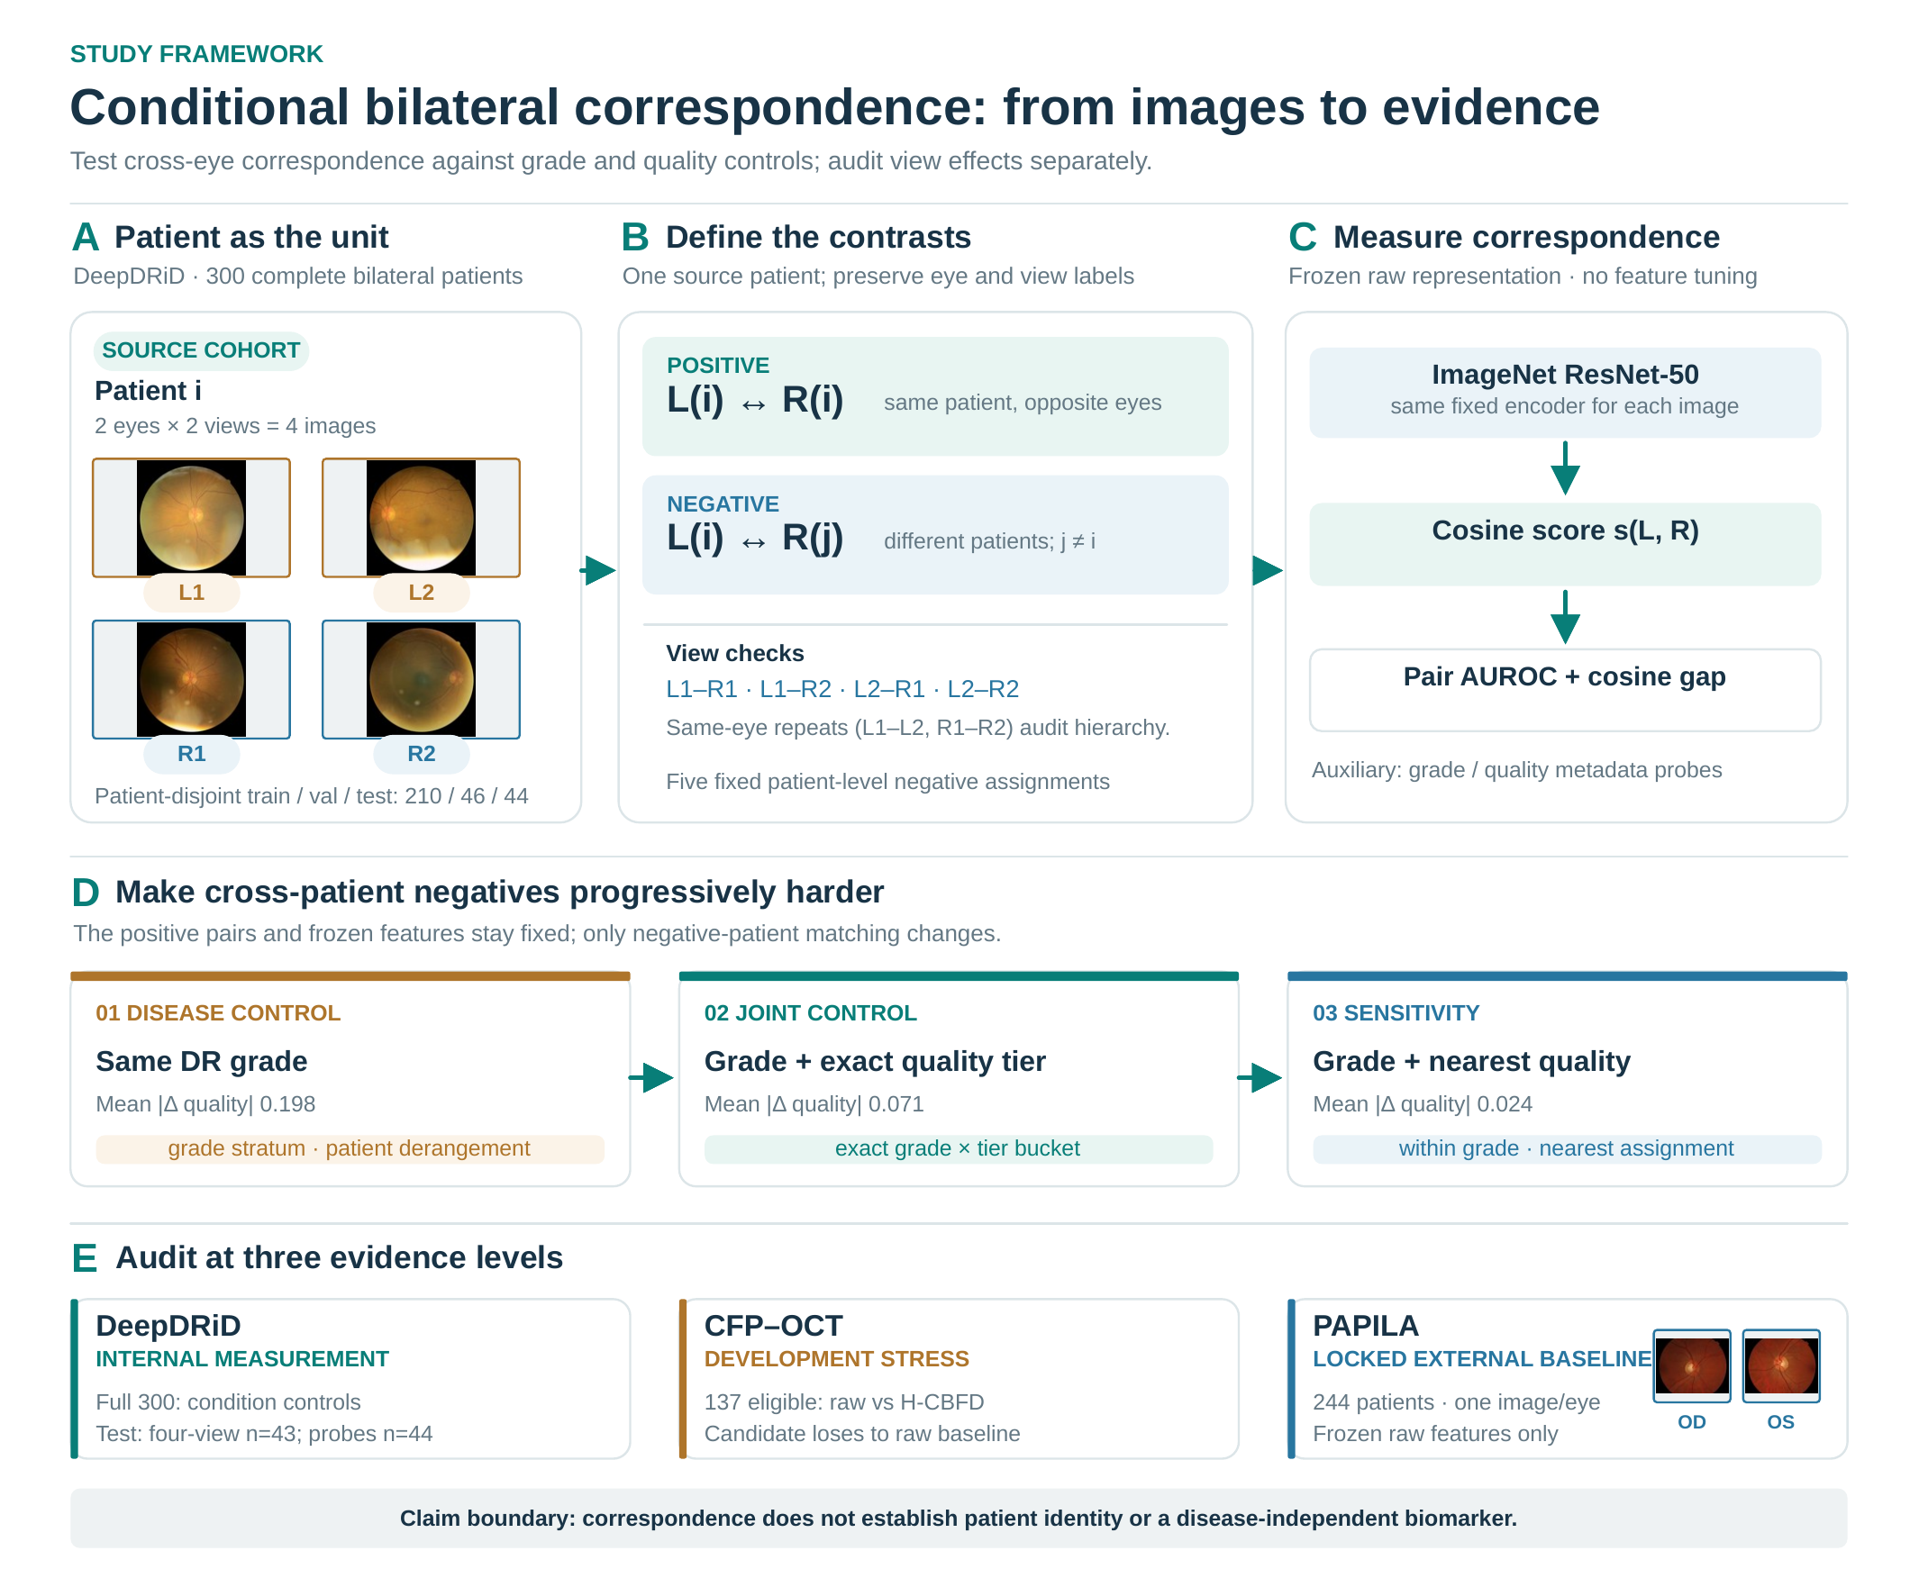
Figure 1. Framework for conditional bilateral fundus correspondence. (A) DeepDRiD contributes 300 complete bilateral patients, with two views per eye; the four source photographs are illustrative. The patient-disjoint split is 210/46/44. (B) Same-patient left–right pairs are compared with cross-patient negatives; four cross-eye view combinations and same-eye repeat views audit view dependence. (C) Fixed ImageNet-pretrained ResNet-50 features are compared by cosine similarity; no representation is trained for this raw-feature measurement. (D) Negative assignment uses DR grade, exact grade × quality tier, and nearest measured quality within grade. Quality-composite differences of 0.1982, 0.0709, and 0.0240 indicate progressively tighter matching, not improving prediction. (E) DeepDRiD supplies internal evidence; CFP–OCT is a previously inspected development stress set; PAPILA is the locked external test of the frozen baseline only. Four DeepDRiD images and the PAPILA OD/OS pair are unmodified illustrative source photographs [10,11].

2. Related work and contribution boundary
The pairwise score considered here depends jointly on the visual representation, the construction of same-patient positives, and the population from which cross-patient negatives are sampled. This is why a high verification score alone cannot identify a patient-specific factor. An unconstrained negative may differ in disease status, image quality, acquisition field, camera, site, or other observable properties. A conditional evaluation should state the patient unit of independence and make the negative-pair rule part of the estimand. The question in this paper is not whether both eyes can ever be matched, but how much of a measured matching result remains under progressively more comparable negative assignments.
Retina identification by vascular registration predates deep representation learning [12]. More directly, Biswas et al. studied interretinal symmetry for person-level verification [3] and subsequently tested bilateral central-vessel similarity across public datasets [13]. Self-FI used bilateral fundus pairs for self-supervised pretraining before disease classification [4], while iGWAS learned same-person cross-eye retinal embeddings for genetic analyses [5]. Recent medical-image re-identification research also includes fundus datasets [14]. Cross-eye pairing and retinal re-identification are thus established research directions. Our narrower contribution is an evaluation protocol that separates repeat views from cross-eye correspondence and tests the score against disease- and quality-constrained alternatives.
A second line of work combines the two eyes for patient-level disease prediction, including age-related macular degeneration grading [15], correlated multi-label ocular diagnosis [16,17], binocular glaucoma assessment [18], and bilateral cross-attention for fundus disease labels [19]. These methods address clinical classification rather than the conditional same-patient versus cross-patient pair comparison evaluated here. Their use of two eyes is an important precedent, not evidence that a correspondence score isolates a patient-specific visual factor.
Retina-specific self-supervised models such as RETFound offer alternative visual representations [20]; generic common/specific multi-view learning is also established [21]. We deliberately retain a frozen ImageNet encoder as the primary readout and treat the low-capacity hierarchical candidate as a stress test. We do not claim a new architecture, nor do we compare all available retinal encoders.
Our contribution is consequently a conditional evaluation design rather than a new identity-recognition architecture. The four-view hierarchy separates repeat-acquisition agreement from cross-eye agreement; matching on recorded disease and quality variables tests alternative explanations; and the dataset roles distinguish an internally developed protocol, an already-inspected stress set, and a locked frozen-baseline external readout. None of these controls establishes invariance to unrecorded age, pigmentation, camera, or site effects. We regard such a boundary as part of the evaluation result, not a footnote to it.

3. Materials and methods

3.1. Cohorts, unit of analysis, and evidence roles
The DeepDRiD analysis uses 300 patients with two explicitly lateralized eyes and four images per patient (1,200 images). Patients, not images, are the split unit: 210 are assigned to training, 46 to validation, and 44 to test. All complete patients enter the full-cohort conditional-controls diagnostic. Strict view analysis requires the literal L1/L2/R1/R2 names and therefore includes 45 validation and 43 test patients. Nonstandard view suffixes are not relabeled. A separate post-hoc held-out control audit uses the same 42 test patients eligible under all three matching rules; two patients in singleton grade × quality-tier strata are excluded before any rule is evaluated. These populations are reported separately rather than pooled.
The locally curated CFP–OCT paired cohort includes 137 eligible bilateral patients. This cohort had already been inspected across exploratory variants and is therefore a development stress set, not a blind final external test. Its diabetic-macular-edema (DME) labels are used only to construct matched cross-patient negatives under two recorded label schemas. PAPILA contributes 244 complete bilateral patients, each with one photograph per explicit eye and an eye-level glaucoma diagnosis [11]. PAPILA was held for one frozen baseline evaluation; no model, threshold, or negative rule was chosen from its results. The accessed PAPILA archive was an audited Kaggle distribution copy of the official dataset, not a new cohort; the official dataset descriptor and repository remain the scientific sources [11].
Table 1. Dataset roles. Cohorts are not pooled, and disease labels are not harmonized across datasets.
Dataset | Eligible patients | Image structure | Evidence role
DeepDRiD | 300 complete; 210/46/44 patient split | Two views per eye; strict four-view subset: 45 validation, 43 test | Protocol development; full-cohort control diagnostic; held-out view and probe checks
CFP–OCT | 137 complete bilateral | Bilateral color fundus photographs | Previously inspected development stress readout for learned candidate
PAPILA | 244 complete bilateral | One explicit left and one right photograph per patient | Locked external evaluation of frozen raw baseline only

Eligibility required an unambiguous patient identifier, explicit left/right laterality, and complete bilateral imagery for the protocol used in that cohort. The four-view DeepDRiD analysis additionally required literal L1/L2/R1/R2 view names. We did not assign nonstandard suffixes to the canonical positions, and we did not mix eye-level records from one patient across train, validation, and test. Although PAPILA's official descriptor reports 244 patients and 488 fundus photographs, the distribution copy was independently audited for archive size, checksum, ZIP integrity, safe paths, right-eye (oculus dexter, OD) and left-eye (oculus sinister, OS) clinical-table linkage, and image existence before features were extracted. These checks establish correspondence to the expected package structure; they do not make Kaggle a new primary source or resolve downstream figure-reuse permissions.

3.2. Frozen representation and pair score
Each photograph is passed through the published IMAGENET1K_V2 preprocessing and fixed Residual Network-50 (ResNet-50) weights [22,23]. The 2,048-dimensional penultimate feature is extracted without fundus fine-tuning. For left image L_i and right image R_j, the frozen feature vector f yields the cosine score
$$s(L_{i},R_{j}) = \frac{{f(L_{i})}^{T}f(R_{j})}{‖f(L_{i})‖_{2}‖f(R_{j})‖_{2}}.$$
An index match (i = j) defines a same-patient positive; a different patient (i ≠ j) defines a negative. For each assignment, pair-identity area under the receiver operating characteristic curve (AUROC) ranks one positive and one cross-patient negative per anchor patient. It is a discrimination statistic under the specified sampling rule, not a clinical authentication operating point. Five fixed negative assignments use seeds 20260922–20260926. Cross-patient assignments forbid self-pairs and preserve a one-to-one derangement within the eligible matching stratum.
The raw-feature analysis has no retinal weight update, representation normalization fitted on PAPILA, or threshold selected for clinical use. We report cosine similarity on the same feature construction for positive and negative pairs. AUROC is computed from the full set of positive and assigned negative scores for one seed, then summarized across seeds. Thus across-seed standard deviation (SD) describes sensitivity to admissible negative assignment, whereas the patient bootstrap addresses sampling variability conditional on an assignment. We do not combine those two sources into a single nominal confidence interval.

3.3. View hierarchy and conditional negatives
For each strict four-view patient, we average cos(L1,L2) and cos(R1,R2) for same-eye cross-view similarity. Cross-eye same-patient similarity averages the four Li–Rj combinations. Cross-patient similarity averages those same four combinations after assignment of another patient's right eye within the same patient DR grade. Validation repeats the analysis without changing the test protocol. These hierarchy estimates are patient-level quantities; seed-dependent negatives are averaged only where the estimand requires them.
For the full-cohort control analysis, each patient's two views per eye are averaged before pair scoring. Patient-level image-quality metadata form a prespecified composite:
$$q_{i} = \frac{1}{4} (O_{i} + \frac{C_{i}}{10} + \frac{F_{i}}{10} + \frac{10 − A_{i}}{10}).$$
Here O, C, F, and A denote the recorded overall-quality, clarity, field-definition, and artifact fields, respectively, each averaged across the four images of patient i. Exact joint matching uses patient DR grade and low (qᵢ ≤ 0.625), middle (0.625 < qᵢ ≤ 0.75), or high (qᵢ > 0.75) quality tier. Every joint stratum has at least six patients; no unmatched fallback is used. A stricter sensitivity analysis obtains a one-to-one negative assignment by minimizing measured quality differences within DR grade. The progressively smaller source–negative mean absolute composite differences, 0.1982, 0.0709, and 0.0240, verify that the controls increase similarity on recorded quality, not that they eliminate all quality confounding.
The three hierarchy levels answer related but nonidentical questions. Same-eye cross-view similarity is a repeat-acquisition reference; cross-eye within-patient similarity asks whether the left/right relationship survives a change of eye; and grade-matched cross-patient similarity is the controlled comparator. Their numerical ordering alone is insufficient: the two adjacent contrasts require uncertainty assessment on patients, not on the four image combinations as though they were independent observations. Separately, each of L1–R1, L1–R2, L2–R1, and L2–R2 receives its own pair-identity AUROC to expose dependence on view selection.
The quality composite is dimensionless and assembled after the original metadata fields are put on the recorded scales shown in the formula. Each image's quality fields are aggregated at patient level across four views before the tier is assigned. Exact raw-field matching would fragment the cohort into small or singleton strata, so the main joint control uses three fixed tiers. The nearest-quality sensitivity control instead uses one-to-one deranged assignment within grade and the direction-aligned original quality fields. We audit both composite and component-wise source–negative differences. These procedures change the negative distribution; an AUROC difference between rows must not be interpreted as a causal effect of image quality.

3.4. Uncertainty, metadata probes, and transfer boundary
We report mean and sample SD over the five fixed negative assignments. For DeepDRiD conditional AUROC, each seed receives 3,000 paired-patient bootstrap resamples. The conservative interval envelope takes the smallest lower and largest upper endpoint across those five separate 95% intervals; it is not a pooled confidence interval. The post-hoc 42-patient held-out control audit applies the same resampling rule on a common eligible denominator. For the locked PAPILA baseline, we first reproduced each archived seedwise AUROC exactly and then bootstrapped patients while holding that seed's negative assignment fixed. PAPILA's interval envelope therefore excludes uncertainty from generating a new matching assignment; the across-seed SD describes that separate sensitivity. View-hierarchy contrasts likewise retain five separate paired-patient intervals. Four images or five seeds are never treated as independent patients.
To test whether frozen features encode observable confounders, we fit a class-balanced multinomial logistic-regression probe with a train-fitted standardizer on 210 DeepDRiD training patients and evaluate it without test fitting on 44 test patients. DR grade and quality tier are separate probe targets. A readable attribute is evidence of representation content, not proof that it caused pair discrimination.
A low-capacity hierarchical conditional bilateral feature-disentangling (H-CBFD) candidate was selected by DeepDRiD validation conditional pair AUROC and non-collapse checks. Its CFP–OCT readout is reported because it exposed a failure of external preservation. We do not use that readout to select a new variant, and we do not evaluate H-CBFD on PAPILA. PAPILA uses the same frozen raw ResNet-50 baseline and two negative rules: unconstrained cross-patient assignment and exact matching on the ordered (left diagnosis, right diagnosis) signature. Dataset-specific diseases are never treated as interchangeable labels.
The H-CBFD screen operates on the frozen 2,048-dimensional features rather than retraining the image encoder. Three separate linear–LayerNorm–ReLU projections map each image to 64-dimensional shared (h), disease (d), and eye/acquisition (e) branches. The shared branch uses a margin-0.20 loss comparing the four within-patient cross-eye view combinations with grade × quality-tier-matched negatives. The selected no-adversary variant adds a DR-grade classifier on d, low-weight quality-tier classifiers on d and e, a same-eye e-consistency term, branch-orthogonality penalties, and a variance floor to discourage collapse. Adam training used 24 epochs, batch size 32, learning rate 0.0015, weight decay 0.0001, and five fixed seeds. Three prespecified variants were fitted on DeepDRiD training patients; the variant was chosen by mean validation joint-matched pair AUROC subject to non-collapse checks, then refitted on train plus validation before the test and CFP–OCT readouts. The selected shared-branch cosine score is not interpreted as an identified biological factor.
For the learned candidate, its source-domain validation readout is compared with raw features on the same eligible patients and the same joint-matching task. The CFP–OCT scores are compared within each of two DME label schemas, patient-max and the previously used eye-mode convention. We do not combine those schemas or choose whichever favors the candidate. Because the cohort was inspected during method exploration, these comparisons diagnose transfer failure but cannot serve as an untouched estimate for model selection. PAPILA was reserved for the already frozen raw-feature protocol; its exact negative strata preserve the ordered two-eye diagnosis signature, which is more restrictive than matching a single patient-level label.

3.5. Analysis plan and reporting conventions
The primary hierarchy report uses the 43-patient strict four-view DeepDRiD test subset; the 300-patient cohort supports descriptive conditional-control sensitivity. The 45-patient strict validation subset is a directional replication, not a pooled extension of test. The 42-patient common-denominator quality-control analysis was added post hoc as a held-out sensitivity audit, not as a prospectively registered primary endpoint. H-CBFD uses a separate 41-patient strict four-view joint-matching test denominator and must not be numerically equated with the 42-patient raw-feature audit. We call a view contrast resolved only when all five separately bootstrapped patient intervals support the same direction. No formal multiple-testing-adjusted claim is made for the view combinations, metadata probes, or ancillary transfer panels. Four decimal places retain ledger fidelity rather than implying clinical precision.

4. Results

4.1. Cross-eye correspondence is separable from grade-matched negatives, but the same-eye increment is unresolved
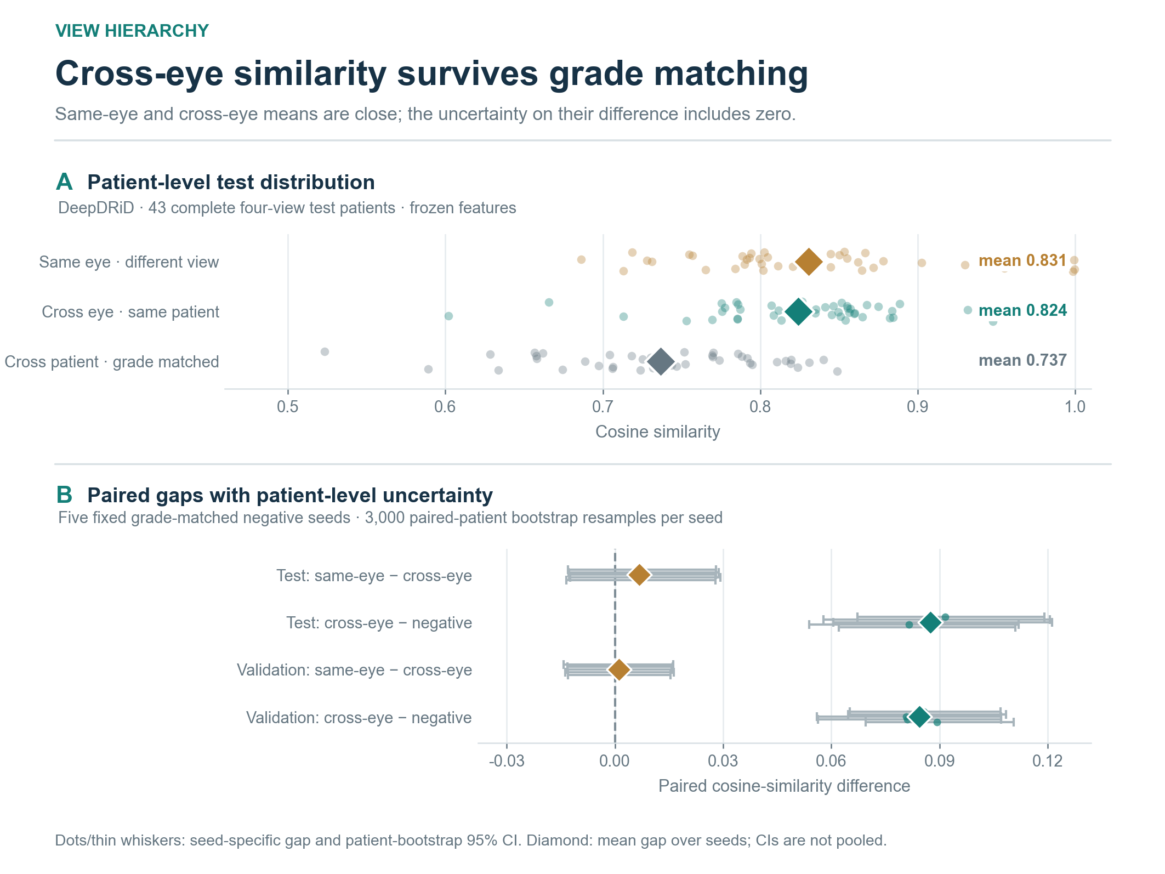
Figure 2. Observed acquisition hierarchy and paired uncertainty under grade-matched negatives. (A) Patient-level test cosine similarities for same-eye different-view, cross-eye same-patient, and grade-matched cross-patient comparisons (43 patients). Cross-patient values are averaged over five fixed assignments within patient; diamonds mark group means. (B) Test and validation contrasts. Thin intervals are five separate 95% paired-patient bootstrap intervals (3,000 resamples per seed); diamonds are across-seed mean differences without a pooled interval. Image quality is not controlled in this panel.
Among 43 strict four-view DeepDRiD test patients, mean cosine similarity was 0.8308 for same-eye repeat views, 0.8241 for cross-eye same-patient views, and 0.7366 for DR-grade-matched cross-patient views (Figure 2A). The test mean same-eye minus cross-eye gap was 0.0067, and every seedwise patient-bootstrap 95% interval included zero. The cross-eye minus matched-negative gap was 0.0875; every seedwise interval excluded zero in the positive direction (Figure 2B). The 45-patient validation subset showed the same qualitative pattern: 0.8385, 0.8374, and 0.7529, with a 0.0011 unresolved same-eye–cross-eye gap and a 0.0844 positive cross-eye–negative gap. The evidence supports cross-eye correspondence beyond DR-grade matching; it does not establish that same-eye agreement is detectably stronger than cross-eye agreement.

4.2. Conditional correspondence under disease and quality matching
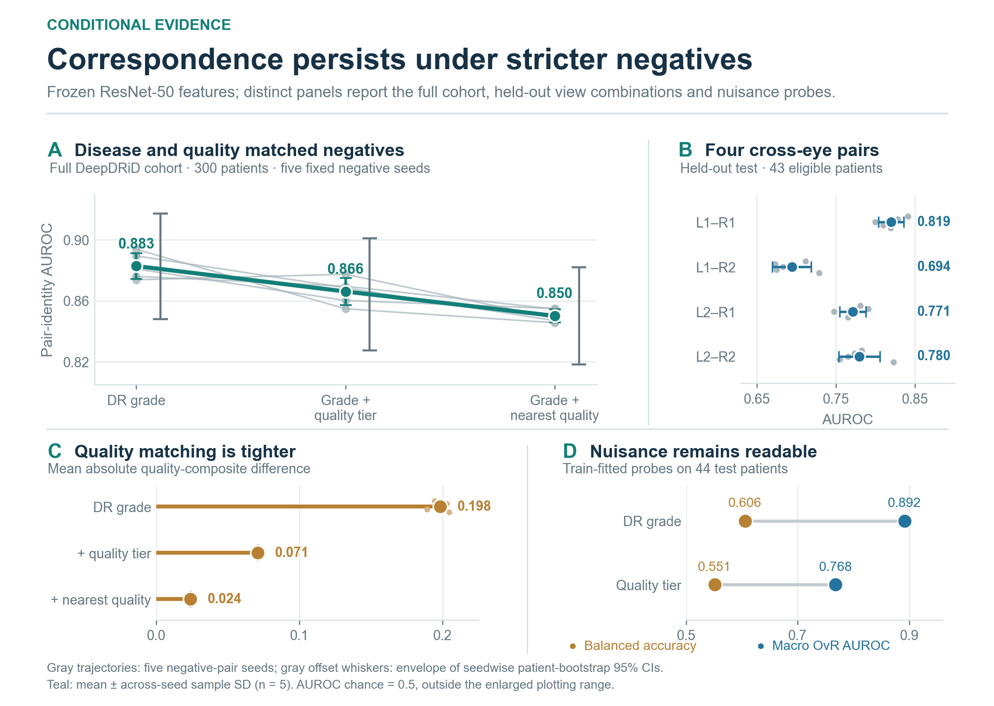
Figure 3. DeepDRiD pair correspondence under progressively stricter negative-patient controls. (A) Full-cohort diagnostic (300 patients). Teal points and whiskers are mean ± across-seed sample SD; offset gray whiskers are the conservative envelope of five separately bootstrapped 95% intervals, not a pooled interval. The enlarged AUROC axis does not show chance level 0.5. (B) Four left–right view combinations in the held-out strict test subset (43 patients), with DR-grade-matched negatives. (C) Mean absolute source–negative difference in the dimensionless quality composite; lower is tighter matching. (D) Train-fitted metadata probes evaluated on 44 test patients. Probe success denotes readable metadata, not causal leakage.
On the 300-patient full-cohort diagnostic, grade-matched negatives yielded pair-identity AUROC 0.8827 ± 0.0086 over five seeds. Exact grade × quality-tier matching reduced it to 0.8660 ± 0.0088, and nearest measured quality within grade reduced it to 0.8500 ± 0.0044 (Figure 3A). The corresponding conservative envelopes of separate patient-bootstrap AUROC intervals were [0.8479, 0.9173], [0.8275, 0.9010], and [0.8181, 0.8818]. Each lower endpoint remains above chance. The lower AUROC under tighter matching in this full-cohort diagnostic is consistent with an observable-quality shortcut, but changing the negative-pair distribution does not isolate a causal quality effect. The full-cohort analysis is a measurement diagnostic, not a held-out score for a fitted predictor.
On the same 42 eligible held-out test patients, the post-hoc raw-feature audit gave grade-matched AUROC 0.8549 ± 0.0173, grade × quality-tier-matched AUROC 0.8348 ± 0.0150, and grade-exact nearest-quality AUROC 0.8731 ± 0.0051 across five assignments. The respective envelopes of five conditional paired-patient bootstrap intervals were [0.7540, 0.9478], [0.7392, 0.9280], and [0.7965, 0.9456]. All three lower endpoints exceed 0.5, but the nearest-quality point estimate is highest rather than lowest. Thus the attenuation sequence in the 300-patient diagnostic is not a stable ordering in this small held-out subset; no between-rule significance or causal attribution is claimed.
Four held-out test view combinations gave grade-matched AUROC 0.8195 ± 0.0143 (L1–R1), 0.6943 ± 0.0220 (L1–R2), 0.7711 ± 0.0147 (L2–R1), and 0.7798 ± 0.0233 (L2–R2; Figure 3B). A single favorable view pairing therefore does not account for all correspondence, although acquisition choice materially changes its magnitude. Quality-composite source–negative differences fell across the three matching rules (Figure 3C). On held-out test patients, the train-fitted DR-grade probe reached balanced accuracy 0.6056 and macro one-versus-rest AUROC 0.8916; the quality-tier probe reached 0.5509 and 0.7677 (Figure 3D). These probe readouts warn against treating the frozen features as disease- or quality-free.
Table 2. Full-cohort conditional-control diagnostic (300 patients). Values are from five negative assignments. The envelope spans the minimum lower and maximum upper endpoints of separate 95% paired-patient bootstrap intervals; it is not itself a pooled 95% confidence interval. Lower quality difference denotes tighter matching.
DeepDRiD negative assignment | AUROC, mean ± seed SD | Conservative bootstrap envelope | Mean absolute quality-composite difference
Same DR grade | 0.8827 ± 0.0086 | [0.8479, 0.9173] | 0.1982
Same DR grade × quality tier | 0.8660 ± 0.0088 | [0.8275, 0.9010] | 0.0709
Same DR grade; nearest measured quality | 0.8500 ± 0.0044 | [0.8181, 0.8818] | 0.0240

4.3. A frozen external baseline transfers; the learned candidate does not pass its stress gate
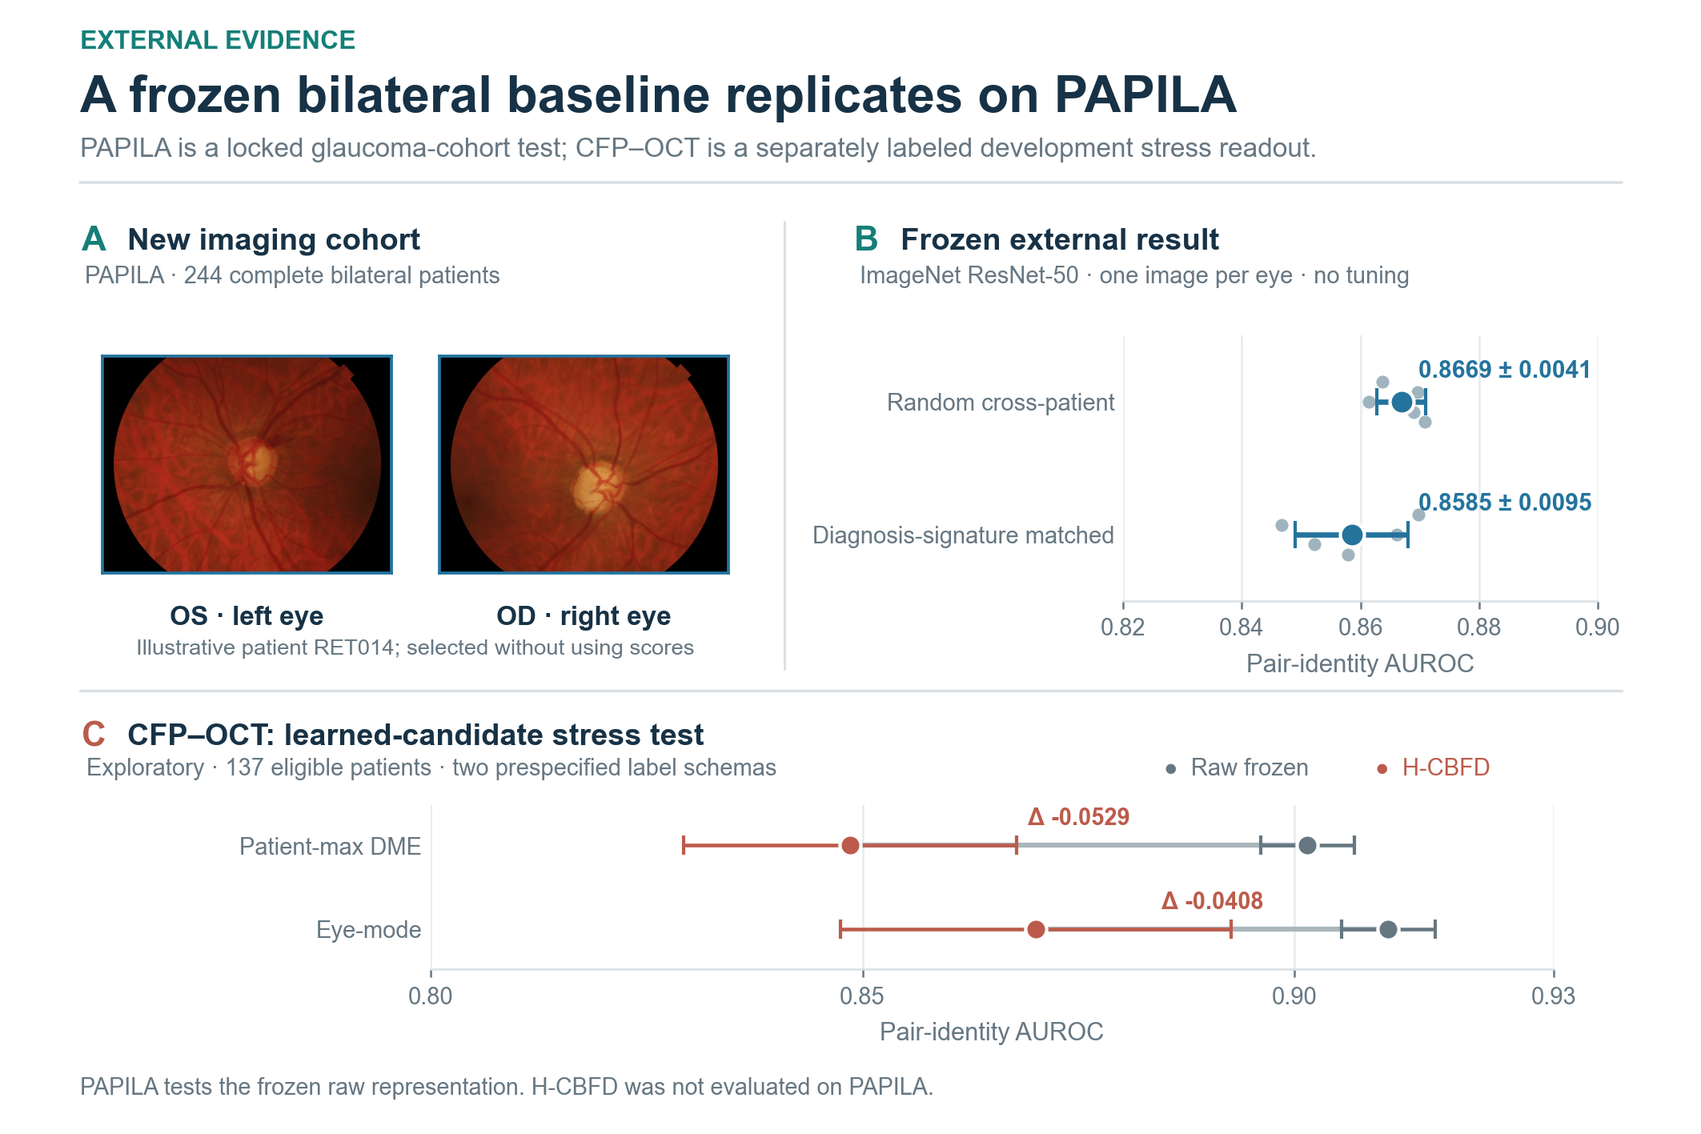
Figure 4. Frozen external baseline and learned-candidate transfer boundary. (A) Unmodified PAPILA left (OS) and right (OD) photographs from illustrative patient RET014, selected by identifier rather than score. (B) Pair-identity AUROC for raw fixed ImageNet-pretrained ResNet-50 features on 244 complete PAPILA patients under random and exact ordered bilateral glaucoma-diagnosis-signature-matched cross-patient negatives. Five dots represent fixed negative assignments; whiskers show across-seed sample SD. PAPILA was not used for tuning. (C) Candidate-versus-raw comparison on 137 previously inspected CFP–OCT development patients under patient-max and legacy eye-mode DME-matched protocols. Points and horizontal whiskers in panel C denote mean ± across-seed sample SD for each estimator and label schema; the connector indicates the within-schema difference, not a confidence interval. H-CBFD was not evaluated on PAPILA.
On PAPILA's 244 complete bilateral patients, the untouched frozen baseline reached pair-identity AUROC 0.8669 ± 0.0041 against random cross-patient negatives and 0.8585 ± 0.0095 against exact ordered bilateral glaucoma-diagnosis-signature-matched negatives (Figure 4A–B). A post-hoc paired-patient bootstrap audit gave conditional interval envelopes [0.8309, 0.8985] and [0.8157, 0.8983], respectively, across the five archived assignments. These are not pooled 95% confidence intervals and do not include rematching uncertainty. This is external replication of the raw-feature correspondence measurement under a new cohort and label system, not external validation of the DeepDRiD-trained H-CBFD candidate.
The selected H-CBFD candidate passed an internal DeepDRiD conditional screen (validation joint grade × quality AUROC 0.8816 ± 0.0174, versus raw 0.8425 ± 0.0118 on the same 42 eligible validation patients). After train-plus-validation refitting, its strict four-view test AUROC was 0.8579 ± 0.0325 versus raw 0.7842 ± 0.0106 on the same 41 eligible patients; this supports an internal conditional gain, not transportability. On the already-inspected CFP–OCT development cohort, however, it scored 0.8485 versus raw 0.9015 under the patient-max DME schema and 0.8701 versus raw 0.9108 under the legacy eye-mode schema (Figure 4C). The approximately 0.053 and 0.041 AUROC deficits fail the external-preservation criterion. We retain this negative result rather than presenting internal improvement as evidence of a transferable learned representation.
Table 3. Estimator- and cohort-specific transfer boundary. All entries are pair-identity AUROC. The DeepDRiD test row compares methods on the same 41-patient strict four-view eligible subset; it is distinct from the 42-patient raw-feature audit. CFP–OCT is not blind external validation, and PAPILA does not validate H-CBFD. PAPILA's random-negative raw baseline was 0.8669 ± 0.0041; its matched conditional bootstrap envelope was [0.8157, 0.8983].
Cohort and protocol | Frozen raw ResNet-50 | H-CBFD | Evidence role
DeepDRiD validation, joint grade × quality | 0.8425 ± 0.0118 | 0.8816 ± 0.0174 | Source-domain model selection on same eligible patients
DeepDRiD test, joint grade × quality (n = 41) | 0.7842 ± 0.0106 | 0.8579 ± 0.0325 | Internal held-out readout after train + validation refit
CFP–OCT, patient-max DME | 0.9015 | 0.8485 | Already-inspected development stress set
CFP–OCT, legacy eye-mode DME | 0.9108 | 0.8701 | Label-schema sensitivity in same stress set
PAPILA, exact bilateral diagnosis signature | 0.8585 ± 0.0095 | Not evaluated | Locked frozen-baseline external readout

5. Discussion
The strongest result is narrower than a patient-identity claim. Frozen generic visual features separate same-patient cross-eye pairs from DR-grade-matched negatives in DeepDRiD, and discrimination remains above chance under the tested measured-quality controls, including a small held-out common-denominator audit. PAPILA independently reproduces a frozen-baseline signal when negatives share the same ordered glaucoma-diagnosis signature. These protocols rule out an explanation based solely on the recorded coarse disease labels and tested quality fields. They cannot rule out unmeasured anatomy, age, site, camera, color, or correlated acquisition practice.
The four-view design changes interpretation. An eye-averaged feature obscures whether matching comes from repeat images of one eye or from a relation that spans two eyes. Here, the cross-eye–negative difference is well resolved, while the same-eye–cross-eye increment is not. Reporting the unresolved contrast is more informative than asserting a strict hierarchy from ordered point means. The view-combination range also makes acquisition dependence part of the evaluation rather than a nuisance hidden by averaging.
The negative transfer of H-CBFD is methodologically consequential. Internal conditional gains did not protect the learned head from falling below raw frozen features on the inspected CFP–OCT cohort. PAPILA cannot repair that weakness because it was deliberately reserved for a different estimator. The present contribution is therefore a conditional measurement protocol, source-domain controls, and a clearly delimited external baseline, not a generalizable new factorization model. Future learned methods should be compared on the same frozen pair assignments and tested on a genuinely uninspected bilateral dataset before any cross-domain improvement claim.
The conditional AUROC sequence should be read alongside the quality-distance audit. In the 300-patient descriptive diagnostic, stricter matching reduces a visible source–negative quality discrepancy and makes discrimination harder. The 42-patient held-out audit does not preserve that monotone AUROC ordering. These findings are consistent with sensitivity to the negative-pair distribution, but they do not estimate how much of the original score was caused by quality. The matched groups are different counterfactual pair populations, and their residual unrecorded differences may also change. That is why the results support a robustness statement—above-chance ranking under the tested controls—rather than a decomposition of variance into patient, disease, quality, and camera fractions.
The PAPILA result is informative precisely because its disease label system and acquisition context differ from DeepDRiD's. Matching the ordered left/right glaucoma diagnosis signature prevents a model from succeeding only by spotting an obvious difference in that coarse bilateral label pattern. It does not establish person-specific anatomy, prospective biometric security, or transfer of a learned DeepDRiD head. Also, a single-view-per-eye cohort cannot reproduce the same-eye repeat-view comparison that the four-view source permits. The two datasets therefore replicate an operational cross-eye measurement at different levels of control rather than identical experimental tasks.
From a method-development perspective, H-CBFD argues against optimizing an attractive within-cohort factorization objective and using that gain as a proxy for transportability. The raw ImageNet baseline is a strong comparator here, while the selected hierarchical head lost performance on both CFP–OCT label conventions. Reporting this failure avoids selection on an already-inspected dataset. Any successor model would need a prespecified, patient-disjoint source selection rule and a new external cohort whose labels, images, and pair assignments remain unopened until the model is frozen.

5.1. Limitations
DeepDRiD's strict four-view test subset contains only 43 patients; the joint-matched H-CBFD test subset contains 41, while the separate raw-feature quality-control audit contains 42. The 300-patient full-cohort conditional analysis is descriptive, and the 42-patient audit was added post hoc; neither substitutes for a larger independent cohort. Quality is summarized from four recorded fields and coarse tiers, leaving residual quality and acquisition confounding. The nearest-quality assignment changes the negative population, so between-rule AUROC changes are not causal estimates; their non-monotone ordering on held-out patients emphasizes this limitation. Paired-patient bootstraps condition on each fixed negative assignment and cannot capture all rematching uncertainty or dataset shift. PAPILA is a relatively small single-view-per-eye glaucoma cohort without comparable quality fields; image-reuse rights require final review. CFP–OCT was inspected during development, so its scores are not blind external validation. Only a frozen generic ResNet-50 and one low-capacity learned candidate were assessed; retina-specific encoders, prospective matching, subgroup fairness, privacy risk, and clinical outcomes remain untested.

6. Conclusion
This patient-level evaluation finds bilateral fundus correspondence beyond the recorded disease and quality variables under specified negative-pair rules, including a locked PAPILA readout of the frozen baseline. The direction of AUROC change between matching rules is cohort-dependent, and the evidence does not identify a disease-independent biological factor. H-CBFD improved an internal held-out readout but did not preserve the raw-feature baseline on the inspected development stress cohort. The protocol and its eligibility, assignment, and uncertainty boundaries should govern subsequent method comparisons.

Declarations and reproducibility status
Data availability. DeepDRiD [10] and PAPILA [11] are available from their cited official sources; CFP–OCT is available from the source repository cited in [24].
Project materials. The PAPILA evaluation used an audited Kaggle distribution copy of the official dataset, not a separate cohort. Analysis scripts, frozen protocols, identity-free figure inputs, aggregate result reports, and editable figure sources are publicly available at https://github.com/kobayashi0512/bilateral-shared-signal. Full source archives, patient-level manifests and split assignments, clinical tables, feature caches, and model checkpoints are not redistributed. Selected illustrative source photographs are embedded in Figures 1 and 4 under their respective dataset terms.
Ethics statement. This retrospective computational study used publicly released retinal image datasets for secondary analysis. No participants were recruited, no intervention or new image acquisition was performed, and the authors did not access directly identifying patient information. The original DeepDRiD and PAPILA publications describe their ethics-approval and informed-consent procedures [10,11].
Author contributions (CRediT). K.D. (Kaiwen Deng): Conceptualization, Methodology, Software, Investigation, Data Curation, Formal Analysis, Validation, Visualization, and Writing—Original Draft. L.L. (Liwei Liu): Supervision, Project Administration, Resources, and Writing—Review & Editing.
Funding. This work was supported by the Fundamental Research Funds for the Provincial Universities of Liaoning under Grant No. LJ212410150016.
Conflicts of interest. The authors declare that they have no known competing financial interests or personal relationships that could have influenced the work reported in this paper.
AI assistance. This working draft and figure integration were assisted by an AI writing tool. The authors must verify every scientific claim, numerical value, citation, figure permission, and the target venue's disclosure requirements.

References
[1] Gulshan V, Peng L, Coram M, Stumpe MC, Wu D, Narayanaswamy A, et al. Development and Validation of a Deep Learning Algorithm for Detection of Diabetic Retinopathy in Retinal Fundus Photographs. JAMA. 2016;316(22):2402–2410. doi:10.1001/jama.2016.17216.
[2] Ting DSW, Cheung CY-L, Lim G, Tan GSW, Quang ND, Gan A, et al. Development and Validation of a Deep Learning System for Diabetic Retinopathy and Related Eye Diseases Using Retinal Images From Multiethnic Populations With Diabetes. JAMA. 2017;318(22):2211–2223. doi:10.1001/jama.2017.18152.
[3] Biswas S, Rohdin J, Drahansky M. Interretinal Symmetry in Color Fundus Photographs. Proceedings of the Annual International Conference of the IEEE Engineering in Medicine and Biology Society. 2020:1980–1983. doi:10.1109/EMBC44109.2020.9175444.
[4] Nguyen TD, Le D-T, Bum J, Kim S, Song SJ, Choo H. Self-FI: Self-Supervised Learning for Disease Diagnosis in Fundus Images. Bioengineering. 2023;10(9):1089. doi:10.3390/bioengineering10091089.
[5] Xie Z, Zhang T, Kim S, Lu J, Zhang W, Lin C-H, et al. iGWAS: Image-based genome-wide association of self-supervised deep phenotyping of retina fundus images. PLOS Genetics. 2024;20(5):e1011273. doi:10.1371/journal.pgen.1011273.
[6] Geirhos R, Jacobsen J-H, Michaelis C, Zemel R, Brendel W, Bethge M, et al. Shortcut learning in deep neural networks. Nature Machine Intelligence. 2020;2:665–673. doi:10.1038/s42256-020-00257-z.
[7] Fu H, Wang B, Shen J, Cui S, Xu Y, Liu J, et al. Evaluation of Retinal Image Quality Assessment Networks in Different Color-Spaces. In: Medical Image Computing and Computer Assisted Intervention – MICCAI 2019. Lecture Notes in Computer Science. 2019;11764:48–56. doi:10.1007/978-3-030-32239-7_6.
[8] Dai L, Wu L, Li H, Cai C, Wu Q, Kong H, et al. A deep learning system for detecting diabetic retinopathy across the disease spectrum. Nature Communications. 2021;12:3242. doi:10.1038/s41467-021-23458-5.
[9] Poplin R, Varadarajan AV, Blumer K, Liu Y, McConnell MV, Corrado GS, et al. Prediction of cardiovascular risk factors from retinal fundus photographs via deep learning. Nature Biomedical Engineering. 2018;2(3):158–164. doi:10.1038/s41551-018-0195-0.
[10] Liu R, Wang X, Wu Q, Dai L, Fang X, Yan T, et al. DeepDRiD: Diabetic Retinopathy—Grading and Image Quality Estimation Challenge. Patterns. 2022;3(6):100512. doi:10.1016/j.patter.2022.100512.
[11] Kovalyk O, Morales-Sánchez J, Verdú-Monedero R, Sellés-Navarro I, Palazón-Cabanes A, Sancho-Gómez J-L. PAPILA: Dataset with fundus images and clinical data of both eyes of the same patient for glaucoma assessment. Scientific Data. 2022;9(1):291. doi:10.1038/s41597-022-01388-1. Official dataset: Figshare doi:10.6084/m9.figshare.14798004.v1.
[12] Figueiredo IN, Moura S, Neves JS, Pinto L, Kumar S, Oliveira CM, et al. Automated retina identification based on multiscale elastic registration. Computers in Biology and Medicine. 2016;79:130–143. doi:10.1016/j.compbiomed.2016.09.019.
[13] Biswas S, Rohdin J, Kavetskyi A, Alves Saraiva G, Biswas A, Drahanský M. Investigation of Bilateral Similarity in Central Retinal Blood Vessels. IEEE Access. 2021;9:63012–63028. doi:10.1109/ACCESS.2021.3074514.
[14] Tian Y, Ji K, Zhang R, Jiang Y, Li C, Wang X, et al. Towards All-in-One Medical Image Re-Identification. Proceedings of the IEEE/CVF Conference on Computer Vision and Pattern Recognition. 2025:30774–30786. https://openaccess.thecvf.com/content/CVPR2025/html/Tian_Towards_All-in-One_Medical_Image_Re-Identification_CVPR_2025_paper.html.
[15] Peng Y, Dharssi S, Chen Q, Keenan TD, Agrón E, Wong WT, et al. DeepSeeNet: A Deep Learning Model for Automated Classification of Patient-based Age-related Macular Degeneration Severity from Color Fundus Photographs. Ophthalmology. 2019;126(4):565–575. doi:10.1016/j.ophtha.2018.11.015.
[16] He J, Li C, Ye J, Qiao Y, Gu L. Multi-label ocular disease classification with a dense correlation deep neural network. Biomedical Signal Processing and Control. 2021;63:102167. doi:10.1016/j.bspc.2020.102167.
[17] Ou X, Gao L, Quan X, Zhang H, Yang J, Li W. BFENet: A two-stream interaction CNN method for multi-label ophthalmic diseases classification with bilateral fundus images. Computer Methods and Programs in Biomedicine. 2022;219:106739. doi:10.1016/j.cmpb.2022.106739.
[18] Kovalyk-Borodyak O, Morales-Sánchez J, Verdú-Monedero R, Sancho-Gómez JL. Glaucoma detection: Binocular approach and clinical data in machine learning. Artificial Intelligence in Medicine. 2025;160:103050. doi:10.1016/j.artmed.2024.103050.
[19] Zhou Y, Wang Q, Zhong H, Chen G, Xiao L, Wang M. A novel bilateral cross-attention network for multi-label fundus disease diagnosis. Computers in Biology and Medicine. 2026;213:111818. doi:10.1016/j.compbiomed.2026.111818.
[20] Zhou Y, Chia MA, Wagner SK, Ayhan MS, Williamson DJ, Struyven RR, et al. A foundation model for generalizable disease detection from retinal images. Nature. 2023;622:156–163. doi:10.1038/s41586-023-06555-x.
[21] Ke G, Wang B, Wang X, He S. Rethinking Multi-view Representation Learning via Distilled Disentangling. Proceedings of the IEEE/CVF Conference on Computer Vision and Pattern Recognition. 2024:26774–26783. https://openaccess.thecvf.com/content/CVPR2024/html/Ke_Rethinking_Multi-view_Representation_Learning_via_Distilled_Disentangling_CVPR_2024_paper.html.
[22] He K, Zhang X, Ren S, Sun J. Deep Residual Learning for Image Recognition. Proceedings of the IEEE Conference on Computer Vision and Pattern Recognition. 2016:770–778. https://openaccess.thecvf.com/content_cvpr_2016/html/He_Deep_Residual_Learning_CVPR_2016_paper.html.
[23] PyTorch Vision. ResNet-50 IMAGENET1K_V2 weight and transform documentation. PyTorch Documentation. https://docs.pytorch.org/vision/0.14/models/generated/torchvision.models.resnet50.html. Accessed 28 September 2026.
[24] Hughes-Cano JA, Quiroz-Mercado H, Hernández-Zimbrón LF, García-Franco R, Rubio Mijangos JF, López-Star E, et al. Improved predictive diagnosis of diabetic macular edema based on hybrid models: An observational study. Computers in Biology and Medicine. 2024;170:107979. doi:10.1016/j.compbiomed.2024.107979.

