Evaluating Same-Patient Matching Between Left- and Right-Eye Fundus Images Under Disease and Image-Quality Controls
Kaiwen Deng¹, Liwei Liu^{1,*}
¹ School of Railway Intelligent Engineering, Dalian Jiaotong University, Dalian, 116028, China
kobayashi20020512@gmail.com (K.D.)
* Correspondence: liutree80@163.com (L.L.)

Abstract
Left- and right-eye fundus images may resemble each other because of shared disease or acquisition conditions, leaving the meaning of a high matching score unclear. We evaluate cross-eye correspondence by comparing same-patient pairs with cross-patient pairs under disease matching and image quality controls. Frozen features from an ImageNet-pretrained 50-layer residual network are tested in 300 patients from DeepDRiD, a retinal dataset with two photographs per eye and patient-disjoint splits. Uncertainty is estimated using patient-level bootstrap resampling. In a post-hoc 34-patient test subset, matching ordered bilateral diabetic retinopathy grades and right-eye quality yields an area under the receiver operating characteristic curve (AUROC) of 0.861, with a patient-level interval envelope of 0.681–0.995. A separate 33-patient four-view analysis shows higher cross-eye similarity than matched-negative similarity; the same-eye–cross-eye difference has an interval spanning zero. In external validation with 244 patients from the PAPILA glaucoma dataset, the frozen baseline yields AUROC 0.859 under bilateral diagnosis matching (interval envelope, 0.804–0.907). A learned hierarchical head improves DeepDRiD validation AUROC from 0.843 to 0.882 but underperforms frozen features in a previously inspected 137-patient fundus–optical coherence tomography cohort (0.849 versus 0.902). These findings support controlled cross-eye correspondence across cohorts and a patient-level protocol for evaluating bilateral representations.
Keywords: fundus images; cross-eye correspondence; disease matching; image quality; external validation

1. Introduction
Deep-learning studies of retinal photographs usually classify disease from individual images [1, 2]. Bilateral images pose a complementary question: can a photograph of one eye be matched to its fellow eye among photographs from other patients? We define cross-eye correspondence as ranking the same patient's fellow-eye photograph above photographs from other patients, given one eye as the query. Repeated photographs of the same eye provide a reference for comparing this correspondence with consistency across acquisitions.
Interretinal verification and bilateral-image studies have examined cross-eye information for subject verification, self-supervised learning, and retinal-phenotype analysis [3–6]. A high pair score, however, may reflect disease grade, image quality, field of view, acquisition conditions, or other patient attributes shared by the images [7–10]. Matching cross-patient negatives on recorded disease and quality controls these measured cues in the comparison. This requires bilateral images, repeat views, and relevant annotations. To support these comparisons, we use DeepDRiD, a retinal-image dataset developed for diabetic retinopathy (DR) grading and image-quality assessment [11]. Its two photographs per eye and clinical and quality annotations support the primary within-cohort evaluation. We construct negatives under progressively stricter matching rules, including a post-hoc control for ordered bilateral DR grades and target-eye quality.
To assess transfer beyond DeepDRiD, we use two additional cohorts. PAPILA, an independent glaucoma dataset, provides one fundus photograph per eye and eye-level diagnoses for 244 patients [12]. It supports external validation of the frozen image-feature baseline with negatives matched on bilateral diagnoses. A separate cohort includes bilateral color fundus photography (CFP) and optical coherence tomography (OCT) data with diabetic macular edema (DME) labels; 137 patients have complete bilateral images [13]. This CFP–OCT cohort supports transfer evaluation of the learned head following exploratory inspection during development.
We test whether same-patient cross-eye scores distinguish paired eyes from cross-patient negatives under disease and measured-quality controls. We compare a fixed ImageNet-pretrained 50-layer residual network (ResNet-50) feature baseline [14, 15] with a low-capacity hierarchical conditional bilateral feature-disentangling head (H-CBFD) that projects features into shared, disease-related, and eye/acquisition branches. The contribution is a controlled evaluation protocol that connects view structure, negative-pair construction, and patient-level uncertainty to within-cohort comparisons and external validation (Figure 1).
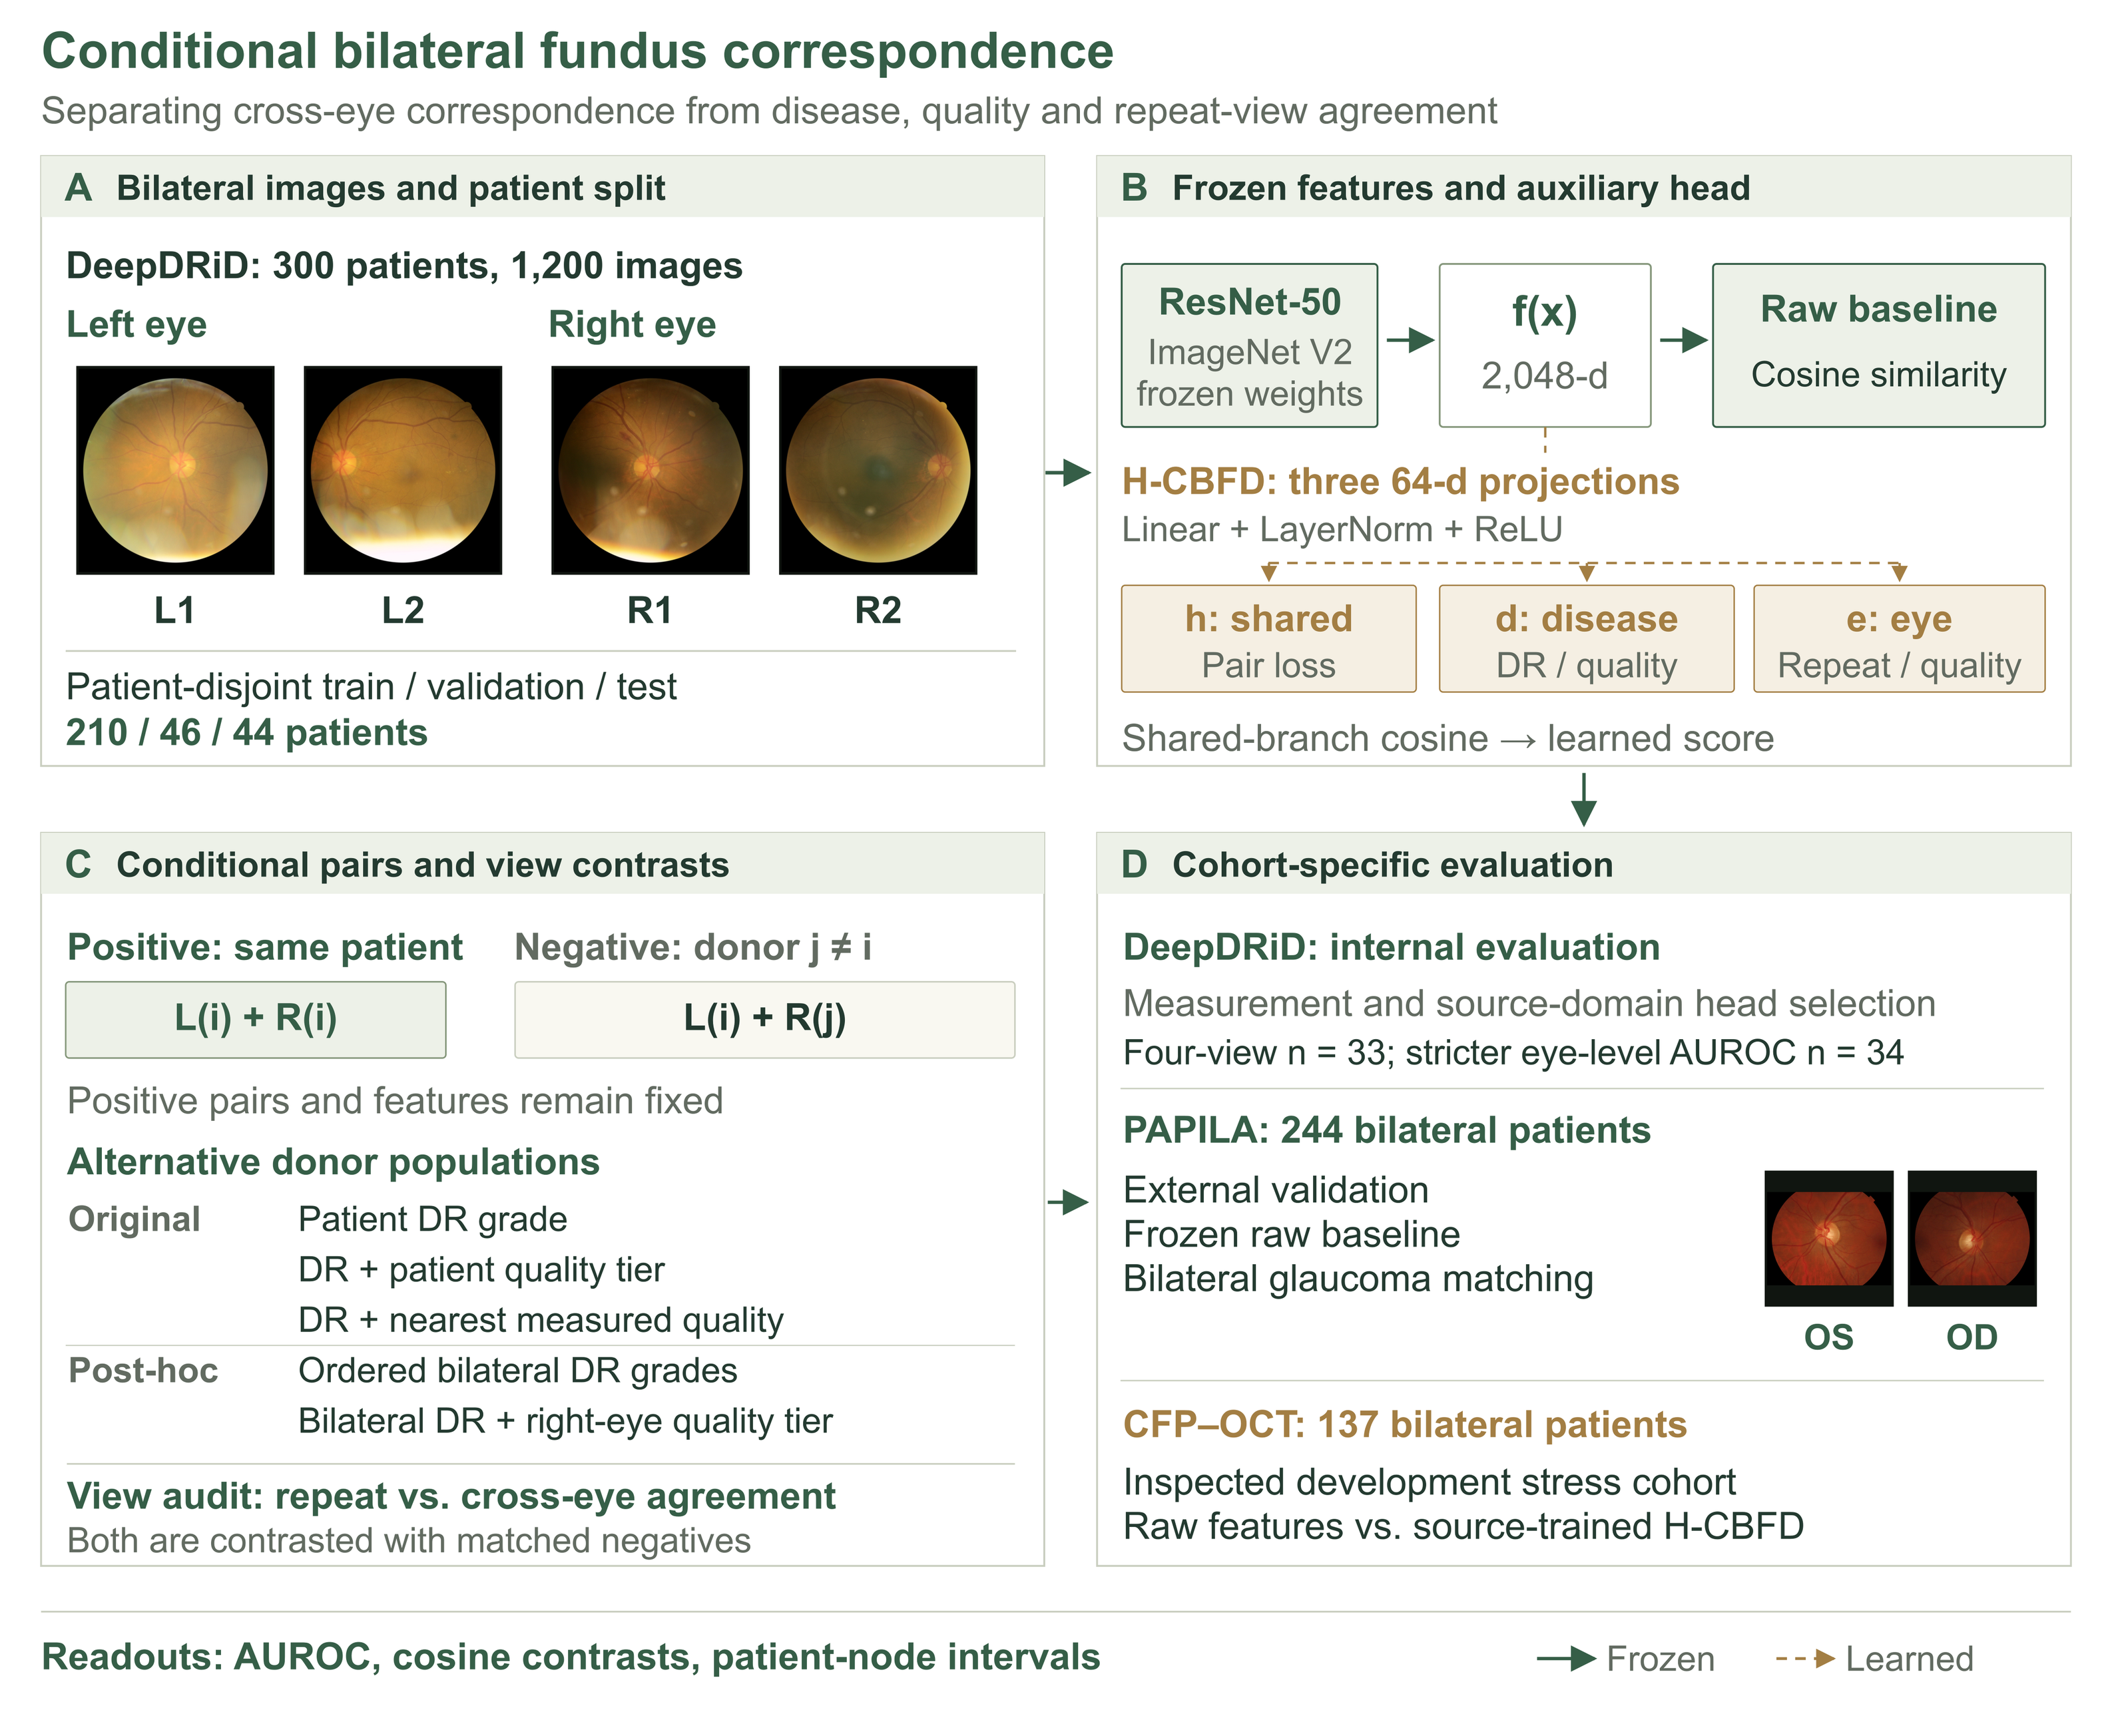
Figure 1. Evaluation framework for bilateral fundus correspondence. (A) Original DeepDRiD images show two views per eye and patient-disjoint splits [11]. (B) A shared frozen ResNet-50 encoder produces 2,048-dimensional features for cosine scoring; the auxiliary H-CBFD head maps features to shared, disease, and eye/acquisition branches. (C) Same-patient cross-eye pairs are compared with donor negatives under disease and quality matching rules, with same-eye repeats as a reference. (D) DeepDRiD supports internal measurement and model selection; PAPILA validates the frozen baseline externally [12]; CFP–OCT evaluates learned transfer during development. PAPILA OS/OD images are illustrative. The area under the receiver operating characteristic curve (AUROC) and cosine contrasts use patient-level uncertainty estimates.

2. Related Work
Retinal matching has been studied through explicit vessel registration, interretinal symmetry, and learned bilateral representations [3, 6, 16]. Self-FI uses fellow-eye images for self-supervised disease representation learning, while an image-based genome-wide association study (iGWAS) uses same-person cross-eye embeddings for genetic analysis [4, 5]. Medical-image re-identification has also been evaluated across imaging modalities [17]. A separate analysis showed that near-identical images can inflate apparent retinal re-identification performance [18]. Our evaluation therefore separates repeat acquisitions from cross-eye pairs and specifies the clinical and quality rules used to select cross-patient negatives.
A separate literature uses both eyes to improve disease classification, including age-related macular degeneration grading, multi-label ocular diagnosis, glaucoma assessment, and fundus-disease classification [19–23]. Those methods combine bilateral information to predict clinical labels. For conditional matching, clinical labels select comparable cross-patient negatives, and performance measures pair discrimination within that matched population.
Retina-specific encoders such as RETFound [24] and common-specific multi-view methods [25] provide alternative representations. We use fixed ImageNet features as the measurement baseline and a low-capacity hierarchical head to test how source-domain optimization affects conditional correspondence after transfer. A fixed pairing protocol makes the two representations directly comparable.

3. Materials and Methods

3.1. Cohorts and eligibility
The primary controlled evaluation includes 300 eligible patients from DeepDRiD, with two photographs per eye and 1,200 images in total [11]. We assign all images from each patient to one of the disjoint training, validation, and test sets of 210, 46, and 44 patients. Eligibility for the strict four-view analysis requires literal L1/L2/R1/R2 identifiers. It includes 45 validation and 43 test patients before matching; exact matching on ordered bilateral DR grades and right-eye quality tier reduces these sets to 35 and 33.
CFP–OCT contributes 137 eligible bilateral patients with DME labels and serves as a transfer stress set following exploratory inspection during development; its two recorded DME schemas are analyzed separately [13]. PAPILA contributes 244 complete bilateral patients, one photograph per eye, and eye-level glaucoma diagnoses [12]. We reserve it for external validation and fix the frozen baseline and negative-pair rules before inspecting its results. Each cohort is analyzed using its own disease labels (Table 1).
Table 1. Cohort size, image structure, and evaluation role. Disease labels and results are analyzed separately for each dataset.
Dataset | Eligible patients | Image structure | Evidence role
DeepDRiD | 300 complete; split 210/46/44 | Two views per eye; strict view subset 45 validation/43 test before exact matching; 35/33 after | Protocol development; descriptive controls; post-hoc patient-level and eye-level sensitivities
CFP–OCT | 137 complete bilateral | Bilateral color fundus photographs | Development-stage transfer evaluation of the learned head
PAPILA | 244 complete bilateral | One explicit left and one right photograph per patient | External validation of the frozen raw baseline
Across cohorts, eligibility requires an unambiguous patient identifier, explicit laterality, and all images required by that cohort's protocol. Every patient's images remain in one split. We obtain PAPILA through a provenance-checked Kaggle distribution copy [12]. Before feature extraction, we verify the archive size, checksum, ZIP integrity, path safety, image availability, and linkage to the official right-eye (OD) and left-eye (OS) clinical tables.

3.2. Frozen representation and pair score
We extract a 2,048-dimensional penultimate feature from each photograph using a fixed ResNet-50, a 50-layer residual network, with the published IMAGENET1K_V2 weights and preprocessing [14, 15]. The ImageNet weights remain frozen, and the same feature extraction is used in every cohort. Let f denote the encoder. For left-eye image Lᵢ and right-eye image Rⱼ, we calculate cosine similarity as follows.
$$s(L_{i},R_{j}) =\frac{{f(L_{i})}^{T}f(R_{j})}{‖f(L_{i})‖_{2}‖f(R_{j})‖_{2}}.$$ | (1)
A pair from the same patient (i = j) is positive; a pair from different patients (i ≠ j) is negative. For each donor assignment, the area under the receiver operating characteristic curve (AUROC) is calculated from one positive and one assigned negative per anchor patient. We use five fixed assignments (seeds 20260922–20260926). Within each eligible matching stratum, a one-to-one derangement assigns each right-eye donor to exactly one different patient. Eligibility for each conditional endpoint requires a cross-patient donor in the same stratum.
PAPILA uses the same frozen encoder and raw-feature cosine score, with no cohort-specific normalization or threshold fitting. AUROC measures discrimination for the specified negative population. Variation across the five assignments measures sensitivity to donor selection, and patient-level intervals estimate sampling uncertainty.

3.3. View comparisons and conditional negatives
The four-view analysis reports three patient-level quantities. Same-eye similarity averages cos(L1,L2) and cos(R1,R2), providing the repeat-acquisition reference. Same-patient cross-eye similarity averages all four Lᵢ–Rⱼ combinations. For matched negatives, we replace each right eye with a donor matched on the ordered bilateral DR-grade signature and right-eye quality tier, then average the same four combinations. The left-eye anchor is fixed in positive and negative comparisons. Their adjacent contrasts test cross-eye correspondence against matched negatives and assess whether repeat views show an additional advantage. We also report each view combination separately.
For the original conditional AUROC analyses, we average each eye's two photograph-level features before calculating cosine similarity. Recorded image-quality fields are combined into a dimensionless composite as follows.
$$q_{i}=\frac{1}{4}(O_{i}+\frac{C_{i}}{10}+\frac{F_{i}}{10}+\frac{10 −A_{i}}{10}).$$ | (2)
The composite uses the recorded overall-quality (O), clarity (C), field-definition (F), and artifact (A) scores. For patient-level controls, each field is averaged across the four photographs. We construct negatives by matching on DR grade alone, on DR grade plus patient quality tier, or on DR grade plus nearest measured quality. Quality tiers are low (qᵢ ≤ 0.625), middle (0.625 < qᵢ ≤ 0.75), and high (qᵢ > 0.75); every joint stratum in the full 300-patient cohort contains at least six patients. Nearest-quality assignment minimizes summed Euclidean distance across the four scaled, direction-aligned fields, subject to one-to-one matching and no self-pairs. A seeded perturbation resolves exact ties without changing DR-grade matches. We report the mean absolute source–negative quality-composite difference to show the remaining measured imbalance.
To control the ordered combination of left- and right-eye DR grades, we add a stricter post-hoc analysis that matches this bilateral signature, with and without the right-eye quality tier. Right-eye quality is averaged across its two photographs and assigned using the same tier boundaries. The fixed left-eye anchor gives positive and negative pairs identical anchor quality. Continuous right-eye quality can still vary within a matched tier.

3.4. Statistical analysis and metadata probes
For each condition, we report the mean and sample standard deviation (SD) across five fixed donor assignments. For each assignment, 3,000 patient-node (pigeonhole) bootstrap resamples estimate sampling uncertainty. Each positive pair receives its patient's resampling multiplicity; each negative pair receives the product of the anchor and donor multiplicities. This weighting preserves dependence when a patient appears in both roles. The four image-level combinations are summarized as one observation per patient.
The interval envelope spans the smallest lower endpoint to the largest upper endpoint across the five separate 95% patient-node intervals. These intervals condition on the original donor assignments and exclude rematching uncertainty. We use the same patient-level procedure for four-view contrasts and common-denominator test audits. For PAPILA, we first reproduce each archived seed-specific AUROC exactly and then calculate the bootstrap intervals.
We use separate probes to measure whether frozen features encode recorded DR grade and image-quality tier. Each is a class-balanced multinomial logistic regression with a standardizer fitted on the 210 training patients and evaluated on the 44 test patients. DR grade and quality tier are separate targets. We report balanced accuracy and macro one-versus-rest AUROC. These probes describe readable attribute information; the conditional-pair analyses test correspondence after matching negatives on those attributes.

3.5. Learned-head design and transfer evaluation
The H-CBFD head keeps the image encoder fixed and maps each 2,048-dimensional feature through three independent projections comprising a linear layer, layer normalization, and a rectified linear unit (ReLU) into 64-dimensional shared (h), disease (d), and eye/acquisition (e) branches. A margin-0.20 loss trains the shared branch to distinguish the mean score across four within-patient cross-eye combinations from negatives matched on DR grade and patient quality tier. The selected no-adversary variant also uses a DR classifier on d, quality-tier classifiers on d and e, same-eye consistency for e, branch-orthogonality penalties, and a variance floor on the shared branch.
The pairing and disease-classification losses each have weight 1.0. Same-eye consistency has weight 0.20; each quality-classification loss, 0.05; the sum of pairwise orthogonality penalties, 0.01; and the shared-branch variance penalty, 0.02. The variance penalty applies when feature standard deviation falls below 0.10 during training. These auxiliary losses shape the branches; conditional correspondence is measured by cosine similarity in the shared branch.
We train with Adam for 24 epochs, batch size 32, learning rate 0.0015, weight decay 0.0001, and five fixed seeds. The training set fits three candidates: a shared-only head, a hierarchical head without adversarial terms, and a hierarchical head with adversarial terms. We select the candidate with the highest mean validation AUROC under joint matching, subject to non-collapse checks, then refit it on training plus validation patients. A retrospective check confirmed that all archived candidates exceeded the branch-wise mean-feature-SD floor of 0.10. Raw features and H-CBFD use the same eligible patients and negative assignments and average scores across the same four cross-eye combinations.
On CFP–OCT, we evaluate the selected head under the patient-max and legacy eye-mode DME schemas and report them separately; the head remains fixed after DeepDRiD selection. On PAPILA, the frozen raw-feature baseline is evaluated against random negatives and donors matched on the ordered left- and right-eye glaucoma diagnoses.

3.6. Analysis scope and reporting conventions
The primary four-view test analysis includes 33 patients; the 35-patient validation analysis is a directional replication. Full-cohort controls are descriptive. The original common-denominator test audit (n = 42) and stricter eye-level audit (n = 34) are post-hoc sensitivity analyses. H-CBFD and raw features are compared on a separate 41-patient test subset under the original joint-matching rule. A view contrast is considered resolved when all five assignment-specific patient-node intervals support the same direction. View combinations, metadata probes, and ancillary transfer comparisons are exploratory and reported without multiplicity adjustment.

4. Results
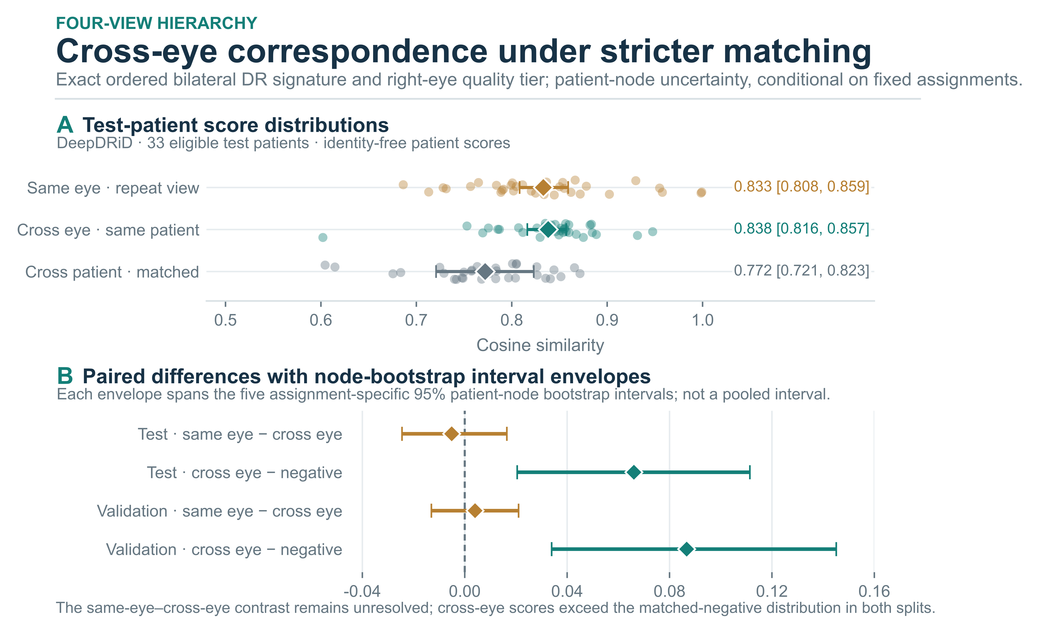
Figure 2. View-level cosine comparisons under matching on ordered bilateral DR grades and right-eye quality tier. (A) Test scores for n = 33; diamonds and colored whiskers show means and 95% patient-node intervals, with the negative interval shown as an envelope across assignments. (B) Adjacent contrasts for validation (n = 35) and test (n = 33). Points show assignment means, and whiskers span the endpoints of their separate patient-node intervals. Intervals condition on fixed assignments. Section 3.3 defines the contrasts.

4.1. Cross-eye agreement exceeds matched negatives
In the strict four-view test subset (n = 33), mean cosine similarity is 0.8331 for same-eye repeats, 0.8382 for same-patient cross-eye pairs, and 0.7721 for matched cross-patient pairs (Figure 2). The cross-eye-minus-negative interval envelope is positive [0.0205, 0.1114]. The same-eye-minus-cross-eye envelope spans zero [−0.0245, 0.0164].
The validation subset shows the same pattern relative to matched negatives (n = 35): mean scores are 0.8447 for same-eye repeats, 0.8407 for cross-eye pairs, and 0.7540 for matched negatives. The cross-eye-minus-negative envelope is positive [0.0339, 0.1451], while the same-eye-minus-cross-eye envelope crosses zero [−0.0130, 0.0210]. Both subsets therefore show higher cross-eye similarity than matched-negative similarity, with uncertainty in the additional contribution of same-eye repetition.

4.2. Disease and quality controls retain correspondence
Across all 300 patients, AUROC is 0.8827 ± 0.0086 with patient-level DR matching, 0.8660 ± 0.0088 after adding patient quality tier, and 0.8500 ± 0.0044 with nearest-quality assignment (Figure 3A; Table 2). All patient-node interval envelopes remain above 0.5. Over the same sequence, the mean absolute source–negative quality-composite difference falls from 0.1982 to 0.0709 and 0.0240. Tighter measured-quality matching therefore changes the negative population, reduces measured imbalance, and lowers the full-cohort AUROC.
The 42-patient test audit shows a different ordering. Patient-grade, grade-by-quality-tier, and nearest-quality matching yield AUROCs of 0.8549 ± 0.0173, 0.8348 ± 0.0150, and 0.8731 ± 0.0051, with interval envelopes [0.7323, 0.9555], [0.6853, 0.9392], and [0.7763, 0.9524], respectively (Figure 3B; Table 2). All exclude 0.5. Nearest-quality matching has the highest test estimate but the lowest full-cohort estimate; the ordering of controls therefore depends on the evaluation subset.
Matching the ordered left/right DR grades controls bilateral disease patterns at the eye level. Across 293 patients, AUROC is 0.8847 ± 0.0089 with ordered-grade matching and 0.8700 ± 0.0052 after adding right-eye quality tier; the mean absolute right-eye quality difference falls from 0.2241 to 0.0808. In the 34-patient test audit, AUROCs are 0.8675 ± 0.0213 and 0.8614 ± 0.0068, with interval envelopes [0.6577, 0.9966] and [0.6814, 0.9947]. Both exclude 0.5. Validation estimates are 0.8946 ± 0.0196 and 0.8776 ± 0.0172 (n = 36). These post-hoc comparisons retain correspondence after matching the recorded bilateral disease pattern and right-eye quality.
Scores also vary by view combination. Under patient-grade matching, test AUROCs are 0.8195 ± 0.0143 for L1–R1, 0.6943 ± 0.0220 for L1–R2, 0.7711 ± 0.0147 for L2–R1, and 0.7798 ± 0.0233 for L2–R2. The test-set metadata probes show that frozen features encode both DR grade (balanced accuracy 0.6056; macro one-versus-rest AUROC 0.8916) and quality tier (0.5509 and 0.7677, respectively; n = 44). These results support matching recorded attributes and reporting acquisition views separately.
Table 2. Conditional AUROC on DeepDRiD. Values are means and sample SDs across five assignments; interval envelopes span the separate 95% patient-node bootstrap intervals. Full-cohort results are descriptive, and test controls are post hoc. Section 3.3 defines the matching rules.
Population / negative-pair rule | n | AUROC (mean ± sample SD) | Patient-node bootstrap interval envelope
Full · same patient DR grade | 300 | 0.8827 ± 0.0086 | [0.8363, 0.9240]
Full · DR grade × patient quality tier | 300 | 0.8660 ± 0.0088 | [0.8140, 0.9094]
Full · DR grade + nearest patient quality | 300 | 0.8500 ± 0.0044 | [0.7989, 0.8952]
Full · exact ordered bilateral DR signature | 293 | 0.8847 ± 0.0089 | [0.8342, 0.9242]
Full · bilateral DR + right-eye quality tier | 293 | 0.8700 ± 0.0052 | [0.8253, 0.9123]
Test · same patient DR grade | 42 | 0.8549 ± 0.0173 | [0.7323, 0.9555]
Test · DR grade × patient quality tier | 42 | 0.8348 ± 0.0150 | [0.6853, 0.9392]
Test · DR grade + nearest patient quality | 42 | 0.8731 ± 0.0051 | [0.7763, 0.9524]
Test · exact ordered bilateral DR signature | 34 | 0.8675 ± 0.0213 | [0.6577, 0.9966]
Test · bilateral DR + right-eye quality tier | 34 | 0.8614 ± 0.0068 | [0.6814, 0.9947]
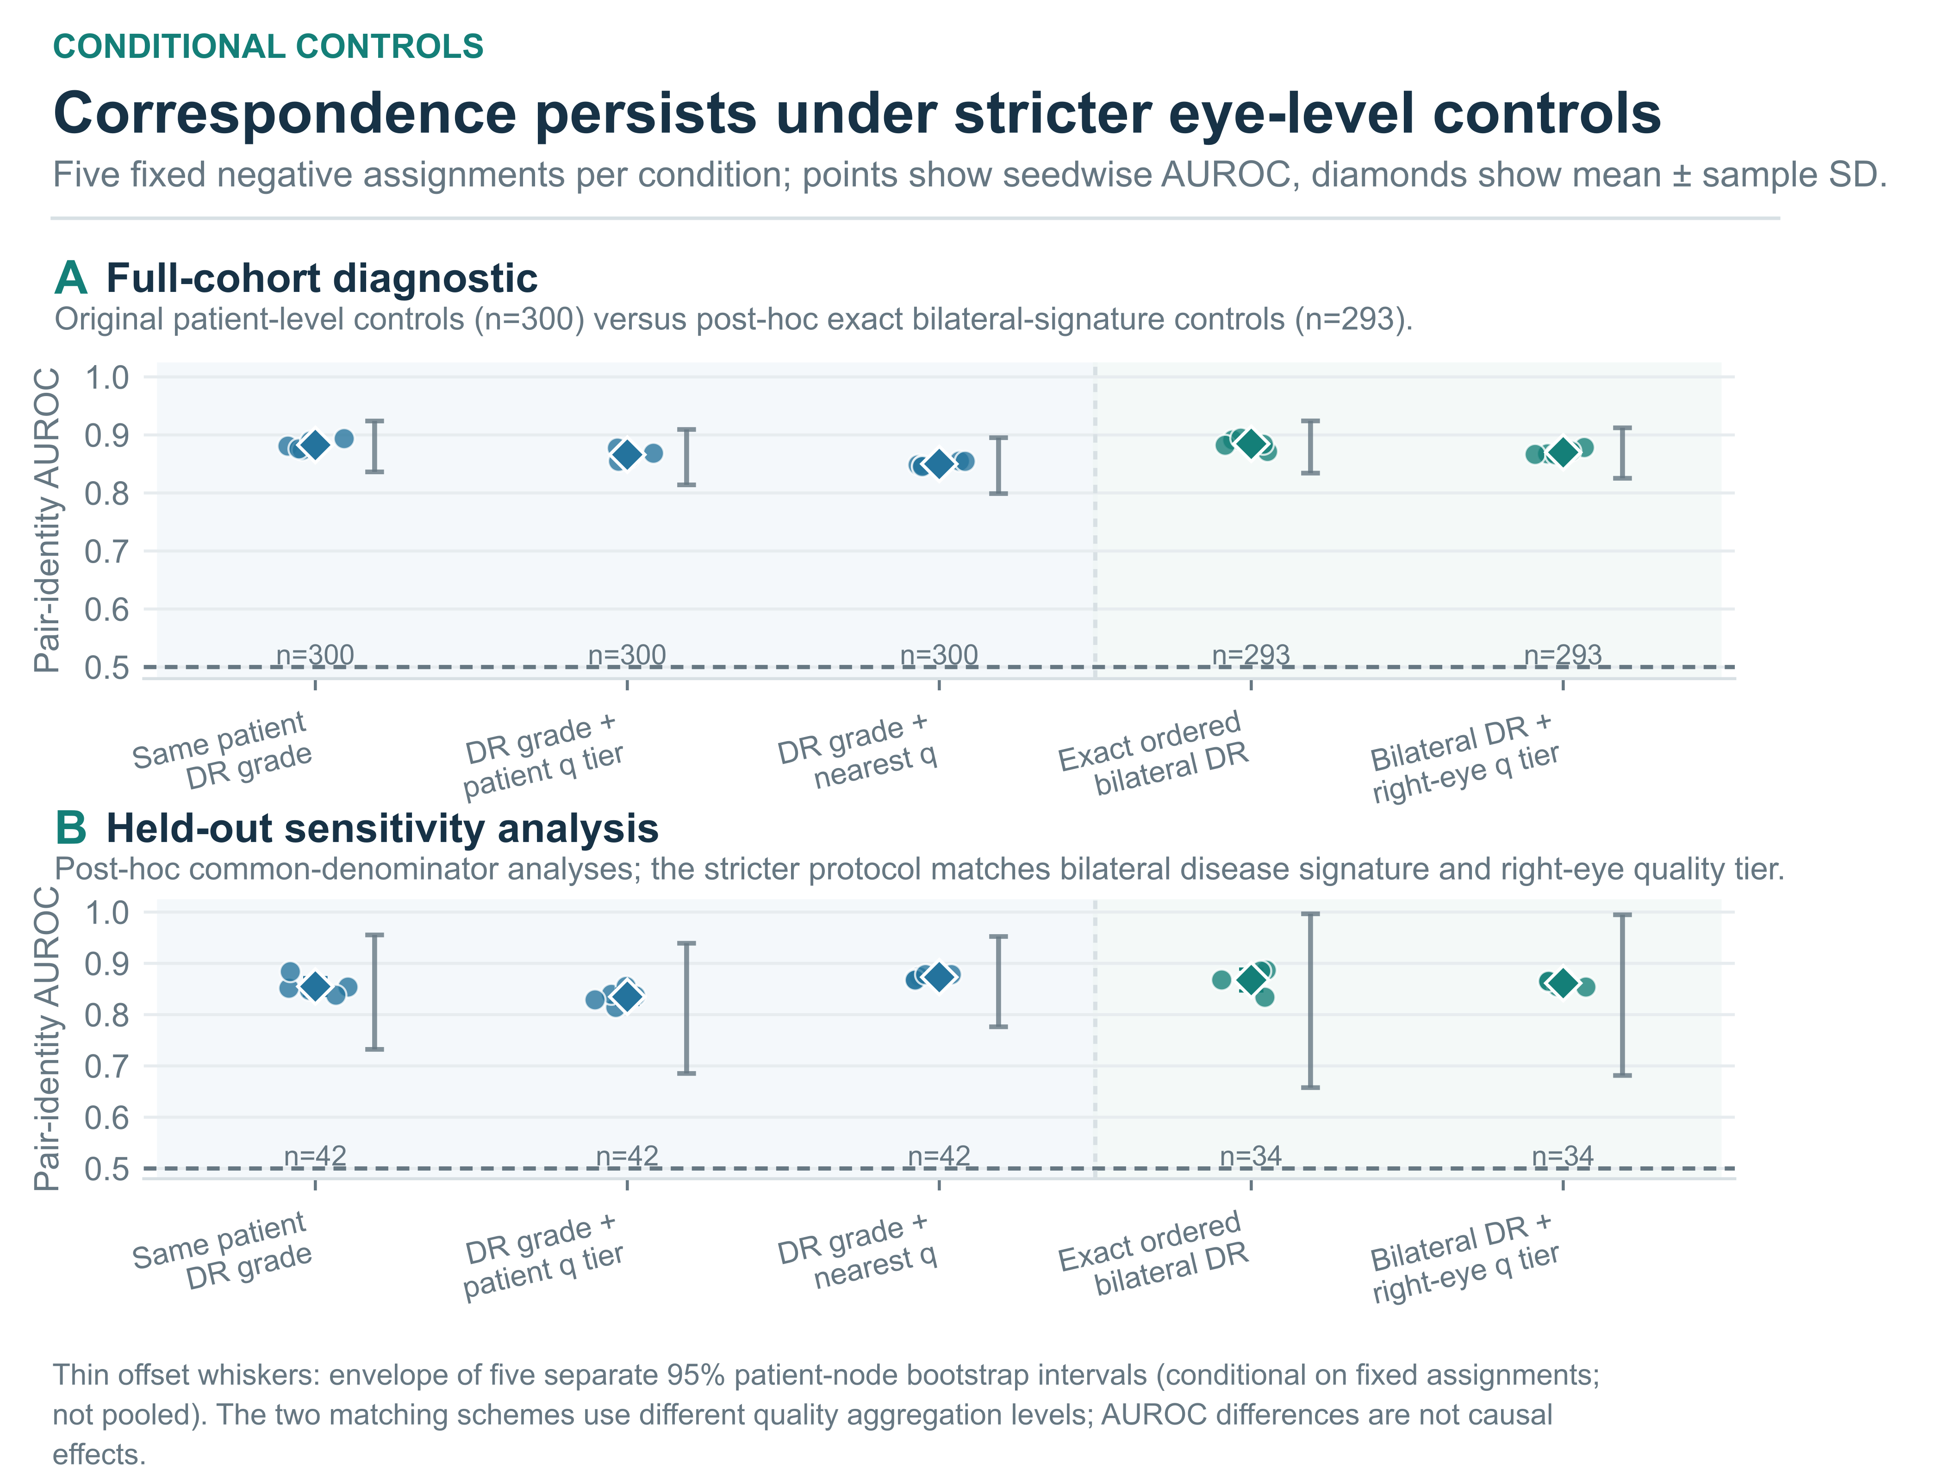
Figure 3. Conditional AUROC under alternative negative-pair rules. (A) Full-cohort controls include 300 patients for the original patient-level rules and 293 for ordered bilateral DR matching. (B) Post-hoc test controls use common denominators of 42 and 34. Colored dots show the five assignment scores; diamonds and bold whiskers show the mean and sample SD. Thin gray whiskers show the envelope of the five separate 95% patient-node intervals. The dashed line marks chance AUROC. Section 3.3 defines patient-level matching and right-eye quality aggregation.

4.3. External baseline validation and learned transfer
On PAPILA, the frozen baseline yields AUROC 0.8669 ± 0.0041 against random negatives and 0.8585 ± 0.0095 against negatives matched on the ordered bilateral glaucoma diagnosis (Figure 4B; Table 3). The corresponding patient-node interval envelopes are [0.8205, 0.9056] and [0.8039, 0.9066], both above 0.5. The frozen features therefore discriminate same-patient pairs from diagnosis-matched pairs in this separate glaucoma cohort.
On DeepDRiD, H-CBFD exceeds raw features on validation: AUROC is 0.8816 ± 0.0195 versus 0.8425 ± 0.0132 (n = 42; Figure 4C; Table 3). After refitting, test AUROC is 0.8579 ± 0.0364 for H-CBFD and 0.7842 ± 0.0118 for raw features on the same 41 patients. Both comparisons use the original joint-matching task and four-view scoring rule.
On the CFP–OCT development-stress cohort, H-CBFD scores below raw features under both DME schemas. With patient-max matching, the scores are 0.8485 ± 0.0193 and 0.9015 ± 0.0054; with the legacy eye-mode schema, they are 0.8701 ± 0.0226 and 0.9108 ± 0.0054. The deficits are approximately 0.053 and 0.041 AUROC, respectively.
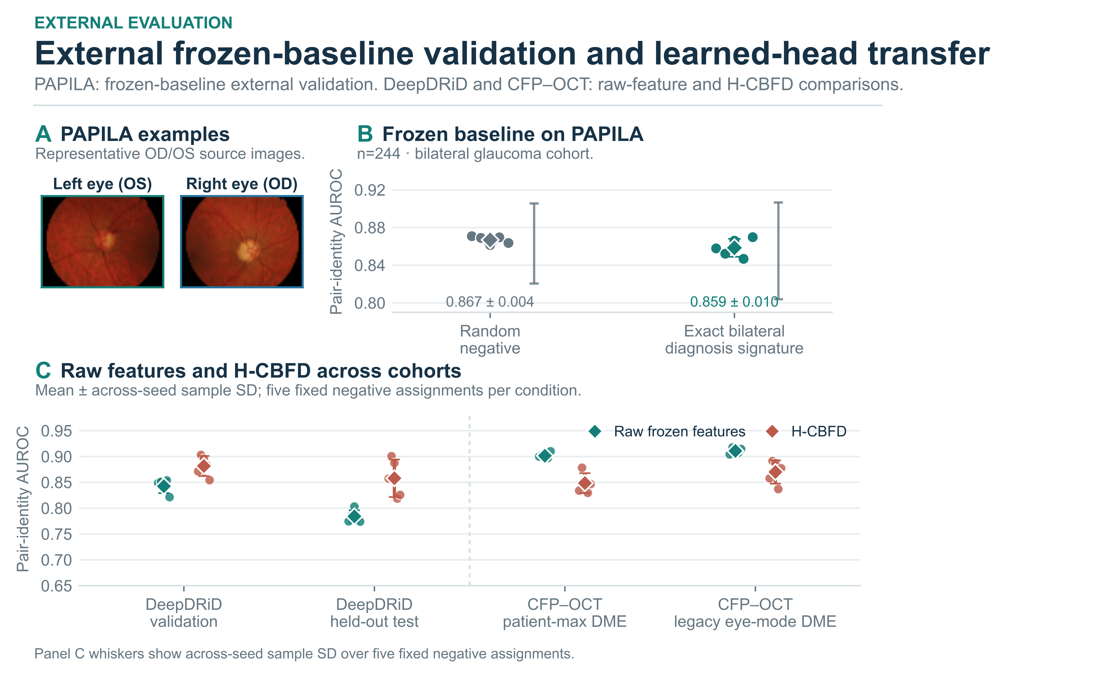
Figure 4. External validation and transfer stress test. (A) PAPILA OS/OD images are shown for illustration. (B) Frozen-baseline AUROC for 244 PAPILA patients. Dots show assignment scores, colored whiskers show the mean and sample SD, and thin gray whiskers show patient-node interval envelopes. (C) Raw features and H-CBFD on DeepDRiD and the CFP–OCT development-stress cohort under both DME schemas. Dots show assignment scores; whiskers show mean ± sample SD across assignments. PAPILA evaluates the frozen baseline; CFP–OCT evaluates learned transfer during development.
Table 3. Frozen-baseline and learned-head results by cohort and protocol. Values are means and sample SDs across five assignments. Comparisons between estimators use the same patients and negatives. CFP–OCT is a development-stress set; PAPILA provides external validation of the frozen baseline.
Cohort and protocol | Frozen raw ResNet-50 | H-CBFD | Evidence role
DeepDRiD validation · patient grade × quality tier (n=42) | 0.8425 ± 0.0132 | 0.8816 ± 0.0195 | Source-domain model selection
DeepDRiD test · patient grade × quality tier (n=41) | 0.7842 ± 0.0118 | 0.8579 ± 0.0364 | Internal test after refitting
CFP–OCT · patient-max DME (n=137) | 0.9015 ± 0.0054 | 0.8485 ± 0.0193 | Development-stage transfer evaluation
CFP–OCT · legacy eye-mode DME (n=137) | 0.9108 ± 0.0054 | 0.8701 ± 0.0226 | Label-schema sensitivity
PAPILA · random negatives (n=244) | 0.8669 ± 0.0041 | Not evaluated | External validation of the frozen baseline
PAPILA · exact bilateral diagnosis signature (n=244) | 0.8585 ± 0.0095 | Not evaluated | External validation of the frozen baseline

5. Discussion
Frozen visual features retain cross-eye correspondence under the tested disease and quality controls. In DeepDRiD, cross-eye similarity exceeds matched negatives in the strict four-view subsets, and the post-hoc eye-level AUROC remains above chance after matching bilateral DR grades and right-eye quality. PAPILA extends the frozen-baseline result to a separate glaucoma cohort using diagnosis-matched negatives.
The four-view analysis identifies higher cross-eye similarity than matched-negative similarity in both validation and test. The same-eye–cross-eye intervals span zero, and individual view combinations produce different AUROCs. Reporting repeat-view, cross-eye, and negative-pair scores separately reveals acquisition-related variation that an eye-averaged score would combine.
Quality matching changes both measured imbalance and AUROC. In the full cohort, closer quality matching narrows the source–negative quality difference and lowers AUROC; in the test audit, nearest-quality matching gives the highest point estimate. Frozen features also retain information about DR grade and quality tier. Reporting quality balance alongside AUROC makes the change in the negative population explicit.
PAPILA broadens the evaluation from DR to glaucoma. The encoder and scoring rule remain fixed while the negative population is constructed from bilateral glaucoma diagnoses. This external validation shows that the same frozen representation supports cross-eye matching under clinical controls specific to a second dataset.
The learned-head results show different outcomes for source-domain performance and transfer. H-CBFD improves DeepDRiD validation AUROC but scores below raw features on the CFP–OCT cohort under both DME schemas. This reversal makes transfer performance a separate criterion for selecting bilateral representations. Future comparisons should fix the patient-level pairing protocol and evaluate the selected model on a cohort reserved until source-domain selection is complete.

6. Limitations
The strict four-view test subset (n = 33) and eye-level sensitivity subset (n = 34) are small; the latter is post hoc and has wide intervals. Larger cohorts would estimate these contrasts more precisely. DR grades and quality tiers are coarse, so residual quality variation and unrecorded age, pigmentation, camera, site, and field-of-view differences may contribute to the observed correspondence.
PAPILA provides one photograph per eye and lacks image-quality fields comparable to DeepDRiD, so its external validation addresses diagnosis-matched correspondence. The representation comparison covers one generic frozen encoder and one low-capacity learned head. Future work can extend the protocol to retina-specific encoders and external cohorts with repeat images and comparable quality annotations, using matching rules specified before model selection.

7. Conclusions
Frozen fundus features distinguish same-patient cross-eye pairs from disease- and quality-matched negatives in DeepDRiD, and PAPILA provides external validation under bilateral glaucoma-diagnosis matching. The four-view analysis separates cross-eye correspondence from repeat-view consistency. H-CBFD improves DeepDRiD validation performance but falls below raw features on the CFP–OCT development-stress cohort. The evaluation protocol connects view structure, negative-pair rules, and patient-level uncertainty to the comparison of bilateral representations across cohorts.

Author Contributions
Conceptualization, K.D.; methodology, K.D.; software, K.D.; investigation, K.D.; data curation, K.D.; formal analysis, K.D.; validation, K.D.; visualization, K.D.; writing—original draft preparation, K.D.; writing—review and editing, L.L.; supervision, L.L.; project administration, L.L.; resources, L.L.

Funding
This work was supported by the Fundamental Research Funds for the Provincial Universities of Liaoning (grant number LJ212410150016).

Institutional Review Board Statement
This study analyzes previously released, de-identified retinal datasets. It involved no new participant recruitment, intervention, or image acquisition, and the authors had no access to directly identifying information. Ethical approvals for the original data collection for DeepDRiD, PAPILA, and CFP–OCT are reported in their source publications [11–13].

Informed Consent Statement
Consent procedures for the original DeepDRiD, PAPILA, and CFP–OCT data collection are described in the source publications [11–13]. The present secondary analysis uses previously released data and involves no participant contact.

Data Availability Statement
DeepDRiD is available from its official repository and Zenodo record [11] (https://github.com/deepdrdoc/DeepDRiD; https://doi.org/10.5281/zenodo.6452623). PAPILA is available from the official Figshare release [12] (https://figshare.com/articles/dataset/PAPILA/14798004). The CFP–OCT cohort is described in [13] and distributed through the dataset authors’ repository (https://github.com/Traslational-Visual-Health-Laboratory/OCT-AND-EYE-FUNDUS-DATASET). Access and reuse must follow the terms specified by each source.
Analysis scripts, frozen protocols, identity-free figure inputs, aggregate reports, and editable figure sources are available at https://github.com/kobayashi0512/bilateral-shared-signal.
The repository includes attributed DeepDRiD and PAPILA examples in the figures. It excludes source archives, patient-level manifests and splits, clinical tables, feature caches, and checkpoints. Full datasets remain available from their original providers under the respective source terms. CFP–OCT photographs are excluded because the source repository does not specify image-reuse permission.

Acknowledgments
We thank the authors and contributors of the source datasets for making their data publicly available.
OpenAI Codex assisted with manuscript drafting and language revision, analysis-script preparation, and figure layout and integration. The authors are responsible for the scientific content, the accuracy of the reported results, and the final manuscript.

Conflicts of Interest
The authors declare no conflicts of interest.

References
[1] Gulshan V, Peng L, Coram M, Stumpe MC, Wu D, Narayanaswamy A, et al. Development and validation of a deep learning algorithm for detection of diabetic retinopathy in retinal fundus photographs. JAMA. 2016;316(22):2402–2410. https://doi.org/10.1001/jama.2016.17216.
[2] Ting DSW, Cheung CY, Lim G, Tan GSW, Quang ND, Gan A, et al. Development and validation of a deep learning system for diabetic retinopathy and related eye diseases using retinal images from multiethnic populations with diabetes. JAMA. 2017;318(22):2211–2223. https://doi.org/10.1001/jama.2017.18152.
[3] Biswas S, Rohdin J, Drahanský M. Interretinal symmetry in color fundus photographs. In: Proceedings of the 42nd Annual International Conference of the IEEE Engineering in Medicine and Biology Society (EMBC). 2020. p. 1980–1983. https://doi.org/10.1109/EMBC44109.2020.9175444.
[4] Nguyen TD, Le DT, Bum J, Kim S, Song SJ, Choo H. Self-FI: Self-supervised learning for disease diagnosis in fundus images. Bioengineering. 2023;10(9):1089. https://doi.org/10.3390/bioengineering10091089.
[5] Xie Z, Zhang T, Kim S, Lu J, Zhang W, Lin CH, et al. iGWAS: Image-based genome-wide association of self-supervised deep phenotyping of retina fundus images. PLOS Genetics. 2024;20(5):e1011273. https://doi.org/10.1371/journal.pgen.1011273.
[6] Biswas S, Rohdin J, Kavetskyi A, Saraiva G, Biswas A, Drahanský M. Investigation of bilateral similarity in central retinal blood vessels. IEEE Access. 2021;9:63012–63028. https://doi.org/10.1109/ACCESS.2021.3074514.
[7] Geirhos R, Jacobsen JH, Michaelis C, Zemel R, Brendel W, Bethge M, et al. Shortcut learning in deep neural networks. Nature Machine Intelligence. 2020;2(11):665–673. https://doi.org/10.1038/s42256-020-00257-z.
[8] Fu H, Wang B, Shen J, Cui S, Xu Y, Liu J, et al. Evaluation of retinal image quality assessment networks in different color-spaces. In: Medical Image Computing and Computer Assisted Intervention – MICCAI 2019. Lecture Notes in Computer Science, vol. 11764. Cham: Springer; 2019. p. 48–56. https://doi.org/10.1007/978-3-030-32239-7_6.
[9] Dai L, Wu L, Li H, Cai C, Wu Q, Kong H, et al. A deep learning system for detecting diabetic retinopathy across the disease spectrum. Nature Communications. 2021;12:3242. https://doi.org/10.1038/s41467-021-23458-5.
[10] Poplin R, Varadarajan AV, Blumer K, Liu Y, McConnell MV, Corrado GS, et al. Prediction of cardiovascular risk factors from retinal fundus photographs via deep learning. Nature Biomedical Engineering. 2018;2(3):158–164. https://doi.org/10.1038/s41551-018-0195-0.
[11] Liu R, Wang X, Wu Q, Dai L, Fang X, Yan T, et al. DeepDRiD: Diabetic retinopathy—Grading and image quality estimation challenge. Patterns. 2022;3(6):100512. https://doi.org/10.1016/j.patter.2022.100512.
[12] Kovalyk O, Morales-Sánchez J, Verdú-Monedero R, Sellés-Navarro I, Palazón-Cabanes A, Sancho-Gómez JL. PAPILA: Dataset with fundus images and clinical data of both eyes of the same patient for glaucoma assessment. Scientific Data. 2022;9:291. https://doi.org/10.1038/s41597-022-01388-1.
[13] Hughes-Cano JA, Quiroz-Mercado H, Hernández-Zimbrón LF, García-Franco R, Rubio Mijangos JF, López-Star E, et al. Improved predictive diagnosis of diabetic macular edema based on hybrid models: An observational study. Computers in Biology and Medicine. 2024;170:107979. https://doi.org/10.1016/j.compbiomed.2024.107979.
[14] He K, Zhang X, Ren S, Sun J. Deep residual learning for image recognition. In: Proceedings of the IEEE Conference on Computer Vision and Pattern Recognition (CVPR). 2016. p. 770–778. https://doi.org/10.1109/CVPR.2016.90.
[15] TorchVision. resnet50. Torchvision 0.20 documentation [Internet]. [cited 2026 Oct 12]. Available from: https:/​/​docs.pytorch.org/​vision/​0.20/​models/​generated/​torchvision.models.resnet50.html.
[16] Figueiredo IN, Moura S, Neves JS, Pinto L, Kumar S, Oliveira CM, et al. Automated retina identification based on multiscale elastic registration. Computers in Biology and Medicine. 2016;79:130–143. https://doi.org/10.1016/j.compbiomed.2016.09.019.
[17] Tian Y, Ji K, Zhang R, Jiang Y, Li C, Wang X, et al. Towards all-in-one medical image re-identification. In: Proceedings of the IEEE/CVF Conference on Computer Vision and Pattern Recognition (CVPR). 2025. p. 30774–30786. https://doi.org/10.1109/CVPR52734.2025.02866.
[18] Engelmann J, Wagner SK, Zhou Y, Keane PA. Matters Arising: Near-identical images, not foundation models, explain purported re-identification of patients from medical imaging. npj Digital Medicine. 2026;9:159. https://doi.org/10.1038/s41746-026-02440-9.
[19] Peng Y, Dharssi S, Chen Q, Keenan TD, Agrón E, Wong WT, et al. DeepSeeNet: A deep learning model for automated classification of patient-based age-related macular degeneration severity from color fundus photographs. Ophthalmology. 2019;126(4):565–575. https://doi.org/10.1016/j.ophtha.2018.11.015.
[20] He J, Li C, Ye J, Qiao Y, Gu L. Multi-label ocular disease classification with a dense correlation deep neural network. Biomedical Signal Processing and Control. 2021;63:102167. https://doi.org/10.1016/j.bspc.2020.102167.
[21] Ou X, Gao L, Quan X, Zhang H, Yang J, Li W. BFENet: A two-stream interaction CNN method for multi-label ophthalmic diseases classification with bilateral fundus images. Computer Methods and Programs in Biomedicine. 2022;219:106739. https://doi.org/10.1016/j.cmpb.2022.106739.
[22] Kovalyk-Borodyak O, Morales-Sánchez J, Verdú-Monedero R, Sancho-Gómez JL. Glaucoma detection: Binocular approach and clinical data in machine learning. Artificial Intelligence in Medicine. 2025;160:103050. https://doi.org/10.1016/j.artmed.2024.103050.
[23] Zhou Y, Wang Q, Zhong H, Chen G, Xiao L, Wang M. A novel bilateral cross-attention network for multi-label fundus disease diagnosis. Computers in Biology and Medicine. 2026;213:111818. https://doi.org/10.1016/j.compbiomed.2026.111818.
[24] Zhou Y, Chia MA, Wagner SK, Ayhan MS, Williamson DJ, Struyven RR, et al. A foundation model for generalizable disease detection from retinal images. Nature. 2023;622(7981):156–163. https://doi.org/10.1038/s41586-023-06555-x.
[25] Ke G, Wang B, Wang X, He S. Rethinking multi-view representation learning via distilled disentangling. In: Proceedings of the IEEE/CVF Conference on Computer Vision and Pattern Recognition (CVPR). 2024. p. 26774–26783. https://doi.org/10.1109/CVPR52733.2024.02528.

