Instagram
Name: FriendlyOnion
Username: FOs_dream_stories
Description: 🌟 Dream Explorers 🌟
Unlock your imagination and embark on endless adventures! 🗺️
This is a realm where dreams come alive and stories unfold. 💫
Join our ever-expanding universe, where you can create, explore, and inspire. 🪐
Unleash your creativity, dream big, and let's build extraordinary worlds together! ✨

(this is a G/PG rated account, please be positive and constructive in your comments)
#DreamExploration #ImaginationUnleashed #StorytellingParadise

Home page / first post, multiple pages.

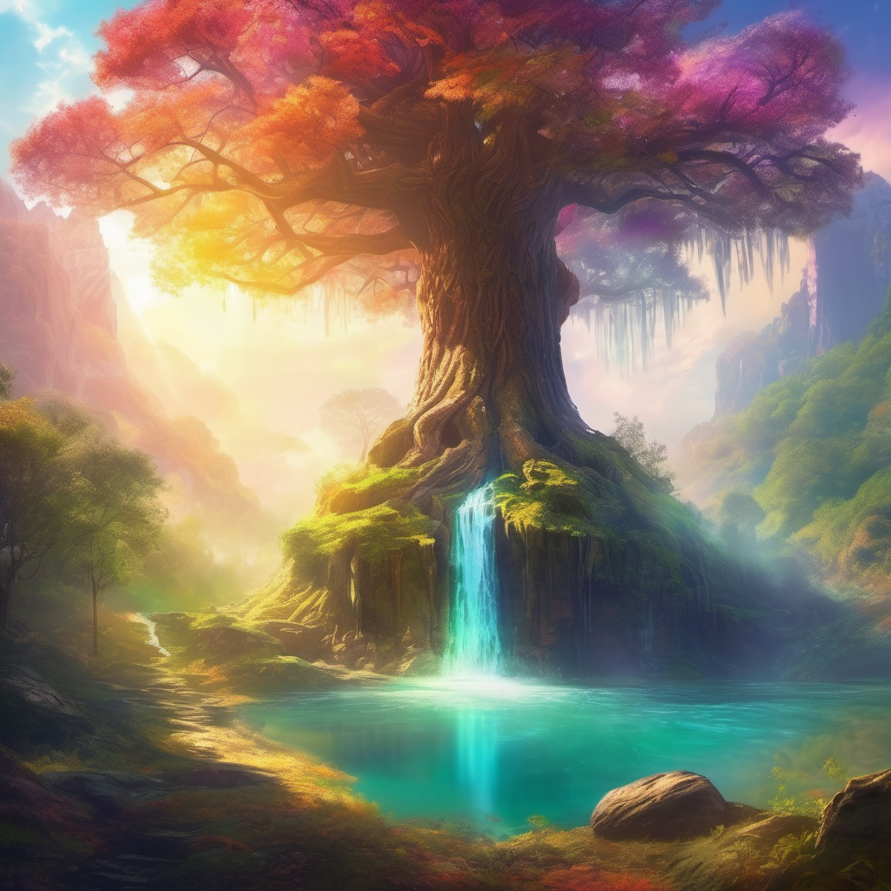
Welcome to FriendlyOnion’s Dream Stories, a world where imagination knows no bounds! 🌟✨
Here, we will travel to an extraordinary place, with magic and wonder all around. In this world, we will help you take the first steps, but how the story unfolds is entirely in your hands.💫
So, let's get ready to unlock the power of your creativity and let your dreams take flight! Together, we'll build a universe filled with wonder, where anything is possible. 🪐

#DreamExploration #ImaginationUnleashed #StorytellingParadise #CreativeAdventures #FriendlyOnion

Hi everyone, young and old (and middle-aged)

We hope that we can share with you the dream world we created.

We started these stories to help us calm down after a busy day and to find that place inside ourselves where we can relax and unwind.

We always begin with closing our eyes and imagining

how I tried to capture one image in my mind and consciously guide that image so it would come alive. Like surfing the waves where the ocean of sleep and dreams comes to the land of waking, where you can find that image floating by or hear a soft sounds, just for a moment, but then take that moment to build your magical adventure.

The world we created for these stories is not complete, we can only show you the places which we believe are special and the direction on how to get there. It is up to you to follow those directions and let your own imagination show you what’s there. Everyone will find something different, so our world is always changing and getting bigger, and by dreaming with us, you can help create new amazing places or adventures.

We can’t say for sure it will help you fall asleep more easily, but we hope that you can find that special place inside your dreams where these stories can find root and further grow into a world that you can explore on your own, full of wonder and magic. Even when we have told all our adventures, we’re sure that you can find more stories to be told…

Before you start a new adventure, please lie down in your favourite sleeping position (if you don’t know, I’m sure your mum or dad will know what position you mostly sleep in, when they come check up on you at night and give you that final kiss goodnight before they go to sleep). Now close your eyes and breath deeply in and out through your nose. Do this at least 3 times before you let the journey begin.

For each story, we will give you an introduction, setting the scene, and you can take it from there, let your imagination run wild. We will give you space on each page to write your own version. Part of the fun and marvel is to share your story with your parents, siblings or friends during the next morning. Try to remember as many details as possible. For example, when you remember that there was a bird, try to visualize the different colours it had and how its wings were capturing the wind to lift it into the sky…

The stories are best read in the sequence they’re written, as sometimes we will take back some elements of previous adventures. But it’s entirely up to you.

Alex, Matthias and Kobe hope you enjoy our world and we’re looking forward to hearing from you, how your adventures went and what magical encounters you have had 🙂. Please find us on instagram #xxx and facebook

WAT ZIE JE, WAT HOOR JE, WAT VOEL JE, WAT RUIK JE ? JE RUIKT HONING…
BEELD JE IN WELKE GEUREN JE NOG KAN RUIKEN.
JE STAAT IN HET HOGE GRAS, VOEL JE HET GRAS KIETELEN AAN JE KUITEN ? JE KAN DE WIND DOOR JE HAREN VOELEN. VOEL JE HET ?

World map
Add website with interactive map where people can add their dreams per story. Where they can see other versions of the story. Where they can search the map to see/hear stories directly.
The map is foggy until you tap a location and add a comment. Worldmap needs to be large with many hidden areas that only become available as we create new stories. We need to be able to zoom in to fine detail, while still have hte overview.

Let's break this down into manageable steps:
- First Steps (Planning Phase):
- Register a domain name (e.g., dreamparadise.com)
- Set up a GitHub account to manage your code
- Create initial mockups using Figma (free) for website layout
- Set up a Canva Pro account for creating visual assets
- Learning Phase (2-4 weeks):
- Complete basic tutorials on:
  - HTML/CSS fundamentals
  - JavaScript basics
  - React.js introduction
  - Git basics
- Development Setup:
- Install necessary development tools:
  - Visual Studio Code
  - Node.js
  - Git
  - MongoDB
- Social Media Strategy:
- Create business accounts on Instagram
- Design a content calendar
- Create story preview templates in Canva
- Plan weekly posts with:
  - Story preview image
  - Engaging caption
  - Call-to-action to visit website
  - Relevant hashtags
Would you like me to elaborate on the first step, starting with domain registration and initial planning?

The Mother Tree
Let’s take our first steps in this new world. Go and lie down in your favourite sleeping position, close your eyes and breathe deeply in and out through your nose.

You’ll see a lot of colors, images and thoughts popping up in front of your eyes. Tell these thoughts that you’ll take time for them later, but that they need to leave you alone for now and you'll see that they will disappear...

Before we begin, remember that this is a magical world where nothing can harm you, where you are completely safe.

Now, imagine yourself in a big forest. It’s nice and warm, and the sun is shining. You see beautiful, tall trees all around you. All the trees have different colours shining in their own unique way: deep-red, emerald-blue, silver, rose-golden, jade-white… colors you never even heard of... When you look up, you see colourful birds silently swooping through the trees and high in the sky. You decide to follow them and you walk deeper and deeper into the forest. While walking, breath in deeply through your nose… that must be the scent of fresh honey and warm milk (Inhales deeply).

This is your first time in this forest, but it already feels like home, and while walking your drawn to this majestic towering tree in the center clearing. The tree is so big that you can’t even see the top of it, as it disappears into the clouds and it’s so wide that you would need a hundred people to give it a big mommabear hug.

You see a staircase carved into the side of the tree that spirals higher and higher, and from time to time it stops at a door in the trunk. You feel at home here and you know that this is your mother tree.

For tonight, let’s take time to explore all the rooms in your mother tree and see what’s there. Anything you can imagine can be in here, every room can bring you a new surprise and new things to do… keep your eyes closed and imagine yourself exploring your home base and gently fall asleep. Tomorrow you can tell us all about your discoveries…

_________________________________________________________________
Alex’s tips
Swimming pool with diving board, cotton candy machine, monkey world, trampoline park, giant slide, gaming room, mirror-maze, cinema, bowling alley, costume room, nerf park with all the nerf guns you can imagine and also the ones you can’t imagine…

Recurring intro

As always, just lie down in your favourite sleeping position, close your eyes and breathe in and out through your nose. In…. and out….

Before we begin, remember that we’re going to your own magical world, where nothing can harm you, where you are completely safe and there is nothing to worry about. Just one fantastic adventure after another…

Okay, now that you’re lying down and closed your eyes, remember to breathe in and out, slowly…

You’ll see a lot of colors, images and thoughts popping up in front of your eyes. Tell these thoughts “I’ll take my time for you later, but not now” and you'll see that they will disappear. Keep doing this as long as new thoughts keep popping up, until it slows down.

(wait 5 seconds).

The upside down waterfall
Imagine you're standing at the foot of the mother tree. have you noticed that there is a little creek flowing clear blue water to the west, where the sun is starting to set in a warm orange light. if you follow the Stream and keep walking past the trees you get to a little Meadow in the forest. The grass in the meadow is covered with daisies white and yellow flowers sticking out their heads above the grass here in the meadow you can feel the warmth of the Setting Sun on your skin and it makes you feel so comfortable.

when you keep following the stream you see that there's a little Lake in the middle of the meadow And while you're walking closer you noticed that there is something very strange about this Lake something you hadn't seen earlier but there's a waterfall not going into the lake but the water is streaming upwards. it's an upside down waterfall and the top of the waterfall disappears into the clouds. I have been told by other Travelers that there is true magic at the top of this waterfall so let's plunge into the water and let ourselves be carried upwards the upside down waterfall to see what's at the top in the clouds. keep your eyes closed and imagine… tomorrow you can tell us all about your discoveries.

Alex’s dream:
Flying dolphins

The tinkle trunk
We begin our journey again at the foot of our mother tree.
A few steps away, there’s a little trunk that I’m sure you hadn’t notice before. It’s not an ugly trunk, it’s actually quite pretty for a trunk. Let’s go closer and take a look. I have to tell you now that this is not just a trunk, but a very special portal that the whistling elves have installed after they came to our land, so we can connect with them more easily.

Notice that while you’re walking, and you listen very carefully, you can already start to hear a very quiet whistling sound. When you’re near the trunk, you see that there’s a little hole in the side of the trunk and there a faint light inside.

You call out… “hello?” but no response. You try again… “hello?” still nothing… and then you see something written underneath the hole… it says” where there’s a whistle, there’s a way” so you try to do the only thing you can think of and make a short whistling sound (fwifwi)... Next thing you know is you’re becoming smaller and smaller and you’re being drawn into the trunk and you see all colours of the world twisting and turning, until your feet land on the softest grass you’ve ever felt. When you look around, you see the same trunk, but you’re in a completely different place. However, it’s not completely the same trunk is this one says: “Welcome to Enid’s kingdom of the Elves… where there’s a whistle, there’s also a way back”.

As we don’t have too much time tonight, we will only be able to explore a tiny part of the elven forest and I know the best place to go to… turn around a walk 10 steps away from the trunk: 1, 2, 3, 4, 5, 6, 7, 8, 9, 10. You’re standing in front of a curtain of leaves and liana vines. When you pull away the curtain, you’ll see something very special, but the funny thing is that everyone I asked sees something different. What will be there for you ? keep your eyes closed and imagine… tomorrow you can tell us all about your discoveries.

Alex’s dream:
A pond with singing and dancing ducks

The Raindrop Castle
This

_________________________________________________________________
_________________________________________________________________
_________________________________________________________________
_________________________________________________________________
_________________________________________________________________
_________________________________________________________________
_________________________________________________________________
_________________________________________________________________
_________________________________________________________________

Alex’s tips:
S

The Sun Cave
This

_________________________________________________________________
_________________________________________________________________
_________________________________________________________________
_________________________________________________________________
_________________________________________________________________
_________________________________________________________________
_________________________________________________________________
_________________________________________________________________
_________________________________________________________________

Alex’s tips:
S

The Sunken Elven Ship in the Sea of Oblivion

_________________________________________________________________
_________________________________________________________________
_________________________________________________________________
_________________________________________________________________
_________________________________________________________________
_________________________________________________________________
_________________________________________________________________
_________________________________________________________________
_________________________________________________________________

Alex’s tips:
S

The Desert Rock
This

_________________________________________________________________
_________________________________________________________________
_________________________________________________________________
_________________________________________________________________
_________________________________________________________________
_________________________________________________________________
_________________________________________________________________
_________________________________________________________________
_________________________________________________________________

Alex’s tips:
S

The Light House
Ride the beam of light

_________________________________________________________________
_________________________________________________________________
_________________________________________________________________
_________________________________________________________________
_________________________________________________________________
_________________________________________________________________
_________________________________________________________________
_________________________________________________________________
_________________________________________________________________

Alex’s tips:
S

The Once-in-a-Lifetime Portal
This

_________________________________________________________________
_________________________________________________________________
_________________________________________________________________
_________________________________________________________________
_________________________________________________________________
_________________________________________________________________
_________________________________________________________________
_________________________________________________________________
_________________________________________________________________

Alex’s tips:
S

The Elven Forest
This

_________________________________________________________________
_________________________________________________________________
_________________________________________________________________
_________________________________________________________________
_________________________________________________________________
_________________________________________________________________
_________________________________________________________________
_________________________________________________________________
_________________________________________________________________

Alex’s tips:
S

Dragon Land and the Syrup Tree
This

_________________________________________________________________
_________________________________________________________________
_________________________________________________________________
_________________________________________________________________
_________________________________________________________________
_________________________________________________________________
_________________________________________________________________
_________________________________________________________________
_________________________________________________________________

Alex’s tips:
S

Pegasus
This

_________________________________________________________________
_________________________________________________________________
_________________________________________________________________
_________________________________________________________________
_________________________________________________________________
_________________________________________________________________
_________________________________________________________________
_________________________________________________________________
_________________________________________________________________

Alex’s tips:
S

Wings of Mount Clastonia
This

_________________________________________________________________
_________________________________________________________________
_________________________________________________________________
_________________________________________________________________
_________________________________________________________________
_________________________________________________________________
_________________________________________________________________
_________________________________________________________________
_________________________________________________________________

Alex’s tips:
S

The Griffon in the Echoing Queen Conch Shell
This

_________________________________________________________________
_________________________________________________________________
_________________________________________________________________
_________________________________________________________________
_________________________________________________________________
_________________________________________________________________
_________________________________________________________________
_________________________________________________________________
_________________________________________________________________

Alex’s tips:
S

“If you think of the subconscious, dreams, and sleep as the ocean, and you think of the waking, rational mind as the land, then the place where water crashes into land is super chaotic. That’s where all the waves are. And that’s where you surf. So liminal dreaming is surfing the edge of conscious and unconscious.” – Jennifer Dumpert

“It might be a little visual glimmer, might be points of light. It might be a sound. It might even just be something that you’re imagining, like you’re daydreaming. And then let that come into your consciousness.”

