**巨量交易分析與應用**

**B02090030張智鈞**

**網址:** **https://github.com/kobe81705**

註冊完帳號登入:

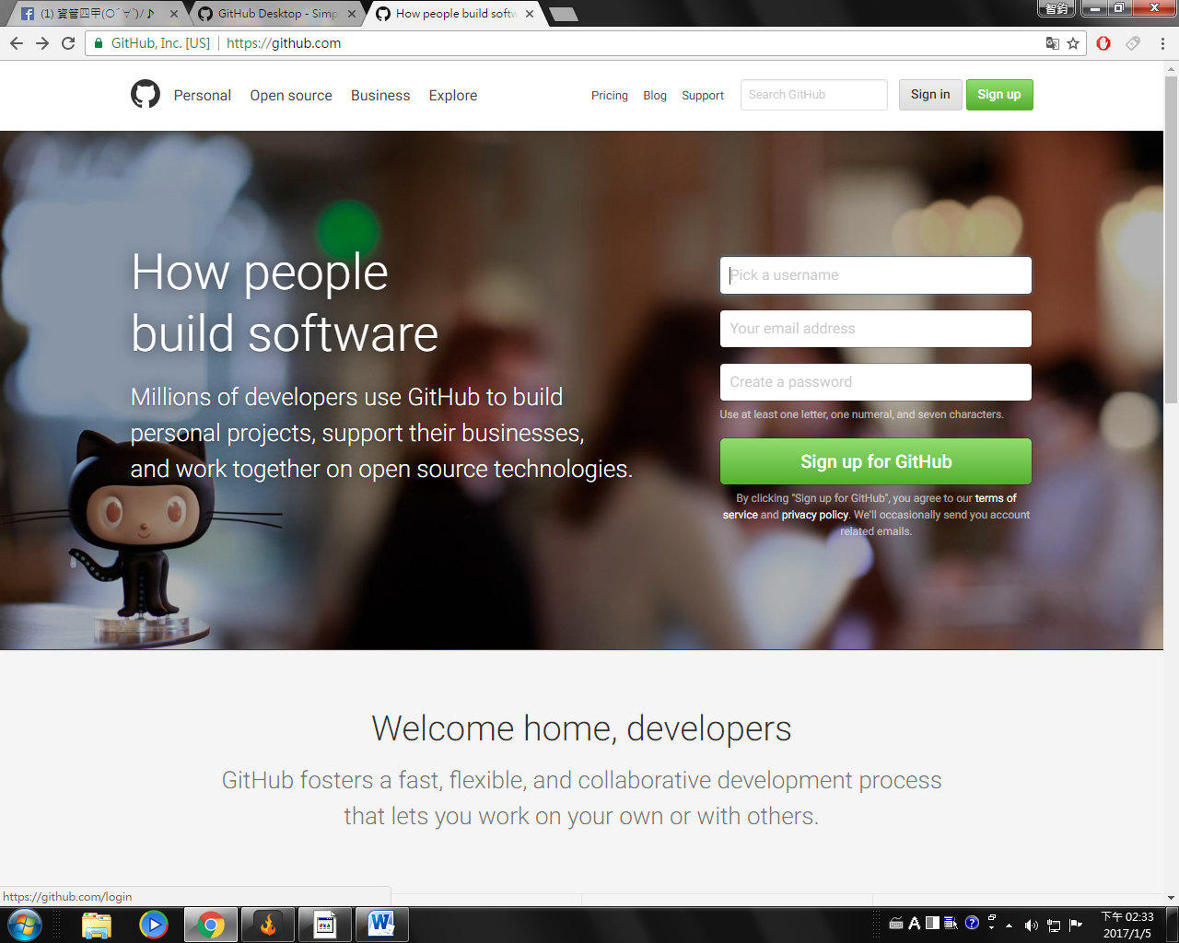

登入畫面 Sign in:

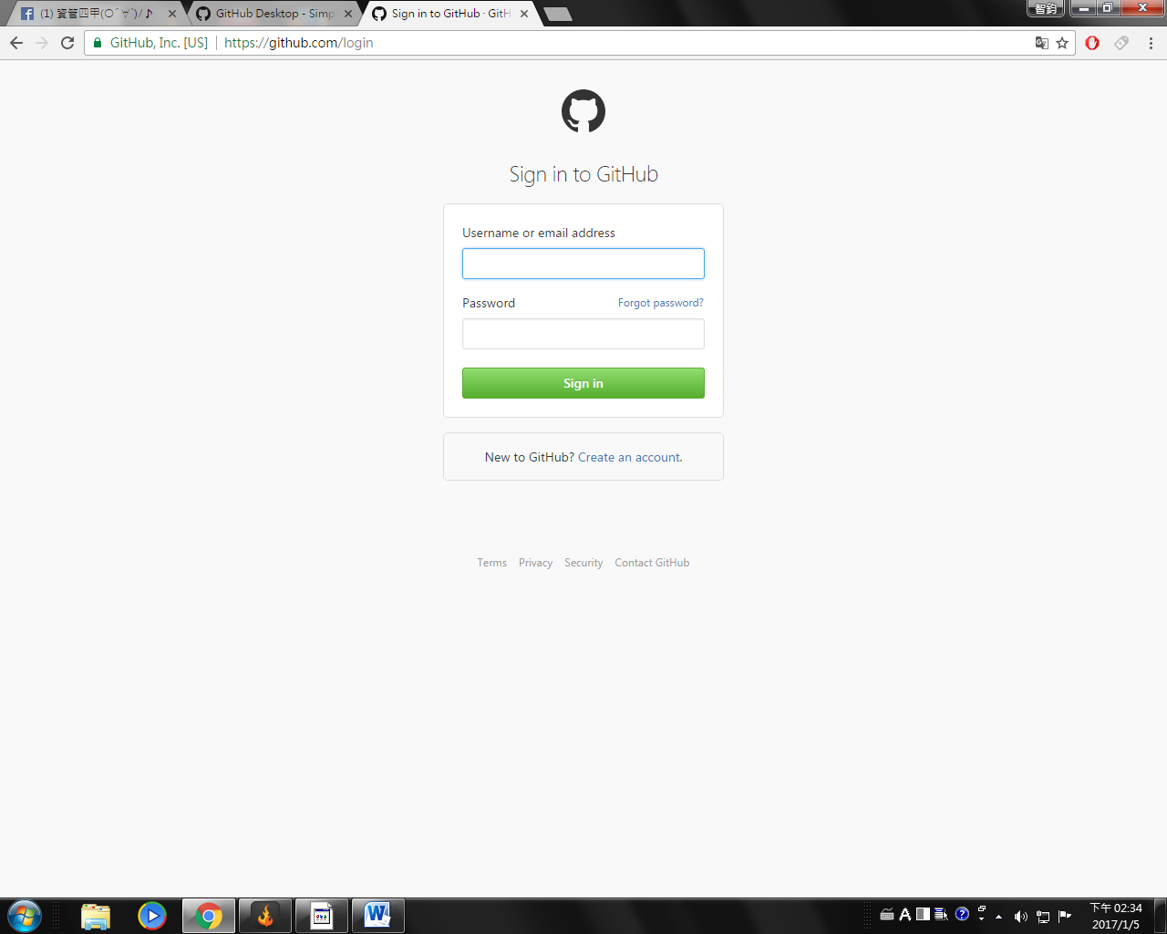

.

進去之後選擇Start a project

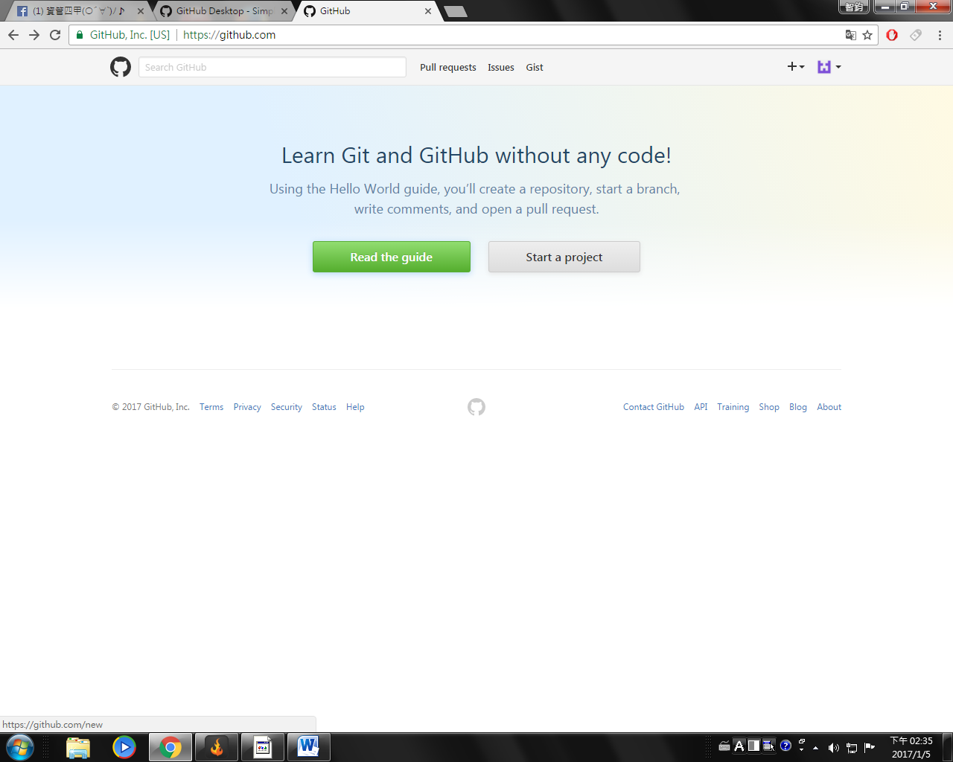

然後建立自己的使用者名稱或暱稱:

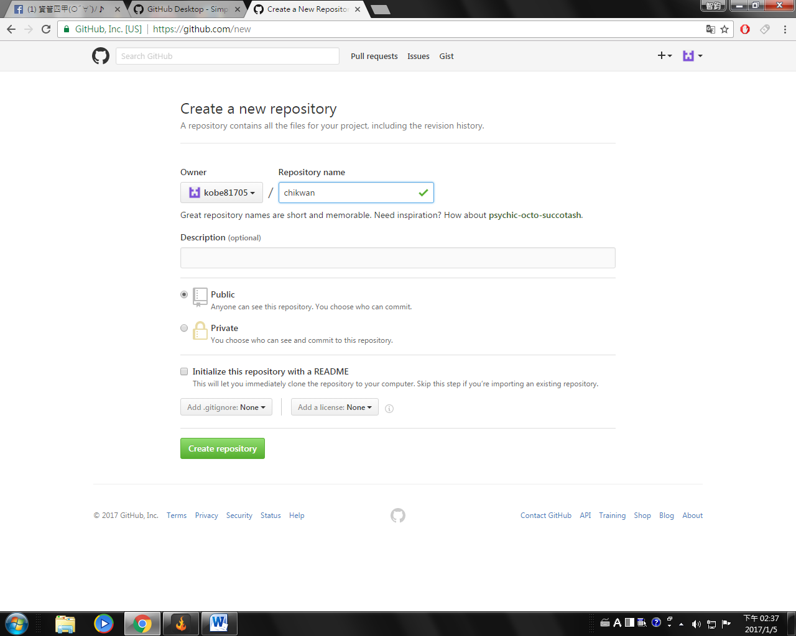

之後就可以建立自己的檔案了:

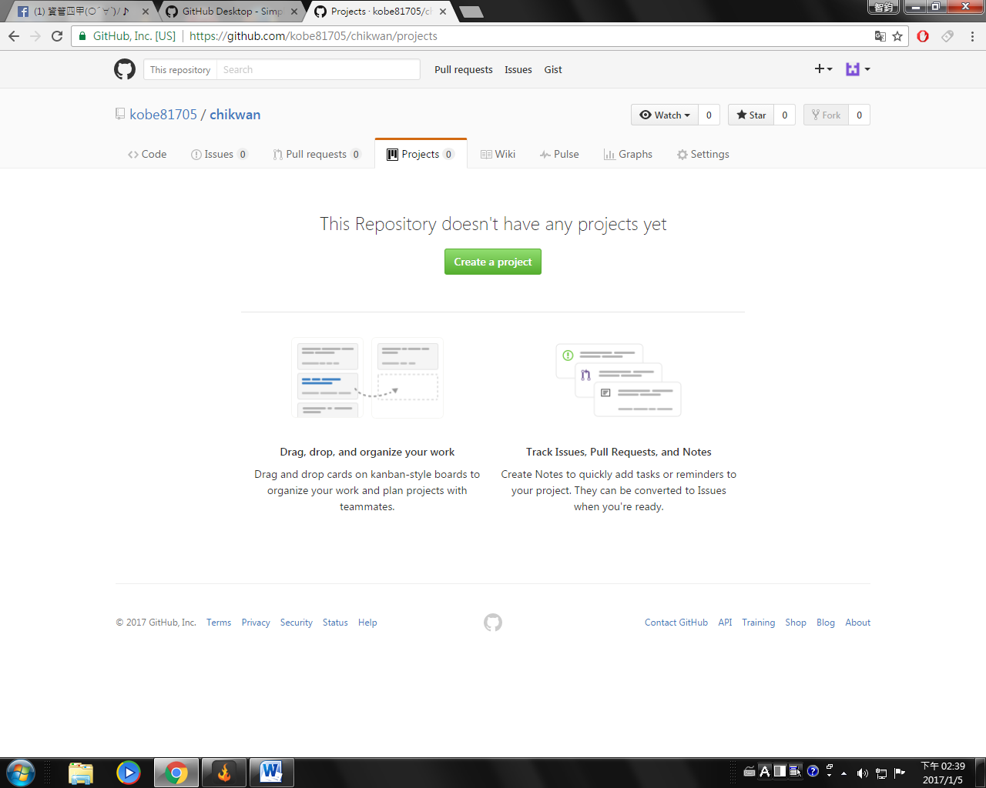

程式碼:

#switch

x <- 1

switch(x, 5, sum(1:10), rnorm(5))

y <-1

switch(y, juice="Apple", meat="Pork")

y<- "juice"

switch(y, juice="Apple", meat="Pork")

#for

x <- 0

for (i in 1:5) x <- x + i

x

x <- 0

y <- 0

for(i in 1:5) {x <- x+ i; y <- i^2}

x

y

#while

sum <- 0

i <- 1

while (i <=10) {sum <- sum +i; i <- i + 1}

sum

#repeat

sum <- 0

i <- 1

repeat{

sum <- sum + i

i <- i +1

if(i > 10)break

}

sum

# %% 餘數 %/% 商

sum <- 0

for(i in 1:50){

if(i %% 2 ==0)next

sum <- sum +i

}

sum

#自訂函數

myfun <- function(x) {y <- x +2; return(y)}

myfun(1)

myfun(100)

# <<- 改變函數外面的值

x <- 1

myfun <- function(x) {x <- 2; print(x)}

myfun(x)

x

x<-1

myfun <- function(x) {x <<- 2; print(x)}

myfun(x)

x

#factorial 階層

factorial <- function(x=1){

y <- 1

for(i in 1:x) y <- y *i

return(y)

}

factorial(5)

factorial(10)

#apply

x <- array(1:24, dim =c(4,6))

x

apply(x, 1, sum)

apply(x, 2, sum)

id <- c(1,2,3,4)

age <- c(20,30,40,50)

sex <- c("male",'male','female','female')

pay <- c(3000,4000,5000,6000)

x_dataframe <- data.frame(id,age,sex,pay)

x_dataframe[3,2]

x_dataframe[4,]

x_dataframe[2]

x_dataframe$age

edit(x_dataframe)

#list

id <- c(1,2,3)

sex <- c("male","male","male")

pay <- c(30000,40000,50000)

y_dataframe <- data.frame(id,sex,pay)

gender <- factor(c("男","男","女"))

Paul.Family <- list(name="paul",wife="Iris",

no.kids=3, kids.age=c(25,27,30), gender,

y_dataframe)

Paul.Family

Paul.Family$kids.age

Paul.Family[4]

Paul.Family[[4]]

Paul.Family$kids.age[2]

Paul.Family[[4]][2]

#錯誤Paul.Family[4][2]

#ch2 資料的讀取與寫入

getwd()

setwd("c:/")

getwd()

x <- read.table("x.csv", sep=",",geader=TRUE)

x