- Compile
javac -d out (Get-ChildItem -Recurse -Filter *.java | ForEach-Object { $_.FullName })
- Run
java -cp out transport.app.MainApp
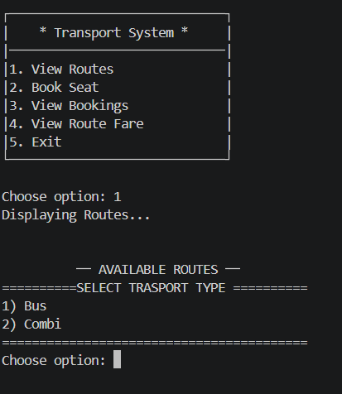
This is option 1. View Routes
You are showed two options

Bus
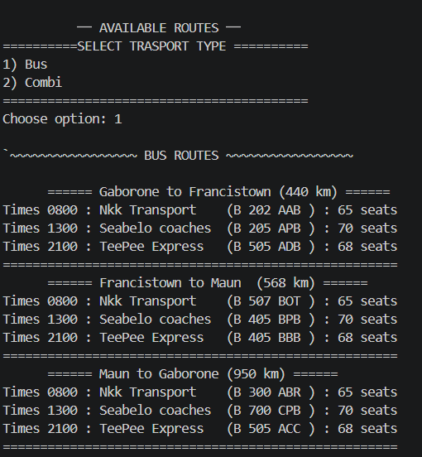

Combi
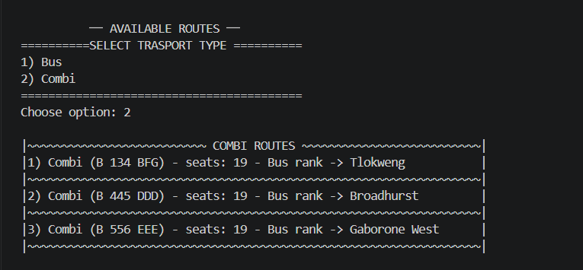

After each it returns to the main menu

Option 2 Book Seat
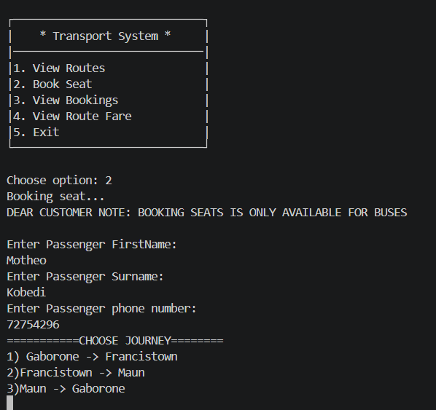
Your are promted to use you names and contact details
Then choose your journey followed by your time of departure
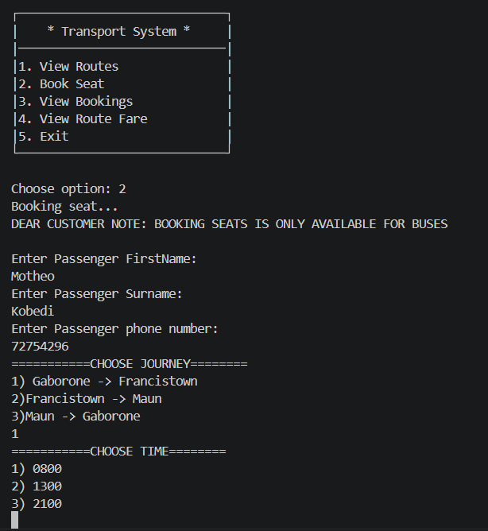
Then you are showed your receipt
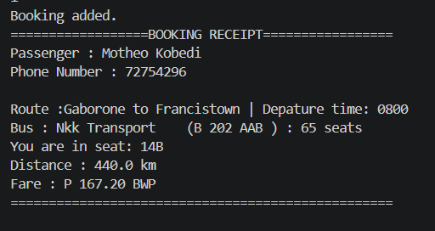
Then after booking it returns to the main menu
You can then book again if you wish

Option 4 View Routes Fare
You are prompted to choose your mode of transport
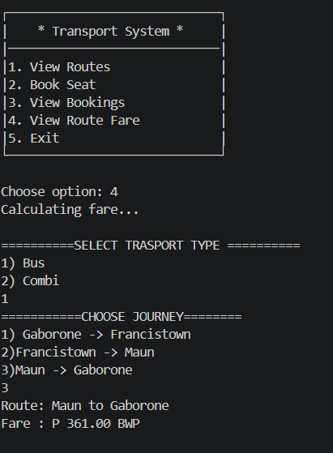
After selecting transport type
You then again select journey if you chose bus, then the fare is displayed

Then for combi they current fare rate is displayed

Option 5 is to terminate the program
