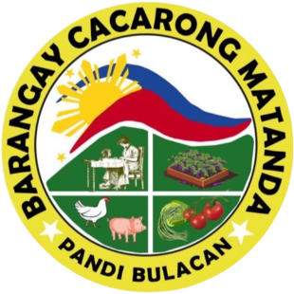

Republic of the Philippines

Province of Bulacan

Municipality of Pandi

**BARANGAY CACARONG MATANDA**

Office of the Punong Barangay



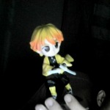

**BSC-000144**

**Renewal**

**BARANGAY BUSINESS CLEARANCE**

TO WHOM IT MAY CONCERN

This is to certify that the business or trade activity described below

**Cosmetix**

(Business Name)

**test, test, test**

(Business Location)

**Ella Kiel Joson**

(President/Owner)

**test**

(Nature of Business)

Proposed to be established in this barangay and is being applied for a Barangay Business Clearance to be used in securing a corresponding Mayor’s Permit has been found to be in conformity with the provisions of existing Barangay Ordinances, rules, and regulations being enforced in this Barangay.

In view of the foregoing, the undersigned interposes no objections for the issuance of the corresponding Mayor’s Permit being applied for.

This permit shall be valid until **December 31, 2024** and can be cancelled/revoked anytime the establishment is found to have violated any law or ordinance within this barangay.

Issued on **November 11, 2024** at **BRY HALL, CACARONG MATANDA, PANDI, BULACAN**.

GERARDO S. CRUZ

Punong Barangay



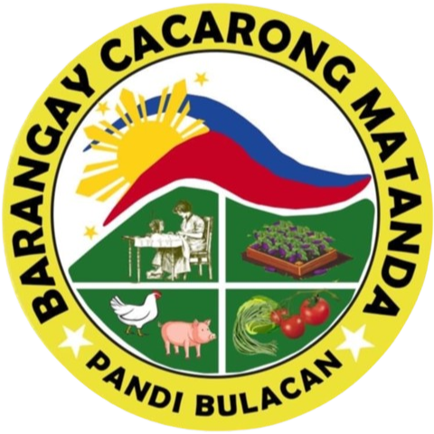

Republic of the Philippines

Province of Bulacan

Municipality of Pandi

**BARANGAY CACARONG MATANDA**

Office of the Punong Barangay



Signature of Applicant

Right Thumb Mark

Left Thumb Mark

TO WHOM IT MAY CONCERN:

This is to certify that the person whose name, signature, thumb marks and other personal data appearing hereon, has requested for a Business Certification from this Office and the results are listed below.

|  |  |
| --- | --- |
| NAME | **Ella Kiel Joson** |
| ADDRESS | **114 Castro Cacarong Matanda, Pandi, Bulacan** |
| DATE OF BIRTH | **July 23, 2003** |
| PLACE OF BIRTH | **Plridel** |
| BUSINESS NAME | **Cosmetix** |
| ADDRESS OF BUSINESS | **test, test, test** |

This certification is issued upon request of the same person to be used for **adawdawd ONLY**

|  |  |
| --- | --- |
| Date Issued | **November 11, 2024** |
| Valid Until | **December 31, 2024** |
| CTC No | **123123** |
| Place Issued | **BRY HALL, CACARONG MATANDA, PANDI, BULACAN** |
| OR No | **123123213** |
| Prepared By | **ADMINISTRATOR** |

**BUSINESS CERTIFICATION**

**BSC-000144**

GERARDO S. CRUZ

Punong Barangay