|  |  |
| --- | --- |
| Date Issued | **{formDateIssued}** |
| Valid Until | **{expirationDate}** |
| CTC No | **{CTCNo}** |
| CTC Date | **{dateIssued}** |
| Place Issued | **{placeIssued}** |
| OR No | **{ORNo}** |
| Prepared By | **ADMINISTRATOR** |
| Form No | **{formNumber}** |

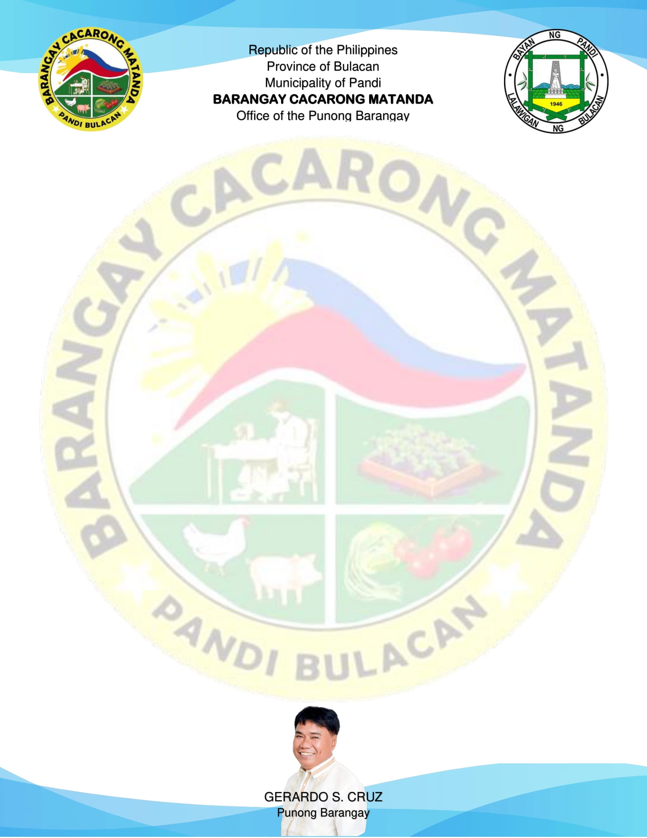

{%image}

Signature of Applicant

Right Thumb Mark

Left Thumb Mark

TO WHOM IT MAY CONCERN:

This is to certify that the person whose name, signature, thumb marks and other personal data appearing hereon, has requested for **Excavation Clearance** from this Office and the results are listed below.

|  |  |
| --- | --- |
| NAME | **{name}** |
| ADDRESS | **{address}** |
| DATE OF BIRTH | **{dateOfBirth}** |
| PLACE OF BIRTH | **{placeOfBirth}** |

This is to further certify that the Office of the Punong Barangay of Cacarong Matanda, Municipality of Pandi, Province of Bulacan interposes no objection to the request of the above named person for the excavation in private property located at  **{excavationLocation}** .

**EXCAVATION CLEARANCE**