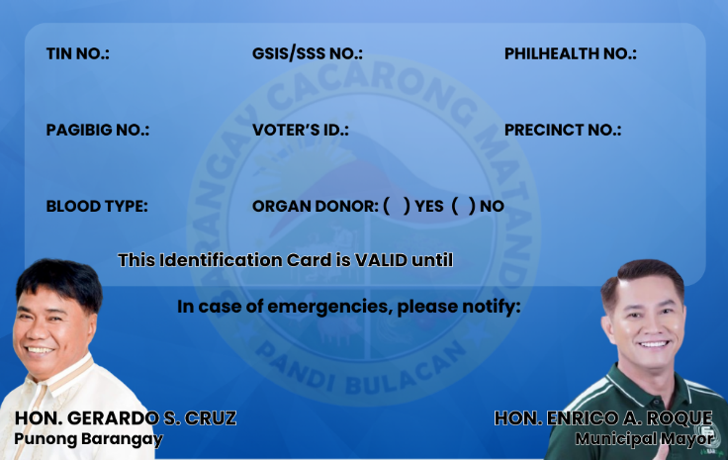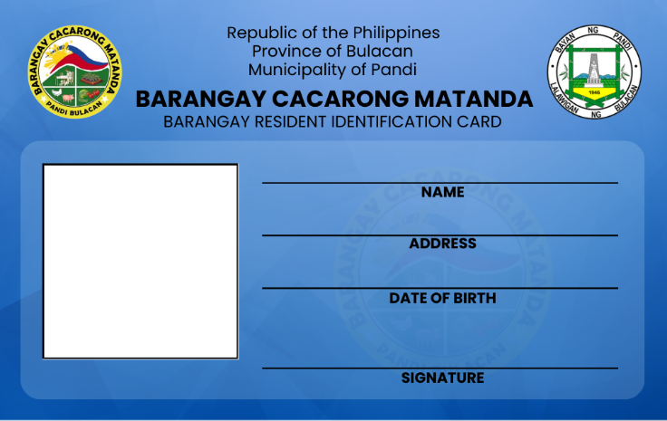

**{number}**

**{emergencyContact}**

**{emergencyAddress}**

**{emergencyName}**

**{expirationDate}**

**x**

**{blood}**

**{philhealth}**

**{precinct}**

**{voter}**

**{pagibig}**

**{sss}**

**{tin}**

**{number}**

{dateOfBirth}

{address}

{name}

{%image}