|  |  |
| --- | --- |
| Date Issued | **{formDateIssued}** |
| Valid Until | **{expirationDate}** |
| CTC No | **{CTCNo}** |
| CTC Date | **{dateIssued}** |
| Place Issued | **{placeIssued}** |
| OR No | **{ORNo}** |
| Prepared By | **ADMINISTRATOR** |
| FormNo | **{formNumber}** |

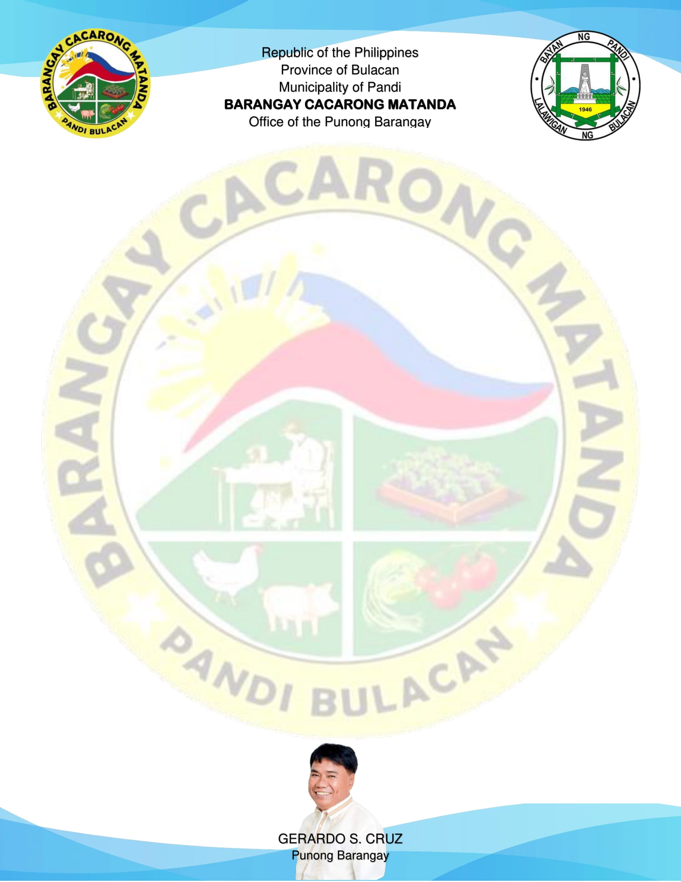

{%image}

Signature of Applicant

Right Thumb Mark

Left Thumb Mark

TO WHOM IT MAY CONCERN:

This is to certify that the person whose name, signature, thumb marks and other personal data appearing hereon, has requested for a **Certification of Solo Parent** from this Office and the results are listed below.

|  |  |
| --- | --- |
| NAME | **{name}** |
| ADDRESS | **{address}** |
| DATE OF BIRTH | **{dateOfBirth}** |
| PLACE OF BIRTH | **{placeOfBirth}** |
| YEARS OF RESIDENCY | **{yrsOfResidency} YEAR/S** |

This is to further certify that this resident is a bonafide resident of this barangay and a solo parent.

This certification is issued upon the request of the above-named person for whatever legal purposes and intents it is deemed necessary.

**SOLO PARENT CERTIFICATION**