1. <https://support.huaweicloud.com/usermanual-kafka/kafka-ug-180413002.html>

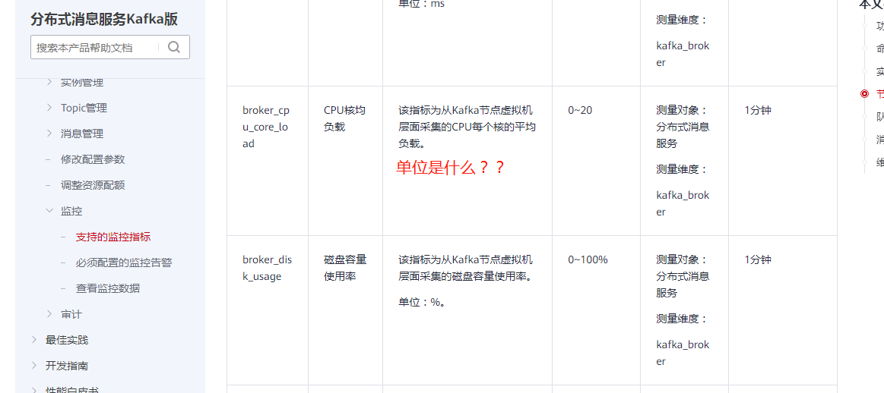

1. <https://support.huaweicloud.com/kafka_faq/kafka-faq-200426001.html>

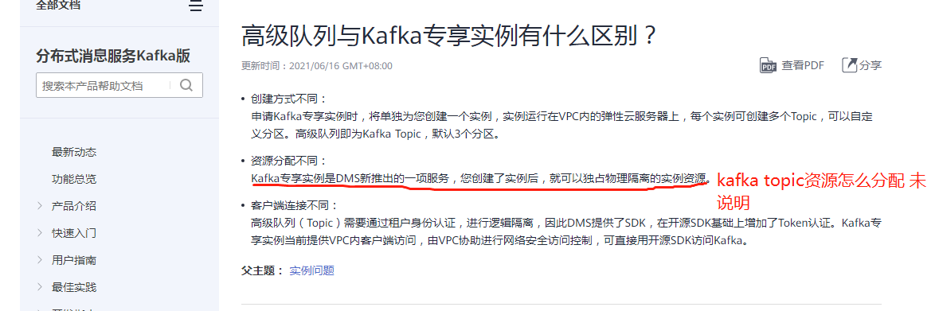

3、https://support.huaweicloud.com/kafka_faq/kafka-faq-200426002.html

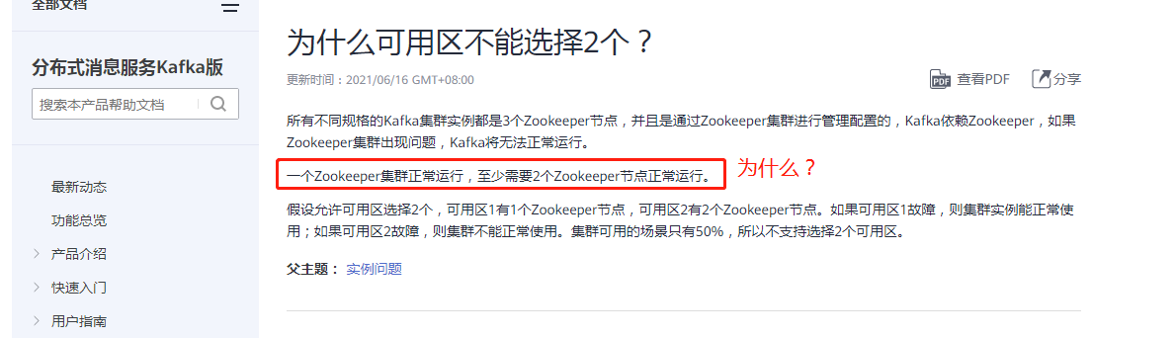

参考：<https://blog.csdn.net/dd2016124/article/details/114038886>

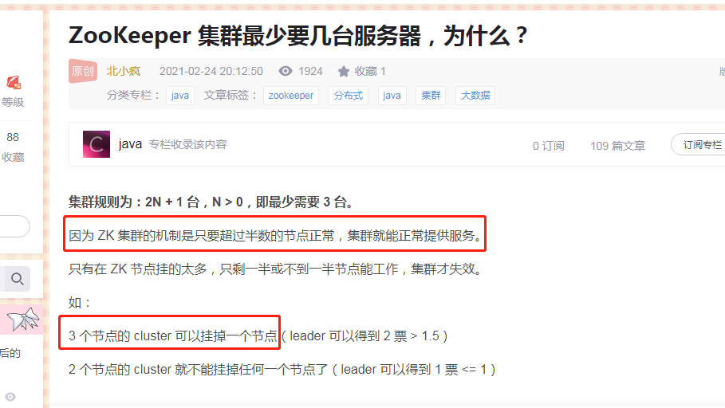

4、https://support.huaweicloud.com/kafka_faq/kafka-faq-200426005.html

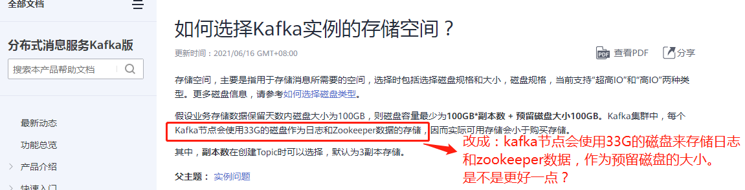

5、https://support.huaweicloud.com/kafka_faq/kafka-faq-200426007.html

