Thin-Layer and Column Chromatography

**Reference:** Handout; Chemistry Lessons: column chromatography, thin layer chromatography, natural products isolation; Green lessons: renewable resources; Zubrick, Ch. 27-28

**Purpose:** To learn and analyze how chromatography works in purifying organic compounds that cannot be easily crystallized. We will learn how to isolate chlorophyll and carotenoid pigments through the use of column and thin-layer chromatography.

**Table of Reagents:**

|  |  |  |  |  |  |
| --- | --- | --- | --- | --- | --- |
| **Reagents** | **Amount** | **MW** | **BP (°C)** | **MP (°C)** | **Density** |
| Acetone | Varies | 58.08 g/mol | 56 °C | -94 °C | 0.785 g/cm3 |
| Hexane | 86.18 g/mol | 68.7 °C | -97 °C | 0.659 g/cm3 |
| Sodium Sulfate | 142.04 g/mol | 1429 °C | 884 °C | 2.68 g/cm3 |
| Methanol | 32.04 g/mol | 64.7 °C | -98 °C | 0.791 g/cm3 |
| Alumina | 101.96 g/mol | 3000 °C | 2054 °C | 3.987 g/cm3 |
| Water (H2O) | 18.02 g/mol | 100 °C | 0 °C | 0.997 gm/cm3 |

**Safety:**

* Do not get the reagents into your eyes or mouth! Always wear proper attire when exposing yourself to the chemicals as they are irritants
* Highly Flammable Reagents (Acetone/Methanol/Hexane)

|  |  |
| --- | --- |
| **Experimental Procedures** | **Data & Observations** |
| **Part A: Spinach Pigment Extraction**  **1.** Tear into pieces ~0.5 g of fresh Spinach leaves. Grind leaves down to very small particles in a mortar with pestle and 1 mL of acetone. | *Spinach Weight:* 0.6162 g |
| **2.** Transfer to centrifuge tube with a Pasteur pipet. (May use < 1 mL of acetone to help transfer). Rinse mortar with pestle with 1 mL of acetone and mix in with tube. Centrifuge the tube (keep it balanced)! | * 4.5 mL of acetone used |
| **3.** Add 2 mL hexane in the tube. Shake afterwards with cap! Add 2 mL of water and shake & vent! Centrifuge the tube! 2 Layers should remain:   1. Bottom Layer (aq.) 🡪remove with Pasteur pipet 2. Top Layer (hexane with Spinach pigment) 🡪 leave layer in tube | *Observations:*   * Bottom Layer 🡪 Light Green (hexane and water) * Top Layer 🡪 Green (hexane and pigment) |
| **4.** Prepare Column   1. Put small plug of cotton into a 5 ¾ inch Pasteur pipet 2. Push cotton to tapered portion of pipet 3. Add ~0.5 g Na2SO4 (drying agent) and pack gently by tapping | *Sodium Sulfate:* 0.6809 g |
| **5.** Clamp column and place a test tube below.  Transfer hexane layer to column with Pasteur pipet. Drain and add ~0.5 mL of hexane to column. Evaporate with air and dissolve residue in 0.5 mL of hexane.  *Keep test tube in draw until ready for column*  ***Oxidation might occur if left in the light*** |  |
| **Part B: Column Chromatography**  **6. Materials Needed**   1. 5 test tubes 🡪 labeled “1” to “5” 2. 2 Pasteur Pipettes with bulb 3. Solvents 🡪 increasing polarity 4. Columns 🡪 add to 5 ¾ inch pipet   ***Prepare everything before starting and work quickly*** | *Alumina added:* 1.2643 g |
| **7.** Clamp pipet. Take test tube #1 and place below the column (leave space between tube and pipet). Add ~3 mL of hexane to column with Pasteur pipet. Drain into tube #1 until solvent reaches top of alumina. Add 1 mL of hexane to top. |  |
| **8.** Add ~0.25 mL pigment extract with 2nd Pasteur Pipet. Store rest in dark until TLC. Drain column and allow to absorb alumina. Add 1 mL hexane and allow solvent to drip from column. |  |
| **9.** Add ~4 mL hexane and continue to drip.   * If 1st yellow band is moving down column, keep adding hexane until bottom * If yellow band not separating, use polar solvent (70:30 | hexane: acetone) |  |
| **10.** Collect yellow band in test tube #2. Follow with tube #3 and collect colorless liquid. Keep adding solvent and change to a more polar solvent if green band doesn’t show. |  |
| **11.** When green band reaches bottom of column, drain into tube #4. Afterwards, drain remaining liquid into tube #5. Evaporate the solvents from tube “E” (original extract), tube #2, and tube #4. Place in warm water and as soon as solvent evaporate 🡪 keep in dark until TLC |  |
| **Part C: TLC**  **12. Prepare TLC plate with 3 Lanes**   1. Mix with pencil where sample will be in TLC plate 2. Add 2 drops of 70:30 (hexane: acetone) to each tube (‘E’,’2’, and ‘4’) 3. Use capillary micropipette to spot “E” extract to the TLC plate. 4. Touch micropipette to the “E” lane and allow to dry before developing 5. Repeat with tubes “2” and “4” 6. Make sure color is prominent in each plate and allow to dry |  |
| **13. Prepare Developing Chamber**   1. Place TLC plate in developing chamber 2. Remove plate when solvent 1-2 cm from top of plate 3. Mark with pencil position of solvent front as soon as you remove plate from chamber 4. Let plate dry and put line spots with pencil as well as indicate their colors. |  |
| **14.** Various color spots should appear on plate in order of decreasing Rf.   1. Carotenes (yellow orange) 2. Pheophytins (grey) 3. Chlorophyll a (blue) & b (green) 4. Xanthophylls (yellow) | *Observations:* Capillary action brought bands onto the plate |
| **15.** Draw TLC plate on data sheet 🡪 Label each spot with color and identity. Record distance traveled by solvent front and b each spot. Calculate Rf values for each spot. |  |

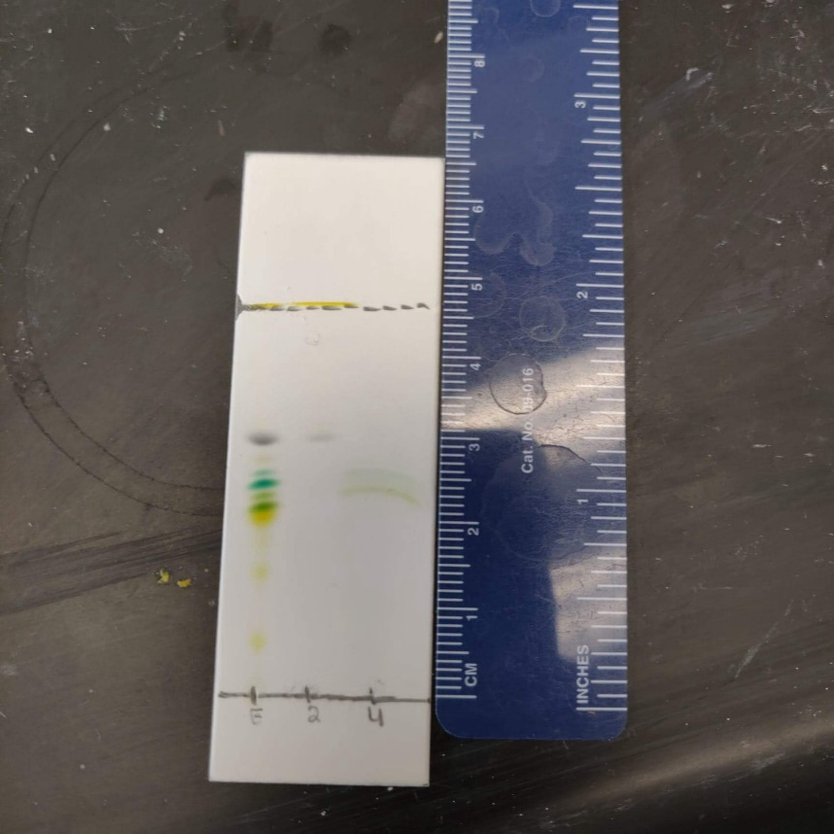**Vial ‘E’:**

Rf = *(Top Band)*

Rf = *(2nd Band)*

Rf = *(3rd Band)*

Rf = *(4th Band)*

Rf = *(5th Band)*

Rf = *(6th Band)*

**Vial ‘2’:**

Rf = (Grey Band)

**Vial ‘4’:**

Rf = *(Green Band)*

Rf = *(Yellow-Green Band)*

**Post-lab Questions:**

**1.** The student cannot see any spots on his TLC plate, because the student has set up his TLC chamber wrong by adding too much solvent. The directions stated that the TLC chamber should not have its solvent level filled to the point that it touches the “application point”, since the compounds will not be push up by capillary action as well as they will be stuck with the solvent.

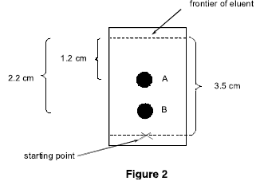**2. a.** Spot B is more polar, because it will take longer for a polar compound to move up the TLC plate through capillary action.

**b.** Rf of Spot A: $\frac{2.3 cm}{3.5 cm}=0.657$

Rf of Spot A: $\frac{1.3 cm}{3.5 cm}=0.371$

**3. a)** The 50:50 hexane: acetone solvent system will be more polar than the 80:20 hexane: acetone, because acetone is more polar than hexane thus since the 50/50 hexane: acetone ratio provides more acetone in its contents resulting in it being more polar.

**b)** Running the TLC of A and B in the 50:50 hexane: acetone solvent system will result in the Rf value becoming larger, since the new solvent system will be stronger in pulling the compounds through capillary action.

**4.** Based on the structures of carotene and chlorophyll, chlorophyll is more polar because it is more electronegative in structure. Chlorophyll has oxygen and nitrogen groups which are electronegative in nature and thus creates unequal pulls within the structure generating polarity. However, carotenes have nonpolar hydrocarbons that extends in its structure, which generates no pull overall. I would expect the carotenes to elute from the column first since its less polar compared to the chlorophyll. In addition, this is consistent with our data as shown with the carotenes (yellow orange) being near the top compared to the chlorophyll(blue/green).

**5.** The bands were not in its purest forms as we probably mixed in some other compounds with it. Our data shows multiple bands, which means that our collection was not pure. We used the most polar solvent which resulted in us trying to catch the material before it left the pipette as it traveled really fast down the pipette. Overall, our column was semi-successful as we did isolate the materials as shown with the picture, however, we could have received better results if we used more hexane than acetone contents.