Electrophilic Aromatic Iodination of Vanillin

**Reference:** Handout; Chemistry lessons: electrophilic aromatic substitution, recrystallization, melting point; Green lessons: safer and easier to handle reagents and solvents, more selective reagents

**Purpose:** To carry out the iodination of vanillin using electrophilic aromatic substitution reactions

**Table of Reagents:**

|  |  |  |  |  |  |
| --- | --- | --- | --- | --- | --- |
| **Reagents** | **MW** | **Amount** | **BP (°C)** | **MP (°C)** | **Density** |
| Vanillin | 152.5 g/mol | 1 g | 285 °C | 82 °C | 1.056 g/cm3 |
| Ethanol (EtOH) | 46.07 g/mol | 20 mL | 78.37 °C | -114.1 °C | 0.789 g/cm3 |
| Sodium Hypochlorite | 74.44 g/mol | 11 mL | 101 °C | 18 °C | 1.11 g/cm3 |
| Sodium Thiosulfate | 158.11 g/mol | 10 mL | 100 °C | 48.3 °C | 1.67 g/cm3 |
| Hydrochloric Acid | 36.46 g/mol | ~6 mL | 48 °C | -26 °C | 1.2 g/cm3 |
| 2-Propanol | 60.1 g/mol | Varies | 82.5 °C | -89 °C | 0.786 g/cm3 |
| Water | 18.02 g/mol | Varies | 100 °C | 0 °C | 1.0 g/cm3 |
| Sodium Iodide | 149.89 g/mol | 1.17 g | 1304 °C | 661 °C | 3.67 g/cm3 |

**Balanced Chemical Equation:**

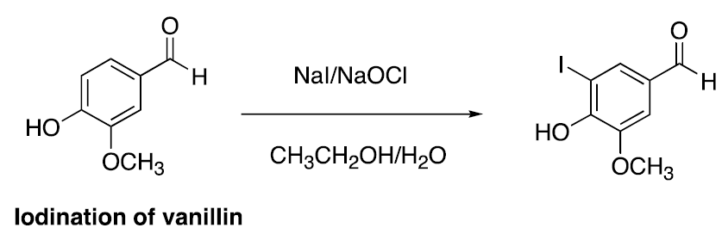

**Safety:**

* Sodium Hypochlorite 🡪bleach; may damage clothing
* Avoid open flames 🡪 methanol/ethanol flammable

|  |  |
| --- | --- |
| **Experimental Procedures** | **Data & Observations** |
| **1.** Obtain 100 mL round-bottom flask; Add 1 g vanillin with 20 mL ethanol 🡪 dissolve; After add 1.17 g sodium iodide, then cool to 0 °C with ice bath | *Vanillin Used:* 1.0237 g |
| **2.** Obtain separatory funnel, add 11 mL of sodium hypochlorite. Add drops to reaction mixture over 10 min period.  ***Color will turn from pale-yellow to red brown  ***Allow to warm to RT when red brown*** | *Observations:* After first 5 drops turned red-brown |
| **3.** Add 10 mL sodium Thiosulfate; Add HCl until acidic (use pH paper)  ***Add ~6 mL of HCL; precipitate should form*** |  |
| **4.** Remove ethanol from suspension on a rotary evaporator; use gentle heating for <10 min  *** Water will still be present*** | *Mass of Product:* 0.0223 g  *Melting Point:* 228.6 °C |
| **5.** Ice bath the flask for 10 min and collect precipitate by vacuum filtration.  🡪Wash with cold water and ethanol  🡪Continue to dry with vacuum; record mass | *Crude Product Mass:* 0.729 g |
| **6.** Recrystallize crude product from ethyl acetate or 2-propanol. Collect crystalline product through vacuum filtration. Weigh product and determine melting point. | *Pure Product Melting Point:* 183 – 185 °C  *Crude Product Melting Point:* 178 °C |
| **7.** Recrystallization 2-propanol/Water  🡪Place crude product in 100 mL Erlenmeyer Flask and heat  🡪 Add enough 2-propanol to dissolve  🡪Add hot water until mixture cloudy  🡪Add 2-propanol to make clear  🡪Allow to cool and place in ice bath to recrystallize | *Color:* White |

**Post-lab Questions:**

**1. a)** We collected 0.729 g of the crude product as well as the color of our product was Eggshell-White.

$$\% Yield= \frac{Product Obtained}{Theoretical Yield}×100$$

*Obtained:* 0.729 g *Color:* Eggshell-White

* First, we must obtain the theoretical value of our crude product in grams:
$$1.0237 g Vanillin×\frac{1 mol Vanillin}{152.15 g Vanillin}×\frac{1 mol Product}{1 mol Vanillin}×\frac{278.04 g Product}{1 mol Product}=1.871 g Product$$

* Next, we must use equation above to get our % Yield:
$$\% Yield=\frac{0.729 g}{1.871 g}×100=38.96\% yield$$

* *We received a 38.96% yield for our product*
* *Our % yield is rather low, which might have resulted in our reagents not mixing properly or has not fully reacted yet*

**b)** Our crude product melted at 178 °C, which concludes that it contains impurites as it has experienced melting point depression. The true melting point range of the pure product was recorded to be between 183 – 185 °C, whereas our product melted below the range. On the same note, this proves that our product’s crystalline structure was disrupted by impuritues, which lowered our thought to be pure product’s melting point (some of the reagents might have been still in the product).

**2.**  On the 1H NMR we expect to see 5 different resonances of the product, while on the 1C NMR, we would expect to see 8 resonances from the product.

**3.**

**a)** The oxidizing agent is the ClO-

**b)** The bleach is environmentally more friendly as it is greener in comparison to using a more powerful oxidizing agent. In addition, generating I2 produced a mono-iodinated product in comparison to a poly-iodinated product.

**4.**

**a)** The practical advantage of reducing excess iodine to iodide is that it effective and selective in creating the desired regiochemistry. In addition, iodine prefers to stay in a gaseous form as it is a halogen. However, by reducing the excess iodine to iodide we would turn it into an aqueous state, which will allow it to react better with the other reagents. We would overall receive a better yield as the reagents would be able to react better.

**5.** The HCl reacts with the product in reducing its solubility, which results in a precipitate. Essentially, a H+ is taken by the polar product in making less soluable

C8H6IO3- (aq) + HCl (aq) 🡪 C8H7IO3 (s) + Cl- (aq)

**6. $Atom Economy= \frac{MW of products}{MW of reactants}×100$**

$Atom Economy= \frac{278.04}{(152.15+74.44+149.89)}×100=73.9\%$

**7.** The iodination occurs preferentially ortho to the hydroxyl group rather than ortho to the aldehyde (“formyl”) group primarily because of resonance stabilization. In this case, para would not be possible in a sense that the hydroxyl and aldehyde groups would be inhibiting that position.

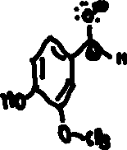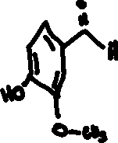

In the instance above, the aldehyde is turned into a carbocation making it a meta directors which is a deactivating group.

In this instance, a hydrogen ion is lost in the hydroxyl group resulting in the support for the ortho position. Furthermore, this results in the O- being a strong activating group, making it a O/P director.

