Webinar Internal – Career Development:

- Title:
Personal Character Quest
- Overview:
This seminar focuses on important qualities and traits that students can develop as they enter the workforce. It highlights how these attributes help create a friendly and comfortable environment for new employees or those doing on-the-job training (OJT). The seminar is interactive, allowing everyone to participate and learn more about the professional skills needed to succeed at work

- Topic Outline:
Topic 1 – D e v e l o p i n g P e r s o n a l i t y
Topic 2 – S e l f - A s s e s s m e n t
Topic 3 – Development of Traits and Character
Topic 4- Filipino Work Values Scale

- Certificate of Attendance:

- Evidence or Proof of Attendance:
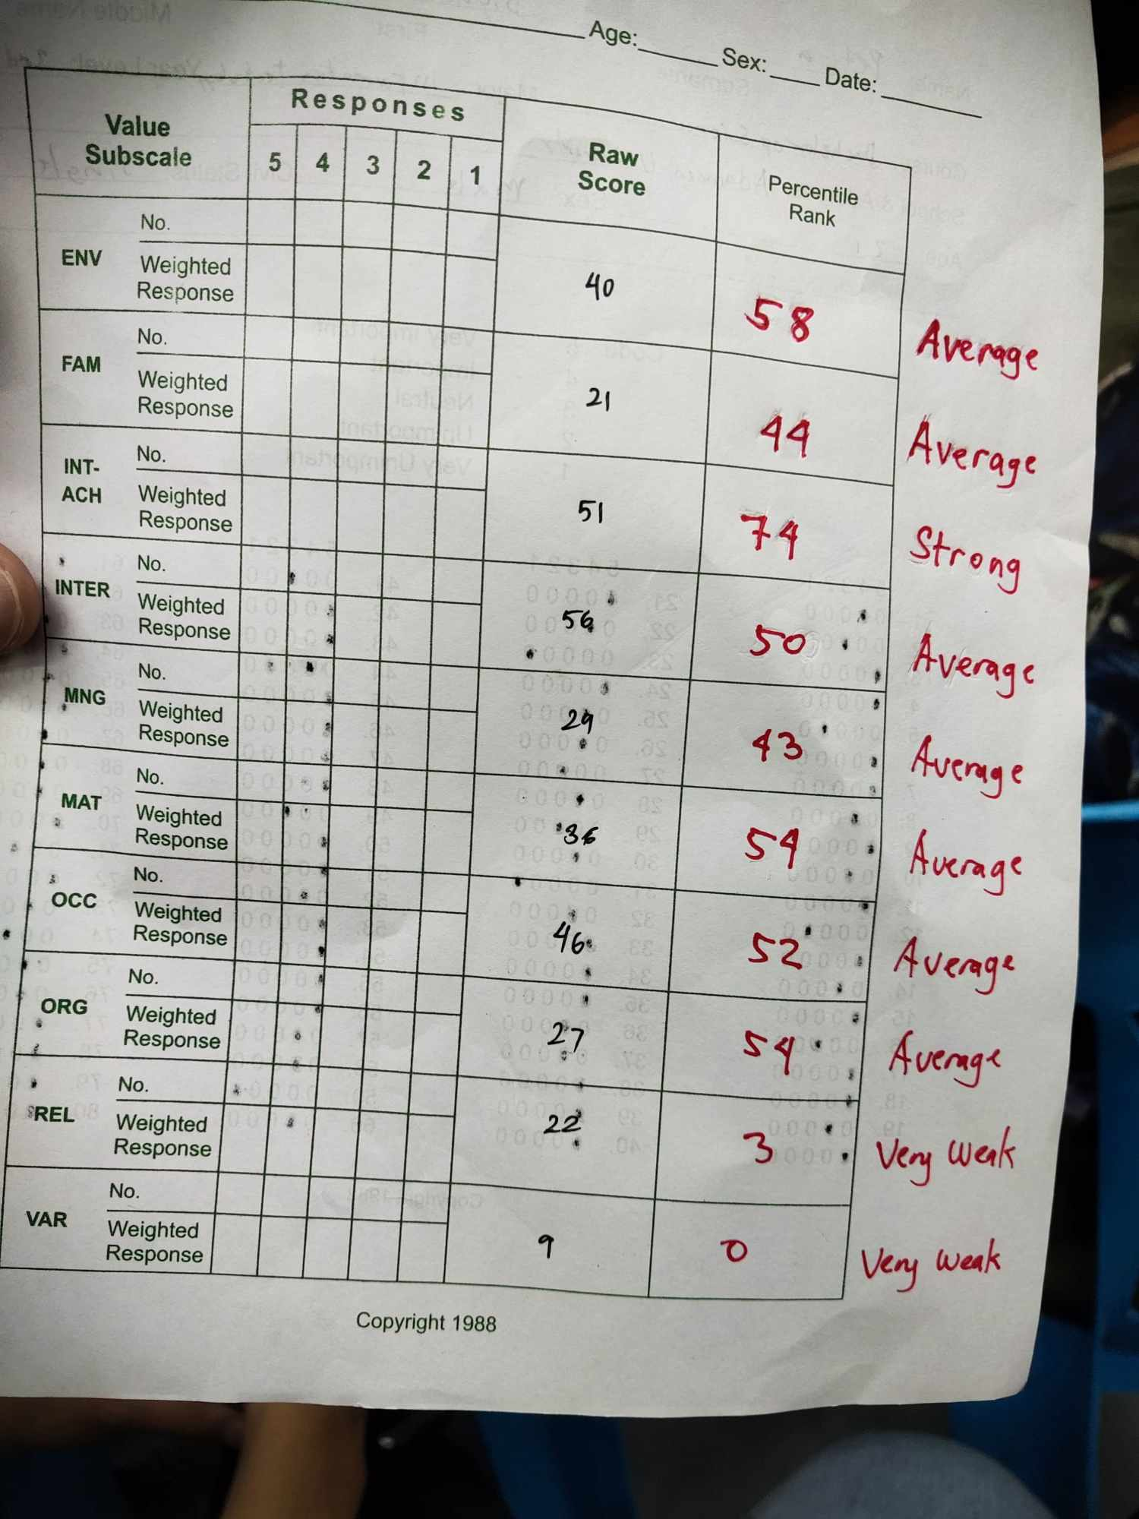

- Selfie Picture:


- Evaluation:
What have you learned in your chosen course or topic?

