Library Management System

2nd year oosd project
kobi bourne
2026
Table of contents
Cover page
• Description – SUMMARY – done
• Requirements – done
• Screenshot database tables - done
• ER Diagram – done
- Components/gui screens
• Interesting source code snippets – mostly done
• Tests - mostly done
3. Source code -
4. Database Dump -- ?
5. Project API -- ?
6. Exectuable jar file- done , might make new
Orders table = borrowing
CREATE orders = user borrows item
UPDATE orders = change borrow details
DELETE orders = return item
To do
Add final valid
Fix orders so create – one from stock of whaever item
And delete adds 1 to stock of whatever item
Check tests make sure everything works

Library Management System Project Description

The system developed for this project is an Online Library Management System. It’s designed to provide an organized way of managing library data including users, items, and orders. The user Interacts with the system through a graphical user interface connected to a database.
The system allows the admin to manage users, items, and orders using CRUD operations. Users represent registered users, items include library resources like books, dvds and games, while orders represent the borrowing and returning of items by users.
The system is built using Java. Java-Swing components are used to implement the GUI. The GUI allows users to interact with the database through forms, buttons, and tables. Data entered by the user is checked and stored in the database. Each table in the database is linked using unique identifiers(primary key).
Orders are linked to users and items through their IDs. An Inner Join is used to combine data from multiple tables, allowing meaningful information to be displayed together.
The system provides a simple interface for managing library operations, allowing data to be added, viewed, updated, and deleted easily. Error handling is included to check valid input and prevent crashes.
The styling is minimal with a white theme, simple sizing and spacing and a logo.
Overall, the Library Management System shows how object-oriented programming, database integration, and GUI design can be used together to create a simple and functional application.

Requirements | Functional?
The system must allow the creation of new users. | Functional
The system must allow viewing all users in the database. | Functional
The system must allow updating user details. | Functional
The system must allow deletion of users. | Functional
The system must allow the creation of new items. | Functional
The system must allow viewing all items. | Functional
The system must allow updating item details. | Functional
The system must allow deletion of items. | Functional
The system must allow the creation of new orders. | Functional
The system must allow viewing all orders. | Functional
The system must allow updating orders. | Functional
The system must allow deletion of orders. | Functional
The system must interact with the database using JDBC. | Functional
The system must provide a graphical user interface. | Functional
The GUI must support full CRUD operations through forms and tables. | Functional
The system must validate user input and prevent invalid data entry. | Functional
The system should be easy to navigate and user-friendly. | Non-Functional
The system should respond quickly to user actions. | Non-Functional
The system should maintain data integrity between database tables. | Non-Functional

Database Tables

User Table
The user table contains all user data that can be interacted with through the GUI.
Data
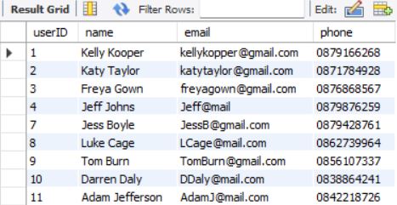

Structure
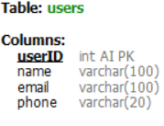

Order Table
The Order Table stores all info related to orders. It stores ItemID and UserID and is linked to the other tables via INNER JOIN
Data
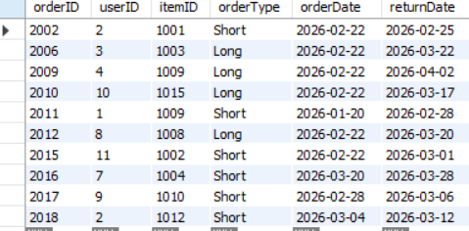

Structure
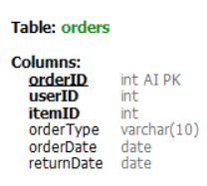

Item Table
The items table contains all item data that the user can interacts with through the GUI.
Data
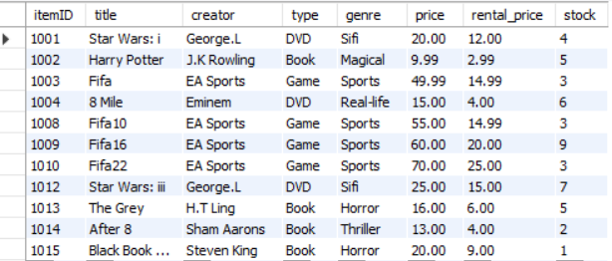

Structure
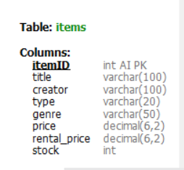

ER Diagram

This ER diagram shows the relationship between all entities within the Library Management System. First level shows all attributes with relationships labelled. Second level shows the primary keys being posted from entity to entity, and which direction iys being posted.

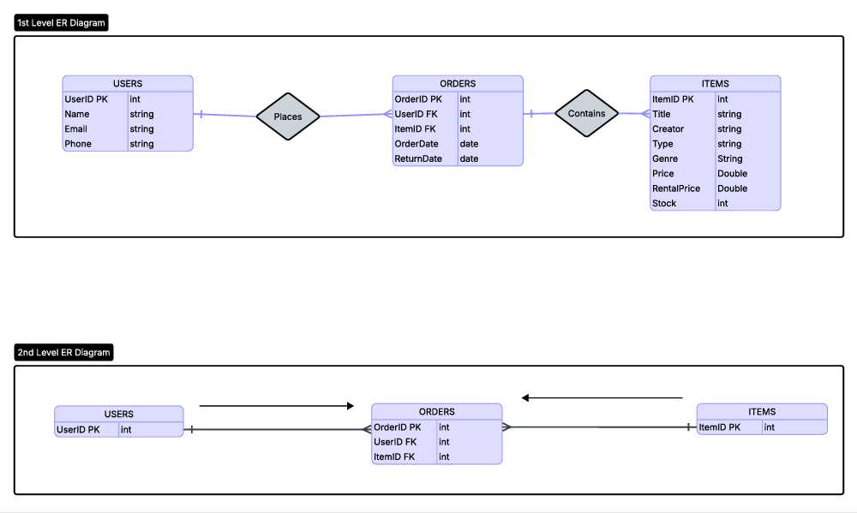

Logo



Library Management System Features
The system allows the user to add, delete, update and view data from the database tables. You can perform said actions(CRUD) through the gui for each table.
Add – add data to text fields, press add button – adds object to db and will now appear in gui table.
Delete – click on object in table, delete button, confirm deletion – object deleted from db and wont show in gui.
Update – click on object in table, change data, click update button – updates in db and gui table.
View – displays table contents on gui window opening

Interesting code snippets
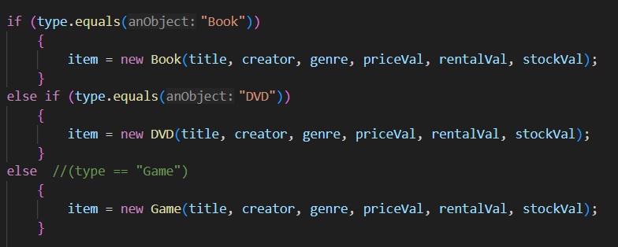
This code shows polymorphism. Based on the type stored in the database, the program creates the correct subclass (Book, DVD, or Game). This lets all objects to be treated as Item while still using their own types.

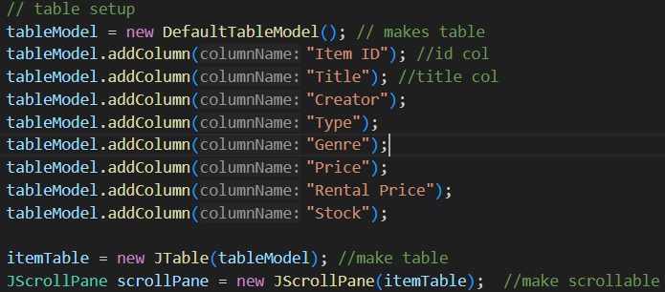
This code is used to create and display a table in the GUI. First, a DefaultTableModel is set up to define how the table is structured and columns are added. A JTable is created to show the data, and is placed inside a JScrollPane to make the table scrollable.

Maybe inner join?

Tests
Test | Input | Expected Result | Actual Result
Add valid item | Book, valid data | Item added | Passed
Empty fields | blank title | Error message | Passed
Letters in price | "abc" | Error message | Passed
Duplicate item | same title/creator | Blocked | Passed
Click table row | select item | fields populated | Passed
Delete item | select + delete | removed from table | Passed

