**Richard D. Ramos**

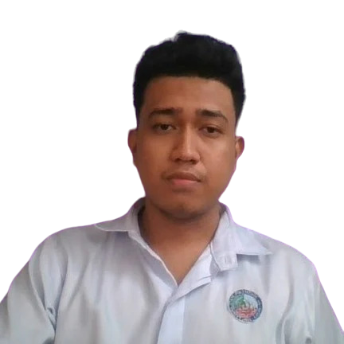

1411 J Ongkiko St., Barangay Santisima Cruz Santa Cruz, Laguna  
ramosrichard310@gmail.com  
0997-890-6269

**OBJECTIVES:**

To challenge myself and to work towards gaining more insight and experiences in a professional work setting.

To put forward a dedicated attitude towards work and be a reliable asset in the position I am to be given.

**EDUCATION**

**LAGUNA STATE POLYTECHNIC UNIVERSITY**Bachelor of Science in Information Technology - Major in Web & Mobile DevelopmentSanta Cruz, Laguna2019 – Present

**PEDRO GUEVARA MEMORIAL NATIONAL HIGHSCHOOL**  
Santa Cruz, Laguna  
2011 – 2015

**SANTISIMA CRUZ ELEMENTARY SCHOOL**  
Santa Cruz, Laguna  
2005 – 2011

**PERSONAL INFORMATION**

Date of Birth : July 22, 1999  
Place of Birth : Santa Cruz, Laguna  
Age : 23 years old  
Civil Status : Single  
Religion : Iglesia Filipina Independiente (IFI)

**SKILLS**

* Computer Literate
* Knowledge in Several Programming and Mark-up Text Languages (HTML, C#, Java, JavaScript, PHP, etc.)
* Good Time Management and Professionalism
* Basic knowledge in photo editing

**WORK EXPERIENCE**

Machine Operator  
**Samsung Electro-mechanics Philippine Corporation**In charge of operating a chip production machines and other given work related positions.  
2018 – 2019

**CHARACTER REFERENCES**

**Joseph Bueno**  
 Seaman   
 Siniloan, Laguna  
  
 **Thirdy Delos Reyes**  
 Animal Shelter Owner, Cookies Nest  
 Calauan, Laguna  
  
 **Joemar Dimaano Monedo**  
 Seaman  
 Lumban, Laguna

I hereby certify that the above information is true and correct to the best of my knowledge and belief.

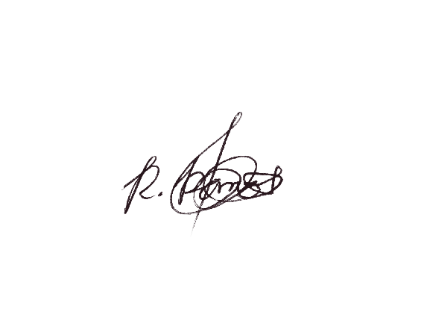

Richard D. Ramos  
 (Applicant)