Names: Kobie Thomas, Catherine Alabanza

Assignment: Project 3 (bonus assignment)

Professor Mao

Data Communications

Bonus Project

After opening the zip file and downloading the packages that are inside of package.json you will be able to run the code by typing in “node serverSide.js” and then going to the browser and typing in “localhost:9001”.

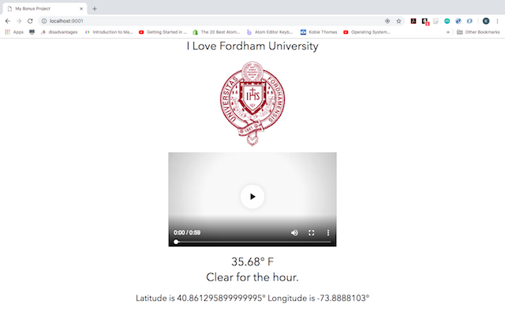

This is the result once you got to localhost:9001. In terminal there is a log of all the GET methods required to display this html file on the browser.

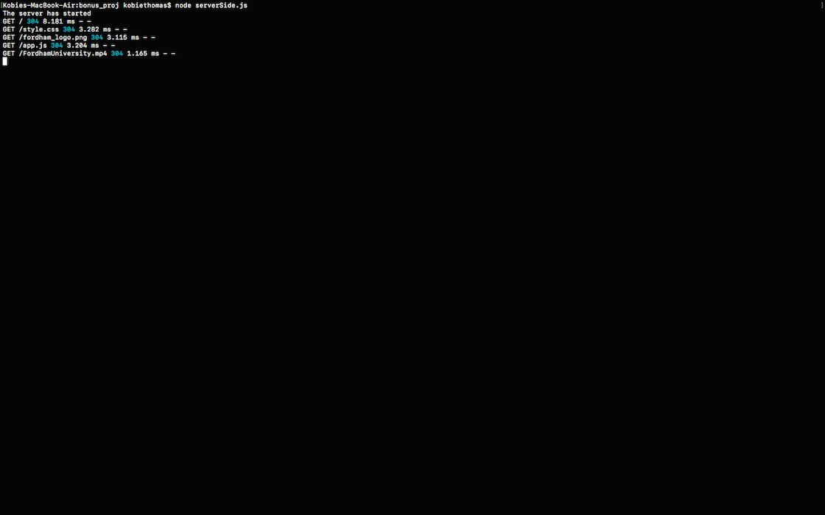

Above is a display of all the GET methods being called during the run of the application.

In the code we added a 404 status code that sends a message to the browser that there was an error if the path was unrecognizable.

