WIRELESS MOTOR SPEED CONTROL

WITH MOMENTUM SIMULATION

David Selasi Koblah

DEPARTMENT OF ELECTRICAL ENGINEERING

AUGUST 2017

ABSTRACT

This paper describes the system of microprocessor-controlled motor speed control that simulates momentum. Acceleration and braking are catered for in the system. Speed control of the vehicle is done wirelessly.

ACKNOWLEDGEMENTS

The author would like to recognize the contributions of the following individuals and groups to the success of this endeavor:

Project Group 5

Hrishikesh Das, Antony Kahumbu

Funding

Department of Electrical Engineering, Texas Tech University

Facilities Accessed

Laboratory Room 007

Tutoring and Consultation

Dr. Mark Storrs

Others

Troy Davis, Victor Obiri

TABLE OF CONTENTS

* Abstract……………………………………………………………………………1
* Acknowledgements………………………………………………………………..2
* Table of Contents………………………………………………………………….3
* List of Figures……………………………………………………………………..4
* Introduction………………………………………………………………………..5
* Preamble…………………………………………………………………………..6
* Summary of Motor Car System……………………………………………….......7
* Radio Controlled Car Chassis……………………………………………………. 8
* H-Bridge Circuit…………………………………………………………………. 9
* DC Motors……………………………………………………………………….10
* MSP430G2553 Launchpad……………………………………………………...10
* Bluetooth Smirf……………………………………………………………….…11
* Motor Movement and Control Program…………………………………………12
* Motor Control Mobile Application…………………………………………..….14
* Conclusion………………………………………………………………..……..17
* Appendices……………………………………………………………….……..18
* References………………………………………………………………....……19

LIST OF FIGURES

Figure 1: Block Diagram of System 7.

Figure 2: Bottom of Car Chassis 8.

Figure 3: Top View of Car Chassis 8.

Figure 4: H-Bridge Circuit. 9.

Figure 5: Basic H-Bridge Schematic. 10.

Figure 6: DC Motor. 11

Figure 7: DC Motor Specifications. 11

Figure 8: MSP430G2553 Pin Allocation 11

Figure 9: BlueSMiRF Top View. 12

Figure 10: BlueSMiRF Bottom View. 12

Figure 11: Flow Operation of Bluetooth Module. 12

Figure 12: Software Interaction. 13

Figure 13: Pulse Width Modulation Cycle 13

Figure 14: Code Snippet (Timers). 13

Figure 15: UART Initialisation. 14

Figure 16: Graphic User Interface. 14

Figure 17: Application Block Logic 15

Figure 18: Code Snippet (Sports Car Mode) . 16

INTRODUCTION

The advancing world relies on motors for so many purposes. From the conveyor belt on the industrial floor moving products to the next stage of the process, to the blender in the kitchen chopping tomatoes up, motors are part of our everyday lives. Engineers seek to find new ways of applying existing technologies.

The system described in this paper explains the control of a motor using various methods. Wireless control was the most efficient method of manipulation.

By the end of the activity, the system would also demonstrate momentum, acceleration and braking.

PREAMBLE

The System Was Made Up of Two Main Parts:

1. Hardware
   1. Radio Controlled Car Chassis
   2. H-Bridge Circuit
   3. DC Motors
   4. MSP430G2553 Launchpad
   5. Bluetooth Modem – Bluesmirf
2. Software
   1. Motor Movement and Control Program
   2. Motor Control Mobile Application

SUMMARY OF MOTOR CAR SYSTEM

**H - BRIDGE**

**TRANSMITTER**

**RECEIVER**

**MICROPROCESSOR**

**SMALL VEHICLE**

Figure 1: Block Diagram of System [1]

The block diagram shows a single cycle for the motor system working with the wireless control system. The transmitting device sends data to the receiving device via the wireless Bluetooth connection. This data is utilized by the microprocessor to produce a value depending on pre-programmed conditions. The H-Bridge initializes movement in the small vehicle.

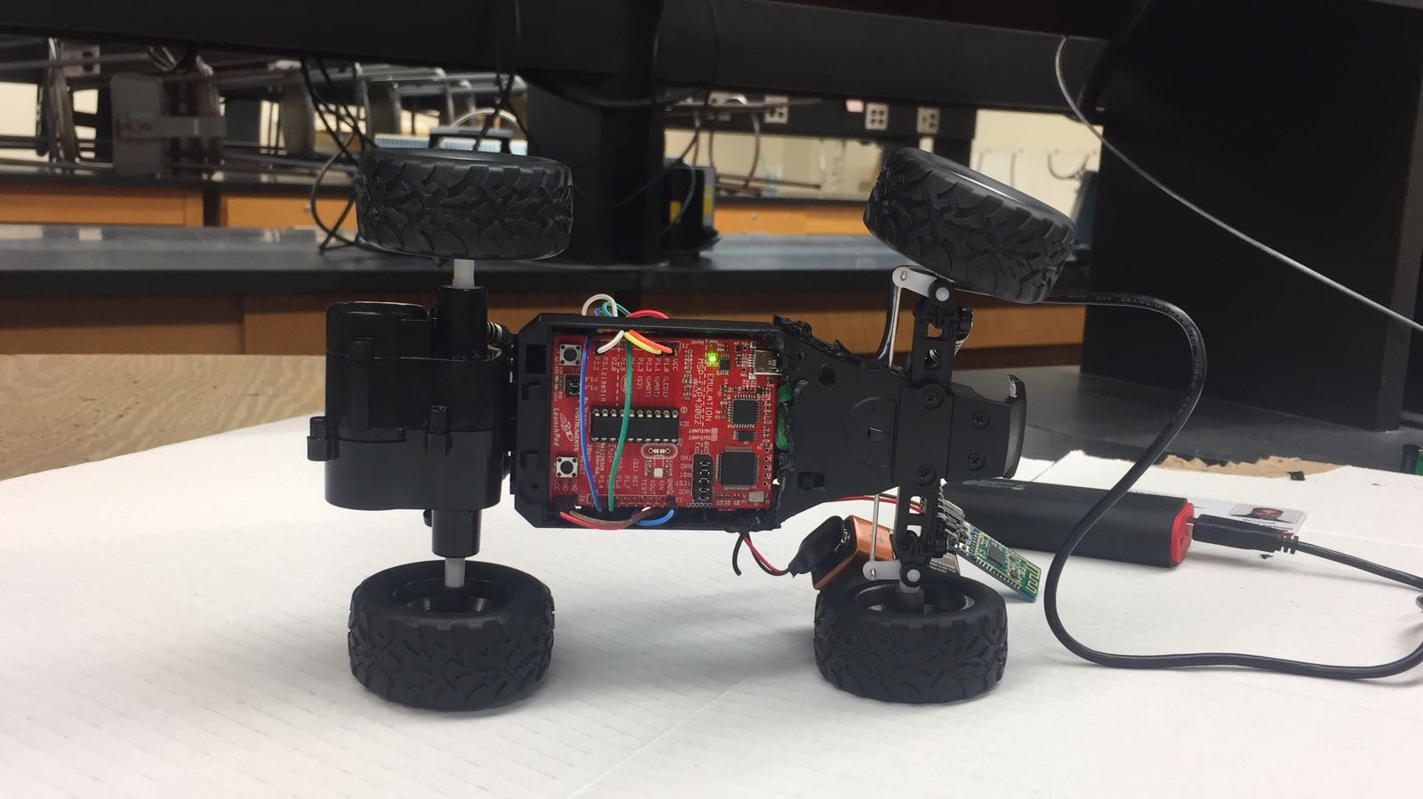RADIO-CONTROLLED CAR CHASSIS

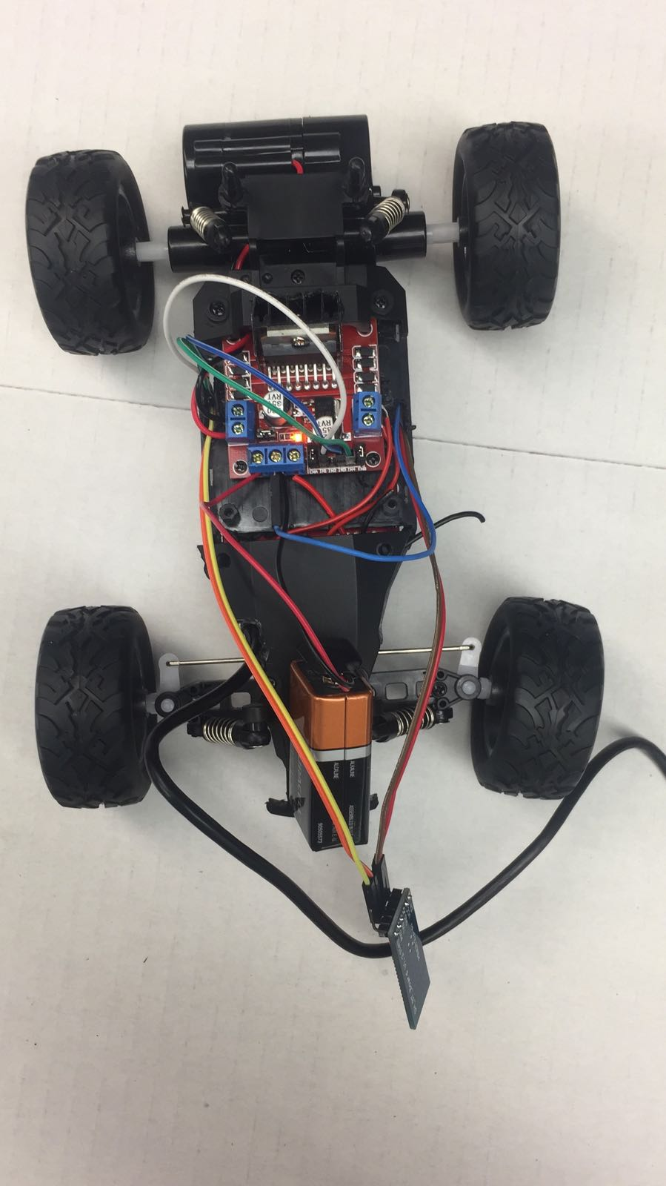

Figure 2: Bottom of Car Chassis [2]

Figure 3: Top View of Car Chassis [2]

SPECIFICATIONS

* Two-Wheel Drive
* Highest speed: 15km/h
* Dimension: 22×15×8cm
* Weight: 0.8kg

The chassis was obtained and altered to contain the MSP430G2553 and the H-Bridge circuit.

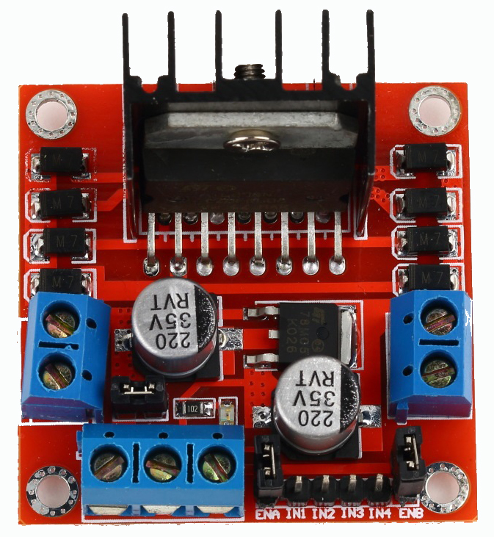H-BRIDGE CIRCUIT

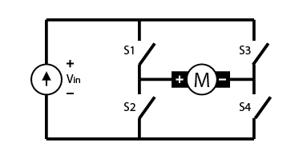

Figure 4: H-Bridge Circuit [1] Figure 5: Basic H-Bridge Schematic[3]

This circuit controls every motor movement in the motor system. IN1 allows forward movement, whiles IN2 allows backward movement. The ports at the bottom right corner are enables for two motors. Enable A controls the rear motor that allows forward movement, while Enable B is responsible for the DC motor at the front (left and right turns). The Enables are constantly on.

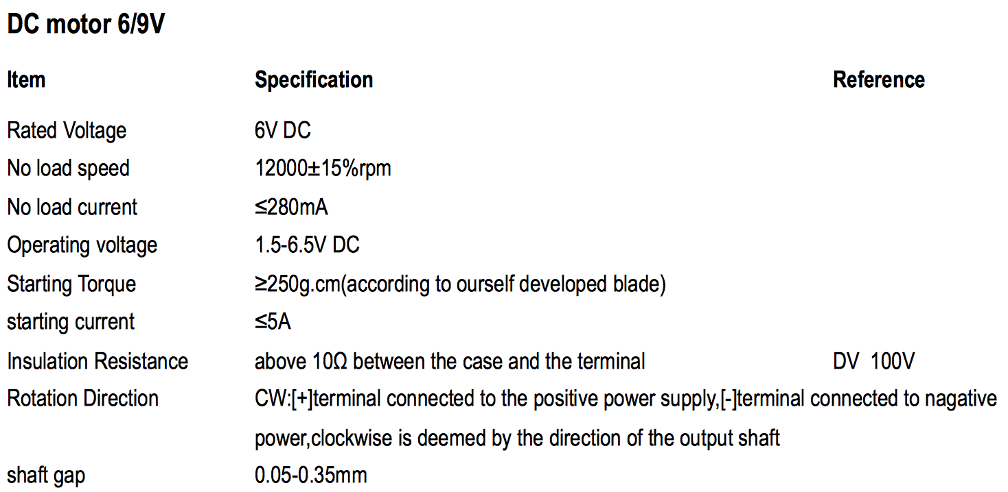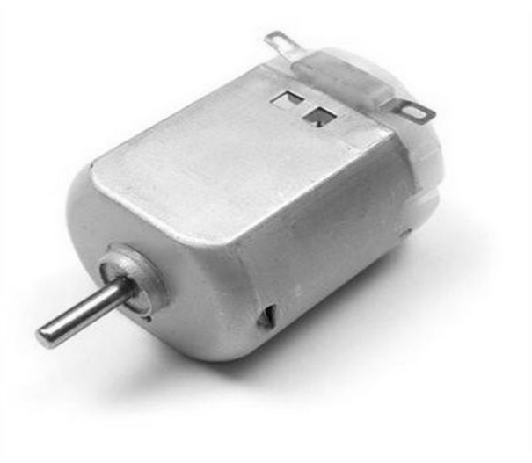DC MOTOR

Figure 6: DC Motor Figure 7: DC Motor Specifications[6]

DC Motors within the car chassis are responsible for forward and backward movement, as well as the turning mechanism of the system. The function of torque in a DC motor is to provide the mechanical output to drive the piece of equipment that the DC motor is attached to. Torque is developed in a DC motor by the armature.

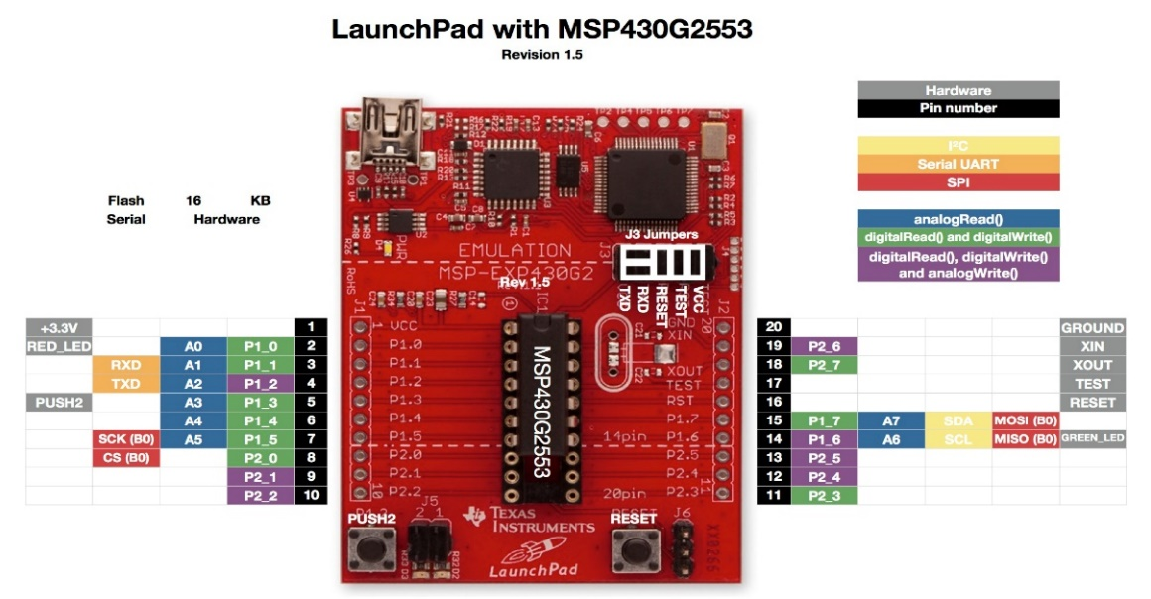MSP430G2553 LAUNCHPAD

Figure 8: MSP430G2553 Pin Allocation[7]

The microcontroller runs the entire operation. Pins 1.1 and 1.2 are used as the RX and TX pins for serial UART communication. The 256 KB flash memory is sufficient for the main program. The RX and TX pins are connected to the TX and RX of the BlueSMiRF mate Silver RN-42 respectively. Pins 2.1, 2.2, 2.4 and 2.5 are outputs of the programming.

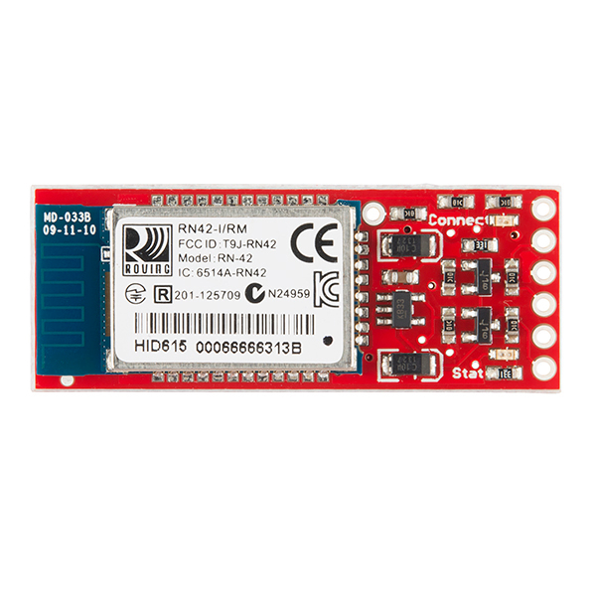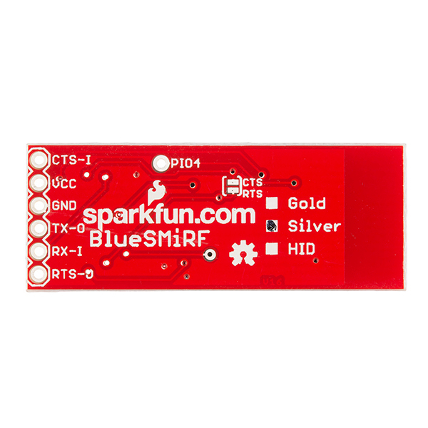BLUETOOTH MODEM – BLUESMIRF

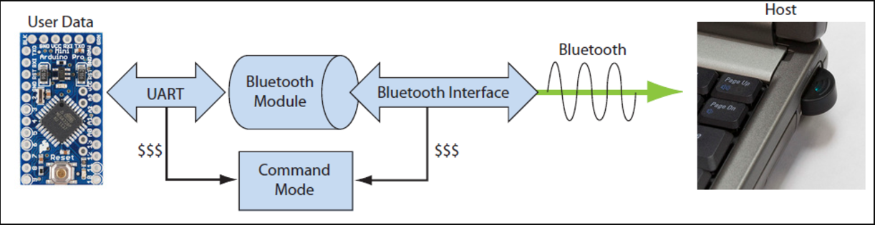Figure 9: BlueSMiRF Top View [2] Figure 10: BlueSMiRF Bottom View [2]

Figure 11: Flow Operation of Bluetooth Module [2]

In this system, the Bluetooth Module receives signals from the Bluetooth-enabled controlling device. The Bluetooth server-client relationship allows the module to receive 8-bit values from the controlling device. The Bluetooth module offers a range of about 15 meters. The brand used is the BlueSMiRF mate Silver RN-42 from Sparkfun. The BlueSMiRF was modified using a series of lettered commands in the Command Mode. The RX-I and TX-0 pins shown in Figure 9 were connected to specially-designated pins on the MSP430G2553. The operating voltage range of the device is 3.3V-6.0V.

MOTOR MOVEMENT AND CONTROL PROGRAM

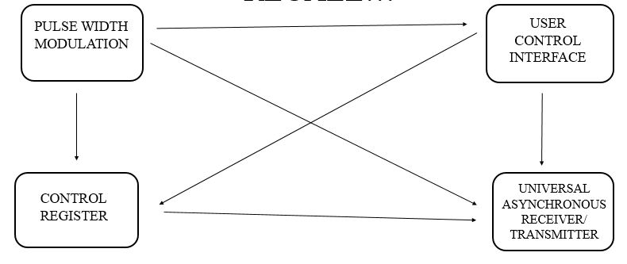

Figure 12: Software Interaction Chart [3]

The chart above describes the interaction between the various software components of the system. Pulse Width Modulation controls movement and speed in of the vehicle. The Control Registers are responsible for various functions of the device. The interrupts and data transfer are all ran by the Control Registers. User Control Interface is embedded in the controlling device. An Android application was built to control the operation of the system. The Universal Asynchronous Receiver/ Transmitter is the data transfer method used by the MSP430G2553.

Pulse Width Modulation signals generate movement in the DC Motors. They are generated via the Timer Compare Registers of the MSP430G2553. The varying speeds of the DC motors are produced by the duty cycles.

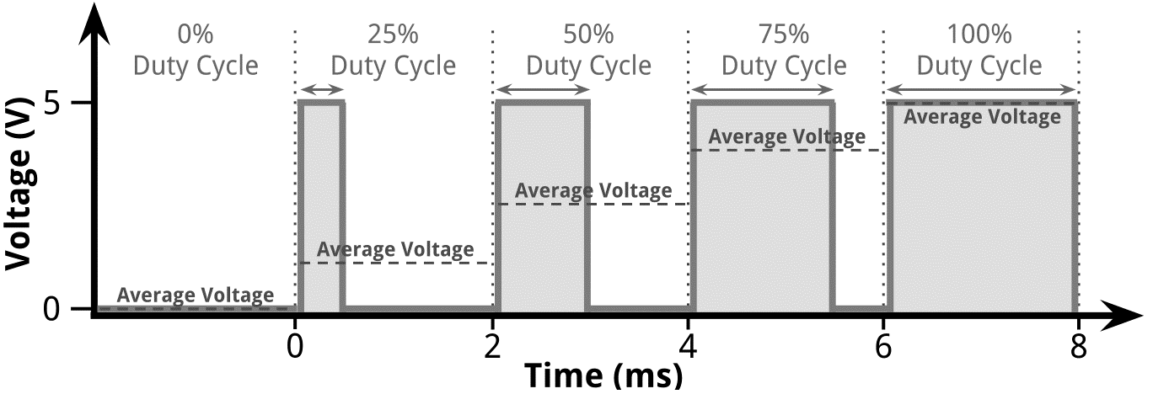

Figure 13: Pulse Width Modulation Cycle [8]

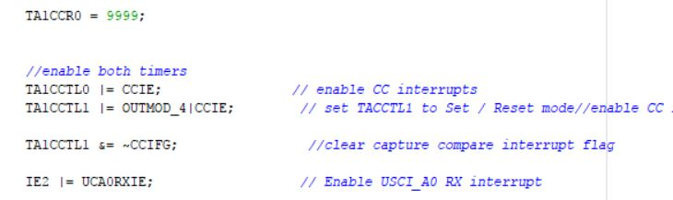

Figure 14: Code Snippet (Timers) [3]

The code snippet above shows various Control Registers. The TACCTL registers are responsible for various interrupts within the program. The changing duty cycles are implemented using the interrupts. Data reception is also done using interrupts.

The Universal Asynchronous Receiver/ Transmitter controls the exchange of data between two devices. The function is activated using registers that control serial communication. It must be noted that UART data size is 8 bits.

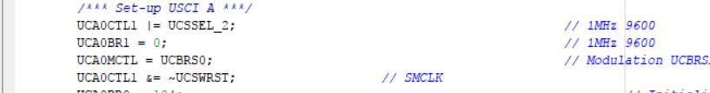

Figure 15: UART Initialization [3]

The snippet above shows the control registers used to initialize the UART and the baud rate.

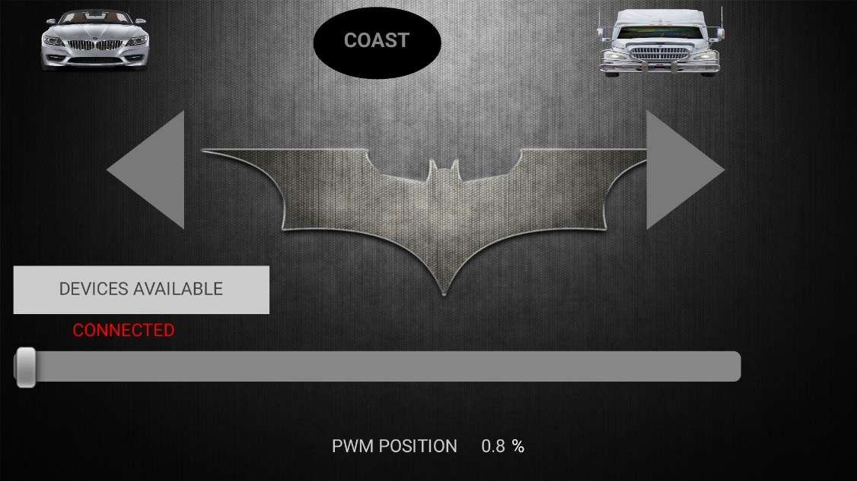MOTOR CONTROL MOBILE APPLICATION

Figure 16: Graphic User Interface [3]

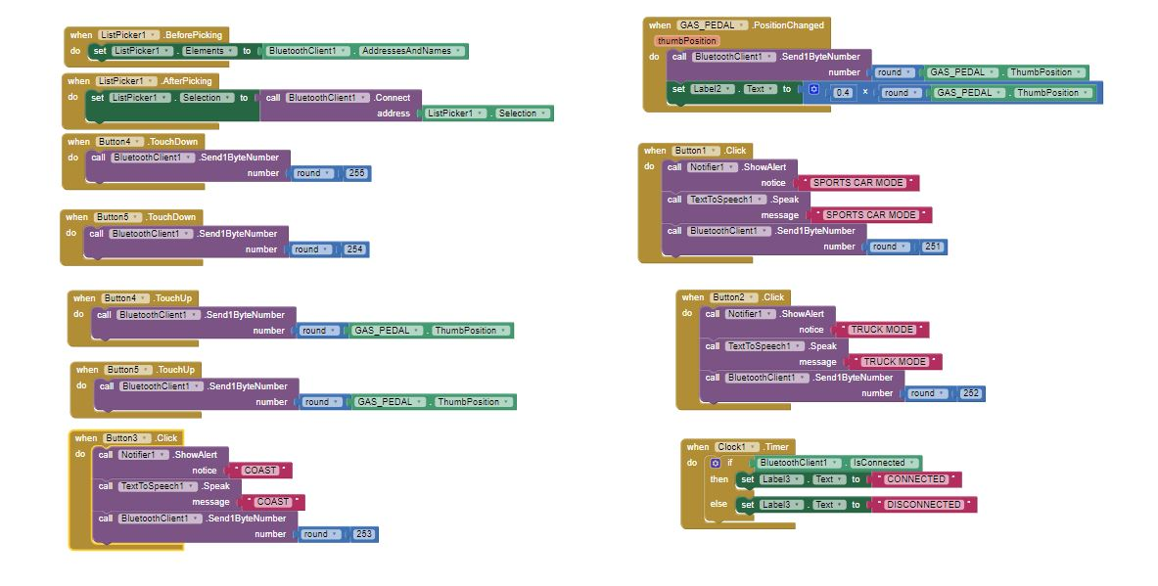

Figure 17: Application Block Logic [4]

The User Control Interface (Figure 16) is an Android application that allows total manipulation of the system. The slider at the bottom controls the Duty Cycle of the Pulse Width Modulation Signal (speed of the vehicle). The directional arrows are responsible for changing the direction of movement. The “Devices Available” button opens a list of detected Bluetooth devices. The top buttons activate various modes of operation. The sports car activates the Sports Car Mode which allows the pulse width to change at a faster rate. The truck indicates the Truck Mode, which mimics the slow speed build-up of a truck (see Appendix C for details) . The “COAST” button throws the least PWM value to the motors, causing the vehicle to slow to a stop.

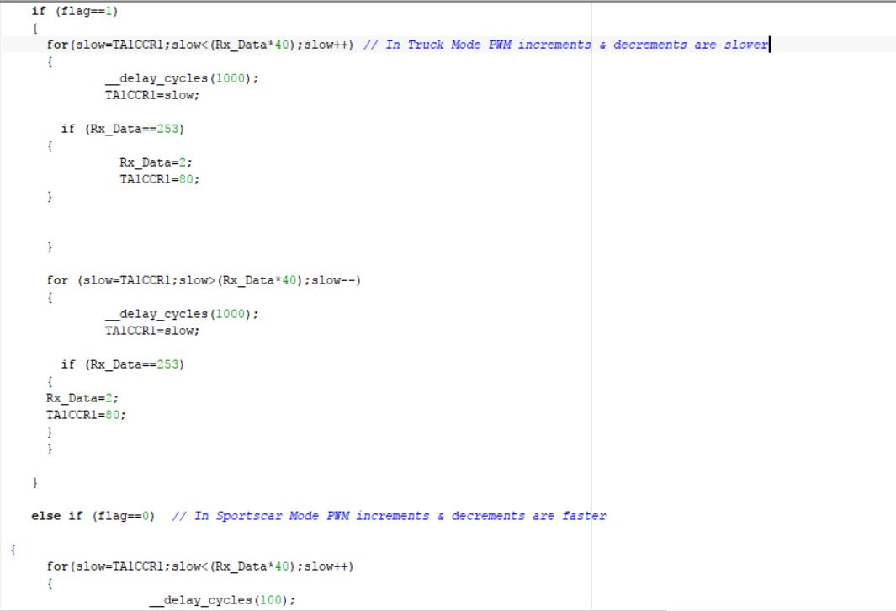

Figure 18: Code Snippet (Sports Car Mode) [3]

POWER USAGE

The MSP430G2553 was powered using a 5V rechargeable battery. A 9.6V lithium ion battery was sufficient to power the DC Motors.

CONCLUSION

The car correctly demonstrates momentum and acceleration. The Sports car and Truck modes are two good methods of showing the effects of the above-stated phenomena. The Bluetooth method of wireless control is very efficient, and allows the user to use the vehicle from moderately large distances.

APPENDICES

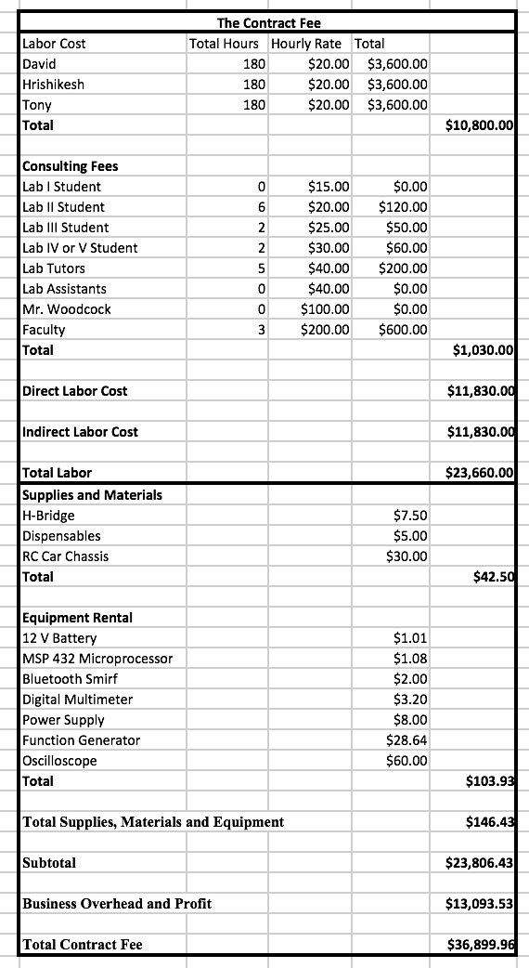Appendix A



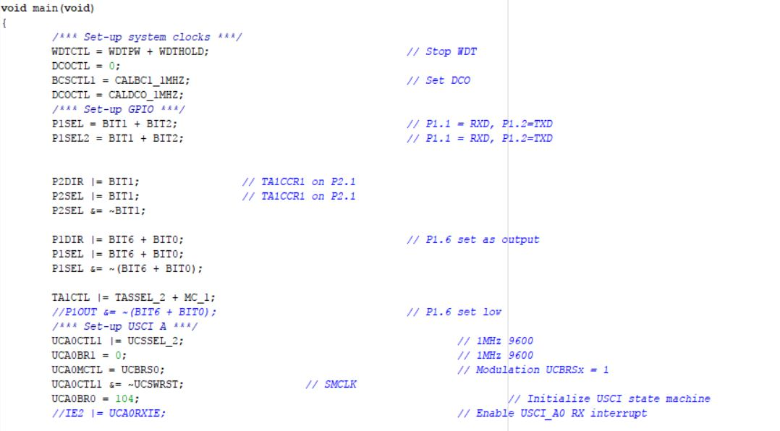Appendix B

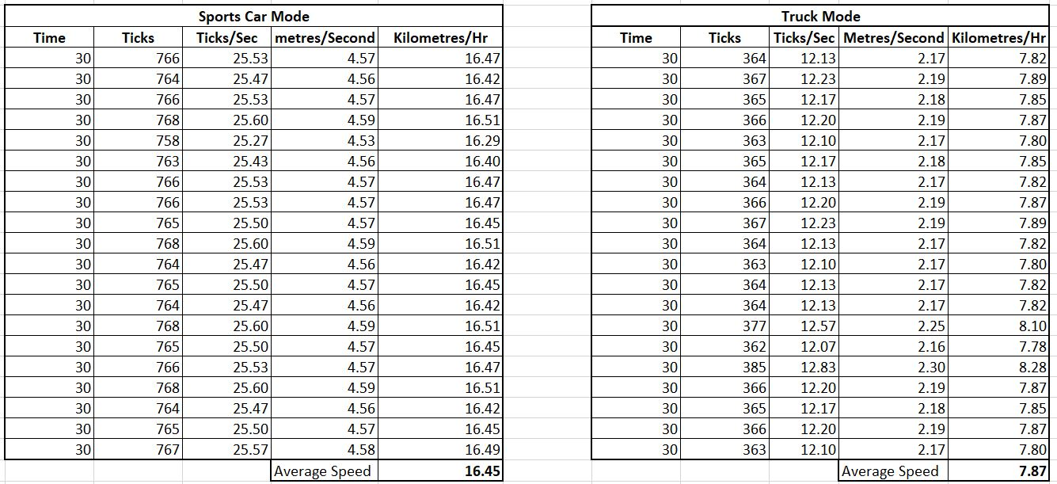Appendix C

Th table above shows various times and distances recorded for both modes using a tachometer.

Appendix D

SAFETY HAZARDS

1. Short circuits between connections to the H-Bridge and the DC Motor could cause fires. The wiring was firmly secured with screws and properly insulated.
2. The highest voltage used to test movement was a 12V, supplied by a DC Voltage station.

REFERENCES

1. Kahumbu, Antony. Weekly Presentation, June 13, 2017.
2. Das, Hrishikesh. Weekly Presentation, June 27, 2017.
3. Koblah, David Selasi. Weekly Presentation, August 1, 2017.
4. Massachusetts Institute of Technology, <http://ai2.appinventor.mit.edu/?locale=en#6432282330791936>
5. Figure 4- <https://www.sparkfun.com/products/12577>
6. Figure 7 - https://www.arduino.cc/documents/datasheets/DCmotor6_9V.pdf
7. Figure 8- <http://energia.nu/Guide_MSP430LaunchPad.html>
8. Figure 13- <http://www.hho4free.com/pulse_width_modulator__pwm.html>