3D Reconstruction of Khon Masks from Multi-View Photography Using Structure from Motion and Multi-View Stereo
  - Progress Report
Bhone Pyae San, Min Htet, Moe Myint Cho
Department of Computer Science, Assumption University of Thailand, Bangkok, Thailand
u6722178@au.edu · u6622085@au.edu · u6632730@au.edu
September 2026
Abstract—This report documents the implementation and testing carried out since the project proposal. A full classical structure-from-motion (SfM) / multi-view stereo (MVS) / Poisson surface-reconstruction pipeline has been implemented end to end and run successfully on our primary subject, a 49-photograph capture of a single gilded Khon mask (sample). The pipeline registers 40 of 49 images into a sparse model, densifies it via a CUDA hand-off through Google Colab to 105,545 points, meshes it into a 255,925-vertex textured surface, and evaluates it with reprojection error, held-out novel-view rendering, and mesh-completeness metrics. In parallel, we ran a dedicated reproducibility investigation because early runs of the default pipeline were highly unstable (5 to 46 of 49 images registered across identical re-runs). Two configuration fixes were identified and applied; they remove the catastrophic failure mode but not all run-to-run variance, and this report states that residual variance explicitly rather than presenting a single run as representative. Four ablation studies (reduced angular overlap at two levels, and reduced bundle-adjustment refinement) have also been completed. Remaining work is dominated by closing a 216° azimuth gap in camera coverage and re-running dense reconstruction at full image resolution.
Keywords—Khon, 3D reconstruction, structure from motion, multi-view stereo, photogrammetry, Poisson surface reconstruction, reproducibility, cultural heritage

I. Introduction
The project proposal outlined a plan to reconstruct a 3D digital model of a Khon mask from multi-view photographs using a classical SfM/MVS pipeline. Since that proposal, we have implemented the full pipeline described there — image ingest, sparse reconstruction, dense reconstruction, surface reconstruction, texturing, and evaluation — as a sequence of reusable stages (khon_recon/) driven by thin, config-driven scripts (scripts/00–08), and run it to completion on our primary capture. This report replaces the “planned” language of the proposal with what was actually built, what it measured, and — because this turned out to be the single largest source of engineering effort — how reliable those measurements are under repetition. Section II walks through the pipeline stage by stage as implemented. Section III reports the reproducibility investigation that now governs how every number in this report must be read. Section IV presents figures and tables from the sample run. Section V lists the concrete engineering problems encountered and how each was resolved. Section VI outlines remaining work.

II. Implemented Pipeline
Fig. 1 shows the five-stage pipeline actually executed, applied to three of the 40 registered camera viewpoints, alongside the source photograph for each. The subsections below describe what each stage does and what it produced on sample.

A. Image Acquisition and Ingest
The primary subject is 49 photographs of a single gilded Khon mask (data/raw/sample/originals), captured with a phone camera and normalised by scripts/00_prepare_images.py into data/raw/sample/images. Ingest applies Pillow’s exif_transpose and preserves the remaining EXIF (in particular FocalLength), rather than using cv2.imwrite, which would silently discard both. This matters concretely for this capture: COLMAP groups images into camera models by focal length, and with EXIF preserved it correctly forms 2 camera groups at 3024×4032 and 4284×5712 rather than one unconstrained camera per image.
An automated capture-quality probe (capture_qc.json) flagged, on the source set of 69 candidate photographs: 7 blurry frames, EXIF evidence that exposure settings (FNumber, FocalLength, ISOSpeedRatings) changed mid-capture, and 49 consecutive image pairs with fewer than 100 inlier feature matches — i.e., most of the sequence is under-overlapped relative to what dense matching prefers. The probe also confirmed mask.enabled: false is the correct setting for this capture (a genuine turntable regime was not detected).

B. Camera Pose Estimation (Structure from Motion)
SfM is implemented via pycolmap/COLMAP: SIFT feature extraction and matching, incremental mapping with bundle adjustment, and a fixed held-out split (sfm.holdout_every) that withholds every k-th image from mapping and registers it afterward with fix_existing_frames, so the held-out set is never used to build the model it is later evaluated against. On sample, 9 of 49 images were held out; of the 40 used for mapping, all 40 registered, producing 2,940 3D points from 14,653 observations (mean track length 4.98 views/point). Two determinism fixes — sfm.multiple_models=true and sfm.mapper_num_threads=1 — are applied; their necessity is the subject of Section III.

C. Dense Reconstruction
COLMAP’s patch_match_stereo is CUDA-only, and this pipeline is developed on Apple Silicon, which has no local CUDA. scripts/02_dense_export.py packages the sparse model and undistorted images for notebooks/colmap_dense_colab.ipynb, which performs dense stereo matching and fusion on a Colab GPU; scripts/03_dense_import.py brings fused.ply back and verifies it against the sparse model (centroid offset 0.49, a 6.2% relative shift, both within tolerance). The resulting dense cloud for sample has 105,545 points with colors and per-point normals from COLMAP’s fusion — normals we deliberately keep rather than re-estimating, since tangent-plane orientation from open3d.estimate_normals is only consistent up to a global sign and would need to be corrected against the camera centres regardless.

D. Surface Reconstruction (Poisson Meshing)
Before meshing, statistical outlier removal discards 1.2% of points as flyers, and a largest-connected-component cluster filter removes a further 5.3% (54 clusters found; the largest kept) — mostly detached tabletop fragments near the mask’s base. This ordering matters: run after Poisson instead of before, the skirt and the mask fuse into one connected component and can no longer be separated this way.
Open3D 0.19’s bundled Poisson implementation aborts the whole process (not a catchable Python exception) on roughly a quarter to a third of runs; mesh.py isolates the call in a child process and treats a missing output file, not a nonzero exit code, as failure, retrying up to mesh.poisson_max_attempts times. Passing n_threads to Poisson — at any value, including its own documented default — was tested and found to raise the crash rate to 100%, so it is never set. At depth 10, this produced 275,212 raw vertices; density-based trimming (removing the lowest-density 6% of the implicit surface) brought this to 255,925 vertices and 506,860 triangles after cleaning, with an outward-normal fraction of 0.985 (comfortably above the 0.5 sanity floor that would flag an inside-out mesh) and a surface area of 8.72 m² in the reconstruction’s own (non-metric) scale. The mesh is not watertight — 55 holes remain, with a combined boundary perimeter of 47.8 — consistent with a single-sided capture that does not observe the underside of the mask.
Because COLMAP’s world frame inherits the camera convention (+Y down), the canonical mesh.ply renders upside-down in ordinary viewers; a second file, mesh_upright.ply, is written in parallel, rotated Y-up using a transform recovered from the camera poses rather than the mesh geometry, purely for external viewing. All ray-casting evaluation in Section II-F is performed on the canonical (non-rotated) mesh, in the frame the cameras were actually estimated in.

E. Texturing
Vertex colors are recovered by projecting each mesh vertex into every camera that can see it — filtered by a maximum view angle of 70° and a visibility (occlusion) test against the mesh itself — and taking the per-channel median across the surviving views, which is more robust to specular highlights on the gilded surface than a mean blend would be. On sample, the median vertex is seen from 22 views (mean 23.6); only 0.98% of vertices are unseen by any qualifying camera, which is the metric we watch for a broken-normals regression, since an inside-out mesh would fail visibility for nearly every vertex instead.

F. Evaluation
scripts/06_evaluate.py computes: reprojection error, recomputed directly from observations (metrics.reprojection_errors()) rather than read from COLMAP’s cached bundle-adjustment value, which goes stale once held-out views are registered afterward; camera coverage (azimuth/elevation span and gaps); dense-point-cloud density; mesh completeness; held-out novel-view PSNR/SSIM via headless ray-casting (open3d.t.geometry.RaycastingScene); and a specularity-vs-reconstruction-density correlation study. Section IV reports the resulting numbers and figures for sample.

G. Ablation Studies
scripts/07_ablations.py re-runs the pipeline from a fresh database under three configuration changes — subsampling every 2nd image (overlap_half), every 3rd image (overlap_third), and reducing bundle-adjustment refinement iterations to 1 (minimal_ba) — each compared against its own full control built under the same fresh-database conditions, not against the main sample run, per the reproducibility finding in Section III. PSNR/SSIM were not computed per ablation variant, since re-running the dense/mesh/texture stages for every variant is substantially more expensive than the SfM-level comparison; this is noted as a gap in Section VI.

III. Reproducibility Investigation
Correctness on a single run is not sufficient for this project, because early testing showed the pipeline’s central number — how many of the 49 images register — is highly sensitive to run-to-run nondeterminism that has nothing to do with the input photographs.
Finding 1 — catastrophic instability at defaults. Five identical runs of scripts/01_sfm.py (same database.db, same config, defaults for sfm.multiple_models and sfm.mapper_num_threads) registered 41, 34, 46, 5, and 45 of 49 images — a coefficient of variation of 49.7%. The 5/49 collapse and the spread among the others were traced to two causes: multiple_models=False lets one bad seed pair terminate the reconstruction early, and multi-threaded bundle adjustment reduces observations in nondeterministic order.
Finding 2 — the fix, and its limit. Setting sfm.multiple_models=true and sfm.mapper_num_threads=1 gives bit-identical reruns from a fixed database — verified by re-mapping sample_full and reproducing 36 images / 2,387 points / 1.1766 px reprojection error exactly. It does not give bit-identical results from a fresh feature extraction: four independent runs with identical config, each building its own database, registered 40, 36, 45 and 35 of 49 images (mean 39, CV 11.7%), with reprojection error far more stable at CV 5.5%. The match graph itself shifts slightly between extractions, and incremental mapping amplifies that shift.
Consequence for this report. Every registration count quoted here for sample (40/49) is a single draw from that ~12%-CV distribution, not a fixed property of the capture. We report it alongside this spread rather than alone, and we do not read small differences between ablation variants and the main run as meaningful, since — per Table II — the ablations’ own full control (36/49, fresh database) already differs from sample’s 40/49 under identical settings.

IV. Sample Run Results
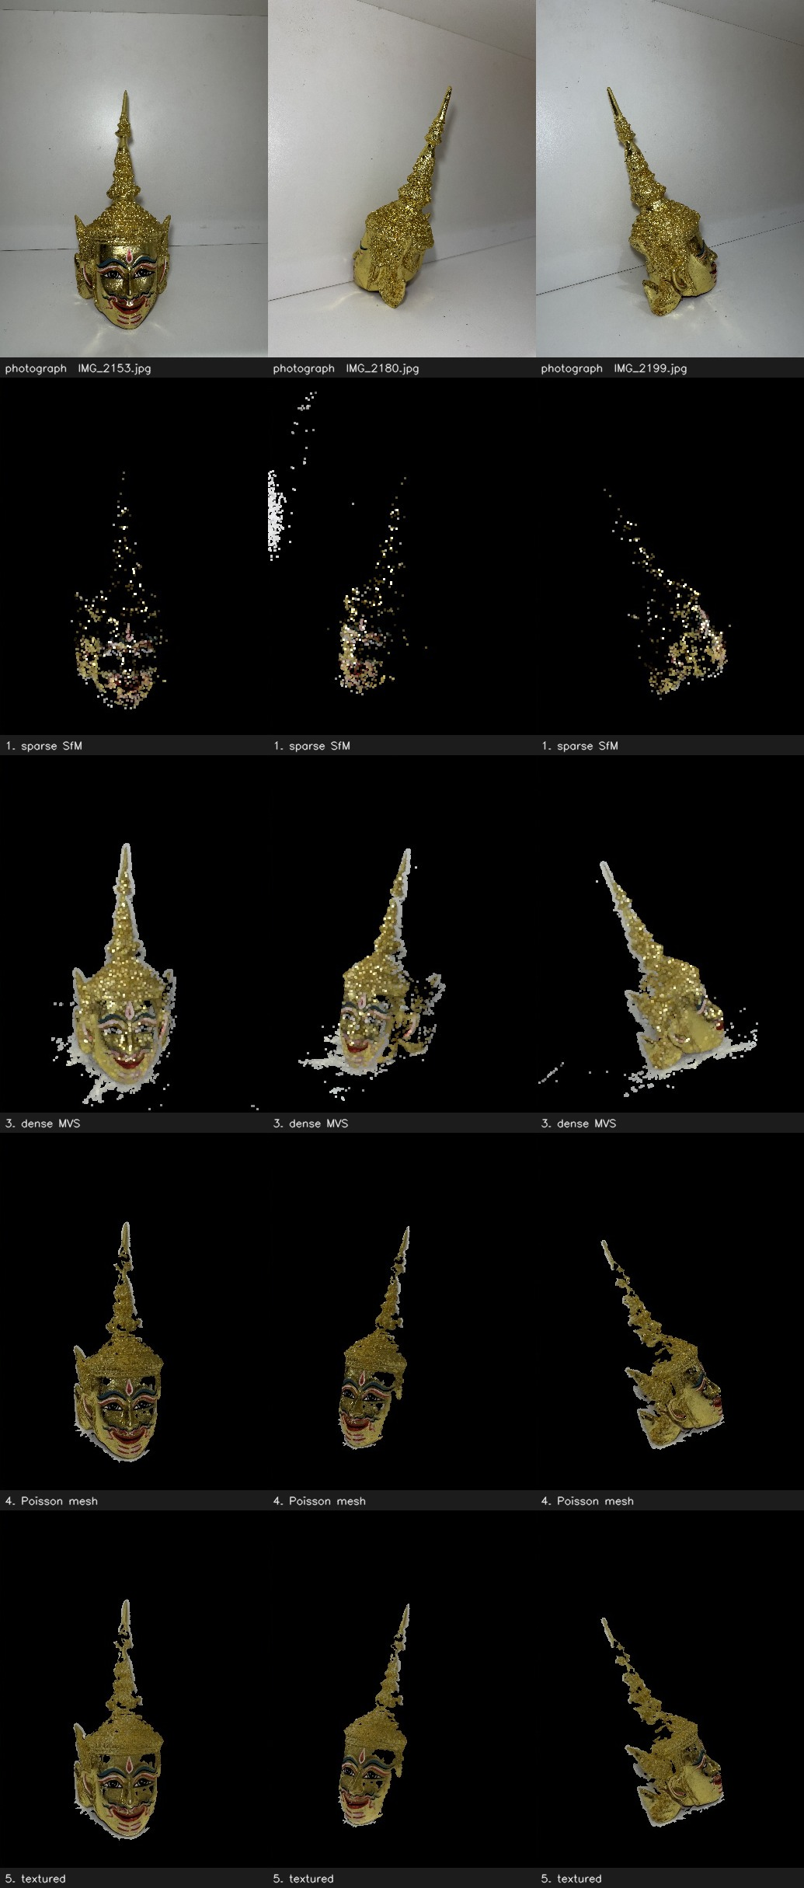
Fig. 1. Photograph, then output at each implemented stage, for three of the 40 registered sample camera viewpoints. Rows: source photograph; sparse SfM point cloud; dense MVS point cloud (Colab hand-off); Poisson mesh (depth 10, largest-cluster filtered); textured mesh (median vertex-color blend).
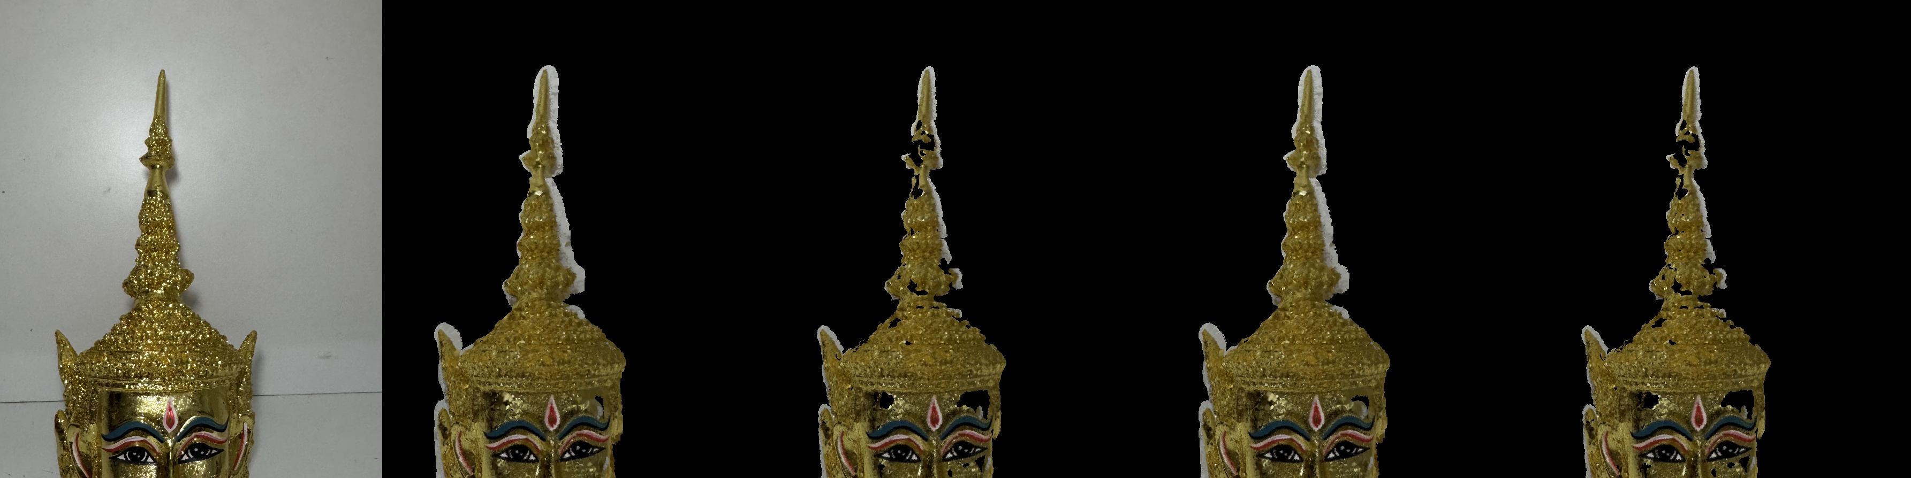
Fig. 2. Poisson reconstruction depth/trim sweep, one registered viewpoint: increasing depth and trim percentage trades hole count against invented (unsupported) surface area. Depth 10 / trim 6% (55 holes, 1.8% invented) is the configuration used for sample.
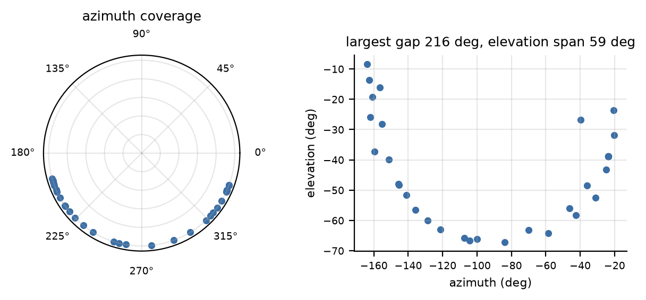
Fig. 3. Camera coverage for sample: azimuth (polar, left) and elevation vs. azimuth (right). Azimuth span 143.8 deg, largest gap 216.2 deg, elevation span 58.8 deg.
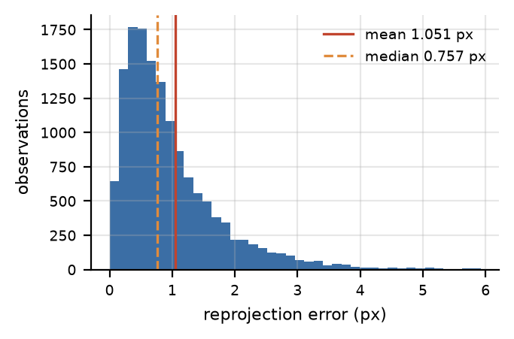
Fig. 4. Distribution of recomputed per-observation reprojection error, 14,653 observations.
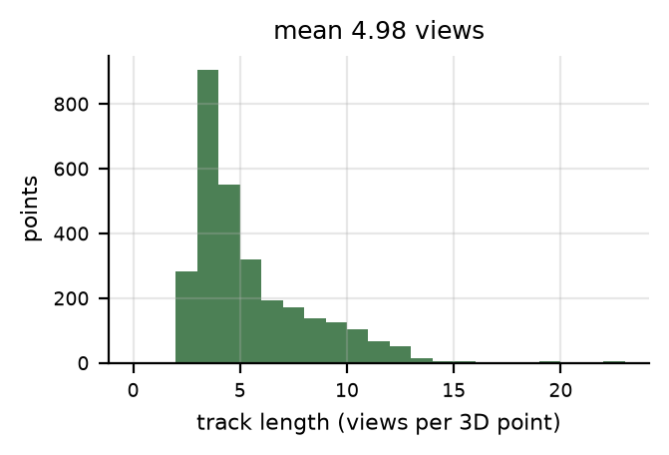
Fig. 5. Distribution of track length (views per 3D point) across 2,940 points.
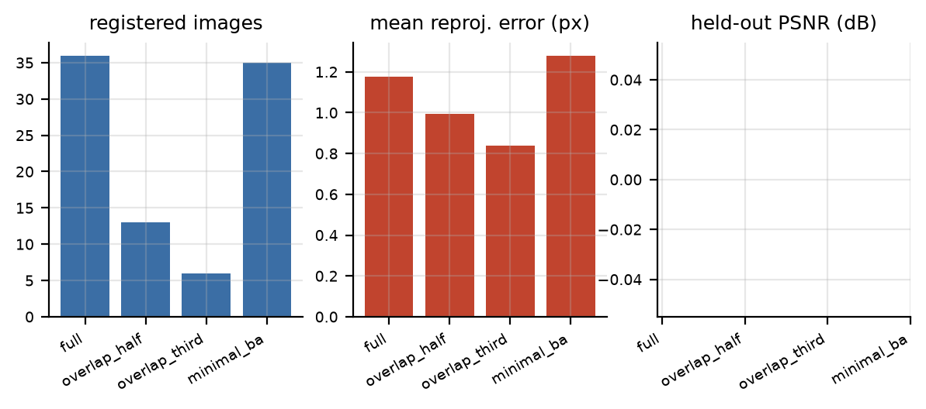
Fig. 6. Reduced-overlap and reduced-BA ablations against their own fresh-database full control (registered images, left; reprojection error, center). The held-out-PSNR panel, right, is empty because novel-view rendering was not re-run per ablation (Section II-G).
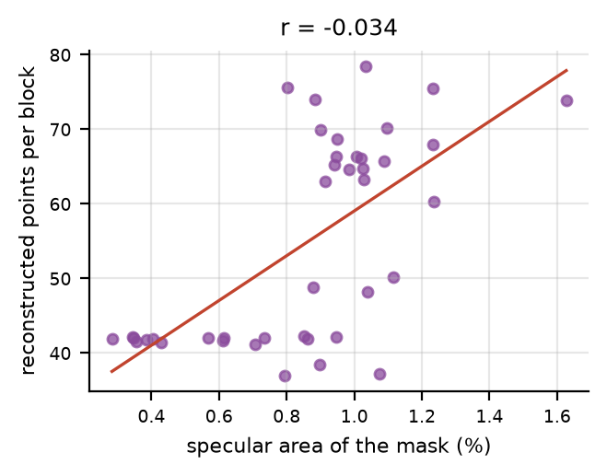
Fig. 7. Specularity-vs-density correlation (r = -0.034), 82,157 image blocks across 40 images: reconstruction density on the gilded mask is not meaningfully explained by local specular highlighting in this capture.
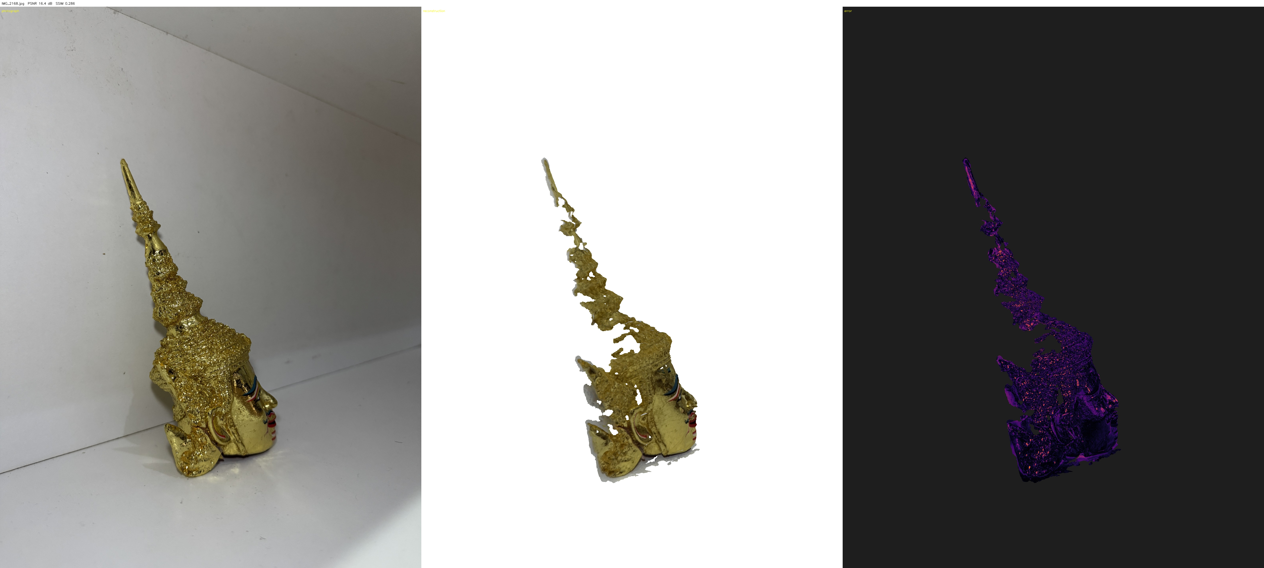
Fig. 8. Held-out view IMG_2168, never used in mapping: captured photograph, ray-cast render from the recovered camera pose, and per-pixel error map (PSNR 16.4 dB, SSIM 0.286). The reconstructed geometry is recognisable but visibly incomplete at this azimuth, consistent with the coverage gap in Fig. 3 – no processing step can recover surface that was never photographed.
TABLE I. RECONSTRUCTION PIPELINE STAGES AND TOOLS
Stage | Method | Output | Tool
Sparse | SIFT matching, incremental SfM, bundle adjustment | Camera poses + sparse cloud | COLMAP (local)
Dense | Patch-match multi-view stereo | Dense point cloud | COLMAP (Colab, CUDA)
Surface | Cluster filter, Poisson reconstruction | Textured mesh | Open3D
TABLE II. SAMPLE RUN SUMMARY vs. ABLATION VARIANTS (each control is its own fresh database — not directly comparable to sample; see Section III)
Run | Registered / 49 | Points3D | Mean reproj. (px) | Mean track len. | Largest az. gap
sample (main) | 40 | 2,940 | 1.051 | 4.98 | 216.2°
full (ablation ctrl.) | 36 | 2,387 | 1.177 | 4.50 | 214.5°
overlap_half | 13 | 462 | 0.994 | 3.98 | 246.9°
overlap_third | 6 | 148 | 0.837 | 3.09 | 229.5°
minimal_ba | 35 | 1,776 | 1.280 | 4.04 | 241.2°
TABLE III. MESH, TEXTURE AND HELD-OUT EVALUATION (sample)
Metric | Value
Dense points (fused.ply) | 105,545
Mesh vertices / triangles | 255,925 / 506,860
Outward-normal fraction | 0.985
Holes / boundary edges | 55 / 5,116
Watertight | No
Unseen-vertex fraction (texture) | 0.98%
Mean views per vertex | 23.6
Held-out PSNR / SSIM | 16.73 dB / 0.364
Train PSNR / SSIM | 15.67 dB / 0.363

V. Engineering Problems Found and Resolved
The following were discovered empirically during implementation, each with a measured before/after, and are now encoded as config defaults or guards rather than left as tribal knowledge:
- Masking hurts this capture. The gilded surface yields few matchable SIFT features, so the background carries most of the geometry (only ~40% of sparse points lie on the mask). Enabling background masking dropped usable pairs from 21.9% to 1.7% and registration to 3/66 on a companion set; mask.enabled is false for sample.
- COLMAP’s cached reprojection error under-reports once held-out views are added. 0.362 px vs. the true recomputed 0.402 px in one comparison; the pipeline now always recomputes.
- Normal orientation is not cosmetic. An inward-oriented mesh renders plausibly but is self-occluded almost everywhere during texturing; COLMAP’s fused normals are used directly rather than re-estimated.
- Poisson’s n_threads argument is actively harmful, raising an unrelated crash’s rate from ~25–33% to 100% at every tested value.
- Ingest must not run in place (the destination would need clearing, risking the only copies of the photographs) and must not use cv2.imwrite, which discards EXIF and broke camera grouping (2 → 49 cameras) before this was caught.
- Merging captures where the object moved is not recoverable. Attempting to merge 20 face-down shots into sample registered 0 of them and dropped the original registration from 45/49 to 34/49.
- Dense reconstruction currently runs at dense.max_image_size: 1600, roughly a third of the captured 4032–5712 px resolution — the leading, and cheapest to fix, cause of the 105,545-point dense cloud being sparser than the source imagery supports.

VI. Remaining Work
Two items dominate what is left before the paper’s final figures and tables can be produced. First, the 216° azimuth gap (Fig. 3) is a coverage problem no processing step can fix — closing it requires an additional capture pass around the mask’s presently unphotographed side, and its effect is directly visible as incomplete geometry in the held-out render in Fig. 8. Second, re-running dense reconstruction at a higher dense.max_image_size needs no reshoot, only another Colab pass, and is expected to meaningfully increase dense point count. Beyond these, per-ablation novel-view PSNR/SSIM (Section II-G) and a short additional reproducibility sweep at the higher resolution are planned before final numbers are written into the paper, together with the previously proposed exploration of specular/cross-polarised lighting and a Gaussian-splatting comparison as future work.

VII. Conclusion
Since the proposal, the full SfM–MVS–Poisson–texture–evaluation pipeline has been implemented and exercised on our primary Khon mask capture, together with a reproducibility investigation that this report treats as a first-class result rather than a caveat: the pipeline’s headline registration count varies by roughly ±12% CV even under a fixed, tuned configuration, and every number in this report is presented with that in mind. The remaining gaps — camera coverage and dense-image resolution — are both identified, measured, and addressed by concrete next steps rather than open questions.

References
- Wikipedia contributors, “Khon,” Wikipedia, The Free Encyclopedia. [Online]. Available: https://en.wikipedia.org/wiki/Khon
- UNESCO, “Khon, masked dance drama in Thailand,” Representative List of the Intangible Cultural Heritage of Humanity, 2018.
- Department of Cultural Promotion, Ministry of Culture, Thailand, “Khon, the Khon Masked Dance-Drama in Thailand,” UNESCO Multimedia Archives, 2017.
- M. L. Robertson, “Khon Masks of Thailand,” SEAsite, Northern Illinois University.
- J. L. Schönberger and J.-M. Frahm, “Structure-from-motion revisited,” in Proc. IEEE Conf. Comput. Vis. Pattern Recognit. (CVPR), 2016, pp. 4104–4113.
- J. L. Schönberger, E. Zheng, M. Pollefeys, and J.-M. Frahm, “Pixelwise view selection for unstructured multi-view stereo,” in Proc. Eur. Conf. Comput. Vis. (ECCV), 2016, pp. 501–518.
- M. Kazhdan, M. Bolitho, and H. Hoppe, “Poisson surface reconstruction,” in Proc. Eurographics Symp. Geometry Process., 2006, pp. 61–70.

