Koby Samuel

iOS Application Development

11/9/15

Activity 1 for App 14

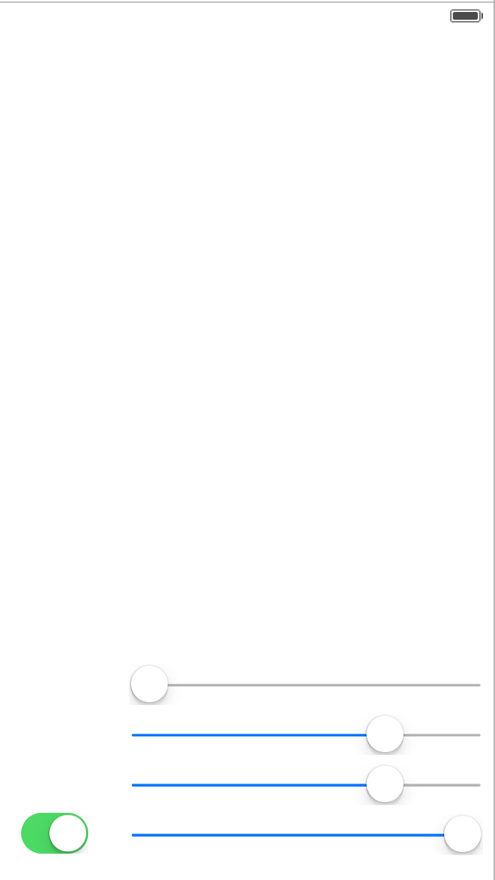

Slider to edit hue values

Slider to edit saturation values

Slider to edit brightness values

Slider to edit alpha levels

Button to enable hue editing