Koby Samuel

iOS Application Development

10/12/15

Activities 1 and 2 for App 3

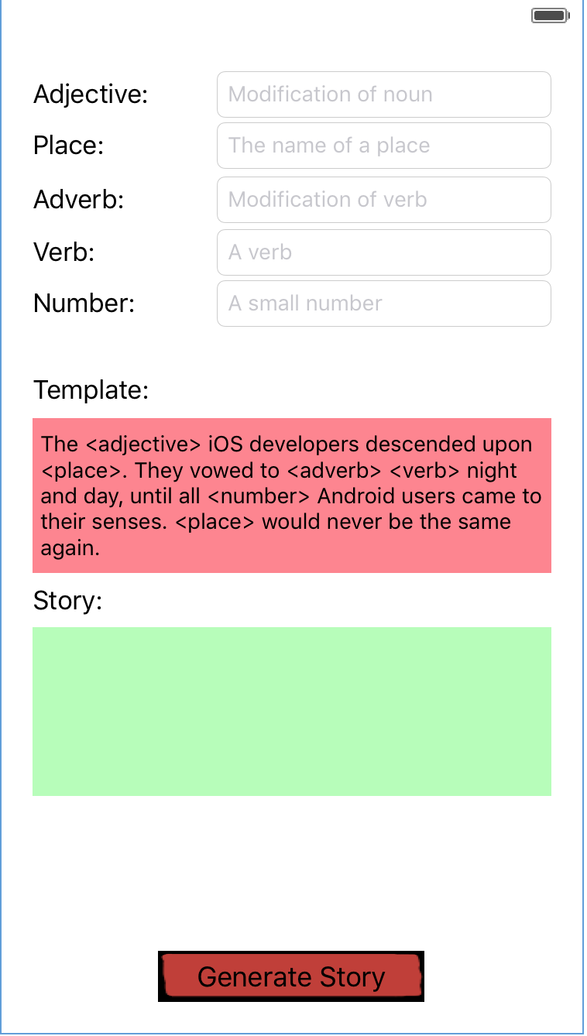Text field to replace

<adjective>

Place where template with replaced text appears

Button to replace fields with text

Text field to replace <number>

Text field to replace <verb>

Text field to replace <adverb>

Text field to replace <place>