Koby Samuel

iOS Application Development

10/12/15

Activities 1 and 2 for App 4

Hops per second, determined by slider value 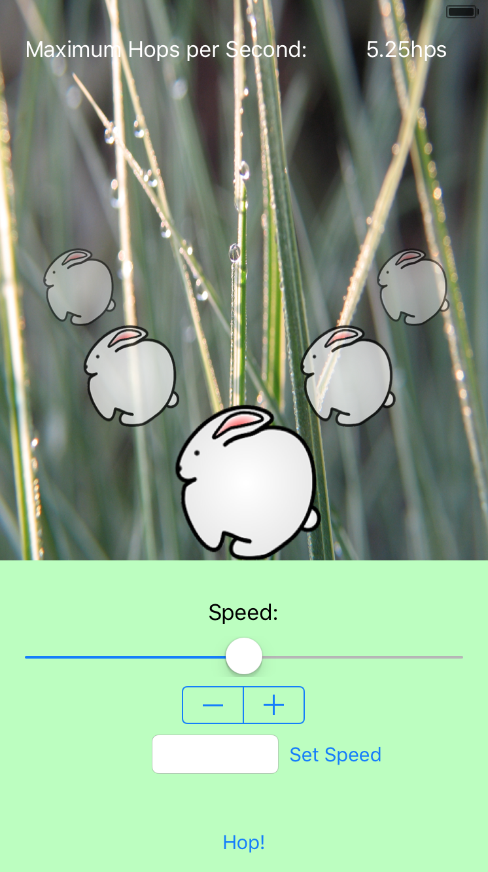

Button to set animation speed to slider value

Button to set animation speed to text field value

Text field to affect animation speed

Stepper to affect animation speed

Slider to affect animation speed

Bunnies