Koby Samuel

iOS Application Development

11/9/15

Activity 2 for App 11

Number of “pushes” by user

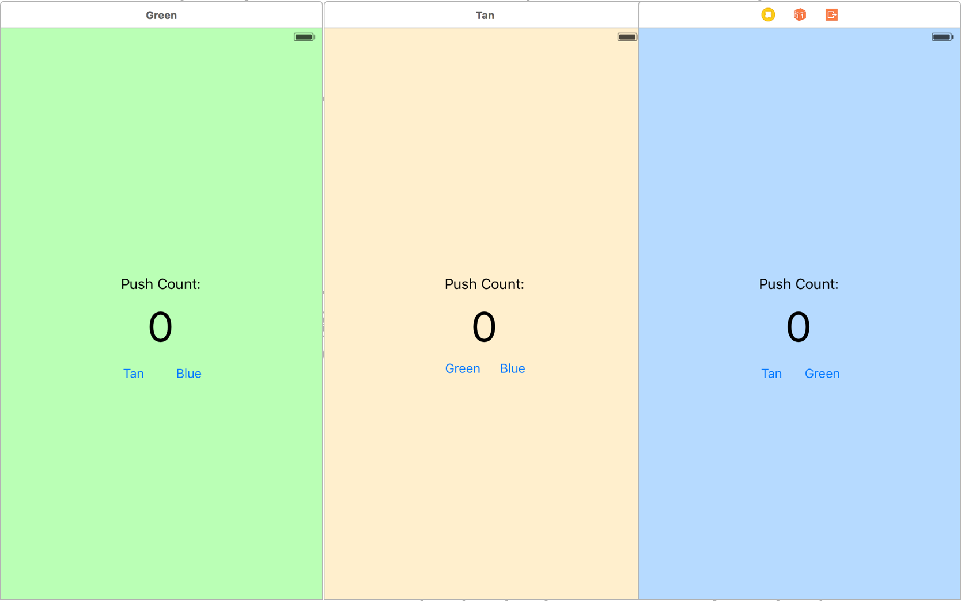Title appropriate for app use

Button to navigate to “blue” screen

Button to navigate to “green” screen

Button to navigate to “tan” screen