Koby Samuel

iOS Application Development

10/12/15

Activity 1 for App 5

Go button

Back button Forward button

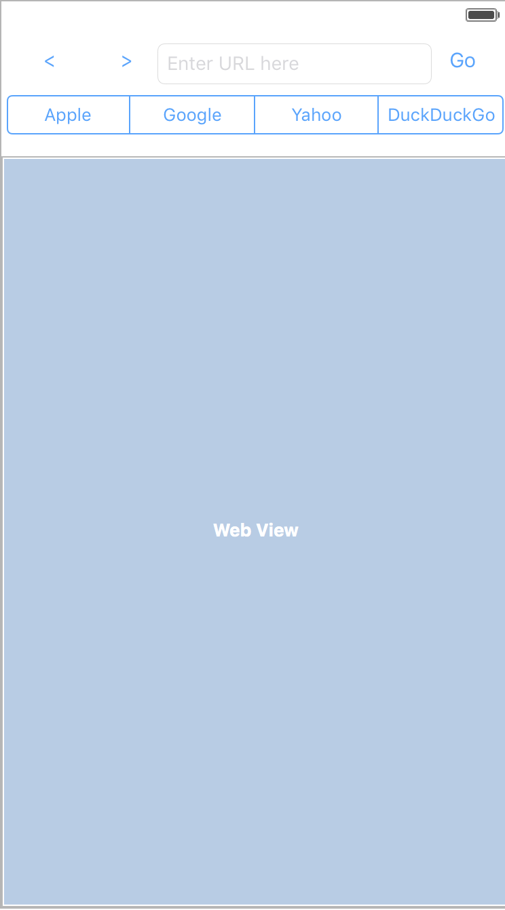

URL bar

Favorites list