Koby Samuel

iOS Application Development

11/9/15

Activity 2 for App 13

Cells populated with title and picture (favicon)

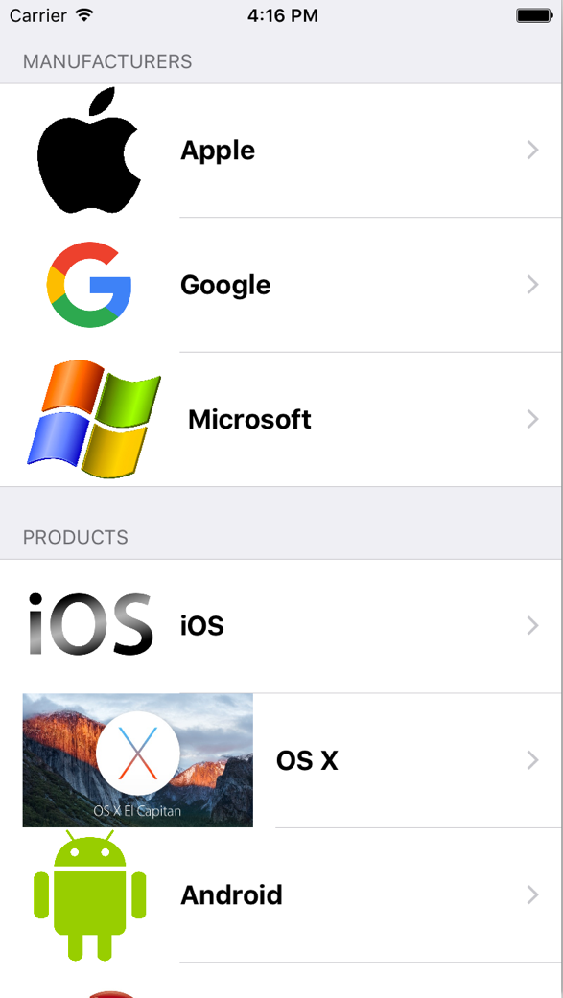Titles of table groups appropriate for cell info