**The Fast Button Game**

A game has two players or users to play. This game consists of two pushbuttons. Both players have to press the push buttons very fast to get the red led light up and buzzer on.

If user one gets the red led light up first, he will be the winner. If the second user gets the red led light up before the first user, he will be the winner.

**Design:**

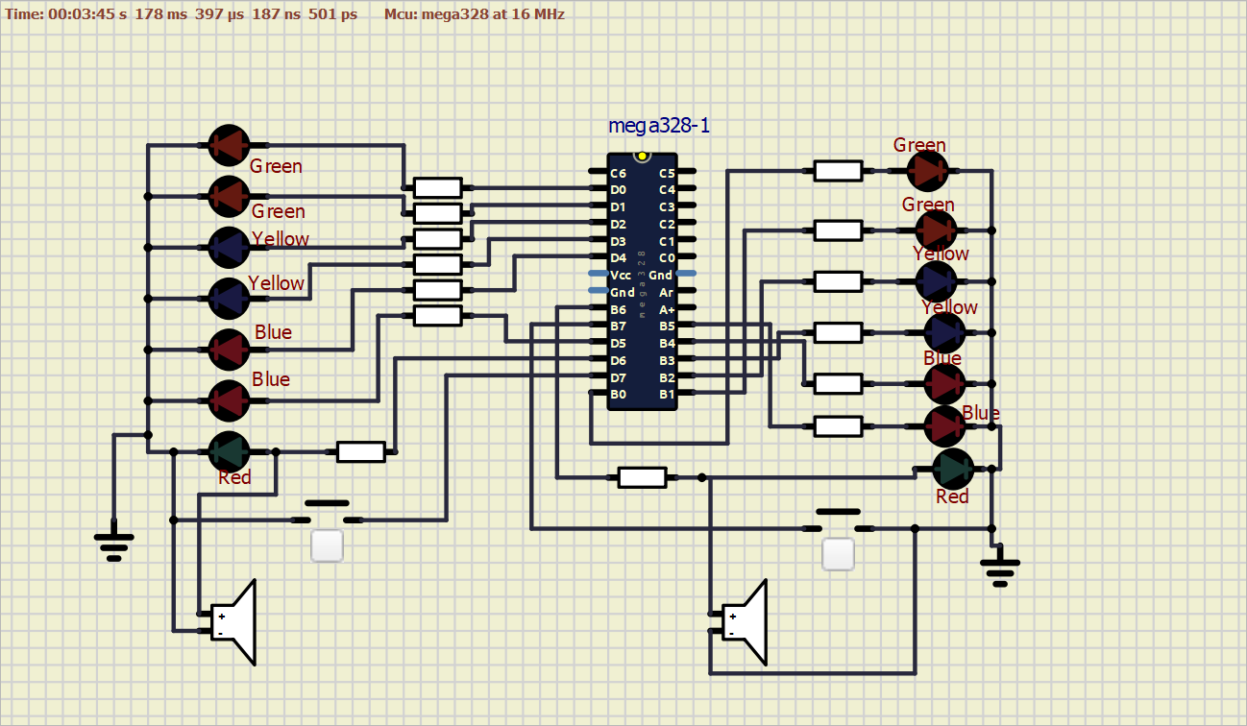

**Working:**

When the push buttons get pressed by the users then led’s will get lightened up one by one. And when the last led that is of red color light up along with the buzzer, the user is declared a winner.

**Requirements:**

1. Led’s

(2-Green,2-Yellow,3-Blue,1-Red)

2.Atmega328 Controller

3. Buzzer x2

4.PushButtons x2

**Flow Chart:**

Push Button Input

Yes No

All Led’s off

Is Input>6

Green Led+ Red Led

Green Led

Green Led