Corrected Pinhole Collimator Geometry

Full 3D Derivation for GateParametrisedPinholeCollimator
Corrected from Kochebina (2022) Equations (9) (10) replaced with unified 3D treatment
February 12, 2026

Contents
1. Known Parameters and Coordinate System 2
1.1 The pinhole's coordinates 3
2. 3D Tilt Angle (Corrected ß) 5
3. Geometrical Cone Parameters 7
3.1 Step 1: Auxiliary angle δ 7
3.2 Step 2: Extension above the plate l 8
3.3 Step 4: Axis segment from midplane to upper plate a 10
3.4 Step 5: Lower offset quantities s, p, g, and b 10
3.5 Step 6: Total cone height Dz (corrected) 11
3.6 Step 7: Cone basis radius (Fig 8) 12
4. Cone Tilt (Rotation Matrix) 13
5. Displacement Correction Due to Tilt 14
5.1 Vertical displacement ∆z 14
5.2 Transverse displacements ∆x and ∆y (corrected) 15
5.3 Application to upper and lower cones 16
6. Summary of All Corrected Equations 17

For more questions contact:
Olga Kochebina, kochebina@gmail.com
Mohammad Mirdoraghi, mirdoraghimohammad@gmail.com

Aim: The purpose of this document is to find the shifted x, y and z coordinates of a tilted hole in the pinhole collimators.

Known Parameters and Coordinate System
Each pinhole is defined by the following parameters (Table 1-5) read from the .pin le and collimator macro settings:

Table 1. Parameters of the pinhole in the .pin file
Parameter | "Between What and What?" | Purpose
ß (Beta) | The Cone Axis and the Horizontal FOV Plane. | The "Steepness. 90º is straight up; 0º is flat.
φ (Phi) | The Horizontal X-axis and the direction of the tilt. | The "Compass." It rotates the direction of the lean on the xy-plane.
α (Alpha) | The Cone Axis and the Cone Wall. | The "Opening Angle." Tells you how wide the "V" shape is.
ϭ(Delta) | The Vertical Normal and the Cone Axis. | An auxiliary angle (90 - alpha - beta) used to find the hole edges.

Table 2. Parameters of the pinhole related to the angles

d | Diameter of the pinhole at its waist
α | Half-angle of the opening cone
(x, y) | Center of the pinhole on the collimator plate
(x_{f} , y_{f} ) | Focal coordinates on the FOV center plane
z | Rotation radius (distance from FOV center to collimator mid-plate)
h | Half-thickness of the collimator plate

Table 3. Parameters related to the lengths and segments of the slanted pinhole
Parameter | Start Point | End Point | Path Shape
a | The Waist (center of plate). | The upper surface of the plate. | Slanted along the axis.
l | The Upper Surface of the plate. | The upper apex (pointy tip). | Slanted along the axis.
b | The Waist (center of plate). | The lower apex (bottom pointy tip). | Slanted along the axis.
$$D_{z}$$ | The Lower Apex. | The upper apex. | The total length of one cone (a+l+b).
$$r_{max}$$ | The cone axis (at apex). | The outer edge of the cone base. | Radius perpendicular to axis.
k | The midplane | a×sin(ß) | Vertical line (projection of a).
n | The Cone Axis at the surface. | The edge of the hole at the surface. | Horizontal offset on the plate.
h | The Midplane. | The plate surface. | Vertical half-thickness of the metal.

Table 4. Parameters related to the positioning & "Nudges"
Parameter | Definition | Logic / Direction
r | Transverse Offset. | Total horizontal distance from (x,y) to ($x_{f}$, $y_{f}$).
Ʌz | Vertical Displacement. | Moves the waist back to the center of the plate (z-axis).
Ʌx | Transverse Correction (X). | Moves the pinhole left/right to account for the tilt.
Ʌy | Transverse Correction (Y). | Moves the pinhole forward/back to account for the tilt.

Table 5. Parameters related to the orientation and the rotation matrix
Parameter | Definition | Mathematics
x, y, z normals | Direction Cosines. | The "Unit Vector" (compass) telling the software where the axis points.
rotX, rotY | Rotation Angles. | The specific degrees of rotation needed to point at the focal point.
x-$x_{f}$, y-$y_{f}$ | Distance Components. | The horizontal "gaps" between the pinhole and the target center.

The pinhole's coordinates
The pinhole's cone axis runs from the pinhole center (x, y) on the collimator surface to the focal point ($x_{f}$ ,$y_{f}$) at the field-of-view (FOV) center, spanning the rotation radius z (Fig 1). Because the axis is tilted in both the x- and y-directions simultaneously, we must use a single, unified 3D tilt angle ß in all subsequent derivations.
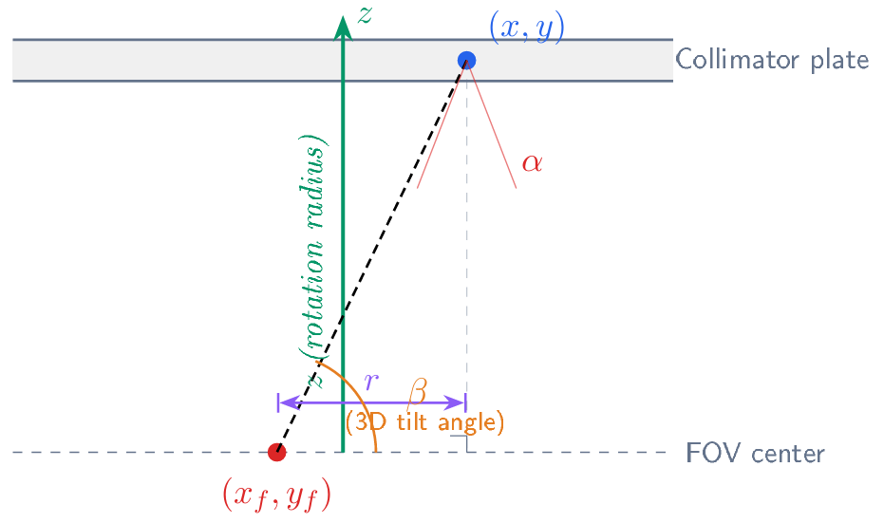
Fig 1. 3D coordinate system. The pinhole at (x, y) on the collimator plate has its axis directed toward the focal point ($x_{f}$ ,$y_{f}$) on the FOV center plane, a distance z (rotation radius) below. The 3D tilt angle ß is measured from the FOV plane.

Additional information: Why does the shape look like this? (The "Double Cone") The pinhole's shape is often called an hourglass or a double cone.
The Physics: A pinhole isn't just a cylinder. To allow radiation to pass through at an angle without getting blocked by the edges of the metal, the hole must be wider at the top and bottom than it is in the middle. The Mathematical "Full" Cone: In simulation software like GATE, a cone is defined as a solid object that goes all the way to a sharp point i.e., the apex. The Intersection: The software takes two of these solid cones and places them tip-to-tip. The metal plate is like a "sandwich" that sits in the middle of these two cones. The parts of the cones that stick out into the air are ignored by the metal, but they are necessary for the math to ensure the "opening" at the surface is the correct size.
The Difference between h and k: This is the most common point of confusion. Both are vertical measurements, but they refer to different things.
h (the Physical Half-Thickness). It is half of the total physical thickness of the metal plate. Start/End: Starts at the Midplane and ends at the plate surface. It is a constant. If your lead plate is 10 mm thick, h is always 5 mm, regardless of how much you tilt the pinhole. Role: It defines where the metal physically stops.
k (The geometric vertical projection): k is the vertical projection of the axis segment a. It is the vertical distance from the collimator's midplane to where the central axis of the slanted pinhole exits the plate surface. Start/End: Starts at the waist (center) and ends at the exit point of the slanted axis. It is a variable that depends on the tilt. Why it's different from h: When a pinhole tilts, the center of the "opening" on the surface shifts. Because of the way the angles alpha (opening) and beta (tilt) interact, the "geometric center" of the hole's mouth doesn't stay exactly at the height of the plate surface in the math—k is the vertical height used to calculate the slanted segment a. In a standard vertical pinhole (beta = 90), k is at its most stable i.e., k = a × sin(ß) = a. As you tilt it down toward the "Small Angle Trap" (beta = alpha), beta goes down from 90º to alpha, k collapses toward zero. At beta = alpha (the grazing point), the tilt is so severe that the lower edge of the cone is perfectly flat against the plate surface. Note that beta = 90 means no tilt, the pinhole is standing up, beta is always greater than or equal to alpha (Tilt = 90º-ß) (Fig 2).

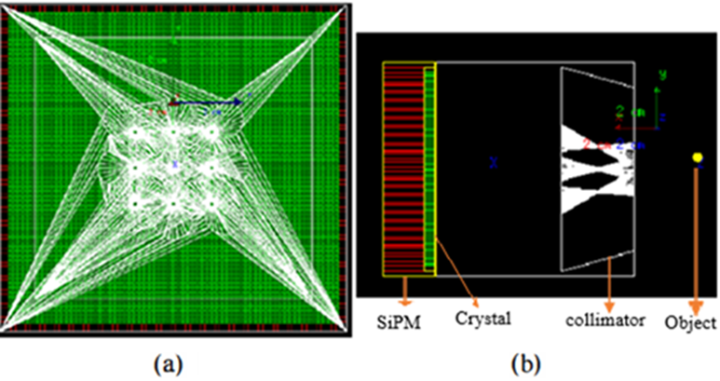
Fig 2. A 9-pinhole collimator in the frontal (a) and lateral view (b). The peripheral pinholes are tilted toward the central pinhole (1).

3D Tilt Angle (Corrected ß)
The original document defines (Eq. 1):

$ß$ = $\left|\frac{π}{2}\right.-atan\left.(\frac{\left|x- \left.x_{f}\right|\right.}{z})\right|$

which considers only the x-displacement. In 3D, the total transverse offset from the focal point to the pinhole projection is:
r = $\sqrt{{(x-x_{f})}^{2}-{(y-y_{f})}^{2}}$ | (1)

and the angle ß between the cone axis and the FOV-center plane becomes:

ß = atan($\frac{z}{r})=$ atan($\frac{z}{\sqrt{{(x-x_{f})}^{2}-{(y-y_{f})}^{2}}})$ | (2)
When y = yf (no y-displacement), this reduces exactly to the original Eq. (1). The azimuthal angle φ of the tilt direction (needed later for displacement corrections) is:

φ = atan(y-$y_{f}, x-x_{f})$ | (3)

Additional information: When beta is a constant 45º, it means the "steepness" of the pinhole never changes. However, as the pinhole tilts into different quadrants of the xy-plane, the azimuthal angle phi changes to act as the compass. In a standard 3D coordinate system, phi starts at the positive x-axis (0) and rotates counter-clockwise. Beta doesn't change its sign in different quadrants but it changes phi (Table 6).

Table 6. φ can optionally be ranged from 0º to 360º or -180º to 180º.
Quadrant | Direction of Tilt | Example ϕ (Center of Quadrant)
Quadrant I | Right & Forward (+x, +y) | 45º
Quadrant II | Left & Forward (-x, +y) | 135º
Quadrant III | Left & Backward (-x, -y) | 225º
Quadrant IV | Right & Backward (+x, -y) | 315º

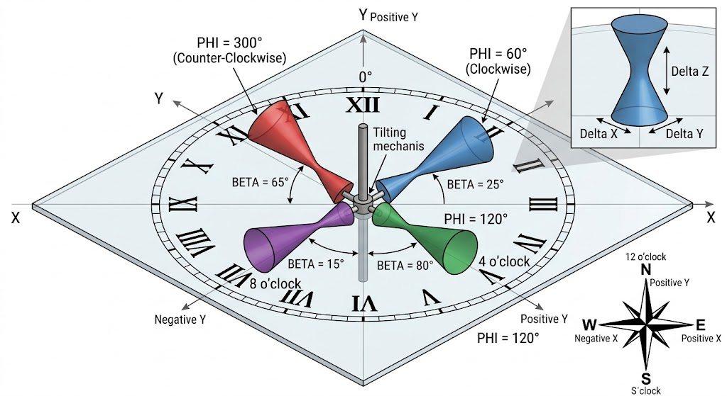

Fig 3. Beta is the angle between the pinhole's axis and XY plane. Phi is the angle that the determines the position of pinhole axis in the XY plane.

-The clock face (The XY plane): The transparent surface acts as your collimator plate. The '12' position (Positive Y-axis) is defined as 0º for the azimuthal orientation.
-The Pinhole Cones: Each color-coded cone represents a distinct pinhole, all meeting at the center (the 'tilting mechanism' or waist).
- The Azimuthal Angle (Phi): This angle is measured within the clock face plane, showing you which 'hour' the pinhole is pointing towards. You can see how the different PHI values (Red at 300º, Blue at 60º) direct the cone around the 3D compass (Fig 3).
- The Tilt Angle (Beta): This angle measures the steepness of the cone's tilt, relative to the horizontal clock face. Note how the cones have different steepness levels (25º for Blue, 65º for Red, 80º for Green, and 15º for Purple), visually separating Beta from the directional Phi.
- The 'Nudges' (Inset): The top right box provides a magnified look at the central waist, illustrating exactly where the vertical correction (Delta Z) and the horizontal corrections (Delta X and Delta Y) are applied to keep the pinhole perfectly centered within the plate after it has been tilted.
"Atan2" Parameter Order
The Detail: Different programming languages (like C++ vs. Excel vs. Python) sometimes swap the order of arguments for atan2(y, x) or atan2(x, y).
The Potential Error: The document lists it as atan2 (y − $y_{f}$ , x – $x_{f}$). While this is standard for C++ (the language used in the GATE software this is meant for), a user using a different tool might swap them and end up with a 90-degree rotation error.

Geometrical Cone Parameters
Below we re-derive all cone geometry parameters using the corrected 3D tilt angle ß. See Fig 4 for the labeling of geometric quantities. All equations below use the corrected ß from eq (2).

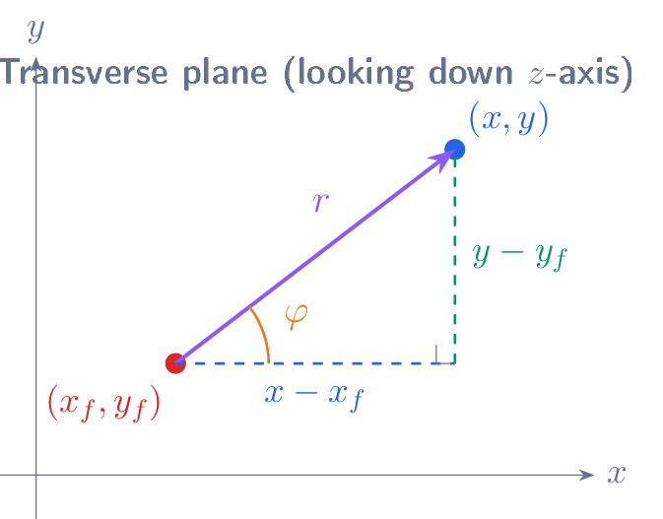
Fig 4. View looking down the z-axis (along the rotation radius). The total transverse offset r combines both x- and y-displacements. The azimuthal angle φ defines the tilt direction.

Step 1: Auxiliary angle δ
The angle δ between the collimator surface normal (vertical) and the cone axis satisfies δ+α+ß = 90◦, giving:

90º + α + β + δ = 180º;  δ = 90◦ − α – β | (4)

Step 2: Extension above the plate l
The segment l runs from the upper plate surface along the cone edge to the cone apex. From the right triangle formed by h, the plate surface, and the cone edge (Fig 5):

$l$ = $\frac{h}{cos⁡(δ+α)}= \frac{h}{sin(ß)}$ | (5)

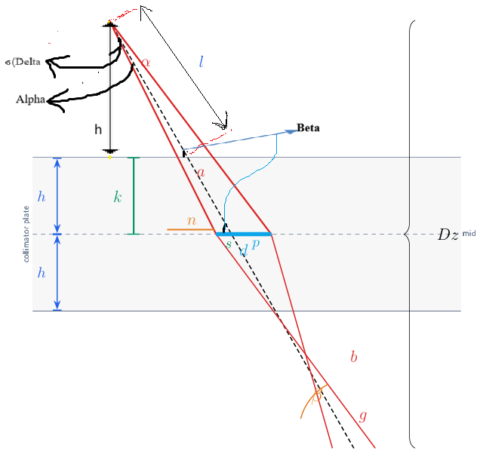
Fig 5. Cross-section of a tilted pinhole cone along the tilt plane. The cone axis makes angle ß with the FOV plane. The aperture diameter is d at the midplane, and the collimator half-thickness is h. Labeled quantities: l (upper extension beyond plate), a (midplane-to-plate along axis), k (vertical projection), n (horizontal offset), b (lower extension), g (lower horizontal run). Total cone height: Dz = a + l + b.

The formula sin(ß) = h/l only works if the vertical height of that air segment is exactly equal to the half-thickness (h) of the plate.
In this specific derivation:
The author assumes the "Hourglass" is perfectly symmetrical.
The "waist" is at the midplane (z=0).
The "apex" (tip) of the cone is placed at a vertical height of exactly 2h (the full thickness of the plate).
Therefore, the vertical distance from the top surface (h) to the apex (2h) is exactly h.
Step 3: Vertical and horizontal projections k and n
Using the two cone edges (at angles δ and δ + 2α from vertical) and the pinhole diameter d at the midplane, we set up the simultaneous equations (Fig 6):

$tan⁡(α+ß$) = $\frac{k}{n}$ | (6)
$tan⁡(ß-α$) = $\frac{k}{n+d}$ | (7)

Eliminating n by solving eq. (6) for n = k/ tan(α + ß), substituting into eq. (7), and solving for k:

k = $\frac{d.tan\left(ß-α\right).tan(α+ß)}{tan\left(α+ß\right)- tan(ß-α)}$ ß ≥α | (8)
n+d = $\frac{k}{tan(α+ß) };$  n = $\frac{k}{tan(α+ß) }-d;$ | (9)

Note: The derivation of k and n follows from the simultaneous equations tan(α + ß) = k/n and tan(ß − α) = k/(n + d). Subtracting eliminates n and yields the expression for k. Note that n in eq. (9) uses tan(α + ß), not tan(ß − α) (Fig 6).

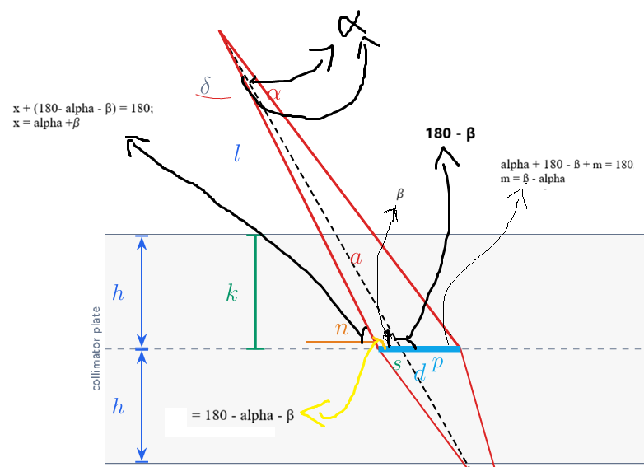

Fig 6. The relationship between different angles and lengths.

Step 4: Axis segment from midplane to upper plate a

a = $\frac{k}{cos⁡(δ+α)}= \frac{k}{sin⁡(ß)}$ | (10)

Step 5: Lower offset quantities s, p, g, and b
tan(ß) = $\frac{k}{s+n}$;  s + n = $\frac{k}{tan(ß) }$;  s = $\frac{k}{tan(ß) }-n;$ | (11)
Then p = d - s. By similar triangles between the upper and lower extensions (Fig 7):

$\frac{g}{d-s}$ = $\frac{a+l}{a}$;  g = $\frac{(d-s)(a+l)}{a }$; | (12)
$\cos{β}$ = $\frac{b}{g}$  b = g$\cos{β}$ = $\frac{\left(d-s\right)\left(a+l\right)\cos{β}}{a}$ | (13)

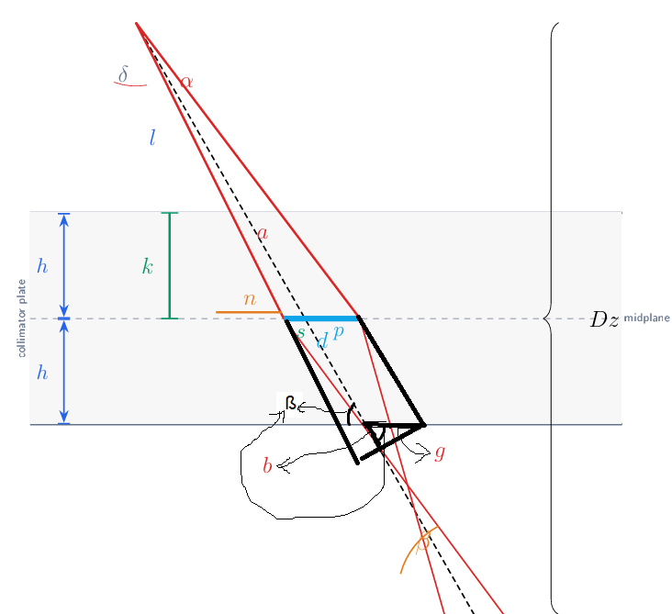
Fig 7. The relationship between g and b.

Step 6: Total cone height Dz (corrected)
This is the key correction. The original document attempts to split $D_{z}$ into separate x- and
y-components (Eqs. 9 and 10) and combine them via:
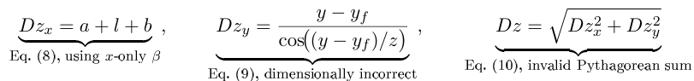
Both Eq. (9) and Eq. (10) are incorrect:
Eq. (9): The argument to cos is a dimensionless ratio of lengths, not an angle. The formula also ignores the cone opening angle α and all the careful trigonometry from the cross-section.
Eq. (10): Dz_{x} and Dz_{y} are both scalar depths along the cone axis they are not orthogonal vector components. A Pythagorean combination of two cone heights is geometrically meaningless.
The correct result, using the 3D tilt angle ß from eq. (2) throughout Eqs. (5) (13), is simply:

$D_{z}$ = a + l + b | (14)

This single equation replaces the original Eqs. (8), (9), and (10).

Expanding fully:


Step 7: Cone basis radius (Fig 8)
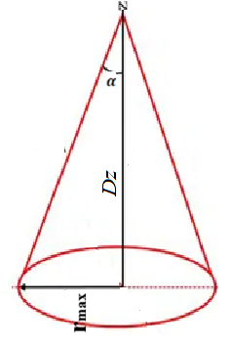
Fig 8. The relationship between g and b.

$\tan\left(α\right)=\frac{r_{max}}{Dz}$;  $r_{max}$ = $Dz$ . $\tan\left(α\right)$ | (16)

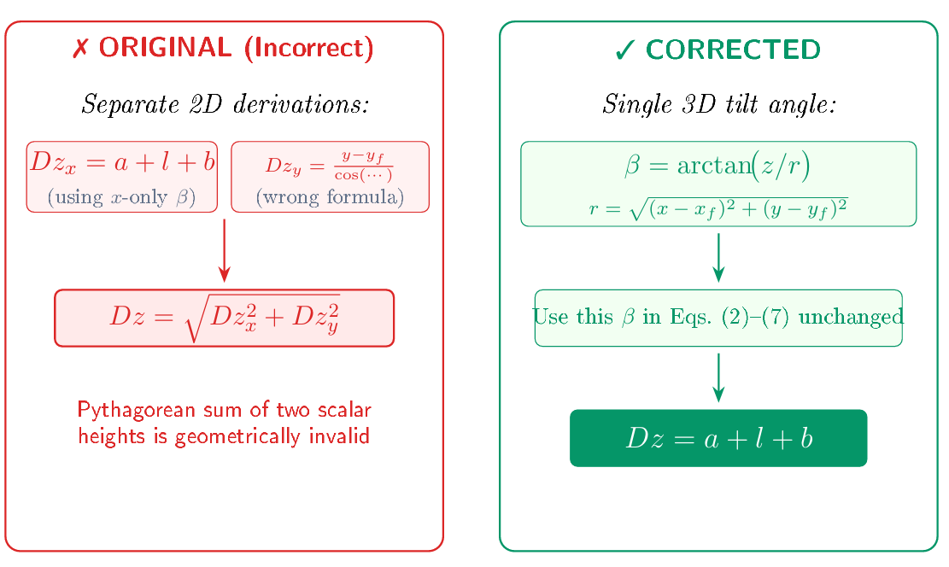
Fig 9. Comparison of the original (incorrect) decomposition vs. the corrected unified approach.

Cone Tilt (Rotation Matrix)
The tilted cone is oriented using G4RotationMatrix with rotations rotateX and rotateY. The direction cosines of the cone axis are computed from the displacement vector x−x_{f} , y−y_{f} , z :

$$t=({x-x_{f})}^{2}+({y-y_{f})}^{2}+ z^{2}$$ | (17)

$$x_{normal}= \frac{x- x_{f}}{\sqrt{t}}$$ | (18)
$$y_{normal}= \frac{y- y_{f}}{\sqrt{t}}$$ | (19)
$$z_{normal}= \frac{z- z_{f}}{\sqrt{t}}$$ | (20)
The rotation angles that align the cone axis with this direction:

$rotX= arctan⁡(\frac{x_{normal}}{z_{normal}}$) | (21)
$roty= arctan⁡(\frac{y_{normal}}{z_{normal}}$) | (22)
Note: These rotation equations are unchanged from the original document. They already operate in 3D since the direction cosines naturally incorporate both x- and y-displacements.

Displacement Correction Due to Tilt
Because the G4Cons is centered at its geometric midpoint while the pinhole center (x, y) is defined at the collimator midplane, we must compute displacement corrections (∆x, ∆y, ∆z) to position the cone correctly (Fig 10).

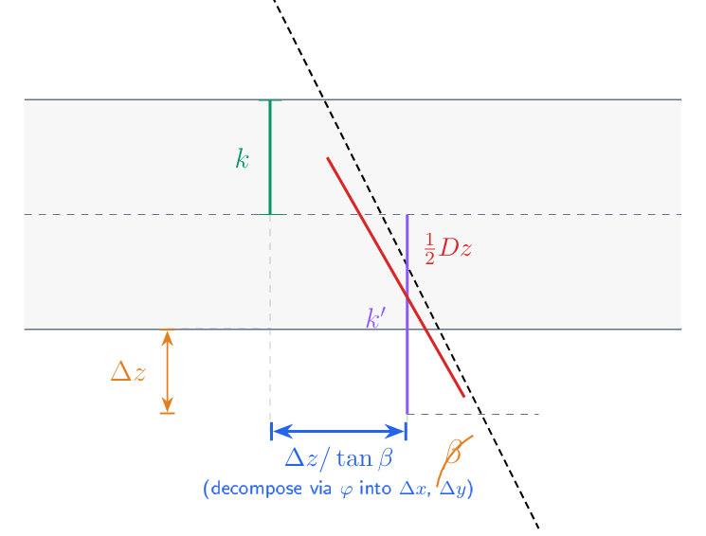
Figure 10: Displacement corrections. The cone center (at $\frac{D_{z}}{2}$ along its axis) is offset from the pinhole center at the midplane by (∆x, ∆y, ∆z).

Vertical displacement ∆z
The cone's geometric center sits at half its total height along the axis. Project this back to the vertical. When there's no tilt (ß = 90 and tilt angle = 90 – ß = 0), the projected height equals k. However, when the hole is tilted, the projected height exceeds the half height of the collimator plate which is called k′. This is along the axis of the collimator's thickness or Z axis. The difference between the projected height in cases of tilt angle = 0 and tilt angle > 0 along the Z axis is ∆z.
How is the difference between two lengths along X and Y dimensions? If the tilted axis of pinhole is situated on one of the X or Y axes i.e., the φ angle is 0, 90, 270, 360, then $\frac{ɅZ}{tan⁡(ß)}$ goes to that X or Y axes.

$$k^{'}=\frac{Dz}{2}.Sin(ß)$$ | (23)
$∆z$ = k - $k^{'}=$ k – $\frac{Dz}{2}.Sin(ß)$ | (24)

Transverse displacements ∆x and ∆y (corrected)
In the case of placing tilted axis of the pinhole on one of the quadrants on the XY plane e.g., 0<φ<90, 90<φ<180, 180<φ<270, and 270<φ<360, the portion of the $\frac{∆Z}{tan(ß)}$ should be calculated for each axis, X and Y, in the XY plane. Therefore, the horizontal offset $\frac{∆Z}{tan(ß)}$ must be decomposed into its x- and y-components using the azimuthal angle φ = atan2(y − y_{f} , x − x_{f} ) (Fig 11):

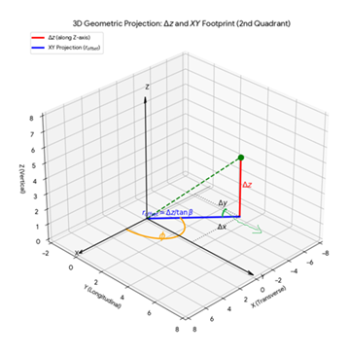
Fig 11. The azimuthal angle between the positive horizontal axis and the pinhole's central axis.

Sin(φ) = $\frac{∆y}{\frac{∆Z}{tan(ß)}}$;  $∆y=$ $\frac{∆Z}{tan(ß)}$ × Sin(φ); | (25)
Cos(φ) = $\frac{∆x}{\frac{∆Z}{tan(ß)}}$;  $∆x=$ $\frac{∆Z}{tan(ß)}$ × Cos(φ); | (26)

Application to upper and lower cones
Each pinhole is drilled from both sides, so there are two cones per pinhole: The entire coordinate system is centered on the collimator midplane (Dz midplane). z = 0 is the horizontal line running through the very center of the plate's thickness. Positive z is anything above the midplane, toward the detector/upper surface. Negative z is Anything below the midplane, toward the patient/FOV. The down cone is shifted toward FOV as Ʌz, it must be moved downward (-Ʌz) from the midplane to be positioned correctly in the bottom half of the plate. Takes shifting toward FOV negative and toward detector positive. For X and Y axes, taking them positive when moving toward FOV. Because the cone is tilted toward the focal point (x_f, y_f), its geometric center is shifted horizontally away from the vertical.

Down cone (toward FOV):  $x_{down}=x+$∆x;  $y_{down}=y+$∆y;  $z_{down}$= -∆z; | (27)
Upper cone (away from FOV):  $x_{up}=x-$∆x;  $y_{up}=y-$∆y;  $z_{up}=+∆z$; | (28)

Summary of All Corrected Equations
Table 7 collects every equation in the derivation. Items marked with ✓ are corrected relative to the original document; all others are unchanged in form but now use the corrected ß.

Table 7. Complete equation summary. Green rows indicate corrections.
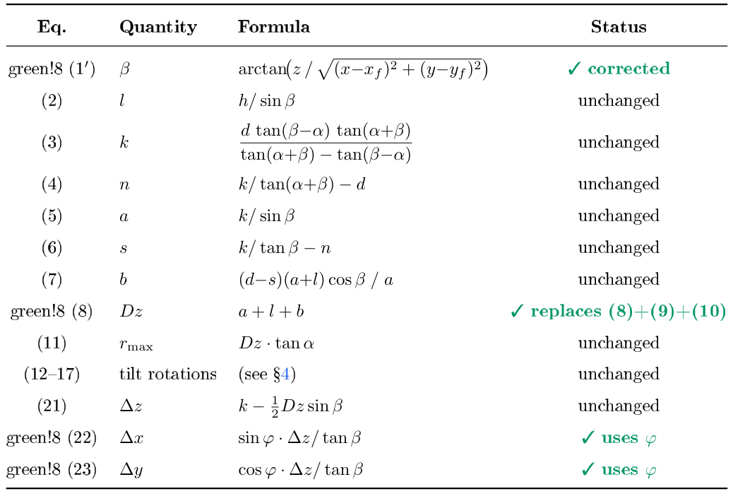

Key insight: The original equations (9) and (10) attempted a 2D+1D decomposition that is mathematically invalid. The x is conceptually simple: compute the true 3D tilt angle ß from the full displacement vector (x − xf , y − yf , z), then use the same 2D cross-sectional geometry (Eqs. 2-7) in the tilt plane. The result is a single scalar cone height Dz = a + l + b that correctly accounts for tilt in any direction.

References

1. Mirdoraghi M, Fard BT, Kochebina O, Mahani H, Ay M, editors. Optimization of Collimator Design in HiReSPECT II: a Monte Carlo Study. EUROPEAN JOURNAL OF NUCLEAR MEDICINE AND MOLECULAR IMAGING; 2024: SPRINGER ONE NEW YORK PLAZA, SUITE 4600, NEW YORK, NY, UNITED STATES.

