Introduction
This report presents a practical demonstration of how Gemini in Google Sheets can support data exploration and visualization workflows. The goal of this work was not to perform deep manual analysis, but to showcase how AI can assist with:
- generating high-level summaries,
- answering analytical questions,
- producing narrative explanations,
- and creating visualizations directly from prompts.
The focus is on AI-assisted analytics, illustrating how Gemini enhances speed, clarity, and efficiency when working with structured datasets. All results highlight how AI responds to prompts and supports the analytical process.

Step 1 - High-Level Data Summary
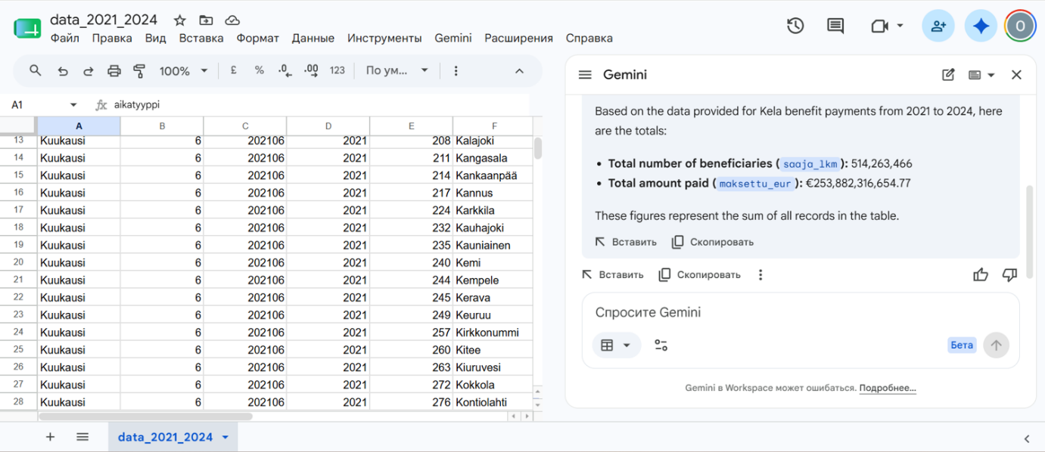

Step 2 - Total Payments by Benefit Type (etuus)
The total amount paid (maksettu_eur) by benefit type (etuus) based on the data provided is as follows (sorted from highest to lowest):
- Eläke-etuudet (pl. takuueläke): 36,192,359,124.26 EUR
- Sairaanhoitokorvaukset: 36,089,896,858.59 EUR
- Työttömyysturva: 31,371,320,815.87 EUR
- Yleinen asumistuki: 26,067,702,166.47 EUR
- Lapsilisä: 22,241,837,445.09 EUR
- Sairauspäivärahat: 17,302,213,407.67 EUR
- Vanhempainpäiväraha: 16,553,746,931.94 EUR
- Perustoimeentulotuki: 11,632,638,087.47 EUR
- Eläkkeensaajan asumistuki: 10,646,510,799.41 EUR
- Vammaisetuudet: 9,668,095,834.46 EUR
- Kuntoutus: 7,798,240,235.78 EUR
- Opintotuki (opintoraha, asumislisä, lainatakaus): 7,772,713,245.63 EUR
- Takuueläke: 4,570,521,126.04 EUR
- Kuntoutusraha: 3,896,172,437.85 EUR
- Lastenhoidon tuet: 3,681,156,067.36 EUR
- Elatustuki: 3,497,888,969.61 EUR
- Opintolainahyvitys: 1,440,601,863.08 EUR
- Koulumatkatuki: 1,046,640,495.64 EUR
- Perhevapaakorvaus: 831,110,000.00 EUR
- Vuosilomakustannuskorvaus: 809,081,823.27 EUR
- Sotilasavustus: 305,311,699.88 EUR
- Eläketuki: 168,446,702.88 EUR
- Äitiysavustus: 152,462,734.44 EUR
- Erityishoitoraha: 95,092,465.08 EUR
- Opintolainan korkoavustus: 48,065,770.04 EUR
- Väliaikainen sähkötuki: 2,489,546.96 EUR
- Opintolainavähennys: 0.00 EUR
The combined total for all benefit types across the period covered (2021–2024) is 253,882,316,654.77 EUR.

Step 3 - Analytical Narrative
From a data analyst's perspective, total expenditure on any social security benefit is fundamentally governed by a basic core equation:

$$\text{Total Expenditure} = \text{Volume (Number of Recipients)} \times \text{Intensity (Average Payout per Recipient)}$$
When analyzing a national system like Finland's Kela—which processes over €17 billion in benefits annually—the drastic variance between total payment buckets boils down to a mix of demographic volumes, macroeconomic sensitivities, and system design structures.
Three main drivers explain why certain benefits have significantly higher total payments than others:
1. High-Volume Universal or Demographic Anchors
Some benefits command multi-billion-euro totals simply because their target recipient pool is massive and structurally permanent.
- Health Insurance & Medical Benefits: This category consistently takes a massive share (over €5.4 billion for Kela in 2025). Why? Because healthcare, prescription medicine reimbursements, and sickness allowances cover nearly the entire population over the course of a year. It has massive volume.
- Family & Pension Benefits: Benefits for families with children or national/guarantee pensions support structural, long-term demographic segments. Because these populations (children under 17, low-income retirees) are consistently large, their baseline total expenditure remains high and predictable.
2. High-Intensity Payouts (The Length of Stay Factor)
A benefit might have fewer recipients but high "intensity"—either because the monthly allowance is large or because recipients stay on the benefit for a very long time.
- Unemployment Benefits: Kela's basic unemployment expenditure routinely hovers above €2 billion. While the recipient pool changes, the individual payout intensity per month is higher than a supplementary benefit (like a basic student supplement).
- Conversely, look at General Housing Allowance. Even though a huge number of people apply for it, it functions as a supplementary safety net. The average payout per person is relatively low compared to a full monthly living allowance, which keeps its relative weight smaller than healthcare or core unemployment.
3. Macroeconomic Volatility and Sensitivity
Some benefit buckets are highly sensitive to economic shifts, causing them to spike rapidly, while others are entirely static.
- The Counter-Cyclical Nature of Unemployment & Social Assistance: During economic downturns, unemployment claims and basic social assistance (the last-resort safety net) surge rapidly in volume. For example, Kela's unemployment expenditures rose by over 8% heading into recent years due to labor market pressures.
- Policy and Legislative Shocks: Rapid changes in totals are often driven by policy adjustments rather than organic changes. For instance, tightening eligibility criteria can cause an immediate drop in an entire bucket's volume, as seen with recent structural cuts to general housing allowances, causing that specific total expenditure to decrease significantly.
The Analyst's View: The "Safety Net Hierarchy"
When visualizing this data on a dashboard, it becomes clear that national social security systems are structured like a pyramid:

[ Last Resort ] -> Basic Social Assistance (Low/Medium Total, High Volatility)
[ Supplementary ] -> Housing Allowance, Student Benefits (Medium Total)
[ Core Safety Net ] -> Unemployment, Pensions, Sickness (High Total, High Intensity)
[ Universal/Systemic ] -> Health Insurance, Child Benefits (Highest Total, Massive Volume)
By analyzing the data through this hierarchy, we can easily see that a high total payment isn't necessarily a sign of system inefficiency; it's usually just a function of large scale or high economic sensitivity.

Step 4 - Data Visualization
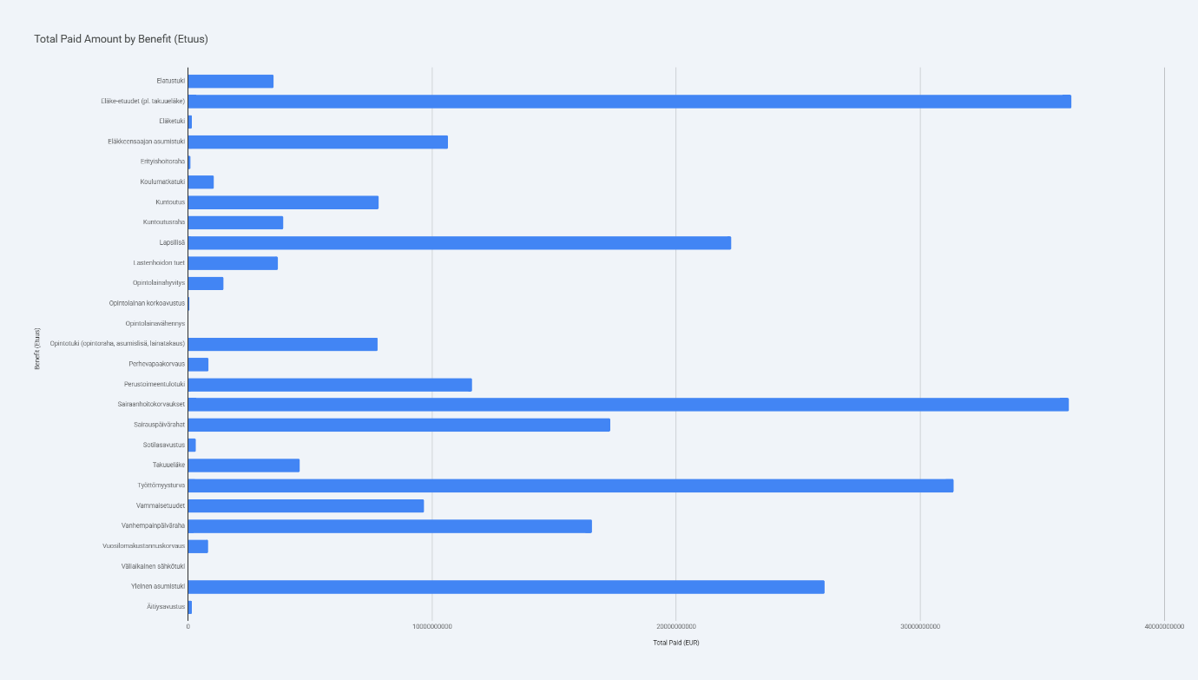

I have created a bar chart showing the total amount paid (maksettu_eur) for each benefit type (etuus) based on the data.
Key Insights:
- Highest Expenditure: The benefit category with the highest total payment is Eläke-etuudet (pl. takuueläke) (Pension benefits, excluding guarantee pension), with approximately €36.19 billion paid out.
- Other Major Benefits:
  - Sairaanhoitokorvaukset (Medical care reimbursements): ~€36.09 billion
  - Työttömyysturva (Unemployment security): ~€31.37 billion
  - Yleinen asumistuki (General housing allowance): ~€26.07 billion
  - Lapsilisä (Child benefit): ~€22.24 billion
- Lowest Expenditure: The category with the lowest non-zero expenditure is Väliaikainen sähkötuki (Temporary electricity subsidy), totaling about €2.49 million. Note that Opintolainavähennys (Student loan deduction) shows a total of 0 in this dataset.
The "Total Paid Amount by Benefit (Etuus)" chart displays the distribution of these payments across all categories, sorted from highest to lowest.

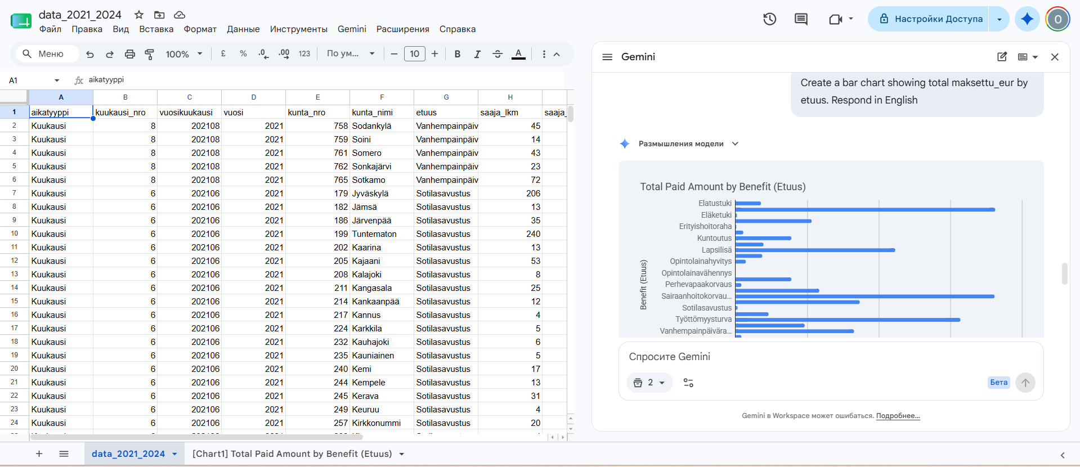
Conclusion
This work demonstrates how Gemini in Google Sheets can support data exploration by generating summaries, answering analytical questions, creating narrative explanations, and producing visualizations directly from prompts. The focus was on showcasing practical AI-assisted workflows rather than performing deep manual analysis. The results highlight how Gemini can accelerate high-level insight generation and simplify the process of working with structured datasets.

