Project: Kela Benefit Dashboard (2018–2026)
Interactive data visualization built with Gemini and Finnish open data

1. Project Overview
This project demonstrates my ability to work with real Finnish open data and create an interactive analytics dashboard using Gemini. The dashboard visualizes Kela benefit statistics (Kelan etuuksien saajat ja maksetut etuudet) across multiple years, showing trends in payments, recipients, and benefit categories (etuus).
The goal of the project is to showcase practical skills in:
- data cleaning and preparation
- SQL transformations
- interactive dashboard creation
- visual analytics and insight generation

2. Data Source
The dataset comes from the official Finnish open data portal Avoindata Suomi, published by Kela.
Dataset: Kelan etuuksien saajat ja maksetut etuudet URL: https://avoindata.suomi.fi/data/en_GB/dataset/kelan-etuuksien-saajat-ja-maksetut-etuudet License: CC BY 4.0
The dataset includes original Finnish column names:
- vuosi, kuukausi_nro, etuus
- saajat_yhteensa, saajat_laskenta_yhteensa
- maksettu_yhteensa, maksettu_laskenta_yhteensa

3. Data Preparation (SQL)
I prepared the dataset using SQL to clean and standardize values. Payment amounts were rounded to whole numbers for clearer visualization.
4. Dashboard Features
The dashboard includes:
- Vuosi and Kuukausi filters
- Etuuslajisuodatin (benefit type filter)
- KPI cards:
  - Maksettu yhteensä
  - Edunsaajat (kumulatiivinen)
  - Keskimääräinen tuki / saaja
  - Aktiiviset etuusluokat

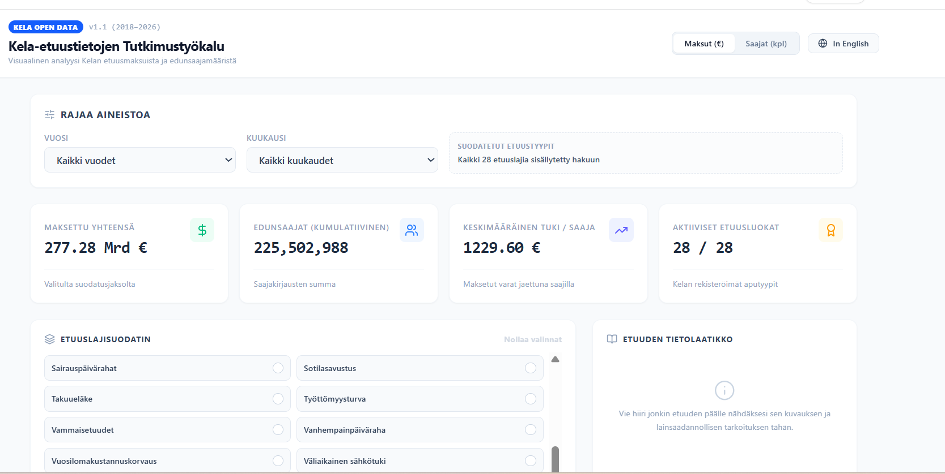
Visualizations included:
- Aikasarja (Time Series) — total payments over time
- Suurimmat etuuslajit (Top 10) — largest benefit categories
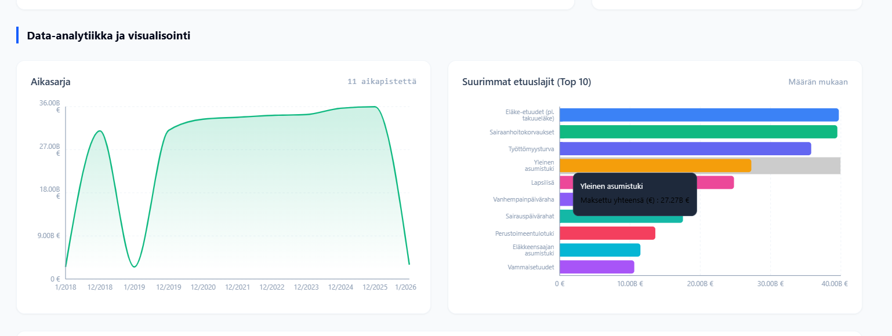

- Data Table — detailed monthly benefit rows
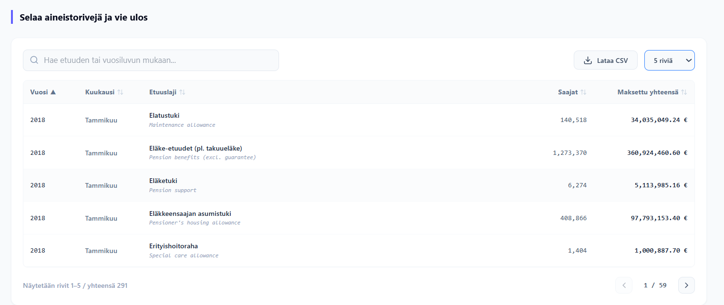

5. Key Insights
- Eläke-etuudet (pl. takuueläke) are the largest expenditure category.
- Yleinen asumistuki shows strong long-term growth.
- Työttömyysturva and Sairaanhoitokorvaukset remain consistently high.
- Seasonal patterns appear in categories like Opintotuki.
6. Skills Demonstrated
- SQL data transformation
- Working with Finnish open data
- Building interactive dashboards in Gemini
- Data visualization and storytelling
- Understanding of social benefit structures in Finland
7. Conclusion
This project demonstrates my ability to transform raw Finnish open data into a clear, interactive dashboard using modern AI-powered tools. By combining SQL preprocessing with Gemini’s application-building capabilities, I was able to quickly generate visualizations, create UI components, and structure the dashboard without manual coding.
Using Gemini as an AI assistant allowed me to:
- accelerate the development process
- automatically generate chart components and KPI cards
- validate data transformations
- focus on analytical logic rather than technical setup
The final dashboard highlights my practical skills in data visualization, open-data analytics, and AI-assisted development — all essential competencies for modern data analytics roles.

