1. Title Page
CSV Cleaner App — AI Studio Project
Author: Oksana Kocherzhat
Date: June 2026
Link to the App: https://ai.studio/apps/194e78d2-0a2d-4128-8b8a-1fbc8e2d169b

2. App Description
Short description of what the app does:
This application automatically cleans CSV datasets by detecting missing values, duplicates, formatting inconsistencies, and outliers. It provides visual diagnostics, column profiling, AI-powered transformations, and allows exporting a fully cleaned dataset.

3. Prompt Used
“I want to build an app that takes a CSV file and does automatic data cleaning (detects duplicates, missing values, inconsistent formats, and outliers) to create a clean, standardized dataset that helps me prepare data for analysis faster.”

4. Workflow Worksheet Summary
Step 1 | Step 2 | Step 3 | Step 4
Goals for the month | Tasks | How AI can help | Time Spent | Frequency | Repetitiveness
Goal 1: Improve my data analysis workflow | Import raw CSV files | Auto-detect structure and columns | Medium | Weekly | High
 | Inspect data for missing values | Identify missing values instantly | Medium | Weekly | High
 | Detect duplicates | Automatically find duplicate rows | Medium | Weekly | High
 | Standardize date and number formats | Convert formats consistently | High | Weekly | High
 | Remove empty or corrupted rows | Auto-clean invalid rows | Low | Weekly | High
Goal 2: Prepare clean datasets for BI dashboards | Validate column types | Detect incorrect data types | Medium | Weekly | High
 | Normalize categorical values | Suggest consistent categories | Medium | Weekly | High
 | Detect outliers | Highlight unusual values | Medium | Weekly | Medium
 | Export cleaned dataset | Generate downloadable cleaned CSV | Low | Weekly | High
 | Document cleaning steps | Auto-generate cleaning summary | Low | Weekly | Medium
Goal 3: Reduce time spent fixing CSV formatting issues | Identify formatting problems | Automatically scan for issues | High | Weekly | High
 | Apply cleaning rules | Apply fixes with one click | Medium | Weekly | High
 | Re-check dataset | Validate cleaned data | Low | Weekly | High
 | Save final version | Export final cleaned file | Low | Weekly | High
 | Prepare dataset for analysis | Provide ready-to-use output | Medium | Weekly | High
Reference
Time Spent: Low = Minutes | Medium = An hour | High = Several hours
Frequency: Low = A few times a month | Medium = Weekly | High = Daily
Repetitiveness: Low = Different every time | Medium = Some repeated elements | High = Nearly identical every time

5. Screenshots (Examples from the App)
Main screen (before upload)
This is the start screen of the CSV Data Cleaner app. Here the user can upload a CSV file or choose a sample dataset. The page shows a large upload area and a “Select CSV File” button.
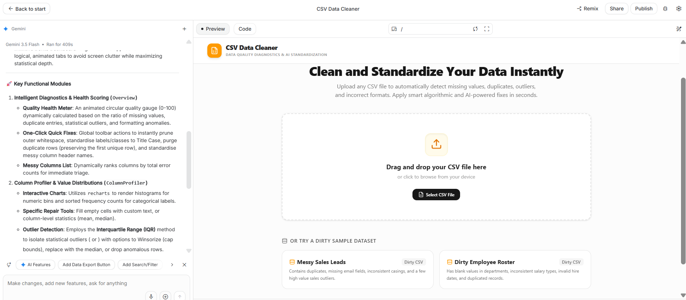

Overview
The Overview page shows the main data quality results. It includes the number of rows and columns, total issues, missing values, duplicates, formatting problems, and numeric outliers. It also shows the Quality Score and quick cleaning actions.
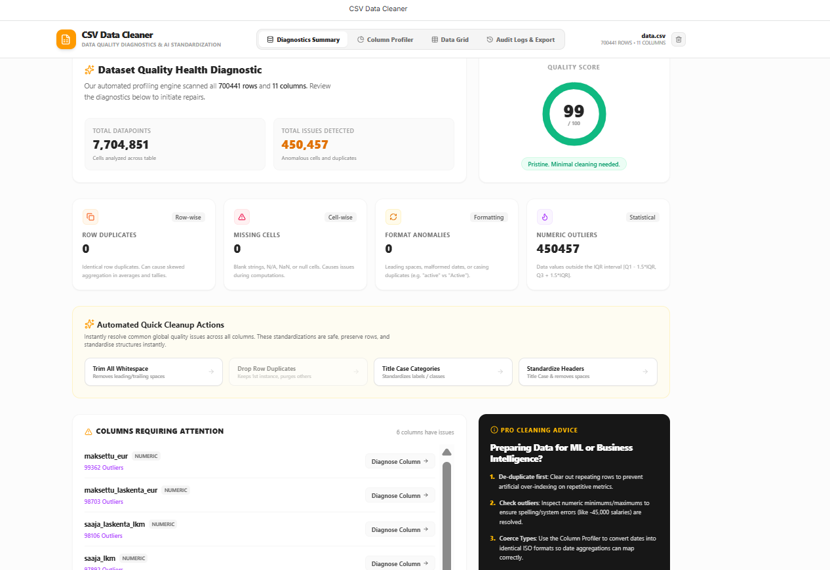
Column Profiler
The Column Profiler shows detailed information about one selected column. It displays value frequencies, number of unique values, missing values, and formatting issues. It also includes simple cleaning tools like trimming spaces or changing text case.
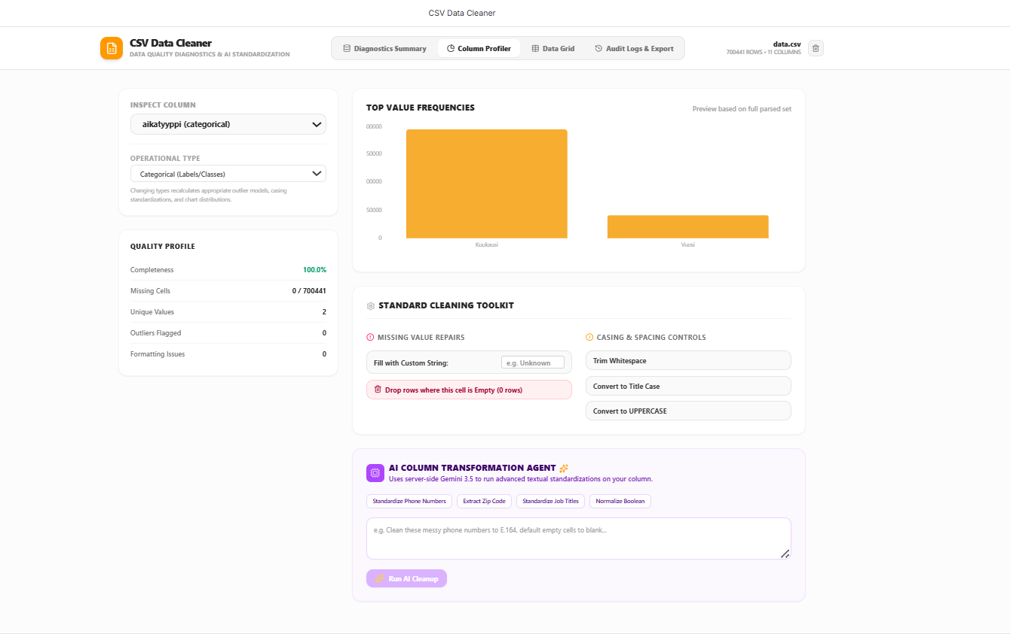

DataGrid
The DataGrid shows the full dataset in a table format. The user can scroll through the data, see all columns, and manually edit any cell. It also shows pagination because the dataset is large.
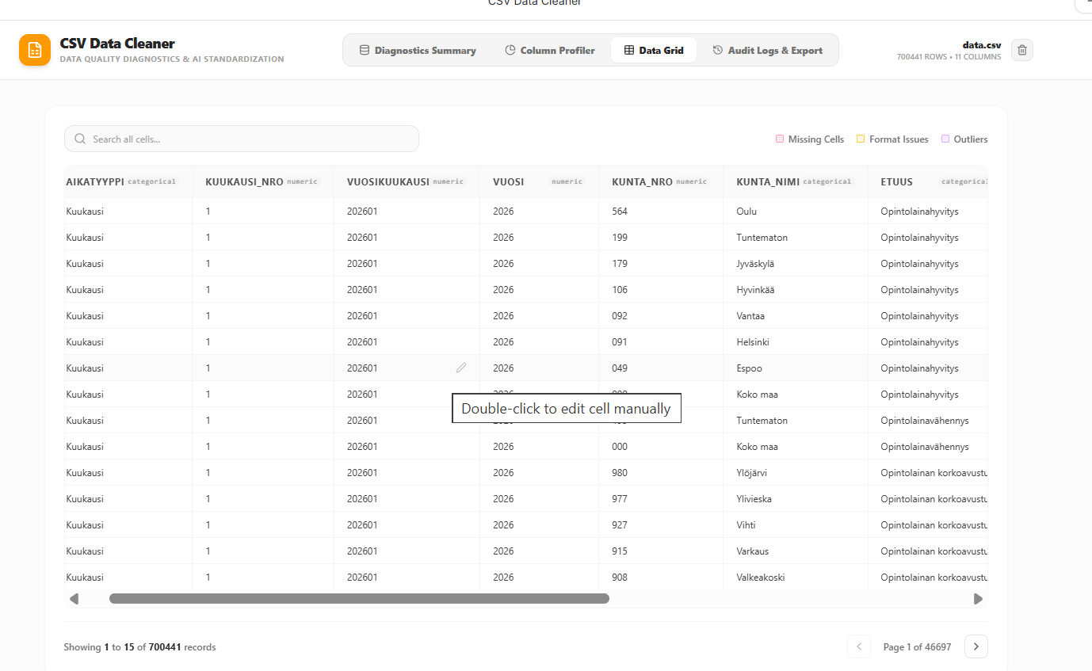
Audit Log & Export
This page shows the export options for the cleaned dataset. The user can choose the delimiter (comma, semicolon, or tab) and other formatting settings. After that, the user can download the cleaned and standardized CSV file using the “Download Standardized CSV” button.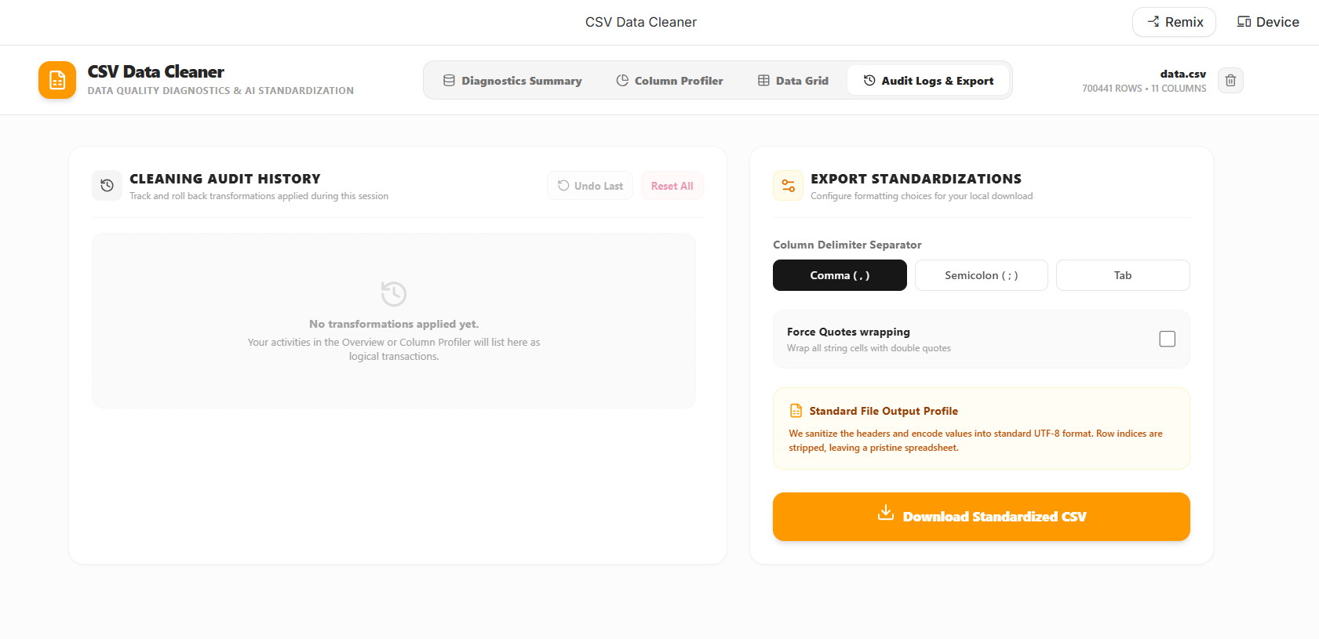

6. How the App Works
- Upload CSV
- App analyzes data
- Shows issues
- Allows quick fixes
- Provides column-level tools
- Allows manual edits
- Tracks all changes
- Exports cleaned dataset

7. Conclusion
This app significantly improves my data cleaning workflow and demonstrates how AI tools can automate repetitive analytical tasks. It is now part of my portfolio and can be reused for future data projects.

